Statistics for Data Science & Machine Learning
A 4-Hour Hands-On Training Workbook
Format: Instructor-led, 240 minutes, live coding in Google Colab
Environment: Google Colab only — every code block in this workbook runs as-is
Project dataset: Statistics_DS_ML_End_to_End_Project.xlsx (provided separately)

The workflow this whole course teaches
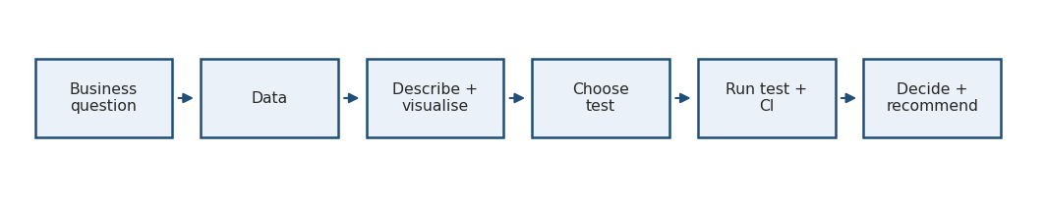

Getting started with Google Colab
- Go to colab.research.google.com and sign in with any Google account.
- Click File → New notebook.
- Click + Code to add a code cell.
- Paste a code block from this workbook into the cell.
- Press Shift + Enter to run it.
- Read the output printed below the cell.
- When the project needs the Excel file, run the upload cell and pick the file from your computer.
Nothing needs to be installed. No Google Drive. No file paths. Every library used here is already available in Colab.
Run this first — it confirms your environment is ready:
import numpy as np
import pandas as pd
import matplotlib.pyplot as plt
import seaborn as sns
from scipy import stats
import statsmodels.api as sm
print("numpy :", np.__version__)
print("pandas :", pd.__version__)
print("scipy : ready")
print("statsmodels:", sm.__version__)
print("Environment is ready.")
Expected output: four version lines and Environment is ready. If this runs, every other code block in this workbook will run.
IMPORTANT — Every code block in this workbook is self-contained: it creates its own data and imports everything it needs. You can run any block in a fresh notebook without running the previous ones. Wherever random numbers are involved we set np.random.seed(42), so your numbers will match the ones printed in this workbook.

MODULE 1 — What statistics actually is

Concept
Statistics is the discipline of turning data into defensible decisions under uncertainty. It has two halves:
- Descriptive statistics — compress what you observed into a few honest numbers and pictures.
- Inferential statistics — go beyond what you observed and say something about the wider population, while stating how wrong you might be.
The chain the business cares about is:
Data → Information → Insight → Decision. Statistics is the machinery in the middle two arrows.

Statistics vs Data Science vs Machine Learning
 | Question it answers | Typical output
Statistics | Is this pattern real, and how uncertain am I? | Estimates, intervals, p-values
Data Science | What is happening in this business, and why? | Analysis, dashboards, recommendations
Machine Learning | Can I predict the next value accurately? | A trained model, predictions
They overlap heavily. The honest summary: ML optimises prediction; statistics protects you from fooling yourself.
WHY IT MATTERS — where statistics shows up in an ML project
- Churn prediction — the target is a Bernoulli variable; the base rate decides your class-imbalance strategy.
- Model evaluation — an AUC of 0.81 versus 0.79 on a 2,000-row test set may be pure noise. Only a sampling-variability argument can tell you.
- Anomaly detection — “unusual” is defined by a distribution, usually via z-scores or quantiles.
- Feature engineering — log transforms, winsorising and standardisation are all distributional decisions.
- Experimentation — every “we shipped it and conversion went up” claim is a hypothesis test whether or not anyone runs one.
- Feature selection — correlation and multiple-testing corrections keep you from selecting noise.

Example
An e-commerce company has 10 million customers. Nobody analyses 10 million rows to answer a question about last quarter’s checkout redesign. They analyse a randomised sample of 20,000 and then generalise. The compression of those 20,000 rows into “average order value = ₹2,082” is descriptive. The claim “the new checkout lifts conversion for all 10 million users” is inferential — and it needs an uncertainty statement attached.

PRACTICAL 1 — Your first five statistics
Dataset: a small customer table created inside the code cell.
import pandas as pd
import numpy as np
df = pd.DataFrame({
"customer_id": range(1, 11),
"category": ["Electronics", "Grocery", "Fashion", "Electronics", "Grocery",
"Electronics", "Fashion", "Grocery", "Electronics", "Grocery"],
"purchase_amount": [2500, 800, 1500, 3200, 950, 2800, 1200, 700, 15000, 1100],
"converted": [1, 1, 0, 1, 1, 1, 0, 1, 1, 0]
})
print(df)
print("\nCustomers :", len(df))
print("Average purchase :", round(df["purchase_amount"].mean(), 2))
print("Median purchase :", round(df["purchase_amount"].median(), 2))
print("Most common cat. :", df["category"].mode()[0])
print("Conversion rate :", round(df["converted"].mean() * 100, 1), "%")
Tasks
- Run the cell and read every number.
- Compare the average and the median. Which one is larger?
- Remove customer 9 (the ₹15,000 buyer) and recompute both.
BUSINESS QUESTION — The CEO asks: “What does a typical customer spend with us?” Which single number would you quote, and why?
Expected learning: a single extreme customer can move the mean a long way and the median hardly at all. Typical almost always means median.
Hint: df[df.customer_id != 9] gives you the reduced table.

MODULE 2 — Descriptive vs inferential statistics

Concept
Descriptive statistics describe what happened in the data you have. Mean, median, mode, percentiles, variance, standard deviation, and every chart you draw. There is no uncertainty here — you are simply summarising rows you can see.
Inferential statistics make claims that go beyond your rows. Estimation, confidence intervals, hypothesis tests, p-values. Here uncertainty is unavoidable, because you looked at 20,000 customers and want to talk about 10 million.
 | Descriptive | Inferential
Scope | The observed data only | The wider population
Key risk | Misleading summaries | Being fooled by randomness
Typical tools | Mean, SD, histogram, boxplot | CI, t-test, ANOVA, chi-square
Sentence it produces | “Our sample averaged ₹2,082.” | “The population average is between ₹1,962 and ₹2,202.”
COMMON MISTAKE — Reporting a sample number as if it were a population fact. “Conversion is 14.2%” is a descriptive statement about your sample. The honest inferential version is “conversion is 14.2%, 95% CI [12.5%, 15.9%]”.

MODULE 3 — Population, sample, parameter, statistic
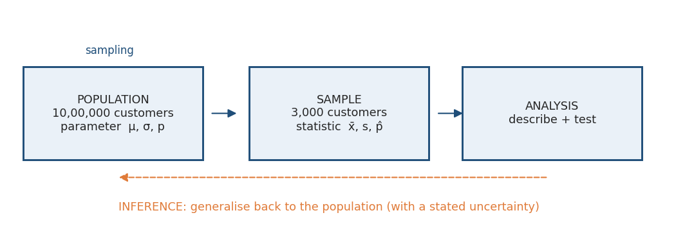
Population and sample
Term | Meaning | Symbol
Population | Every unit you care about | —
Parameter | A number describing the population (fixed, usually unknown) | μ, σ, p
Sample | The subset you actually measured | —
Statistic | A number computed from the sample (varies sample to sample) | x̄, s, p̂
Sampling error | The natural gap between statistic and parameter | —
Sampling error is not a mistake. It is the price of not measuring everyone, and it shrinks predictably as the sample grows. A bias, by contrast, is a systematic error that a bigger sample does not fix.
Why we sample: cost, time, and sometimes destruction of the unit (you cannot crash-test every car). In analytics, the reason is usually latency — a query over 10 million rows that takes 40 minutes kills the analysis loop.

MODULE 4 — Sampling techniques
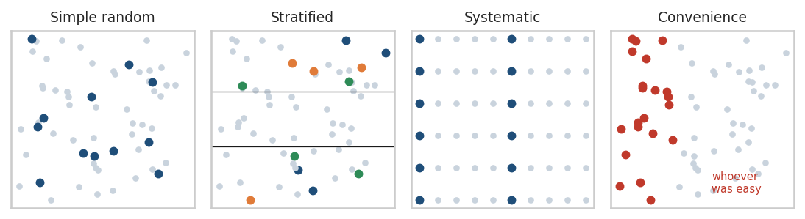
Sampling techniques
Technique | How it works | Advantage | Disadvantage | Use when
Simple random | Every unit has an equal chance | Unbiased, easy to reason about | Small groups may be missed | You have a clean, complete list
Stratified | Split into strata, sample inside each | Guarantees representation, lower variance | Needs strata known in advance | Subgroups matter (region, segment)
Systematic | Take every k-th unit after a random start | Simple, cheap on streams | Fails badly if data has a cycle of period k | Ordered data, no periodicity
Convenience | Take whoever is easy | Fast and free | Biased in ways you cannot measure | Exploratory only — never for inference
Examples. Simple random: pulling 20,000 customer IDs for a satisfaction survey. Stratified: a customer base that is 60% urban and 40% rural — a proportional stratified sample of 1,000 takes 600 urban and 400 rural, so a rural-heavy pattern cannot be washed out. Systematic: quality-checking every 50th package on a conveyor. Convenience: surveying people who reply to a pop-up — the unhappy and the very happy reply far more often than the indifferent majority.
import pandas as pd
import numpy as np
np.random.seed(42)
# 1,000 customers: 60% Urban, 40% Rural
pop = pd.DataFrame({
"customer_id": range(1, 1001),
"location": np.random.choice(["Urban", "Rural"], 1000, p=[0.6, 0.4]),
"spend": np.random.gamma(4, 500, 1000).round(2)
})
# --- Simple random sampling ---
srs = pop.sample(n=100, random_state=42)
# --- Proportional stratified sampling (10% from each stratum) ---
strat = pd.concat([g.sample(frac=0.10, random_state=42)
for _, g in pop.groupby("location")])
# --- Systematic sampling: every 10th customer ---
systematic = pop.iloc[np.arange(0, len(pop), 10)]
# --- Convenience sampling: the first 100 rows (whoever was easiest) ---
convenience = pop.head(100)
print("Population mix :\n", pop.location.value_counts(normalize=True).round(3))
print("\nSRS mix :\n", srs.location.value_counts(normalize=True).round(3))
print("\nStratified mix :\n", strat.location.value_counts(normalize=True).round(3))
print("\nPopulation mean spend :", round(pop.spend.mean(), 2))
for name, s in [("SRS", srs), ("Stratified", strat),
("Systematic", systematic), ("Convenience", convenience)]:
print(f"{name:<12} mean spend : {s.spend.mean():.2f} (n={len(s)})")
Expected output: the population is about 61% Urban / 39% Rural. The stratified sample reproduces that split almost exactly; the simple random sample is close but not exact; every sample mean sits near the population mean but none equals it. That gap is sampling error.

PRACTICAL 2 — Does the sampling design matter?
Tasks
- Change the simple random sample size from 100 to 20 and rerun. How stable is the urban/rural split now?
- Draw ten different simple random samples of 100 (loop over random_state=0..9) and print the ten means.
- Build a systematic sample with k = 3 and compare it with the stratified one.
BUSINESS QUESTION — Marketing wants to survey 500 of our 1,000,000 customers about a rural-focused product. They propose emailing the 500 most recently active customers. What is wrong with that plan, and what would you propose instead?
Expected learning: design beats size. A biased sample of 500,000 is worse than a random sample of 500.
Hint: think about who is systematically excluded by “most recently active”.

MODULE 5 — Variables: the type decides the technique
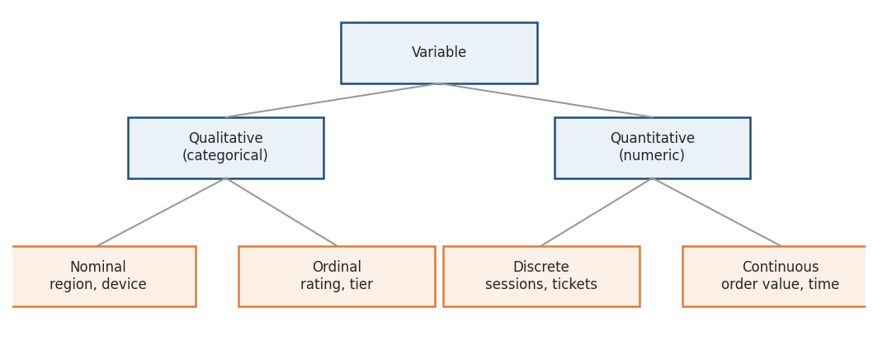
Variable types
Every statistical test in this workbook is chosen by answering one question first: what type are my variables?
- Qualitative / categorical — labels.
  - Nominal: no order. region, payment_method, device.
  - Ordinal: ordered but the gaps are not equal. customer_rating 1–5, customer_segment Regular < Premium.
- Quantitative / numeric — quantities.
  - Discrete: countable. sessions, support_tickets, purchases.
  - Continuous: measurable on a scale. order_value, time_on_site.
DS/ML APPLICATION — Type drives the whole pipeline: nominal features get one-hot encoded, ordinal features can be integer-encoded, continuous features get scaled, and count features often get a log or square-root transform. Choosing the wrong encoding is one of the most common silent bugs in a model.
import pandas as pd
import numpy as np
np.random.seed(42)
df = pd.DataFrame({
"region": np.random.choice(["North", "South", "East", "West"], 200),
"rating": np.random.choice([1, 2, 3, 4, 5], 200, p=[.05, .10, .25, .35, .25]),
"sessions": np.random.poisson(4, 200),
"order_value": np.random.gamma(4, 500, 200).round(2)
})
print(df.dtypes)
print("\nNominal -> counts only:\n", df.region.value_counts())
print("\nOrdinal -> median is meaningful, mean is debatable:", df.rating.median())
print("Discrete -> mean count of sessions:", round(df.sessions.mean(), 2))
print("Continuous -> mean order value :", round(df.order_value.mean(), 2))
BUSINESS QUESTION — A colleague reports “average customer rating = 3.87”. Is averaging an ordinal 1–5 rating defensible? What would you report instead, and why might the product team still prefer the average?

MODULE 6 — Histograms, bins and bin width

Concept
A histogram slices a numeric variable into intervals (bins) and draws the count (frequency) in each. Bin width is the only real choice you make, and it changes the story:
- Too few bins — everything looks like one smooth lump; you lose the shape.
- Too many bins — every random wobble becomes a “pattern”; you see noise.
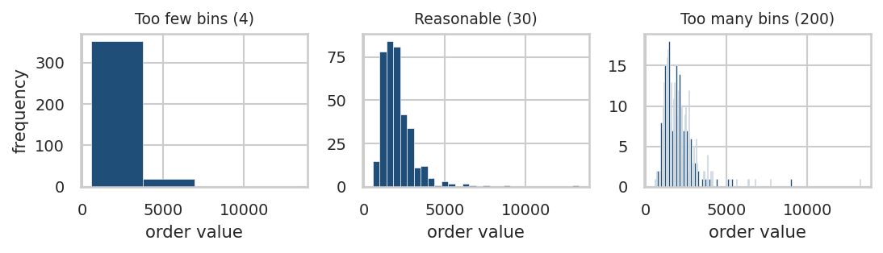
Effect of bin size
A reasonable default is 20–50 bins for a few thousand rows. Better practice: plot it three ways and only trust the features that survive all three.

What the shape tells you
Shape | Reading | Typical action
Symmetric bell | Roughly normal | Mean and SD are good summaries
Long right tail | Right-skewed (money, time) | Report median; consider a log transform
Two peaks | Two populations mixed | Segment before modelling
Isolated far-right bars | Outliers or a different process | Investigate before deleting
DS/ML APPLICATION — Linear regression does not require normal features, but heavy skew inflates the influence of a handful of rows. A log transform of order_value often improves both linear models and distance-based models such as k-NN and k-means.
import numpy as np
import pandas as pd
import matplotlib.pyplot as plt
np.random.seed(42)
order_value = np.random.lognormal(mean=7.4, sigma=0.6, size=2000)
fig, axes = plt.subplots(1, 3, figsize=(15, 4))
for ax, b in zip(axes, [5, 30, 200]):
ax.hist(order_value, bins=b, color="#1f4e79", edgecolor="white")
ax.set_title(f"{b} bins")
ax.set_xlabel("order value")
axes[0].set_ylabel("frequency")
plt.tight_layout()
plt.show()
print("Skewness:", round(pd.Series(order_value).skew(), 2))
print("Skewness after log:", round(pd.Series(np.log(order_value)).skew(), 2))
Expected output: three histograms of the same data. Skewness around 2.4 on the raw scale and close to 0.0 after the log — the log transform turns a lopsided distribution into an almost symmetric one.

MODULE 7 — Measures of central tendency

Concept
Measure | Definition | Breaks when
Mean x̄ | Sum ÷ count | There are outliers or strong skew
Median | The middle value when sorted | Rarely — it is robust
Mode | The most frequent value | Continuous data (use the histogram peak)
The mean formula:
x̄ = (x₁ + x₂ + ... + xₙ) / n
where xᵢ is the i-th observation and n is the number of observations. It is the balance point of the data — which is exactly why one very heavy value tips it.

The salary example
Six salaries: 30K, 32K, 35K, 38K, 40K, 500K
- Mean = 112.5K — a number no one earns.
- Median = 36.5K — the honest middle.
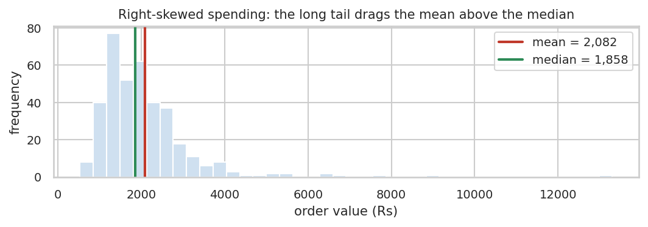
Mean versus median
The chart uses the real course dataset: mean ₹2,082 against median ₹1,858. That ₹224 gap is the long tail of big spenders pulling the mean up.
WHY IT MATTERS — Use the median for money, time and anything with a floor at zero and no ceiling: salary, house price, order value, delivery time, page-load latency. Use the mean when you need a total: revenue forecasting genuinely needs the mean, because mean × customers = total revenue. The median cannot do that.
import numpy as np
import pandas as pd
salaries = pd.Series([30000, 32000, 35000, 38000, 40000, 500000])
print("Mean :", round(salaries.mean(), 2))
print("Median :", salaries.median())
print("Mode :", pd.Series([3, 3, 5, 7, 7, 7, 9]).mode()[0])
# Remove the single extreme value and watch each statistic react
trimmed = salaries[salaries < 100000]
print("\nAfter removing the 500K outlier")
print("Mean :", round(trimmed.mean(), 2), " (moved a lot)")
print("Median :", trimmed.median(), " (barely moved)")
Expected output: mean 112,500 → 35,000 (a 69% move); median 36,500 → 35,000 (a 4% move). That contrast is the entire lesson.

PRACTICAL 3 — Which average would you defend?
import numpy as np
import pandas as pd
np.random.seed(42)
spend = pd.Series(np.random.lognormal(7.4, 0.6, 1000).round(2))
print("Mean :", round(spend.mean(), 2))
print("Median :", round(spend.median(), 2))
print("Skew :", round(spend.skew(), 2))
print("Share of customers below the mean:",
round((spend < spend.mean()).mean() * 100, 1), "%")
Tasks
- Run it and note what share of customers fall below the average.
- Add one artificial customer who spent ₹5,000,000 and rerun.
- Compute a 5% trimmed mean with stats.trim_mean(spend, 0.05) (needs from scipy import stats).
BUSINESS QUESTION — Finance reports “average order value ₹2,082” in the quarterly deck. The CX head says “but most of my customers spend far less than that”. Are they contradicting each other?
Expected learning: in a right-skewed distribution well over half the population sits below the mean, so both statements can be true at once.

MODULE 8 — Measures of dispersion

Concept
Two datasets can share an average and behave completely differently. Dispersion measures how spread out the values are.
- Range = max − min. One outlier destroys it.
- Variance = the average squared distance from the mean.
- Standard deviation (SD) = √variance — back in the original units, so it is the one you quote.
Population variance: σ² = Σ(xᵢ − μ)² / N
Sample variance: s² = Σ(xᵢ − x̄)² / (n − 1)
Every symbol: xᵢ an observation, μ the population mean, x̄ the sample mean, N the population size, n the sample size. The n − 1 (Bessel’s correction) exists because you already used the data once to estimate x̄; dividing by n would systematically under-estimate the spread.
Tiny worked example. Values 2, 4, 4, 4, 5, 5, 7, 9 → mean = 5. Squared deviations: 9, 1, 1, 1, 0, 0, 4, 16 → sum 32. Population variance 32/8 = 4, SD = 2. Sample variance 32/7 = 4.57, SD = 2.14.
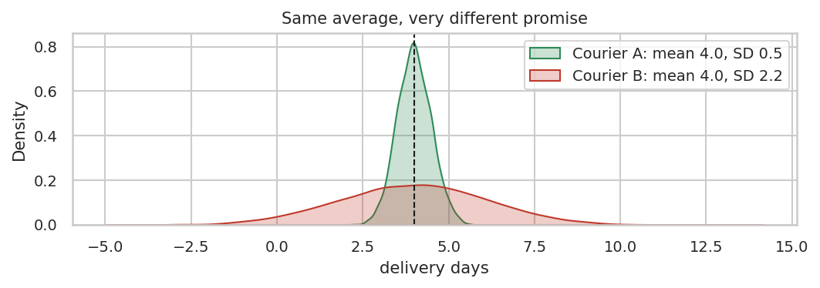
Two couriers

Industry example
Two couriers both average 4.0 days. Courier A has SD 0.5, Courier B has SD 2.2. Same average, different promise:
- Courier A: essentially every parcel lands in 3–5 days.
- Courier B: a meaningful share lands in 8+ days, and those are the customers who raise tickets, leave 1-star ratings, and churn.
Operations should prefer A. Customers experience variance, not averages.
DS/ML APPLICATION — SD underpins standardisation (StandardScaler), z-score anomaly detection, control charts in manufacturing, and volatility in finance. In model evaluation, the SD of cross-validation scores tells you whether a 1-point accuracy gain is real or noise.
import numpy as np
import pandas as pd
np.random.seed(42)
courier_a = np.random.normal(4.0, 0.5, 1000)
courier_b = np.random.normal(4.0, 2.2, 1000)
for name, x in [("Courier A", courier_a), ("Courier B", courier_b)]:
x = pd.Series(x)
print(f"{name}: mean={x.mean():.2f} sd={x.std(ddof=1):.2f} "
f"range={x.max()-x.min():.2f} P(>7 days)={100*(x>7).mean():.1f}%")
# population vs sample variance on the same data
v = pd.Series([2, 4, 4, 4, 5, 5, 7, 9])
print("\nPopulation variance (ddof=0):", v.var(ddof=0))
print("Sample variance (ddof=1):", round(v.var(ddof=1), 2))
Expected output: both couriers average about 4.0 days; Courier A almost never breaches 7 days while Courier B does so about 10% of the time.
BUSINESS QUESTION — Operations proposes switching to a cheaper courier with the same average delivery time but double the standard deviation. Write the two-sentence argument you would send to the COO.

MODULE 9 — Random variables
A random variable is a rule that attaches a number to the outcome of an uncertain process. It is the bridge between “something happened” and “here is the maths”.
- Discrete — countable outcomes: number of purchases, defects on a line, clicks on a banner, support tickets.
- Continuous — measurable outcomes: revenue, delivery time, weight, temperature, latency.
Notation: capital X is the random variable (“tomorrow’s order count”), lowercase x is a realised value (“47”). Every model you build in ML is a statement about the distribution of some X: logistic regression models P(Y = 1 | X), linear regression models E[Y | X].
COMMON MISTAKE — Treating an encoded categorical as a continuous random variable. payment_method coded 1/2/3/4 is not a quantity, and its mean of 2.3 means nothing.

MODULE 10 — Percentiles and quartiles
The p-th percentile is the value below which p% of the data falls.
- P25 = Q1 — first quartile
- P50 = Q2 = median
- P75 = Q3 — third quartile
Percentiles are the language of SLAs and pricing tiers because they are robust and directly interpretable. “P95 response time = 800 ms” means 95% of requests were faster than 800 ms — a promise you can write into a contract. An average response time of 200 ms hides the 5% of users having a terrible experience.
import numpy as np
import pandas as pd
np.random.seed(42)
response_ms = pd.Series(np.random.lognormal(5.0, 0.7, 5000))
print("Mean :", round(response_ms.mean(), 1))
print(response_ms.quantile([0.25, 0.50, 0.75, 0.90, 0.95, 0.99]).round(1))
print("\nShare of requests slower than the mean:",
round((response_ms > response_ms.mean()).mean() * 100, 1), "%")
Expected output: the mean sits well above the median, and P99 is several times the median — the classic latency profile that makes engineers report percentiles, never averages.

MODULE 11 — Five-number summary, IQR and outliers
The five-number summary is Minimum, Q1, Median, Q3, Maximum. A box plot draws exactly those five numbers, plus flagged outliers.
IQR = Q3 − Q1 Lower fence = Q1 − 1.5 × IQR Upper fence = Q3 + 1.5 × IQR
These are the standard Tukey fences. A point outside them is flagged for investigation — not automatically deleted.
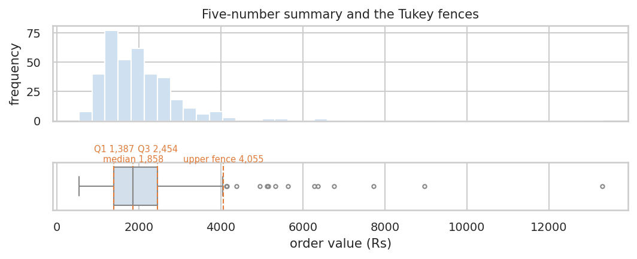
Five-number summary
IMPORTANT — An outlier is a question, not a verdict. In the course dataset the top order values are real high-value customers, and deleting them would understate revenue. Delete only what you can prove is an error (a negative age, a ₹0.01 order, a duplicated row).
import numpy as np
import pandas as pd
import matplotlib.pyplot as plt
import seaborn as sns
np.random.seed(42)
order_value = pd.Series(np.random.lognormal(7.4, 0.6, 1000).round(2))
q1, q2, q3 = order_value.quantile([0.25, 0.50, 0.75])
iqr = q3 - q1
low, high = q1 - 1.5 * iqr, q3 + 1.5 * iqr
outliers = order_value[(order_value < low) | (order_value > high)]
print(f"Min {order_value.min():.0f} | Q1 {q1:.0f} | Median {q2:.0f} | "
f"Q3 {q3:.0f} | Max {order_value.max():.0f}")
print(f"IQR {iqr:.0f} | fences [{low:.0f}, {high:.0f}]")
print(f"Flagged outliers: {len(outliers)} ({100*len(outliers)/len(order_value):.1f}%)")
plt.figure(figsize=(10, 3))
sns.boxplot(x=order_value, color="#cfe0f0")
plt.title("Order value with Tukey fences")
plt.xlabel("order value")
plt.show()

PRACTICAL 4 — Outlier hunt
Tasks
- Run the block and note how many points are flagged.
- Rerun the IQR rule on np.log(order_value). How many outliers now?
- Compare with a z-score rule: flag |z| > 3 where z = (x - x.mean()) / x.std().
BUSINESS QUESTION — Your outlier rule flags 34 orders above ₹9,000. The head of sales says these are the best customers of the year. What do you do with them in (a) a revenue report, (b) a churn model?
Expected learning: the IQR rule flags many points in a skewed distribution, far fewer after a log transform. The rule is a lens, not a law.

MODULE 12 — The normal (Gaussian) distribution

Concept
The normal distribution is the symmetric bell curve defined entirely by two numbers: its mean μ (where it is centred) and its standard deviation σ (how wide it is). For a perfectly normal variable, mean = median = mode.
The empirical rule — for a normal distribution only:
- ≈ 68% of values lie within μ ± 1σ
- ≈ 95% within μ ± 2σ
- ≈ 99.7% within μ ± 3σ
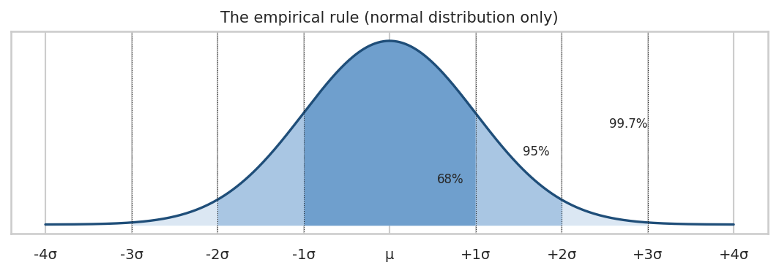
Empirical rule

Where it genuinely appears
Measurement error, manufacturing dimensions around a target, standardised test scores, biological measurements such as adult height. Where it does not appear: income, order value, session duration, latency, insurance claims — all right-skewed.
COMMON MISTAKE — “My data must be normal for statistics to work.” Almost never true. The t-test needs the sampling distribution of the mean to be approximately normal, which the Central Limit Theorem delivers for reasonable sample sizes even when the raw data is skewed. What genuinely breaks is the empirical rule and any prediction interval computed from raw σ.
import numpy as np
import pandas as pd
from scipy import stats
import matplotlib.pyplot as plt
np.random.seed(42)
heights = np.random.normal(170, 8, 10000) # roughly normal
spend = np.random.lognormal(7.4, 0.6, 10000) # right-skewed
for name, x in [("heights", heights), ("spend", spend)]:
x = pd.Series(x)
within1 = ((x > x.mean() - x.std()) & (x < x.mean() + x.std())).mean()
within2 = ((x > x.mean() - 2*x.std()) & (x < x.mean() + 2*x.std())).mean()
print(f"{name:8} skew={x.skew():6.2f} within 1 SD={within1:.1%} within 2 SD={within2:.1%}")
fig, axes = plt.subplots(1, 2, figsize=(13, 4))
axes[0].hist(heights, bins=50, color="#2e8b57", edgecolor="white"); axes[0].set_title("Heights: normal")
axes[1].hist(spend, bins=50, color="#c0392b", edgecolor="white"); axes[1].set_title("Spend: right-skewed")
plt.show()
Expected output: heights land close to 68% / 95%; spend gives roughly 81% / 96% — the empirical rule quietly fails on the skewed variable.

MODULE 13 — The empirical distribution function (ECDF)

Concept
The ECDF answers one question directly: what fraction of my data is at or below this value? Sort the data, and step up by 1/n at each observation.
F(x) = (number of observations ≤ x) / n
Unlike a histogram, an ECDF has no bin choice, so it cannot be tuned to tell a different story. It is the honest picture of a distribution.
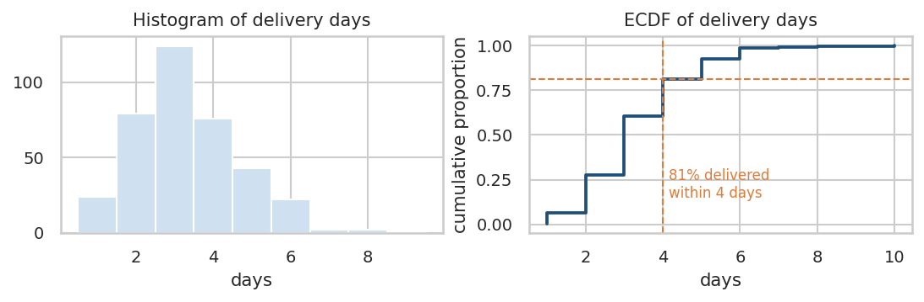
ECDF
Reading it: find your threshold on the x-axis, go up to the curve, read the proportion on the y-axis. In the chart above, 4 days on the x-axis maps to about 0.81 — roughly 81% of orders arrive within 4 days.
Where it is used: SLA and latency analysis (“what percentage of API calls finish under 300 ms?”), delivery performance, customer-spend thresholds, and comparing two groups without assuming any distribution.
import numpy as np
import pandas as pd
import matplotlib.pyplot as plt
np.random.seed(42)
delivery_days = np.random.gamma(6, 0.55, 1000).round()
x = np.sort(delivery_days)
y = np.arange(1, len(x) + 1) / len(x)
plt.figure(figsize=(10, 4))
plt.step(x, y, where="post", color="#1f4e79", lw=2)
plt.axvline(4, color="#e07b39", ls="--")
plt.axhline((delivery_days <= 4).mean(), color="#e07b39", ls="--")
plt.xlabel("delivery days"); plt.ylabel("cumulative proportion")
plt.title("ECDF of delivery days")
plt.show()
for d in [2, 3, 4, 5, 7]:
print(f"P(delivery <= {d} days) = {(delivery_days <= d).mean():.1%}")
BUSINESS QUESTION — Marketing wants to promise “delivery in 3 days or your money back”. Using the ECDF, what percentage of orders would trigger a refund, and what would that cost at ₹2,082 average order value?

MODULE 14 — Standard normal distribution and z-scores

Concept
The standard normal is the normal distribution with mean 0 and SD 1. Any normal variable becomes standard normal by standardising:
z = (x − μ) / σ
Every symbol: x the raw value, μ the mean, σ the standard deviation. The z-score answers: how many standard deviations from average is this value?
- z = 0 → exactly average
- z = +2 → two SDs above average (top ~2.3% if normal)
- z = −1.5 → one and a half SDs below average
- |z| > 3 → rare enough to be worth a look
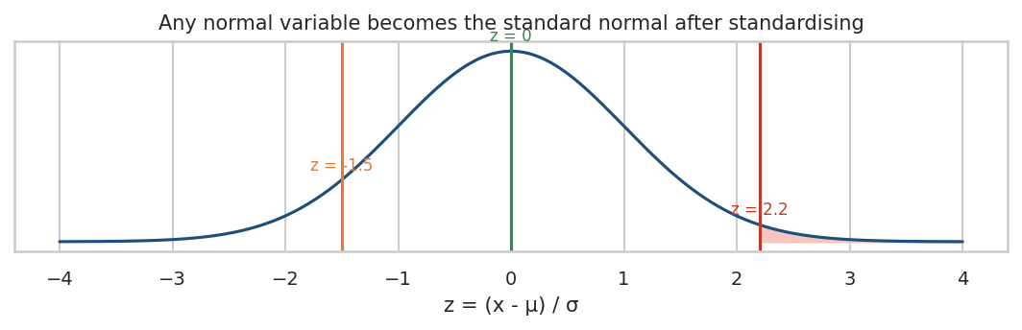
Z-scores
DS/ML APPLICATION — Standardisation puts features with different units (₹ and minutes) on a comparable scale, which is mandatory for k-NN, k-means, SVM, PCA and regularised regression. Z-scores are also the simplest anomaly detector in production monitoring.
import numpy as np
import pandas as pd
from scipy import stats
np.random.seed(42)
scores = pd.Series(np.random.normal(500, 100, 5000))
z = (scores - scores.mean()) / scores.std(ddof=0)
print("A score of 650 has z =", round((650 - scores.mean()) / scores.std(ddof=0), 2))
print("Percentile of z=1.5 :", round(stats.norm.cdf(1.5) * 100, 1), "%")
print("Share with |z| > 2 :", round((z.abs() > 2).mean() * 100, 2), "%")
print("Share with |z| > 3 :", round((z.abs() > 3).mean() * 100, 2), "%")
Expected output: roughly 4.7% beyond |z| = 2 and about 0.3% beyond |z| = 3 — matching the empirical rule, because this data really is normal.

PRACTICAL 5 — Standardise and compare
Tasks
- A customer spends ₹8,000 where the mean is ₹2,082 and the SD is ₹1,180. Compute the z-score by hand, then in Python.
- Compute z-scores for a right-skewed variable (np.random.lognormal(7.4, 0.6, 5000)) and check what share exceeds |z| = 3.
- Explain why the answer to (2) does not match the empirical rule.
BUSINESS QUESTION — Risk wants a fraud alert on “any transaction more than 3 SDs above the customer’s average”. On heavily skewed spend data, will this rule fire too often or too rarely? What would you use instead?
Hint: compare the count of |z| > 3 on raw versus log-transformed values.

MODULE 15 — The Central Limit Theorem

Concept
This is the single most important idea in the course, so read it slowly.
Take a population — any shape at all, skewed, bimodal, ugly. Draw a random sample of size n and compute its mean. Do that again and again. The collection of those sample means is called the sampling distribution of the mean, and the Central Limit Theorem says:
As n grows, the sampling distribution of the mean becomes approximately normal, centred on the population mean μ, with standard deviation σ / √n — regardless of the shape of the original population.
That σ / √n has its own name: the standard error (SE). It is the typical distance between a sample mean and the truth.
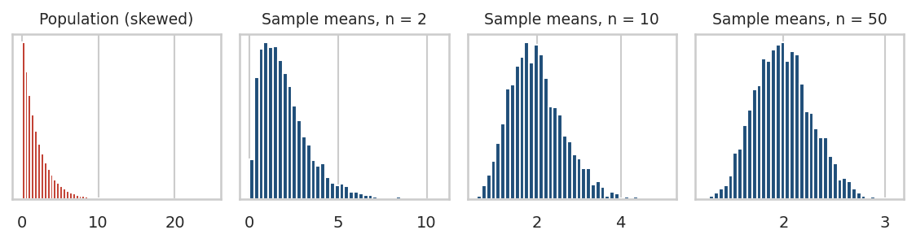
Central Limit Theorem
The left panel is a violently skewed population. By n = 50, the distribution of sample means is a clean bell curve. Nothing about the population changed — only what we chose to plot.

Why this makes inferential statistics possible
Your customer spend is skewed and always will be. But you never test a single customer — you test an average. The CLT says that average behaves normally, which is why a t-test on skewed revenue data still works. Everything downstream — confidence intervals, z-tests, t-tests, A/B tests — rests on this one theorem.
Two consequences worth memorising:
- SE shrinks with √n, not n. To halve your uncertainty you need four times the data. This is why “just collect more data” gets expensive fast.
- Skew slows convergence. For mildly skewed data n ≈ 30 is plenty; for heavily skewed revenue data you may want n ≈ 100+.
import numpy as np
import pandas as pd
import matplotlib.pyplot as plt
np.random.seed(42)
# A deliberately non-normal population: heavily right-skewed spend
population = np.random.exponential(scale=2000, size=200000)
fig, axes = plt.subplots(1, 4, figsize=(16, 3.5))
axes[0].hist(population, bins=60, color="#c0392b", edgecolor="white")
axes[0].set_title(f"Population (skew={pd.Series(population).skew():.2f})")
for ax, n in zip(axes[1:], [2, 10, 50]):
sample_means = np.random.choice(population, size=(4000, n)).mean(axis=1)
ax.hist(sample_means, bins=40, color="#1f4e79", edgecolor="white")
ax.set_title(f"Means of samples, n={n}\nSE={sample_means.std():.0f}")
plt.tight_layout(); plt.show()
print("Population mean :", round(population.mean(), 1))
print("Population SD :", round(population.std(), 1))
for n in [2, 10, 50, 200]:
means = np.random.choice(population, size=(4000, n)).mean(axis=1)
print(f"n={n:>3} mean of means={means.mean():8.1f} observed SE={means.std():7.1f} "
f"theory sigma/sqrt(n)={population.std()/np.sqrt(n):7.1f}")
Expected output: the mean of the sample means stays pinned near 2,000 at every sample size, while the observed SE falls roughly as σ/√n — from about 1,410 at n = 2 to about 141 at n = 200. The histograms go from skewed to bell-shaped as n rises.

PRACTICAL 6 — Break the CLT (or try to)
Tasks
- Replace the exponential population with np.random.pareto(1.5, 200000) * 1000 (an extremely heavy tail) and rerun. Does n = 50 still look normal?
- Increase to n = 500 and look again.
- Report the SE at n = 30 and n = 120 and confirm the ratio is about √4 = 2.
BUSINESS QUESTION — Your A/B test currently has 1,000 users per arm and the confidence interval is too wide to decide. Your manager asks how many users are needed to halve the width. What is your answer, and how long will that take at current traffic?
Expected learning: halving uncertainty costs 4× the sample. This single fact governs every experiment-design conversation you will ever have.

MODULE 16 — Probability essentials

Concept
- Sample space (S) — every possible outcome. For one customer visit: {converts, does not convert}.
- Event (A) — a subset of outcomes you care about. “Customer converts”.
- Probability P(A) — a number between 0 and 1. 0 = impossible, 1 = certain.
- Complement — P(not A) = 1 − P(A). If conversion is 0.125, non-conversion is 0.875.
Two ways to get a probability: theoretical (a fair die gives 1/6 by symmetry) and empirical (out of 3,000 visitors, 374 converted → 0.125). In analytics, essentially all probabilities are empirical.
DS/ML APPLICATION — Every classifier outputs a probability, not a class. predict_proba gives P(fraud | features); the 0.5 threshold most people accept by default is a business decision about the cost of false positives versus false negatives, not a statistical one. Spam filters, medical triage, credit scoring and recommender ranking are all probability-threshold problems.

MODULE 17 — The Bernoulli distribution
A Bernoulli random variable has exactly two outcomes coded 1 and 0:
P(X = 1) = p P(X = 0) = 1 − p E[X] = p Var(X) = p(1 − p)
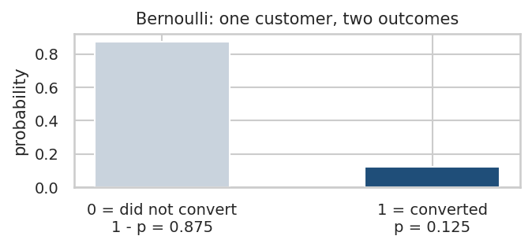
Bernoulli
Business examples: churn (yes/no), purchase (yes/no), click (yes/no), fraud (yes/no), loan default (yes/no). The mean of a 0/1 column is the conversion rate — which is why df.converted.mean() is such a useful line of code.
Note that the variance p(1 − p) is largest at p = 0.5 and small near 0 or 1. That is why rare-event experiments (0.5% conversion) need enormous samples: not because the effect is small, but because you need many trials to see enough of the rare outcome.
import numpy as np
import pandas as pd
np.random.seed(42)
converted = np.random.binomial(1, 0.125, 3000) # 3,000 Bernoulli trials
s = pd.Series(converted)
p = s.mean()
print("Conversion rate p :", round(p, 4))
print("Theoretical variance :", round(p * (1 - p), 4))
print("Observed variance :", round(s.var(ddof=0), 4))
print("Standard error of p :", round(np.sqrt(p * (1 - p) / len(s)), 4))
print("Rough 95% interval :",
np.round([p - 1.96*np.sqrt(p*(1-p)/len(s)), p + 1.96*np.sqrt(p*(1-p)/len(s))], 4))
Expected output: p near 0.125, theoretical and observed variance agreeing to three decimals, SE around 0.006, and an interval of roughly [0.113, 0.137].

MODULE 18 — Events: mutually exclusive or not
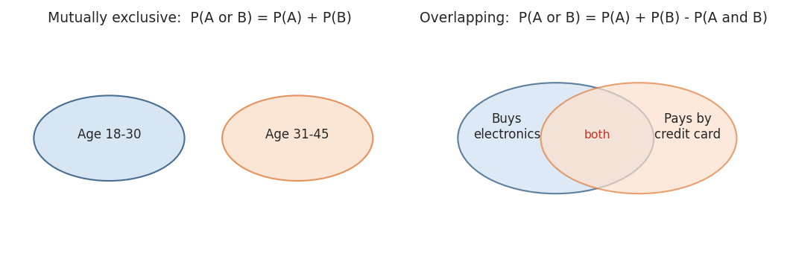
Venn diagrams
Mutually exclusive events cannot both happen: P(A or B) = P(A) + P(B). A single customer’s age band is either 18–30 or 31–45 — never both.
Overlapping events can co-occur: P(A or B) = P(A) + P(B) − P(A and B). A customer can buy electronics and pay by credit card, so you must subtract the double-counted overlap.
COMMON MISTAKE — Adding probabilities of overlapping events. “35% buy electronics, 40% pay by card, so 75% do one of them” is wrong whenever anyone does both. If 15% do both, the answer is 60%.

MODULE 19 — The multiplication rule
For independent events: P(A and B) = P(A) × P(B).
For dependent events you must use conditional probability: P(A and B) = P(A) × P(B | A), read as “probability of B given that A happened”.
When the simple rule is wrong: almost always in customer data. Clicking an ad and buying are not independent — clicking is exactly what makes buying more likely. If 20% click and 10% buy overall, P(click and buy) is not 2%; it is 0.20 × P(buy | click), and P(buy | click) might be 30%, giving 6%.
import numpy as np
import pandas as pd
np.random.seed(42)
n = 20000
clicked = np.random.binomial(1, 0.20, n)
# buying depends on clicking - this is the whole point
bought = np.random.binomial(1, np.where(clicked == 1, 0.30, 0.05))
df = pd.DataFrame({"clicked": clicked, "bought": bought})
p_click = df.clicked.mean()
p_buy = df.bought.mean()
p_both = ((df.clicked == 1) & (df.bought == 1)).mean()
p_buy_given_click = df.loc[df.clicked == 1, "bought"].mean()
print("P(click) :", round(p_click, 4))
print("P(buy) :", round(p_buy, 4))
print("P(click) x P(buy) :", round(p_click * p_buy, 4), " <- WRONG if dependent")
print("Actual P(click and buy) :", round(p_both, 4))
print("P(buy | click) :", round(p_buy_given_click, 4))
print("P(click) x P(buy|click) :", round(p_click * p_buy_given_click, 4), " <- correct")
Expected output: the naive product understates the joint probability by roughly a factor of three. That gap is the value of the ad channel.

MODULE 20 — Permutations and combinations
Permutation — order matters. nPr = n! / (n − r)!
Combination — order does not matter. nCr = n! / (r! (n − r)!)
- Awarding 1st, 2nd and 3rd prize to 3 of 10 customers: a permutation, 720 ways.
- Selecting 3 of 10 customers for a survey: a combination, 120 ways.
DS/ML APPLICATION — Combinations quantify search spaces. Choosing 5 features from 50 gives 2,118,760 subsets — which is why exhaustive feature selection is off the table and why greedy or regularised methods exist. The same arithmetic explains why testing many hypotheses at once inflates false positives (Module 30).
from math import perm, comb
print("Permutations 10P3 :", perm(10, 3))
print("Combinations 10C3 :", comb(10, 3))
print("Feature subsets, choose 5 from 50 :", comb(50, 5))
print("All pairwise comparisons among 4 regions :", comb(4, 2))
Expected output: 720, 120, 2118760, 6. Hold on to that last one — six pairwise comparisons is exactly why we will need ANOVA instead of six t-tests.

MODULE 21 — Covariance

Concept
Covariance measures whether two variables move together.
Cov(X, Y) = Σ (xᵢ − x̄)(yᵢ − ȳ) / (n − 1)
If both variables are above their means at the same time, the product is positive; a consistently positive product gives positive covariance.
- Positive — ad spend and sales rise together.
- Negative — delivery days and customer rating move in opposite directions.
- Near zero — no linear co-movement.
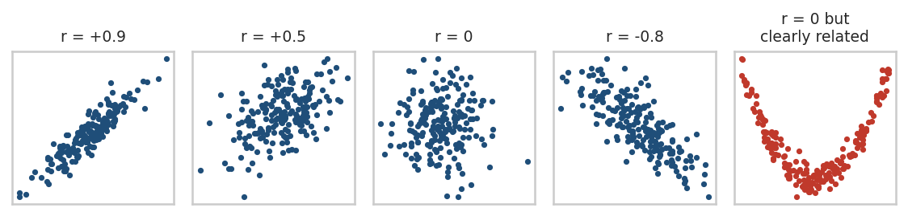
Correlation shapes

The four problems with covariance
- Scale dependent — measure spend in paise instead of rupees and the covariance multiplies by 100, though nothing changed.
- Uninterpretable magnitude — a covariance of 40,750 is meaningless on its own. Is that strong? You cannot tell.
- Not comparable across pairs — Cov(ad spend, order value) and Cov(time on site, rating) are in different units and cannot be ranked.
- Units are a product of units — “rupee-minutes” is not a quantity anyone can reason about.
The fix is to divide by both standard deviations. That gives correlation.

MODULE 22 — Pearson correlation
r = Cov(X, Y) / (sₓ · s_y)
The result is unit-free and always between −1 and +1:
- r = +1 — perfect positive straight line
- r = 0 — no linear relationship
- r = −1 — perfect negative straight line
Rough reading for business data: |r| below 0.2 is weak, 0.2–0.5 moderate, above 0.5 strong. Social and behavioural data rarely exceeds 0.6.

Three ways Pearson lies to you
- Outliers — a handful of extreme points can create or destroy an apparent correlation.
- Non-linearity — the rightmost panel above has a perfect deterministic relationship and r ≈ 0.
- Confounding — ice cream sales and drowning deaths correlate because both rise with temperature.
IMPORTANT — correlation does not imply causation. In our dataset, delivery_days and customer_rating correlate at r = −0.43. Plausible? Yes. Proven? No. Slow deliveries may cluster in regions that also have other service problems. The only way to establish causation is a randomised experiment (Module 32) or a carefully controlled model.
import numpy as np
import pandas as pd
from scipy import stats
import matplotlib.pyplot as plt
np.random.seed(42)
n = 300
ad_spend = np.random.gamma(3, 120, n)
sales = 500 + 4.5 * ad_spend + np.random.normal(0, 900, n)
print("Covariance :", round(np.cov(ad_spend, sales)[0, 1], 2))
print("Pearson r :", round(stats.pearsonr(ad_spend, sales)[0], 4))
print("p-value :", f"{stats.pearsonr(ad_spend, sales)[1]:.3e}")
# scale-dependence demonstration: same relationship, different units
print("\nCovariance with spend in paise:", round(np.cov(ad_spend * 100, sales)[0, 1], 2))
print("Pearson r with spend in paise:", round(stats.pearsonr(ad_spend * 100, sales)[0], 4))
plt.figure(figsize=(8, 4))
plt.scatter(ad_spend, sales, s=10, color="#1f4e79", alpha=0.6)
plt.xlabel("ad spend"); plt.ylabel("sales"); plt.title("Ad spend vs sales")
plt.show()
Expected output: covariance changes by a factor of 100 when the units change; r does not move at all. That is the whole argument for correlation over covariance.

MODULE 23 — Spearman rank correlation
Spearman’s ρ is Pearson’s r computed on the ranks instead of the raw values. It measures whether the relationship is monotonic (consistently increasing or decreasing), not whether it is a straight line.
 | Pearson | Spearman
Measures | Linear association | Monotonic association
Input | Raw values | Ranks
Outlier sensitivity | High | Low
Works on ordinal data | Not really | Yes
Use for | Roughly normal, linear pairs | Skewed data, rankings, ratings
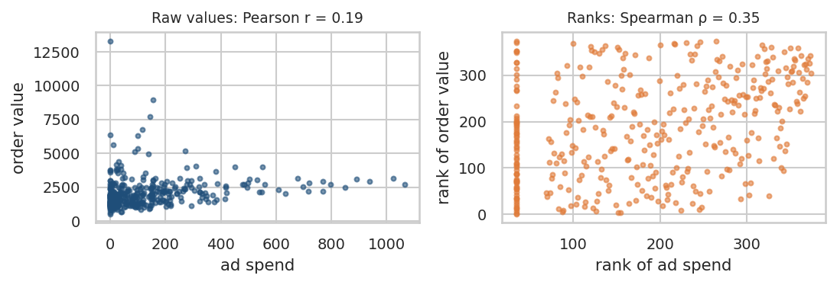
Pearson vs Spearman
The panels use the real course data. On raw ad_spend versus order_value, Pearson gives r = 0.19. Convert both to ranks and Spearman gives ρ = 0.35 — nearly double. The relationship is real and monotonic; the right tail of order value was diluting the linear measure.
RULE OF THUMB — When Pearson and Spearman disagree noticeably, believe Spearman and go look at the scatter plot. The gap is telling you about skew, outliers or curvature.
import numpy as np
import pandas as pd
from scipy import stats
np.random.seed(42)
satisfaction = np.random.randint(1, 6, 200) # ordinal 1-5
renewal_prob = 0.15 + 0.14 * satisfaction + np.random.normal(0, 0.05, 200)
print("Pearson :", round(stats.pearsonr(satisfaction, renewal_prob)[0], 3))
print("Spearman :", round(stats.spearmanr(satisfaction, renewal_prob)[0], 3))
# now add a curved, monotonic relationship
x = np.arange(1, 101)
y = np.exp(x / 20)
print("\nExponential but monotonic relationship")
print("Pearson :", round(stats.pearsonr(x, y)[0], 3), " <- understates it")
print("Spearman :", round(stats.spearmanr(x, y)[0], 3), " <- perfect 1.0")
Expected output: on the curved data Pearson lands around 0.85 while Spearman is exactly 1.0, because the relationship is perfectly monotonic even though it is not a straight line.

PRACTICAL 7 — Correlation detective
Tasks
- Build x = np.random.normal(0, 1, 200) and y = 2*x + np.random.normal(0, 1, 200), then compute Pearson.
- Change one single point to x[0], y[0] = 15, -15 and recompute. How much did r move?
- Compute Spearman on the same contaminated data.
BUSINESS QUESTION — An analyst reports “ad spend correlates 0.72 with revenue, so doubling the budget will roughly double revenue.” Give two reasons this conclusion is not supported, and describe the one study design that would support it.
Expected learning: a single leverage point can dominate Pearson; and no correlation, however strong, licenses a causal or extrapolative claim.

MODULE 24 — The inferential statistics roadmap
Everything from here to the end of the course follows one path:
Sample
↓
Sampling distribution (how much would this statistic wobble?)
↓
Point estimate (single best guess: x̄, p̂)
↓
Hypothesis (H0 and H1, fixed BEFORE looking)
↓
Test statistic (observed difference ÷ its standard error)
↓
p-value (how surprising is this if H0 is true?)
↓
Decision (reject H0 or fail to reject)
↓
Confidence interval (how big is the effect, plausibly?)
↓
Business interpretation (so what should we do?)

Term | Meaning | Example
Population parameter | The unknown truth | True conversion rate of all customers
Sample statistic | What you computed | 14.2% in this sample
Point estimate | The statistic used as a guess for the parameter | “We estimate 14.2%”
Interval estimate | A range with a stated confidence | “12.5% to 15.9%”

MODULE 25 — The sampling distribution
The sampling distribution is the distribution of a statistic across all possible samples. It is a thought experiment you almost never run — but it is what every p-value and confidence interval is quietly referring to.
- Sampling distribution of the mean: centred on μ, standard error σ / √n.
- Sampling distribution of a proportion: centred on p, standard error √(p(1 − p) / n).
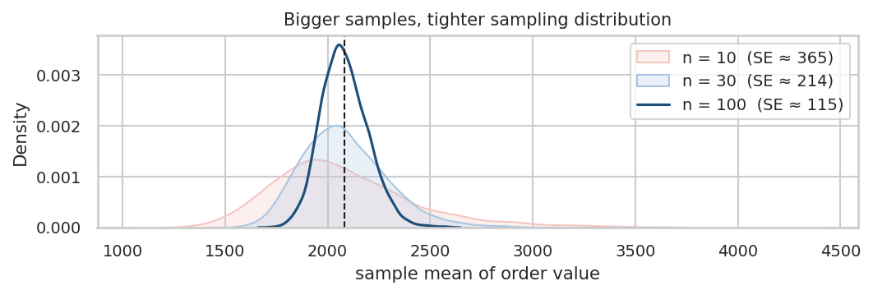
Sampling distribution
import numpy as np
import pandas as pd
import matplotlib.pyplot as plt
np.random.seed(42)
population = np.random.lognormal(7.4, 0.6, 100000)
plt.figure(figsize=(10, 4))
for n, color in [(10, "#f5c6c0"), (30, "#a9c6e3"), (100, "#1f4e79")]:
means = np.array([np.random.choice(population, n).mean() for _ in range(3000)])
plt.hist(means, bins=50, alpha=0.65, color=color, label=f"n={n}, SE={means.std():.0f}")
plt.axvline(population.mean(), color="black", ls="--", label="population mean")
plt.xlabel("sample mean"); plt.legend(); plt.title("Sampling distribution of the mean")
plt.show()
Expected output: three overlaid bell curves, all centred on the population mean, each narrower than the last. The SE roughly halves as n goes from 25 to 100.

MODULE 26 — Null and alternative hypotheses
H0 (null) — the boring claim: no difference, no effect, nothing happening. This is what you actually test. H1 / Ha (alternative) — the interesting claim you are hoping to support.
You never “prove H0”. You either reject it (the data were too surprising under H0) or fail to reject it (the data are compatible with H0 — which is not the same as H0 being true).
Example. An e-commerce company claims average delivery time is 2 days.
- Two-sided: H0: μ = 2 versus H1: μ ≠ 2
- One-sided: H0: μ ≤ 2 versus H1: μ > 2 (only if “worse than promised” is the only outcome you would act on)
IMPORTANT — Write both hypotheses down before you look at the data, and fix your significance level α at the same time. Everything after this module assumes you did.

MODULE 27 — The test statistic
A test statistic converts “the difference I observed” into “how many standard errors away from H0 that is”. Almost all of them share one shape:
test statistic = (observed − expected under H0) / standard error
Test | Statistic | Used for
z-test | (x̄ − μ₀) / (σ / √n) | A mean, σ known or n large
t-test | (x̄ − μ₀) / (s / √n) | A mean, σ unknown (the usual case)
Proportion z-test | (p̂ − p₀) / √(p₀(1−p₀)/n) | A rate or proportion
ANOVA F | between-group variance ÷ within-group variance | 3+ means
Chi-square | Σ (O − E)² / E | Association between categories
A large test statistic means “far from what H0 predicted”. The p-value converts that distance into a probability.

MODULE 28 — The p-value

Say this out loud
The p-value is the probability of observing a result at least as extreme as the one you got, assuming the null hypothesis is true.
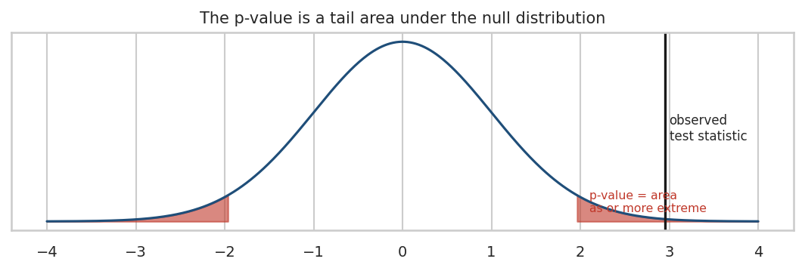
p-value

What it is NOT
- ✗ It is not the probability that H0 is true.
- ✗ It is not the probability that your result was a fluke.
- ✗ It is not a measure of effect size. p = 0.001 does not mean “big”; it often just means “large sample”.
- ✗ 1 − p is not the probability that H1 is true.
Why the first misreading is wrong: the p-value is computed by assuming H0 is true. A quantity that treats H0 as given cannot also tell you how likely H0 is. It is P(data | H0), never P(H0 | data).

The threshold
The convention α = 0.05 is exactly that — a convention, and an arbitrary one. Physics uses 0.0000003. Early-stage product experiments sometimes accept 0.10. What matters is that you choose α before you see the data and that you report the effect size and confidence interval alongside the p-value.
COMMON MISTAKE — p-hacking: running the test, seeing p = 0.07, then adding a week of data, dropping outliers, or switching to a one-tailed test until p drops under 0.05. Each of these is defensible in isolation and indefensible after seeing the result.

MODULE 29 — Type I and Type II errors
 | H0 is actually true | H0 is actually false
You reject H0 | Type I error (false positive), probability α | Correct — power = 1 − β
You fail to reject | Correct | Type II error (false negative), probability β
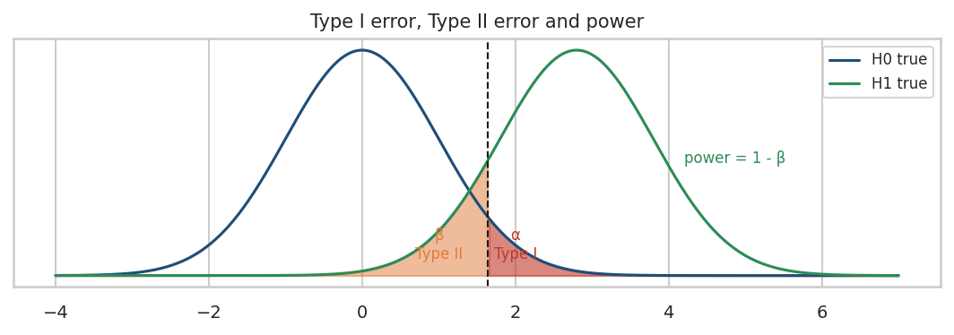
Type I and Type II
Business translation of a Type I error: you ship a redesign that does nothing, you block a legitimate transaction as fraud, you tell a healthy patient they are ill, you send a real email to spam.
Business translation of a Type II error: you scrap a genuinely better checkout, you let real fraud through, you miss a disease, you keep a worse product.
Power (1 − β) is your chance of detecting a real effect. Convention targets 80%. Power rises with sample size, with effect size, and with a lower variance — and falls as α gets stricter. This is the trade-off behind every sample-size calculation: α and β pull against each other unless you buy more data.

MODULE 30 — Multiple testing
Run one test at α = 0.05 and you have a 5% false-positive risk. Run 100 independent tests where every null is true, and the probability of at least one “significant” result is:
1 − 0.95¹⁰⁰ = 99.4%
You are practically guaranteed several false discoveries. Expected count of false positives: 100 × 0.05 = 5.
Two standard fixes:
- Bonferroni — test each hypothesis at α / m. With m = 100 that means α = 0.0005. Simple, very conservative, kills power.
- Benjamini–Hochberg (FDR) — controls the expected proportion of false discoveries among your rejections rather than the chance of any at all. Far more powerful and the default in genomics and large-scale feature screening.
import numpy as np
from statsmodels.stats.multitest import multipletests
from scipy import stats
np.random.seed(42)
# 100 tests where the null is TRUE in every single case
p_values = []
for _ in range(100):
a = np.random.normal(0, 1, 50)
b = np.random.normal(0, 1, 50) # identical distributions - no real effect
p_values.append(stats.ttest_ind(a, b).pvalue)
p_values = np.array(p_values)
print("Raw significant at 0.05 :", (p_values < 0.05).sum(), "of 100 (all are false positives)")
bonf = multipletests(p_values, alpha=0.05, method="bonferroni")[0]
bh = multipletests(p_values, alpha=0.05, method="fdr_bh")[0]
print("Significant after Bonferroni :", bonf.sum())
print("Significant after Benjamini-H :", bh.sum())
print("\nProbability of at least one false positive in 100 tests:",
round(1 - 0.95**100, 4))
Expected output: a handful of raw “significant” results out of 100 — every one of them false — and zero survivors after either correction.
DS/ML APPLICATION — Screening 500 candidate features by correlation p-value without correction will hand you a shortlist of noise. The same applies to segment-slicing an A/B test: testing 20 segments for “where did it work?” is 20 hypotheses.

MODULE 31 — Statistical vs practical significance
A website conversion rate moves from 10.00% to 10.05%. With 50 million users that is comfortably statistically significant. Should you care?
Statistical significance answers “is it real?”. Practical significance answers “is it big enough to matter?”. They are independent questions, and a large enough sample makes even a trivial difference significant.
 | Statistically significant | Not statistically significant
Practically large | Ship it | Inconclusive — get more data
Practically tiny | Real but probably not worth it | Ignore
Always convert the effect into money or units. A 0.05 pp lift on 50 million sessions at ₹2,082 average order value is roughly 25,000 extra orders — about ₹5.2 crore. Suddenly it does matter. On 50,000 sessions it is 25 orders and matters to nobody. The same p-value, opposite decisions.
STATISTICAL DETECTIVE — For each, decide: statistically significant, practically significant, both, or neither?
- n = 50,000,000; conversion 10.00% → 10.02%; p = 0.003
- n = 60; average order value +₹450; p = 0.21
- n = 3,000; conversion 10.6% → 14.2%; p = 0.003
- n = 2,000,000; churn 12.0% → 11.9%; p = 0.04
Answers in the solutions section.

MODULE 32 — A/B testing end to end
Block time: 35 minutes (Modules 32–37, 39)

The anatomy of a valid experiment
Element | In our experiment
Unit | One customer
Randomisation | Each customer independently assigned to control or treatment
Control | Existing checkout page
Treatment | New checkout page
Primary metric | converted (0/1)
H0 | p_treatment = p_control
H1 | p_treatment ≠ p_control (two-sided)
α | 0.05, fixed in advance
Test | Two-proportion z-test
Randomisation is what buys you causation. Because assignment is random, the two groups differ only by chance and by the treatment — so a significant difference can be attributed to the treatment. This is the one situation where you may say “caused”.
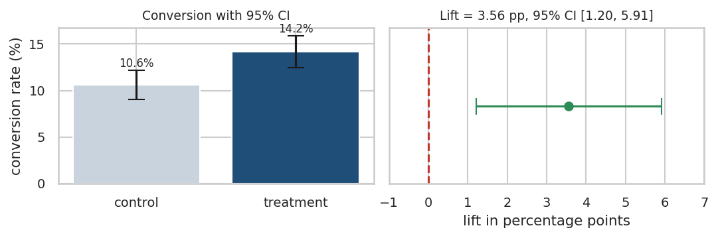
A/B test result
import numpy as np
import pandas as pd
from statsmodels.stats.proportion import proportions_ztest, proportion_confint
# Observed results from the course experiment
control_conv, control_n = 154, 1449
treatment_conv, treatment_n = 220, 1551
p_c = control_conv / control_n
p_t = treatment_conv / treatment_n
z, p_value = proportions_ztest([treatment_conv, control_conv],
[treatment_n, control_n])
se_diff = np.sqrt(p_t*(1-p_t)/treatment_n + p_c*(1-p_c)/control_n)
diff = p_t - p_c
ci_low, ci_high = diff - 1.96*se_diff, diff + 1.96*se_diff
print(f"Control conversion : {p_c:.4f} ({control_conv}/{control_n})")
print(f"Treatment conversion : {p_t:.4f} ({treatment_conv}/{treatment_n})")
print(f"Absolute lift : {diff*100:.2f} percentage points")
print(f"Relative lift : {diff/p_c*100:.1f} %")
print(f"z statistic : {z:.3f}")
print(f"p-value : {p_value:.5f}")
print(f"95% CI for the lift : [{ci_low*100:.2f} pp, {ci_high*100:.2f} pp]")
print("Decision :", "Reject H0" if p_value < 0.05 else "Fail to reject H0")
Expected output
Control conversion : 0.1063 (154/1449)
Treatment conversion : 0.1418 (220/1551)
Absolute lift : 3.56 percentage points
Relative lift : 33.5 %
z statistic : 2.947
p-value : 0.00321
95% CI for the lift : [1.20 pp, 5.91 pp]
Decision : Reject H0
How to read this to a stakeholder: “The new checkout converted 14.2% of visitors against 10.6% for the current page. That is a 3.6 percentage-point improvement, and the data are inconsistent with the two pages being equally effective (p = 0.003). Our best estimate of the true lift is 3.6 points, and the plausible range is 1.2 to 5.9 points. Even at the pessimistic end of that range, the change pays for itself.”

PRACTICAL 8 — Run the experiment yourself
Tasks
- Reproduce the block above and confirm every number.
- Change treatment_conv to 175 (a much smaller lift) and rerun. What happens to the p-value and the CI?
- Multiply all four counts by 10 (simulating 10× traffic) with the original rates. What happens to the CI width?
BUSINESS QUESTION — The lift is 3.6 pp with a 95% CI of [1.2, 5.9]. Rolling out costs ₹40 lakh in engineering time. Monthly traffic is 200,000 sessions and average order value is ₹2,082. Is the rollout justified at the pessimistic end of the interval?

MODULE 33 — One-tailed and two-tailed tests
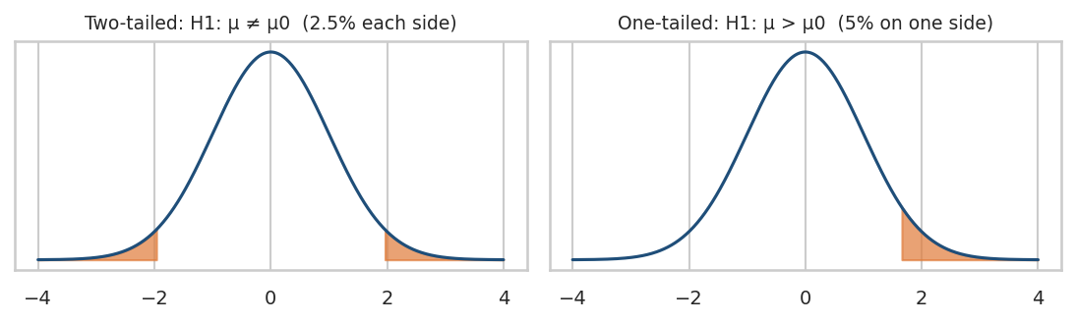
One vs two tailed
- Two-tailed (H1: μ ≠ μ₀) splits α across both tails, 2.5% each side. Use it when a difference in either direction would change your decision. This should be your default.
- One-tailed (H1: μ > μ₀) puts all 5% in one tail, which makes it easier to reach significance — but you have declared in advance that a difference in the opposite direction is irrelevant to you.
COMMON MISTAKE — Switching to one-tailed after seeing p = 0.08 two-tailed. That halves your p-value to 0.04 and doubles your real false-positive rate. If a colleague proposes it mid-analysis, the answer is no.

MODULE 34 — The z-test for a mean
Use when: the population standard deviation σ is genuinely known, or n is large enough that s is an excellent stand-in (n > 30 as a rough guide) and the sampling distribution is approximately normal.
z = (x̄ − μ₀) / (σ / √n)
In practice you rarely know σ, so the t-test (Module 36) is the honest default. The z-test remains standard for proportions, where the standard error is determined by p itself.
import numpy as np
from scipy import stats
np.random.seed(42)
# Historical process: delivery SD is known from years of data
sigma_known = 1.4
sample = np.random.normal(3.4, sigma_known, 200)
mu_0 = 3.0
z = (sample.mean() - mu_0) / (sigma_known / np.sqrt(len(sample)))
p_value = 2 * (1 - stats.norm.cdf(abs(z)))
print(f"Sample mean : {sample.mean():.3f}")
print(f"z statistic : {z:.3f}")
print(f"p-value : {p_value:.6f}")
print("Decision :", "Reject H0" if p_value < 0.05 else "Fail to reject H0")

MODULE 35 — The z-test for proportions
One-proportion test — is our conversion rate different from a claimed 12%?
Two-proportion test — do two groups convert at different rates? (This is the A/B test of Module 32.)
import numpy as np
from statsmodels.stats.proportion import proportions_ztest, proportion_confint
# One-proportion: 374 conversions in 3,000 visitors. Claim: the true rate is 12%
count, nobs = 374, 3000
z, p = proportions_ztest(count, nobs, value=0.12, prop_var=0.12)
print("Observed rate :", round(count/nobs, 4))
print(f"z = {z:.3f} p = {p:.4f}")
print("95% CI :", np.round(proportion_confint(count, nobs, method="normal"), 4))
print("Decision :", "Reject H0" if p < 0.05 else "Fail to reject H0")
Expected output: observed rate 0.1247, z ≈ 0.79, p ≈ 0.43, CI [0.1128, 0.1365]. The claim of 12% sits comfortably inside the interval, so the data give no reason to doubt it.
ASSUMPTION CHECK — The normal approximation needs roughly n·p ≥ 10 and n·(1−p) ≥ 10. Here 374 and 2,626 — comfortably fine. For very rare events (p = 0.001) use an exact binomial test instead.

MODULE 36 — The t-test

Why the t-distribution exists
When σ is unknown you estimate it with s, and that estimate carries its own error. The t-distribution compensates with heavier tails. It has one parameter, the degrees of freedom (n − 1). At df = 5 the tails are noticeably fat; by df = 30 it is nearly indistinguishable from the normal; by df = 100 the difference is cosmetic.

The three t-tests
Variant | Question | Python
One-sample | Does this mean differ from a target value? | stats.ttest_1samp(x, mu0)
Independent two-sample | Do two separate groups differ? | stats.ttest_ind(a, b, equal_var=False)
Paired | Did the same units change before vs after? | stats.ttest_rel(before, after)
Assumptions: independent observations; approximately normal sampling distribution of the mean (CLT usually delivers this); for the pooled two-sample version, similar variances — which is why equal_var=False (Welch’s t-test) is the safer default and costs almost nothing.
import numpy as np
from scipy import stats
np.random.seed(42)
# 1) One-sample: is average delivery time different from the promised 3 days?
delivery = np.random.gamma(6, 0.55, 150)
t1 = stats.ttest_1samp(delivery, 3.0)
print(f"One-sample : mean={delivery.mean():.3f} t={t1.statistic:.3f} p={t1.pvalue:.5f}")
# 2) Independent two-sample: do two customer segments spend differently?
premium = np.random.lognormal(7.7, 0.5, 160)
regular = np.random.lognormal(7.4, 0.5, 150)
t2 = stats.ttest_ind(premium, regular, equal_var=False)
print(f"Two-sample : {premium.mean():.0f} vs {regular.mean():.0f} "
f"t={t2.statistic:.3f} p={t2.pvalue:.2e}")
print("Levene equal-variance check p =", round(stats.levene(premium, regular).pvalue, 4))
# 3) Paired: same 80 customers, spend before and after a campaign
before = np.random.normal(2000, 400, 80)
after = before + np.random.normal(120, 300, 80) # same people, measured twice
t3 = stats.ttest_rel(before, after)
print(f"Paired : mean change={np.mean(after-before):.1f} "
f"t={t3.statistic:.3f} p={t3.pvalue:.5f}")
COMMON MISTAKE — Using an independent two-sample test on before/after data from the same customers. Pairing removes each customer’s individual level from the comparison, which usually makes the test far more sensitive. Using the wrong one throws away real power.

MODULE 37 — ANOVA (the F-test)

Why not just run t-tests?
Four regions give 4C2 = 6 pairwise comparisons. At α = 0.05 each, the probability of at least one false positive is 1 − 0.95⁶ = 26.5%. One-way ANOVA asks a single question at a single α: are all group means equal?
H0: μ₁ = μ₂ = μ₃ = μ₄ H1: at least one differs
F = between-group variance / within-group variance
If the groups genuinely differ, the spread between group means is large relative to the noise within groups, and F is large.
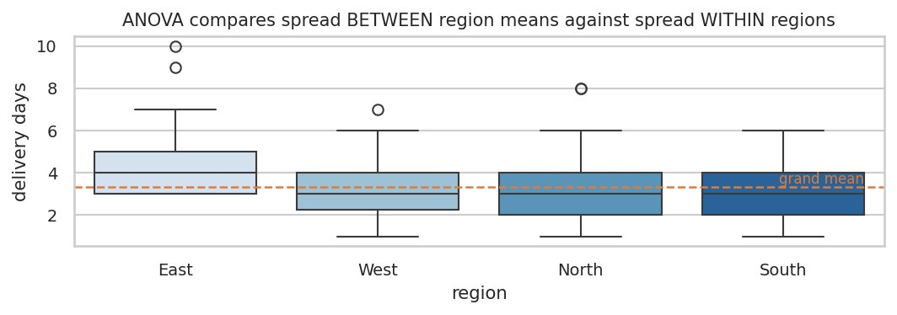
ANOVA
ANOVA tells you that someone is different — never who. For that you need a post-hoc test such as Tukey HSD, which compares every pair while controlling the family-wise error rate.
import numpy as np
import pandas as pd
from scipy import stats
from statsmodels.stats.multicomp import pairwise_tukeyhsd
np.random.seed(42)
df = pd.DataFrame({
"region": np.repeat(["North", "South", "East", "West"], 120),
"delivery_days": np.concatenate([
np.random.gamma(6, 0.55, 120),
np.random.gamma(5.4, 0.55, 120),
np.random.gamma(7.6, 0.55, 120),
np.random.gamma(6.2, 0.55, 120)])
})
groups = [g["delivery_days"].values for _, g in df.groupby("region")]
f_stat, p_value = stats.f_oneway(*groups)
print(df.groupby("region")["delivery_days"].agg(["count", "mean", "std"]).round(2))
print(f"\nF = {f_stat:.3f} p = {p_value:.3e}")
print("Decision:", "At least one region differs" if p_value < 0.05 else "No evidence of difference")
print("\n", pairwise_tukeyhsd(df.delivery_days, df.region))
Expected output: a large F with a tiny p-value, then a Tukey table where each row shows the mean difference, an adjusted p-value and a reject flag identifying exactly which region pairs differ.
Assumptions: independent groups, roughly similar variances (check with Levene), approximately normal residuals. If variances differ badly, use Welch’s ANOVA or the non-parametric Kruskal–Wallis test.

MODULE 38 — Confidence intervals

Concept
A point estimate with no interval is a guess dressed as a fact. The confidence interval attaches the uncertainty:
CI = point estimate ± (critical value × standard error)
For a mean: x̄ ± t₍₀.₉₇₅, n−1₎ × (s / √n). The part after the ± is the margin of error.

What “95% confident” actually means
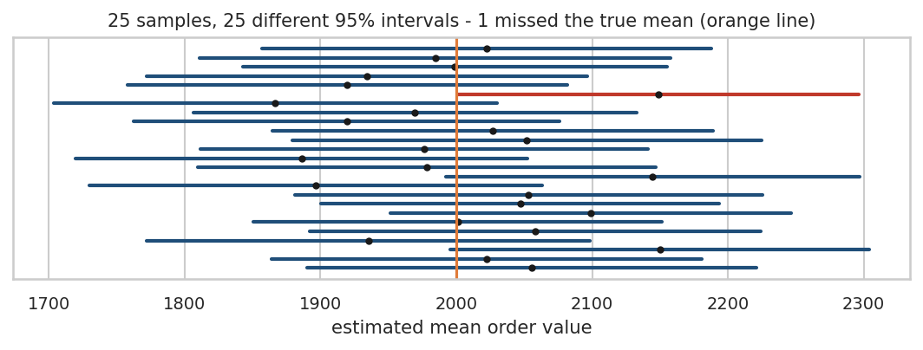
Confidence intervals
The correct frequentist reading: if you repeated this whole sampling procedure many times, about 95% of the intervals you built would contain the true parameter. The chart shows 25 samples from the same population — 25 different intervals, and one or two miss the true value entirely.
What you must not say: “there is a 95% probability that the true mean lies in this interval”. The true mean is a fixed number; this particular interval either contains it or does not. The 95% is a property of the method, not of the interval you happen to be holding.
WHY IT MATTERS — The width of the interval is often more decision-relevant than the p-value. A CI of [1.2 pp, 5.9 pp] says “even in the worst case this helps”. A CI of [−0.4 pp, 7.2 pp] with the same point estimate says “we do not yet know” — and the honest answer to the business is keep the test running.
import numpy as np
from scipy import stats
from statsmodels.stats.proportion import proportion_confint
np.random.seed(42)
order_value = np.random.lognormal(7.4, 0.6, 374)
mean = order_value.mean()
se = order_value.std(ddof=1) / np.sqrt(len(order_value))
ci = stats.t.interval(0.95, len(order_value) - 1, loc=mean, scale=se)
print(f"Mean order value : {mean:,.2f}")
print(f"Standard error : {se:,.2f}")
print(f"95% CI : [{ci[0]:,.2f}, {ci[1]:,.2f}]")
print(f"Margin of error : +/- {1.96*se:,.2f}")
# Confidence interval for a conversion rate
low, high = proportion_confint(220, 1551, alpha=0.05, method="normal")
print(f"\nConversion 220/1551 = {220/1551:.4f}")
print(f"95% CI : [{low:.4f}, {high:.4f}]")
# Wider confidence = wider interval
for level in [0.90, 0.95, 0.99]:
lo, hi = stats.t.interval(level, len(order_value)-1, loc=mean, scale=se)
print(f"{int(level*100)}% CI width: {hi-lo:,.2f}")
Expected output: the 99% interval is noticeably wider than the 90% one. More confidence always costs precision — there is no way around that trade.

MODULE 39 — The chi-square test of independence

Concept
Both variables are categorical. You want to know whether they are associated.
χ² = Σ (O − E)² / E
where O is the observed count in a cell and E is the count you would expect if the two variables were completely independent: E = (row total × column total) / grand total.
H0: the two variables are independent H1: they are associated
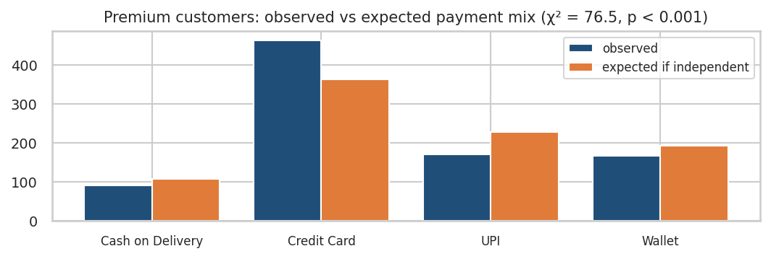
Chi-square
The chart shows Premium customers’ actual payment mix against what independence would predict: far more credit card use than expected, far less UPI and cash on delivery. The gaps drive the statistic.
import pandas as pd
from scipy import stats
# Contingency table: customer segment x payment method (course dataset)
observed = pd.DataFrame(
[[51, 196, 121, 107],
[92, 464, 171, 167],
[216, 562, 477, 376]],
index=["Loyal", "Premium", "Regular"],
columns=["Cash on Delivery", "Credit Card", "UPI", "Wallet"])
chi2, p, dof, expected = stats.chi2_contingency(observed)
print("OBSERVED\n", observed)
print("\nEXPECTED IF INDEPENDENT\n",
pd.DataFrame(expected, index=observed.index, columns=observed.columns).round(1))
print(f"\nchi-square = {chi2:.3f} dof = {dof} p = {p:.3e}")
print("Minimum expected count:", round(expected.min(), 1), "(needs to be >= 5)")
print("Decision:", "Segment and payment method are associated" if p < 0.05 else "No evidence of association")
Expected output: χ² = 76.46, dof = 6, p ≈ 1.9 × 10⁻¹⁴. Premium customers use credit cards far more than independence predicts and cash on delivery far less.
Assumptions: independent observations (one row per customer, not per transaction) and expected counts of at least 5 in essentially every cell. If cells are too thin, combine categories or use Fisher’s exact test.
COMMON MISTAKE — Reading a significant chi-square as “which category is best”. The test says only that the variables are related. To say how, compare observed against expected cell by cell, exactly as the chart above does.

PRACTICAL 9 — Pick the right test
For each scenario, name the test before you code anything:
- Average order value this quarter versus the ₹2,000 target.
- Conversion rate: new checkout versus old checkout.
- Spend of the same 200 customers before and after a loyalty programme.
- Average delivery days across North, South, East and West.
- Is device type related to payment method?
- Do time on site and order value move together?
Expected learning: the test is chosen by variable types and group count, never by which test you remember best. Answers in the solutions.

MODULE 40 — End-to-end business project

The business context
ShopNova is an Indian e-commerce retailer. Over one quarter, 3,000 randomly selected customers were tracked across their sessions, orders, deliveries and support interactions. During the same period, half of them were randomly shown a new checkout experience (experiment_group = treatment) while the other half saw the existing one (control).
The leadership team has questions, and you have 3,000 rows.
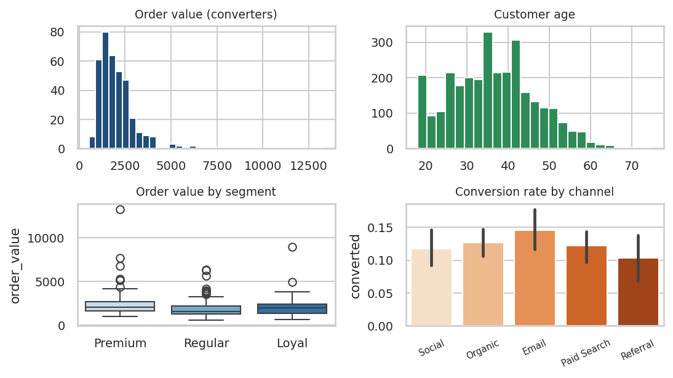
Project overview

Loading the data in Google Colab
Run this cell, then choose Statistics_DS_ML_End_to_End_Project.xlsx from your computer when the file picker appears:
from google.colab import files
uploaded = files.upload()
Then load and inspect it:
import pandas as pd
import numpy as np
df = pd.read_excel("Statistics_DS_ML_End_to_End_Project.xlsx", sheet_name="customer_data")
print("Shape:", df.shape)
print("\nMissing values:\n", df.isna().sum()[lambda s: s > 0])
print("\nOverall conversion rate:", round(df.converted.mean(), 4))
df.head()
Expected output: 3,000 rows × 22 columns; 2,626 missing values in both delivery_days and customer_rating; overall conversion 0.1247.
IMPORTANT — the first analytical decision of the project. delivery_days and customer_rating are missing for exactly the customers who never ordered. That is not dirty data; it is structurally missing — you cannot have a delivery date without an order. Never impute these with a mean. For anything about orders, filter to df[df.converted == 1] first. The same logic applies to order_value, which is a structural zero for non-converters.

The four sheets in the workbook
Sheet | What it holds
customer_data | The 3,000-row dataset
data_dictionary | Every column: description, type, business meaning
business_questions | The 28 questions you must answer
expected_analysis | Hints on technique — no answers

Your brief
Answer the 28 questions on the business_questions sheet and produce a one-page recommendation for the leadership team. Structure the analysis exactly as the workflow diagram at the front of this workbook prescribes:
Load data → Understand → Clean → Describe → Visualise → Sample →
Distribution → Outliers → Correlation → Hypothesis tests →
Confidence intervals → Business interpretation → Recommendation
The five stakeholder questions that matter most:
- CFO: “Is our average order value above ₹2,000?”
- Head of Product: “Did the new checkout actually improve conversion?”
- Head of Marketing: “Do Premium customers really spend more than Regular ones?”
- COO: “Is one region genuinely slower on delivery, or is that just noise?”
- Head of Payments: “Does payment preference vary by customer segment?”
Each requires a different test. Choosing correctly is the exam.

Common statistical mistakes data scientists make
# | Mistake | What it looks like in the wild
1 | Mean where median belongs | Quoting “average order value ₹2,082” when 60% of customers spend less than that.
2 | Confusing sample and population | Reporting “conversion is 14.2%” with no interval, then being surprised when next month reads 12.9%.
3 | Misreading the p-value | “p = 0.03, so there is a 97% chance the new page is better.” It says nothing of the sort.
4 | Correlation as causation | “Customers who use the app spend more, so push everyone to the app.” Heavy spenders install the app; the app may not create them.
5 | Deleting outliers reflexively | Dropping the top 1% of orders and under-forecasting revenue by 8%.
6 | Pearson for everything | Reporting r = 0.02 on a clearly curved relationship and declaring “no relationship”.
7 | Many pairwise t-tests | Six region-pair t-tests, one comes back p = 0.04, and it gets a slide.
8 | Ignoring multiple testing | Slicing an A/B test by 20 segments and reporting the one that “worked”.
9 | Significance mistaken for importance | Shipping a 0.02 pp lift that took three sprints, because p < 0.05.
10 | One-tailed after the fact | p = 0.08 two-tailed becomes p = 0.04 one-tailed and suddenly it ships.
11 | Misreading the CI | “95% chance the true mean is in this interval.” The method has the 95%, not the interval.
12 | Forgetting assumptions | Paired data run through an independent t-test, halving the power for no reason.
13 | Ignoring sample size | Declaring a winner after 40 conversions per arm on day two of a test.
14 | Over-reading small data | A 12-customer segment shows a 40% lift; the interval spans −10% to +90%.
15 | Peeking | Checking the test daily and stopping the moment p dips under 0.05. This inflates the false-positive rate above 30%.

Statistical test selection cheat sheet
Start at the top and answer honestly.
What kind of variable is my OUTCOME?
|-- NUMERIC outcome
| |
| |-- Comparing it to ONE fixed target value?
| | -> One-sample t-test stats.ttest_1samp(x, mu0)
| | (z-test if sigma is truly known)
| |
| |-- Comparing TWO independent groups?
| | -> Independent t-test stats.ttest_ind(a, b, equal_var=False)
| |
| |-- SAME units measured twice (before / after)?
| | -> Paired t-test stats.ttest_rel(before, after)
| |
| |-- THREE OR MORE groups?
| | -> One-way ANOVA stats.f_oneway(g1, g2, g3, ...)
| | then Tukey HSD pairwise_tukeyhsd(values, groups)
| |
| |-- Relationship with ANOTHER numeric variable?
| -> Linear? Pearson stats.pearsonr(x, y)
| -> Monotonic / skewed / ordinal?
| Spearman stats.spearmanr(x, y)
|
|-- CATEGORICAL outcome
|
|-- ONE proportion vs a claimed value?
| -> One-proportion z-test proportions_ztest(count, nobs, value=p0)
|
|-- TWO proportions (A/B test)?
| -> Two-proportion z-test proportions_ztest([c1, c2], [n1, n2])
|
|-- Association between TWO categorical variables?
-> Chi-square test stats.chi2_contingency(crosstab)
(Fisher's exact if expected counts < 5)
Three questions that resolve almost every case: Is my outcome numeric or categorical? How many groups am I comparing? Are the groups independent or the same units measured twice?

Formula cheat sheet
Quantity | Formula | Meaning / when to use
Mean | x̄ = Σxᵢ / n | Balance point; use when you need totals
Median | middle value of sorted data | Typical value; use with skew or outliers
Population variance | σ² = Σ(xᵢ − μ)² / N | Spread when you have everyone
Sample variance | s² = Σ(xᵢ − x̄)² / (n − 1) | Spread from a sample; n−1 corrects the bias
Standard deviation | s = √s² | Spread in original units
z-score | z = (x − μ) / σ | How many SDs from average
IQR | Q3 − Q1 | Robust spread; the middle 50%
Lower / upper fence | Q1 − 1.5·IQR / Q3 + 1.5·IQR | Tukey outlier flags
Addition rule (exclusive) | P(A or B) = P(A) + P(B) | Events cannot co-occur
Addition rule (general) | P(A or B) = P(A) + P(B) − P(A and B) | Events may overlap
Multiplication (independent) | P(A and B) = P(A)·P(B) | Only if truly independent
Multiplication (general) | P(A and B) = P(A)·P(B\|A) | Always valid
Permutation | nPr = n! / (n−r)! | Order matters
Combination | nCr = n! / (r!(n−r)!) | Order does not matter
Covariance | Cov = Σ(xᵢ−x̄)(yᵢ−ȳ) / (n−1) | Direction of co-movement, scale-dependent
Pearson r | r = Cov(X,Y) / (sₓ·s_y) | Unit-free linear association, −1 to +1
Standard error of mean | SE = s / √n | Typical distance from the truth
SE of a proportion | SE = √(p(1−p)/n) | Uncertainty on a rate
z-test (mean) | z = (x̄ − μ₀) / (σ/√n) | σ known or n large
t-test (one sample) | t = (x̄ − μ₀) / (s/√n), df = n−1 | σ unknown — the usual case
Two-proportion z | z = (p̂₁ − p̂₂) / SE_pooled | A/B tests on rates
Confidence interval | x̄ ± t₍₀.₉₇₅,n−1₎ · s/√n | Plausible range for the parameter
ANOVA F | F = MS_between / MS_within | 3+ group means at one α
Chi-square | χ² = Σ (O − E)² / E | Association between categories
Expected cell count | E = (row total × col total) / grand total | The independence benchmark

COMPLETE SOLUTIONS
Solutions are deliberately placed here rather than beside each exercise. Attempt the practical first.

Solution 1 — Your first five statistics (Module 1)
import pandas as pd
df = pd.DataFrame({
"customer_id": range(1, 11),
"category": ["Electronics", "Grocery", "Fashion", "Electronics", "Grocery",
"Electronics", "Fashion", "Grocery", "Electronics", "Grocery"],
"purchase_amount": [2500, 800, 1500, 3200, 950, 2800, 1200, 700, 15000, 1100],
"converted": [1, 1, 0, 1, 1, 1, 0, 1, 1, 0]
})
no_outlier = df[df.customer_id != 9]
print("With outlier -> mean:", df.purchase_amount.mean(),
"median:", df.purchase_amount.median())
print("Without outlier -> mean:", round(no_outlier.purchase_amount.mean(), 2),
"median:", no_outlier.purchase_amount.median())
Expected output: with the ₹15,000 customer, mean 2,975.00 and median 1,350.00. Without that customer, mean 1,638.89 and median 1,200.00.
Interpretation. Removing one customer out of ten moved the mean by 45% and the median by 11%. The mean is a balance point and therefore sensitive to distance; the median is a rank position and only cares about order.
Business conclusion. Quote the median (₹1,350) when the CEO asks what a typical customer spends. Quote the mean only when multiplying by customer count to get total revenue, and say so explicitly. Best practice: report both, plus the count of customers above and below.

Solution 2 — Does the sampling design matter? (Module 4)
At n = 20 the urban/rural split swings wildly between roughly 45% and 75% urban across seeds; the stratified sample is 60/40 by construction every single time. Ten simple random samples of 100 produce ten different means, all clustered around the population mean — this is sampling error, visible.
Business answer. Emailing the 500 most recently active customers is convenience sampling dressed as a survey. It systematically excludes lapsed customers, low-frequency buyers, and — critically for a rural-focused product — anyone in a region with weaker connectivity or lower engagement. The sample will over-represent exactly the customers who least need the new product, and no sample size fixes it. Propose instead a proportional stratified random sample stratified by region and customer segment, with follow-up reminders to keep non-response from re-introducing the same bias.

Solution 3 — Which average would you defend? (Module 7)
Expected output: mean ≈ 1,975, median ≈ 1,661, skew ≈ 2.85, and roughly 63% of customers sit below the mean. Adding a single ₹5,000,000 customer pushes the mean past 6,900 while the median moves by a few rupees. The 5% trimmed mean lands between the two.
Business answer. They are not contradicting each other, and both are right. In a right-skewed distribution the mean sits above the median, so a clear majority of customers spend less than “the average”. The reporting fix: publish “median order value ₹1,858, mean ₹2,082” side by side, and use the mean only where a total is needed.

Solution 4 — Outlier hunt (Module 11)
Expected output: about 5% of raw values are flagged by the Tukey fences; after a log transform that drops to well under 1%. The z-score rule (|z| > 3) flags far fewer points than the IQR rule on the same raw data, because the outliers themselves inflate the standard deviation used to compute z.
Business answer.
- (a) Revenue report — keep them. They are real orders and real money; excluding them understates revenue and misleads the forecast. Report median and mean, and note the concentration (“the top 4% of orders contribute 18% of revenue”).
- (b) Churn model — do not delete, but cap or transform. Winsorising at P99 or modelling log(order_value) stops a handful of rows dominating the loss function while keeping every customer in the training data.

Solution 5 — Standardise and compare (Module 14)
z = (8000 − 2082) / 1180 = 5.02. That customer is five standard deviations above average — extraordinarily unusual if spend were normal.
On the log-normal variable, the share beyond |z| = 3 comes out near 1.6%, far above the 0.3% the empirical rule predicts, and essentially all of it is in the upper tail. Skew is the reason: the rule is a property of the normal distribution, not of z-scores in general.
Business answer. A “3 SD above average” fraud rule on raw skewed spend will fire too often, and almost exclusively on the retailer’s best customers — the worst possible false positives. Better options: threshold on a percentile (flag above the customer’s own P99), z-score the log of spend, or use a per-customer baseline rather than a population one.

Solution 6 — Break the CLT (Module 15)
With a Pareto(1.5) population the tail is so heavy that at n = 50 the distribution of sample means is still visibly right-skewed. By n = 500 it is close to normal. The SE at n = 120 is about half the SE at n = 30, confirming the √n rule (√(120/30) = 2).
Business answer. To halve the width of a confidence interval you need four times the sample. If each arm currently has 1,000 users, you need 4,000 per arm — 8,000 total. At 200,000 sessions a month and a 50/50 split, that is a matter of days of traffic; at 2,000 sessions a month it is two years, and the honest recommendation is to pick a more sensitive metric or accept a bigger detectable effect.

Solution 7 — Correlation detective (Module 23)
Expected output: the clean data gives Pearson ≈ 0.89. After forcing one point to (15, −15), Pearson collapses to roughly 0.20 — a single observation out of 200 wiped out most of the measured relationship. Spearman on the same contaminated data stays around 0.86, because in rank space that point is just “the largest x and the smallest y”, not “fifteen units away”.
Business answer. Two reasons the doubling claim fails: (1) correlation is not causation — high-spend categories may attract both more ad budget and more organic revenue, so a confounder drives both; (2) correlation says nothing about the slope, and nothing about extrapolation — even a genuine linear relationship inside the observed budget range gives no licence to predict at double the budget, where diminishing returns and audience saturation dominate. The design that would support the claim: a randomised geo experiment — randomly assign markets to increased and unchanged budgets, and measure the difference.

Solution 8 — Run the experiment yourself (Module 32)
With treatment_conv = 175 the lift falls to about 0.7 pp, the p-value rises to roughly 0.57, and the CI spans zero — the correct call is fail to reject, not “a small improvement”. Multiplying all counts by 10 leaves the rates unchanged but shrinks the CI width by about √10 ≈ 3.2×.
Business answer. Decide on the pessimistic bound, 1.2 pp:
- 200,000 sessions × 1.2 pp = 2,400 extra orders per month
- × ₹2,082 average order value ≈ ₹0.50 crore of additional monthly revenue
- Against a one-off ₹40 lakh build, payback is under one month even in the worst case the data support.
Roll it out. Had the CI been [−0.4 pp, 7.2 pp], the same point estimate would have justified only “keep testing”.

Solution 9 — Pick the right test (Module 39)
# | Scenario | Test | Why
1 | AOV vs ₹2,000 target | One-sample t-test | One numeric mean against a fixed value, σ unknown
2 | New vs old checkout conversion | Two-proportion z-test | Categorical outcome, two independent groups
3 | Same 200 customers before/after | Paired t-test | Same units measured twice
4 | Delivery days across 4 regions | One-way ANOVA + Tukey HSD | Numeric outcome, 3+ independent groups
5 | Device vs payment method | Chi-square test of independence | Two categorical variables
6 | Time on site vs order value | Pearson (and Spearman, since both are skewed) | Two numeric variables

Solution — Statistical detective (Module 31)
- Statistically significant, not practically significant — 0.02 pp is a rounding error, though at 50 million users it may still be worth shipping if the change is free. Compute the money before deciding.
- Neither — p = 0.21 on n = 60 means underpowered, not “no effect”. The +₹450 may be real; the study cannot tell. Get more data.
- Both — a 3.6 pp lift on a 10.6% base is a 34% relative improvement, and p = 0.003. Ship it.
- Statistically significant, practically marginal — 0.1 pp of churn on 2 million customers is 2,000 retained customers, which may be substantial. This one genuinely depends on customer lifetime value; do the arithmetic before arguing.

FINAL PROJECT — COMPLETE SOLUTION
Every number below was produced by the code shown, run against the supplied Excel file.
NOTE — this is the one place in the workbook where cells run in sequence. Run the Setup cell once; every later cell in this section reuses df, buyers and the imports it creates. If you get a NameError, rerun Setup.

Setup
import pandas as pd
import numpy as np
from scipy import stats
from statsmodels.stats.proportion import proportions_ztest, proportion_confint
from statsmodels.stats.multicomp import pairwise_tukeyhsd
# In Colab, run files.upload() first and pick the Excel file
df = pd.read_excel("Statistics_DS_ML_End_to_End_Project.xlsx", sheet_name="customer_data")
# Structural rule: order-level questions use converters only
buyers = df[df.converted == 1].copy()
print("Rows, columns:", df.shape)
print("Converters :", len(buyers), f"({df.converted.mean():.2%})")
Rows, columns: (3000, 22)
Converters : 374 (12.47%)
Data-cleaning note. The 2,626 missing values in delivery_days and customer_rating are structurally missing — those customers never ordered. Imputing them would invent deliveries that never happened. order_value = 0 for non-converters is a structural zero, not a small order.

Q1–Q6 Descriptive statistics
ov = buyers.order_value
q1, q2, q3 = ov.quantile([.25, .50, .75])
iqr = q3 - q1
low, high = q1 - 1.5*iqr, q3 + 1.5*iqr
print(f"Mean : {ov.mean():,.2f}")
print(f"Median : {ov.median():,.2f} skew = {ov.skew():.2f}")
print(f"Std : {ov.std():,.2f}")
print(f"Age : mean={df.age.mean():.1f} median={df.age.median():.1f} sd={df.age.std():.1f} skew={df.age.skew():.2f}")
print(f"P25={q1:,.2f} P50={q2:,.2f} P75={q3:,.2f} IQR={iqr:,.2f}")
print(f"Fences=[{low:,.2f}, {high:,.2f}] outliers={((ov<low)|(ov>high)).sum()} max={ov.max():,.2f}")
Mean : 2,081.69
Median : 1,858.27 skew = 3.87
Std : 1,180.26
Age : mean=36.5 median=36.0 sd=10.4 skew=0.25
P25=1,386.66 P50=1,858.27 P75=2,453.96 IQR=1,067.30
Fences=[-214.30, 4,054.92] outliers=14 max=13,300.65
Interpretation. Order value is strongly right-skewed (skew 3.87): mean ₹2,082 exceeds median ₹1,858 by ₹223. Fourteen orders exceed the upper fence, topping out at ₹13,301. Age, by contrast, is nearly symmetric (skew 0.25) with mean and median essentially identical — a textbook contrast between a “money” variable and a “human measurement” variable.

Q7–Q10 Distribution analysis
print("Skewness :", round(ov.skew(), 2))
print("Shapiro-Wilk p :", f"{stats.shapiro(ov.sample(300, random_state=42)).pvalue:.2e}")
print("Skew after log :", round(np.log(ov).skew(), 2))
d = buyers.delivery_days.dropna()
print("P(delivery <= 3) :", f"{(d<=3).mean():.1%}")
print("P(delivery <= 4) :", f"{(d<=4).mean():.1%}")
z = (ov - ov.mean()) / ov.std(ddof=0)
print("Orders with |z| > 3 :", int((z.abs() > 3).sum()), " max z =", round(z.max(), 2))
Skewness : 3.87
Shapiro-Wilk p : 1.12e-22
Skew after log : 0.56
P(delivery <= 3) : 60.7%
P(delivery <= 4) : 81.0%
Orders with |z| > 3 : 7 max z = 9.52
Interpretation. Order value is decisively not normal (Shapiro p ≈ 10⁻²²), and the log transform nearly fixes it (skew 3.87 → 0.56). This does not block the t-tests below — the CLT applies to the sampling distribution of the mean, and n = 374 is ample. It does mean the empirical rule and any raw-σ prediction interval would be wrong here.

Q11–Q13 Sampling
sample = df.sample(200, random_state=42)
print(f"Population mean time_on_site : {df.time_on_site.mean():.3f}")
print(f"Sample (n=200) mean : {sample.time_on_site.mean():.3f}")
for n in [30, 100, 500]:
means = [df.time_on_site.sample(n, random_state=i).mean() for i in range(200)]
print(f"n={n:>3} SE of the sample means = {np.std(means):.3f}")
Population mean time_on_site : 19.378
Sample (n=200) mean : 18.989
n= 30 SE of the sample means = 2.295
n=100 SE of the sample means = 1.251
n=500 SE of the sample means = 0.504
Interpretation. The 200-customer sample missed the population mean by 0.39 minutes — sampling error, not a bug. Quadrupling n from 30 to 120 would roughly halve the SE; going from 100 to 500 (5×) cuts it by about √5 ≈ 2.2, exactly as observed (1.251 → 0.504).

Q14–Q17 Relationships
print("Covariance ad_spend vs order_value :", round(np.cov(buyers.ad_spend, buyers.order_value)[0,1], 2))
print("Pearson r :", round(stats.pearsonr(buyers.ad_spend, buyers.order_value)[0], 4))
print("Spearman rho:", round(stats.spearmanr(buyers.ad_spend, buyers.order_value).statistic, 4))
print("\ntime_on_site vs converted, r :", round(stats.pearsonr(df.time_on_site, df.converted)[0], 4))
conv_t = df.loc[df.converted == 1, "time_on_site"]
noconv_t = df.loc[df.converted == 0, "time_on_site"]
t = stats.ttest_ind(conv_t, noconv_t, equal_var=False)
print(f"Converted mean {conv_t.mean():.2f} min vs not-converted {noconv_t.mean():.2f} min")
print(f"Welch t = {t.statistic:.3f}, p = {t.pvalue:.2e}")
print("\ndelivery_days vs rating, Pearson :",
round(stats.pearsonr(buyers.delivery_days, buyers.customer_rating)[0], 4))
Covariance ad_spend vs order_value : 40750.31
Pearson r : 0.1899
Spearman rho: 0.3548
time_on_site vs converted, r : 0.2728
Converted mean 28.38 min vs not-converted 18.10 min
Welch t = 11.696, p = 1.41e-27
delivery_days vs rating, Pearson : -0.4266
Interpretation. Covariance (40,750) is uninterpretable on its own — that is exactly why we normalise it. Pearson (0.19) badly understates the ad-spend relationship because order value has a heavy right tail; Spearman (0.35) nearly doubles it, and the scatter plot in Module 23 confirms a real monotonic pattern.
Customers who convert spend 10.3 more minutes on site on average, and the difference is overwhelming (p ≈ 10⁻²⁷). This does not mean time causes conversion — the causal arrow plausibly runs the other way: people who intend to buy browse longer. The same caution applies to delivery days and rating (r = −0.43): the relationship is strong and plausible, but East region has both the slowest deliveries and other characteristics we have not controlled for.

Q18 CFO: is average order value above ₹2,000?
t18 = stats.ttest_1samp(ov, 2000)
se = ov.std(ddof=1) / np.sqrt(len(ov))
ci = stats.t.interval(0.95, len(ov)-1, loc=ov.mean(), scale=se)
print(f"n = {len(ov)}, mean = {ov.mean():,.2f}")
print(f"t = {t18.statistic:.4f}, p = {t18.pvalue:.4f}")
print(f"95% CI = [{ci[0]:,.2f}, {ci[1]:,.2f}]")
n = 374, mean = 2,081.69
t = 1.3386, p = 0.1815
95% CI = [1,961.69, 2,201.70]
- H0: μ = 2,000 H1: μ ≠ 2,000, α = 0.05, two-sided
- Assumptions: independent customers ✓; CLT covers the skew at n = 374 ✓
- Decision: p = 0.18 > 0.05 → fail to reject H0
Business interpretation. “Our observed average order value is ₹2,082, which is above ₹2,000 — but the data are not strong enough to conclude that the true average exceeds ₹2,000. The plausible range is ₹1,962 to ₹2,202, and ₹2,000 sits inside it. We should not report ‘AOV has crossed ₹2,000’ as an achievement this quarter.” Note carefully: this is not evidence that AOV equals ₹2,000. It is evidence that we cannot yet tell the difference.

Q19 Product: did the new checkout improve conversion?
tab = df.groupby("experiment_group")["converted"].agg(["sum", "count", "mean"])
z, p = proportions_ztest([tab.loc["treatment","sum"], tab.loc["control","sum"]],
[tab.loc["treatment","count"], tab.loc["control","count"]])
pt, pc = tab.loc["treatment","mean"], tab.loc["control","mean"]
se_d = np.sqrt(pt*(1-pt)/tab.loc["treatment","count"] + pc*(1-pc)/tab.loc["control","count"])
print(tab.round(4))
print(f"z = {z:.4f}, p = {p:.5f}")
print(f"lift = {100*(pt-pc):.2f} pp 95% CI = [{100*(pt-pc-1.96*se_d):.2f}, {100*(pt-pc+1.96*se_d):.2f}] pp")
print(f"relative lift = {100*(pt-pc)/pc:.1f}%")
sum count mean
control 154 1449 0.1063
treatment 220 1551 0.1418
z = 2.9466, p = 0.00321
lift = 3.56 pp 95% CI = [1.20, 5.91] pp
relative lift = 33.5%
- H0: p_treatment = p_control H1: p_treatment ≠ p_control, α = 0.05
- Assumptions: random assignment ✓; n·p and n·(1−p) both far above 10 ✓
- Decision: p = 0.0032 → reject H0

Q20 Marketing: do Premium customers spend more?
prem = buyers.loc[buyers.customer_segment == "Premium", "order_value"]
reg = buyers.loc[buyers.customer_segment == "Regular", "order_value"]
print("Levene p :", round(stats.levene(prem, reg).pvalue, 4))
t20 = stats.ttest_ind(prem, reg, equal_var=False)
se_seg = np.sqrt(prem.var(ddof=1)/len(prem) + reg.var(ddof=1)/len(reg))
d = prem.mean() - reg.mean()
print(f"Premium {prem.mean():,.2f} (n={len(prem)}) vs Regular {reg.mean():,.2f} (n={len(reg)})")
print(f"Welch t = {t20.statistic:.4f}, p = {t20.pvalue:.6f}")
print(f"difference = {d:,.2f} 95% CI = [{d-1.96*se_seg:,.2f}, {d+1.96*se_seg:,.2f}]")
Levene p : 0.2574
Premium 2,327.53 (n=156) vs Regular 1,833.58 (n=147)
Welch t = 3.7406, p = 0.000223
difference = 493.95 95% CI = [235.13, 752.77]
Decision: reject H0. Premium customers spend on average ₹494 more per order, and even the pessimistic end of the interval is ₹235 — a real, commercially meaningful gap that justifies differentiated retention spend on the Premium tier.

Q21 Operations: does delivery performance differ by region?
print(buyers.groupby("region")["delivery_days"].agg(["count", "mean", "std"]).round(2))
groups = [g["delivery_days"].values for _, g in buyers.groupby("region")]
f_stat, p_val = stats.f_oneway(*groups)
print(f"\nF = {f_stat:.4f}, p = {p_val:.3e}")
print(pairwise_tukeyhsd(buyers.delivery_days, buyers.region))
count mean std
East 58 4.29 1.41
North 112 3.24 1.27
South 122 2.90 1.28
West 82 3.51 1.46
F = 14.8332, p = 3.865e-09
East North -1.052 0.0 reject=True
East South -1.3915 0.0 reject=True
East West -0.7809 0.0041 reject=True
North South -0.3394 0.2134 reject=False
North West 0.2711 0.5034 reject=False
South West 0.6106 0.0082 reject=True
Decision: reject H0 — at least one region differs. Tukey then identifies exactly which: East is significantly slower than all three other regions (by 0.78 to 1.39 days), and South is faster than West. North versus South and North versus West are not distinguishable — differences that six naive t-tests might well have reported as findings.
Business interpretation. “East is genuinely slower, by roughly a day, and that is not noise. Given the −0.43 correlation between delivery days and rating, closing that gap is the single clearest operational lever we have on customer satisfaction in that region.”
(For contrast: an ANOVA of order value across regions gives F = 1.59, p = 0.19 — no evidence that regions differ in spend. Same four regions, opposite conclusion, because the question changed.)

Q22 Payments: is payment method associated with segment?
ct = pd.crosstab(df.customer_segment, df.payment_method)
chi2, p, dof, expected = stats.chi2_contingency(ct)
print(ct)
print(f"\nchi-square = {chi2:.4f}, dof = {dof}, p = {p:.3e}")
print("Minimum expected count:", round(expected.min(), 1))
payment_method Cash on Delivery Credit Card UPI Wallet
Loyal 51 196 121 107
Premium 92 464 171 167
Regular 216 562 477 376
chi-square = 76.4591, dof = 6, p = 1.921e-14
Minimum expected count: 56.8
Decision: reject H0 — segment and payment method are associated. Comparing observed with expected: Premium customers use credit cards far more than independence predicts (464 vs 364) and UPI and cash on delivery far less. Assumption check: the smallest expected count is 56.8, comfortably above 5.

Q23–Q24 Confidence intervals
- Mean order value: ₹2,081.69, 95% CI [₹1,961.69, ₹2,201.70], margin of error ± ₹119.62
- Treatment conversion rate: 14.18%, 95% CI [12.45%, 15.92%]
- Lift (treatment − control): 3.56 pp, 95% CI [1.20 pp, 5.91 pp]

Q25–Q28 The recommendation
sessions_per_month = 200000
aov = ov.mean()
for label, lift in [("point estimate", pt-pc),
("pessimistic (CI low)", pt-pc-1.96*se_d),
("optimistic (CI high)", pt-pc+1.96*se_d)]:
extra = sessions_per_month * lift
print(f"{label:<22}: {lift*100:5.2f} pp -> {extra:,.0f} extra orders/month "
f"-> Rs {extra*aov/1e7:,.2f} crore/month")
point estimate : 3.56 pp -> 7,113 extra orders/month -> Rs 1.48 crore/month
pessimistic (CI low) : 1.20 pp -> 2,408 extra orders/month -> Rs 0.50 crore/month
optimistic (CI high) : 5.91 pp -> 11,817 extra orders/month -> Rs 2.46 crore/month

One-page recommendation to leadership
Roll out the new checkout experience to all users.
In a randomised test on 3,000 customers, the new checkout converted 14.2% of visitors against 10.6% for the current page — an absolute improvement of 3.6 percentage points, or 33.5% in relative terms. A difference this large is very unlikely to arise by chance if the two pages were equally effective (two-proportion z-test, z = 2.95, p = 0.003). Our best estimate of the true lift is 3.6 points, and the data are consistent with anything from 1.2 to 5.9 points.
Sizing the pessimistic end of that range against 200,000 monthly sessions and an average order value of ₹2,082: roughly 2,400 additional orders and ₹0.50 crore of incremental revenue per month. At the point estimate it is closer to ₹1.5 crore. The change is therefore both statistically significant and comfortably practically significant, and it pays back a ₹40 lakh build within the first month even in the worst case the evidence supports.
Two things we are not claiming. First, average order value has not been shown to exceed ₹2,000 (₹2,082 observed, 95% CI ₹1,962–₹2,202, p = 0.18) — that headline should not appear in the quarterly deck. Second, the strong link between time on site and conversion is not evidence that keeping people on the page longer makes them buy; the causation plausibly runs the other way.
Separate and urgent: East region averages 4.3 delivery days against 2.9–3.5 elsewhere, a gap confirmed by ANOVA (F = 14.8, p < 0.001) and Tukey post-hoc comparisons. With delivery days correlated −0.43 with customer rating, this is our clearest operational lever on satisfaction.

Q28 — What we would do before and after rollout
- Run the test for full weekly cycles. Conversion behaviour differs sharply between weekdays and weekends; a partial week biases the estimate.
- Guard against novelty effects. A new interface can lift conversion temporarily. Re-measure two to four weeks after rollout.
- Check guardrail metrics. Conversion is the primary metric, but average order value, return rate, support tickets and churn must not degrade. A 3.6 pp conversion lift that comes with smaller baskets may be revenue-neutral.
- Treat segment analysis as exploratory. Slicing the result by region, device and segment is 10+ additional hypotheses; apply a Benjamini–Hochberg correction and label anything that survives as a hypothesis for the next test, not a finding.
- Confirm randomisation held. Compare age, segment and channel mix across arms; a significant imbalance means the assignment mechanism is broken and the causal claim is void.
- Pre-register the next test. Metric, α, minimum detectable effect and sample size fixed before launch — the single most effective defence against p-hacking.

Statistics in 10 minutes — the whole course on one spread
Idea | The question it answers | The one thing to remember
Descriptive statistics | What happened? | Median for skewed money and time; mean when you need totals
Dispersion | How consistent is it? | Customers experience variance, not averages
Distribution | How is the data behaving? | Plot it before you test it; skew is the norm, not the exception
Probability | How likely is something? | Between 0 and 1; every classifier outputs one
Sampling | How do we learn about millions from thousands? | Design beats size; a biased sample never self-corrects
Central Limit Theorem | Why does any of this work? | The mean goes normal even when the data does not
Standard error | How wobbly is my estimate? | σ/√n — halving it costs 4× the data
Hypothesis testing | Is this difference likely to be real? | The p-value is P(data \| H0), never P(H0 \| data)
Confidence interval | How big is the effect, plausibly? | Decide on the pessimistic end of the interval
Correlation | Do these move together? | Never implies causation; only randomisation does
Practical significance | Does it actually matter? | Convert every effect into money or units before deciding

Where statistics shows up in the ML lifecycle
Stage | The statistics inside it
Data preprocessing | Distributions, skew, log transforms, missing-data mechanisms
Feature engineering | Standardisation (z-scores), binning by quantile, ratio features
Feature selection | Correlation, multicollinearity, multiple-testing correction
Model evaluation | Sampling variability of metrics, cross-validation SD, confidence intervals on AUC
Probability predictions | Bernoulli outcomes, calibration, threshold selection by cost
Uncertainty estimation | Prediction intervals, bootstrap, conformal methods
Anomaly detection | z-scores, quantiles, distributional distance
Experimentation | A/B tests, power analysis, sequential-testing corrections
Model interpretation | Effect sizes, partial dependence, confounding
Monitoring | Drift detection — a two-sample test on last month versus this month
The exit test. If you can look at a business question and say “that is a two-sample comparison of a categorical outcome, so it is a proportion z-test, and I will report the lift with its confidence interval in rupees” — you have got what this course was for. The formulas are in the cheat sheet; the judgement is what you take away.

