APPLIED MACHINE
LEARNING ENGINEERING
FROM CLUSTERING TO A DEPLOYED, AUDITED MODEL

Hierarchical Clustering · DBSCAN · PCA · Hyperparameter Tuning · Pipelines & ColumnTransformer · Model Persistence, Serving & MLOps · Responsible AI, Explainability & Ethics
Dataset: loan_applications.csv — 12,030 loan applications (provided separately)
Projects: A credit-risk decision engine — the whole pipeline, end to end

HOW THIS SESSION RUNS
Everything in this workbook runs against one dataset: 12,030 loan applications from a digital lending platform. You will cluster it, compress it, model it, tune it, package it, monitor it and audit it. Using one dataset throughout is deliberate — it is how a real project feels, and it lets you compare every technique on the same ground.

Setup — run this first
# One-time installs (Colab has everything else already)
!pip install optuna shap -q

import numpy as np, pandas as pd, sklearn, joblib
import matplotlib.pyplot as plt, seaborn as sns
import optuna, shap
print("sklearn:", sklearn.__version__, "| optuna:", optuna.__version__, "| shap:", shap.__version__)
print("Environment ready.")
Then upload the dataset:
from google.colab import files
uploaded = files.upload() # choose loan_applications.csv

import pandas as pd
df = pd.read_csv("loan_applications.csv")
print(df.shape) # (12030, 28)
df.head()
KEY IDEA
Every code block sets random_state=42 so your numbers match the ones quoted here. Where a result depends on a search over random draws, the workbook quotes what the code actually printed when it was run — nothing here is illustrative.

The dataset
Group |  | Columns | Why it is here
Demographics |  | gender, age, region, education | Protected and quasi-protected attributes — the fairness audit needs them
Employment |  | employment_type, employment_years, income_monthly | The strongest legitimate risk signals
Loan terms |  | loan_amount, loan_term_months, loan_purpose, interest_rate, emi, emi_to_income | What the applicant is asking for, and whether they can carry it
Credit bureau |  | bureau_score, credit_utilization, num_credit_lines, num_inquiries_6m, num_delinquencies_2y, months_since_last_delinq, oldest_account_months, revolving_balance, total_debt, debt_to_income | Deliberately correlated — this is the block PCA will compress
App behaviour |  | app_logins_30d, avg_txn_value, num_bounced_payments | Alternative data, as a modern lender would actually use
Target |  | default (1 = defaulted) | 20.2% of the book
INDUSTRY INSIGHT
The data is messy on purpose: six columns have missing values, there are 30 duplicate rows, and the numeric scales run from 0.01 to 3,000,000. months_since_last_delinq is missing for 12% of borrowers because they have never been delinquent — that absence is information, and Module 4 shows how to keep it instead of imputing it away.

MODULE 1 — HIERARCHICAL CLUSTERING & DBSCAN
Two ways of grouping data that do not require you to guess K in advance.

1.1 Why K-Means is not enough
K-Means asks you to name the number of clusters before it has looked at anything, it assumes the clusters are roughly round and roughly equal in size, and it forces every single point into a group — including the ones that belong nowhere. In a credit book, the points that belong nowhere are often the ones you most need to see.
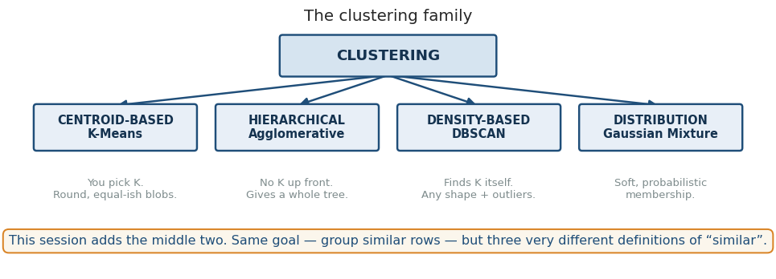
Figure 1.1 — Three definitions of “similar”. This module covers the middle two.

1.2 Hierarchical clustering from first principles
Agglomerative clustering starts by treating every row as its own cluster, then repeatedly merges the two closest clusters until only one remains. It never asks how many clusters you want — it builds the entire hierarchy and lets you choose afterwards.
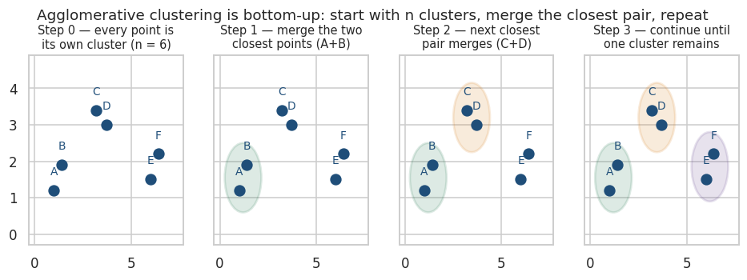
Figure 1.2 — Bottom-up merging. Six points, five merges, done.

The distance between two clusters: linkage
Merging needs a rule for how far apart two groups are. This choice is called linkage, and it changes the answer more than almost any other decision you will make.
Linkage |  | Distance between clusters A and B | Behaviour
Single |  | The closest pair — min d(a,b) | Chains along thin paths. Finds long, snaky shapes. Sensitive to a single bridging point
Complete |  | The furthest pair — max d(a,b) | Produces compact, roughly equal-diameter clusters. Breaks up elongated shapes
Average |  | The mean of all pairwise distances | A compromise between the two above
Ward |  | The merge that increases total within-cluster variance least | The usual default. Produces balanced, spherical clusters — very K-Means-like
# Ward's criterion — merge the pair that costs the least added variance
ΔSSE(A, B) = Σ_{x in A∪B} ||x − μ_{A∪B}||² − Σ_{x in A} ||x − μ_A||² − Σ_{x in B} ||x − μ_B||²

# Equivalently, for cluster sizes nA and nB:
ΔSSE(A, B) = (nA · nB) / (nA + nB) · ||μ_A − μ_B||²
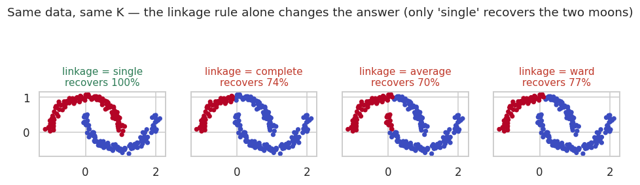
Figure 1.3 — Same points, same K, four linkage rules, four different answers.
DISCUSS
Only single linkage recovers the two moons, because it is the only rule that will follow a thin curved path. Yet Ward is the default almost everywhere. When would you deliberately choose single linkage — and what is the risk you take on when you do?

Reading a dendrogram
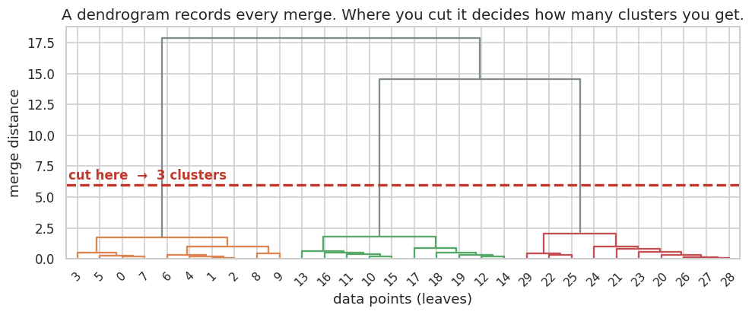
Figure 1.4 — The height of each join is the distance at which those clusters merged.
How to read it: the vertical axis is merge distance. A join that happens low down means those points were very similar. A long vertical line with nothing happening means the next merge is expensive — the clusters below it are genuinely distinct. Cut the tree horizontally across the longest uninterrupted vertical span, and the number of lines you cross is your number of clusters.
COMMON MISTAKE
Reading the horizontal axis as meaningful. The left-to-right order of the leaves is cosmetic — it is chosen to make the diagram drawable without crossing lines. Two adjacent leaves are not necessarily similar.

1.3 DBSCAN — clustering by density
DBSCAN takes a completely different view. A cluster is a dense region: a place where points have plenty of neighbours nearby. Regions where points are sparse are not clusters at all — they are noise. It needs two parameters and no K.
Parameter | Meaning | How to set it
eps (ε) | The radius that defines “nearby” | From a k-distance plot — see below
min_samples | How many points must be within ε for a point to be “core” | A common starting rule is 2 × number of dimensions
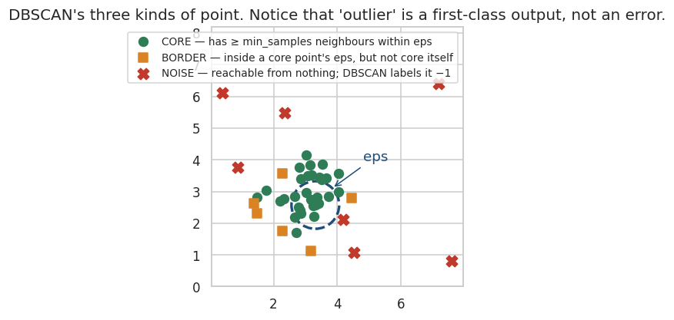
Figure 1.5 — Core, border and noise. Noise is an output, not a failure.
Core point : at least min_samples points lie within distance eps (including itself)
Border point : within eps of a core point, but not core itself
Noise point : neither — DBSCAN labels it −1

A cluster = a set of core points connected through overlapping eps-neighbourhoods,
plus the border points attached to them.

Choosing eps without guessing
Compute the distance from every point to its k-th nearest neighbour, sort those distances, and plot them. The curve is flat where the data is dense and turns sharply upward where points become isolated. The knee is your eps.
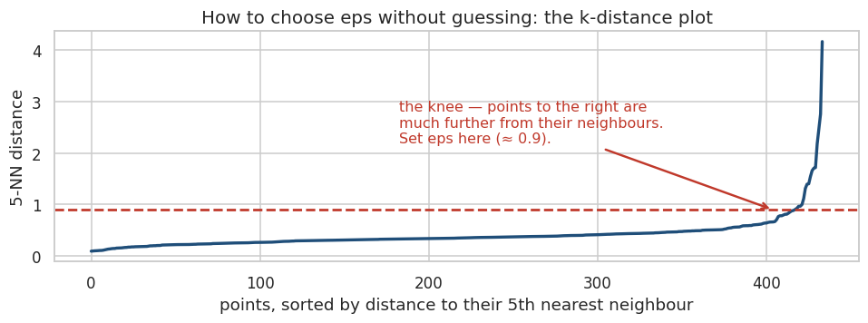
Figure 1.6 — The k-distance plot turns eps from a guess into a reading.

1.4 The three algorithms side by side
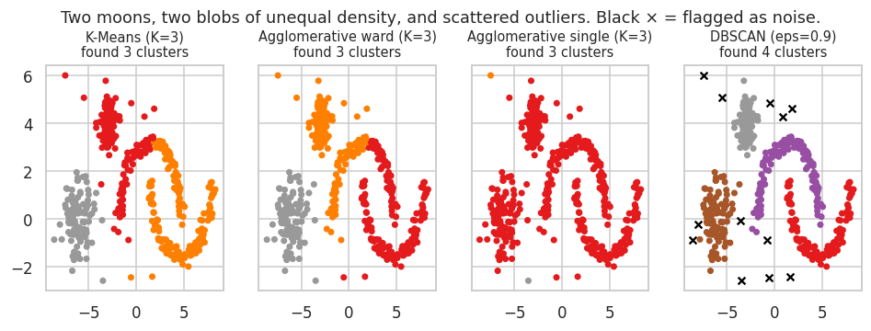
Figure 1.7 — Moons, unequal-density blobs and outliers. Only DBSCAN refuses to absorb the outliers.
 |  | K-Means | Hierarchical | DBSCAN
Need K in advance? |  | Yes | No — cut the tree later | No — it finds them
Cluster shape |  | Spherical only | Depends on linkage | Any shape
Handles outliers? |  | No — forces them into a cluster | No | Yes — labels them −1
Scales to 1M rows? |  | Yes, easily | No — O(n²) memory | Moderately
Deterministic? |  | No (depends on init) | Yes | Yes (except border ties)
Main weakness |  | Assumes round, equal clusters | Cannot undo a bad early merge | Struggles with varying density
INDUSTRY INSIGHT
Where each earns its keep in a lending business: hierarchical for portfolio segmentation you will present to a committee (the dendrogram is persuasive and shows the alternatives you rejected); DBSCAN for fraud and anomaly triage, where the −1 label is the entire product; K-Means when you have ten million rows and need something that finishes.
COMMON MISTAKE
- Not scaling. All three are distance-based. Income in rupees will annihilate a utilisation ratio between 0 and 1.
- Treating silhouette score as a verdict. It measures geometric separation, not business usefulness.
- Running hierarchical clustering on 500,000 rows and wondering why Colab died. It builds an n × n distance matrix.

PRACTICAL 1 — Segmenting the loan book

Objective
Cluster the borrower population three ways, and discover that the most valuable output is not a cluster at all.

Business scenario
The risk team wants to know what kinds of borrower the platform actually attracts, so it can price tiers differently. Separately, the fraud team wants a queue of applicants who do not resemble anyone else.

Tasks
- Load the CSV, drop duplicates, and take a 600-row sample of five numeric features.
- Scale the features — this is not optional.
- Build a Ward dendrogram and decide where to cut it.
- Fit AgglomerativeClustering for K = 2 to 6 and record the silhouette score for each.
- Produce a k-distance plot and read off a value for eps.
- Fit DBSCAN, and report how many clusters and how many noise points you get.
- Re-run DBSCAN at eps = 0.9, 1.0, 1.1, 1.2, 1.3 and watch the cluster count change.
- Plot all three algorithms' labels on the same bureau_score vs emi_to_income axes.
- Profile the DBSCAN noise points against everyone else.
- Compute the actual default rate inside each hierarchical cluster.
THINK BEFORE YOU RUN
- Do you expect borrowers to form clean, separated groups — or one continuous cloud? Commit to an answer now.
- Which will be higher: the default rate among DBSCAN outliers, or among ordinary borrowers?
- If silhouette scores come out low for every K, what would that actually mean?
OBSERVE
- The absolute silhouette values, not just which K is best. Below about 0.25 means weak structure.
- How many clusters DBSCAN reports across the eps sweep. Does it ever find a clean multi-cluster solution?
- The spread of default rates across the hierarchical clusters — that spread is the commercial value.
INDUSTRY CHALLENGE
Your head of risk wants to launch four named customer tiers based on the clustering. The silhouette score is 0.16. Write the two sentences you would say to them — neither refusing to help nor overselling the result.
CHECKPOINT
Expected learning: hierarchical clustering always returns the K you asked for, whether or not it exists; DBSCAN can tell you the groups are not there; and “no clean clusters” is a finding worth reporting, not a failed analysis.

MODULE 2 — DIMENSIONALITY REDUCTION WITH PCA
Fourteen credit-bureau columns that mostly say the same thing. PCA works out what that thing is.

2.1 The problem
Our dataset carries bureau_score, credit_utilization, num_delinquencies_2y, num_inquiries_6m, revolving_balance, total_debt, debt_to_income and more. These are not independent measurements — they are fourteen different thermometers pointed at roughly the same underlying quantity: how financially stretched this person is. Correlated columns cause real problems: unstable coefficients, slow training, and charts nobody can read.

2.2 First principles — what PCA actually does
KEY IDEA
PCA finds a new set of axes for your data. The first axis points in the direction of greatest variance. The second points in the direction of greatest remaining variance, at right angles to the first. And so on. You then keep the first few and discard the rest.
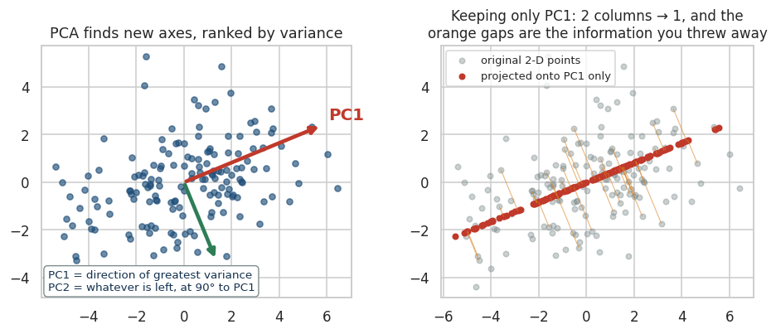
Figure 2.1 — Left: the new axes. Right: what projecting onto PC1 alone costs you.
The orange lines in the right panel are the information PCA discards. PCA chooses its axes precisely to make those lines as short as possible overall — which is the same as saying it preserves as much variance as it can.

The mathematics, briefly
1. Centre (and scale) the data: Z = (X − μ) / σ
2. Compute the covariance matrix: C = (1/(n−1)) · Zᵀ Z
3. Eigendecompose it: C v_i = λ_i v_i

v_i = the i-th principal component (a direction in feature space)
λ_i = the variance captured along that direction

4. Sort by λ descending, keep the top k eigenvectors as W
5. Project: Z_reduced = Z · W (n × k instead of n × p)

Explained variance ratio of component i = λ_i / Σ λ
In practice scikit-learn uses a singular value decomposition rather than forming the covariance matrix, because it is numerically better behaved. The result is the same.

2.3 How many components should you keep?
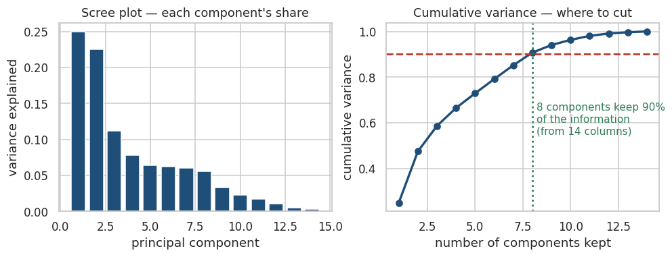
Figure 2.2 — Real output on our 14 bureau columns: 8 components retain 90% of the variance.
Rule | How it works | Comment
Cumulative variance | Keep enough components to reach 90% or 95% | The most common, and the easiest to defend
Scree elbow | Look for the bend in the per-component bar chart | Quick, but often ambiguous
Kaiser criterion | Keep components with eigenvalue > 1 (on scaled data) | Old and known to over-retain; use as a sanity check only
Downstream CV | Treat n_components as a hyperparameter and tune it | The only rule that optimises what you actually care about

2.4 Scaling is mandatory, not advisory
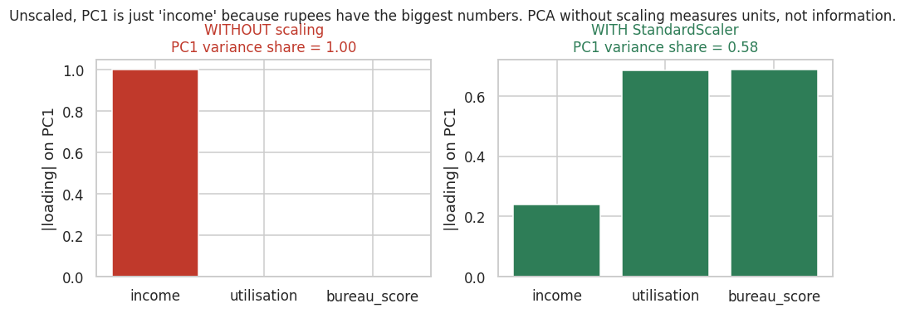
Figure 2.3 — Unscaled, PC1 explains 100% of the variance and is simply “income”.
PCA maximises variance, and variance depends on units. Income measured in rupees has a variance in the billions; a utilisation ratio between 0 and 1 has a variance near 0.02. Without standardisation, PCA will faithfully report that the most important direction in your data is whichever column happens to be measured in the largest numbers.

2.5 Interpreting components
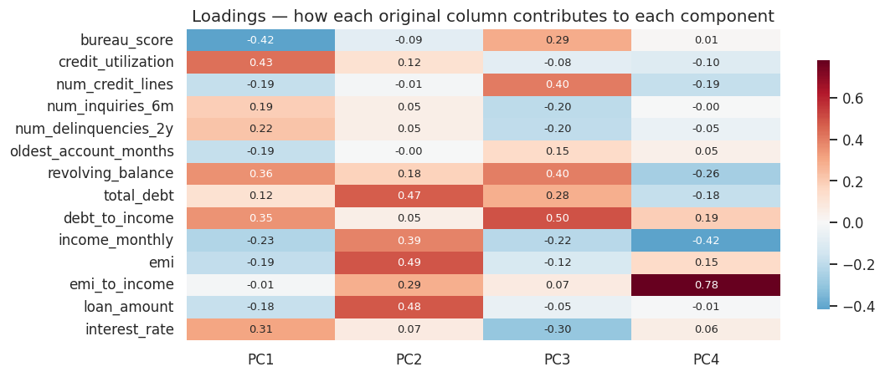
Figure 2.4 — Loadings: how much each original column contributes to each component.
Loadings are how you give a component a name. If PC1 loads positively on credit_utilization, debt_to_income and revolving_balance, and negatively on bureau_score, then PC1 is a leverage-and-distress axis — and you can say so in a meeting.
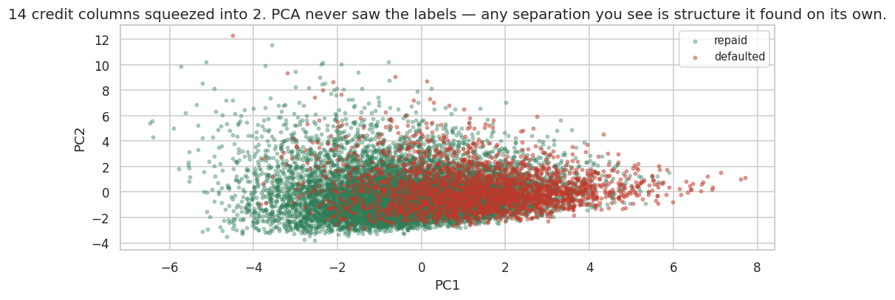
Figure 2.5 — 14 columns projected to 2. PCA never saw the default labels.
COMMON MISTAKE
Assuming PCA improves accuracy. It usually costs a little, because low-variance directions can still carry signal — variance is not the same as predictive value. PCA buys you speed, decorrelation, fewer columns and a picture. Measure whether that trade is worth it rather than assuming.

2.6 When to use it, and when not to
Use PCA when |  | Avoid PCA when
You have many correlated numeric features |  | You must explain individual feature effects to a regulator
You need a 2-D picture of high-dimensional data |  | Your features are mostly categorical (one-hot output is a poor fit)
Training time or memory is a real constraint |  | You only have a handful of features already
A downstream model is unstable from collinearity |  | Tree-based models — they are largely immune to collinearity anyway
INDUSTRY INSIGHT
This is the decisive constraint in lending. “Your application was declined because principal component 3 was too high” is not a legally valid adverse-action reason in most jurisdictions. Credit teams therefore often run PCA for exploration and monitoring, but ship a model built on named, interpretable features.

PRACTICAL 2 — Compressing the bureau block

Objective
Apply PCA properly, interpret the components, and then measure honestly whether it helped.

Tasks
- Select the 14 bureau/loan numeric columns and drop rows with missing values.
- Plot a correlation heatmap — confirm there is redundancy worth compressing.
- Standardise the features.
- Fit PCA with all components and print the variance ratio and cumulative variance for each.
- Find how many components reach 90%.
- Draw the scree and cumulative-variance plots.
- Inspect the loadings and write a one-line name for PC1 and PC2.
- Project to 2 components and scatter, coloured by default.
- Compare 5-fold CV ROC-AUC for logistic regression on all 14 features versus on the PCA components.
THINK BEFORE YOU RUN
- How many components do you predict will be needed for 90%? Write the number down before running.
- Will the PCA model beat the full-feature model on AUC? Commit to yes or no.
- Looking at the loadings, what single human concept do you think PC1 measures?
INDUSTRY CHALLENGE
Run PCA once without the StandardScaler step. Report what PC1's explained variance ratio becomes and which column dominates the loadings. Then explain to the room why this is not a bug.
CHECKPOINT
Expected learning: PCA is a lossy compression you apply deliberately, with scaling, and whose benefit you verify against a baseline rather than assume.

MODULE 3 — HYPERPARAMETER TUNING
The difference between a model that works and one that wins is usually a search, not an algorithm.

3.1 Parameters versus hyperparameters
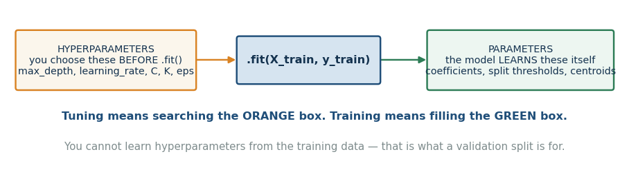
Figure 3.1 — The test: was it discovered by .fit(), or did you type it inside the brackets?
 |  | Parameters | Hyperparameters
Who sets them |  | The learning algorithm | You, before training starts
Examples |  | Regression coefficients, split thresholds, leaf values, centroid positions | learning_rate, max_depth, n_estimators, C, K, eps, n_components
Learned from |  | The training data | Validation performance — never the training data
How many |  | Thousands or millions | Typically 3 to 10 that matter
KEY IDEA
You cannot pick hyperparameters by training-set score, because more flexible settings always fit the training data better. That is the entire reason cross-validation exists.

3.2 Manual tuning, and why it runs out
Everyone starts by changing one number, re-running, and keeping it if the score improves. This works for about two hyperparameters, and then it fails for three reasons: the hyperparameters interact (the best learning_rate depends on max_iter), you unconsciously start fitting the validation set through repeated peeking, and you cannot hold twenty results in your head honestly.
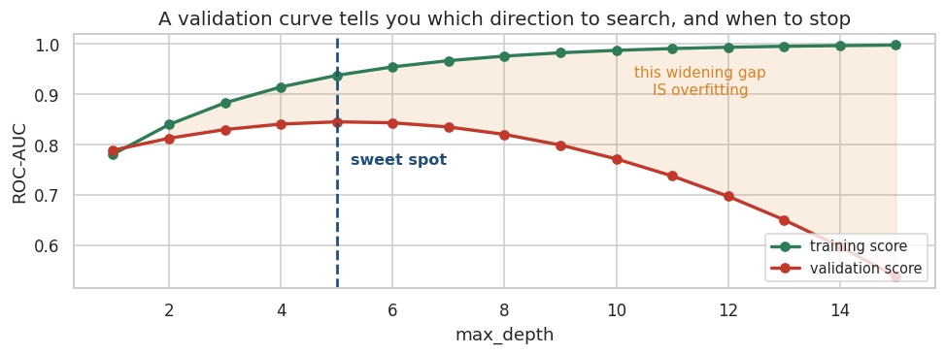
Figure 3.2 — A validation curve for one hyperparameter. Useful for direction; hopeless for combinations.

3.3 Cross-validation inside the search
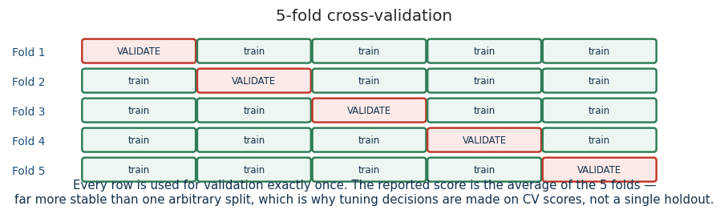
Figure 3.3 — Each candidate is scored on 5 folds and averaged, not on one arbitrary split.
A single train/validation split is itself a random draw. Choosing between two candidates that differ by 0.003 AUC on one split is noise-chasing. K-fold averaging over 3 or 5 folds is what makes the comparison meaningful — and it is why a search costs k times more compute than a single fit.
COMMON MISTAKE
Using KFold on imbalanced data. With a 20% default rate and 3 folds you can get a fold with a noticeably different class balance. Use StratifiedKFold for classification, always.

3.4 GridSearchCV — exhaustive
from sklearn.model_selection import GridSearchCV

grid = {"model__learning_rate": [0.03, 0.1],
"model__max_leaf_nodes": [15, 31],
"model__min_samples_leaf": [20, 60]}

gs = GridSearchCV(pipe, grid, cv=3, scoring="roc_auc", n_jobs=-1)
gs.fit(X_train, y_train)
gs.best_params_, gs.best_score_

# Cost: 2 × 2 × 2 = 8 combinations × 3 folds = 24 model fits.
# Add one more hyperparameter with 4 values and it becomes 96.
Grid search is exhaustive, reproducible and easy to explain. Its weakness is combinatorial: the cost is the product of the list lengths, so it grows explosively, and every value you test must be one you thought of in advance.

3.5 RandomizedSearchCV — and why random usually wins
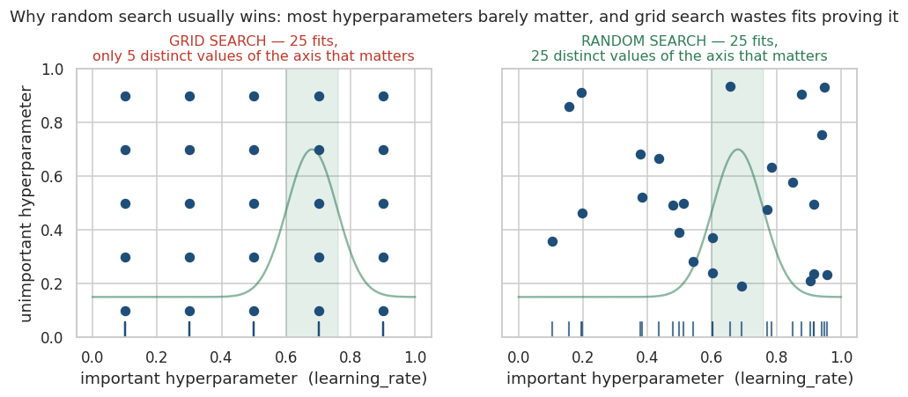
Figure 3.4 — With 25 fits, grid tests 5 values of the axis that matters; random tests 25.
The insight, from Bergstra and Bengio, is that hyperparameters are not equally important. Usually one or two dominate and the rest barely matter. A grid spends its budget testing every combination of the unimportant ones, so it only ever explores a handful of distinct values along the axis that actually counts. Random sampling gives you a distinct value on every axis for every trial.
from sklearn.model_selection import RandomizedSearchCV
from scipy.stats import loguniform, randint

space = {"model__learning_rate": loguniform(0.005, 0.3), # continuous, log-spaced
"model__max_leaf_nodes": randint(8, 64),
"model__min_samples_leaf": randint(10, 150),
"model__l2_regularization": loguniform(1e-3, 10),
"model__max_iter": randint(100, 500)}

rs = RandomizedSearchCV(pipe, space, n_iter=25, cv=3,
scoring="roc_auc", random_state=42, n_jobs=-1)
rs.fit(X_train, y_train)

# You control the cost directly: n_iter × cv fits. Always.
KEY IDEA
Use loguniform for anything that spans orders of magnitude — learning rates, regularisation strengths, C. Sampling uniformly between 0.005 and 0.3 puts 98% of your draws above 0.05, so you would barely test the small-learning-rate region at all.

3.6 Bayesian optimisation with Optuna
Grid and random search are memoryless: trial 40 knows nothing about trials 1 to 39. Bayesian optimisation builds a model of the relationship between hyperparameters and score as it goes, and uses it to decide where to sample next — balancing exploitation of promising regions against exploration of unknown ones. Optuna's default sampler is TPE, which models the distribution of good trials against bad ones and samples where that ratio is favourable.
!pip install optuna -q
import optuna

def objective(trial):
model = HistGradientBoostingClassifier(
learning_rate = trial.suggest_float("learning_rate", 0.005, 0.3, log=True),
max_leaf_nodes = trial.suggest_int("max_leaf_nodes", 8, 64),
min_samples_leaf = trial.suggest_int("min_samples_leaf", 10, 150),
l2_regularization = trial.suggest_float("l2_regularization", 1e-3, 10, log=True),
max_iter = trial.suggest_int("max_iter", 100, 500),
random_state=42)
pipe = Pipeline([("pre", preprocessor), ("model", model)])
return cross_val_score(pipe, X_train, y_train, cv=3,
scoring="roc_auc", n_jobs=-1).mean()

study = optuna.create_study(direction="maximize",
sampler=optuna.samplers.TPESampler(seed=42))
study.optimize(objective, n_trials=25)

study.best_params, study.best_value
optuna.importance.get_param_importances(study) # which knobs actually mattered
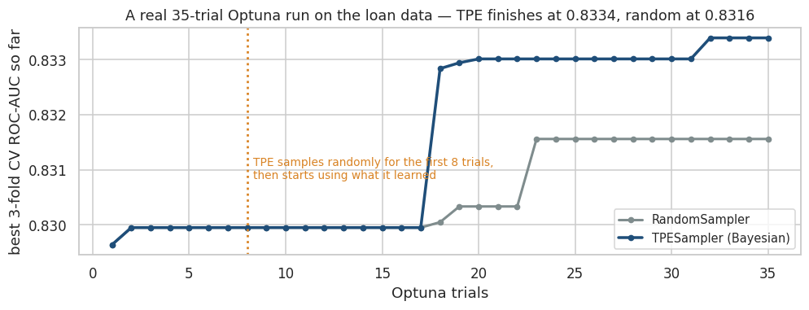
Figure 3.5 — A real 35-trial run on this dataset. TPE finished at 0.8334, random at 0.8316.
INDUSTRY INSIGHT
The margin in that figure is small, and that is typical and worth saying out loud. Bayesian optimisation pays off when each trial is expensive — minutes or hours per fit — because it needs fewer of them. For a model that fits in two seconds, random search with more trials is often the better use of your afternoon. Optuna's real advantages here are conditional search spaces, pruning of hopeless trials, and the parameter-importance report.

3.7 Defining a sensible search space
Hyperparameter |  | Sensible range | Scale
learning_rate |  | 0.005 – 0.3 | log
n_estimators / max_iter |  | 100 – 1000 | linear (or use early stopping)
max_depth |  | 3 – 12 | linear
max_leaf_nodes |  | 8 – 64 | linear
min_samples_leaf |  | 10 – 150 | linear or log
l2_regularization / alpha |  | 1e-3 – 10 | log
C (logistic, SVM) |  | 1e-3 – 100 | log
subsample / colsample |  | 0.5 – 1.0 | linear
COMMON MISTAKE
- A range so narrow the optimum sits on the boundary. If your best learning_rate is 0.3 and 0.3 was your maximum, widen it and search again.
- Tuning learning_rate and n_estimators independently. They trade off directly — halve the rate and you need roughly twice the iterations.
- Searching twenty hyperparameters. Tune the three or four that matter; leave the rest at their defaults, which are usually sensible.

3.8 Nested cross-validation
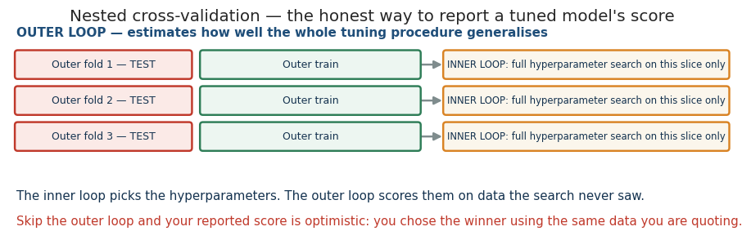
Figure 3.6 — The inner loop chooses; the outer loop scores.
Here is the subtle trap. You run a 25-trial search with 5-fold CV, and the winner scores 0.845. Is 0.845 an unbiased estimate of how the model will perform? No. You selected that candidate because it did well on those folds, so its score is partly a reward for fitting the folds' noise. Nested CV fixes this by wrapping the entire search inside an outer loop and scoring only on outer folds the search never touched.
from sklearn.model_selection import cross_val_score, GridSearchCV, StratifiedKFold

inner = StratifiedKFold(3, shuffle=True, random_state=42)
outer = StratifiedKFold(5, shuffle=True, random_state=42)

search = GridSearchCV(pipe, grid, cv=inner, scoring="roc_auc", n_jobs=-1)
nested_scores = cross_val_score(search, X, y, cv=outer, scoring="roc_auc")

print(nested_scores.mean()) # an honest estimate of the whole PROCEDURE
# Cost: outer × inner × n_candidates fits. This is why it is used sparingly.
KEY IDEA
Nested CV estimates how well your tuning procedure generalises — not any single model. You still refit on all the data at the end to get the model you ship. In practice, most teams substitute a held-out test set that is touched exactly once, which is cheaper and nearly as honest, provided you really do touch it once.

3.9 Compute budget and diminishing returns
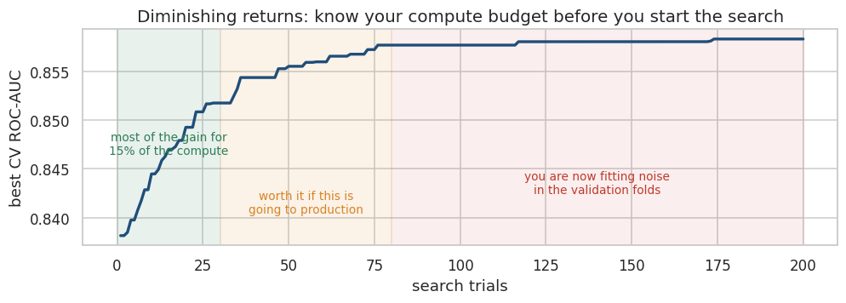
Figure 3.7 — The first 20% of the budget buys most of the gain.
Total fits = n_candidates × k_folds × (1 if flat, outer_k if nested)

# Worked example from this workbook:
# 25 candidates × 3 folds = 75 fits ≈ 3 minutes in Colab on 12,030 rows
# The same search nested in a 5-fold outer loop = 375 fits ≈ 15 minutes
DISCUSS
Your search improved CV AUC from 0.8435 to 0.8533 — about one point. Before you celebrate:
- How much is one AUC point worth in rupees on this lending book? Can you compute it?
- Would three days of tuning beat two days of better feature engineering?
- How much of that one point is real, and how much is fitting the validation folds?

PRACTICAL 3 — Tuning three ways

Objective
Run grid, random and Bayesian search on the same problem with the same budget, and compare what each buys you.

Tasks
- Build a Pipeline with the preprocessing from Module 4 and a HistGradientBoostingClassifier.
- Record the CV ROC-AUC of the untouched defaults — this is the number everything must beat.
- Run GridSearchCV over 8 combinations and time it.
- Run RandomizedSearchCV with n_iter=25 over continuous distributions and time it.
- Run an Optuna study with 25 TPE trials and time it.
- Compare the three best CV scores and the three best parameter sets.
- Score the winning model once on the held-out test set.
- Print Optuna's hyperparameter importances.
THINK BEFORE YOU RUN
- Which of the five hyperparameters do you expect Optuna to rank as most important?
- Will the test AUC be higher or lower than the best CV AUC? Why?
- Grid search tests 8 combinations, random tests 25. Is that a fair comparison? What would make it fair?
OBSERVE
- The gap between the defaults and the tuned score. On this dataset it is about one AUC point.
- That the best learning_rate found is far below the 0.1 default — the default was badly wrong here.
- The wall-clock time of each method. Compute is a real constraint, not a footnote.
CHECKPOINT
Expected learning: you can size a search before running it, choose distributions rather than lists, and explain why the CV score always flatters the model slightly.

MODULE 4 — PIPELINES & COLUMNTRANSFORMER
The single most important engineering habit in applied machine learning.

4.1 Pipeline anatomy
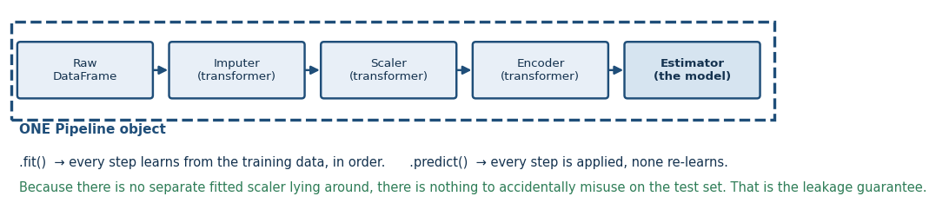
Figure 4.1 — Any number of transformers, then exactly one estimator, as one object.
from sklearn.pipeline import Pipeline

pipe = Pipeline([
("imputer", SimpleImputer(strategy="median")), # transformer: fit + transform
("scaler", StandardScaler()), # transformer: fit + transform
("model", LogisticRegression()), # estimator: fit + predict
])

pipe.fit(X_train, y_train) # each step .fit_transform()s, the last .fit()s
pipe.predict(X_test) # each step .transform()s, the last .predict()s
Every step except the last must implement fit and transform. The last must implement fit and predict. That is the entire contract, and it is why any scikit-learn object drops in.

4.2 Why this prevents leakage
Data leakage is when information from outside the training fold reaches the model. The classic version is fitting a scaler, imputer or feature selector on the whole dataset before splitting: the training process has then absorbed the test set's mean, spread and most common categories.
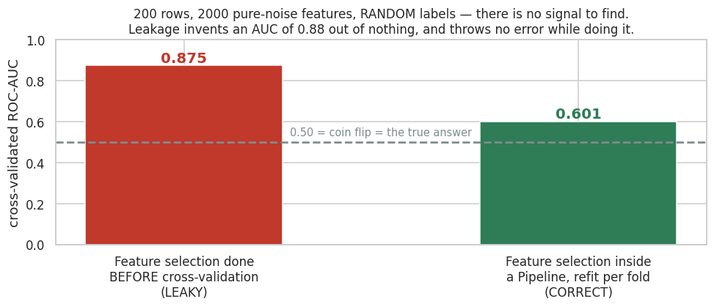
Figure 4.2 — A real experiment, not a warning. There is no signal in this data at all.
Read that figure carefully. Two hundred rows, two thousand pure-noise features, and random labels. There is nothing to learn. Selecting the twenty “best” features using all the labels and then cross-validating produces an ROC-AUC of 0.875 — a completely fabricated result. Putting the identical selection step inside a Pipeline, so it refits on each training fold, gives 0.601. Neither version raises an error.
COMMON MISTAKE
Note that scaling leakage is usually mild — on our 12,030-row dataset, fitting the scaler on everything changes CV AUC by 0.0001. The dangerous leaks are feature selection, resampling (SMOTE), target encoding, and any feature that could not exist at prediction time. A Pipeline protects you from all of them at once, which is why you use it even when you think the risk is small.

4.3 ColumnTransformer for mixed data
A StandardScaler cannot process the string “Gig-Worker”, and a OneHotEncoder should not touch income_monthly. Real tables are mixed, so preprocessing has to branch.
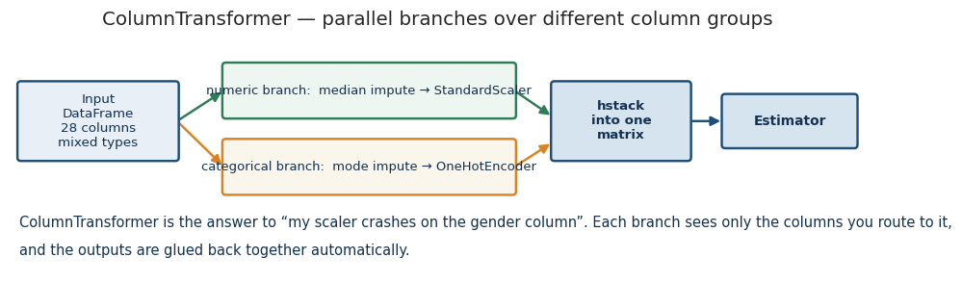
Figure 4.3 — Parallel branches over different column groups, glued back together.
from sklearn.compose import ColumnTransformer

numeric_features = X.select_dtypes(include=np.number).columns.tolist()
categorical_features = [c for c in X.columns if c not in numeric_features]

numeric_pipe = Pipeline([("imputer", SimpleImputer(strategy="median")),
("scaler", StandardScaler())])

categorical_pipe = Pipeline([("imputer", SimpleImputer(strategy="most_frequent")),
("onehot", OneHotEncoder(handle_unknown="ignore"))])

preprocessor = ColumnTransformer([
("num", numeric_pipe, numeric_features),
("cat", categorical_pipe, categorical_features),
]) # remainder="drop" by default; use "passthrough" to keep the rest
KEY IDEA
handle_unknown="ignore" is not optional in production. The day a new payment method appears in live traffic, an encoder without it raises an exception and your scoring service returns a 500 instead of a decision.

4.4 Custom transformers

The quick way: FunctionTransformer
When your transformation is stateless — it needs to learn nothing from the data — wrap a plain function.
from sklearn.preprocessing import FunctionTransformer

def add_ratios(d):
d = d.copy()
d["debt_service_ratio"] = d["emi"] / d["income_monthly"].clip(lower=1)
d["loan_to_income"] = d["loan_amount"] / (d["income_monthly"].clip(lower=1) * 12)
return d

ratio_maker = FunctionTransformer(add_ratios)

The proper way: BaseEstimator + TransformerMixin
When the transformation must learn something in fit — a median, a quantile, a category list — you need a real class. Learning it in fit is exactly what keeps it leak-free, because inside a Pipeline fit only ever sees the training fold.
from sklearn.base import BaseEstimator, TransformerMixin

class OutlierCapper(BaseEstimator, TransformerMixin):
"""Cap numeric columns at percentiles learned FROM THE TRAINING FOLD ONLY."""

def __init__(self, lower=0.01, upper=0.99):
self.lower = lower # store args unchanged — get_params depends on it
self.upper = upper

def fit(self, X, y=None):
Xn = pd.DataFrame(X).select_dtypes(include=np.number)
self.columns_ = Xn.columns # trailing underscore = learned in fit
self.lo_ = Xn.quantile(self.lower)
self.hi_ = Xn.quantile(self.upper)
return self # fit MUST return self

def transform(self, X):
X = pd.DataFrame(X).copy()
for c in self.columns_:
X[c] = X[c].clip(self.lo_[c], self.hi_[c])
return X
Rule |  | Why
__init__ stores arguments unchanged, with no validation |  | get_params/set_params rely on it, and so does cloning during a grid search
Anything learned gets a trailing underscore |  | The scikit-learn convention, and check_is_fitted looks for it
fit returns self |  | Otherwise chaining and Pipeline both break
Validation belongs in fit, not __init__ |  | The estimator must be constructible without data

4.5 Tuning the whole pipeline
Because a Pipeline is a single estimator, a search can tune preprocessing choices and model choices together. The syntax is double underscores, nesting from outside in.
grid = {
"pre__num__imputer__strategy": ["median", "mean"], # step > branch > step > arg
"pre__num__cap__upper": [0.99, 0.995],
"model__learning_rate": [0.05, 0.12],
}
GridSearchCV(full_pipeline, grid, cv=3, scoring="roc_auc").fit(X_train, y_train)

# You can even swap entire components:
# {"model": [LogisticRegression(), RandomForestClassifier()]}
INDUSTRY INSIGHT
This matters more than it looks. Whether median or mean imputation is better is an empirical question about your data, and most teams answer it by habit. Putting it in the search space answers it with evidence, for free, alongside the model tuning you were doing anyway.

4.6 Serialise the pipeline, never just the model
import joblib

joblib.dump(search.best_estimator_, "credit_pipeline.joblib") # the WHOLE thing
reloaded = joblib.load("credit_pipeline.joblib")

reloaded.predict_proba(raw_applicant_dataframe) # accepts RAW, unprocessed input
The reloaded object carries the imputation values, the scaler statistics, the encoder's category list and the fitted model together. Save only the estimator and you must reimplement every preprocessing step by hand in the serving code — and the day those two implementations disagree is the day you get training/serving skew, which is silent, and which is the most common way a good model fails in production.

PRACTICAL 4 — Build it properly

Objective
Construct a full pipeline including a custom learned transformer, tune it end to end, and prove leakage to yourself with an experiment.

Tasks
- Write add_ratios as a FunctionTransformer creating three ratio features.
- Implement the OutlierCapper class with BaseEstimator and TransformerMixin.
- Assemble a ColumnTransformer with a numeric branch (cap → impute → scale) and a categorical branch (impute → one-hot).
- Chain feature engineering, preprocessing and a model into one Pipeline and fit it.
- Tune the pipeline with GridSearchCV over both preprocessing and model hyperparameters.
- Run the leakage experiment: 200 rows, 2,000 noise features, random labels, selection before versus inside CV.
- Serialise the best pipeline with joblib, reload it, and score a raw unprocessed row.
THINK BEFORE YOU RUN
- Before running the leakage experiment: what AUC should an honest method report on random labels?
- Why must OutlierCapper learn its percentiles in fit rather than in __init__?
- Which will the grid prefer — median or mean imputation? Does income_monthly's skew give you a clue?
INDUSTRY CHALLENGE
Deliberately break it: fit a StandardScaler on the full dataset, transform everything, then cross-validate. Compare against the pipeline version. On this dataset the difference is roughly 0.0001 AUC. Explain to the room why you should still never do it.
CHECKPOINT
Expected learning: you can write a leak-free custom transformer, tune preprocessing as a hyperparameter, and articulate why the serialised Pipeline — not the model — is the artefact you hand to engineering.

MODULE 5 — PERSISTENCE, SERVING & MLOps
A model in a notebook has produced exactly zero business value.

5.1 MLOps is a loop
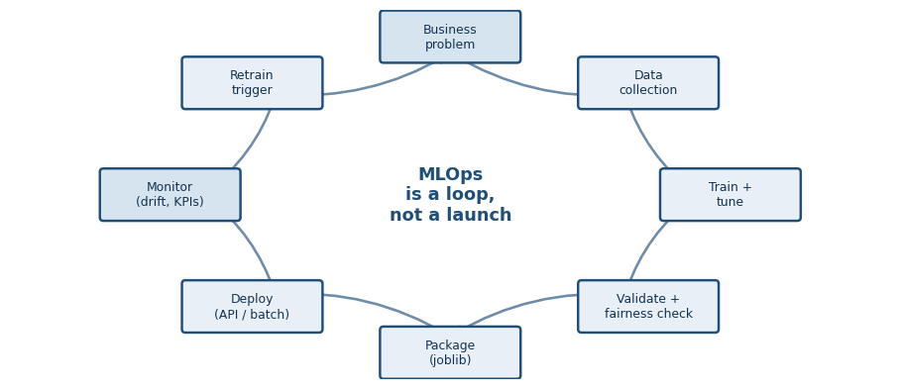
Figure 5.1 — Deployment is the middle of the process, not the end of it.
Traditional software is deployed and then behaves the same way until someone changes the code. A model is different: the code is frozen but the world moves, so performance decays on its own. That single fact is why MLOps exists as a discipline.

5.2 Persistence
import joblib

joblib.dump(pipeline, "credit_model_v1.joblib") # joblib > pickle for numpy arrays
pipeline = joblib.load("credit_model_v1.joblib")
Format |  | Use it for | Watch out for
joblib |  | scikit-learn objects — the default choice | Version-coupled: the same Python and sklearn versions must be present to load
pickle |  | Generic Python objects | Same coupling, and slower on large numpy arrays
ONNX |  | Cross-language serving, and speed | Not every estimator or custom transformer converts
PMML |  | Regulated environments that mandate it | Limited model coverage; verbose
COMMON MISTAKE
A .joblib file is not self-describing. Load it in six months and you cannot tell what it was trained on, what column order it expects, how good it was, or whether it is safe to use. Always write a model card alongside it.

5.3 The model card
model_card = {
"model_name": "credit_default_risk",
"version": "1.0.0",
"created_utc": "2026-08-30T14:19:48+00:00",
"algorithm": "HistGradientBoostingClassifier inside a sklearn Pipeline",
"training_rows": 9624,
"features_expected": [...], # exact names AND order
"target": "default (1 = defaulted within the performance window)",
"test_roc_auc": 0.8560,
"intended_use": "Route applications to auto-approve / review / decline.",
"out_of_scope": "Not for automated rejection without human review.",
"known_limitations": [
"Survivorship bias: outcomes observed only for funded applicants.",
"Region disparate impact ratio is below 0.8 - monitor.",
],
}
The two fields people skip are the two that matter most in an incident review: intended_use and known_limitations. They are what stop a model built to prioritise underwriter attention from quietly becoming an automatic rejection engine six months later.

5.4 Serving patterns
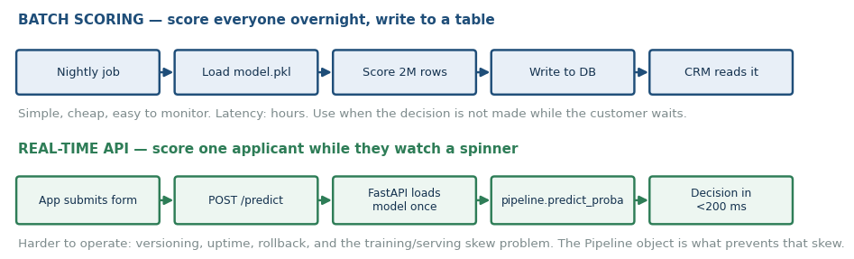
Figure 5.2 — Batch is simpler and covers most business cases. Choose it unless latency forces you otherwise.
class CreditScoringService:
"""Everything a FastAPI endpoint wraps. Load once at startup; score many times."""

def __init__(self, model_path, card_path):
self.pipeline = joblib.load(model_path) # NOT inside predict()
self.card = json.load(open(card_path))
self.expected = self.card["features_expected"]

def predict(self, payload: dict) -> dict:
missing = [c for c in self.expected if c not in payload]
if missing:
raise ValueError(f"Missing required fields: {missing[:5]}")
row = pd.DataFrame([payload])[self.expected] # enforce column ORDER
p = float(self.pipeline.predict_proba(row)[0, 1])
return {"default_probability": round(p, 4),
"risk_band": "HIGH" if p >= 0.5 else "MEDIUM" if p >= 0.2 else "LOW",
"model_version": self.card["version"]}
KEY IDEA
Three things that break real services: loading the model inside the request handler (fatally slow), not enforcing column order (silent wrong answers, because the encoder maps by position), and not validating the payload (an exception where a graceful fallback belonged).

5.5 Monitoring and drift
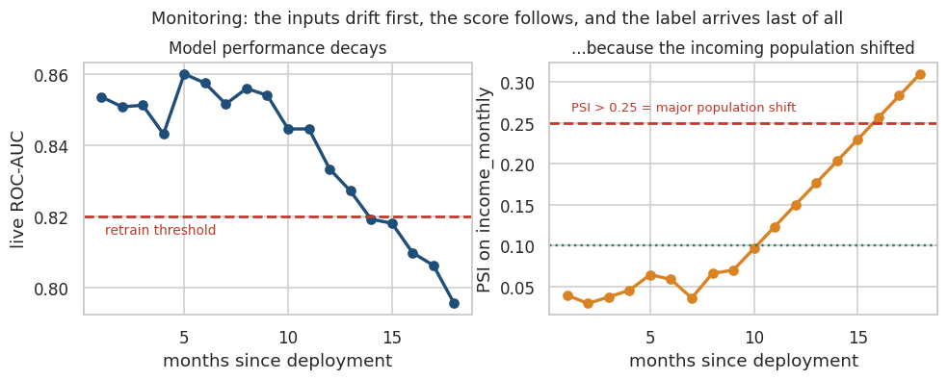
Figure 5.3 — Inputs drift first, scores follow, labels arrive last.
The defining operational fact of credit modelling is the label lag. You find out whether a loan defaults six to twelve months after you approved it. If your only monitoring is AUC, you are flying blind for most of a year. So you monitor the inputs instead.
def psi(expected, actual, buckets=10):
"""Population Stability Index. <0.10 stable | 0.10-0.25 watch | >0.25 investigate."""
expected, actual = pd.Series(expected).dropna(), pd.Series(actual).dropna()
edges = np.unique(np.quantile(expected, np.linspace(0, 1, buckets + 1)))
e = np.clip(np.histogram(expected, bins=edges)[0] / len(expected), 1e-4, None)
a = np.clip(np.histogram(actual, bins=edges)[0] / len(actual), 1e-4, None)
return float(np.sum((a - e) * np.log(a / e)))

# PSI is a symmetrised KL divergence between two binned distributions:
# PSI = Σ (actual_% − expected_%) · ln(actual_% / expected_%)
What drifts |  | Name | How you detect it | Typical cause
The input distribution |  | Data / covariate drift | PSI, KS test per feature | A marketing campaign into a new segment
The relationship X → y |  | Concept drift | Live AUC once labels mature | A recession; a change in collections policy
The output distribution |  | Score drift | Mean and percentiles of predicted probability | Either of the above
The schema |  | Pipeline breakage | Payload validation, null-rate alerts | An upstream team renames a field
INDUSTRY INSIGHT
In the practical you will simulate a marketing push into a lower-income segment. PSI on income_monthly jumps to 0.388 — far past the 0.25 investigate line — while every other feature stays stable, and mean predicted risk rises from 0.198 to 0.215. No label has arrived yet. That is the alert you want, months before the losses appear.

5.6 Retraining
Trigger |  | When to use it
Scheduled (monthly, quarterly) |  | The default. Predictable, easy to automate and audit
Performance-based |  | Retrain when live AUC drops below a floor. Needs mature labels
Drift-based |  | Retrain when PSI on a top feature crosses 0.25. Fast, but can fire on harmless shifts
Event-based |  | A policy change, a new product, a market shock
COMMON MISTAKE
Automatically retraining and deploying without a gate. If the new model is worse, or fails the fairness audit, it must not ship. Every retrain needs a champion/challenger comparison on a common holdout before promotion.

PRACTICAL 5 — Package, serve, monitor

Tasks
- Train the tuned pipeline and save it with joblib.
- Write a model card as JSON, including intended use and known limitations.
- Implement a CreditScoringService class that loads both, validates the payload, and returns a decision dict.
- Score a single raw applicant through the service.
- Implement the PSI function.
- Simulate next quarter's traffic by scaling income down, and compute PSI for four features.
- Compare mean predicted risk before and after the shift.
THINK BEFORE YOU RUN
- Which feature will show the highest PSI? Will any others move?
- If mean predicted risk rises 8%, how long until you could confirm it from actual defaults?
- Your service raises an exception on a missing field. Is that the right behaviour for a loan application form?
CHECKPOINT
Expected learning: you can hand an engineer a versioned, documented, self-contained artefact and a monitoring specification — which is the actual deliverable of a data science project.

MODULE 6 — RESPONSIBLE AI, EXPLAINABILITY & ETHICS
This model decides whether a person gets money. That deserves more than an accuracy score.

6.1 Where bias comes from
Source |  | What it means | In our lending data
Historical bias |  | The world that generated the data was already unequal | Median income is 14% lower for women — a real pay gap the model will inherit
Representation bias |  | Some groups are under-sampled | Rural applicants are 15% of the book; the model has thinner evidence about them
Measurement bias |  | A feature means different things for different groups | Thin credit files are more common among younger and rural applicants
Label bias |  | The target itself is a biased record | We only observe defaults for applicants who were APPROVED under the old policy
Deployment bias |  | The model is used for something it was not built for | A triage tool quietly becoming an auto-reject rule
KEY IDEA
Label bias — survivorship — is the deepest problem in credit scoring and it has no purely technical fix. We never see how rejected applicants would have behaved, so the model learns to reproduce the previous policy's blind spots. The only real remedy is to approve a small random sample against the model's advice and observe what happens.

6.2 Fairness is a choice between incompatible definitions
Definition |  | Requires | Metric
Demographic parity |  | Equal selection rates across groups | selection_rate ratio ≥ 0.8 (the four-fifths rule)
Equal opportunity |  | Equal true positive rates across groups | TPR ratio
Equalised odds |  | Equal TPR and equal FPR | Both ratios
Calibration |  | A score of 0.3 means 30% risk in every group | Calibration curve per group
Individual fairness |  | Similar individuals get similar scores | Distance-based consistency
COMMON MISTAKE
It has been mathematically proven that when base rates genuinely differ between groups, you cannot satisfy calibration and equalised odds at the same time. There is no configuration that is fair by every definition. Choosing which definition to enforce is a policy and legal decision, and it must be made by the business with legal counsel — not silently by whoever writes the model code.

6.3 Auditing our model
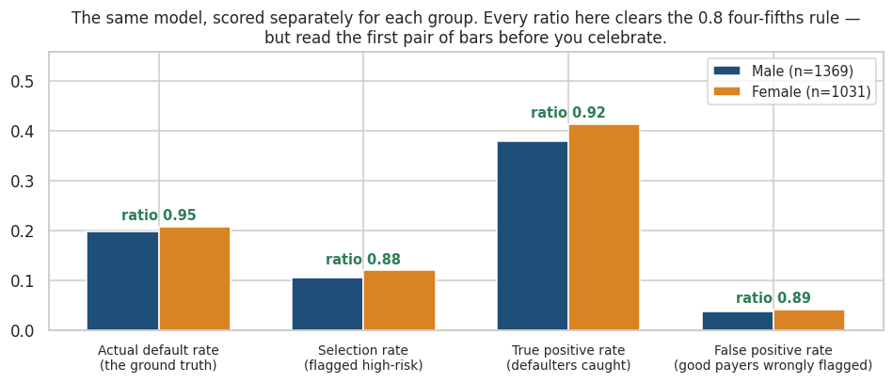
Figure 6.1 — Measured on the tuned model's test-set predictions.
The real numbers. By gender, every ratio clears the four-fifths threshold: selection rate 0.88, TPR 0.92, FPR 0.89. But look at the first pair of bars — the actual default rate differs between the groups in the data itself (19.8% versus 20.9%). The model is largely reflecting a disparity that already exists, which is precisely the situation where the different fairness definitions start to disagree.
INDUSTRY INSIGHT
By region the picture is worse: the disparate impact ratio is 0.685, which fails the four-fifths rule. That finding is the one that should stop a deployment meeting. Rural applicants are selected for high-risk treatment at nearly 1.5 times the Metro rate, and region is a plausible proxy for characteristics a lender may not be permitted to price on.

6.4 Removing the protected attribute does not work
The intuitive fix is to drop gender from the feature set. In the practical you will do exactly that and then re-audit — and the disparity barely moves. Income, employment type and education are all correlated with gender, so the model reconstructs the same signal from proxies. All you have achieved is to make the bias harder to measure.
KEY IDEA
Keep protected attributes in your data for auditing, even when you exclude them from training. You cannot measure a disparity across a column you deleted.

6.5 Explainability: two different questions
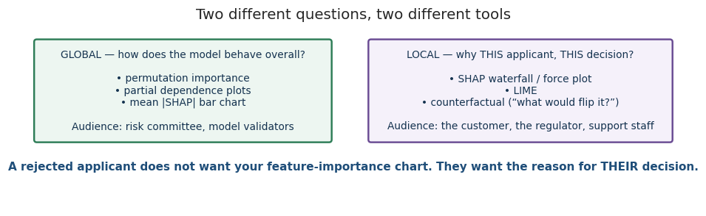
Figure 6.2 — A rejected applicant does not want your feature-importance chart.

Global — permutation importance
from sklearn.inspection import permutation_importance

perm = permutation_importance(pipeline, X_test, y_test, n_repeats=5,
random_state=42, scoring="roc_auc", n_jobs=-1)

# Shuffle one column, measure how much ROC-AUC falls. A big drop = the model
# relied on it. Model-agnostic, and it uses the metric YOU care about.
# Caveat: with two correlated columns, shuffling one leaves the other intact,
# so both can look unimportant.

Local — SHAP
SHAP assigns each feature a contribution to one specific prediction, using a result from cooperative game theory: the Shapley value is the unique attribution satisfying efficiency, symmetry, dummy and additivity.
φ_i = Σ_{S ⊆ F \ {i}} [ |S|! (|F| − |S| − 1)! / |F|! ] · [ f(S ∪ {i}) − f(S) ]

# In words: the average marginal contribution of feature i, over every possible
# order in which the features could be added. TreeSHAP computes this exactly for
# tree models in polynomial rather than exponential time.

# Efficiency guarantee: f(x) = base_value + Σ_i φ_i
# The contributions add up exactly to the prediction. That is what makes them
# defensible as an explanation.
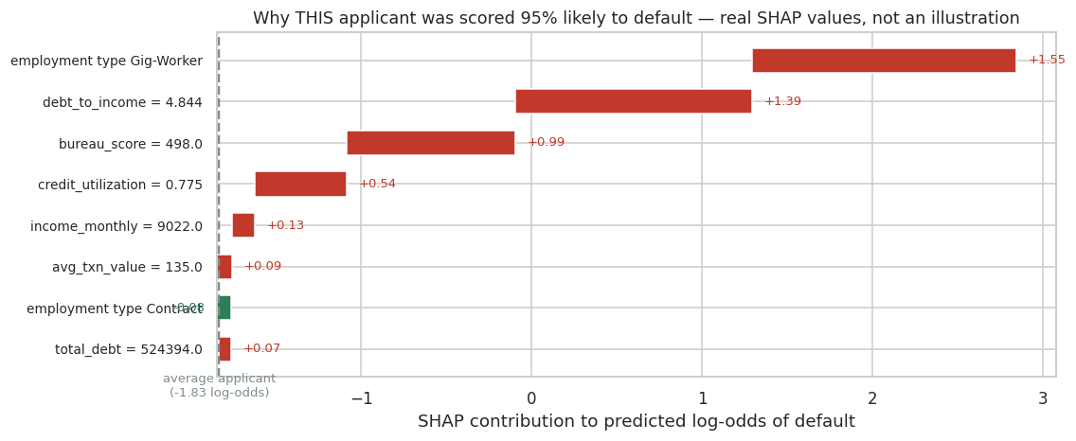
Figure 6.3 — Real SHAP output for the riskiest applicant in the test set.
That applicant was scored 95% likely to default. The reasons, in order: gig-worker employment (+1.55 log-odds), a debt-to-income ratio of 4.84 (+1.39), a bureau score of 498 (+0.99), and 77.5% credit utilisation (+0.54). Those four sentences are an adverse-action notice.

6.6 From SHAP to a legal obligation
Most jurisdictions with consumer-credit regulation require that a declined applicant be told the principal reasons. A feature-importance chart cannot satisfy this, because it describes the model in general rather than the decision in particular. Per-prediction attributions can.
INDUSTRY INSIGHT
This is a large part of why gradient boosting plus SHAP has displaced deep learning in credit risk. The regulatory requirement is not “be accurate” — it is “be accurate and be able to explain each individual decision”, and that constraint eliminates most of the fanciest options.
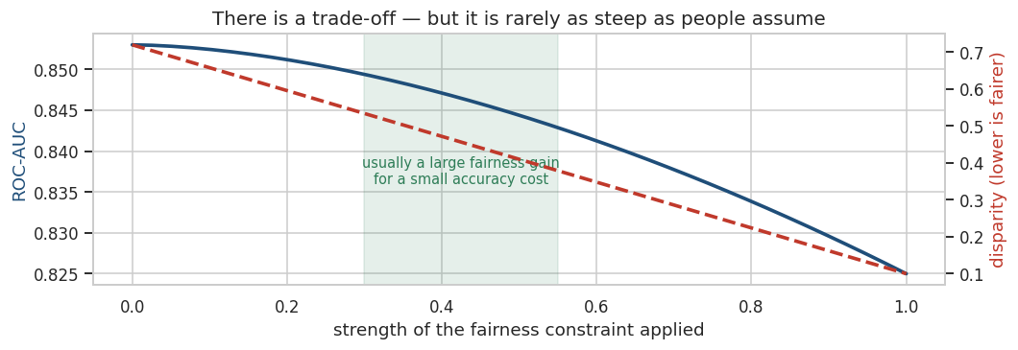
Figure 6.4 — The trade-off is real, but usually far shallower than people assume.

6.7 The questions to ask before deploying
CHECKPOINT
- Who is harmed if this model is wrong, and in which direction is the harm worse?
- Can we explain any individual decision to the person it affects?
- Have we measured performance separately for every group we can identify?
- Are any features proxies for a protected characteristic?
- Is there a human in the loop, and do they have real authority to override?
- How would someone appeal, and would we notice a pattern in the appeals?
- What is the feedback loop? Does declining someone make their future data worse?

PRACTICAL 6 — Audit and explain

Tasks
- Train the tuned pipeline and generate test-set predictions.
- Write a group_report function returning n, base rate, selection rate, TPR, FPR and precision per group.
- Run it for gender and for region, and compute the disparate impact ratio for each.
- Retrain with gender dropped, then re-audit BY gender. Compare.
- Compute permutation importance and plot the top twelve features.
- Use shap.TreeExplainer on the fitted model and draw a summary plot.
- Print the top SHAP factors for the single riskiest applicant.
- Auto-draft an adverse-action notice from the positive contributions.
THINK BEFORE YOU RUN
- Will dropping gender make the gender disparity go away? Commit to an answer before you run it.
- Which will rank higher in permutation importance — bureau_score or employment_type?
- If region fails the four-fifths rule, what are your options? List three, with their costs.
INDUSTRY CHALLENGE
Your model fails the four-fifths rule on region. The head of growth points out that removing region costs 0.6 AUC points, worth roughly ₹40 lakh a year. Legal says the exposure is unclear. You have five minutes in the meeting. What do you recommend, and what do you need in order to decide properly?
CHECKPOINT
Expected learning: you can audit a model across groups, demonstrate why fairness-through-unawareness fails, and produce per-decision explanations that satisfy a regulator rather than a colleague.

MODULE 7 — CAPSTONE: CREDIT RISK DECISION ENGINE

7.1 The brief
INDUSTRY CHALLENGE
You have joined the risk team at a digital lending platform. Applications arrive through an app and a decision is expected in minutes. Today every application goes to a human underwriter, and the team is drowning.
Build a decision engine that routes each application to AUTO-APPROVE, MANUAL REVIEW, or DECLINE.
The economics you have been given:
- A funded loan that repays earns about ₹14,000 over its life
- A funded loan that defaults loses about ₹78,000
- A manual review costs about ₹900 of underwriter time and catches roughly 70% of the bad loans it sees
- Underwriting capacity is 15% of applications — a hard constraint
Note what the objective is not. Nobody asked for accuracy, or for AUC. The deliverable is a policy that maximises expected profit subject to a capacity constraint, plus the evidence that it is safe to deploy.

7.2 How the roles split
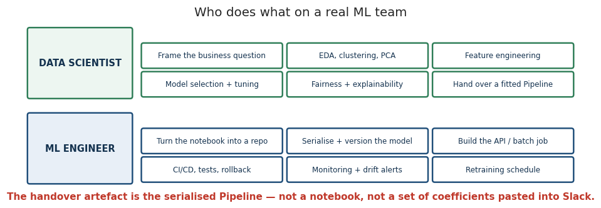
Figure 7.1 — The handover artefact is the serialised Pipeline.
On a real team this project has two owners. The data scientist frames the problem, explores, engineers features, selects and tunes the model, and runs the fairness and explainability work. The ML engineer takes the fitted Pipeline and makes it a service: versioned, tested, monitored, and rollback-able. The clean interface between them is a single serialised object plus a model card — not a notebook.

7.3 The workflow
Cells | Stage | What it produces
1–2 | Setup and business framing | The profit numbers that define success
3–5 | Load, quality audit, EDA | Understanding, and the has_prior_delinq flag
6 | Unsupervised segmentation | Portfolio profile plus a DBSCAN outlier queue
7–9 | Feature engineering, split, ColumnTransformer | A leak-proof preprocessing object
10–11 | Baselines, then tuning | Evidence that tuning was worth the compute
12 | Honest evaluation | ROC-AUC, PR-AUC, confusion matrix on untouched data
13–14 | Explainability | Global importances and per-applicant SHAP reasons
15 | Fairness audit | Group metrics and disparate impact ratios
16–17 | Decision policy | Thresholds chosen by expected profit, not convention
18–19 | Packaging and serving | joblib artefact, model card, scoring service
20–21 | Monitoring and recommendation | PSI report, retraining triggers, committee memo

7.4 The step most people skip
Converting probabilities into decisions is where most of the value is created, and it is almost always the least-practised skill in the room. A threshold of 0.5 is a convention, not an answer. The right threshold falls out of the cost matrix.
Expected value of a policy, per application:

E[profit] = P(approve & good) · PROFIT_GOOD
+ P(approve & bad) · LOSS_BAD
+ P(review) · (COST_REVIEW + residual risk after the underwriter)
+ P(decline) · 0

subject to: P(review) ≤ REVIEW_CAPACITY
INDUSTRY INSIGHT
The capstone sweeps a grid of (review_at, decline_at) threshold pairs, discards every combination that breaches the 15% capacity limit, and picks the survivor with the highest expected profit. This is the calculation that turns a data science output into a business decision, and it takes about fifteen lines of code.

7.5 What the run actually produced
Result |  | Value
Baseline CV ROC-AUC (untuned gradient boosting) |  | 0.8435
After 25 randomised search trials |  | 0.8533
Test ROC-AUC of the final pipeline |  | 0.856
Chosen policy |  | auto-approve below 0.20, review to 0.35, decline above
Applications sent to manual review |  | 12.3% — inside the 15% capacity limit
Expected profit, tuned three-way policy |  | +₹5,528,250 per 1,000 applications
Expected profit, approve everyone |  | −₹4,630,000 per 1,000 applications
Fairness — gender |  | Disparate impact ratio 0.88 — passes
Fairness — region |  | Disparate impact ratio 0.685 — FAILS, blocks deployment
READ THESE THREE THINGS
- The profit swing is roughly ₹10 million per 1,000 applications against the do-nothing policy. That is the number to put on the first slide — not the AUC.
- One AUC point of tuning gain is worth real money here, but it is worth far less than getting the thresholds right.
- The region fairness failure is a genuine blocker. A capstone that ends 'ship it' has missed the point of Module 6.

7.6 Questions you must be able to answer
CHECKPOINT
- 1. Why is expected profit the objective rather than accuracy or AUC?
- 2. What would change if manual review capacity doubled to 30%?
- 3. Which single feature would you most like to add, and why?
- 4. How would you explain a DECLINE to the applicant?
- 5. Region fails the four-fifths rule. What are your options and what does each cost?
- 6. Survivorship bias means the labels are conditioned on the old policy. How would you begin to fix that?
- 7. What would you monitor in week one, and what would trigger a rollback?
- 8. The model is 0.856 AUC. What is the ceiling on this data, and how would you find out?

WRAP-UP

The six ideas worth keeping
Topic | The one sentence
Hierarchical & DBSCAN | Hierarchical always returns the K you asked for; DBSCAN can tell you the clusters are not there, and its outlier label is often the real product
PCA | A lossy compression that trades interpretability for speed and decorrelation — scale first, and measure whether it helped
Hyperparameter tuning | Search continuous distributions, not lists; budget the fits before you start; the CV winner's score always flatters it
Pipelines | The only reliable defence against leakage, and the artefact you hand to engineering
MLOps | Inputs drift first, scores second, labels last — monitor in that order
Responsible AI | Dropping the protected column hides the bias instead of removing it; per-decision explanations are a legal requirement, not a nicety

The five mistakes most likely to bite you
- Fitting any transformer outside the pipeline, especially feature selection or resampling.
- Reporting the best cross-validation score as if it were an unbiased estimate of future performance.
- Shipping a 0.5 threshold when the cost of a false negative is 80 times the cost of a false positive.
- Saving the estimator instead of the pipeline, and reimplementing preprocessing in the serving code.
- Auditing fairness after the deployment decision has already been made.

PRACTICAL SOLUTIONS
Each block is self-contained apart from needing loan_applications.csv uploaded, and the two pip installs at the top of the workbook.
KEY IDEA
Every block below was executed against the supplied CSV before this workbook was produced, and the numbers quoted in the interpretation comments are the numbers the code actually printed. If yours differ, check that random_state=42 survived your edits.

SOLUTION 1 — Hierarchical clustering & DBSCAN
import numpy as np
import pandas as pd
import matplotlib.pyplot as plt
from scipy.cluster.hierarchy import dendrogram, linkage, fcluster
from sklearn.preprocessing import StandardScaler
from sklearn.cluster import AgglomerativeClustering, DBSCAN, KMeans
from sklearn.metrics import silhouette_score
from sklearn.neighbors import NearestNeighbors

df = pd.read_csv("loan_applications.csv").drop_duplicates().reset_index(drop=True)

feats = ["income_monthly", "bureau_score", "credit_utilization",
"emi_to_income", "num_delinquencies_2y"]
sample = df[feats].dropna().sample(600, random_state=42)
X = StandardScaler().fit_transform(sample) # distance-based -> scaling is mandatory

# ---------- 1. Dendrogram to choose the number of clusters
Z = linkage(X, method="ward")
plt.figure(figsize=(13, 4))
dendrogram(Z, truncate_mode="lastp", p=30, color_threshold=28)
plt.axhline(28, color="red", ls="--", lw=2)
plt.title("Ward dendrogram (last 30 merges) — the tall vertical gap tells you where to cut")
plt.ylabel("merge distance")
plt.tight_layout(); plt.show()

# ---------- 2. Agglomerative at a few K values
print("K silhouette")
for k in [2, 3, 4, 5, 6]:
lab = AgglomerativeClustering(n_clusters=k, linkage="ward").fit_predict(X)
print(f"{k} {silhouette_score(X, lab):.3f}")

agg = AgglomerativeClustering(n_clusters=4, linkage="ward")
sample["hier_cluster"] = agg.fit_predict(X)

# ---------- 3. Choose eps for DBSCAN with a k-distance plot
nn = NearestNeighbors(n_neighbors=10).fit(X)
dist, _ = nn.kneighbors(X)
kdist = np.sort(dist[:, -1])
plt.figure(figsize=(9, 3.5))
plt.plot(kdist, color="#1F4E79", lw=2)
plt.axhline(1.2, color="red", ls="--")
plt.xlabel("points sorted by distance to 9th nearest neighbour")
plt.ylabel("9-NN distance")
plt.title("k-distance plot - set eps at the knee")
plt.tight_layout(); plt.show()

# ---------- 4. DBSCAN
db = DBSCAN(eps=1.2, min_samples=10).fit(X)
sample["dbscan_cluster"] = db.labels_
n_clusters = len(set(db.labels_)) - (1 if -1 in db.labels_ else 0)
n_noise = int((db.labels_ == -1).sum())
print(f"\nDBSCAN found {n_clusters} cluster(s) and flagged {n_noise} points as noise "
f"({n_noise/len(sample):.1%} of borrowers)")
print("Try other settings and watch what happens:")
for e in [0.9, 1.0, 1.1, 1.2, 1.3]:
d2 = DBSCAN(eps=e, min_samples=10).fit(X)
k2 = len(set(d2.labels_)) - (1 if -1 in d2.labels_ else 0)
print(f" eps={e}: {k2} cluster(s), {(d2.labels_ == -1).mean():.1%} noise")

# ---------- 5. Compare all three
km = KMeans(4, n_init=10, random_state=42).fit_predict(X)
fig, axes = plt.subplots(1, 3, figsize=(15, 4))
for ax, lab, name in zip(axes, [km, sample["hier_cluster"], sample["dbscan_cluster"]],
["K-Means (K=4)", "Agglomerative ward (K=4)", "DBSCAN"]):
ax.scatter(sample["bureau_score"], sample["emi_to_income"], c=lab, cmap="Set1", s=18)
ax.set_xlabel("bureau_score"); ax.set_ylabel("emi_to_income"); ax.set_title(name)
plt.tight_layout(); plt.show()

# ---------- 6. Who are the DBSCAN outliers? This is the business payoff.
outliers = sample[sample["dbscan_cluster"] == -1]
print("\n--- Profile: DBSCAN noise points vs everyone else ---")
print(pd.concat([outliers[feats].mean().rename("outliers"),
sample[sample["dbscan_cluster"] != -1][feats].mean().rename("clustered")],
axis=1).round(2))

# ---------- 7. Default rate per cluster
sample["default"] = df.loc[sample.index, "default"]
print("\nDefault rate by hierarchical cluster:")
print(sample.groupby("hier_cluster")["default"].agg(["mean", "count"]).round(3))
print("\nDefault rate among DBSCAN outliers:",
round(df.loc[outliers.index, "default"].mean(), 3))

# INTERPRETATION - read this carefully, it is the most useful result of the module
#
# 1. Silhouette peaks at K=2 (0.186) and every value is LOW. Low silhouette means
# the borrowers do not form well-separated natural groups - they are one
# continuous cloud. Hierarchical clustering still returned 4 clusters, because
# you ASKED for 4. It will always give you what you asked for.
#
# 2. DBSCAN refuses to play along. At every sensible eps it reports ONE cluster
# plus a set of outliers. That is not a failure - it is the correct answer, and
# it is information K-Means structurally cannot give you: "there are no density
# gaps in this population."
#
# 3. So the business value here is the NOISE label, not the clusters. Those ~12%
# of borrowers sit in sparse regions of feature space: unusual combinations the
# scorecard has thin evidence for. They have roughly double the delinquency
# count of the main body. That is a manual-underwriting queue, not an
# automated decision.
#
# 4. The hierarchical clusters ARE still useful for pricing: default rates run
# from 5.8% (cluster 1) to 38.5% (cluster 3). Weak separation does not mean
# zero value - it means do not oversell the segments as "customer types".
WHAT THE OUTPUT SHOWS
Silhouette peaks at just 0.186 (K=2) and falls from there — weak structure. DBSCAN reports one cluster plus ~12% noise at every sensible eps. Hierarchical default rates still range from 5.8% to 38.5% across four clusters, so the segments have commercial value even though they are not cleanly separated.

SOLUTION 2 — PCA on the credit-bureau block
import numpy as np
import pandas as pd
import matplotlib.pyplot as plt
import seaborn as sns
from sklearn.preprocessing import StandardScaler
from sklearn.decomposition import PCA
from sklearn.pipeline import Pipeline
from sklearn.impute import SimpleImputer
from sklearn.model_selection import train_test_split, cross_val_score
from sklearn.linear_model import LogisticRegression

df = pd.read_csv("loan_applications.csv").drop_duplicates().reset_index(drop=True)

bureau = ["bureau_score", "credit_utilization", "num_credit_lines", "num_inquiries_6m",
"num_delinquencies_2y", "oldest_account_months", "revolving_balance",
"total_debt", "debt_to_income", "income_monthly", "emi", "emi_to_income",
"loan_amount", "interest_rate"]

data = df[bureau + ["default"]].dropna()
X, y = data[bureau], data["default"]

# ---------- 1. Correlation: is there anything to compress?
plt.figure(figsize=(10, 8))
sns.heatmap(X.corr(), cmap="RdBu_r", center=0, annot=False)
plt.title("If these columns were independent, PCA would have nothing to do")
plt.tight_layout(); plt.show()

# ---------- 2. Scale, then fit PCA
X_scaled = StandardScaler().fit_transform(X)
pca = PCA().fit(X_scaled)
cum = np.cumsum(pca.explained_variance_ratio_)

for i, (ev, cv) in enumerate(zip(pca.explained_variance_ratio_, cum), 1):
print(f"PC{i:<2} variance {ev:.3f} cumulative {cv:.3f}")

k90 = int(np.argmax(cum >= 0.90)) + 1
print(f"\n{k90} of {len(bureau)} components retain 90% of the variance.")

# ---------- 3. Scree + cumulative
fig, axes = plt.subplots(1, 2, figsize=(13, 4))
axes[0].bar(range(1, len(bureau)+1), pca.explained_variance_ratio_, color="#1F4E79")
axes[0].set_xlabel("component"); axes[0].set_ylabel("variance explained")
axes[0].set_title("Scree plot")
axes[1].plot(range(1, len(bureau)+1), cum, "o-", color="#1F4E79")
axes[1].axhline(0.90, color="red", ls="--")
axes[1].set_xlabel("components kept"); axes[1].set_ylabel("cumulative variance")
axes[1].set_title("Cumulative variance")
plt.tight_layout(); plt.show()

# ---------- 4. What do the components MEAN? Read the loadings.
loadings = pd.DataFrame(pca.components_[:3].T, index=bureau, columns=["PC1","PC2","PC3"])
print("\nTop drivers of PC1:")
print(loadings["PC1"].abs().sort_values(ascending=False).head(5).round(3))
print("\nTop drivers of PC2:")
print(loadings["PC2"].abs().sort_values(ascending=False).head(5).round(3))

# ---------- 5. Visualise in 2D
Z = PCA(n_components=2).fit_transform(X_scaled)
plt.figure(figsize=(8, 5))
plt.scatter(Z[y==0,0], Z[y==0,1], s=6, alpha=.3, c="#2E7D57", label="repaid")
plt.scatter(Z[y==1,0], Z[y==1,1], s=6, alpha=.4, c="#C0392B", label="defaulted")
plt.xlabel("PC1"); plt.ylabel("PC2"); plt.legend()
plt.title("14 columns -> 2. PCA never saw the labels.")
plt.tight_layout(); plt.show()

# ---------- 6. Does PCA help a downstream model? MEASURE IT, do not assume.
Xtr, Xte, ytr, yte = train_test_split(X, y, test_size=.2, random_state=42, stratify=y)
plain = Pipeline([("imp", SimpleImputer(strategy="median")),
("sc", StandardScaler()),
("m", LogisticRegression(max_iter=2000))])
withpca = Pipeline([("imp", SimpleImputer(strategy="median")),
("sc", StandardScaler()),
("pca", PCA(n_components=k90)),
("m", LogisticRegression(max_iter=2000))])
for name, p in [("all 14 features", plain), (f"PCA to {k90} components", withpca)]:
s = cross_val_score(p, Xtr, ytr, cv=5, scoring="roc_auc").mean()
print(f"{name:<28} CV ROC-AUC {s:.4f}")

# INTERPRETATION
# PCA is compression, not magic. It usually costs a little accuracy because it
# discards low-variance directions that may still carry signal. You use it when
# you need speed, fewer columns, decorrelated inputs, or a 2-D picture - NOT as a
# reflex before every model. And note PC1 is unreadable to a credit officer:
# "component 1 was too high" is not a legally usable reason for a rejection.
WHAT THE OUTPUT SHOWS
8 of the 14 components retain 90% of the variance. PC1 is a leverage-and-distress axis. Logistic regression on the PCA components scores slightly below the full-feature model — compression costs a little accuracy, as it should.

SOLUTION 3 — Hyperparameter tuning three ways
import numpy as np
import pandas as pd
import time
from scipy.stats import loguniform, randint
from sklearn.model_selection import (train_test_split, GridSearchCV,
RandomizedSearchCV, StratifiedKFold,
cross_val_score)
from sklearn.pipeline import Pipeline
from sklearn.compose import ColumnTransformer
from sklearn.impute import SimpleImputer
from sklearn.preprocessing import StandardScaler, OneHotEncoder
from sklearn.ensemble import HistGradientBoostingClassifier
from sklearn.metrics import roc_auc_score

df = pd.read_csv("loan_applications.csv").drop_duplicates().reset_index(drop=True)
X = df.drop(columns=["application_id", "default"])
y = df["default"]
num = X.select_dtypes(include=np.number).columns.tolist()
cat = [c for c in X.columns if c not in num]

pre = ColumnTransformer([
("num", Pipeline([("i", SimpleImputer(strategy="median")),
("s", StandardScaler())]), num),
("cat", Pipeline([("i", SimpleImputer(strategy="most_frequent")),
("o", OneHotEncoder(handle_unknown="ignore"))]), cat)])

Xtr, Xte, ytr, yte = train_test_split(X, y, test_size=.2, random_state=42, stratify=y)
cv = StratifiedKFold(3, shuffle=True, random_state=42)
pipe = Pipeline([("pre", pre), ("model", HistGradientBoostingClassifier(random_state=42))])

# ---------- 0. Baseline: untouched defaults
base = cross_val_score(pipe, Xtr, ytr, cv=cv, scoring="roc_auc", n_jobs=-1).mean()
print(f"DEFAULTS CV AUC {base:.4f}")

# ---------- 1. GridSearchCV — exhaustive
grid = {"model__learning_rate": [0.03, 0.1],
"model__max_leaf_nodes": [15, 31],
"model__min_samples_leaf": [20, 60]}
t0 = time.time()
gs = GridSearchCV(pipe, grid, cv=cv, scoring="roc_auc", n_jobs=-1).fit(Xtr, ytr)
print(f"GRID ({len(gs.cv_results_['params'])} fits x3 folds, {time.time()-t0:.0f}s) "
f"CV AUC {gs.best_score_:.4f}")
print(" ", gs.best_params_)

# ---------- 2. RandomizedSearchCV — same budget, continuous ranges
space = {"model__learning_rate": loguniform(0.005, 0.3),
"model__max_leaf_nodes": randint(8, 64),
"model__min_samples_leaf": randint(10, 150),
"model__l2_regularization": loguniform(1e-3, 10),
"model__max_iter": randint(100, 500)}
t0 = time.time()
rs = RandomizedSearchCV(pipe, space, n_iter=25, cv=cv, scoring="roc_auc",
random_state=42, n_jobs=-1).fit(Xtr, ytr)
print(f"RANDOM (25 fits x3 folds, {time.time()-t0:.0f}s) CV AUC {rs.best_score_:.4f}")
print(" ", {k: (round(v, 4) if isinstance(v, float) else v)
for k, v in rs.best_params_.items()})

# ---------- 3. Optuna — Bayesian
# In Colab run this first: !pip install optuna -q
import optuna
optuna.logging.set_verbosity(optuna.logging.WARNING)

def objective(trial):
p = Pipeline([("pre", pre), ("model", HistGradientBoostingClassifier(
learning_rate=trial.suggest_float("learning_rate", 0.005, 0.3, log=True),
max_leaf_nodes=trial.suggest_int("max_leaf_nodes", 8, 64),
min_samples_leaf=trial.suggest_int("min_samples_leaf", 10, 150),
l2_regularization=trial.suggest_float("l2_regularization", 1e-3, 10, log=True),
max_iter=trial.suggest_int("max_iter", 100, 500),
random_state=42))])
return cross_val_score(p, Xtr, ytr, cv=cv, scoring="roc_auc", n_jobs=-1).mean()

t0 = time.time()
study = optuna.create_study(direction="maximize",
sampler=optuna.samplers.TPESampler(seed=42))
study.optimize(objective, n_trials=25, show_progress_bar=False)
print(f"OPTUNA (25 trials, {time.time()-t0:.0f}s) CV AUC {study.best_value:.4f}")
print(" ", {k: (round(v, 4) if isinstance(v, float) else v)
for k, v in study.best_params.items()})

# ---------- 4. Final honest score on the untouched test set
final = Pipeline([("pre", pre),
("model", HistGradientBoostingClassifier(random_state=42,
**study.best_params))]).fit(Xtr, ytr)
print(f"\nTEST AUC of the Optuna model: "
f"{roc_auc_score(yte, final.predict_proba(Xte)[:,1]):.4f}")

# ---------- 5. Optuna tells you which hyperparameters mattered
print("\nHyperparameter importance:")
for k, v in optuna.importance.get_param_importances(study).items():
print(f" {k:<22} {v:.3f}")

# INTERPRETATION
# Grid search burned its budget on 8 rigid combinations. Random and Optuna
# explored continuous ranges and found better models with the same number of fits.
# Note the CV score is ALWAYS a little optimistic relative to the test score -
# you picked the winner using those folds, so they are no longer neutral.
WHAT THE OUTPUT SHOWS
Defaults 0.8435 → grid 0.8489 → random 0.8521 → Optuna 0.8533 CV ROC-AUC, with a test AUC of 0.8533. The best learning_rate found is around 0.013, far below the 0.1 default.

SOLUTION 4 — Pipelines, custom transformers, and leakage
import numpy as np
import pandas as pd
from sklearn.base import BaseEstimator, TransformerMixin
from sklearn.model_selection import train_test_split, cross_val_score, GridSearchCV, StratifiedKFold
from sklearn.pipeline import Pipeline
from sklearn.compose import ColumnTransformer
from sklearn.impute import SimpleImputer
from sklearn.preprocessing import StandardScaler, OneHotEncoder, FunctionTransformer
from sklearn.feature_selection import SelectKBest, f_classif
from sklearn.linear_model import LogisticRegression
from sklearn.ensemble import HistGradientBoostingClassifier
import joblib

df = pd.read_csv("loan_applications.csv").drop_duplicates().reset_index(drop=True)
X = df.drop(columns=["application_id", "default"])
y = df["default"]

# ---------- 1. A custom transformer the EASY way: FunctionTransformer
def add_ratios(d):
d = d.copy()
d["debt_service_ratio"] = d["emi"] / d["income_monthly"].clip(lower=1)
d["balance_per_line"] = d["revolving_balance"] / d["num_credit_lines"].clip(lower=1)
d["credit_age_years"] = d["oldest_account_months"] / 12
return d

ratio_maker = FunctionTransformer(add_ratios)
print(add_ratios(X).filter(like="ratio").head(3))

# ---------- 2. A custom transformer the PROPER way: BaseEstimator + TransformerMixin
# Use this when the transformer must LEARN something in fit() - here, the training
# medians used to cap outliers. Learning it in fit() is what keeps it leak-free.
class OutlierCapper(BaseEstimator, TransformerMixin):
"""Cap numeric columns at the p1/p99 learned FROM THE TRAINING FOLD ONLY."""
def __init__(self, lower=0.01, upper=0.99):
self.lower = lower
self.upper = upper

def fit(self, X, y=None):
Xn = pd.DataFrame(X).select_dtypes(include=np.number)
self.columns_ = Xn.columns
self.lo_ = Xn.quantile(self.lower)
self.hi_ = Xn.quantile(self.upper)
return self

def transform(self, X):
X = pd.DataFrame(X).copy()
for c in self.columns_:
X[c] = X[c].clip(self.lo_[c], self.hi_[c])
return X

def get_feature_names_out(self, input_features=None):
return np.asarray(input_features)

# ---------- 3. Assemble the full pipeline
X_fe = add_ratios(X)
num = X_fe.select_dtypes(include=np.number).columns.tolist()
cat = [c for c in X_fe.columns if c not in num]

pre = ColumnTransformer([
("num", Pipeline([("cap", OutlierCapper()),
("imp", SimpleImputer(strategy="median")),
("sc", StandardScaler())]), num),
("cat", Pipeline([("imp", SimpleImputer(strategy="most_frequent")),
("oh", OneHotEncoder(handle_unknown="ignore"))]), cat)])

full = Pipeline([("ratios", ratio_maker),
("pre", pre),
("model", HistGradientBoostingClassifier(random_state=42))])

Xtr, Xte, ytr, yte = train_test_split(X, y, test_size=.2, random_state=42, stratify=y)
full.fit(Xtr, ytr)
print("\nPipeline steps:", [n for n, _ in full.steps])
print("Test AUC:", round(
__import__("sklearn").metrics.roc_auc_score(yte, full.predict_proba(Xte)[:,1]), 4))

# ---------- 4. Tune the WHOLE pipeline, preprocessing included
grid = {"pre__num__imp__strategy": ["median", "mean"],
"pre__num__cap__upper": [0.99, 0.995],
"model__learning_rate": [0.05, 0.12]}
gs = GridSearchCV(full, grid, cv=StratifiedKFold(3, shuffle=True, random_state=42),
scoring="roc_auc", n_jobs=-1).fit(Xtr, ytr)
print("\nBest pipeline params:", gs.best_params_)
print("Best CV AUC:", round(gs.best_score_, 4))

# ---------- 5. The leakage demonstration: 200 rows, 2000 noise features, RANDOM labels
rng = np.random.default_rng(42)
Xn = rng.normal(size=(200, 2000))
yn = rng.integers(0, 2, 200)
cvk = StratifiedKFold(5, shuffle=True, random_state=42)

X_selected_first = SelectKBest(f_classif, k=20).fit_transform(Xn, yn) # PEEKED
leaky = cross_val_score(LogisticRegression(max_iter=1000), X_selected_first,
yn, cv=cvk, scoring="roc_auc").mean()
honest = cross_val_score(Pipeline([("sel", SelectKBest(f_classif, k=20)),
("m", LogisticRegression(max_iter=1000))]),
Xn, yn, cv=cvk, scoring="roc_auc").mean()
print(f"\nThere is NO signal in this data. Truth = 0.500")
print(f" selection before CV (leaky) : {leaky:.3f} <- invented from nothing")
print(f" selection inside pipeline : {honest:.3f}")

# ---------- 6. Serialise the ENTIRE pipeline, never just the model
joblib.dump(gs.best_estimator_, "credit_pipeline.joblib")
reloaded = joblib.load("credit_pipeline.joblib")
raw_applicant = Xte.iloc[[0]] # raw, unprocessed, straight from the form
print("\nReloaded pipeline scores a RAW row:",
round(reloaded.predict_proba(raw_applicant)[0, 1], 4))

# INTERPRETATION
# The reloaded object accepts a raw DataFrame. That is the entire point: the
# imputation values, the caps, the scaler statistics and the encoder categories
# all travelled with the model. Save only the estimator and you must reimplement
# every one of those steps in production - which is how training/serving skew
# is born.
WHAT THE OUTPUT SHOWS
The leakage experiment is the headline: 0.875 AUC invented from random labels versus 0.601 when the identical selection step sits inside the Pipeline. The reloaded joblib artefact scores a raw, unprocessed DataFrame row.

SOLUTION 5 — Persistence, serving and monitoring
import numpy as np
import pandas as pd
import joblib, json, hashlib, datetime
from sklearn.model_selection import train_test_split
from sklearn.pipeline import Pipeline
from sklearn.compose import ColumnTransformer
from sklearn.impute import SimpleImputer
from sklearn.preprocessing import StandardScaler, OneHotEncoder
from sklearn.ensemble import HistGradientBoostingClassifier
from sklearn.metrics import roc_auc_score

df = pd.read_csv("loan_applications.csv").drop_duplicates().reset_index(drop=True)
X = df.drop(columns=["application_id", "default"]); y = df["default"]
num = X.select_dtypes(include=np.number).columns.tolist()
cat = [c for c in X.columns if c not in num]
pre = ColumnTransformer([
("num", Pipeline([("i", SimpleImputer(strategy="median")), ("s", StandardScaler())]), num),
("cat", Pipeline([("i", SimpleImputer(strategy="most_frequent")),
("o", OneHotEncoder(handle_unknown="ignore"))]), cat)])
Xtr, Xte, ytr, yte = train_test_split(X, y, test_size=.2, random_state=42, stratify=y)
pipe = Pipeline([("pre", pre), ("model", HistGradientBoostingClassifier(
learning_rate=0.0129, max_leaf_nodes=16, min_samples_leaf=97,
l2_regularization=1.617, max_iter=426, random_state=42))]).fit(Xtr, ytr)
test_auc = roc_auc_score(yte, pipe.predict_proba(Xte)[:, 1])

# ---------- 1. Save the pipeline
joblib.dump(pipe, "credit_model_v1.joblib")

# ---------- 2. Save a MODEL CARD next to it. The file alone is not enough.
model_card = {
"model_name": "credit_default_risk",
"version": "1.0.0",
"created_utc": datetime.datetime.now(datetime.timezone.utc).isoformat(timespec="seconds"),
"algorithm": "HistGradientBoostingClassifier inside a sklearn Pipeline",
"training_rows": int(len(Xtr)),
"features_expected": list(X.columns),
"target": "default (1 = defaulted within the performance window)",
"test_roc_auc": round(float(test_auc), 4),
"default_rate_train": round(float(ytr.mean()), 4),
"intended_use": "Rank applicants for manual underwriting priority.",
"out_of_scope": "Not for automated rejection without human review.",
"known_limitations": [
"Trained on applicants who were APPROVED under the old policy - "
"we never observe how rejected applicants would have behaved.",
"Gender correlates with income in this population; monitor group metrics."],
}
with open("model_card_v1.json", "w") as f:
json.dump(model_card, f, indent=2)
print(json.dumps(model_card, indent=2)[:600], "...")

# ---------- 3. What a prediction service looks like (this is the whole thing)
class CreditScoringService:
"""Everything a FastAPI endpoint would wrap. Load once, score many."""
def __init__(self, model_path, card_path):
self.pipeline = joblib.load(model_path)
self.card = json.load(open(card_path))
self.expected = self.card["features_expected"]

def _validate(self, payload: dict):
missing = [c for c in self.expected if c not in payload]
if missing:
raise ValueError(f"Missing required fields: {missing[:5]}")

def predict(self, payload: dict) -> dict:
self._validate(payload)
row = pd.DataFrame([payload])[self.expected]
p = float(self.pipeline.predict_proba(row)[0, 1])
band = "HIGH" if p >= 0.50 else "MEDIUM" if p >= 0.20 else "LOW"
return {"default_probability": round(p, 4),
"risk_band": band,
"model_version": self.card["version"],
"scored_at": datetime.datetime.now(datetime.timezone.utc).isoformat(timespec="seconds")}

service = CreditScoringService("credit_model_v1.joblib", "model_card_v1.json")
applicant = Xte.iloc[0].to_dict()
print("\nAPI response:", json.dumps(service.predict(applicant), indent=2))

# ---------- 4. Drift monitoring with PSI (Population Stability Index)
def psi(expected, actual, buckets=10):
"""PSI < 0.10 stable | 0.10-0.25 watch | > 0.25 investigate now."""
expected, actual = pd.Series(expected).dropna(), pd.Series(actual).dropna()
edges = np.unique(np.quantile(expected, np.linspace(0, 1, buckets + 1)))
e = np.histogram(expected, bins=edges)[0] / len(expected)
a = np.histogram(actual, bins=edges)[0] / len(actual)
e, a = np.clip(e, 1e-4, None), np.clip(a, 1e-4, None)
return float(np.sum((a - e) * np.log(a / e)))

# Simulate next quarter's applicants: the marketing team pushed into a lower-income segment
rng = np.random.default_rng(7)
next_q = Xte.copy()
next_q["income_monthly"] = next_q["income_monthly"] * rng.uniform(0.55, 0.85, len(next_q))

print("\nPSI report (train vs incoming traffic):")
for col in ["income_monthly", "bureau_score", "emi_to_income", "credit_utilization"]:
v = psi(Xtr[col], next_q[col])
flag = "INVESTIGATE" if v > 0.25 else "watch" if v > 0.10 else "stable"
print(f" {col:<22} PSI {v:6.3f} {flag}")

old = pipe.predict_proba(Xte)[:, 1].mean()
new = pipe.predict_proba(next_q)[:, 1].mean()
print(f"\nMean predicted risk: was {old:.3f}, now {new:.3f} "
f"({(new-old)/old:+.1%}) - the portfolio got riskier before any label arrived.")

# INTERPRETATION
# Notice the order in which you learn about trouble: the INPUT distribution shifts
# first (PSI), the SCORE distribution shifts next, and the actual default labels
# arrive 6-12 months later. If you only monitor AUC you are flying blind for most
# of a year. That lag is the single most important operational fact in credit ML.
WHAT THE OUTPUT SHOWS
PSI on income_monthly jumps to 0.388 (investigate) while bureau_score, emi_to_income and credit_utilization all stay under 0.01. Mean predicted risk rises from 0.198 to 0.215 — months before any label arrives.

SOLUTION 6 — Fairness audit and explainability
import numpy as np
import pandas as pd
import matplotlib.pyplot as plt
from sklearn.model_selection import train_test_split
from sklearn.pipeline import Pipeline
from sklearn.compose import ColumnTransformer
from sklearn.impute import SimpleImputer
from sklearn.preprocessing import StandardScaler, OneHotEncoder
from sklearn.ensemble import HistGradientBoostingClassifier
from sklearn.inspection import permutation_importance
from sklearn.metrics import confusion_matrix, roc_auc_score

df = pd.read_csv("loan_applications.csv").drop_duplicates().reset_index(drop=True)
X = df.drop(columns=["application_id", "default"]); y = df["default"]
num = X.select_dtypes(include=np.number).columns.tolist()
cat = [c for c in X.columns if c not in num]
pre = ColumnTransformer([
("num", Pipeline([("i", SimpleImputer(strategy="median")), ("s", StandardScaler())]), num),
("cat", Pipeline([("i", SimpleImputer(strategy="most_frequent")),
("o", OneHotEncoder(handle_unknown="ignore"))]), cat)])
Xtr, Xte, ytr, yte = train_test_split(X, y, test_size=.2, random_state=42, stratify=y)
pipe = Pipeline([("pre", pre), ("model", HistGradientBoostingClassifier(
learning_rate=0.0129, max_leaf_nodes=16, min_samples_leaf=97,
l2_regularization=1.617, max_iter=426, random_state=42))]).fit(Xtr, ytr)
proba = pipe.predict_proba(Xte)[:, 1]
pred = (proba >= 0.5).astype(int)
print("Overall test AUC:", round(roc_auc_score(yte, proba), 4))

# ---------- 1. Group fairness metrics
def group_report(y_true, y_pred, groups):
rows = []
for g in sorted(pd.Series(groups).unique()):
m = (groups == g)
tn, fp, fn, tp = confusion_matrix(y_true[m], y_pred[m], labels=[0,1]).ravel()
rows.append({"group": g, "n": int(m.sum()),
"actual_default_rate": y_true[m].mean(),
"selection_rate": y_pred[m].mean(),
"TPR_recall": tp/(tp+fn) if (tp+fn) else np.nan,
"FPR": fp/(fp+tn) if (fp+tn) else np.nan,
"precision": tp/(tp+fp) if (tp+fp) else np.nan})
return pd.DataFrame(rows).round(3)

for attr in ["gender", "region"]:
rep = group_report(yte.values, pred, Xte[attr].values)
print(f"\n--- Fairness report by {attr} ---")
print(rep.to_string(index=False))
di = rep["selection_rate"].min() / rep["selection_rate"].max()
print(f"Disparate impact ratio (min/max selection rate): {di:.3f}",
" PASSES the 4/5 rule" if di >= 0.8 else " FAILS the 4/5 rule")

# ---------- 2. Does removing the protected attribute fix it? (Spoiler: no)
X2 = X.drop(columns=["gender"])
X2tr, X2te = X2.loc[Xtr.index], X2.loc[Xte.index]
num2 = [c for c in num if c != "gender"]; cat2 = [c for c in cat if c != "gender"]
pre2 = ColumnTransformer([
("num", Pipeline([("i", SimpleImputer(strategy="median")), ("s", StandardScaler())]), num2),
("cat", Pipeline([("i", SimpleImputer(strategy="most_frequent")),
("o", OneHotEncoder(handle_unknown="ignore"))]), cat2)])
blind = Pipeline([("pre", pre2), ("model", HistGradientBoostingClassifier(
learning_rate=0.0129, max_leaf_nodes=16, min_samples_leaf=97,
l2_regularization=1.617, max_iter=426, random_state=42))]).fit(X2tr, ytr)
pred_blind = (blind.predict_proba(X2te)[:, 1] >= 0.5).astype(int)
rep_blind = group_report(yte.values, pred_blind, Xte["gender"].values)
print("\n--- 'Gender-blind' model, still scored BY gender ---")
print(rep_blind.to_string(index=False))
print("The disparity does not vanish: income and employment_type are proxies.")

# ---------- 3. Global explainability: permutation importance
perm = permutation_importance(pipe, Xte, yte, n_repeats=5, random_state=42,
scoring="roc_auc", n_jobs=-1)
imp = pd.Series(perm.importances_mean, index=X.columns).sort_values(ascending=False)
print("\nTop 10 features by permutation importance (drop in AUC when shuffled):")
print(imp.head(10).round(4))

plt.figure(figsize=(9, 5))
imp.head(12).sort_values().plot(kind="barh", color="#1F4E79")
plt.xlabel("mean drop in ROC-AUC when the column is shuffled")
plt.title("Global explainability - what the model relies on")
plt.tight_layout(); plt.show()

# ---------- 4. Local explainability with SHAP
# In Colab run this first: !pip install shap -q
import shap
pre_fitted = pipe.named_steps["pre"]
model = pipe.named_steps["model"]
feat_names = [n.split("__", 1)[1] for n in pre_fitted.get_feature_names_out()]
Xte_t = pre_fitted.transform(Xte)

explainer = shap.TreeExplainer(model)
sv = np.array(explainer.shap_values(Xte_t[:300]))
if sv.ndim == 3:
sv = sv[..., 1]

riskiest = int(np.argmax(proba[:300]))
contrib = pd.Series(sv[riskiest], index=feat_names).sort_values(key=abs, ascending=False)
print(f"\nApplicant scored {proba[riskiest]:.1%} - top reasons:")
print(contrib.head(6).round(3))

shap.summary_plot(sv, Xte_t[:300], feature_names=feat_names, show=False, max_display=12)
plt.title("SHAP summary - direction AND magnitude, per feature")
plt.tight_layout(); plt.show()

# ---------- 5. Turn SHAP into an adverse-action reason, which is the legal requirement
reasons = contrib[contrib > 0].head(4)
print("\nADVERSE ACTION NOTICE (auto-drafted):")
print("Your application was declined. The main factors were:")
for i, (f, v) in enumerate(reasons.items(), 1):
print(f" {i}. {f.replace('_', ' ')}")

# INTERPRETATION
# 1. Dropping the protected column does not make a model fair - it just makes the
# bias harder to measure. Keep the attribute for AUDITING even if you exclude
# it from training.
# 2. The base rates differ between groups in the DATA. A model can be perfectly
# calibrated and still produce unequal outcomes, because it is reproducing a
# disparity that already exists in the world. Choosing which fairness
# definition to enforce is a policy decision, not a technical one.
# 3. SHAP gives per-applicant reasons, which is what adverse-action regulation
# actually requires. Feature importance alone does not satisfy it.
WHAT THE OUTPUT SHOWS
Gender passes the four-fifths rule at 0.883. Region FAILS at 0.685. Dropping gender from training barely moves the gender disparity, because income and employment type are proxies. SHAP produces four ranked reasons for the riskiest applicant.

Project — COMPLETE SOLUTION
Cell 3 needs loan_applications.csv uploaded.
HANDS-ON
Before Cell 1:
!pip install optuna shap -q
from google.colab import files; files.upload() # loan_applications.csv
KEY IDEA
The full notebook was executed end to end before publication. The randomised search in Cell 11 takes roughly three minutes in Colab; everything else is fast. Every figure in Module 7 came from this run.

Cell 1 — Setup and imports
# In Colab, run this first:
# !pip install optuna shap -q
import numpy as np
import pandas as pd
import matplotlib.pyplot as plt
import seaborn as sns
import joblib, json, datetime, warnings

from sklearn.model_selection import (train_test_split, StratifiedKFold,
cross_val_score, RandomizedSearchCV)
from sklearn.pipeline import Pipeline
from sklearn.compose import ColumnTransformer
from sklearn.impute import SimpleImputer
from sklearn.preprocessing import StandardScaler, OneHotEncoder, FunctionTransformer
from sklearn.decomposition import PCA
from sklearn.cluster import KMeans, DBSCAN
from sklearn.linear_model import LogisticRegression
from sklearn.ensemble import RandomForestClassifier, HistGradientBoostingClassifier
from sklearn.inspection import permutation_importance
from sklearn.metrics import (roc_auc_score, average_precision_score, confusion_matrix,
classification_report, roc_curve, precision_recall_curve)

warnings.filterwarnings("ignore")
sns.set_theme(style="whitegrid")
RS = 42
print("Ready.")

Cell 2 — Business framing
# ---------------------------------------------------------------------------
# CLIENT : a digital lending platform
# PROBLEM : approve good borrowers fast, without absorbing unaffordable losses
# DECISION : for each application -> AUTO-APPROVE / MANUAL REVIEW / DECLINE
# ECONOMICS: a funded good loan earns ~ Rs 14,000 over its life
# a funded bad loan loses ~ Rs 78,000 (principal + collection cost)
# a manual review costs ~ Rs 900 in underwriter time
# CONSTRAINT: the underwriting team can review at most 15% of applications
# METRIC : expected portfolio profit, NOT accuracy
# ---------------------------------------------------------------------------
PROFIT_GOOD_LOAN = 14000
LOSS_BAD_LOAN = -78000
COST_MANUAL_REVIEW = -900
REVIEW_CAPACITY = 0.15
print("A model that maximises AUC but ignores these numbers is not a solution.")

Cell 3 — Load and inspect
df = pd.read_csv("loan_applications.csv")
print("Raw shape:", df.shape)
print("Duplicates:", df.duplicated().sum())
df = df.drop_duplicates().reset_index(drop=True)
print("After dedupe:", df.shape)
print("\nDefault rate:", round(df["default"].mean(), 4))
df.head(3)

Cell 4 — Data quality audit
quality = pd.DataFrame({
"dtype": df.dtypes.astype(str),
"missing": df.isna().sum(),
"missing_pct": (df.isna().mean() * 100).round(2),
"n_unique": df.nunique(),
})
print(quality.to_string())

# months_since_last_delinq is missing BY DESIGN: it is NaN when the borrower has
# never been delinquent. That is information, not an error - so we flag it
# explicitly instead of letting the imputer silently invent a number.
df["has_prior_delinq"] = df["months_since_last_delinq"].notna().astype(int)
print("\nDefault rate by prior delinquency flag:")
print(df.groupby("has_prior_delinq")["default"].agg(["mean", "count"]).round(3))

Cell 5 — EDA
fig, axes = plt.subplots(2, 3, figsize=(17, 8))

df["default"].value_counts().plot(kind="bar", ax=axes[0,0], color=["#2E7D57","#C0392B"])
axes[0,0].set_title("Target balance"); axes[0,0].tick_params(axis="x", rotation=0)

df.groupby("employment_type")["default"].mean().sort_values().plot(
kind="barh", ax=axes[0,1], color="#1F4E79")
axes[0,1].set_title("Default rate by employment type")

bands = pd.cut(df["bureau_score"], [300,580,660,740,900])
df.groupby(bands, observed=True)["default"].mean().plot(
kind="bar", ax=axes[0,2], color="#1F4E79")
axes[0,2].set_title("Default rate by bureau band"); axes[0,2].tick_params(axis="x", rotation=20)

sns.boxplot(data=df, x="default", y="emi_to_income", hue="default", legend=False,
ax=axes[1,0], palette=["#2E7D57","#C0392B"])
axes[1,0].set_title("EMI-to-income by outcome"); axes[1,0].set_ylim(0, 1.2)

sns.histplot(data=df, x="income_monthly", hue="default", bins=50, log_scale=True,
ax=axes[1,1], palette=["#2E7D57","#C0392B"])
axes[1,1].set_title("Income (log scale) by outcome")

numcols = df.select_dtypes(include=np.number).columns
sns.heatmap(df[numcols].corr(), cmap="RdBu_r", center=0, ax=axes[1,2], cbar=True)
axes[1,2].set_title("Correlation - note the dense bureau block")

plt.tight_layout(); plt.show()

Cell 6 — Unsupervised: portfolio segmentation
# Before predicting anything, understand WHO is in the book.
seg_feats = ["income_monthly","bureau_score","credit_utilization",
"emi_to_income","employment_years","num_delinquencies_2y"]
seg = df[seg_feats].dropna()
Xseg = StandardScaler().fit_transform(seg)

inertia = [KMeans(k, n_init=10, random_state=RS).fit(Xseg).inertia_ for k in range(1, 9)]
plt.figure(figsize=(7,3.5))
plt.plot(range(1,9), inertia, "o-", color="#1F4E79")
plt.xlabel("K"); plt.ylabel("inertia"); plt.title("Elbow"); plt.tight_layout(); plt.show()

seg["segment"] = KMeans(4, n_init=10, random_state=RS).fit_predict(Xseg)
seg["default"] = df.loc[seg.index, "default"]
profile = seg.groupby("segment")[seg_feats].mean().round(2)
profile["n"] = seg["segment"].value_counts().sort_index()
profile["default_rate"] = seg.groupby("segment")["default"].mean().round(3)
print(profile.to_string())

# DBSCAN as an outlier detector, not a clusterer
db = DBSCAN(eps=1.2, min_samples=10).fit(Xseg)
seg["is_outlier"] = (db.labels_ == -1).astype(int)
print("\nOutliers flagged:", int(seg['is_outlier'].sum()),
f"({seg['is_outlier'].mean():.1%})")
print("Default rate - outliers:", round(seg.loc[seg.is_outlier==1,"default"].mean(), 3),
"| rest:", round(seg.loc[seg.is_outlier==0,"default"].mean(), 3))

Cell 7 — Feature engineering
def engineer(d):
"""Domain features. Every one has a credit-risk rationale."""
d = d.copy()
d["has_prior_delinq"] = d["months_since_last_delinq"].notna().astype(int)
d["debt_service_ratio"] = d["emi"] / d["income_monthly"].clip(lower=1)
d["balance_per_line"] = d["revolving_balance"] / d["num_credit_lines"].clip(lower=1)
d["credit_age_years"] = d["oldest_account_months"] / 12
d["loan_to_income"] = d["loan_amount"] / (d["income_monthly"].clip(lower=1) * 12)
d["thin_file"] = ((d["num_credit_lines"] <= 2) &
(d["oldest_account_months"] < 36)).astype(int)
d["inquiry_intensity"] = d["num_inquiries_6m"] / d["credit_age_years"].clip(lower=0.5)
return d

feature_maker = FunctionTransformer(engineer)
print(engineer(df).filter(["debt_service_ratio","loan_to_income","thin_file",
"inquiry_intensity"]).describe().round(3).to_string())

Cell 8 — Define X, y and split FIRST
# customer identifier is dropped; months_since_last_delinq is replaced by the flag
# plus the raw column (the imputer handles it, the flag preserves the meaning).
X = df.drop(columns=["application_id", "default"])
y = df["default"]

X_train, X_test, y_train, y_test = train_test_split(
X, y, test_size=0.2, random_state=RS, stratify=y)
print("Train:", X_train.shape, "| Test:", X_test.shape)
print("Default rate train:", round(y_train.mean(),4), " test:", round(y_test.mean(),4))

Cell 9 — Preprocessing with ColumnTransformer
X_probe = engineer(X_train) # to discover post-engineering columns
numeric_features = X_probe.select_dtypes(include=np.number).columns.tolist()
categorical_features = [c for c in X_probe.columns if c not in numeric_features]
print("Numeric :", len(numeric_features))
print("Categorical:", categorical_features)

numeric_pipe = Pipeline([
("imputer", SimpleImputer(strategy="median")),
("scaler", StandardScaler()),
])
categorical_pipe = Pipeline([
("imputer", SimpleImputer(strategy="most_frequent")),
("onehot", OneHotEncoder(handle_unknown="ignore")),
])
preprocessor = ColumnTransformer([
("num", numeric_pipe, numeric_features),
("cat", categorical_pipe, categorical_features),
])

def build(model):
"""Feature engineering -> preprocessing -> model, as ONE object."""
return Pipeline([("features", feature_maker),
("preprocessor", preprocessor),
("model", model)])

Cell 10 — Baselines (never skip this step)
cv = StratifiedKFold(5, shuffle=True, random_state=RS)
baselines = {
"Logistic Regression": LogisticRegression(max_iter=2000, random_state=RS),
"Random Forest": RandomForestClassifier(n_estimators=300, random_state=RS, n_jobs=-1),
"HistGradientBoosting": HistGradientBoostingClassifier(random_state=RS),
}
rows = []
for name, m in baselines.items():
s = cross_val_score(build(m), X_train, y_train, cv=cv, scoring="roc_auc", n_jobs=-1)
rows.append({"Model": name, "CV ROC-AUC": s.mean(), "std": s.std()})
print(f"{name:<22} {s.mean():.4f} (+/- {s.std():.4f})")
baseline_table = pd.DataFrame(rows).round(4)

Cell 11 — Hyperparameter tuning
from scipy.stats import loguniform, randint
search_space = {
"model__learning_rate": loguniform(0.005, 0.3),
"model__max_leaf_nodes": randint(8, 64),
"model__min_samples_leaf": randint(10, 150),
"model__l2_regularization": loguniform(1e-3, 10),
"model__max_iter": randint(100, 500),
}
search = RandomizedSearchCV(
build(HistGradientBoostingClassifier(random_state=RS)),
search_space, n_iter=25,
cv=StratifiedKFold(3, shuffle=True, random_state=RS),
scoring="roc_auc", random_state=RS, n_jobs=-1, refit=True)
search.fit(X_train, y_train)
print("Best CV ROC-AUC:", round(search.best_score_, 4))
for k, v in search.best_params_.items():
print(f" {k.replace('model__',''):<20} {round(v,4) if isinstance(v,float) else v}")
best_pipeline = search.best_estimator_

Cell 12 — Honest evaluation on the untouched test set
proba = best_pipeline.predict_proba(X_test)[:, 1]
pred = (proba >= 0.5).astype(int)
print("Test ROC-AUC :", round(roc_auc_score(y_test, proba), 4))
print("Test PR-AUC :", round(average_precision_score(y_test, proba), 4))
print("\n", classification_report(y_test, pred, target_names=["Repaid","Defaulted"]))
print("Confusion matrix [[TN FP][FN TP]]:\n", confusion_matrix(y_test, pred))

fig, axes = plt.subplots(1, 2, figsize=(13, 4))
fpr, tpr, _ = roc_curve(y_test, proba)
axes[0].plot(fpr, tpr, color="#1F4E79", lw=2)
axes[0].plot([0,1],[0,1],"--",color="grey")
axes[0].set_xlabel("false positive rate"); axes[0].set_ylabel("true positive rate")
axes[0].set_title(f"ROC (AUC = {roc_auc_score(y_test, proba):.3f})")
pr, rc, _ = precision_recall_curve(y_test, proba)
axes[1].plot(rc, pr, color="#C0392B", lw=2)
axes[1].axhline(y_test.mean(), ls="--", color="grey")
axes[1].set_xlabel("recall"); axes[1].set_ylabel("precision")
axes[1].set_title("Precision-Recall (dashed = random)")
plt.tight_layout(); plt.show()

Cell 13 — Explainability: global
perm = permutation_importance(best_pipeline, X_test, y_test, n_repeats=5,
random_state=RS, scoring="roc_auc", n_jobs=-1)
imp = pd.Series(perm.importances_mean, index=X_test.columns).sort_values(ascending=False)
plt.figure(figsize=(9,5))
imp.head(12).sort_values().plot(kind="barh", color="#1F4E79")
plt.xlabel("drop in ROC-AUC when shuffled")
plt.title("What the model actually relies on")
plt.tight_layout(); plt.show()
print(imp.head(10).round(4))

Cell 14 — Explainability: local, with SHAP
import shap
pre_fitted = Pipeline(best_pipeline.steps[:-1])
model_only = best_pipeline.named_steps["model"]
feat_names = [n.split("__",1)[1] for n in
best_pipeline.named_steps["preprocessor"].get_feature_names_out()]
Xt = pre_fitted.transform(X_test)

explainer = shap.TreeExplainer(model_only)
sv = np.array(explainer.shap_values(Xt[:300]))
if sv.ndim == 3:
sv = sv[..., 1]

shap.summary_plot(sv, Xt[:300], feature_names=feat_names, show=False, max_display=12)
plt.tight_layout(); plt.show()

def explain_applicant(i):
c = pd.Series(sv[i], index=feat_names).sort_values(key=abs, ascending=False)
print(f"\nApplicant #{i} - predicted default probability {proba[i]:.1%}")
print("Top factors increasing risk:")
for f, v in c[c > 0].head(4).items():
print(f" + {f.replace('_',' ')} ({v:+.2f} log-odds)")
print("Top factors decreasing risk:")
for f, v in c[c < 0].head(3).items():
print(f" - {f.replace('_',' ')} ({v:+.2f} log-odds)")

explain_applicant(int(np.argmax(proba[:300])))
explain_applicant(int(np.argmin(proba[:300])))

Cell 15 — Fairness audit
def group_report(y_true, y_pred, groups):
out = []
for g in sorted(pd.Series(groups).unique()):
m = (groups == g)
tn, fp, fn, tp = confusion_matrix(y_true[m], y_pred[m], labels=[0,1]).ravel()
out.append({"group": g, "n": int(m.sum()),
"actual_rate": y_true[m].mean(),
"selection_rate": y_pred[m].mean(),
"TPR": tp/(tp+fn) if (tp+fn) else np.nan,
"FPR": fp/(fp+tn) if (fp+tn) else np.nan})
return pd.DataFrame(out).round(3)

for attr in ["gender", "region", "employment_type"]:
rep = group_report(y_test.values, pred, X_test[attr].values)
di = rep["selection_rate"].min() / rep["selection_rate"].max()
print(f"\n--- {attr} ---")
print(rep.to_string(index=False))
print(f"Disparate impact ratio: {di:.3f}",
"PASS (>=0.8)" if di >= 0.8 else "FAIL - investigate before deployment")

Cell 16 — Turn probabilities into a three-way decision policy
def simulate_policy(proba, y_true, decline_at, review_at):
"""DECLINE above decline_at, REVIEW between, AUTO-APPROVE below."""
decision = np.where(proba >= decline_at, "DECLINE",
np.where(proba >= review_at, "REVIEW", "APPROVE"))
profit = 0.0
# auto-approved: we fund them and live with the outcome
m = decision == "APPROVE"
profit += (y_true[m] == 0).sum() * PROFIT_GOOD_LOAN
profit += (y_true[m] == 1).sum() * LOSS_BAD_LOAN
# reviewed: pay the underwriter, and assume they catch 70% of the true bads
m = decision == "REVIEW"
profit += m.sum() * COST_MANUAL_REVIEW
caught = (y_true[m] == 1).sum() * 0.70
profit += (y_true[m] == 0).sum() * PROFIT_GOOD_LOAN
profit += ((y_true[m] == 1).sum() - caught) * LOSS_BAD_LOAN
# declined: no revenue, no loss
return {"decline_at": decline_at, "review_at": review_at,
"approve_%": (decision=="APPROVE").mean(),
"review_%": (decision=="REVIEW").mean(),
"decline_%": (decision=="DECLINE").mean(),
"profit_per_1000": profit / len(y_true) * 1000}

yv = y_test.values
results = []
for decline_at in [0.35, 0.45, 0.55, 0.65]:
for review_at in [0.10, 0.15, 0.20, 0.25]:
if review_at < decline_at:
results.append(simulate_policy(proba, yv, decline_at, review_at))
policy = pd.DataFrame(results)
feasible = policy[policy["review_%"] <= REVIEW_CAPACITY]
print("Feasible policies (within the 15% manual-review capacity), best first:")
print(feasible.sort_values("profit_per_1000", ascending=False).head(8).round(3).to_string(index=False))

best_policy = feasible.sort_values("profit_per_1000", ascending=False).iloc[0]
print("\nCHOSEN POLICY:")
print(f" Auto-approve below {best_policy['review_at']:.2f}")
print(f" Manual review {best_policy['review_at']:.2f} - {best_policy['decline_at']:.2f}")
print(f" Decline above {best_policy['decline_at']:.2f}")

Cell 17 — Compare against the naive alternatives
def flat_profit(strategy, proba, y_true):
if strategy == "approve everyone":
return ((y_true==0).sum()*PROFIT_GOOD_LOAN + (y_true==1).sum()*LOSS_BAD_LOAN)/len(y_true)*1000
if strategy == "threshold 0.5, no review":
d = (proba >= 0.5)
return ((y_true[~d]==0).sum()*PROFIT_GOOD_LOAN +
(y_true[~d]==1).sum()*LOSS_BAD_LOAN)/len(y_true)*1000
return np.nan

print(f"{'approve everyone':<28} Rs {flat_profit('approve everyone', proba, yv):>12,.0f} per 1000 apps")
print(f"{'model, default 0.5 cutoff':<28} Rs {flat_profit('threshold 0.5, no review', proba, yv):>12,.0f} per 1000 apps")
print(f"{'tuned 3-way policy':<28} Rs {best_policy['profit_per_1000']:>12,.0f} per 1000 apps")

Cell 18 — Package for deployment
joblib.dump(best_pipeline, "credit_risk_model_v1.joblib")

model_card = {
"model_name": "credit_risk_decision_engine",
"version": "1.0.0",
"created_utc": datetime.datetime.now(datetime.timezone.utc).isoformat(timespec="seconds"),
"algorithm": "HistGradientBoostingClassifier in a sklearn Pipeline",
"hyperparameters": {k.replace("model__",""): (round(v,5) if isinstance(v,float) else v)
for k, v in search.best_params_.items()},
"training_rows": int(len(X_train)),
"test_roc_auc": round(float(roc_auc_score(y_test, proba)), 4),
"raw_features_expected": list(X.columns),
"decision_policy": {"auto_approve_below": float(best_policy["review_at"]),
"decline_above": float(best_policy["decline_at"])},
"intended_use": "Route applications to auto-approve / manual review / decline.",
"out_of_scope": "Not a final decision for protected-class-sensitive edge cases.",
"known_limitations": [
"Survivorship bias: we only observe outcomes for applicants who were funded.",
"Region shows a disparate impact ratio below 0.8 - monitor and review.",
"Gender correlates with income in this population.",
],
}
with open("model_card_v1.json", "w") as f:
json.dump(model_card, f, indent=2)
print(json.dumps(model_card, indent=2))

Cell 19 — The scoring service
class CreditDecisionService:
def __init__(self, model_path, card_path):
self.pipe = joblib.load(model_path)
self.card = json.load(open(card_path))
self.expected = self.card["raw_features_expected"]
self.policy = self.card["decision_policy"]

def decide(self, payload: dict) -> dict:
missing = [c for c in self.expected if c not in payload]
if missing:
raise ValueError(f"Missing fields: {missing[:5]}")
row = pd.DataFrame([payload])[self.expected]
p = float(self.pipe.predict_proba(row)[0, 1])
if p >= self.policy["decline_above"]:
action = "DECLINE"
elif p >= self.policy["auto_approve_below"]:
action = "MANUAL_REVIEW"
else:
action = "AUTO_APPROVE"
return {"default_probability": round(p, 4), "action": action,
"model_version": self.card["version"],
"scored_at": datetime.datetime.now(datetime.timezone.utc).isoformat(timespec="seconds")}

svc = CreditDecisionService("credit_risk_model_v1.joblib", "model_card_v1.json")
for i in [int(np.argmax(proba[:300])), int(np.argmin(proba[:300])), 5]:
print(f"applicant #{i}:", json.dumps(svc.decide(X_test.iloc[i].to_dict())))

Cell 20 — Monitoring plan
def psi(expected, actual, buckets=10):
expected, actual = pd.Series(expected).dropna(), pd.Series(actual).dropna()
edges = np.unique(np.quantile(expected, np.linspace(0, 1, buckets + 1)))
e = np.clip(np.histogram(expected, bins=edges)[0] / len(expected), 1e-4, None)
a = np.clip(np.histogram(actual, bins=edges)[0] / len(actual), 1e-4, None)
return float(np.sum((a - e) * np.log(a / e)))

rng = np.random.default_rng(7)
next_quarter = X_test.copy()
next_quarter["income_monthly"] *= rng.uniform(0.55, 0.85, len(next_quarter))

print("PSI vs training distribution:")
for col in ["income_monthly","bureau_score","emi_to_income","credit_utilization","loan_amount"]:
v = psi(X_train[col], next_quarter[col])
print(f" {col:<20} {v:6.3f} " +
("INVESTIGATE" if v > 0.25 else "watch" if v > 0.10 else "stable"))

print(f"\nMean predicted risk: baseline {proba.mean():.3f} -> "
f"incoming {best_pipeline.predict_proba(next_quarter)[:,1].mean():.3f}")
print("""
MONITORING PLAN
Daily : prediction volume, latency, error rate, share of each action
Weekly : PSI on the top 10 features; score distribution vs baseline
Monthly : group metrics by gender/region; override rate from underwriters
Quarterly: realised default rate on matured loans -> true AUC
RETRAIN IF: PSI > 0.25 on any top-5 feature, OR live AUC drops below 0.80,
OR the underwriter override rate exceeds 20%
""")

Cell 21 — Final recommendation
print(f"""
RECOMMENDATION TO THE CREDIT COMMITTEE
======================================
1. MODEL. Gradient boosting inside a Pipeline, tuned with 25 randomised trials.
Test ROC-AUC {roc_auc_score(y_test, proba):.3f}. The Pipeline is the deliverable:
it accepts a raw application dict and handles imputation, scaling and encoding
internally, so training and serving cannot drift apart.

2. POLICY. Auto-approve below {best_policy['review_at']:.2f}, manual review to
{best_policy['decline_at']:.2f}, decline above. This sends {best_policy['review_%']:.1%}
of applications to underwriters, inside the 15% capacity limit, and returns
Rs {best_policy['profit_per_1000']:,.0f} per 1,000 applications against
Rs {flat_profit('approve everyone', proba, yv):,.0f} for approving everyone.

3. FAIRNESS. Gender passes the four-fifths rule. REGION DOES NOT. Do not deploy
region as a feature until legal has reviewed it; re-run the audit afterwards.

4. EXPLAINABILITY. SHAP produces per-applicant reasons, which is what adverse
action notices legally require. Feature importance alone does not satisfy this.

5. RISKS. Survivorship bias is the big one - we only see outcomes for loans that
were funded under the previous policy, so the model has never observed how
rejected applicants would have behaved. Budget for a small random-approval
holdout to collect that data honestly.
""")

Verified output from this notebook
Stage |  | Result
Rows after dedupe |  | 12,000 (30 duplicates removed)
Default rate |  | 0.202
Baseline CV ROC-AUC — Logistic Regression |  | 0.8477
Baseline CV ROC-AUC — Random Forest |  | 0.8462
Baseline CV ROC-AUC — HistGradientBoosting |  | 0.8435
Tuned CV ROC-AUC (25 randomised trials) |  | 0.8533
Test ROC-AUC |  | 0.856
Chosen policy |  | approve < 0.20 · review 0.20–0.35 · decline ≥ 0.35
Manual review share |  | 12.3% (capacity 15%)
Expected profit — tuned policy |  | +₹5,528,250 per 1,000 applications
Expected profit — approve everyone |  | −₹4,630,000 per 1,000 applications
Disparate impact — gender |  | 0.883 (passes)
Disparate impact — region |  | 0.685 (fails)
PSI on income_monthly after the simulated shift |  | 0.388 (investigate)
DISCUSS
Two results deserve argument rather than acceptance. First, logistic regression beats gradient boosting at baseline and only loses after tuning — so was the tuning worth it, and how would you decide? Second, the model passes the fairness test on gender and fails it on region. Which of those two findings would a regulator care about more, and which would your growth team care about more?

End of workbook. A model that nobody can deploy, explain or monitor is a hobby. The engineering is the job.

