SNOWFLAKE CORTEX AGENTS
LLM Model Selection Knowledge Base
Claude vs OpenAI vs Gemini: which model, when, and why

1. The Problem: Why Model Choice Matters
PROBLEM STATEMENT: Our teams are building multiple Cortex Agents (finance analytics, sales assistants, support triage, document Q&A). Cortex Agents lets us pick from 18 models across three providers, or let Snowflake choose with auto. Without a shared rulebook, each team picks differently. The result is inconsistent quality, surprise credit spend, models that are not available in our cloud region, and preview models accidentally shipped to production.

In Cortex Agents the model you select is the orchestration model: the "brain" that runs the plan → use tools → reflect loop. It parses the request, decides which tools to call (Cortex Analyst for SQL over semantic views, Cortex Search for documents, code execution, custom tools, MCP connectors, web search), reads the results, and writes the final answer. The tools do the data work; the model decides what work to do.
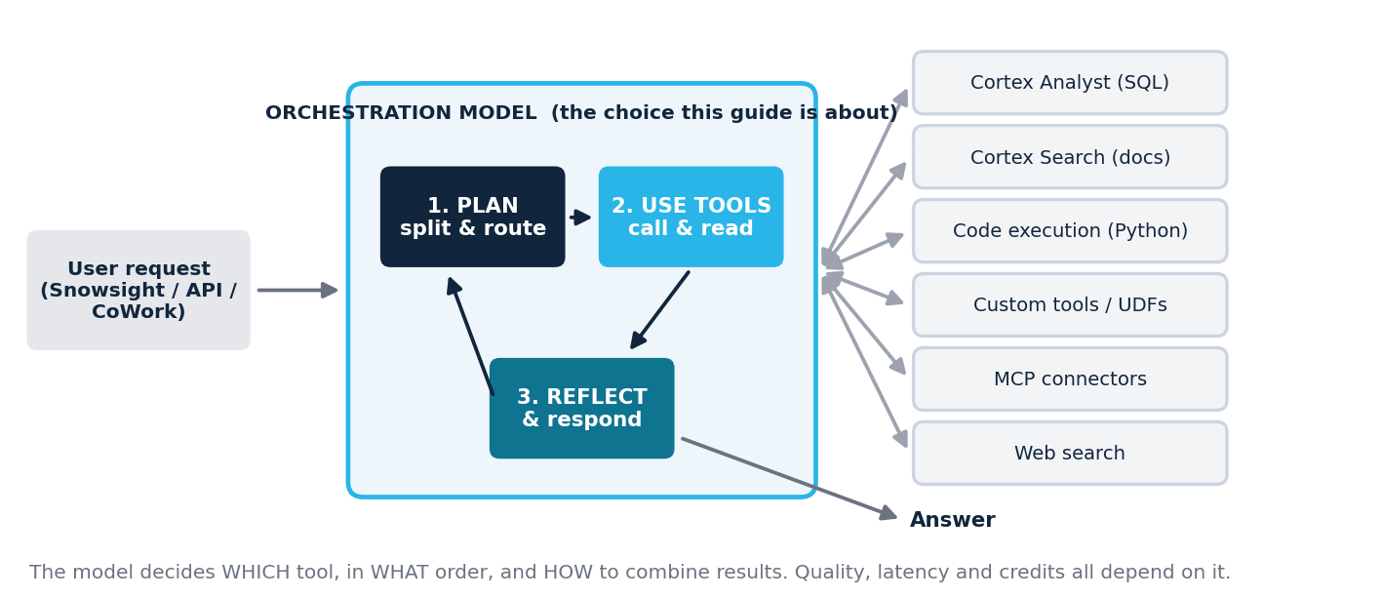

Five questions decide the model
# | Decision factor | What to check | Why it matters for an agent
1 | Platform & compliance | Which cross-region routing scope is enabled (CORTEX_ENABLED_CROSS_REGION)? Any Gov / FedRAMP / residency rule? | A model not available in your scope simply cannot be called. This eliminates options before quality is even considered.
2 | Task complexity | How many tools per question? How many reasoning steps? How costly is a wrong answer? | Multi-step planning and tool routing are where large models earn their price.
3 | Volume & latency | Requests per day, users, response-time target. | At high volume, small models cut cost and latency dramatically.
4 | Input / output size | Size of tool results, documents, conversation threads; length of the answer. | Context window must fit all tool results; max output caps report length.
5 | Production readiness | GA, public preview, private preview or legacy? | Snowflake states preview models are not intended for production; legacy models are on a path to end-of-life.

Snowflake's default advice: Select auto when creating an agent. Cortex then picks the highest-quality model available to your account and upgrades as new models arrive. This guide explains when to override auto with a pinned model, and which one.

2. Quick Decision Guide
Use this flow first. Hard constraints (cloud scope, compliance) are applied before quality, because they remove options entirely.
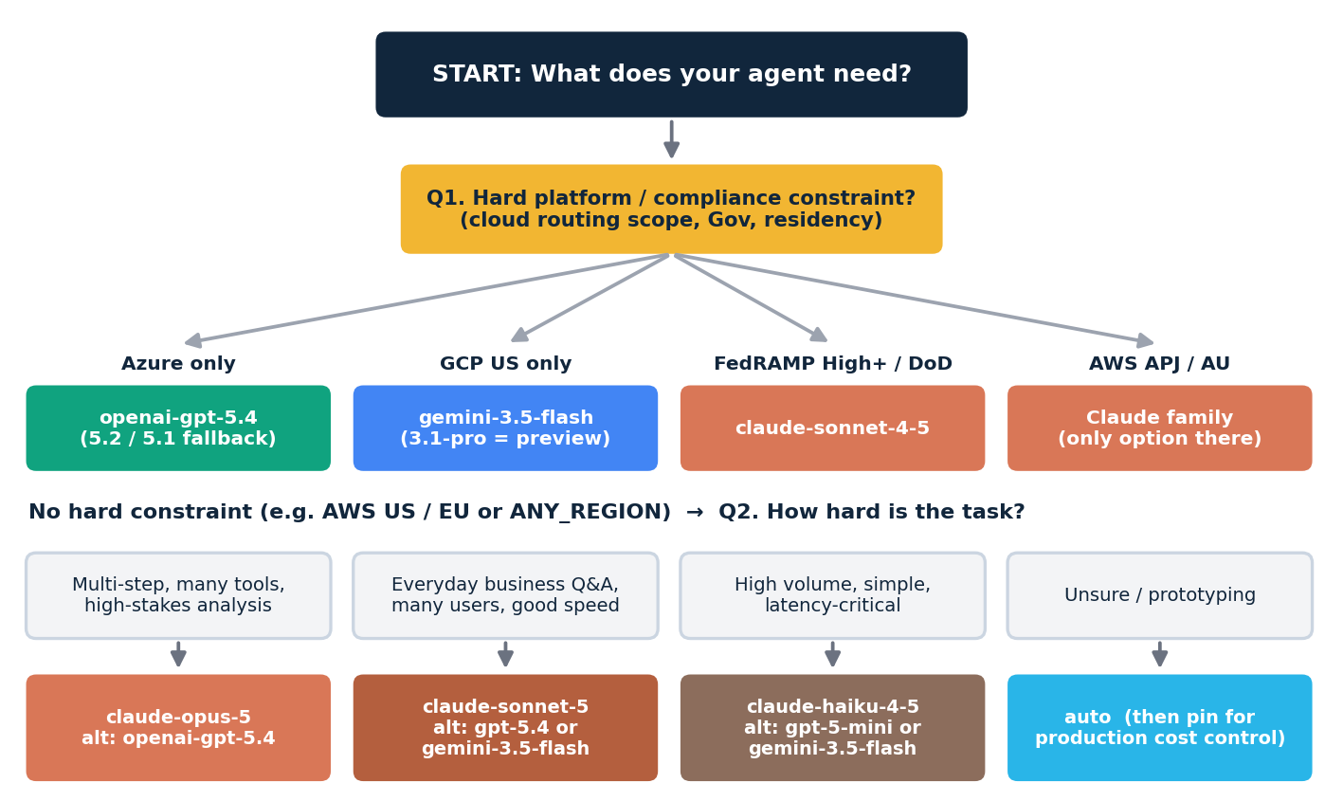

Problem → model cheat sheet
If your problem is… | Start with | Alternatives | Why
Complex multi-step analysis across Analyst + Search + code; high cost of error | claude-opus-5 | openai-gpt-5.4; gemini-3.1-pro (evaluation only, preview) | Snowflake's most capable tier; deepest planning; 128K output for long reports.
Business Q&A agent for hundreds or thousands of users | claude-sonnet-5 | openai-gpt-5.4; gemini-3.5-flash | Strong tool use at lower latency and cost than Opus; 1M context.
High-volume triage, classification, short answers, sub-agents | claude-haiku-4-5 | openai-gpt-5-mini; gemini-3.5-flash | Fast, cost-efficient; built for throughput over deep reasoning.
Snowflake account where routing must stay on Azure | openai-gpt-5.4 | openai-gpt-5.2 / 5.1 / 5 | OpenAI models are the ones routed through Azure scopes.
Snowflake account where routing must stay on Google Cloud US | gemini-3.5-flash | gemini-3.1-pro (preview) | Gemini models are the ones routed through Google Cloud US.
US public sector: FedRAMP High Plus or DoD scope | claude-sonnet-4-5 | claude-sonnet-4-6 / claude-haiku-4-5 (Commercial Gov only) | Only agent model listed in FedRAMP High Plus and DoD scopes.
Routing restricted to AWS APJ or AWS AU | claude-sonnet-5 / claude-opus-5 | claude-haiku-4-5 | No OpenAI or Gemini model is available in these scopes.
Long generated output (reports, code files > 8K tokens) | claude-opus-5 or openai-gpt-5.4 | claude-sonnet-5 (64K) | Avoid gpt-5, gpt-5.1 and gpt-5-mini: 8,192-token output cap.
Very large inputs in one call (many documents or long threads) | Any 1M-window model | opus-5, sonnet-5, sonnet-4-6, gpt-5.4, gemini | Fits more tool output before truncation or error.
Audio / video-heavy multimodal content | gemini-3.5-flash | gemini-3.1-pro (preview) | Google positions Gemini as natively multimodal across text, image, audio, video and PDF.
Not sure yet / prototype | auto | Pin after evaluation | Best quality by default; pin in production for predictable cost.

3. Complete Model Catalogue for Cortex Agents
All models supported by Cortex Agents, grouped by provider. Limits come from Snowflake's AI_COMPLETE limits table unless marked † (provider-published spec; the model is not yet listed in Snowflake's limits table, so confirm in your account).
Model ID | Provider | Status | Tier | Context | Max output | Best for
claude-opus-5 | Anthropic | GA | Large | 1M | 128K | Hardest multi-step agentic work, long reports
claude-opus-4-8 | Anthropic | GA | Large | 1M | 128K | Pinned agents validated on 4.8
claude-opus-4-7 | Anthropic | GA | Large | 1M | 128K | Pinned agents validated on 4.7
claude-opus-4-6 | Anthropic | GA | Large | 1M | 128K | Pinned agents validated on 4.6
claude-opus-4-5 | Anthropic | GA | Large | 200K | 64K | Older Opus; narrower scope
claude-sonnet-5 | Anthropic | GA | Medium | 1M | 64K | Default workhorse for most agents
claude-sonnet-4-6 | Anthropic | GA | Medium | 1M | 64K | Workhorse incl. AWS US Commercial Gov
claude-sonnet-4-5 | Anthropic | GA | Medium | 200K | 64K | FedRAMP High Plus / DoD agents
claude-4-sonnet | Anthropic | Legacy | Medium | 200K † | — | Migrate away
claude-haiku-4-5 | Anthropic | GA | Small | 200K | 64K | Fast, high-volume, sub-agents
openai-gpt-5.4 | OpenAI | GA | Large | ~1.05M † | 128K † | Frontier model on Azure routing
openai-gpt-5.2 | OpenAI | GA | Medium–Large | 400K † | 128K † | Stable GPT-5.x on Azure US
openai-gpt-5.1 | OpenAI | GA | Medium | 272K | 8,192 | Short-answer agents on Azure
openai-gpt-5 | OpenAI | GA | Medium | 272K | 8,192 | Existing GPT-5 agents
openai-gpt-5-mini | OpenAI | GA | Small | 272K | 8,192 | Low-latency tasks on Azure
openai-gpt-4.1 | OpenAI | Legacy | Medium | 128K | 32K | Migrate away
gemini-3.1-pro | Google | Public preview | Large | 1M | 64K | Evaluation / PoC, multimodal reasoning
gemini-3.5-flash | Google | GA | Medium (fast) | 1M † | 65K † | Fast multimodal agents on GCP routing

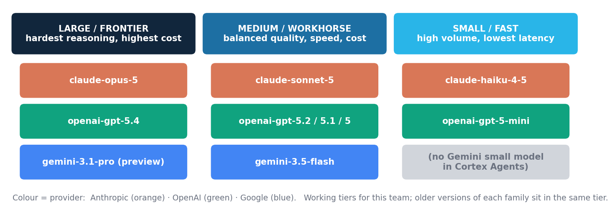

4. Availability and Size Limits at a Glance
Cortex Agents models run through cross-region inference. A model is callable only if your account's routing scope (the CORTEX_ENABLED_CROSS_REGION parameter) is marked for it. This single chart often decides the provider before any quality discussion.
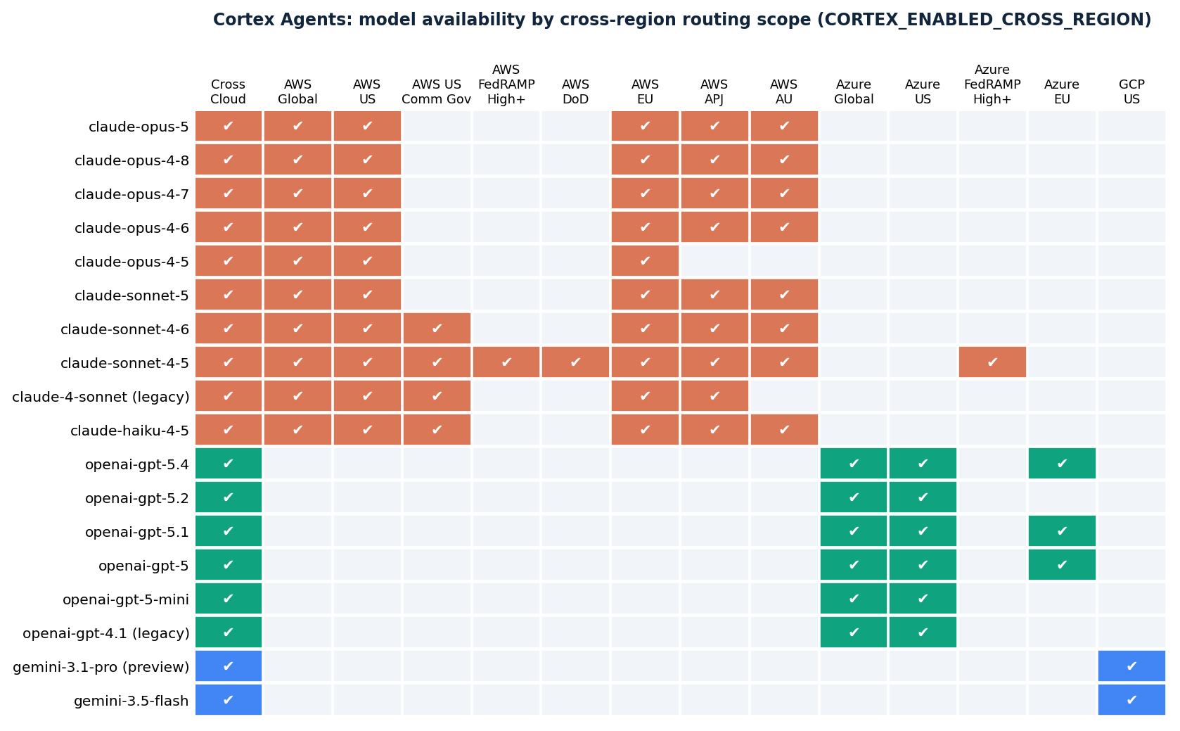
Read the pattern: Claude models are routed on AWS scopes (including EU, APJ, AU and Gov variants). OpenAI models are routed on Azure scopes. Gemini models are routed on Google Cloud US. Cross Cloud (Any Region) reaches every model but routes requests wherever capacity exists, which may conflict with data-residency rules.

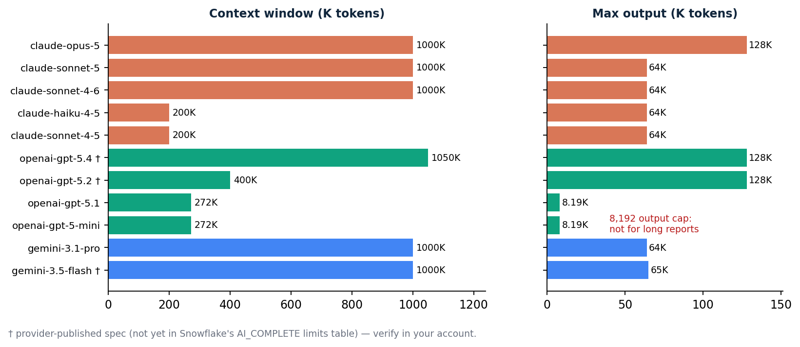
How limits work in Snowflake: input that exceeds the context window returns an error; output beyond the limit is truncated. Output is capped by both the model's max-output value and the space left in the window after the input. Use AI_COUNT_TOKENS to measure prompts before sending.

5. Provider Families Compared
Dimension | Anthropic Claude | OpenAI GPT | Google Gemini
Models in Cortex Agents | 10 (Opus 5 / 4.8 / 4.7 / 4.6 / 4.5, Sonnet 5 / 4.6 / 4.5, Haiku 4.5, Sonnet 4 legacy) | 6 (GPT-5.4, 5.2, 5.1, 5, 5-mini, 4.1 legacy) | 2 (3.1 Pro preview, 3.5 Flash GA)
Routing footprint | Widest: AWS US, EU, APJ, AU, Gov, FedRAMP High Plus, DoD, Azure FedRAMP High Plus | Azure Global, US, EU | Google Cloud US
Size ladder | Full ladder: Large (Opus), Medium (Sonnet), Small (Haiku) | Large (5.4), Medium (5.x), Small (mini) | Large (Pro, preview), fast Medium (Flash)
Context window | 1M on Opus 4.6+ and Sonnet 4.6+; 200K on Haiku and older | ~1.05M on 5.4; 272K–400K on the rest | 1M on both
Max output | 64K–128K | 128K on 5.4 / 5.2; 8,192 on 5, 5.1, mini | 64–65K
Where it stands out | Long-horizon agentic work, tool use, coding, long documents (per Snowflake model descriptions) | Frontier general reasoning, document understanding and tool use on Azure | Native multimodality (audio, video, images, PDF) and speed on GCP
Watch-outs | Opus is the most expensive tier; auto may move to newer Opus and raise spend | Output cap on older 5.x; Azure-only routing | Pro is preview only; only one routing scope
Pick this family when | You're on AWS, need residency outside the US, or want one family covering every size | Your account is Azure-based or your team has standardised on OpenAI | Your account is GCP-based or content is heavily multimodal

Balanced view: No single provider wins every task. Frontier models from all three providers are close on general benchmarks and change every few months. For agents, the deciding factors are usually (1) routing availability, (2) tool-calling reliability on your semantic views and search services, and (3) credits per successful answer. Measure these on your own evaluation set (Section 8).

6. Model Profiles: Problem First, Then the Model
Each profile starts with a real-world problem statement, then explains why that model is the right fit. Profiles are ordered by provider; legacy models are covered in Section 7.

claude-opus-5 Anthropic · Large / flagship · GA

PROBLEM STATEMENT: Finance asks: "Why did EMEA gross margin fall 3 points last quarter, which product lines and contracts drove it, and what should we renegotiate?" The agent must query revenue and COGS through Cortex Analyst, pull contract clauses through Cortex Search, run a variance decomposition in the code execution tool, then write a board-ready narrative.

Why this model fits
- Snowflake names it one of the two most capable models in Cortex, with improved coding, long-horizon agentic work and professional tasks such as document drafting and data analysis.
- The question needs 5–10 tool calls in the right order. Planning errors multiply across steps, so the strongest planner pays for itself.
- A 1M-token window holds large SQL results, many retrieved chunks and the thread. The 128K output cap allows full reports in one pass.

Context window / max output | 1,000,000 tokens / 128,000 output (Snowflake-documented)
Status & availability | GA. Cross Cloud, AWS Global, AWS US, AWS EU, AWS APJ, AWS AU. Not in Gov / FedRAMP / DoD scopes; not routed through Azure or GCP scopes.
Key use cases | Multi-tool root-cause analysis; combined structured + unstructured research; long analytical reports; complex SQL and Python generation; agents that must ask clarifying questions on ambiguous requests.
Strengths | Deepest planning and reflection in the Claude line; very long outputs; 1M context; broad AWS residency coverage including EU, APJ and AU.
Limitations | Highest cost and latency of the Claude family; overkill for lookups and classification. With auto, agents may switch to newer, pricier Opus versions without notice, so pin and set budgets.
Real-world applications | CFO / FP&A analytics agent; due-diligence agent over data room + financials; data-engineering copilot; compliance investigation agent.

claude-sonnet-5 Anthropic · Medium / workhorse · GA

PROBLEM STATEMENT: A sales assistant in Snowflake Intelligence serves 2,000 reps. Typical question: "Show my top 10 at-risk accounts this quarter and summarise their latest support escalations." Answers must arrive in seconds, stay accurate across two tools, and keep monthly credits predictable.

Why this model fits
- Snowflake describes it as strong on coding, tool use and agentic tasks at lower latency and cost than the Opus models.
- Two to three tool calls per question is squarely within its range; the Opus premium adds little here but multiplies cost across thousands of daily runs.
- 1M context and 64K output comfortably cover long threads and tables.

Context window / max output | 1,000,000 tokens / 64,000 output (Snowflake-documented)
Status & availability | GA. Cross Cloud, AWS Global, AWS US, AWS EU, AWS APJ, AWS AU.
Key use cases | Self-service BI agents; customer-360 Q&A; support copilots; SQL-generating assistants; policy / document Q&A with citations.
Strengths | Best quality-to-cost balance in the Claude family; fast enough for interactive chat; large context.
Limitations | Can trail Opus on the hardest multi-step or ambiguous requests; 64K output (half of Opus). Not available in Gov scopes (use Sonnet 4.6 / 4.5 there).
Real-world applications | Sales / RevOps assistant; HR policy agent; supply-chain status agent; marketing performance Q&A.

claude-haiku-4-5 Anthropic · Small / fast · GA

PROBLEM STATEMENT: A support-operations agent processes 50,000 tickets a day: classify each ticket, extract the order ID, check order status through a custom tool, and draft a one-paragraph summary for the human agent, with a response target of a few seconds.

Why this model fits
- Snowflake positions Haiku 4.5 for low-latency, high-throughput summarisation, classification and question answering where speed and cost matter more than top-tier reasoning.
- Each ticket needs one or two simple tool calls, which small models handle reliably.
- Available in AWS US Commercial Gov as well as EU, APJ and AU, so it works for most regulated and non-US deployments.

Context window / max output | 200,000 tokens / 64,000 output (Snowflake-documented)
Status & availability | GA. Cross Cloud, AWS Global, AWS US, AWS US Commercial Gov, AWS EU, AWS APJ, AWS AU.
Key use cases | Ticket triage and routing; FAQ agents; entity extraction; fast sub-agents inside agent toolsets; high-volume enrichment.
Strengths | Low latency and cost; generous 64K output for a small model; wide regional footprint.
Limitations | Weaker at long plans with many tools and at ambiguous analytical questions; 200K context (not 1M).
Real-world applications | Support triage bot; IT help-desk agent; order-status assistant; routing layer in front of a larger model.

openai-gpt-5.4 OpenAI · Large / frontier · GA

PROBLEM STATEMENT: An insurer runs Snowflake on Azure in the EU, and policy says inference routing must stay on Azure. They need a high-quality agent that answers underwriting questions by joining a claims semantic view with policy documents in Cortex Search.

Why this model fits
- OpenAI models are the models routed through Azure scopes; GPT-5.4 is the newest of them and is available in Azure Global, Azure US and Azure EU.
- OpenAI positions GPT-5.4 as its frontier model for professional, document-heavy and agentic work, with improved coding, document understanding, tool use and instruction following.
- Provider spec of ~1.05M context and 128K output supports large tool results and long answers.

Context window / max output | ~1,050,000 tokens / 128,000 output † (OpenAI-published; not yet in Snowflake's limits table)
Status & availability | GA. Cross Cloud, Azure Global, Azure US, Azure EU. Not routed through AWS or GCP scopes.
Key use cases | Frontier-quality agents on Azure accounts; document-heavy Q&A; complex SQL / Python generation; multi-tool analysis.
Strengths | Frontier reasoning and tool use; very large context and output; the natural choice for Azure-resident deployments and OpenAI-standardised teams.
Limitations | Only Azure scopes (or Cross Cloud); effective limits in Cortex should be verified; frontier-tier cost. Prompts tuned for Claude may need adjustment.
Real-world applications | Azure-based underwriting or claims agent; legal / contract analysis on Azure; engineering copilots.

openai-gpt-5.2 · 5.1 · 5 OpenAI · Medium · GA (previous GPT-5.x generations)

PROBLEM STATEMENT: An existing Azure-based HR agent was built, evaluated and approved on GPT-5.x. The team needs stable behaviour for the next quarter while they evaluate GPT-5.4, and answers are short (a paragraph plus a table).

Why this model fits
- Pinning an already-validated model avoids behaviour drift in production while a newer model is evaluated.
- Short answers fit comfortably under the 8,192-token output cap of GPT-5 and 5.1; GPT-5.2 has a larger provider-spec output (128K †).
- All three are GA and available in Azure US; 5.1 and 5 also in Azure EU.

Context window / max output | gpt-5.2: 400K / 128K † (provider spec) · gpt-5.1: 272K / 8,192 · gpt-5: 272K / 8,192 (Snowflake-documented)
Status & availability | GA. gpt-5.2: Cross Cloud, Azure Global, Azure US. gpt-5.1 and gpt-5: Cross Cloud, Azure Global, Azure US, Azure EU.
Key use cases | Stable production agents already validated on 5.x; tool-routing agents with short responses; Azure US / EU deployments.
Strengths | Mature and predictable; cheaper than the newest frontier model; Azure EU option (5.1, 5).
Limitations | 8,192-token output cap on 5 and 5.1 truncates long reports; older generation will move towards legacy; 5.2 not in Azure EU.
Real-world applications | HR / IT policy agent on Azure; finance KPI lookup agent; internal knowledge assistant.

openai-gpt-5-mini OpenAI · Small / fast · GA

PROBLEM STATEMENT: An Azure-hosted marketplace needs a fast agent that labels incoming seller queries into 15 categories and answers simple status questions through one custom tool, at tens of thousands of requests per day.

Why this model fits
- Snowflake describes it as the small, fast GPT-5 variant for low-latency tasks where quick responses matter more than top-tier reasoning.
- It is the small-tier option for Azure-routed accounts, where Claude Haiku is not available.
- 272K context is large for a small model; short labels and answers fit under the output cap.

Context window / max output | 272,000 tokens / 8,192 output (Snowflake-documented)
Status & availability | GA. Cross Cloud, Azure Global, Azure US.
Key use cases | Classification, intent detection, simple lookups, sub-agent roles in Azure deployments.
Strengths | Low latency and cost on Azure; large context for its tier.
Limitations | 8,192-token output cap; limited multi-step reasoning; no Azure EU scope.
Real-world applications | Seller / customer query router; notification summariser; lightweight status bots.

gemini-3.1-pro Google · Large · PUBLIC PREVIEW

PROBLEM STATEMENT: A claims team wants to test whether an agent can reason over large scanned claim packets (PDFs with photos and handwritten forms) alongside claims tables. This is a proof of concept, not production.

Why this model fits
- Snowflake lists Gemini 3.1 Pro with Claude Opus 5 as the most capable models in Cortex, suited to advanced reasoning and multimodal tasks.
- In AI_COMPLETE, Gemini 3.1 Pro accepts documents up to 10 MB versus 4.5 MB for Claude models, which helps with large scanned files.
- 1M context and 64K output support big multimodal inputs.

Context window / max output | 1,000,000 tokens / 64,000 output (Snowflake-documented)
Status & availability | Public preview. Cross Cloud and Google Cloud US only. Snowflake states preview models are not intended for production workloads.
Key use cases | Proofs of concept, benchmark baselines against Opus / GPT-5.4, multimodal document reasoning experiments.
Strengths | Frontier reasoning with native multimodality; larger per-document size limit.
Limitations | Preview status: no production use, behaviour and availability may change; single routing scope.
Real-world applications | Claims-packet PoC; engineering-drawing Q&A pilot; model bake-off baseline.

gemini-3.5-flash Google · Medium / fast · GA

PROBLEM STATEMENT: A retailer on Snowflake in Google Cloud US needs a fast shopping-insights agent that answers questions over product catalogues, reviews and product images for merchandisers, with low latency and cost at scale.

Why this model fits
- It is the GA Gemini model in Cortex Agents and is routed on Google Cloud US, which matches the account's cloud.
- Google positions 3.5 Flash as its most intelligent Flash model, bringing strong agentic and coding performance at Flash speed and cost.
- Multimodal input (text, images, audio, video, PDF) with a 1M window and ~65K output (provider spec).

Context window / max output | 1,000,000 tokens / ~65,000 output † (Google-published)
Status & availability | GA. Cross Cloud and Google Cloud US.
Key use cases | GCP-resident agents; high-volume Q&A; multimodal catalogue or media analysis; fast sub-agents.
Strengths | Speed and cost efficiency with strong capability; native multimodality; production-ready unlike 3.1 Pro.
Limitations | Only Google Cloud US routing; Google recommends keeping default sampling settings (temperature, top_p, top_k) for Gemini 3.x; fewer Cortex-specific community patterns so far.
Real-world applications | Merchandising insights agent; media / content tagging; GCP-based customer service agent.

claude-sonnet-4-5 · 4-6 · opus-4-x Anthropic · Previous generations · GA

PROBLEM STATEMENT: A US federal agency using Snowflake in a FedRAMP High Plus environment wants a Cortex Agent over grant and spending data. Separately, a commercial team has an Opus 4.7 agent that passed audit and must not change behaviour this quarter.

Why this model fits
- claude-sonnet-4-5 is the only Cortex Agents model available in AWS US FedRAMP High Plus, AWS US DoD and Azure US FedRAMP High Plus scopes.
- claude-sonnet-4-6 and claude-haiku-4-5 cover AWS US Commercial Gov.
- Pinning claude-opus-4-8 / 4-7 / 4-6 keeps an audited agent stable while a newer model is evaluated side by side.

Context window / max output | opus-4-8 / 4-7 / 4-6: 1M / 128K · sonnet-4-6: 1M / 64K · sonnet-4-5 and opus-4-5: 200K / 64K (Snowflake-documented)
Status & availability | All GA. Sonnet 4.5: widest scope list (incl. FedRAMP High Plus, DoD). Sonnet 4.6: adds AWS US Commercial Gov. Opus 4.5: Cross Cloud, AWS Global, US, EU only.
Key use cases | Government and defence agents; change-controlled production agents; regression baselines for upgrades.
Strengths | Proven, stable behaviour; unique compliance coverage (Sonnet 4.5).
Limitations | Older generation: will eventually be marked legacy; 200K context on Sonnet 4.5 and Opus 4.5.
Real-world applications | Public-sector spending agent; regulated banking agent under change control; A/B baseline.

7. Legacy Models, Lifecycle and Governance

Legacy models: do not use for new agents
Legacy model | Why not | Migrate to
claude-4-sonnet | Legacy status; accounts that never used it cannot start using it; end-of-life will follow. | claude-sonnet-5 (or claude-sonnet-4-6 where Commercial Gov scope is needed)
openai-gpt-4.1 | Legacy status; smaller context (128K) and older reasoning. | openai-gpt-5.4 (or openai-gpt-5.2 for a closer behavioural match)
Snowflake retires models in two stages. After the legacy date only accounts that already used a model can keep calling it; after the end-of-life date nobody can. Run SHOW CORTEX BASE MODELS to see lifecycle_status, legacy_date and eol_date for each model.

auto vs pinned model
Option | When to use | Risk
auto | Prototypes, internal tools, teams that want quality upgrades automatically. | Model (and cost per run) can change when Snowflake adds newer models. Practitioners have reported credit spikes when auto moved to a newer Opus.
Pinned model | Production agents, audited workflows, fixed budgets, residency-constrained accounts. | Must be reviewed and upgraded before legacy / end-of-life dates.

Pinning the orchestration model
CREATE OR REPLACE AGENT analytics_db.agents.sales_assistant
FROM SPECIFICATION
$$
models:
orchestration: claude-sonnet-5 # or: auto | openai-gpt-5.4 | gemini-3.5-flash
instructions:
response: "Answer concisely. Cite the source table or document."
$$;

Governance and cost controls to apply with any model
- Routing scope: an ACCOUNTADMIN sets CORTEX_ENABLED_CROSS_REGION. Choose the narrowest scope that satisfies residency; ANY_REGION maximises model choice but may route outside your geography.
- Access: callers need SNOWFLAKE.CORTEX_USER or CORTEX_AGENT_USER plus privileges on the agent and on every tool's objects. Data access follows existing RBAC.
- Budgets: set an orchestration budget per run, resource budgets per agent, and per-user AI quotas to cap spend.
- External calls: web search and MCP connectors send requests over the public internet, regardless of which model you choose.
- Review outputs: Snowflake does not guarantee the accuracy of LLM responses or citations; keep human review for high-stakes answers.

8. How the Team Picks and Validates a Model
Treat model selection as an engineering decision with evidence. Use this five-step process for every new agent:
Step | Action | Output
1. Filter | Apply hard constraints: routing scope, compliance, GA-only for production. | Short list of 2–3 eligible models
2. Golden set | Collect 30–50 real questions with expected answers, including ambiguous and multi-tool ones. | Evaluation dataset
3. Bake-off | Run the same agent spec (tools, instructions) with each candidate model, using Cortex Agent evaluations. | Correctness, tool-choice accuracy, latency, credits per run
4. Decide | Pick the cheapest model that meets the quality bar, not the most capable one available. | Pinned model + documented rationale
5. Re-check | Quarterly, or when a new model appears or a legacy date is announced: rerun step 3. | Upgrade or keep decision

Scorecard template
Metric | Target | Model A | Model B | Model C
Answer correctness on golden set | ≥ 90%
Correct tool selected / right order | ≥ 95%
p95 latency per run | ≤ 15 s (interactive)
Average credits per successful answer | Within budget
Available in our routing scope, GA | Yes

One-page summary
Situation | Model
Hardest, highest-stakes, multi-tool analysis | claude-opus-5 (alt: openai-gpt-5.4)
Default for most business agents | claude-sonnet-5 (alt: openai-gpt-5.4 or gemini-3.5-flash)
High volume, simple, fast | claude-haiku-4-5 (alt: openai-gpt-5-mini or gemini-3.5-flash)
Azure-only routing | openai-gpt-5.4 → 5.2 / 5.1 / 5 → 5-mini
Google Cloud US routing | gemini-3.5-flash (3.1-pro for preview evaluation)
FedRAMP High Plus / DoD | claude-sonnet-4-5
AWS APJ / AU residency | Claude family only
Unsure / prototype | auto, then pin for production

References
Snowflake: Cortex Agents — docs.snowflake.com/en/user-guide/snowflake-cortex/cortex-agents
Snowflake: Models and regional availability for Cortex AI Functions — docs.snowflake.com/en/user-guide/snowflake-cortex/aisql-regional-availability
OpenAI API model pages (GPT-5.4, GPT-5) — developers.openai.com · Google: What's new in Gemini 3.5 Flash — ai.google.dev

