Online Shopping Mart Customer Support RAG Assistant
Domain: Online Shopping / Customer Service Help Center

1. Executive Summary
This project implements a Retrieval-Augmented Generation (RAG) customer support assistant for a fictitious e-commerce platform ('Online Shopping Mart'). The application uses Snowflake Cortex Search to index the company's Help Center policies and Streamlit to provide an interactive chatbot interface.

2. System Architecture & Entity Relationships
The architecture restricts all vector search and LLM generation within the Snowflake Virtual Private Cloud. Below is the Architecture Blueprint detailing the table schema and data flow:
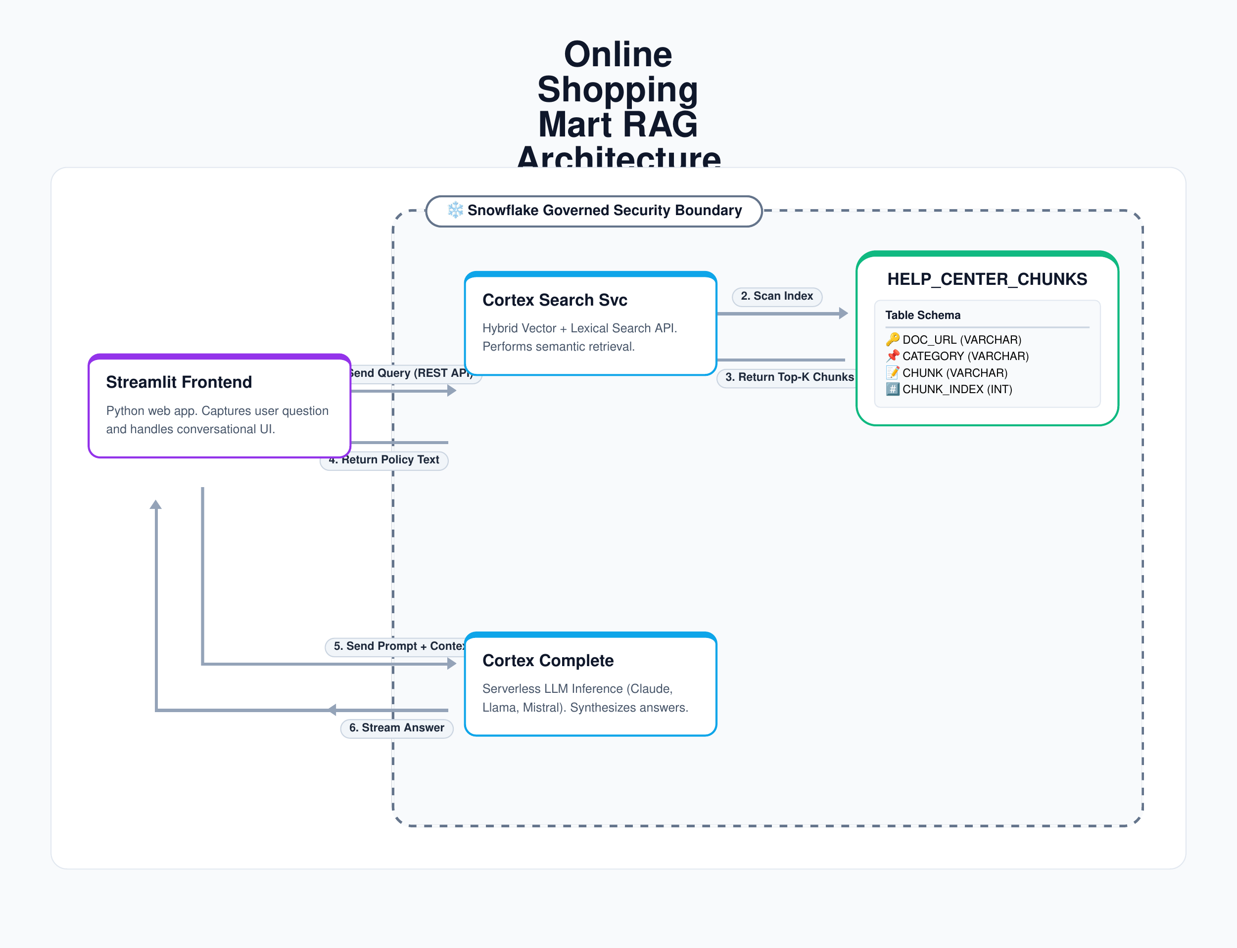

3. Logic Routing & Execution Flow
When a user submits a question, the application routes the query based on the active RAG mode, ensuring the LLM only generates grounded answers. The flow is visualized below:
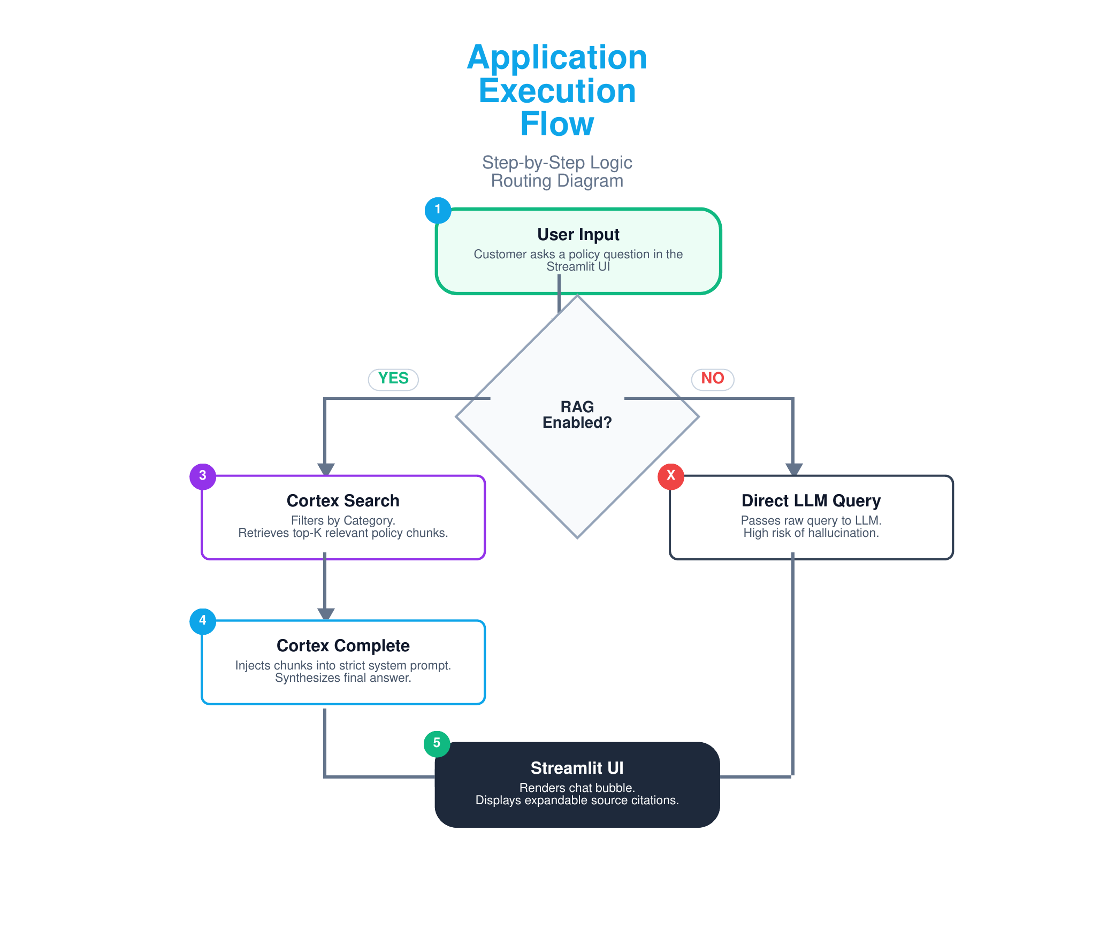

4. Validation Scenarios

Test Case 1
User Prompt: "I want to return a laptop I bought 20 days ago. Can I get a full refund?"
Expected Behavior: Cortex retrieves the 'Electronics Return Policy' chunk. The agent informs the user that electronics only have a 14-day return window.
Result: PASSED (Enforced exact return window).
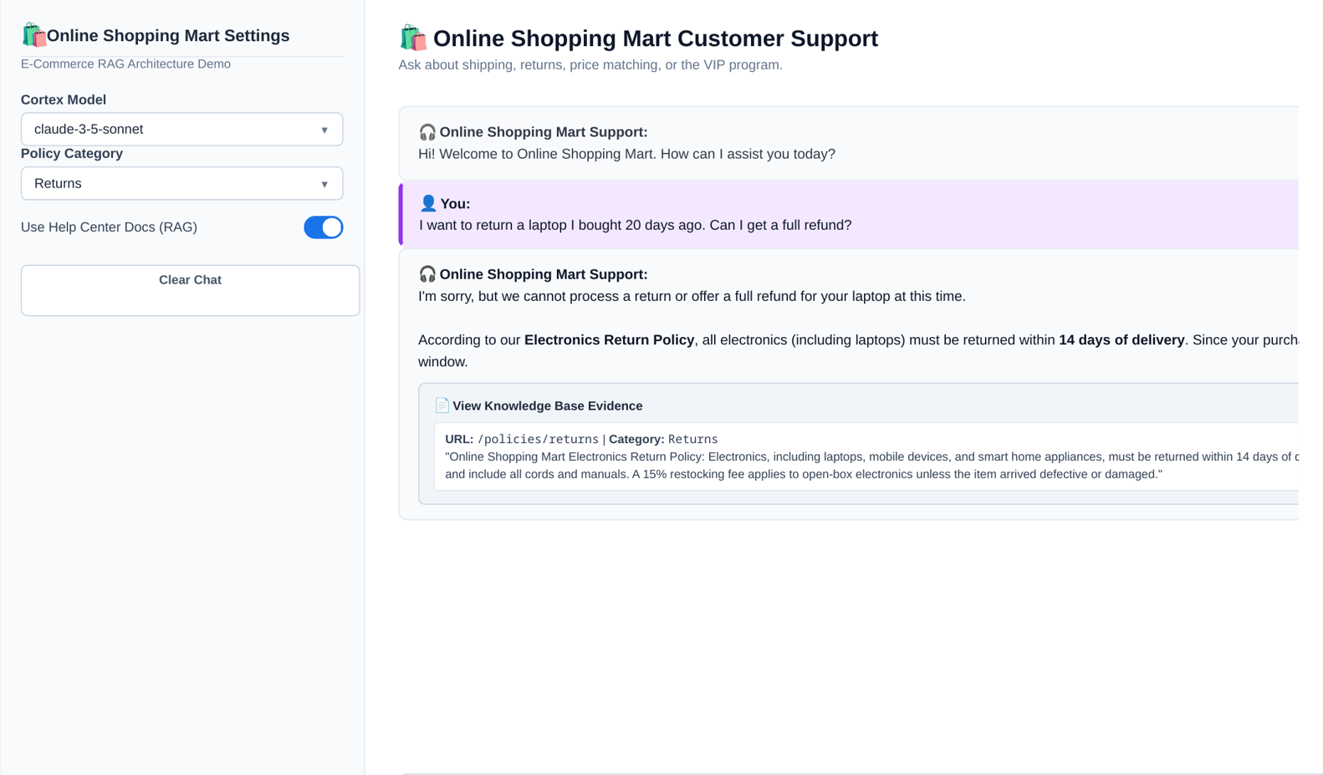

Test Case 2
User Prompt: "I found this identical TV at BestBuy. Will you match the price if I use a BestBuy coupon?"
Expected Behavior: Retrieves the 'Price Match' policy. Agent confirms price matching is allowed within 7 days, but explicitly states competitor coupons are NOT accepted.
Result: PASSED (Identified boundary condition regarding coupons).
