SNOWFLAKE AI · TECHNICAL TRAINING GUIDE
Snowflake Cortex Agents & Agent Studio
Comprehensive Technical Training Guide
Architecture, configuration, orchestration, security, evaluation and operations of governed AI agents on Snowflake — with Semantic Views, Cortex Analyst, Cortex Search, Skills and MCP.

1. Cortex Agents Overview

1.1 What a Cortex Agent is
A Cortex Agent is a fully managed agentic runtime inside Snowflake. It is defined as a schema-level AGENT object that bundles an orchestration model, natural-language instructions, a set of tools with their resources, optional skills and optional MCP connectors. At run time the agent reasons over a request, plans the work, calls tools, reflects on results and generates a response — without you building or hosting an orchestration loop, a tool runtime or a sandbox.
Because the agent is a Snowflake object, it inherits the platform's control plane: it is created with SQL, REST or Snowsight, secured with grants, versioned (LIVE plus immutable VERSION$N snapshots), traced into an event table and evaluated with built-in LLM-judge metrics. Data access is governed by the caller's Snowflake privileges and by the execution context of each tool.
KEY CONCEPT An agent is configuration, not code
Everything that defines an agent lives in its specification (YAML or JSON): models, orchestration, instructions, tools, tool_resources, skills and mcp_servers. Agent Studio, the REST API and CREATE/ALTER AGENT are three editors for the same specification.

1.2 The problem Cortex Agents solve
Enterprise questions rarely map to one query or one document. "Which of our top customers are complaining about delayed shipments?" needs a governed metric (revenue), a ranking, a lookup over unstructured tickets and a join of the two result sets. Before agents, teams had to hand-build that orchestration: prompt chains, routing code, retrieval plumbing, SQL safety checks, state management, logging and evaluation harnesses. Cortex Agents move that loop into the platform so the engineering effort shifts to the semantic layer, retrieval quality, tool descriptions and instructions.

1.3 How an agent compares with other approaches
Table 1 — Agent versus adjacent approaches
Compared with | What the other approach does | What a Cortex Agent adds
Traditional SQL / BI workflow | A human (or dashboard) knows the schema, writes or pre-defines the query and interprets the result. | Natural-language intent, automatic decomposition, tool routing, iteration on intermediate results and a narrated answer — while SQL still executes under the caller's RBAC.
Simple LLM application (prompt + model) | Single model call; no governed data access; answers from model knowledge or pasted context. | Tool use against governed data, multi-step planning, reflection, budgets, threads, traces, evaluations and object-level security.
Cortex Analyst (standalone) | Text-to-SQL over one or more semantic views; returns SQL and results. | Analyst becomes one tool among many; the agent can combine it with Search, custom tools, charts, code execution, skills and MCP. Snowflake now recommends transitioning standalone Analyst use to Cortex Agents.
Cortex Search (standalone) | Hybrid retrieval service returning ranked rows/chunks. | Query rewriting, dynamic filters, per-query column/result selection, grounding and citations, and combination with structured results.

1.4 Why orchestration is required
Orchestration is the decision layer that turns a question into a plan. It is required whenever the right answer depends on which data source to use, in what order, with what parameters and whether the evidence is sufficient. The orchestrator can disambiguate ("Acme" could be an account, a product or a region), split a request into sub-tasks, pass the output of one tool into the input of the next (for example customer IDs into a search filter), retry with a refined query, or stop and ask a clarifying question.

1.5 High-level lifecycle of a user request
Every user message is one turn; each turn is recorded as one trace made of spans (planning, tool calls, SQL execution, chart generation, response generation). Conceptually:
User → Agent → Orchestration (plan) → Tool selection → Cortex Analyst / Cortex Search / other tool → Result → Agent reasoning (reflect) → Response
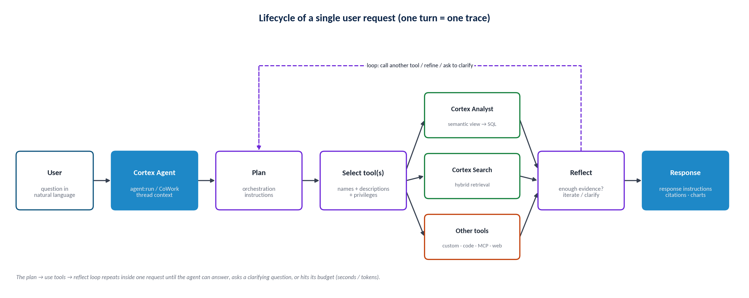
Figure — Lifecycle of a single request through a Cortex Agent
- Receive. The request arrives through Snowflake CoWork (formerly Snowflake Intelligence), the agent:run REST endpoint, the SNOWFLAKE.CORTEX.DATA_AGENT_RUN SQL function, or an external MCP client via a Snowflake-managed MCP server. Threads supply prior-turn context.
- Plan. The orchestration model combines Snowflake's base system instructions, your orchestration instructions, and the names and descriptions of tools and skills to decide what to do.
- Use tools. Selected tools execute: Cortex Analyst generates and runs SQL over a semantic view; Cortex Search retrieves ranked text; custom tools run UDFs or procedures; MCP connectors call remote tools.
- Reflect. The agent evaluates each result and decides whether to call another tool, refine a query, ask for clarification or answer.
- Respond. Response instructions shape tone and format; the agent may add tables, charts and citations. The run stops early if the time or token budget is exhausted.

New Update :
Apr 13, 2026: Improved SQL generation in Cortex Agents
Cortex Agents that use Cortex Analyst semantic views as tools now generate SQL directly, rather than delegating SQL generation to the Cortex Analyst service as a separate step. This results in improved accuracy and lower latency for analytical queries.

The tool definition in your agent configuration remains the same. No changes to your agent configuration or semantic views are required. Other resources defined in your semantic view, such as Cortex Search services, continue to be used by the agent.

Changes to the response format
Tool use and tool result blocks of type cortex_analyst_text_to_sql are replaced by blocks of type system_execute_sql. The system_execute_sql tool use block contains a sql field with the SQL generated by the agent. The tool result block contains the query_id, result_set, and final sql.
If your application parses the agent response for cortex_analyst_text_to_sql blocks, update it to look for system_execute_sql instead.

2. Cortex Agent Architecture
The architecture is best understood as layers with governance, quality and monitoring cutting across them. Figure 2 is the reference model used throughout this guide.
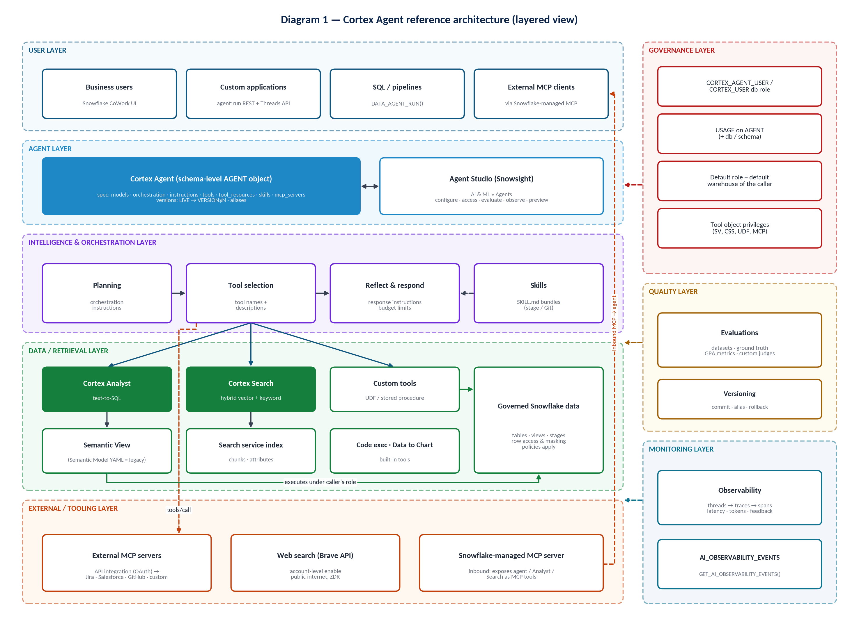
Diagram 1 — Overall Cortex Agent architecture by layer

2.1 Component roles
Table 2 — Architecture components
Component | Layer | Role in the architecture
Agent (AGENT object) | Agent | Container for the specification; unit of security (USAGE / MODIFY / MONITOR / OWNERSHIP), versioning and observability.
Agent Studio | Agent | Snowsight experience (AI & ML » Agents) to configure, grant access to, preview, evaluate and observe agents.
Orchestration instructions | Intelligence | Business rules for planning: routing, sequencing, clarification, boundaries.
Response instructions | Intelligence | Output tone, structure, formatting and error messaging.
Tools | Intelligence → Data | Typed capabilities the agent can invoke (Analyst, Search, custom, code execution, Data to Chart, web search, toolsets).
Skills | Intelligence | Portable SKILL.md bundles of instructions and scripts, discovered by name/description and loaded on demand.
Semantic Views | Data | Schema objects defining logical tables, relationships, facts, dimensions, metrics, instructions and verified queries for Cortex Analyst.
Semantic Models (YAML) | Data (legacy) | Stage-hosted YAML definitions still supported for backward compatibility.
Cortex Analyst | Data | Text-to-SQL engine grounded by the semantic layer; SQL runs on a warehouse.
Cortex Search | Data | Managed hybrid (vector + keyword + rerank) retrieval over text.
MCP | External | Outbound: EXTERNAL MCP SERVER objects give agents remote tools. Inbound: Snowflake-managed MCP SERVER objects expose agents and Cortex services to external MCP clients.
Access controls | Governance | Database roles, object privileges, default role/warehouse, tool-object privileges, OAuth for MCP.
Evaluations | Quality | Batch scoring of an agent version against a dataset with system and custom metrics.
Observability | Monitoring | Threads, traces, spans, latency, tokens and user feedback in SNOWFLAKE.LOCAL.AI_OBSERVABILITY_EVENTS.

2.2 How the components interact
- The semantic layer and search services are built by data engineers independently of any agent; agents reference them by fully qualified name in tool_resources.
- The tool description is what the orchestrator sees first. It does not inspect your full data model before choosing a tool, so the description is the contract between the orchestration layer and the data layer.
- Skills sit beside tools: their name and description are always visible to the orchestrator; the full instructions are fetched only when a skill is selected. Scripts in skills require the code execution tool.
- Governance is evaluated per caller: the caller's default role must be able to use the agent and each tool's underlying object. Missing tool privileges are handled by orchestration.tool_not_accessible.
- Evaluations run a chosen agent version against a dataset and record full traces; observability records the same trace shape for live traffic. Both feed changes back into instructions, tool descriptions and semantic views.

2.3 Where agents are consumed
Table 3 — Consumption surfaces
Surface | Mechanism | Notes
Snowflake CoWork | Agent UI at ai.snowflake.com | Business-user chat; shows agent description and sample questions; users connect MCP connectors via OAuth.
Custom application | POST /api/v2/databases/{db}/schemas/{schema}/agents/{name}:run | Streams SSE events by default; use threads to persist context; optional /versions/{version}:run.
SQL | SNOWFLAKE.CORTEX.DATA_AGENT_RUN('db.schema.agent[!version]', <json>) | Returns the aggregated JSON response; useful for pipelines and notebooks.
External MCP client | CREATE MCP SERVER … type CORTEX_AGENT_RUN | Gives an external agent one governed entry point instead of raw SQL.
Cortex Code | agent-studio bundled skill | Assists with building, evaluating and optimizing agents and semantic views.

IMPORTANT Runtime limitation
Cortex Agents APIs are not supported from a Streamlit in Snowflake app on a warehouse runtime; use a container runtime for SiS apps that call agents.

3. Semantic Views

3.1 What a Semantic View is
A semantic view is a schema-level object that stores business semantics directly in the database: logical tables mapped to physical tables or queries, the relationships between them, and the facts, dimensions and metrics users reason about. It is queryable with SQL (SEMANTIC_VIEW(...) clause), shareable through listings, governed by Snowflake privileges and consumed by Cortex Analyst as its grounding context. Semantic views are treated as metadata.

3.2 Why Semantic Views are required
A physical schema tells a model what columns exist, not what they mean. Without a semantic layer, text-to-SQL guesses at join paths, aggregation rules, fiscal calendars, status codes and business synonyms. The semantic view makes those decisions explicit and reusable, so every consumer — BI, SQL, Analyst and agents — computes "revenue" or "active customer" the same way.

3.3 Building blocks
Table 4 — Semantic view elements
Element | Definition | Effect on NL-to-SQL
Logical table | Business entity mapped to a table, view or SQL query; PRIMARY KEY / UNIQUE declared. | Defines entity grain; keys determine relationship cardinality.
Relationship | Foreign-key style link between logical tables (equality, ASOF or range join). | Pre-defined join paths; prevents invented or fan-out joins.
Fact | Row-level quantitative attribute ("how much"), often a helper for metrics. Can be PRIVATE. | Building block for metric expressions.
Dimension | Categorical or time attribute used to group and filter; synonyms, comments, SAMPLE_VALUES, IS_ENUM, optional Cortex Search service. | Maps user vocabulary to columns; IS_ENUM restricts filter literals to known values.
Metric | Aggregation (SUM, AVG, COUNT…) scoped to a logical table, or a derived metric across tables; NON ADDITIVE BY for snapshots. | Guarantees the correct formula for KPIs.
Business terminology | WITH SYNONYMS and COMMENT on tables, dimensions, facts and metrics. | Resolves "sales", "bookings" and "revenue" to the intended object.
Custom instructions | AI_SQL_GENERATION and AI_QUESTION_CATEGORIZATION clauses. | Default filters, rounding, rejection or clarification rules.
Verified queries | AI_VERIFIED_QUERIES: question + validated SQL (+ onboarding flag). | Few-shot grounding for common or complex questions.

3.4 Semantic View versus ordinary view
Table 5 — Ordinary view vs semantic view
Aspect | Ordinary view | Semantic view
Content | A fixed SELECT with a fixed shape. | A model of entities, joins, facts, dimensions and metrics; shape is chosen at query time.
Querying | SELECT * FROM view | SELECT * FROM SEMANTIC_VIEW(sv DIMENSIONS … METRICS …) — the engine composes joins and aggregation.
Aggregation logic | Hard-coded in the view | Declared per metric, including derived and semi-additive metrics.
AI metadata | None | Synonyms, sample values, enums, custom instructions, verified queries.
Privileges to query | SELECT on view | SELECT on the semantic view (not on the base tables) for direct SQL queries.

3.5 How semantic views are created
Three authoring paths exist: the Snowsight editor with Semantic View Autopilot (uses query history, table metadata and optional example SQL or Tableau files), SQL DDL (CREATE [OR REPLACE | OR ALTER] SEMANTIC VIEW), and YAML via SYSTEM$CREATE_SEMANTIC_VIEW_FROM_YAML. Creating one requires CREATE SEMANTIC VIEW on the schema, USAGE on the database and schema, and SELECT on the referenced tables and views.
SQL — semantic view for the sales domain (DDL)
CREATE OR REPLACE SEMANTIC VIEW sales_support_db.semantic.sales_sv
TABLES (
customers AS sales_support_db.crm.customers
PRIMARY KEY (customer_id)
WITH SYNONYMS ('accounts', 'clients')
COMMENT = 'One row per customer account',
orders AS sales_support_db.crm.orders
PRIMARY KEY (order_id)
COMMENT = 'One row per order; excludes test orders'
)
RELATIONSHIPS (
orders_to_customers AS orders (customer_id) REFERENCES customers
)
FACTS (
orders.net_amount AS amount_usd - discount_usd
COMMENT = 'Order value after discounts, USD'
)
DIMENSIONS (
customers.customer_name AS customers.name
WITH SYNONYMS = ('account name', 'client')
COMMENT = 'Legal customer name',
customers.segment AS customers.segment
COMMENT = 'Commercial segment'
SAMPLE_VALUES ('Enterprise', 'Mid-Market', 'SMB')
IS_ENUM,
orders.order_date AS order_date
COMMENT = 'Date the order was booked',
orders.fiscal_quarter AS fiscal_quarter_label
COMMENT = 'Fiscal quarter label, e.g. FY26-Q2 (fiscal year starts Feb 1)'
)
METRICS (
orders.total_revenue AS SUM(orders.net_amount)
WITH SYNONYMS = ('sales', 'revenue', 'bookings')
COMMENT = 'Net revenue in USD',
orders.order_count AS COUNT(order_id)
COMMENT = 'Number of orders',
avg_order_value AS DIV0(orders.total_revenue, orders.order_count)
COMMENT = 'Derived metric: revenue per order'
)
COMMENT = 'Governed sales metrics for the Sales & Support agent'
AI_SQL_GENERATION 'Round currency to 2 decimals. If no period is given, use the last completed fiscal quarter.'
AI_QUESTION_CATEGORIZATION 'If a question asks for revenue without a period and cannot be defaulted, ask the user for the period.';

VERIFY Clause order
The optional trailing clauses (COMMENT, AI_SQL_GENERATION, AI_QUESTION_CATEGORIZATION, AI_VERIFIED_QUERIES, COPY GRANTS) must follow the order in the CREATE SEMANTIC VIEW syntax reference. Verify against the current Snowflake documentation before implementation.

SQL — verified query clause and direct query
-- Inside CREATE SEMANTIC VIEW (after COMMENT, before COPY GRANTS)
AI_VERIFIED_QUERIES (
top_customers_by_revenue AS (
QUESTION 'Who are the top 10 customers by revenue last quarter?'
VERIFIED_AT 1772645863
ONBOARDING_QUESTION TRUE
VERIFIED_BY '(STEWARD = sales_data_stewards)'
SQL 'SELECT c.customer_name, SUM(o.net_amount) AS revenue
FROM orders AS o JOIN customers AS c ON o.customer_id = c.customer_id
GROUP BY c.customer_name ORDER BY revenue DESC LIMIT 10'
)
)

-- Query the semantic view directly (useful to validate metric logic)
SELECT * FROM SEMANTIC_VIEW(
sales_support_db.semantic.sales_sv
DIMENSIONS customers.customer_name
METRICS orders.total_revenue
)
ORDER BY total_revenue DESC
LIMIT 10;

3.6 Maintenance
- Use CREATE OR ALTER SEMANTIC VIEW to change definitions while preserving grants; CREATE OR REPLACE … COPY GRANTS is the alternative. ALTER SEMANTIC VIEW only changes the comment.
- Inspect with DESCRIBE SEMANTIC VIEW, SHOW SEMANTIC DIMENSIONS | FACTS | METRICS IN <sv>, SHOW SEMANTIC DIMENSIONS FOR METRIC, and GET_DDL('SEMANTIC_VIEW', …); export YAML with SYSTEM$READ_YAML_FROM_SEMANTIC_VIEW.
- Keep definitions in Git and deploy through CI; validate YAML first by calling SYSTEM$CREATE_SEMANTIC_VIEW_FROM_YAML(…, TRUE) (verify-only mode).
- Review Cortex Analyst monitoring and verified-query suggestions regularly; frequently asked, unmatched questions are surfaced as candidate verified queries.
- Run Cortex Analyst evaluations (verified queries as ground truth) after each change to catch regressions.

3.7 How agents consume semantic views
A Cortex Analyst tool in the agent specification references one or more semantic views in tool_resources, together with the warehouse (execution environment) and a query timeout. The agent passes a natural-language sub-question to Analyst; Analyst uses the semantic view to generate SQL, runs it on the warehouse, and returns SQL and rows to the agent. When Analyst is invoked through an agent, custom question-categorization instructions can be written in plain language — state keywords such as UNCLEAR are not required.
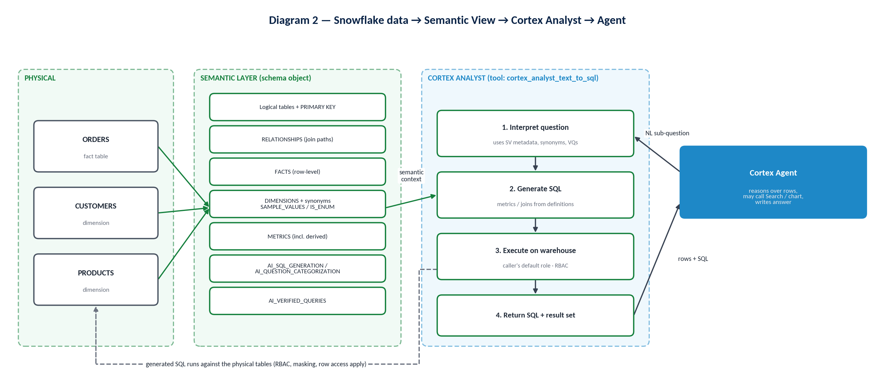
Diagram 2 — Snowflake data → Semantic View → Cortex Analyst → Agent

3.8 Best practices
- Scope each semantic view to a coherent domain (a set of tables that are queried together); give agents several focused views rather than one enterprise-wide view.
- Write comments that state grain, units, currency, time zone and exclusions. Add synonyms for every term the business actually uses.
- Declare primary keys on every logical table; model many-to-many through bridge tables and resolve multi-path joins with USING (relationship) on metrics.
- Use SAMPLE_VALUES for high-cardinality text columns and IS_ENUM only when the list is complete. For very high-cardinality names, attach a Cortex Search service to the dimension (WITH CORTEX SEARCH SERVICE) to improve literal matching.
- Encode data defaults (default time window, excluded internal accounts) in AI_SQL_GENERATION, not in agent instructions.
- Mark helper facts and metrics PRIVATE; use NON ADDITIVE BY for balances and snapshots.
- Seed 10–30 verified queries from real questions; flag the best as onboarding questions.

3.9 Limitations and considerations
- A dimension's base table must have equal or lower granularity than the metric's base table in a query; otherwise the query fails with a granularity error.
- Multiple relationship paths between two tables require an explicit USING clause on affected metrics.
- Derived metrics cannot aggregate metrics, reference physical columns, use window functions, or use USING.
- Direct SQL queries require only SELECT on the semantic view, but the agent tool path has its own privilege checks — see Section 15.
- Cross-table dimension references are DDL-only (not available in YAML).

4. Semantic Models

4.1 Terminology first
Snowflake documentation uses "semantic model" in two senses. Conceptually, it is the logical representation of business data — entities, dimensions, measures, relationships and metrics — that grounds Cortex Analyst. Concretely, a semantic model file is the original YAML artifact stored on a stage (or passed inline) and referenced by semantic_model_file. Today the same conceptual model is best implemented as a semantic view; stage-hosted YAML files are supported for backward compatibility.
IMPORTANT Current guidance
Use semantic views for new implementations. Stage-hosted semantic model YAML is legacy. The Snowflake-managed MCP server supports only semantic views for its Cortex Analyst tool, and semantic views add RBAC, sharing, derived metrics, access modifiers and custom instructions.

4.2 Purpose and structure
The model describes a dataset in business terms so that Cortex Analyst can plan SQL without guessing. The YAML specification (shared with semantic views) is organized as:
Table 6 — Semantic model YAML structure
YAML element | Purpose
name, description | Identity and scope of the model.
tables[] with base_table | Logical entities mapped to database.schema.table; primary_key columns.
dimensions[] / time dimensions | Categorical and temporal attributes with expr, data_type, synonyms, description, sample values.
facts[] (formerly measures) | Row-level numeric expressions.
metrics[] | Aggregated KPIs with expr.
filters[] | Named, reusable filter expressions (where supported by the spec).
relationships[] | left_table, right_table, relationship_columns, relationship_type (e.g. many_to_one).
verified_queries[] | Question/SQL pairs used as grounding examples.
custom instructions | Model-level guidance for SQL generation.

YAML — semantic model (same spec used by SYSTEM$CREATE_SEMANTIC_VIEW_FROM_YAML)
name: SALES_SV
description: Governed sales metrics for the Sales & Support agent
tables:
- name: CUSTOMERS
description: One row per customer account
base_table:
database: SALES_SUPPORT_DB
schema: CRM
table: CUSTOMERS
primary_key:
columns: [CUSTOMER_ID]
dimensions:
- name: CUSTOMER_NAME
synonyms: [account name, client]
description: Legal customer name
expr: NAME
data_type: VARCHAR
- name: ORDERS
description: One row per order; excludes test orders
base_table:
database: SALES_SUPPORT_DB
schema: CRM
table: ORDERS
primary_key:
columns: [ORDER_ID]
dimensions:
- name: ORDER_DATE
description: Date the order was booked
expr: ORDER_DATE
data_type: DATE
facts:
- name: NET_AMOUNT
description: Order value after discounts, USD
expr: AMOUNT_USD - DISCOUNT_USD
data_type: "NUMBER(18,2)"
metrics:
- name: TOTAL_REVENUE
description: Net revenue in USD
expr: SUM(orders.net_amount)
relationships:
- name: ORDERS_TO_CUSTOMERS
left_table: ORDERS
right_table: CUSTOMERS
relationship_columns:
- left_column: CUSTOMER_ID
right_column: CUSTOMER_ID
relationship_type: many_to_one

SQL — validate, then create a semantic view from YAML
-- Verify only (third argument TRUE): no object is created
CALL SYSTEM$CREATE_SEMANTIC_VIEW_FROM_YAML('sales_support_db.semantic', $$ <yaml above> $$, TRUE);

-- Create the semantic view
CALL SYSTEM$CREATE_SEMANTIC_VIEW_FROM_YAML('sales_support_db.semantic', $$ <yaml above> $$);

4.3 How the model is consumed and how it shapes SQL
- Analyst uses model metadata only (names, descriptions, synonyms, types, sample values) to generate SQL; the query then runs in your warehouse.
- Relationships determine the join clauses and prevent fan-out; metric expressions become the SELECT aggregates; dimension expressions become GROUP BY and filter targets.
- Synonyms and descriptions decide which column a phrase maps to; sample values and enums decide filter literals.
- Verified queries steer phrasing-to-SQL for known questions and serve as evaluation ground truth.
- Legacy files: a Cortex Analyst tool can reference semantic_model_file (stage path) instead of semantic_view; access is then controlled by the stage (READ/WRITE), and anyone with stage access can read every model on it.

4.4 When to use each approach
- Semantic view (DDL or YAML → object): all new work; anything shared, governed, exposed through MCP, or used by multiple agents.
- Stage-hosted YAML file: existing Analyst deployments not yet migrated; plan migration with SYSTEM$CREATE_SEMANTIC_VIEW_FROM_YAML.
- Inline YAML in an API request: quick experiments only.

4.5 Common mistakes
COMMON MISTAKE Modelling pitfalls
- Mirroring every physical column instead of the business vocabulary users actually use.
- Missing primary keys, causing ambiguous cardinality and double counting.
- Defining the same KPI in two tables with different formulas.
- Relative-time wording in verified queries ("this year") that drifts over time.
- Storing several models on one stage and granting READ broadly — every role with stage access can read all of them, even without SELECT on the tables.

5. Semantic View vs Semantic Model
Table 7 — Semantic View vs Semantic Model
Area | Semantic View | Semantic Model (YAML file)
Purpose | Native semantic layer object for Analyst, agents, SQL and BI. | Original Analyst grounding artifact; retained for backward compatibility.
Representation | Schema-level object (DDL or YAML spec → object). | YAML file on a stage or inline in a request.
Maintenance | CREATE OR ALTER / REPLACE; DESCRIBE, SHOW, GET_DDL; Autopilot and Snowsight editor. | Edit and re-upload the file; no object-level lifecycle.
Cortex Analyst usage | semantic_view in tool_resources; recommended. | semantic_model_file in tool_resources; supported.
Deployment | SQL/CI; YAML import; sharing via listings. | PUT/COPY to stage; version via file paths.
Governance | RBAC on the object (SELECT, REFERENCES, MONITOR, OWNERSHIP); private facts/metrics. | Access follows stage privileges; no per-model grants.
MCP server support | Supported (CORTEX_ANALYST_MESSAGE tool). | Not supported.
Best use case | All new agents and shared semantic layers. | Legacy Analyst apps pending migration.
Advantages | Derived metrics, access modifiers, custom instructions, sharing, SQL queryability, catalog integration. | Simple file portability.
Limitations | Granularity and multi-path rules; some features DDL-only. | No native object governance or sharing; stage-wide exposure risk.

BEST PRACTICE Architect's decision
Choose a semantic view unless you are maintaining an existing file-based Analyst deployment. Treat YAML as an authoring and interchange format that is materialized into a semantic view, not as the runtime artifact.

6. Cortex Analyst

6.1 What it is
Cortex Analyst is a fully managed, LLM-powered text-to-SQL service for structured data. It interprets a question against the semantic layer, generates SQL, executes it on your warehouse and returns SQL plus results. Inside an agent it is the cortex_analyst_text_to_sql tool. Snowflake recommends building new experiences on Cortex Agents rather than the standalone Analyst API.

6.2 Natural language → SQL workflow
- Receive a sub-question from the agent (the agent may rewrite the user's wording).
- Ground it in the semantic view: resolve synonyms, entities, metrics, time grains and filter literals; consult verified queries and custom instructions.
- Classify the question: answerable, ambiguous (ask for clarification) or out of scope (per AI_QUESTION_CATEGORIZATION).
- Generate SQL using declared metric formulas and relationship join paths.
- Execute on the configured warehouse under the caller's role, respecting masking and row access policies, bounded by the query timeout.
- Return SQL, interpretation and result rows to the agent, which reasons over them and may chart or combine them.
The flow is shown in Diagram 2 (Section 3.7).

6.3 Worked example: "What were total sales last quarter?"
Step | What happens
User → Agent | Question arrives in CoWork. Orchestration instructions say revenue questions go to SalesAnalytics.
Agent → Cortex Analyst | Sub-question: "total revenue for the last completed fiscal quarter".
Semantic layer | "sales" → synonym of TOTAL_REVENUE; "last quarter" → AI_SQL_GENERATION rule (fiscal year starts Feb 1) → fiscal_quarter dimension.
SQL | SELECT SUM(amount_usd - discount_usd) … WHERE fiscal_quarter_label = 'FY27-Q2' (illustrative).
Snowflake | Runs on the tool warehouse as the caller's default role; masking/row policies apply.
Result → Agent | One row returned; agent states the value, the quarter used and data freshness per response instructions.

6.4 How an agent invokes Cortex Analyst
YAML — Analyst tool in an agent specification
tools:
- tool_spec:
type: "cortex_analyst_text_to_sql"
name: "SalesAnalytics"
description: >
Net revenue, order counts and average order value by customer, segment,
date and fiscal quarter (FY starts Feb 1). Data refreshed nightly.
Use for rankings, totals, trends. Do NOT use for ticket text or policies.
tool_resources:
SalesAnalytics:
semantic_view: "SALES_SUPPORT_DB.SEMANTIC.SALES_SV"
execution_environment:
type: "warehouse"
warehouse: "AGENT_WH"

In Snowsight you provide the same information: name, semantic view, warehouse, query timeout (seconds) and description; Generate with Cortex can draft the description from the semantic view, which you then refine. An Analyst tool can route across multiple semantic views.

6.5 When to select — and not select — Cortex Analyst
Select Analyst when | Do not select Analyst when
The answer is a number, list, ranking or trend computable with SQL. | The answer lives in free text (tickets, contracts, policies) — use Search.
A governed metric or join path already exists in a semantic view. | The question needs broad qualitative insight ("what trends do you see?") with no computable target.
Filters and time windows can be mapped to dimensions. | The operation is an action (create ticket, update record) — use a custom or MCP tool.
Follow-ups refine a previous analytical question. | The question needs statistics beyond SQL — pair with code execution.

6.6 Accuracy, ambiguity and grounding
- Accuracy is driven primarily by semantic-layer quality: descriptive names, synonyms, sample values, correct keys, explicit metrics, verified queries.
- Ambiguous questions: define clarification rules in AI_QUESTION_CATEGORIZATION (data-level) and in orchestration instructions (agent-level). Prefer asking over guessing when multiple entities match.
- Semantic grounding: the agent should pass specific, self-contained sub-questions (absolute dates, explicit metric names) rather than raw conversational fragments.
- Business metrics: define each KPI once as a metric; never rely on the model to invent a formula.
- Standalone Analyst multi-turn cannot reference results of previous SQL; agents mitigate this by keeping results in turn/thread context, but instructions should still request explicit filters.

6.7 Security and performance considerations
- Generated SQL runs with the caller's default role; RBAC, masking and row access policies apply. Analyst uses metadata, not table contents, for SQL generation.
- Caller needs access to the semantic view (the agent pre-checks this) and SELECT on the referenced tables (checked when SQL runs), plus USAGE on any Cortex Search service embedded in a dimension.
- Use a dedicated, right-sized warehouse and set the query timeout; pre-aggregate heavy metrics or use semantic view materializations where available.
- When Analyst is invoked by an agent, open-source LLMs are not used by Analyst and token counts affect Analyst cost.

6.8 Troubleshooting Analyst
- Inspect generated SQL in the agent trace (Observability) and in Analyst monitoring: SELECT * FROM TABLE(SNOWFLAKE.LOCAL.CORTEX_ANALYST_REQUESTS('SEMANTIC_VIEW', 'SALES_SUPPORT_DB.SEMANTIC.SALES_SV'));
- Wrong column chosen → add synonyms/descriptions; wrong literal → add sample values or IS_ENUM or a search-backed dimension; wrong join → fix keys or add USING; wrong formula → define a metric; recurring question → add a verified query.
- Granularity or multi-path compilation errors → revisit relationships and metric scoping (Section 3.9).

7. Cortex Search

7.1 What it is
Cortex Search is a managed, low-latency hybrid retrieval engine over text in Snowflake. Each query combines vector search, keyword search and semantic reranking. You define a Cortex Search service over a source query; Snowflake handles embedding, indexing and incremental refresh. In agents it is the cortex_search tool and the retrieval layer for unstructured data.

7.2 Retrieval use cases
- Support tickets, call transcripts, emails and chat logs.
- Policies, contracts, product documentation and knowledge bases (including PDFs parsed from stages).
- Entity lookup for high-cardinality names (also usable inside semantic view dimensions).
- Analytical search (public preview): counts, aggregates and trends over large document collections by combining Search with AI functions and SQL.

7.3 Service, indexing and refresh
SQL — chunk tickets and create the search service
-- Chunk long text (recommendation: chunks of <= 512 tokens)
CREATE OR REPLACE TABLE support.ticket_chunks AS
SELECT t.ticket_id,
t.customer_id,
t.topic,
t.created_at,
c.value::VARCHAR AS chunk_text
FROM support.tickets t,
LATERAL FLATTEN(
SNOWFLAKE.CORTEX.SPLIT_TEXT_RECURSIVE_CHARACTER(t.body, 'none', 1500, 200)
) c;

ALTER TABLE support.ticket_chunks SET CHANGE_TRACKING = TRUE;

CREATE OR REPLACE CORTEX SEARCH SERVICE support.ticket_search
ON chunk_text
ATTRIBUTES customer_id, topic
WAREHOUSE = search_refresh_wh
TARGET_LAG = '1 hour'
EMBEDDING_MODEL = 'snowflake-arctic-embed-l-v2.0'
AS (
SELECT chunk_text, ticket_id, customer_id, topic, created_at
FROM support.ticket_chunks
);

GRANT USAGE ON CORTEX SEARCH SERVICE support.ticket_search TO ROLE sales_agent_user_role;
- ON names the searchable text column; ATTRIBUTES names filterable columns; every other selected column can be returned.
- Refresh follows dynamic-table semantics; the source query must be eligible for incremental refresh and change tracking must be enabled on base objects. Five consecutive refresh failures suspend indexing.
- An optional PRIMARY KEY (TEXT columns) enables an optimized refresh path that re-embeds only changed rows.
- Multi-index services support separate TEXT INDEXES and VECTOR INDEXES, and user-provided embeddings.
- Serving can auto-suspend after inactivity (AUTO_SUSPEND, minimum 1800 seconds); expect HTTP 429 during resume.

7.4 Query, results, metadata and filtering
SQL — preview the service
SELECT PARSE_JSON(
SNOWFLAKE.CORTEX.SEARCH_PREVIEW(
'sales_support_db.support.ticket_search',
'{
"query": "shipment arrived late",
"columns": ["chunk_text", "ticket_id", "customer_id", "created_at"],
"filter": {"@eq": {"topic": "shipping"}},
"limit": 5
}'
)
)['results'] AS results;

Inside an agent, the tool resource describes the service so the orchestrator can build good queries and filters. The agent can dynamically adjust filters, retrieved columns, result counts, per-index queries and time-decay settings.
YAML — Cortex Search tool
tools:
- tool_spec:
type: "cortex_search"
name: "SupportTicketSearch"
description: >
Semantic search over customer support ticket text (last 24 months).
Use for complaints, sentiment, reasons and quotes. Filter by customer_id
when customers are already known. Do NOT use for revenue or counts.
tool_resources:
SupportTicketSearch:
search_service: "SALES_SUPPORT_DB.SUPPORT.TICKET_SEARCH"
max_results: 8
id_column: "TICKET_ID"
title_column: "TICKET_ID"
columns_and_descriptions:
CHUNK_TEXT:
description: "Ticket body excerpt written by the customer or support rep"
type: "string"
searchable: true
filterable: false
CUSTOMER_ID:
description: "Customer identifier, e.g. C-000123; matches SALES_SV customer_id"
type: "string"
searchable: false
filterable: true
TOPIC:
description: "Ticket topic. Values: shipping, billing, product, onboarding"
type: "string"
searchable: false
filterable: true

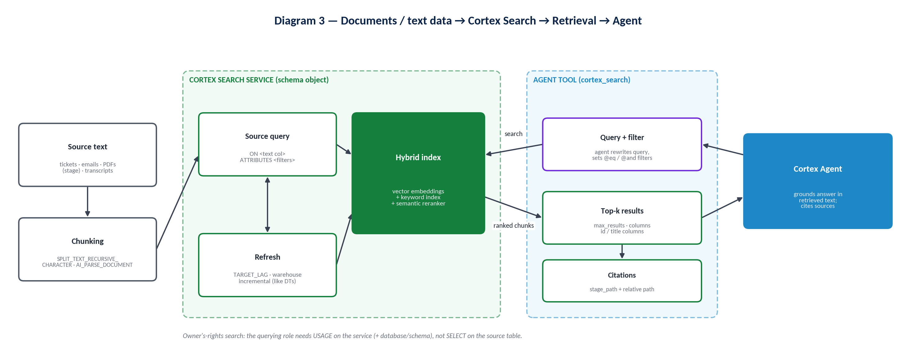
Diagram 3 — Documents/text → Cortex Search → Retrieval → Agent

7.5 Analyst or Search? How the agent decides
The orchestrator decides from tool names, tool descriptions and orchestration instructions. Make the boundary explicit: computation over records → Analyst; meaning inside text → Search. When a question needs both, instruct the sequence (usually Analyst first to identify entities, then Search filtered by those entities).

7.6 Combined scenario
- Structured data → Cortex Analyst: rank customers by revenue.
- Unstructured data → Cortex Search: find delay complaints, filtered to the ranked customer IDs and the shipping topic.
- Agent → orchestrates both: intersects entities, checks coverage, presents a table with ticket citations.

7.7 When to use and when not to use Search
Use Search for | Avoid Search for
Finding passages, evidence, quotes and reasons. | Exact totals, counts and rankings over records (use Analyst; or analytical search for document-level aggregates).
Fuzzy matching of names and concepts. | Real-time operational state that is not indexed (respect TARGET_LAG).
Policy and documentation Q&A with citations. | Data the caller must not see — the service runs with owner's rights (see below).

7.8 Best practices, limitations and security
- Chunk to ≤ 512 tokens (≈385 words); smaller chunks generally improve retrieval and answer quality. Text beyond the embedding model's context window is truncated for vector search (keyword search still uses the full text).
- Return a stable ID and title column so citations are meaningful; set stage_path and relative_path_column for stage-hosted files so CoWork can open the source (the querying role needs READ on the stage).
- Describe every filterable column with sample values; expose only attributes the agent should filter on.
- Use a dedicated warehouse no larger than MEDIUM for refresh; set max_results to control payload size and latency.
- Limits: materialized result below 400M rows by default; throughput limits (HTTP 429) require backoff; no cloning; don't modify or drop base tables while the service runs.
- Security: services search with owner's rights. The caller needs only USAGE on the service (plus database and schema), not SELECT on the source table. Build separate services (or filter by entitlement attributes) when different audiences may see different documents.
- Monitor service requests with GET_AI_OBSERVABILITY_EVENTS(..., 'CORTEX SEARCH SERVICE') after enabling REQUEST_LOGGING (requires MONITOR or OWNERSHIP on the service).

8. Cortex Analyst vs Cortex Search
Table 8 — Cortex Analyst vs Cortex Search
Dimension | Cortex Analyst | Cortex Search
Data type | Structured tables and views | Text (tables of text, parsed documents)
Primary purpose | Compute answers with SQL | Retrieve relevant passages
Input | Natural-language question + semantic view | Query text + optional filters, columns, limit
Output | SQL + result rows (+ interpretation) | Ranked rows/chunks with attributes and scores
Query behavior | Deterministic SQL execution on a warehouse | Hybrid vector + keyword retrieval with reranking
Structured data | Native | Only as filter attributes / returned columns
Unstructured data | Not suited | Native
Semantic layer | Required (semantic view or legacy model) | Not used (column descriptions in tool_resources)
Retrieval | Row-level results of a query | Top-k semantically relevant items
Natural-language questions | "How much / how many / which top N" | "What / why / what are people saying"
Example questions | "Top 10 customers by revenue last quarter" | "What are customers saying about delayed shipments?"
Agent usage | tool type cortex_analyst_text_to_sql | tool type cortex_search
Ideal use cases | KPIs, trends, rankings, comparisons | RAG, policy Q&A, complaint analysis, entity lookup
Limitations | Needs good semantic modeling; SQL-answerable only | Freshness bound by TARGET_LAG; owner's-rights exposure; not for exact aggregates
Security model | Caller's rights on tables | Owner's rights; caller needs USAGE on service

An agent needs both because real questions mix measurement and meaning: revenue identifies who matters, tickets explain what is wrong. Neither tool alone can join those perspectives; the orchestrator does, using the output of one as the scope of the other.
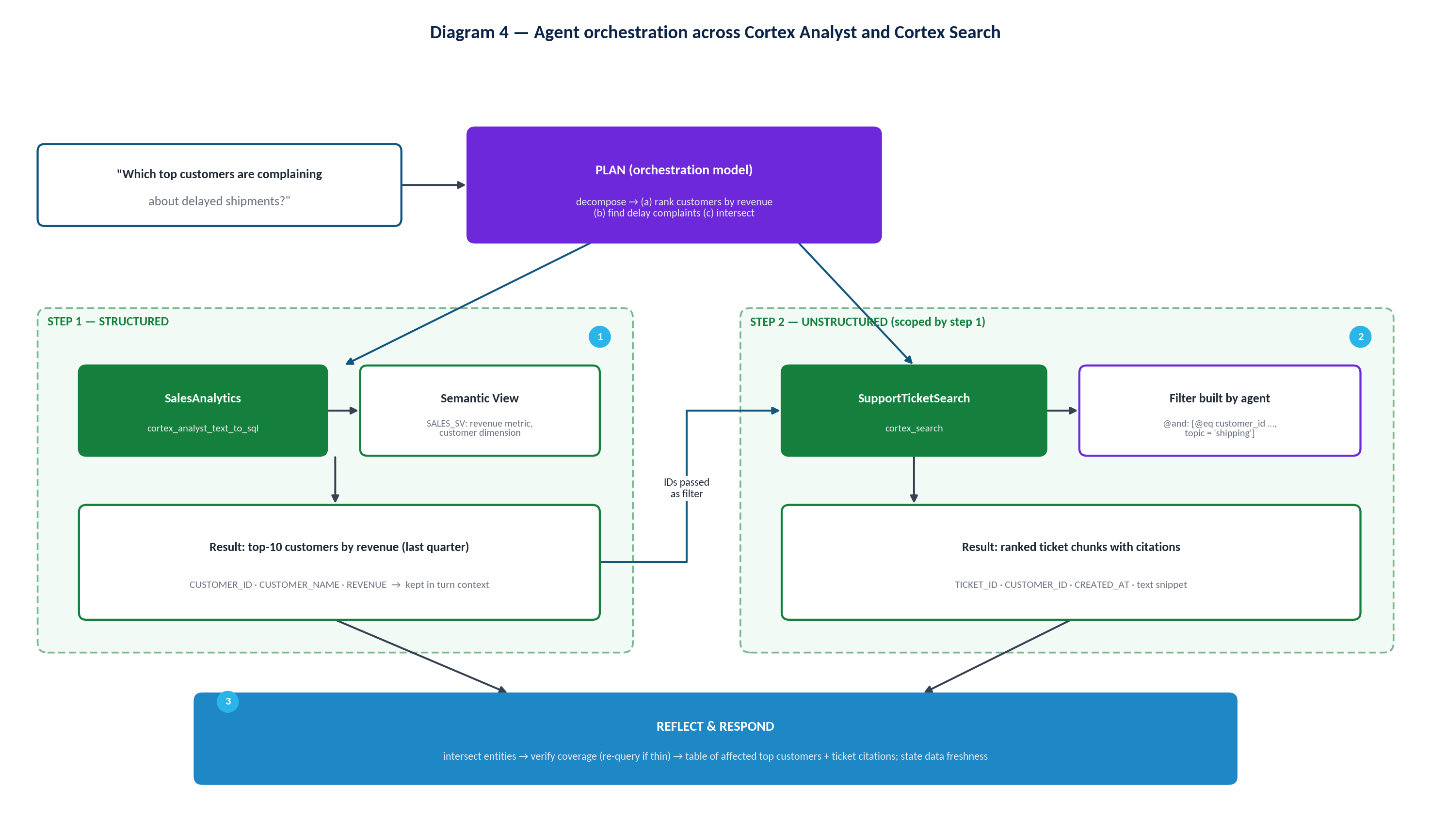
Diagram 4 — Agent orchestration between Analyst and Search

9. Agent Studio
Agent Studio is Snowflake's name for the experience used to build, evaluate and monitor agents. In Snowsight it is reached through AI & ML » Agents: the agent list, account-level settings (web search, Tools and Connectors, CoWork settings) and, per agent, the configuration, access, evaluation, observability and preview areas described below. Snowflake's product pages describe Agent Studio as rolling out, so exact tab names and grouping can differ between accounts.
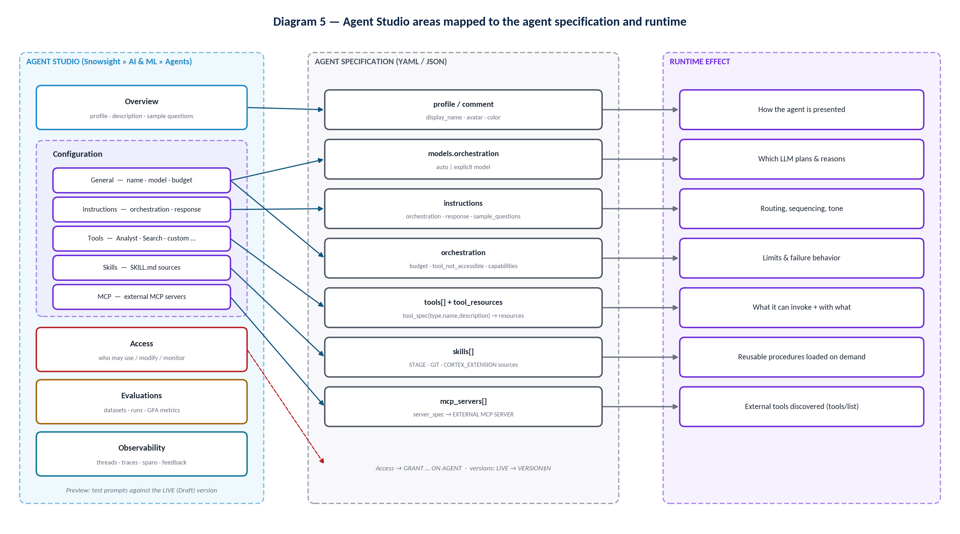
Diagram 5 — Agent Studio areas mapped to specification keys and runtime effect

9.1 Overview
Aspect | Overview
Purpose | Identity and discoverability of the agent.
Controls | Agent object name (SQL/REST identifier), display name (also the handle users reference), description, avatar/color (PROFILE), sample questions (instructions.sample_questions), version panel.
How to configure | Create agent → set database/schema, object name, display name; Edit → description and sample questions.
Important settings | Description and sample questions are what CoWork users see when choosing an agent.
Example | Display name "Sales & Support Assistant"; samples: "Top 10 customers by revenue last quarter", "Summarize shipping complaints for Acme".
Best practices | Describe scope and exclusions in one or two sentences; use sample questions the agent already answers well; keep samples independent.
Common mistakes | Generic names ("DataBot"); sample questions the agent fails on; describing capabilities it doesn't have.
Runtime effect | Presentation only. The description is not a substitute for orchestration instructions.

9.2 Configuration → General
Aspect | General
Purpose | Engine-level settings for the agent.
Controls | models.orchestration (recommend auto), orchestration.budget (seconds, tokens), orchestration.tool_not_accessible, orchestration.capabilities (e.g. analytical_search).
How to configure | Orchestration settings in Snowsight (model, budget) or the spec; the SQL SET SPECIFICATION replaces the whole specification.
Important settings | Budget tokens apply to orchestration only, not to tokens consumed by Analyst, Search or other tools. When either limit is reached, generation stops.
Example | models: {orchestration: auto}; budget: {seconds: 60, tokens: 32000}; tool_not_accessible: accept.
Best practices | Start with auto (quality improves as models are added); size budgets from observed p95 traces; pin a model only for compliance or reproducibility.
Common mistakes | Budgets so tight that multi-step questions end mid-plan; choosing a model not available in your cross-region scope.
Runtime effect | Determines which LLM plans and reasons, how long it may work, and whether missing privileges abort a run.

9.3 Configuration → Instructions
Aspect | Instructions
Purpose | Domain logic for planning and communication.
Controls | instructions.orchestration (planning instructions) and instructions.response (response instructions).
How to configure | Orchestration pane: Planning instructions, Response instruction.
Important settings | Keep tool routing, sequencing and conditional rules in orchestration; keep tone and format in response.
Example | See the template in Section 11.6.
Best practices | Don't restate generic agent behavior (Snowflake's base instructions already cover tool use, validation, citations, safety). Be specific about business terms, fiscal calendars and boundaries.
Common mistakes | Mixing formatting into routing rules; contradicting tool descriptions; unbounded "always call every tool" rules.
Runtime effect | Changes the plan, tool order, clarification behavior and final wording.

9.4 Configuration → Tools
Aspect | Tools
Purpose | Declare what the agent can invoke and with which resources.
Controls | tools[].tool_spec (type, name, description) and tool_resources.<name>: Cortex Analyst (semantic views, warehouse, timeout), Cortex Search (service, filters, columns, max results, ID/title columns, source stage), custom tools (function/procedure, parameters, warehouse), web search toggle, analytical search toggle.
How to configure | Tools → + Add per tool type; Generate with Cortex drafts Analyst descriptions; Data to Chart and code execution are set in the spec.
Important settings | Tool names 1–64 characters; custom tool parameters of type object are not supported; users need USAGE on the function/procedure.
Example | SalesAnalytics (Analyst), SupportTicketSearch (Search), data_to_chart.
Best practices | Domain + function names; descriptions that state data coverage, when to use and when NOT to use; explicit parameter formats.
Common mistakes | "Tool1"; two tools with overlapping descriptions; no filterable-column descriptions for Search.
Runtime effect | Defines the action space; descriptions drive tool-selection accuracy.

9.5 Configuration → Skills
Aspect | Skills
Purpose | Attach reusable, task-specific procedures.
Controls | skills[] entries with name and source (STAGE, GIT, or CORTEX_EXTENSION).
How to configure | Skills tab → Add Skill → Stage or Git → path to the skill folder.
Important settings | SKILL.md must be at the folder root; scripts must be in the same folder; scripts need the code execution tool; Git tag references update only after FETCH.
Example | shipment-escalation-brief at @SALES_SUPPORT_DB.AGENTS.SKILL_STAGE/skills/shipment-escalation-brief.
Best practices | One job per skill; precise description (it's the only part visible before selection); pin commits for production.
Common mistakes | Using a skill for what should be an orchestration rule; forgetting USAGE on the stage.
Runtime effect | Skill metadata is always visible to the orchestrator; full instructions load only when selected.

9.6 Configuration → MCP
Aspect | MCP
Purpose | Add tools hosted on remote MCP servers.
Controls | mcp_servers[].server_spec referencing EXTERNAL MCP SERVER objects created by an admin (Settings → Tools and Connectors).
How to configure | MCP Connectors tab → select an available connector → Add to agent.
Important settings | Tool list is fetched at run start (tools/list); calls use tools/call; server and API integration must be enabled; users authenticate with OAuth.
Example | SALES_SUPPORT_DB.INTEGRATIONS.JIRA_MCP to create escalation tickets.
Best practices | Descriptive server names; orchestration rules for external vs internal tools; require confirmation before write actions.
Common mistakes | Assuming MCP resources or prompts are available (tools only); hostnames with underscores.
Runtime effect | Extends the action space with external tools, per user, per connection state.

9.7 Access
Aspect | Access
Purpose | Decide who can use, change and monitor the agent.
Controls | Grants on the AGENT object: USAGE (run), MODIFY (edit), MONITOR (threads/logs/traces), OWNERSHIP. CoWork visibility can be curated with the Snowflake Intelligence (CoWork) object.
How to configure | Grant in the UI or with SQL (Section 15).
Important settings | Agent USAGE does not grant tool-object privileges; callers need a default role and default warehouse.
Best practices | Grant to functional roles, not users; separate builder, operator and consumer roles.
Common mistakes | Granting agent USAGE and expecting data access to follow; broad PUBLIC grants.
Runtime effect | Determines whether the run starts and which tools are usable.

9.8 Evaluations
Aspect | Evaluations
Purpose | Score an agent version on a dataset before and after changes.
Controls | Datasets, runs, agent version selector, role/warehouse selectors, system metrics and versions, custom metrics from a staged YAML.
How to configure | Create a dataset (or use Cortex Code), Create evaluation run → select version → dataset → metrics.
Runtime effect | None on production; produces traces and scores for comparison (Section 16).

9.9 Observability
Aspect | Observability
Purpose | Inspect live conversations and execution traces.
Controls | Thread list (first input, feedback, length, user, updated, version), trace view per turn, role/warehouse selectors.
Runtime effect | Read-only; requires MONITOR (Section 17).

9.10 Preview
Aspect | Preview
Purpose | Interactive testing against the current configuration.
Controls | Agent playground on the agent details page; "Preview in Snowflake Intelligence/CoWork" link.
Best practices | Test the golden questions after every edit; test with a consumer role, not only the owner role.
Common mistakes | Testing only as ACCOUNTADMIN, which hides missing grants.
Runtime effect | Runs the LIVE (Draft) version; traces appear in Observability.

10. Agent Configuration

10.1 Configuration questions
Concept | Question it answers | Where it lives
Configuration | What capabilities and resources does the agent have? | The whole specification + object properties
Instructions | How should the agent behave? | instructions.orchestration / instructions.response
Tools | What can the agent invoke? | tools[] + tool_resources
Skills | What reusable procedures can the agent apply? | skills[]
MCP | How can the agent reach MCP-hosted tools? | mcp_servers[] → EXTERNAL MCP SERVER

10.2 Complete specification example
SQL — create the Sales & Support agent
CREATE OR REPLACE AGENT sales_support_db.agents.sales_support_agent
COMMENT = 'Sales and support intelligence for account teams'
PROFILE = '{"display_name": "Sales & Support Assistant", "color": "blue"}'
FROM SPECIFICATION
$$
models:
orchestration: auto

orchestration:
tool_not_accessible: accept
budget:
seconds: 60
tokens: 32000

instructions:
orchestration: >
<see Section 11.6 template>
response: >
Lead with the direct answer. Use tables for more than 3 rows.
Always state the time period and data freshness. Cite ticket IDs.
sample_questions:
- question: "What were the top 10 customers by revenue last quarter?"
- question: "What are customers saying about delayed shipments?"

tools:
- tool_spec:
type: "cortex_analyst_text_to_sql"
name: "SalesAnalytics"
description: "Revenue, orders, AOV by customer/segment/fiscal quarter. Not for ticket text."
- tool_spec:
type: "cortex_search"
name: "SupportTicketSearch"
description: "Support ticket text. Filter by customer_id/topic. Not for totals."
- tool_spec:
type: "data_to_chart"
name: "data_to_chart"
description: "Generates visualizations from data"

tool_resources:
SalesAnalytics:
semantic_view: "SALES_SUPPORT_DB.SEMANTIC.SALES_SV"
execution_environment:
type: "warehouse"
warehouse: "AGENT_WH"
SupportTicketSearch:
search_service: "SALES_SUPPORT_DB.SUPPORT.TICKET_SEARCH"
max_results: 8
id_column: "TICKET_ID"
title_column: "TICKET_ID"

skills:
- name: "shipment-escalation-brief"
source:
type: "STAGE"
path: "@SALES_SUPPORT_DB.AGENTS.SKILL_STAGE/skills/shipment-escalation-brief"

mcp_servers:
- server_spec:
name: "SALES_SUPPORT_DB.INTEGRATIONS.JIRA_MCP"
$$;

EXPECTED BEHAVIOR
Revenue questions route to SalesAnalytics; complaint questions route to SupportTicketSearch; combined questions run Analyst first and pass customer IDs as a Search filter; escalation requests load the skill and, after user confirmation, call a Jira MCP tool. If a caller lacks a tool privilege, the run continues with a warning.

WHY THIS CONFIGURATION WORKS
Each tool has a single domain with explicit exclusions, so selection is unambiguous; data defaults live in the semantic view; routing lives in orchestration instructions; format lives in response instructions; limits are explicit; and the object is ready to be committed as a named version.

10.3 Default and runtime behavior
- With no tools, an agent can still converse but answers only from general model knowledge; it cannot query your account.
- The model defaults to Snowflake-selected when auto is used. Every custom instruction is combined with Snowflake's base system instructions.
- tool_not_accessible defaults to accept.
- Unversioned calls target the DEFAULT version (the latest committed version unless set explicitly). Creating an agent creates VERSION$1 and a LIVE version with the same spec.
- Permissions are evaluated from the caller's default role (REST callers can override with the X-Snowflake-Role header).

10.4 Agent context
- Threads persist conversation context server-side: create a thread (POST /api/v2/cortex/threads), then pass thread_id and parent_message_id (initially 0) on each run.
- Without an agent object, POST /api/v2/cortex/agent:run accepts the full configuration per request; the client must then manage context itself.
- Within a turn, tool results are available to later planning steps; across turns, the thread supplies history.
REST — run the agent within a thread
curl -X POST "$SNOWFLAKE_ACCOUNT_BASE_URL/api/v2/databases/SALES_SUPPORT_DB/schemas/AGENTS/agents/SALES_SUPPORT_AGENT:run" \
--header 'Content-Type: application/json' \
--header "Authorization: Bearer $PAT" \
--data '{
"thread_id": <thread_id>,
"parent_message_id": 0,
"messages": [{"role": "user",
"content": [{"type": "text",
"text": "Which top customers are complaining about delayed shipments?"}]}]
}'

SQL — versioning workflow
DESCRIBE AGENT sales_support_db.agents.sales_support_agent;
ALTER AGENT sales_support_db.agents.sales_support_agent COMMIT COMMENT = 'v2: Jira escalation';
SHOW VERSIONS IN AGENT sales_support_db.agents.sales_support_agent;
ALTER AGENT sales_support_db.agents.sales_support_agent MODIFY VERSION VERSION$2 SET ALIAS = production;
ALTER AGENT sales_support_db.agents.sales_support_agent SET DEFAULT_VERSION = 'VERSION$2';
ALTER AGENT sales_support_db.agents.sales_support_agent ADD LIVE VERSION FROM LAST; -- resume development

SELECT SNOWFLAKE.CORTEX.DATA_AGENT_RUN(
'SALES_SUPPORT_DB.AGENTS.SALES_SUPPORT_AGENT!production',
$${"messages": [{"role": "user", "content": [{"type": "text", "text": "Top 10 customers by revenue last quarter"}]}]}$$
);

IMPORTANT SET SPECIFICATION replaces everything
ALTER AGENT … MODIFY LIVE VERSION SET SPECIFICATION replaces the whole specification. Start from the current LIVE spec (DESCRIBE AGENT) and include all unchanged fields, or you will silently drop tools, skills or settings. Named versions are immutable: to change production behavior, edit LIVE, commit, then repoint the alias or default.

11. Orchestration Instructions

11.1 What orchestration means
Orchestration is the LLM-driven plan → use tools → reflect loop. The orchestrator decides the next action from four inputs: the conversation, Snowflake's base instructions, your orchestration instructions, and the tool/skill catalog (names and descriptions). Orchestration instructions are the only one of those you write purely to encode business process.

11.2 What instructions influence
Influence | Typical instruction
Tool selection | "Revenue, orders and AOV → SalesAnalytics. Complaints and reasons → SupportTicketSearch."
Sequencing | "When a customer is named, resolve customer_id with SalesAnalytics before searching tickets."
Parameterization | "Pass customer IDs as a customer_id filter; use topic = shipping for delivery issues."
Interpretation | "'Last quarter' means the last completed fiscal quarter; FY starts Feb 1."
Clarification | "If more than one customer matches a name, ask which one."
Tool avoidance | "Answer questions about what you can do without calling tools."
Boundaries | "Do not forecast revenue. Do not reveal contact details."
Response hand-off | Formatting rules belong in response instructions, not here.

Diagram 4 (Section 8) shows how these influences combine for a question that needs both Analyst and Search.

11.3 Ambiguity, missing information and multi-step tasks
- Ask when the answer would materially change based on an unstated choice (which entity, which region, which metric definition) and no documented default exists.
- Default when the business has a rule (e.g. last completed fiscal quarter) — state the default in the answer rather than asking.
- Invoke a tool when the answer depends on account data; don't for meta questions, greetings, capability questions or pure explanation of terms defined in instructions.
- Multi-step: write numbered workflows for recurring composite requests; tell the agent which outputs feed which inputs.
- Avoid unnecessary calls: forbid "call every tool to be safe"; require Search only when text evidence is requested; cap result sizes and require aggregation above a row threshold.

11.4 Poor versus improved instruction
COMMON MISTAKE Poor orchestration instruction
"You are a helpful assistant. Use the tools to answer questions about sales and support. Be accurate and ask questions if needed. Search when necessary."

BEST PRACTICE Improved orchestration instruction
Role: You support account executives with revenue and support insight for commercial customers.
Routing: Revenue, orders, AOV, rankings and trends → SalesAnalytics. Complaint content, reasons, sentiment and quotes → SupportTicketSearch. Never use SupportTicketSearch to count or total.
Sequencing: For questions combining customer value and complaints, first get customer_id values from SalesAnalytics, then call SupportTicketSearch with a customer_id filter (and topic = shipping for delivery issues).
Defaults: 'last quarter' = last completed fiscal quarter (FY starts Feb 1). 'Top customers' = top 10 by net revenue unless a number is given.
Clarify: If a named customer matches more than one account, ask which one. Do not ask about time period when the default applies — state it.
Boundaries: No forecasts. No personal contact data. Escalations to Jira only after the user explicitly confirms.

The improved version names tools exactly, gives positive and negative routing rules, defines the sequence and the data hand-off, encodes defaults so the agent doesn't over-ask, limits clarification to real ambiguity, and states hard boundaries including a confirmation gate for write actions.

11.5 Instruction-writing best practices
- Separate orchestration (what to do, which tools, in what order) from response (format, tone).
- Use the same vocabulary as tool names, descriptions and semantic view synonyms.
- Prefer short, testable rules over prose; every rule should map to an evaluation case.
- Don't duplicate data rules that belong in the semantic view (default filters, rounding).
- Don't describe generic agent mechanics; Snowflake's base instructions already do.
- Change one thing at a time and re-run the evaluation set.

11.6 Reusable orchestration instructions template
Template — instructions.orchestration
ROLE AND SCOPE
- You are <agent name>, serving <users> for <purpose>.
- In scope: <topics>. Out of scope: <topics> -> respond "<redirect message>".

DOMAIN CONTEXT
- Fiscal calendar: <rule>. Data refresh: <schedule/lag>.
- Terms: <term> = <definition>; <term> = <definition>.

TOOL SELECTION
- <ToolA>: use for <questions>. Examples: "<q1>", "<q2>". Do NOT use for <x>.
- <ToolB>: use for <questions>. Do NOT use for <x>.
- No tool: greetings, capability questions, definitions given above.

SEQUENCING AND HAND-OFFS
- When <condition>, call <ToolA> first to obtain <field>, then call <ToolB> with filter <field>.

DEFAULTS AND CLARIFICATION
- Default <parameter> to <value> and state it in the answer.
- Ask a clarifying question only when <ambiguity condition>.

BUSINESS RULES
- If results exceed <N> rows, aggregate before presenting.
- If a tool returns an access error, say "<message>" and do not retry other tools for the same data.

ACTIONS AND BOUNDARIES
- Never <prohibited action>. Perform <write action> only after explicit user confirmation.

12. Tools

12.1 What a tool is and why it is required
A tool is a typed capability the orchestrator can invoke, defined by a tool_spec (type, name, description) and, where needed, a tool_resources entry binding it to Snowflake objects and execution settings. Tools are the only way an agent touches your data or systems; without them it is a conversational model.
Table 9 — Tool types (verify preview status in your account)
Tool type | Purpose | Resources / notes
cortex_analyst_text_to_sql | Text-to-SQL over semantic views | semantic_view (or legacy semantic_model_file), execution environment (warehouse), timeout
cortex_search | Retrieval over text | search_service, filter, max_results, columns_and_descriptions, id/title columns, stage_path, relative_path_column
Analytical search (preview) | Counts/aggregates/trends over documents | orchestration.capabilities.analytical_search: true; adds warehouse + AI function cost
generic (custom tool) | Call a UDF or stored procedure | function/procedure identifier, parameters, warehouse; USAGE required; owner's/caller's rights preserved
code_execution | Python in an isolated sandbox | tool_resources: code_execution: {}; required for skill scripts; mutually exclusive with code_toolset_all
code_toolset_all | Managed coding sandbox (bash, files, SQL, skills) | Coding Agent feature; one of code_toolset_all / code_execution per request
data_to_chart | Visualizations from tool data | No resources
web_search | Public web via Brave Search API | Account-level enablement by ACCOUNTADMIN; traffic crosses the public internet (ZDR with Brave)
Agent toolsets | Inherit another agent's tools at run time | USAGE on the referenced agent; silently skipped otherwise
MCP connector tools | Remote tools | mcp_servers (Section 14)

12.2 Tool definition: inputs, outputs, descriptions, boundaries
- Name: domain + function (SupportTicketSearch, not Search1). For Analyst, the semantic view name is also used to identify the tool.
- Description formula: what it does + what data it covers + when to use + when NOT to use + key parameters.
- Inputs: specify types, formats (ISO dates), required vs optional with defaults, valid values, and how to obtain IDs.
- Outputs: say what comes back (rows, chunks, JSON) so the agent can plan hand-offs.
- Boundaries: explicit exclusions prevent a tool being used for everything remotely related.

12.3 Invocation, chaining, errors and permissions
- Invocation: the orchestrator emits a call with arguments; Snowflake executes it and returns the result into the loop. Callers of agent:run can constrain tools with tool_choice (for example required with a list of names).
- Chaining: results from one call are available to later calls in the same turn; instruct the hand-off explicitly.
- Errors: a failing custom/code/SQL tool returns its error as a tool result and the agent continues reasoning; instruct fallback behavior and user-facing messages.
- Permissions: Search, Analyst, MCP and skill tools are pre-checked at run start; custom, code execution and SQL execution tools fail at call time if privileges are missing.
- Result interpretation: ask the agent to state assumptions (period, filters) and to flag empty or suspicious results.
EXAMPLE Custom tool description
Name: GetShipmentStatus. Description: Returns carrier, promised date and actual delivery date for one order_id (format ORD-########) from the logistics system. Use when the user asks about a specific order's delivery. Do NOT use for aggregate delay rates (use SalesAnalytics). Parameters: order_id (string, required; obtain from SalesAnalytics if the user gives a customer instead).

12.4 Best practices
- Give an agent exactly the tools its target questions require — no more.
- Prefer one well-described Analyst tool per coherent semantic view over many tiny ones.
- Use dedicated, least-privileged warehouses for tool execution.
- Scope code execution carefully: it inherits the agent owner's role privileges; enable PyPI or external access only when needed.
- Write orchestration rules for web search vs internal tools so the agent doesn't default to the web.

13. Skills

13.1 What a skill is and why Snowflake provides skills
A skill is a modular, portable folder containing a SKILL.md (name, description, instructions) and optional scripts, stored on a named stage, in a Git repository, or packaged in a Cortex Extension. Skills let teams encode a repeatable procedure once and reuse it across agents, without bloating every agent's instructions. Agents reference skills in place and read them on demand; updating the files updates every agent that references them (Git tags after FETCH).

13.2 How skills influence behavior
- At run time the orchestrator sees each skill's name and description.
- If a skill looks relevant, the agent retrieves the full SKILL.md instructions and script paths.
- The agent follows those instructions, calling tools (and code execution for scripts) as directed.
- Invocations appear in thinking steps in CoWork and in monitoring alongside other orchestration spans.
SKILL.md — shipment escalation brief (illustrative)
---
name: shipment-escalation-brief
description: Produce an escalation brief for a customer with delayed-shipment complaints, including revenue at risk and ticket evidence.
---
# Instructions
1. Confirm the customer (customer_id) with SalesAnalytics; get trailing-4-quarter revenue.
2. Search SupportTicketSearch with customer_id and topic = shipping; keep the 5 most relevant tickets.
3. Summarize: revenue at risk, complaint themes, first/last complaint dates, ticket IDs.
4. Offer to open a Jira escalation; create it only after explicit confirmation.

VERIFY
The documented required SKILL.md fields are name, description and instructions. The front-matter layout above is illustrative; follow the format in the current Agent skills documentation.

SQL — stage a skill and attach it
CREATE STAGE IF NOT EXISTS sales_support_db.agents.skill_stage;
PUT file:///repo/skills/shipment-escalation-brief/SKILL.md
@sales_support_db.agents.skill_stage/skills/shipment-escalation-brief/;
LS @sales_support_db.agents.skill_stage/ PATTERN='.*SKILL\.md';

-- then include in the full specification:
-- skills:
-- - name: "shipment-escalation-brief"
-- source: { type: "STAGE", path: "@SALES_SUPPORT_DB.AGENTS.SKILL_STAGE/skills/shipment-escalation-brief" }

GRANT USAGE ON STAGE sales_support_db.agents.skill_stage TO ROLE sales_agent_user_role;

13.3 Distinctions
Table 10 — Instruction vs Tool vs Skill vs MCP
Component | Purpose | Visible to orchestrator | Executes?
Instruction | Always-on behavioural rules: routing, sequencing, tone, boundaries. | Always, in full | No
Tool | A single invocable capability bound to a Snowflake object or service. | Name + description | Yes — Snowflake executes it
Skill | A reusable multi-step procedure (instructions ± scripts) loaded when relevant. | Name + description; body on demand | Indirectly — through tools / code execution
MCP | A connector to a remote server that contributes additional tools. | Discovered tool names + descriptions | Yes — on the remote server

- Skill vs Tool: a tool does one thing; a skill tells the agent how to combine things for a task.
- Skill vs Instruction: instructions apply to every turn and cost context every time; skills load only when needed and are shareable across agents.
- Skill vs MCP: MCP adds new external capabilities; a skill adds know-how for using existing capabilities.
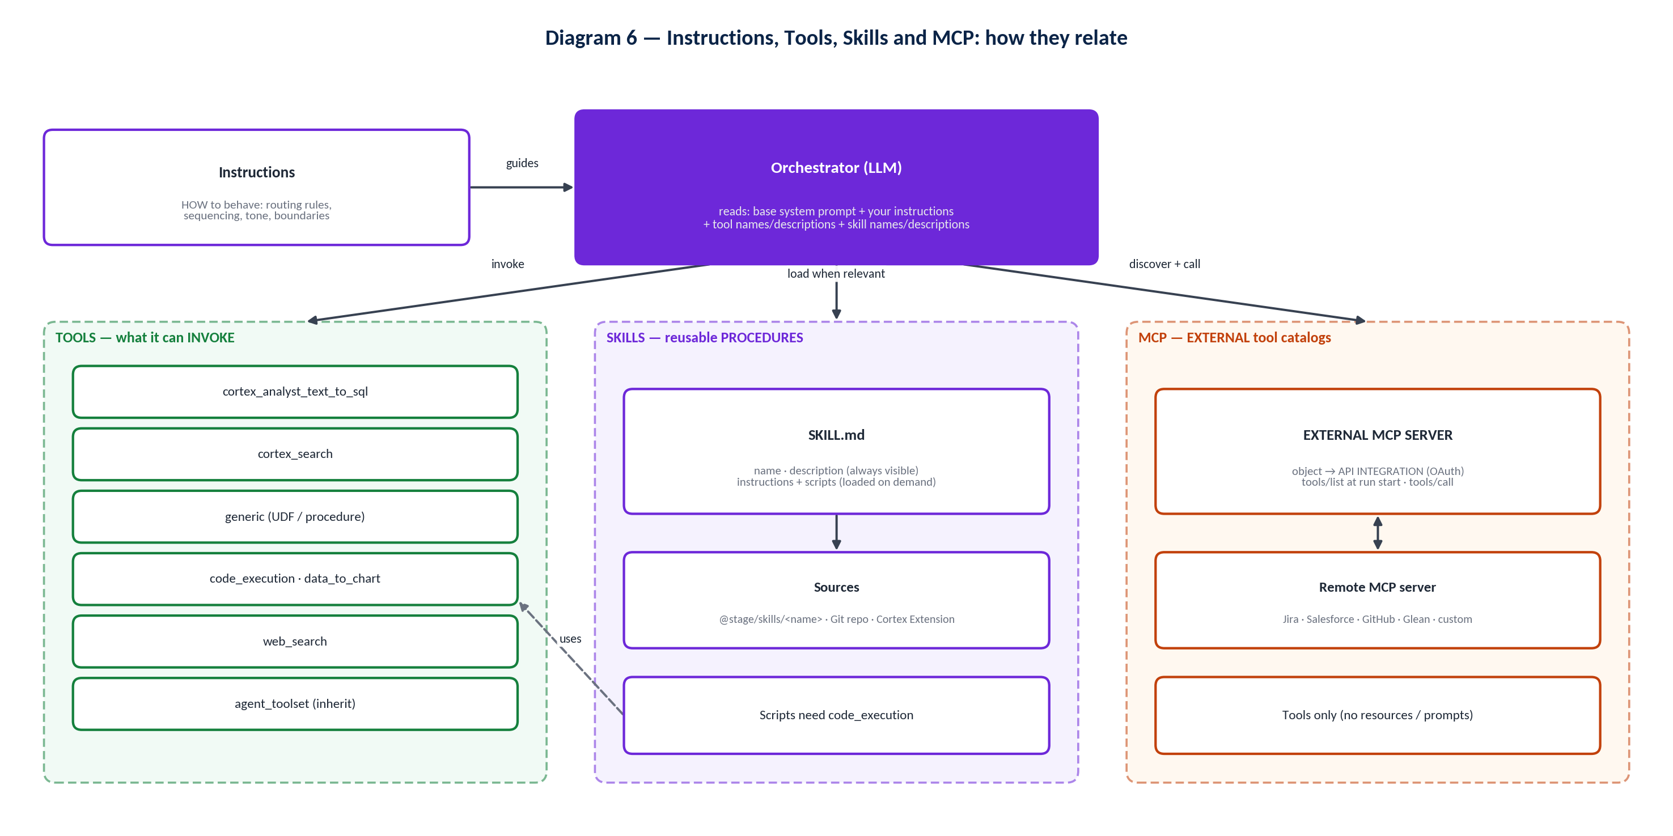
Diagram 6 — Tools, Skills and MCP relationship

13.4 When to use skills and best practices
- Use a skill for recurring, multi-step tasks with a stable procedure (briefs, reconciliations, forecasts with a script). Keep one-line routing rules in instructions.
- Write descriptions that state trigger conditions precisely — the description is the selection signal.
- Keep scripts in the skill folder; enable code_execution when scripts exist.
- Pin Git commit hashes for production; use tags only when automatic updates after FETCH are intended.
- Grant USAGE on the stage or Git integration (READ on a Cortex Extension); MODIFY on the agent is needed to add skills.
- In CoWork, configured skills are available automatically and can be selected explicitly with the + button.

14. MCP

14.1 MCP in the context of Cortex Agents
Model Context Protocol is an open standard for agents to discover and invoke tools. Snowflake uses it in two directions, and both are relevant to agent architecture.
Table 11 — Two MCP integration patterns
 | MCP connectors (outbound) | Snowflake-managed MCP server (inbound)
Direction | Cortex Agent → remote MCP server | External MCP client → Snowflake
Object | EXTERNAL MCP SERVER + API INTEGRATION (API_PROVIDER = external_mcp) | MCP SERVER (CREATE MCP SERVER … FROM SPECIFICATION)
Tools | Whatever the remote server lists (tools/list) | CORTEX_AGENT_RUN, CORTEX_ANALYST_MESSAGE, CORTEX_SEARCH_SERVICE_QUERY, SYSTEM_EXECUTE_SQL, GENERIC (max 50 per server)
Auth | OAuth only (OAUTH2 or dynamic client registration), per user | Snowflake OAuth by default or External OAuth; no dynamic client registration
Protocol scope | Tools only (no resources, prompts, sampling…) | Tools only; revision 2025-11-25
Typical use | Create Jira issues, query Salesforce, GitHub, Glean, Linear, Google Workspace | Let Claude, ChatGPT, Cursor or custom agents use a governed Cortex Agent

Figure — MCP positions within the overall architecture (Diagram 1, repeated)

14.2 How an agent interacts with an MCP connector
- Admin creates the provider-side OAuth app and registers Snowflake's callback URL.
- Admin creates an API integration and an EXTERNAL MCP SERVER object (or uses Settings → Tools and Connectors → Browse Connectors for Atlassian, GitHub, Glean, Linear, Salesforce).
- Developer adds the server to the agent's mcp_servers.
- Users connect (OAuth) in CoWork; API clients use SYSTEM$START_USER_OAUTH_FLOW / SYSTEM$FINISH_OAUTH_FLOW.
- At run start the agent calls tools/list on each enabled, connected server; during orchestration it calls tools/call. Snowflake verifies the server and its integration are enabled before each call.
SQL — custom MCP connector
CREATE API INTEGRATION jira_mcp_integration
API_PROVIDER = external_mcp
API_ALLOWED_PREFIXES = ('https://mcp.atlassian.com')
API_USER_AUTHENTICATION = (
TYPE = OAUTH_DYNAMIC_CLIENT,
OAUTH_RESOURCE_URL = 'https://mcp.atlassian.com/v1/mcp'
)
ENABLED = TRUE;

CREATE EXTERNAL MCP SERVER sales_support_db.integrations.jira_mcp
WITH DISPLAY_NAME = 'Atlassian (Jira & Confluence)'
URL = 'https://mcp.atlassian.com/v1/mcp'
API_INTEGRATION = jira_mcp_integration;

GRANT USAGE ON EXTERNAL MCP SERVER sales_support_db.integrations.jira_mcp TO ROLE sales_agent_user_role;
GRANT USAGE ON INTEGRATION jira_mcp_integration TO ROLE sales_agent_user_role;

-- Maintenance: disable (invalidates user tokens, keeps config) vs drop (deletes secrets)
ALTER API INTEGRATION jira_mcp_integration SET ENABLED = FALSE;

SQL — expose the agent through a Snowflake-managed MCP server
CREATE OR REPLACE MCP SERVER sales_support_db.agents.sales_mcp
FROM SPECIFICATION $$
tools:
- title: "Sales & Support agent"
name: "sales_support_agent"
type: "CORTEX_AGENT_RUN"
identifier: "SALES_SUPPORT_DB.AGENTS.SALES_SUPPORT_AGENT"
description: "Governed answers about customer revenue and support tickets."
$$;
-- Endpoint: https://<account_url>/api/v2/databases/SALES_SUPPORT_DB/schemas/AGENTS/mcp-servers/SALES_MCP
GRANT USAGE ON MCP SERVER sales_support_db.agents.sales_mcp TO ROLE mcp_access_role;
GRANT USAGE ON AGENT sales_support_db.agents.sales_support_agent TO ROLE mcp_access_role;

14.3 MCP versus native tools
Use MCP when | Use native tools when
The capability lives in a SaaS system with an MCP server (Jira, Salesforce, GitHub). | The data is in Snowflake — Analyst, Search or a UDF is governed, cheaper and faster.
Actions must be taken as the individual user in that system (per-user OAuth). | You need the call covered by agent evaluations (MCP tools are not exercised during evaluations).
You want external agents to reach Snowflake through one governed entry (inbound). | You would otherwise expose raw SQL execution to an external client.

14.4 Security and access implications
- External MCP servers are not provided, maintained or verified by Snowflake; verify trustworthiness and review every tool's description to avoid tool poisoning or shadowing.
- Grant USAGE on both the EXTERNAL MCP SERVER and its API integration; access to a server does not by itself grant access to its tools.
- Set OAUTH_REFRESH_TOKEN_VALIDITY (≥ 3600 seconds) for OAUTH2 integrations; the default (0) never expires.
- Use hyphens, not underscores, in hostnames.
- Inbound: prefer exposing a Cortex Agent over SYSTEM_EXECUTE_SQL; if SQL is required, put it on a separate server with a dedicated least-privileged role. Restrict the OAuth integration with ALLOWED_ROLES_LIST and OAUTH_USE_SECONDARY_ROLES = NONE; clients such as Claude use the user's DEFAULT_ROLE.
- Avoid recursive agent ↔ MCP loops; Snowflake enforces a maximum recursion depth of 10.
- Network policies must allow the MCP client provider's egress IPs for inbound use; MCP server objects are not replicated in failover groups.
- MCP tool spans appear in observability; full inputs/outputs may be redacted without READ UNREDACTED AI OBSERVABILITY EVENTS TABLE.

15. Access and Security

15.1 Agent access versus underlying data access
Granting USAGE on an agent lets a role start a run. It does not grant the role anything the agent's tools touch. Each tool call is authorized separately against the caller's default role (or the tool's owner, for owner's-rights objects). This separation is deliberate: one agent can serve users with different entitlements, and row access and masking policies still apply to every generated query.
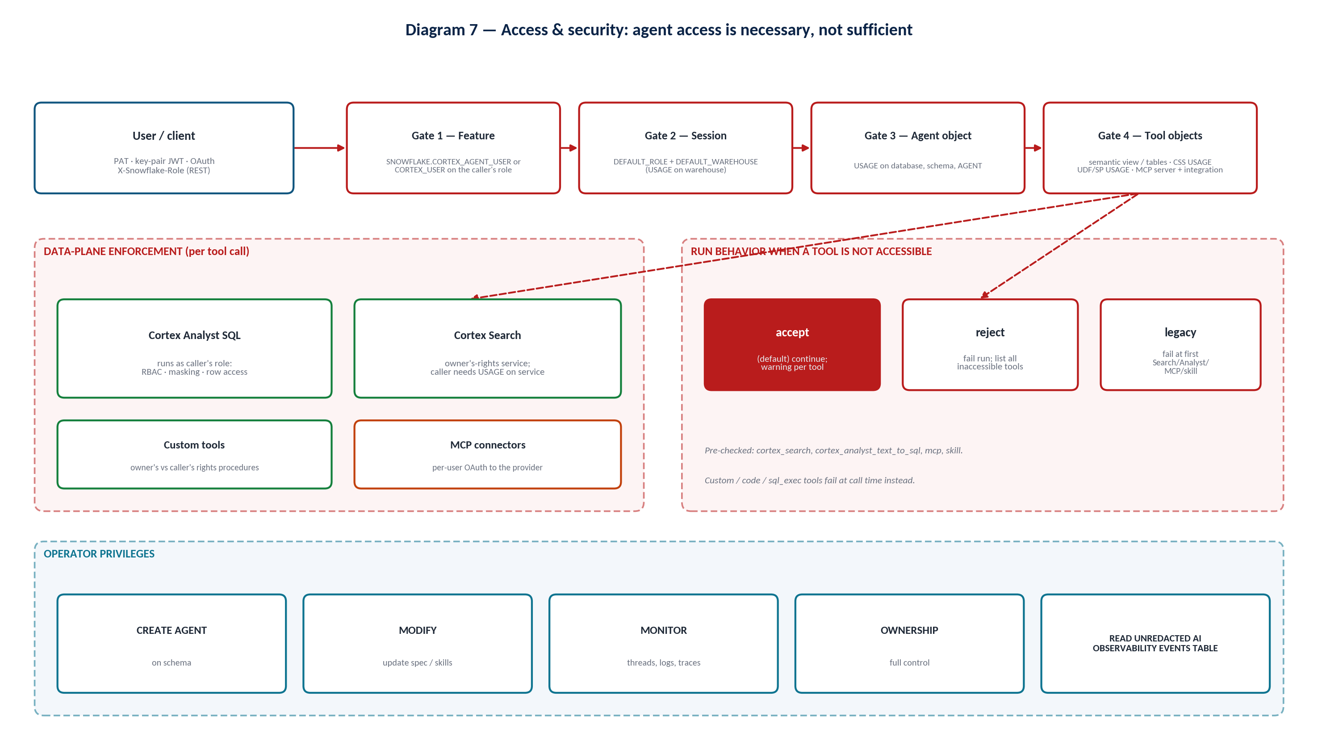
Diagram 7 — Access and security gates
IMPORTANT Why agent access ≠ data access
- A sales rep and a finance analyst can use the same agent; row access policies make Analyst return only each user's territory.
- Cortex Search runs with the service owner's rights: anyone with USAGE on the service can retrieve its indexed text. Control exposure at the service level.
- Owner's-rights stored procedures used as custom tools can act beyond the caller's privileges — review them like any privileged API.

15.2 Required roles and privileges
Table 12 — Privilege reference
Who | Privilege / role | Object | Purpose
Callers | SNOWFLAKE.CORTEX_AGENT_USER (agents only) or SNOWFLAKE.CORTEX_USER (all covered AI features) | Database role granted to an account role | Call agent:run / use agents
Callers | USAGE | Database, schema, AGENT | Run the agent
Callers | USAGE | Default warehouse | Run agent queries and tools
Callers | USAGE (+ db/schema) | Cortex Search service | Search tool
Callers | Access to the semantic view; SELECT on referenced tables | Semantic view / tables | Analyst tool
Callers | USAGE | Function / procedure | Custom tools
Callers | USAGE | EXTERNAL MCP SERVER + API integration | MCP connector tools
Callers | USAGE (READ for Cortex Extension) | Stage / Git integration | Skills
Callers | READ | Stage in stage_path | Open cited source files in CoWork
Builders | CREATE AGENT | Schema | Create agents
Builders | MODIFY | AGENT | Update spec, add skills
Operators | MONITOR (or OWNERSHIP) + CORTEX_USER | AGENT | View threads, logs, traces
Operators | READ UNREDACTED AI OBSERVABILITY EVENTS TABLE | Account | See full inputs/outputs/feedback text
Admins | CREATE EXTERNAL MCP SERVER; CREATE MCP SERVER | Schema | Create MCP objects

VERIFY Semantic view privilege wording
Snowflake pages describe the Analyst tool's requirement differently (USAGE vs SELECT on the semantic view/model, and USAGE vs SELECT on referenced tables). Direct SQL queries need SELECT on the semantic view; the MCP server's Analyst tool requires SELECT on the semantic view. Grant SELECT on the semantic view and its referenced tables and verify against the current access-control documentation before implementation.

SQL — consumer role setup
USE ROLE ACCOUNTADMIN;
-- Optional: stop giving every user all Cortex features
REVOKE DATABASE ROLE SNOWFLAKE.CORTEX_USER FROM ROLE PUBLIC;

CREATE ROLE IF NOT EXISTS sales_agent_user_role;
GRANT DATABASE ROLE SNOWFLAKE.CORTEX_AGENT_USER TO ROLE sales_agent_user_role;

GRANT USAGE ON DATABASE sales_support_db TO ROLE sales_agent_user_role;
GRANT USAGE ON SCHEMA sales_support_db.agents TO ROLE sales_agent_user_role;
GRANT USAGE ON SCHEMA sales_support_db.semantic TO ROLE sales_agent_user_role;
GRANT USAGE ON SCHEMA sales_support_db.support TO ROLE sales_agent_user_role;
GRANT USAGE ON AGENT sales_support_db.agents.sales_support_agent TO ROLE sales_agent_user_role;
GRANT USAGE ON WAREHOUSE agent_wh TO ROLE sales_agent_user_role;

GRANT SELECT ON SEMANTIC VIEW sales_support_db.semantic.sales_sv TO ROLE sales_agent_user_role;
GRANT SELECT ON TABLE sales_support_db.crm.customers TO ROLE sales_agent_user_role;
GRANT SELECT ON TABLE sales_support_db.crm.orders TO ROLE sales_agent_user_role;
GRANT USAGE ON CORTEX SEARCH SERVICE sales_support_db.support.ticket_search TO ROLE sales_agent_user_role;

GRANT ROLE sales_agent_user_role TO USER jdoe;
ALTER USER jdoe SET DEFAULT_ROLE = sales_agent_user_role DEFAULT_WAREHOUSE = agent_wh;

-- Operators
CREATE ROLE IF NOT EXISTS agent_ops_role;
GRANT MONITOR ON FUTURE AGENTS IN SCHEMA sales_support_db.agents TO ROLE agent_ops_role;
GRANT DATABASE ROLE SNOWFLAKE.CORTEX_USER TO ROLE agent_ops_role;

15.3 Authentication and authorization
- REST calls require a token: programmatic access token (PAT), key-pair JWT or OAuth. Use X-Snowflake-Role to run under a role other than the default.
- Permissions come from the caller's default role, and the caller must have a default warehouse. If either is missing, calls fail even when the current session role is sufficient.
- CoWork initializes sessions with the default role and warehouse; all queries use the user's credentials, and RBAC and masking apply.
- ALLOWED_INTERFACES can restrict a user to CoWork only; LOGIN_IDP_REDIRECT sends unauthenticated users to the IdP.

15.4 Runtime security
tool_not_accessible | Behavior
accept (default) | Continue with accessible tools; emit one response.warning per inaccessible named tool (also in the non-streaming warnings array and the trace).
reject | Fail the run with one 4XX error listing every inaccessible pre-checked tool.
legacy | Fail at the first inaccessible Search, Analyst, MCP or skill tool.

VERIFY
The Cortex Agents overview page still states that a missing tool privilege rejects the request with a 4XX error, while the dedicated "Inaccessible tool handling" page documents accept as the default. Set the mode explicitly in every specification.

15.5 Governance and least privilege
- Separate roles for builders (CREATE AGENT, MODIFY), operators (MONITOR), and consumers (USAGE + tool objects).
- Revoke CORTEX_USER from PUBLIC if not every user should access Cortex; grant CORTEX_AGENT_USER to specific roles.
- Use row access and masking policies on base tables — they flow through Analyst automatically.
- Partition Search services by audience or include entitlement attributes and enforce filters.
- Curate CoWork visibility with the Snowflake Intelligence (CoWork) object; the legacy SNOWFLAKE_INTELLIGENCE.AGENTS schema approach is deprecated.
- Enable web search only when needed (account-level) and document that queries traverse the public internet.
- Control cost exposure with orchestration budgets, agent resource budgets and per-user AI quotas.
- Use Cortex AI Guardrails where required (supported for CoWork and Cortex Agents).

16. Evaluations

16.1 Why evaluate and what to evaluate
Agents are non-deterministic and depend on models, data, instructions and descriptions that all change. Evaluations give a repeatable, versioned score so you know when an agent is ready and when a change regressed it. Snowflake's metrics follow the Goal-Plan-Action (GPA) framework, judging each stage of reasoning rather than only the final answer.
Table 13 — Evaluation metrics
Metric | Stage | Ground truth key | Notes
tool_selection_accuracy (preview) | Goal → plan | ground_truth_invocations[].tool_name | Deterministic: matched / max(expected, actual); penalizes too few, too many and wrong tools.
tool_execution_accuracy (preview) | Plan → action | ground_truth_invocations[].tool_input / tool_output | LLM judge; extra calls not penalized (use TSA).
answer_correctness | Action → goal | ground_truth_output | Compares the full streamed reply against a plain-language rubric.
logical_consistency | Whole loop | none (reference-free) | Consistency across instructions, planning and tool calls.
Custom metrics | Any | entire ground truth via {{ground_truth}} | LLM-judge prompt with score ranges; can reference {{tool_info}}, {{duration}}, etc.

TSA/TEA currently score Cortex Analyst, Cortex Search, web search and custom tools. Use answer correctness, logical consistency or custom metrics for other tool types.

16.2 Datasets and expected answers
SQL — evaluation dataset
CREATE OR REPLACE TABLE eval_db.eval_schema.sales_agent_eval (
input_query VARCHAR,
ground_truth VARIANT
);

INSERT INTO eval_db.eval_schema.sales_agent_eval
SELECT 'Which of our top 10 customers by revenue in FY27-Q1 opened shipping complaints in that quarter?',
PARSE_JSON('{
"ground_truth_output": "Names exactly the customers among the FY27-Q1 top 10 by net revenue that have shipping tickets in FY27-Q1 (expected: Acme Corp, Globex). Cites ticket IDs. Does not include customers outside the top 10.",
"ground_truth_invocations": [
{"tool_name": "SalesAnalytics",
"tool_input": "top 10 customers by net revenue for FY27-Q1",
"tool_output": "10 rows with customer_id and revenue"},
{"tool_name": "SupportTicketSearch",
"tool_input": "shipping delay complaints filtered to the top-10 customer_ids",
"tool_output": "tickets for Acme Corp and Globex"}
]
}');

- Use absolute dates in questions and ground truth to prevent drift.
- Write ground_truth_output as a rubric with literal values, tolerances and exclusions.
- Use [] for ground_truth_invocations when no tool should be called (e.g. out-of-scope questions).
- Create datasets with SYSTEM$CREATE_EVALUATION_DATASET, the Evaluations tab, or Cortex Code (synthetic or production-sourced questions).

16.3 Running evaluations
YAML — evaluation configuration (upload to a stage with the YAML file format)
evaluation:
agent_params:
agent_name: "SALES_SUPPORT_DB.AGENTS.SALES_SUPPORT_AGENT"
agent_type: "CORTEX AGENT"
agent_version: "VERSION$3"
run_params:
label: "v3 regression"
source_metadata:
type: "dataset"
dataset_name: "SALES_AGENT_EVAL_DS"

metrics:
- name: "answer_correctness"
version: "v3"
- name: "logical_consistency"
version: "v3"
- name: "tool_selection_accuracy"
version: "v3"
- name: "tool_execution_accuracy"
version: "v3"
- name: "citation_quality"
model: "claude-sonnet-4-6"
score_ranges:
min_score: [1, 3]
median_score: [4, 6]
max_score: [7, 10]
prompt: |
Score 1-10: does {{output}} cite ticket IDs for every complaint claim,
consistent with {{ground_truth}} and the tools in {{tool_info}}?

SQL — start, monitor and read results
CALL EXECUTE_AI_EVALUATION('START', OBJECT_CONSTRUCT('run_name', 'v3-regression'),
'@eval_db.eval_schema.evaluation_config/sales_agent_eval.yaml');
CALL EXECUTE_AI_EVALUATION('STATUS', OBJECT_CONSTRUCT('run_name', 'v3-regression'),
'@eval_db.eval_schema.evaluation_config/sales_agent_eval.yaml');

SELECT * FROM TABLE(SNOWFLAKE.LOCAL.GET_AI_EVALUATION_DATA(
'SALES_SUPPORT_DB', 'AGENTS', 'SALES_SUPPORT_AGENT', 'CORTEX AGENT', 'v3-regression'));

IMPORTANT Evaluation gotchas
- Omit the dataset: block for repeated runs on an existing dataset; otherwise each START tries to recreate it and can fail.
- Pin a committed version (not LIVE) and pin metric versions so runs are comparable. The v1 judge model (claude-4-sonnet) is legacy; accounts without prior use must pin v2 or v3.
- Evaluations don't call MCP connector tools, don't pass session attributes (row-access-dependent agents can't be evaluated faithfully), and don't persist code-execution file outputs.
- The running role needs CORTEX_USER, AI_COMPLETE access, EXECUTE TASK, USAGE + MONITOR on the agent, access to all tools, and schema privileges for tasks, file formats and datasets.

16.4 Interpreting results and improving
Signal | Likely cause | Improve
Low tool selection accuracy | Overlapping/vague tool descriptions; missing routing rules | Rewrite descriptions with when/when-not; add routing + examples to orchestration instructions.
Low tool execution accuracy (Analyst) | Semantic gaps | Synonyms, sample values, metrics, verified queries; run Analyst evaluations.
Low tool execution accuracy (Search) | Poor query/filter construction or chunking | Describe filterable columns; tune chunking; adjust max_results.
Low answer correctness, good tool scores | Synthesis or formatting issues | Response instructions; require stating period and assumptions.
Low logical consistency | Contradictory instructions or plans | Remove conflicts between instructions, descriptions and semantic custom instructions.

Use Compare to view up to three runs side by side (per-input score changes) and the trend charts to track each metric version over time. Cortex Code sub-skills can investigate runs and suggest optimizations.

16.5 Evaluation in the development lifecycle
Build → Test → Evaluate → Improve → Re-test → Deploy, then observe production and feed hard cases back into the dataset. Schedule EXECUTE_AI_EVALUATION from a task to catch regressions from model, data or configuration drift.
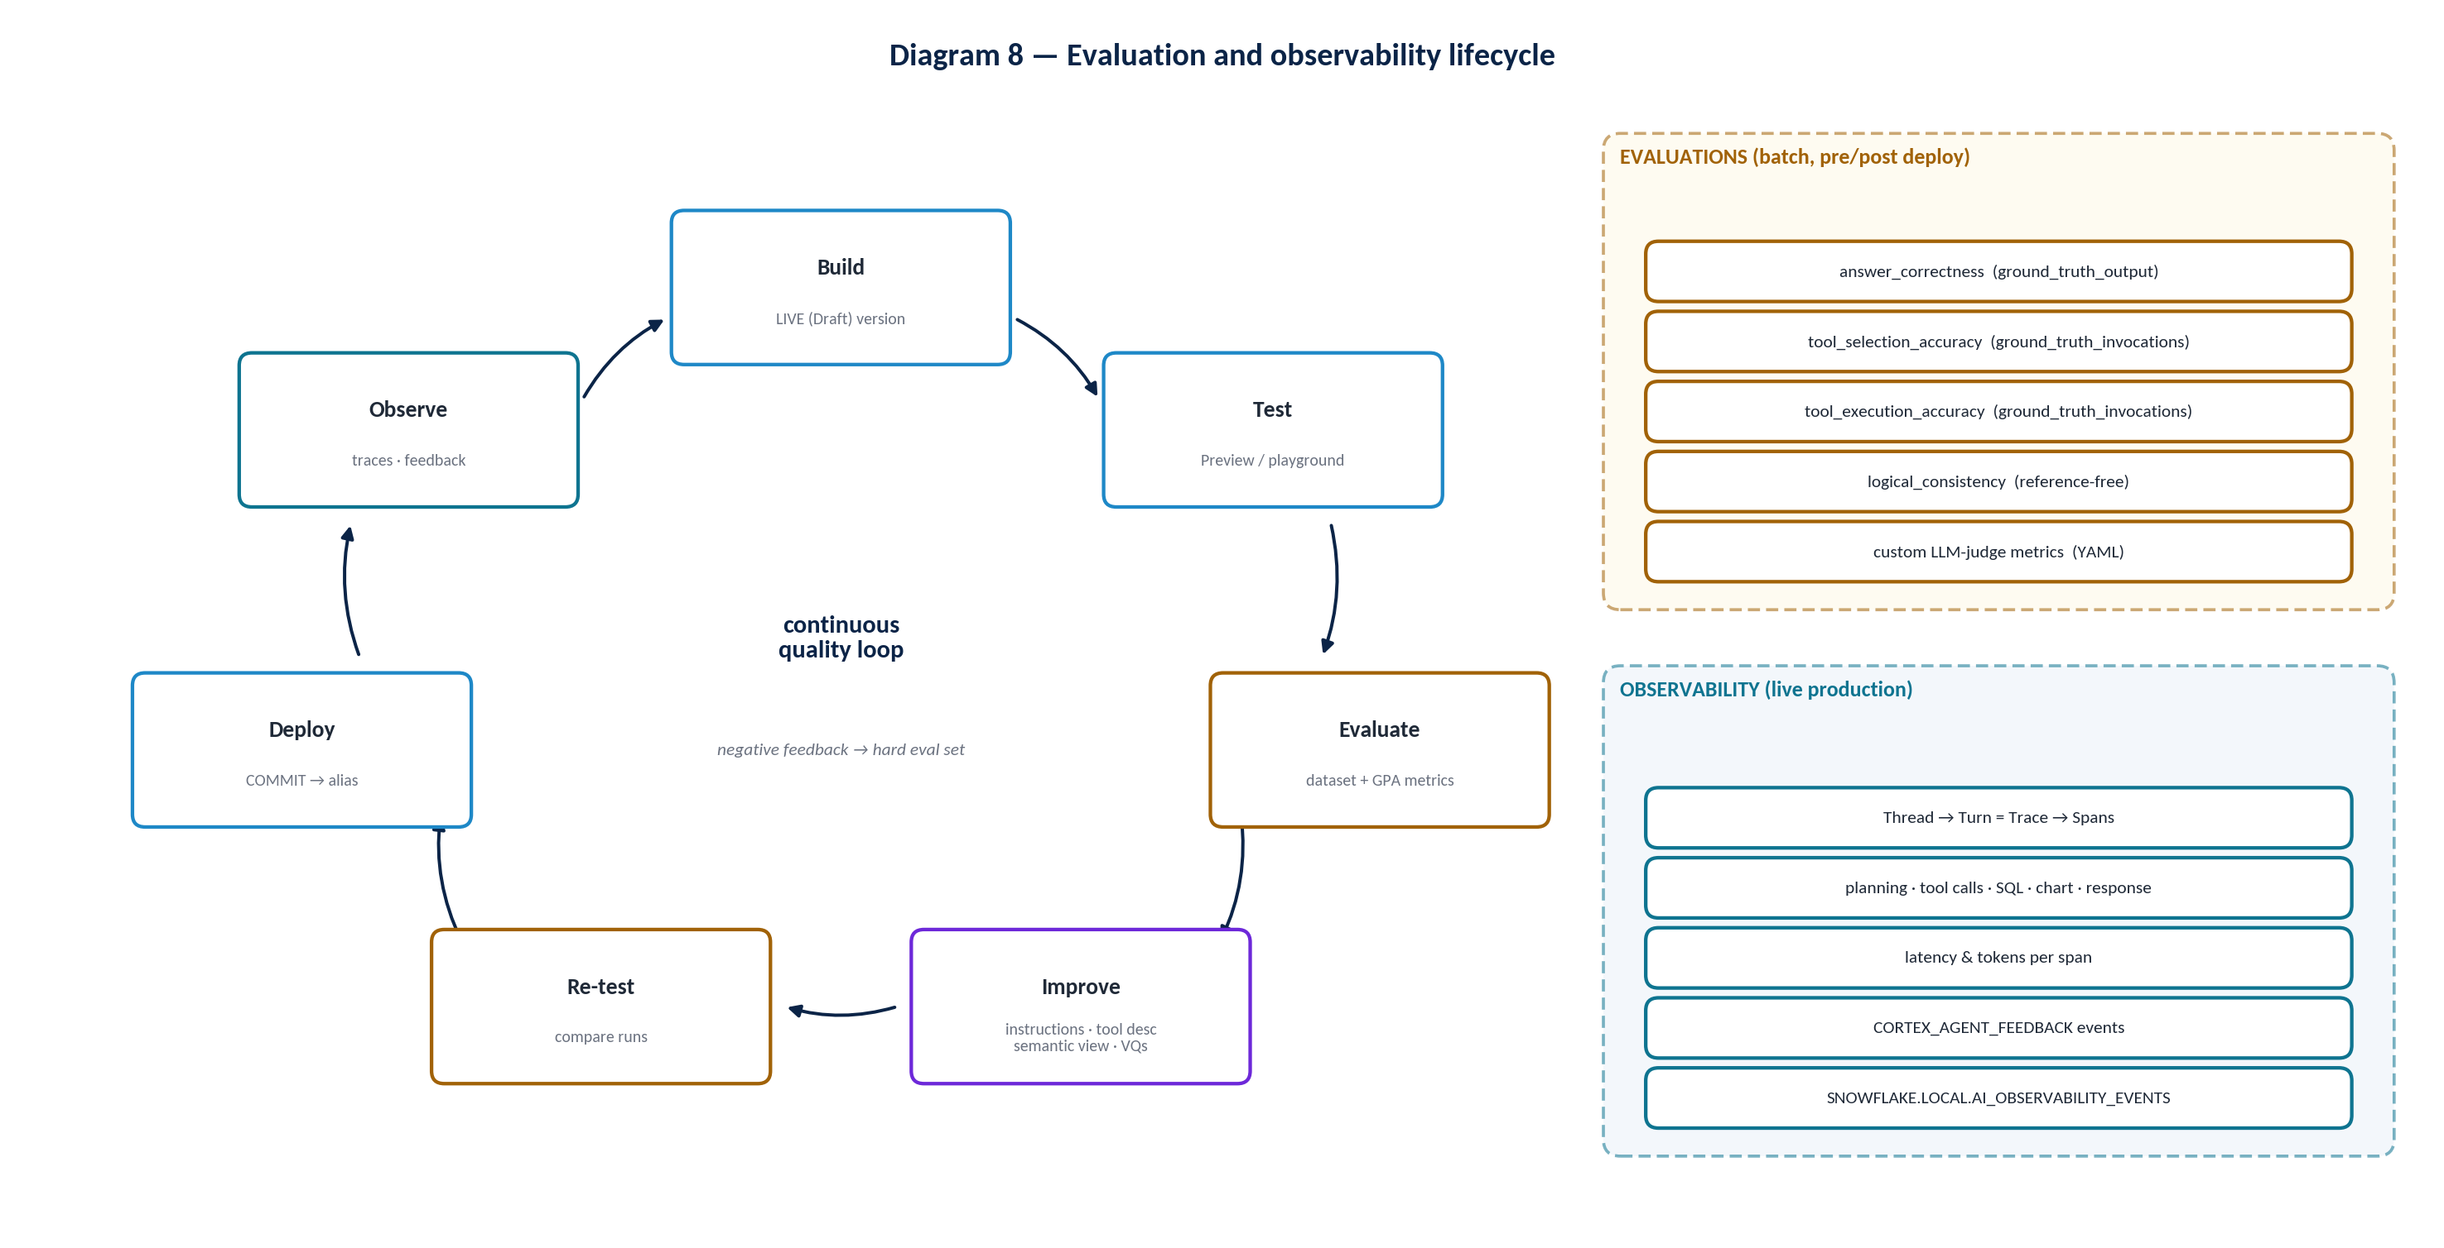
Diagram 8 — Evaluation and observability lifecycle

Table 14 — Example evaluation scenarios
Scenario | Question | Expected behavior
Structured | Top 10 customers by revenue in FY27-Q1 | SalesAnalytics only; exact list
Unstructured | What are customers saying about late deliveries (Jan–Mar 2026)? | SupportTicketSearch only; themes with citations
Combined | Top-10 FY27-Q1 customers with shipping complaints | Analyst then Search with customer_id filter
Ambiguous | How is Acme doing? | Clarify which Acme account if several match
Out of scope | Forecast next year's revenue | Declines per boundary; no tool calls
Capability | What can you help with? | No tool calls
Access-limited | Same combined question as a role without Search | Partial answer + explanation (accept mode)

17. Observability

17.1 Why it matters and what is captured
Observability explains why an agent behaved as it did in production. Cortex Agent monitoring records OpenTelemetry-style events in SNOWFLAKE.LOCAL.AI_OBSERVABILITY_EVENTS: conversation history per thread; per turn one trace with spans for LLM planning, tool execution (Search, Analyst, web search, code execution, MCP connector calls, custom tools), SQL execution, chart generation and response generation; inputs and outputs per span; and user feedback.
Term | Meaning
Thread | Persisted conversation (thread_id); the Observability pane lists one row per thread.
Turn | One user message and the agent's full response (one agent:run).
Trace | All telemetry for one turn (one trace_id).
Span | One step: planning, a tool call, SQL, chart, response.
Snowflake session | Platform session context (user, role, warehouse) — distinct from a thread.

17.2 Using the Observability tab
- Threads list: first input, feedback, thread length, user, last updated, and serving version (an icon marks threads that used several versions).
- Open a thread to see each turn's trace, the version that served it, and each span's inputs, outputs and duration.
- Use the Role and Warehouse selectors to query monitoring data under a specific role.
- Without READ UNREDACTED AI OBSERVABILITY EVENTS TABLE, roles see metadata (tool names, tokens, latency, model, error severity) but not full content.

17.3 SQL access
SQL — events, feedback, Analyst requests
-- All monitoring events for the agent
SELECT *
FROM TABLE(SNOWFLAKE.LOCAL.GET_AI_OBSERVABILITY_EVENTS(
'SALES_SUPPORT_DB', 'AGENTS', 'SALES_SUPPORT_AGENT', 'CORTEX AGENT'));

-- Only end-user feedback
SELECT *
FROM TABLE(SNOWFLAKE.LOCAL.GET_AI_OBSERVABILITY_EVENTS(
'SALES_SUPPORT_DB', 'AGENTS', 'SALES_SUPPORT_AGENT', 'CORTEX AGENT'))
WHERE RECORD:name = 'CORTEX_AGENT_FEEDBACK';

-- Scope to one turn: filter on TRACE:trace_id
-- ... WHERE TRACE:trace_id = '<trace_id>'

-- Generated SQL and errors for the semantic view behind SalesAnalytics
SELECT * FROM TABLE(SNOWFLAKE.LOCAL.CORTEX_ANALYST_REQUESTS(
'SEMANTIC_VIEW', 'SALES_SUPPORT_DB.SEMANTIC.SALES_SV'));

End-user feedback is collected through the Feedback API (…/agents/<name>:feedback with request_id, positive, feedback_message, categories, thread_id) and through CoWork thumbs up/down. The Cortex Code agent-observability-report sub-skill can summarize usage, latency percentiles, token economics, tool stats, conversation depth and feedback.

17.4 Answering the key diagnostic questions
Table 15 — Observability diagnostics
Question | Where to look | What to conclude
Why did the agent choose this tool? | Planning span output (reasoning/plan) preceding the tool span; tool descriptions in the served version. | Selection follows descriptions + instructions — fix whichever led it astray.
Why did it return this answer? | Tool spans' outputs (SQL + rows, retrieved chunks) and the response span. | Distinguish bad evidence (tool problem) from bad synthesis (response problem).
Why Search instead of Analyst? | Planning span; compare the user wording with both descriptions. | Add explicit routing rule and 'Do NOT use' clause; add a regression eval case.
Why did the agent fail? | Spans with error status; response.warning events (TOOL_NOT_ACCESSIBLE); Analyst request errors. | Privileges, disabled MCP integration, SQL compile errors, timeouts, budget exhaustion.
Which step introduced latency? | Span durations in the trace view. | Slow SQL → warehouse/model; slow search → payload/max_results; many planning spans → unclear instructions.

17.5 Identifying common problem patterns
- Poor orchestration: many planning spans, repeated calls to the same tool, clarifications for questions with documented defaults.
- Incorrect tool selection: tool span doesn't match the question domain; frequent in threads with negative feedback.
- Retrieval problems: Search spans returning off-topic chunks, empty results, or missing filters.
- Analyst problems: SQL with wrong column/filter/join; compare with verified queries; check CORTEX_ANALYST_REQUESTS.
- Production troubleshooting loop: negative feedback → open trace → classify failure → fix the layer → add the case to the hard evaluation set → re-run evaluation → commit → move alias.

18. Agent Development Lifecycle
The methodology below is the implementation sequence used for every agent in this program. Phases 12–15 repeat for every change.
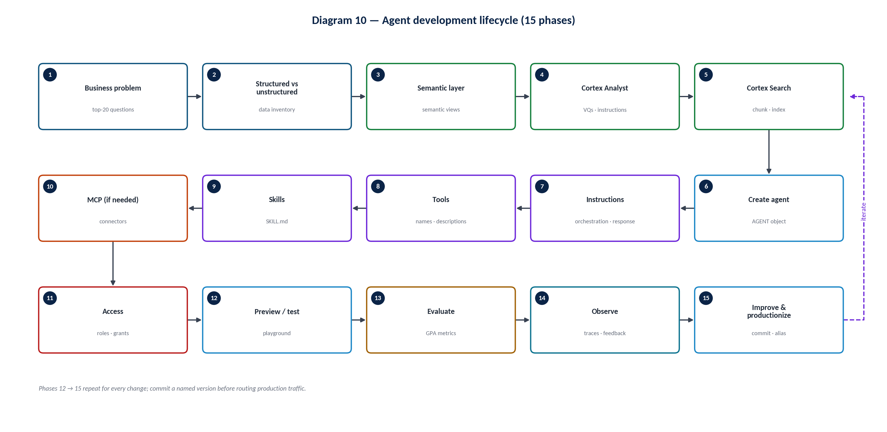
Diagram 10 — Agent development lifecycle
Table 16 — Lifecycle phases
Phase | Key activities | Exit criteria / artifacts
1. Understand the business problem | Identify users and the top ~20 questions with stakeholders; define scope and non-goals; prefer narrow agents. | Question list; scope statement; success metrics.
2. Structured vs unstructured | For each question, list the tables, documents and systems needed. | Question → source → tool mapping.
3. Build semantic layer | Semantic views per domain; keys, relationships, metrics, synonyms, sample values, instructions. | Semantic views in Git; SEMANTIC_VIEW() spot checks.
4. Configure Cortex Analyst | Verified queries; AI_SQL_GENERATION / AI_QUESTION_CATEGORIZATION; Analyst evaluations. | Analyst evaluation baseline.
5. Configure Cortex Search | Parse and chunk; create services with attributes; preview queries; grants. | Search services; relevance spot checks.
6. Create agent | CREATE AGENT (model auto, budget, tool_not_accessible), profile, description. | Agent object with VERSION$1 and LIVE.
7. Configure instructions | Orchestration template (Section 11.6); response instructions; sample questions. | Reviewed instruction text.
8. Configure tools | Analyst, Search, custom, chart, code, web as required; descriptions with when/when-not. | Tool catalog review.
9. Configure skills | SKILL.md for recurring procedures; stage/Git; code execution if scripts. | Skill folders with pinned references.
10. Configure MCP (if required) | API integration, EXTERNAL MCP SERVER, agent mcp_servers, OAuth test; inbound MCP server if external clients need access. | Connector tested per user.
11. Configure access | Consumer/builder/operator roles; default role/warehouse; tool-object grants. | Grant script; access test with consumer role.
12. Preview / test | Golden questions in the playground as a consumer role. | Manual pass on golden set.
13. Evaluate | Dataset with ground truth; GPA + custom metrics; pinned versions. | Scores above agreed thresholds.
14. Observe | Pilot users; monitor traces, latency, tokens, feedback. | Issue backlog; hard eval set.
15. Improve / productionize | Fix at the right layer; commit; alias production; schedule evals; budgets; rollback plan. | Named version behind production alias.

19. End-to-End Example: Enterprise Sales & Support Agent
This example ties together every component. The agent serves account executives and support leads, answering structured, unstructured and combined questions and optionally opening Jira escalations.
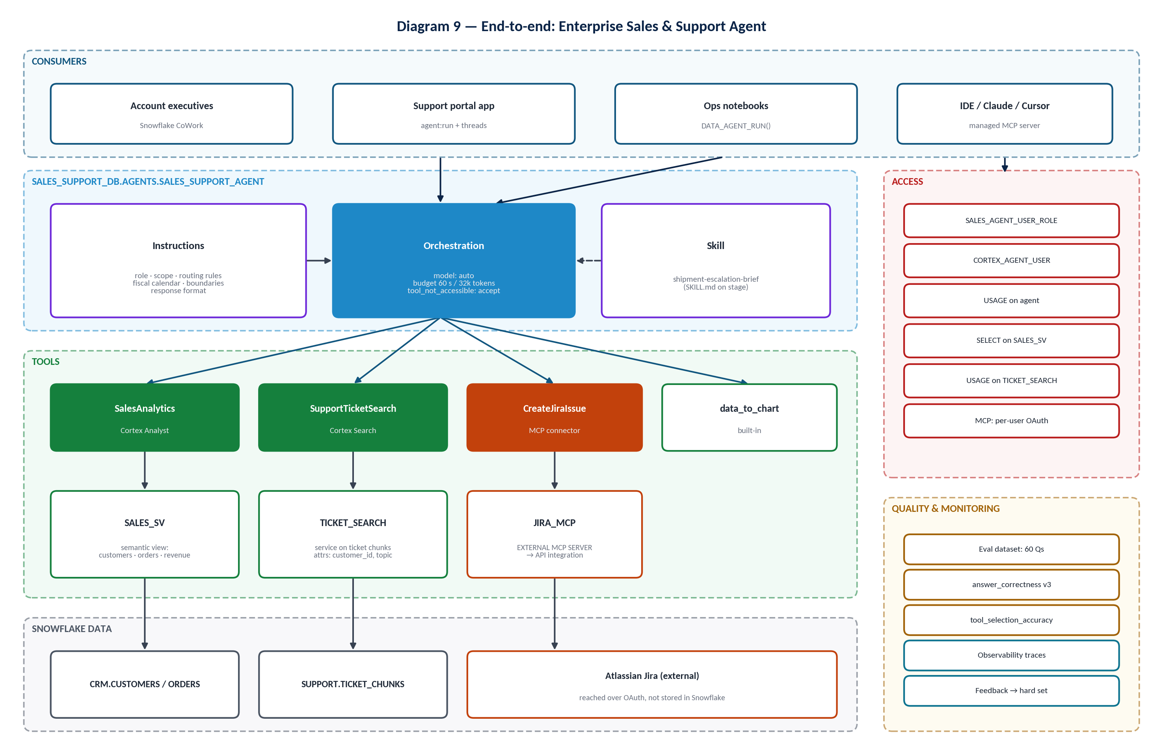
Diagram 9 — End-to-end enterprise agent architecture

19.1 Data
Object | Type | Content
CRM.CUSTOMERS | Table | customer_id, name, segment, region, owner
CRM.ORDERS | Table | order_id, customer_id, order_date, fiscal_quarter_label, amount_usd, discount_usd, promised_date, delivered_date
SUPPORT.TICKETS | Table | ticket_id, customer_id, topic, created_at, body
SUPPORT.TICKET_CHUNKS | Table | Chunked ticket text with attributes (Section 7.3)
Row access policy | Policy on CUSTOMERS/ORDERS | AEs see only their region's accounts

19.2 Semantic layer, Analyst and Search
- SALES_SV (Section 3.5): customers/orders, total_revenue, order_count, avg_order_value, fiscal quarter default, verified query for top customers.
- Cortex Analyst tool SalesAnalytics bound to SALES_SV on AGENT_WH.
- TICKET_SEARCH service (Section 7.3) with attributes customer_id, topic; tool SupportTicketSearch with column descriptions.

19.3 Agent, instructions, tools, skills and MCP
- Agent specification: Section 10.2 (model auto, 60 s / 32k budget, accept mode).
- Orchestration instructions: improved version in Section 11.4; response instructions: direct answer first, tables >3 rows, period + freshness, ticket citations.
- Tools: SalesAnalytics, SupportTicketSearch, data_to_chart (+ code_execution only if skill scripts are added).
- Skill: shipment-escalation-brief (Section 13.2).
- MCP: JIRA_MCP connector for escalation tickets, gated by explicit user confirmation. Optionally, SALES_MCP (inbound) exposes the agent to approved external MCP clients.

19.4 Question flows
Table 17 — Example question routing
Question | Route | Flow
"What were the top 10 customers by revenue last quarter?" | Cortex Analyst | Plan → SalesAnalytics (fiscal default applied by semantic view) → SQL on AGENT_WH under AE's role (row policy limits region) → table + stated quarter → optional bar chart.
"What are customers saying about delayed shipments?" | Cortex Search | Plan → SupportTicketSearch (topic = shipping) → top chunks → themes with ticket citations; no Analyst call.
"Which of our top customers are complaining about delayed shipments?" | Analyst + Search + orchestration | Plan decomposes → SalesAnalytics returns top-10 customer_ids → SupportTicketSearch with @and filter on customer_id + topic → reflect: intersect, re-search if coverage thin → table of affected customers with revenue and ticket IDs.
"Draft an escalation for Globex and open a Jira ticket." | Skill + MCP | Skill selected → brief built from Analyst + Search → user confirms → Jira MCP tools/call with the user's OAuth identity.

Combined-question filter the agent constructs (illustrative)
{
"@and": [
{"@or": [ {"@eq": {"customer_id": "C-000123"}},
{"@eq": {"customer_id": "C-000456"}} ]},
{"@eq": {"topic": "shipping"}}
]
}

VERIFY
Filter operators follow the Cortex Search query filter syntax (@eq, @and, @or, @not and others). Verify the supported operators for your service before relying on them in instructions.

19.5 Access, evaluation and observability
- Access: SALES_AGENT_USER_ROLE (Section 15.2) with CORTEX_AGENT_USER, agent USAGE, SV + table SELECT, service USAGE, MCP server + integration USAGE, stage USAGE; AGENT_OPS_ROLE with MONITOR.
- Evaluation: 60-question dataset covering the scenarios in Section 16.5, pinned to VERSION$N with v3 metrics; threshold gates before moving the production alias.
- Observability: weekly review of negative-feedback threads; latency p95 by span type; additions to the hard evaluation set. MCP escalations are reviewed in traces because evaluations do not exercise MCP tools.

20.1 Additional: minimal agent for a first lab
SQL — smallest useful agent
CREATE OR REPLACE AGENT lab_db.lab.first_agent
COMMENT = 'Lab agent over one semantic view'
FROM SPECIFICATION
$$
models:
orchestration: auto
instructions:
response: "Answer concisely and state the time period used."
tools:
- tool_spec:
type: "cortex_analyst_text_to_sql"
name: "SalesAnalytics"
description: "Revenue and orders by customer and date. Not for text documents."
tool_resources:
SalesAnalytics:
semantic_view: "LAB_DB.LAB.SALES_SV"
execution_environment:
type: "warehouse"
warehouse: "LAB_WH"
$$;

EXPECTED BEHAVIOR
Revenue questions produce SQL over SALES_SV and a concise answer with the period; document questions are declined because no search tool exists.

WHY THIS CONFIGURATION WORKS
One tool with a clear boundary removes routing ambiguity, which isolates semantic-view quality as the only variable — ideal for a first evaluation baseline.

20.2 Additional: code execution and web search tool specs
YAML — fragments to merge into a full specification
tools:
- tool_spec:
type: code_execution
name: code_execution
- tool_spec:
type: "web_search"
name: "Web Search"
tool_resources:
code_execution: {}
orchestration:
capabilities:
analytical_search: true # only if a cortex_search tool exists

21. Best Practices
Table 18 — Best practices by area
Area | Practice
Semantic layer — naming | Business names, not column codes; consistent terms across views, tools and instructions.
Semantic layer — definitions | Comments state grain, units, currency, time zone, exclusions.
Semantic layer — metrics | One definition per KPI; derived metrics for cross-table ratios; NON ADDITIVE BY for snapshots; PRIVATE helpers.
Semantic layer — relationships | Primary keys everywhere; bridge tables for many-to-many; USING for multi-path metrics.
Semantic layer — ambiguity | Synonyms, SAMPLE_VALUES, IS_ENUM, search-backed dimensions, AI_QUESTION_CATEGORIZATION.
Cortex Analyst — grounding | Verified queries from real questions; defaults in AI_SQL_GENERATION.
Cortex Analyst — accuracy & testing | Analyst evaluations after every semantic change; review monitoring and suggestions.
Cortex Search — quality | ≤512-token chunks; clean text; right embedding model (multilingual if needed).
Cortex Search — indexing | Primary keys for incremental refresh; right-sized TARGET_LAG; dedicated ≤MEDIUM warehouse; auto-suspend for idle services.
Cortex Search — metadata/filtering | Expose only needed attributes; describe values; return ID/title and source path columns.
Agent — instructions | Separate orchestration and response; explicit routing, sequencing, defaults, boundaries.
Agent — tool descriptions | What + data + when + when-not + parameters; domain+function names.
Agent — tool selection | Minimal tool set; no overlapping domains; tool_choice for deterministic app flows.
Agent — lifecycle | Narrow agents; commit versions; alias-based promotion and rollback; explicit budgets.
Skills | One procedure per skill; precise descriptions; pinned sources; code execution only when scripts exist.
MCP | Trusted servers only; review tool descriptions; confirmation before writes; disable (don't drop) for maintenance; finite refresh-token validity.
Security — least privilege | CORTEX_AGENT_USER instead of CORTEX_USER; revoke from PUBLIC where appropriate; role separation; default role/warehouse set.
Security — access control | Row access and masking on base data; audience-partitioned search services; review owner's-rights procedures.
Evaluation — test cases | Representative golden set incl. ambiguous, out-of-scope and access-limited cases; absolute dates.
Evaluation — regression | Pinned agent and metric versions; scheduled runs; compare runs before alias moves.
Observability — monitoring | Grant MONITOR to operators (FUTURE AGENTS); track latency, tokens, feedback; restrict unredacted access.
Observability — debugging | Trace-first triage; classify failures by layer; convert fixes into eval cases.

22. Common Mistakes and Troubleshooting
Table 19 — Troubleshooting guide
Problem | Possible cause | How to diagnose | Recommended fix
Agent chooses wrong tool | Vague or overlapping descriptions; no routing rule; generic tool names | Planning span in trace; low TSA score | Rewrite descriptions (when/when-not); add routing examples; rename tools; add eval cases
Cortex Analyst generates incorrect SQL | Missing synonyms/metrics; wrong keys; ambiguous literals; multi-path joins | SQL in trace; CORTEX_ANALYST_REQUESTS; Analyst evaluations | Enrich semantic view; add verified queries; IS_ENUM / sample values; USING clauses
Cortex Search returns irrelevant results | Oversized chunks; poor query rewriting; missing filters; stale index | Search span outputs; SEARCH_PREVIEW; DESCRIBE service (indexing state) | Re-chunk ≤512 tokens; describe filter columns; adjust TARGET_LAG; resume indexing after fixing errors
Agent asks unnecessary questions | Instructions demand clarification broadly; no documented defaults | Turns ending in questions; feedback | Encode defaults in semantic view/instructions; restrict clarification to real ambiguity
Agent cannot access data | Missing CORTEX_AGENT_USER/USAGE; no default role or warehouse; tool-object privileges missing | HTTP 4XX; response.warning TOOL_NOT_ACCESSIBLE; test as consumer role | Apply grant script (15.2); set DEFAULT_ROLE/DEFAULT_WAREHOUSE; choose accept/reject deliberately
MCP tool fails | User not connected / token expired; integration disabled; missing USAGE on server or integration; underscore hostname | Warnings in trace; SHOW/DESCRIBE EXTERNAL MCP SERVER; integration ENABLED state | Reconnect OAuth; enable integration; grant both USAGEs; fix hostname
Agent response is inaccurate | Bad evidence or bad synthesis | Compare tool outputs with the response in the trace; answer correctness vs TEA | Fix the tool layer if evidence is wrong; response instructions if synthesis is wrong
High latency | Slow SQL; oversized warehouse queueing; large search payloads; excessive planning; cold auto-suspended search | Span durations; Analyst query profile; planning span count | Optimize/pre-aggregate; tune warehouse; lower max_results; tighten instructions; adjust AUTO_SUSPEND
Evaluation score is poor | Bad ground truth; relative dates; judge/version mismatch; unsupported tools (MCP); session-attribute dependence | Record details; metric explanations; GET_AI_OBSERVABILITY_LOGS | Rewrite rubrics with literals; absolute dates; pin metric versions; exclude unsupported scenarios
Run stops mid-answer | Orchestration budget reached | Trace ends early; duration ≈ budget | Raise seconds/tokens based on p95; simplify workflow
Changes not visible in production | Edited LIVE but callers use a named version/alias | SHOW VERSIONS; version column in Observability | Commit and repoint alias/default

23. Decision Framework
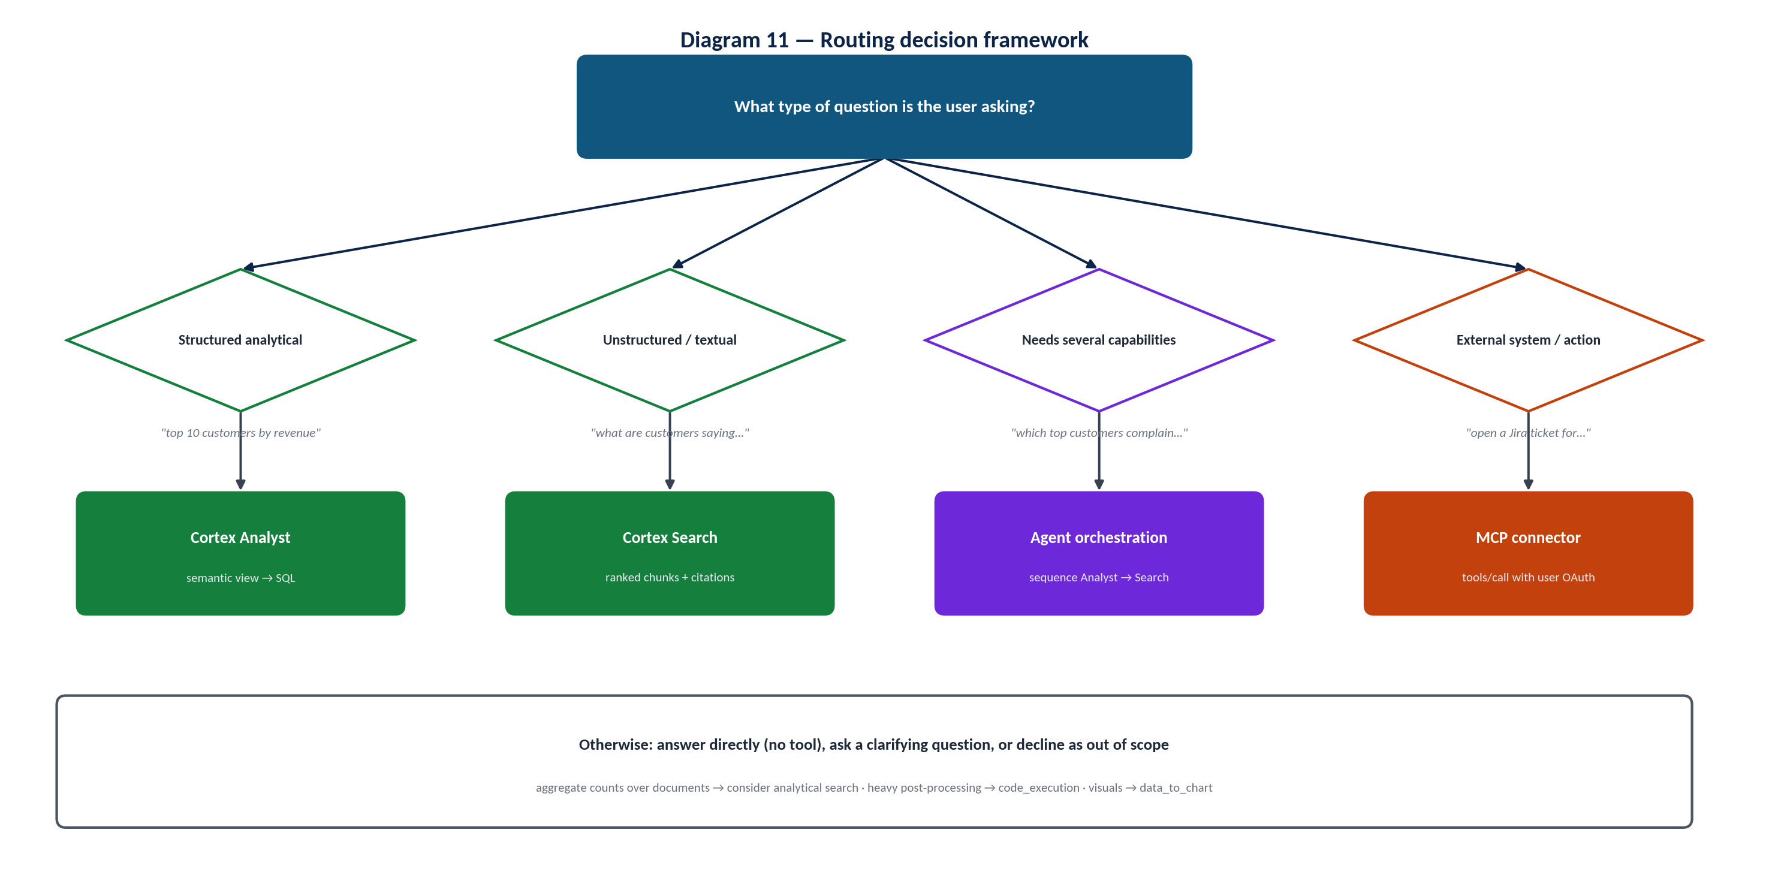
Diagram 11 — Routing decision framework
Branch | Route | Reasoning
Structured analytical question | Cortex Analyst | Answer is computed from records; the semantic layer guarantees correct joins and formulas; SQL runs under the caller's governance.
Unstructured / textual retrieval | Cortex Search | Answer is contained in text; hybrid retrieval finds semantically relevant passages and supports citations.
Requires multiple capabilities | Agent orchestration | Neither tool alone can join measurement and meaning; the agent sequences tools and passes results as parameters.
Requires external / MCP capability | MCP connector | Data or action lives in another system; MCP provides per-user OAuth access to its tools.
None of the above | No tool / clarify / decline | Capability or definition questions need no tools; true ambiguity warrants a question; out-of-scope requests follow boundaries.

Refinements: counts or trends across large document sets → consider analytical search; statistics or transformations beyond SQL → code execution; visual output → Data to Chart; public, current information → web search (if enabled).

24. Reference Architecture
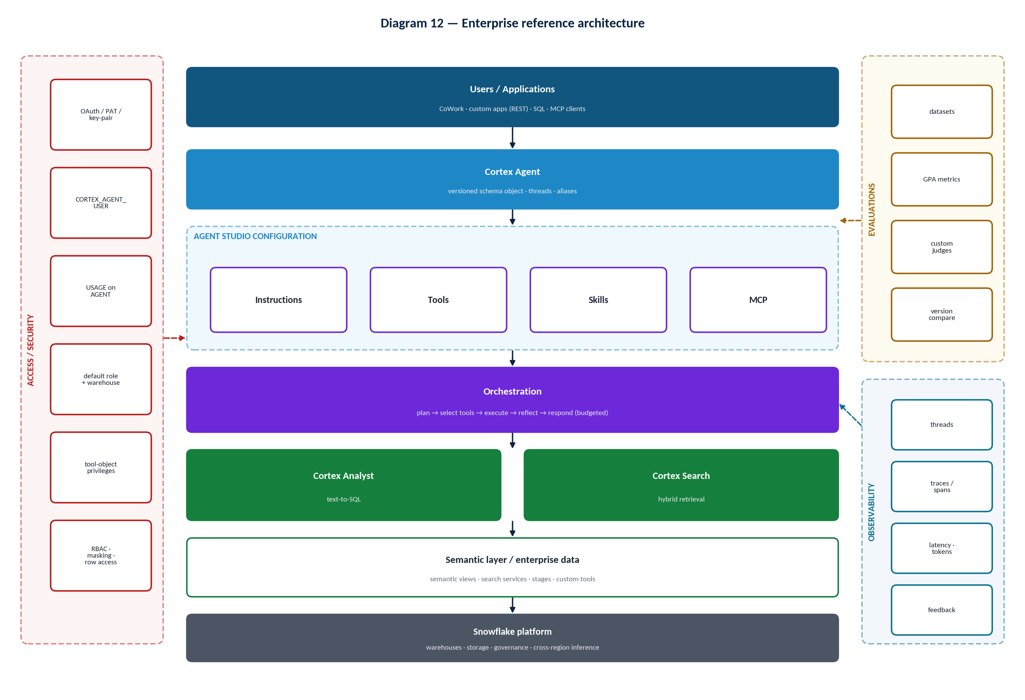
Diagram 12 — Enterprise reference architecture
- Users / applications reach the agent through CoWork, REST (with threads), SQL or inbound MCP.
- Cortex Agent is a versioned schema object; production traffic targets an alias.
- Agent Studio configuration supplies instructions, tools, skills and MCP connectors.
- Orchestration plans, executes tools, reflects and responds within budget.
- Cortex Analyst + Cortex Search convert intent into governed SQL and retrieval.
- Semantic layer / enterprise data (semantic views, search services, stages, custom tools) sits on the Snowflake platform.
- Access/security wraps every layer (authentication, database roles, agent and tool privileges, RBAC, masking, row access). Evaluations gate configuration changes; observability covers orchestration and tool execution in production.

26. References & Further Reading
Official Snowflake sources were used as the authority for all technical statements. Community articles are secondary and should be validated against the documentation.

26.1 Official Snowflake documentation
Table 20 — Official documentation
Title | URL | Why it is useful
Cortex Agents | https://docs.snowflake.com/en/user-guide/snowflake-cortex/cortex-agents | Concepts, tool list, models, access summary, costs.
Get started with Cortex Agents | https://docs.snowflake.com/en/user-guide/snowflake-cortex/cortex-agents-get-started | End-to-end walkthrough; Cortex Code-assisted build.
Create and manage agents | https://docs.snowflake.com/en/user-guide/snowflake-cortex/cortex-agents-manage | Snowsight, REST and SQL for creation, tools, orchestration, threads, feedback.
Access control and authentication | https://docs.snowflake.com/en/user-guide/snowflake-cortex/cortex-agents-setup | Database roles, agent and tool privileges, default-role requirement.
Inaccessible tool handling | https://docs.snowflake.com/en/user-guide/snowflake-cortex/cortex-agents-inaccessible-tool-handling | accept / reject / legacy modes and warnings.
Cortex Agent versioning | https://docs.snowflake.com/en/user-guide/snowflake-cortex/cortex-agents-versioning | LIVE, named versions, aliases, CI/CD.
Agent skills | https://docs.snowflake.com/en/user-guide/snowflake-cortex/cortex-agents-skills | SKILL.md, sources, privileges, limitations.
MCP Connectors | https://docs.snowflake.com/en/user-guide/snowflake-cortex/cortex-agents-mcp-connectors | External MCP servers, OAuth, grants, monitoring, limitations.
Snowflake-managed MCP server | https://docs.snowflake.com/en/user-guide/snowflake-cortex/cortex-agents-mcp | Inbound MCP, tool types, OAuth roles, client setup, troubleshooting.
Cortex Agent evaluations | https://docs.snowflake.com/en/user-guide/snowflake-cortex/cortex-agents-evaluations | GPA metrics, datasets, YAML, SQL functions, limitations.
Monitor Cortex Agent requests | https://docs.snowflake.com/en/user-guide/snowflake-cortex/cortex-agents-monitor | Threads/traces/spans, event table, feedback, privileges.
Cortex Analyst | https://docs.snowflake.com/en/user-guide/snowflake-cortex/cortex-analyst | Analyst behavior, legacy semantic models, access, model selection.
Cortex Analyst administrator monitoring | https://docs.snowflake.com/user-guide/snowflake-cortex/cortex-analyst/admin-observability | CORTEX_ANALYST_REQUESTS and required privileges.
Cortex Analyst evaluations | https://docs.snowflake.com/user-guide/snowflake-cortex/cortex-analyst-evaluations | Verified-query-based semantic view evaluation.
Overview of semantic views | https://docs.snowflake.com/en/user-guide/views-semantic/overview | Concepts: logical tables, facts, dimensions, metrics.
Using SQL commands to create and manage semantic views | https://docs.snowflake.com/en/user-guide/views-semantic/sql | DDL, relationships, derived/semi-additive metrics, custom instructions, verified queries, YAML import.
Querying semantic views | https://docs.snowflake.com/en/user-guide/views-semantic/querying | SEMANTIC_VIEW clause and privileges.
CREATE SEMANTIC VIEW | https://docs.snowflake.com/en/sql-reference/sql/create-semantic-view | Authoritative syntax and clause order.
Semantic View Autopilot | https://docs.snowflake.com/user-guide/views-semantic/autopilot | AI-assisted semantic view generation.
Cortex Search | https://docs.snowflake.com/en/user-guide/snowflake-cortex/cortex-search/cortex-search-overview | Service creation, refresh, embedding models, costs, limits, privileges.
User access and settings for agents (CoWork) | https://docs.snowflake.com/en/user-guide/snowflake-cortex/snowflake-cowork/deploy-agents | CoWork privileges, visibility object, private connectivity.
Documentation index for LLMs and agents | https://docs.snowflake.com/llms.txt | Discover all current Cortex pages (Markdown versions available).

26.2 Official Snowflake guides, blogs and release notes
Table 21 — Official guides, blogs and release notes
Title | URL | Why it is useful
Best Practices for Building Cortex Agents | https://www.snowflake.com/en/developers/guides/best-practices-to-building-cortex-agents/ | Instruction layers, tool description patterns, full example configuration.
Best Practices for Evaluating Cortex Agents | https://www.snowflake.com/en/developers/guides/best-practices-for-evaluating-cortex-agents/ | Dataset design and evaluation methodology.
Getting Started with Cortex Agent Evaluations | https://www.snowflake.com/en/developers/guides/getting-started-with-cortex-agent-evaluations/ | Programmatic evaluation walkthrough.
Getting Started with MCP Connectors | https://www.snowflake.com/en/developers/guides/getting-started-with-mcp-connectors/ | Connector setup lab.
GPA framework for AI agent evaluation (engineering blog) | https://www.snowflake.com/en/engineering-blog/ai-agent-evaluation-gpa-framework/ | Rationale behind the evaluation metrics.
Snowflake CoWork product page | https://www.snowflake.com/en/product/snowflake-cowork/ | CoWork (formerly Snowflake Intelligence) and Agent Studio positioning.
Release note: Cortex Agents GA (Nov 4, 2025) | https://docs.snowflake.com/en/release-notes/2025/other/2025-11-04-cortex-agents | GA scope.
Release note: Cortex Agents Coding Agent GA (Aug 26, 2026) | https://docs.snowflake.com/en/release-notes/2026/other/2026-08-26-cortex-agents-coding-agent-ga | code_toolset_all tool type.
Snowflake server release notes and feature updates | https://docs.snowflake.com/en/release-notes/new-features | Track evaluation, MCP and semantic view changes.
Getting Started with Managed Snowflake MCP Server (quickstart) | https://quickstarts.snowflake.com/guide/getting-started-with-snowflake-mcp-server/index.html | Hands-on inbound MCP lab.
Cortex Analyst advanced SiS demo (Snowflake-Labs GitHub) | https://github.com/Snowflake-Labs/sf-samples/tree/main/samples/cortex-analyst/Advanced%20SiS%20Demo | Reference Streamlit implementation.

26.3 Community / Medium references
IMPORTANT Community / Medium Reference
The following are community articles, not Snowflake documentation. Some predate recent changes (for example, the rename to Snowflake CoWork and the semantic model → semantic view guidance). Validate every detail against the official sources above.

Table 22 — Community references (Community / Medium Reference)
Title | URL | Why it is useful
Mastering Semantic Views and Cortex Agents with Cortex Code (Snowflake Builders Blog) | https://medium.com/snowflake/mastering-semantic-views-and-cortex-agents-with-cortex-code-ba97afcc5aa9 | Workflow for building and optimizing semantic views and agents with Cortex Code skills.
How to Evaluate Your Snowflake Cortex Agents — A Complete Hands-On Guide | https://medium.com/@katyayen.pranav/how-to-evaluate-your-snowflake-cortex-agents-a-complete-hands-on-guide-9f467917d195 | Multi-tool agent build plus evaluation walkthrough.
Snowflake Cortex Agent Tutorial: From dbt Models to Natural Language Analytics | https://medium.com/@vidaan95/snowflake-dbt-and-cortex-pipeline-40335f507363 | Semantic views over dbt models; agent with Analyst and Search tools.
Building a Production-Grade Snowflake AI Agent using MCP Server with Cortex AI | https://medium.com/towards-data-engineering/building-a-production-grade-snowflake-ai-agent-using-mcp-server-with-cortex-ai-d5253ee1305d | Managed MCP server implementation with Search, Analyst and UDFs.
Getting started with Snowflake Semantic View (Snowflake Builders Blog) | https://medium.com/snowflake/getting-started-with-snowflake-semantic-view-7eced29abe6f | Introductory semantic view walkthrough (linked from Snowflake's best-practices guide).
How to make useful data science agents (Snowflake Builders Blog) | https://medium.com/snowflake/how-to-make-useful-data-science-agents-dbacbf1643b8 | Lessons learned on agent scoping (linked from Snowflake's best-practices guide).
Guide to Snowflake Cortex Analyst and Semantic Models (Select Star) | https://medium.com/selectstar/guide-to-snowflake-cortex-analyst-and-semantic-models-e5f9bd7a74ce | Background on YAML semantic models (legacy approach).

