Power BI Service – Quick Insights & Q&A in Dashboard

✅ Section 1: Get Quick Insights in Power BI Service
Power BI's Quick Insights automatically scans your dataset using machine learning to find interesting patterns and trends. These insights can help guide further analysis.

Step-by-Step Guide to Use Quick Insights:

Step 1: Open Dataset for Insights
1. In the Workspace, find your uploaded dataset.
2. Click the More options (three dots) next to the dataset.
3. Choose 'Get quick insights'.

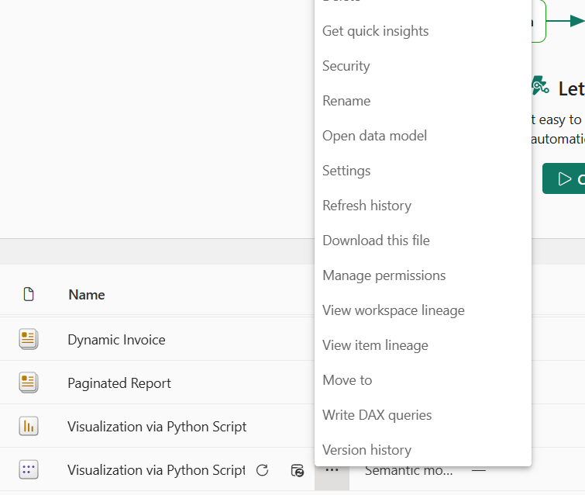

Step 3: View the Quick Insights
1. Power BI will take a few moments to scan the dataset.
2. Once ready, click 'View insights'.
3. A dashboard of visuals generated from your data appears.

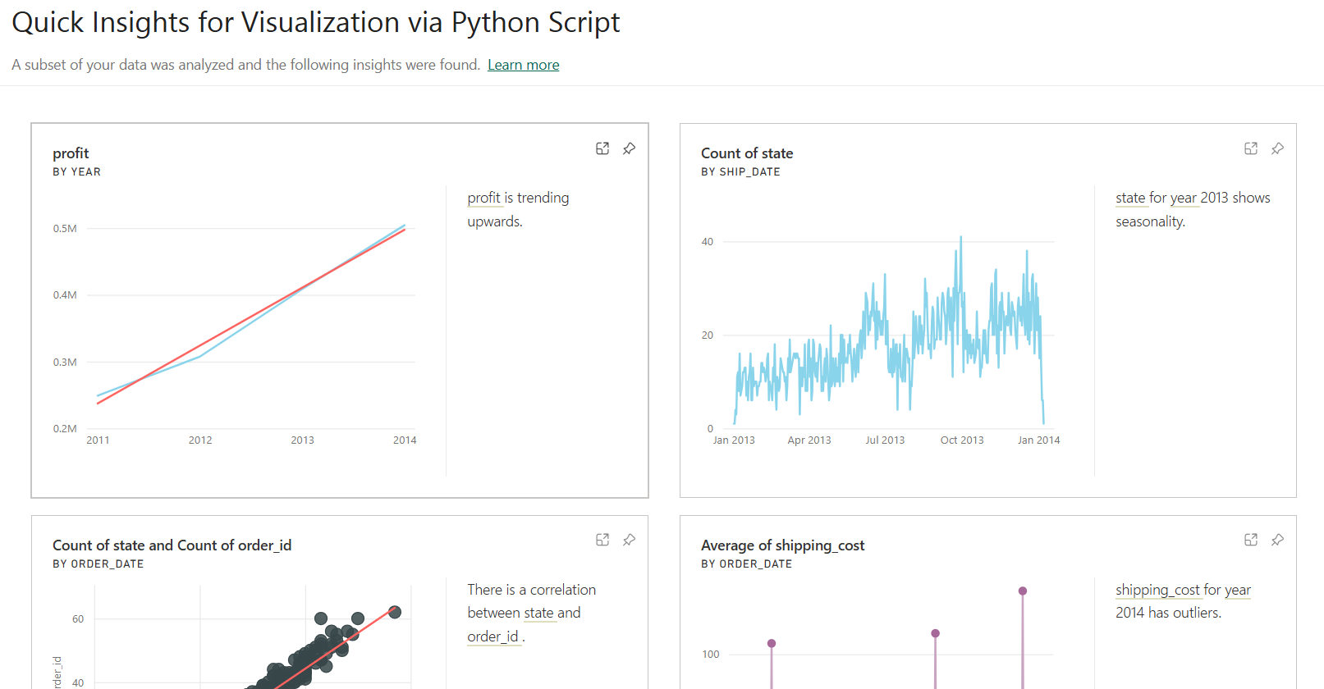

Step 4: Pin an Insight to Dashboard
1. Hover over any chart and click the 'Pin visual' icon.
2. Choose an existing dashboard or create a new one.
3. Click 'Pin'.
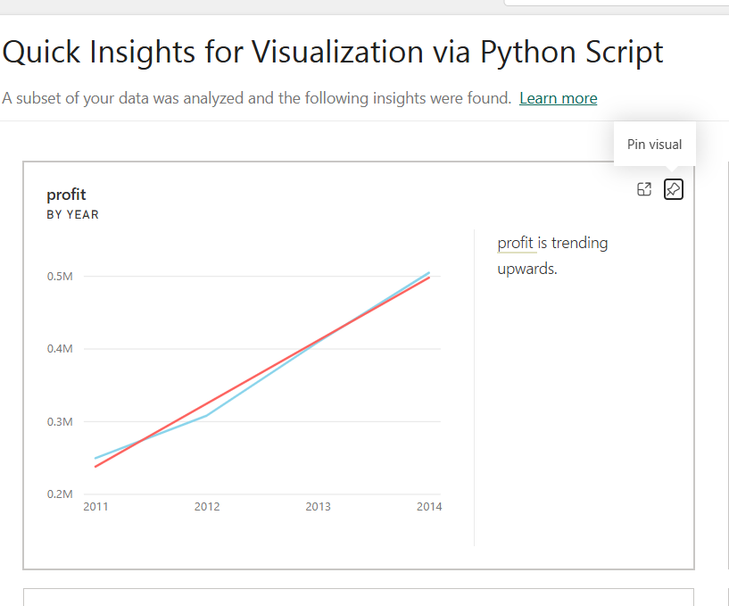

💬 Section 2: Use Q&A in Power BI Dashboard
The Q&A visual allows users to ask questions in natural language and get instant visuals as answers.
Open the dashboard where you pinned your insights.
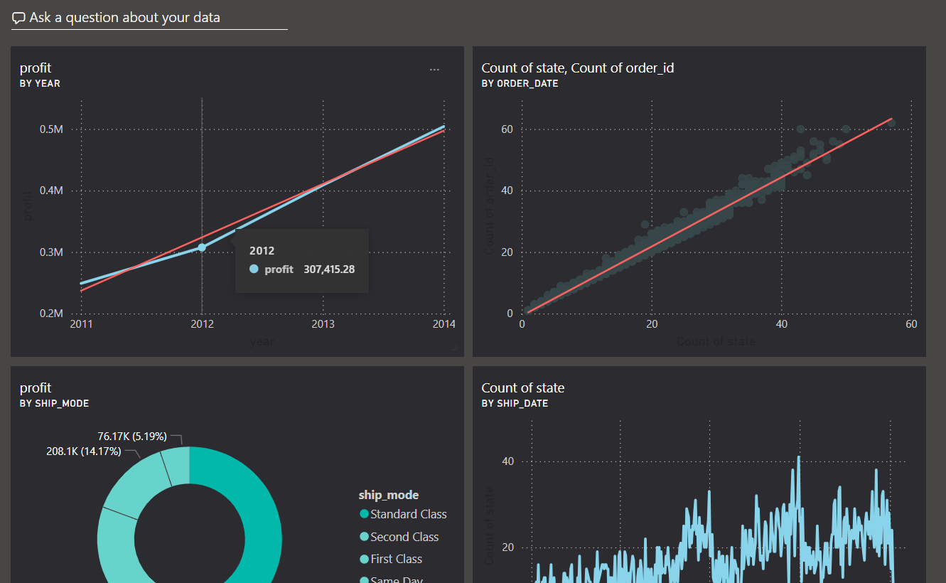
1. In the Q&A box, type something like:
"Total Sales by Category" or "Top 5 products by revenue"
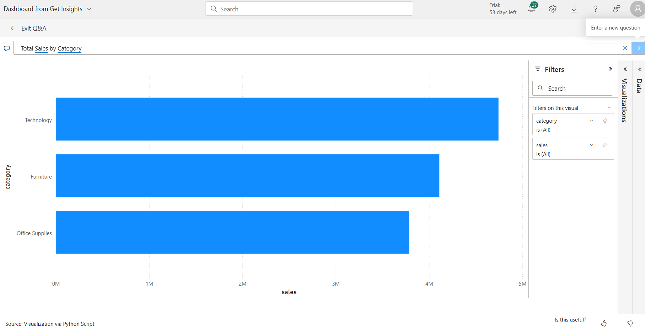
2. Power BI shows the result visually.
3. Click 'Ask a related question' to continue exploration.

