AQI Tracking System
Project Walkthrough
Open-source streaming + batch lakehouse for real-time Air Quality Index monitoring

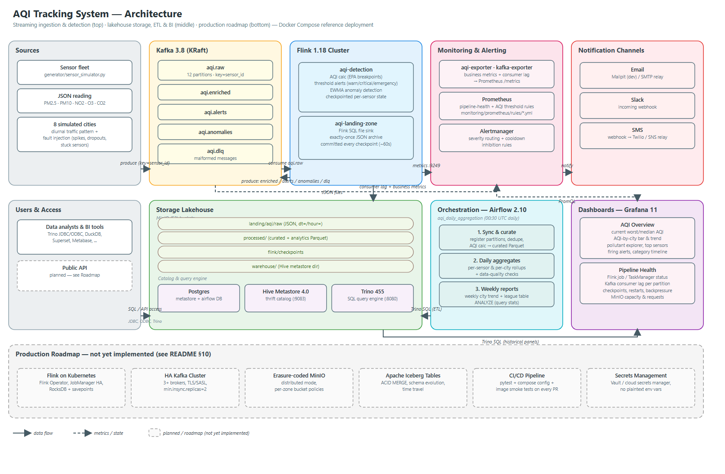

Kafka · Flink · MinIO · Hive Metastore · Trino · Airflow · Prometheus · Alertmanager · Grafana

Contents
1. Introduction & Purpose
2. Architecture at a Glance
3. Technology Stack
4. Repository Layout
5. Walkthrough: From Sensor Reading to Dashboard
5.1 Ingestion — Sensor Simulator → Kafka
5.2 Real-Time Processing — Flink Detection Job
5.3 Landing Zone — Raw Data Archival
5.4 Batch ETL — Airflow + Trino
5.5 Monitoring & Alerting
5.6 Visualization — Grafana Dashboards
6. Running the Project
7. Verifying the Deployment
8. Testing & Quality Assurance
9. Operating the System
10. Production Hardening & Next Steps
Appendix A — Environment Variables
Appendix B — Service & Port Reference

1. Introduction & Purpose
The AQI Tracking System is a production-style, fully open-source reference platform for ingesting, processing, storing, querying, monitoring and visualizing Air Quality Index (AQI) data. It solves a problem most reference architectures split into two disconnected halves: real-time visibility (is the air unhealthy right now, and who should be paged) and durable historical analytics (trends, compliance reporting, BI). This project builds both against the *same* AQI calculation logic, so the live dashboard and the historical report never disagree about what "AQI 160" means.
Who this is for:
- Data / platform engineers who want a runnable Kafka → Flink → Lakehouse → BI reference architecture to adapt for a real sensor fleet.
- Environmental / public-health teams who need live AQI dashboards and threshold alerting (email, Slack, SMS) without a SaaS platform.
- Engineers learning the stack — Kafka, Flink, Hive, Trino, Airflow, Prometheus and Grafana are all wired together and verified to run end-to-end, which is usually the hardest part of learning any one of them from documentation alone.

2. Architecture at a Glance
The diagram below (generated from docs/architecture.py, kept in sync with the code) shows every service and how data moves between them. Solid arrows are data flow; dashed arrows are metrics or checkpoint state.
At a high level, the pipeline is:
sensor-simulator --(JSON, key=sensor_id)--> Kafka(aqi.raw)
Kafka(aqi.raw) --> Flink(aqi-detection) --> Kafka(enriched / alerts / anomalies / dlq)
Kafka(aqi.raw) --> Flink(aqi-landing-zone) --> MinIO(landing/aqi/raw/dt=/hour=)
Kafka(enriched/alerts/anomalies) --> aqi-exporter --> Prometheus --> Grafana / Alertmanager
Airflow --(Trino SQL)--> Trino <-> Hive Metastore <-> Postgres
Trino --(read landing, write curated+analytics Parquet)--> MinIO(processed/)
Alertmanager --> Mailpit (email) / webhook (Slack, SMS relay)

3. Technology Stack
Layer | Technology | Role in this project
Ingestion | Apache Kafka 3.8 (KRaft) | aqi.raw topic, 12 partitions keyed by sensor_id
Stream processing | Apache Flink 1.18 (PyFlink) | Per-reading AQI, threshold alerts, anomaly detection, landing-zone sink
Object storage | MinIO (S3 API) | landing (raw JSON) and processed (curated Parquet) zones
Catalog | Hive Metastore 4.0 + Postgres | Table & partition metadata for raw, curated, aggregated datasets
Query engine | Trino 455 | Ad-hoc SQL, ETL engine, BI / Grafana backend
Orchestration | Apache Airflow 2.10 | Daily curation, daily/weekly aggregation, partition sync, data-quality checks
Monitoring | Prometheus + Alertmanager | Pipeline health & AQI threshold alerts via email, Slack, SMS
Visualization | Grafana 11 | Real-time AQI (Prometheus) + historical trends (Trino)
Containerization | Docker Compose v2 | ~20 services, 5 custom-built images
Testing | pytest, DuckDB, sqlglot, Jinja2 | 53 unit tests incl. SQL-vs-Python equivalence checks

4. Repository Layout
aqi_common/ shared AQI + detection logic (used by Flink AND Airflow/Trino)
generator/ sensor simulator (Kafka producer) + Dockerfile
kafka/create-topics.sh topic provisioning (partitions, retention)
flink/ PyFlink image, jobs/ (detection, landing zone), submit-jobs.sh
hive/ Hive Metastore image (Postgres JDBC + S3A) and hive-site.xml
trino/catalog/ Trino Hive connector config (MinIO native S3)
trino/sql/ddl.sql schemas + tables for raw, curated, aggregated datasets
airflow/ Airflow image, DAGs and templated Trino SQL
exporter/ Kafka -> Prometheus bridge for AQI business metrics
monitoring/prometheus/ scrape config + alert rules
monitoring/alertmanager/ routing (email/Slack/SMS), message templates
grafana/ provisioning (datasources, dashboards) + dashboard JSON
minio/, postgres/ bucket/lifecycle and database bootstrap
tests/ unit tests (AQI math, detection, SQL templates)
docs/ architecture diagram + this walkthrough

5. Walkthrough: From Sensor Reading to Dashboard
This section follows one sensor reading through the entire system, in the order it actually happens.
Step 5.1 Ingestion — Sensor Simulator → Kafka
generator/sensor_simulator.py models a fleet of sensors across 8 cities with realistic diurnal traffic patterns, occasional multi-minute "pollution episodes," and injected sensor faults (spikes, negative values, dropouts, stuck sensors). Each reading is published as JSON to the aqi.raw Kafka topic, keyed by sensor_id so a sensor's readings stay ordered within one partition.
{"schema_version":1,"sensor_id":"delhi-0000","city":"Delhi","latitude":28.50,"longitude":77.31,
"pm25":64.17,"pm10":112.75,"no2":33.27,"o3":18.96,"co2":463.1,"firmware":"2.3.1",
"event_time":"2026-09-23T03:27:47.948Z"}
kafka/create-topics.sh provisions five topics up front: aqi.raw (12 partitions, 7-day retention), aqi.enriched (12 partitions, 3-day retention), aqi.alerts / aqi.anomalies (3 partitions, 30-day retention for audit), and aqi.dlq for malformed messages.
Step 5.2 Real-Time Processing — Flink Detection Job
flink/jobs/aqi_detection_job.py consumes aqi.raw and, per reading:
- Parses & validates the JSON (aqi_common.detection.parse_reading) — malformed messages are routed to aqi.dlq instead of crashing the job.
- Computes AQI (aqi_common.aqi.compute_aqi) using the 2024 EPA breakpoint tables for PM2.5 / PM10 / NO2 / O3, taking the maximum sub-index and recording the dominant pollutant. CO2 gets its own indoor-air-quality level.
- Keeps per-sensor keyed state, checkpointed to MinIO every 30 seconds:
- `ThresholdAlerter` — severity escalates warning → critical → emergency as AQI/CO2 cross fixed limits (AQI ≥151/≥201/≥301; CO2 ≥1500/≥2000/≥5000 ppm); re-fires after a 15-minute cooldown (event-time based); emits RESOLVED on recovery. Output: aqi.alerts.
- `AnomalyDetector` — an EWMA mean/variance per pollutant per sensor flags z-score spikes/drops (|z| ≥ 4 after a 20-reading warm-up), physically impossible values, and "stuck" sensors repeating the same value 30 times in a row. Output: aqi.anomalies.
Every reading, enriched with its AQI, is written to aqi.enriched — the topic the live dashboard reads from.
Step 5.3 Landing Zone — Raw Data Archival
flink/jobs/landing_zone_job.py is a separate PyFlink SQL job (independently scalable from detection) that archives every raw reading as newline-delimited JSON to s3a://landing/aqi/raw/dt=YYYY-MM-DD/hour=HH/ in MinIO. Files are committed exactly once, tied to Flink's checkpoint cycle, so a crash never produces duplicate or partial files.
Step 5.4 Batch ETL — Airflow + Trino
airflow/dags/aqi_daily_aggregation.py runs nightly at 00:30 UTC and executes, entirely in Trino SQL:
- Sync partitions — register any new landing-zone folders in the Hive Metastore.
- Wait for data — a sensor that ensures the day's raw data has actually landed.
- Build `curated.readings` — de-duplicate, drop physically implausible values, compute AQI (via Trino SQL generated from the *same* aqi_common.aqi module used by Flink — see the Testing section), write partitioned Parquet.
- Data-quality check — row counts, duplicate keys, null-AQI ratio, timestamp bounds (SQLCheckOperator).
- Aggregate — daily_sensor_aqi, daily_city_aqi, then weekly_city_aqi.
- `ANALYZE` — refresh table statistics for the query planner.
Every step overwrites its own partition, so re-running or backfilling any day is always safe. A second DAG, aqi_landing_partition_sync, registers new raw partitions every 15 minutes so ad-hoc SQL sees near-real-time data without waiting for the nightly run.
Step 5.5 Monitoring & Alerting
exporter/aqi_exporter.py bridges the Kafka business topics (aqi.enriched, aqi.alerts, aqi.anomalies) into Prometheus metrics — latest AQI per sensor, active alerts, anomaly rates. Prometheus rules (monitoring/prometheus/rules/) split into two groups:
- Pipeline health — Kafka consumer lag, Flink job state, checkpoint failures, dead-letter queue growth, MinIO capacity.
- AQI business alerts — city/sensor thresholds (AQIUnhealthy, AQIVeryUnhealthy, AQIHazardous), sensor silence, anomaly bursts.
Alertmanager routes each alert by its category/severity/team labels to email (via Mailpit locally), Slack, and an SMS webhook, with inhibition rules so a Hazardous alert suppresses the redundant lower-severity alert for the same city.
Step 5.6 Visualization — Grafana Dashboards
Two dashboards are auto-provisioned in Grafana's AQI folder:
- AQI Overview — current worst/median AQI, AQI by city, pollutant explorer, top sensors, streaming alert/anomaly rates, firing Alertmanager alerts, an AQI category timeline, and historical panels (daily average AQI, % unhealthy readings, weekly summary) sourced from Trino.
- AQI Pipeline Health — Flink job/TaskManager status, Kafka consumer lag per group/partition, topic throughput, DLQ rate, checkpoint duration, restarts, backpressure, and MinIO capacity.

6. Running the Project
Prerequisites: Docker Desktop / Engine 24+ with Compose v2, ~12 GB RAM allocated, ~10 GB free disk.
Start the full stack:
cd AQI
cp .env.example .env # optional — every value has a working local default
docker compose up -d --build
docker compose ps
The first build downloads PyFlink, Hive JDBC/S3A and Airflow provider dependencies (several minutes). Startup order is automatic via Compose's depends_on + healthchecks: postgres, kafka, minio → kafka-init, minio-init → jobmanager, taskmanager → flink-job-submitter → hive-metastore → trino → trino-init → airflow-*. The one-shot init containers should show Exited (0) when done; everything else should be running/healthy.
Backfill history so the batch dashboards have data:
docker compose run --rm sensor-simulator \
--bootstrap=kafka:9092 --sensors=40 --backfill-hours=48 --backfill-step=300 --exit-after-backfill
# then trigger the daily DAG for a specific day in the Airflow UI or:
docker compose exec airflow-scheduler airflow dags trigger aqi_daily_aggregation \
-c '{"target_date": "2026-09-24"}'

7. Verifying the Deployment
- Flink jobs running: curl localhost:8081/jobs/overview should list aqi-detection and aqi-landing-zone both RUNNING.
- Messages flowing: docker compose exec kafka /opt/kafka/bin/kafka-console-consumer.sh --bootstrap-server kafka:9092 --topic aqi.alerts --max-messages 5
- Files landing in MinIO: open the console at localhost:9001 and browse the landing bucket, or use mc ls -r inside the minio-init container.
- Metrics exposed: curl localhost:8000/metrics (aqi-exporter) should show aqi_index series per sensor.
- Dashboards populated: open Grafana at localhost:3000 (admin/admin) → AQI folder.
This exact sequence was run against a live deployment during development: both Flink jobs reached RUNNING, aqi.enriched produced correct aqi_index values in the exporter, a 48-hour backfill (11,520 messages) and a full aqi_daily_aggregation run completed with all 8 tasks green, producing 5,760 curated rows and city aggregates matching the simulated pollution episodes (e.g., Delhi: average AQI 193, 94.7% of readings Unhealthy), and a live AQIHazardous alert was delivered to the Mailpit inbox end-to-end.

8. Testing & Quality Assurance
Run with:
pip install -r requirements-dev.txt
python -m pytest tests -q # 53 passed
Test file | What it validates
tests/test_aqi.py | EPA AQI breakpoint math (truncation, boundaries, categories), and — critically — that the generated Trino SQL produces identical results to the Python implementation (verified by executing the SQL in DuckDB against thousands of random values per pollutant). This is what guarantees the real-time and batch AQI numbers never diverge.
tests/test_detection.py | Reading parsing/validation, the AnomalyDetector state machine (warm-up, spikes, stuck sensors), and the ThresholdAlerter state machine (escalation, cooldown, resolution, JSON-serializable state for Flink checkpointing).
tests/test_sql_templates.py | Every templated Airflow SQL file renders to valid, parseable Trino SQL (via sqlglot), including parameter overrides, and that the DDL script parses correctly.

Two real defects were found and fixed via live end-to-end testing rather than unit tests alone: a PyFlink packaging issue (the shared aqi_common module needed to be shipped as a zip, not a directory, for Python UDF workers to import it) and a Hive Metastore 4 / Trino incompatibility with ANALYZE on timestamp columns. Both are documented in the README troubleshooting section.

9. Operating the System
Task | Command
Scale Flink processing | docker compose up -d --scale taskmanager=3, raise DETECTION_PARALLELISM, resubmit
Resubmit Flink jobs (idempotent) | docker compose run --rm flink-job-submitter
Reload Prometheus rules | curl -X POST localhost:9090/-/reload
Reprocess a day | Trigger aqi_daily_aggregation with target_date; partitions overwrite safely
Tear down (keep data) | docker compose down
Tear down (delete all data) | docker compose down -v

10. Production Hardening & Next Steps
- Kafka: 3+ brokers, dedicated KRaft controller quorum, replication factor 3, TLS/SASL, and a schema registry (Avro/Protobuf) for the sensor contract.
- Flink: run on Kubernetes via the Flink Kubernetes Operator, JobManager HA, RocksDB state backend with incremental checkpoints, periodic savepoints.
- MinIO: distributed erasure-coded mode (4+ nodes), TLS, per-zone bucket policies, scoped service accounts instead of the root user.
- Trino / Hive Metastore: HA Postgres, multiple Trino workers, OAuth2/LDAP authentication, and access control (file-based rules or Apache Ranger).
- Table format: consider migrating the curated zone to Apache Iceberg (same Hive Metastore, Trino's iceberg connector) for ACID MERGE, schema evolution and time travel.
- Airflow: CeleryExecutor/KubernetesExecutor, secrets in a real secrets backend (Vault, AWS Secrets Manager), on_failure_callback notifications.
- CI/CD: no pipeline is configured yet — add one to run pytest, docker compose config --quiet, and build/smoke-test the custom images on every PR.
- Feature ideas: a thin read-only public API over Trino, geospatial interpolation between sensors for AQI heatmaps, and per-subscriber alerting built on the existing aqi.alerts topic.

Appendix A — Key Environment Variables
Set in .env (copy from .env.example); every value has a working local default.
Variable | Purpose
MINIO_ROOT_USER / MINIO_ROOT_PASSWORD | MinIO credentials
POSTGRES_USER / POSTGRES_PASSWORD | Shared Postgres instance (Metastore + Airflow DBs)
AIRFLOW_ADMIN_USER / AIRFLOW_ADMIN_PASSWORD | Airflow UI login
ALERT_EMAIL_TO / SMTP_* | Where and how Alertmanager sends email
SLACK_WEBHOOK_URL / SLACK_CHANNEL_* | Slack alert routing
SMS_WEBHOOK_URL | Any relay accepting Alertmanager's webhook JSON (Twilio, SNS, ...)
AQI_RAW_PARTITIONS | Partition count for aqi.raw (scale with consumer parallelism)
ALERT_COOLDOWN_MINUTES / ANOMALY_Z_THRESHOLD | Streaming detection tuning
SIM_SENSORS / SIM_INTERVAL_SECONDS / SIM_ANOMALY_RATE | Sensor simulator load & fault rate
LANDING_RETENTION_DAYS / PROMETHEUS_RETENTION | Storage retention

Appendix B — Service & Port Reference
Service | URL | Credentials
Grafana | http://localhost:3000 | admin / admin
Flink UI | http://localhost:8081 | —
Trino UI | http://localhost:8080 | any user
Airflow | http://localhost:8088 | admin / admin
MinIO console | http://localhost:9001 | aqiadmin / aqiadmin-secret
Prometheus | http://localhost:9090 | —
Alertmanager | http://localhost:9093 | —
Mailpit (alert emails) | http://localhost:8025 | —
Kafka (from host) | localhost:9094 | —
AQI exporter metrics | http://localhost:8000/metrics | —

Generated from the AQI Tracking System repository — see README.md for full reference documentation.

