


Manual
A Geometrical Analysis Tool

A product of geometricalanalysis.com

iNDEX

1. TOOLBAR 1
2. TOOLBAR 2
3. OVERLAYS

CONTENTS 1 TOOLBAR1

Sr no ICON DESCRIPTION PAGE NO

1.  PLOTTING TOOL ............................................................. 4
2.  COUNTING .............................................................. 5
3. 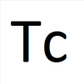 TIME CALCULATOR .............................................................. 5
4.  LOOKBACK .............................................................. 5
5. PRICE DAY RANGE .............................................................. 5
6.  ACTUAL ANGLE .............................................................. 5
7.  GARTLEY .............................................................. 5
8.  IMPULSE TARGET .............................................................. 5
7. RATIO CALCULATOR .............................................................. 5
8.  FORWARD COUNT .............................................................. 5
9.  CALENDER TO TRADING DAY CONVERSION .................................... 5
10.  RETRACEMENT % .............................................................. 5

CONTENTS 2 TOOLBAR1

SR NO ICON DESCRIPTION PAGE NO

11. PERCENTAGE MOVE .............................................................. 5
12. ABCD BEARISH .............................................................. 5
13. ABCD BULLISH .............................................................. 5
14. 3 POINT PROJECTION DOWN ........................................................... 5
15. 3 POINT PROJECTION UP .............................................................. 5
16.  LAYER MANAGER .............................................................. 5
17.  SQUARE OF HIGH / LOW .............................................................. 5
18. 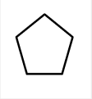 PENTAGON .............................................................. 5
19. 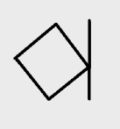 SQRANGLE .............................................................. 5
20.  EQUILATERAL TRIANGLE .............................................................. 5

CONTENTS 3 TOOLBAR1

SR NO ICON DESCRIPTION PAGE NO

21. SQUARE OF NUMBERS .............................................................. 5
22.  ARC PLOTTER .............................................................. 5
23. 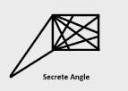 SECRET ANGLE .............................................................. 5
24. 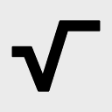 SQUARE ROOT OF PRICE IN TIME ....................................................... 5
25. SQUARE OF ALL .............................................................. 5
26.  HEXAGON .............................................................. 5
27. 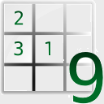 SQUARE OF 9 .............................................................. 5
28. SQUARRING OF RANGE .............................................................. 5
29.  PLANETORY LINES .............................................................. 5
30.  MOON CYCLES .............................................................. 5

CONTENT 4 TOOLBAR1

SR NO ICON DESCRIPTION PAGE NO

31. SQUARE OF 9 PRICE LINES .............................................................. 5
32. SQUARE OF 9 TIME LINES .............................................................. 5
33.  LUCAS TIME SERIES .............................................................. 5
34. FIBONACCI TIME SERIES .............................................................. 5
35. 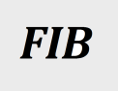 FIBONACCI RETRACEMENTS .............................................................. 5
36.  FIBONACCI PROJECTION CONFLUENCE ................................................... 5
37. 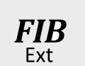 FIBONACCI SQUARE ROOT EXTENSION ................................................... 5
38.  LOW EXTENSIONS .............................................................. 5
39. 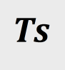 TIME SERIES .............................................................. 5
40. TAN/ COS/ SIN TRIGNOMETRY ............................................................. 5

CONTENT5 TOOLBAR1

SR NO ICON DESCRIPTION PAGE NO

41. TIME CONVERSION BAR ............................................................. 5
42. 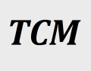 TRIPPLE CROWN METHOD ............................................................. 5
43. 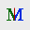 SQUARRING THE RANGE TRADIN SYSTEM .................................... 5
44. ANDREW PICHFORK ............................................................. 5
45.  ELLIOT WAVE ............................................................. 5
46. 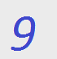 SQUARE OF 9 SEARCH ENGIN ............................................................. 5
47.  JENKINS TRUE TREND LINE ............................................................. 5

TOOLBAR2

SR NO ICON DESCRIPTION PAGE NO

48. ANGLES ............................................................. 5
49. ZERO BOUNCING 1 ............................................................. 5
50. ZERO BOUNCING 2 ............................................................. 5
51. ZERO BOUNCING 3 ............................................................. 5
52. HIGH LOW ZERO BOUNCING ......................................................... 5
53. VIBRATION OCTAVE ............................................................. 5
54.  GANN ZERO BOUNCING ............................................................. 5
55.  PRICE CONVERSION ............................................................. 5
56.  PLANETORY INFLUENCE SHEET ....................................................... 5

OVERLAYS

Sr no ICON DESCRIPTION PAGE NO

57. 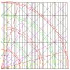 ABSS (up) ....................................................... 5
58. 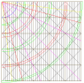 ABSS (down) ....................................................... 5
59. 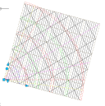 ABSS (rotational-up) ....................................................... 5
60. 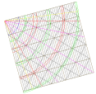 ABSS (rotational-down) ....................................................... 5
61. 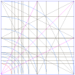 FIBO-EXTENSIONS ....................................................... 5
62. 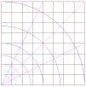 GEOMETRIC ....................................................... 5
63. 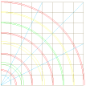 FLATS ....................................................... 5
64. 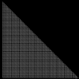 360X360 GRID ....................................................... 5
65. 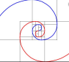 VORTEX-180° ....................................................... 5
66. 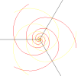 VORTEX-120° ....................................................... 5
67. 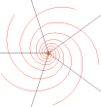 VORTEX-72° ....................................................... 5
68. 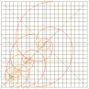 VAS (VORTEX ARC SYSTEM) ....................................................... 5
69. 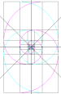 VORTEX SQUARES ....................................................... 5
70.  SPOKES ....................................................... 5
71.  DEMAND ZONE ....................................................... 5
72.  SUPPLY ZONE ....................................................... 5
73.  CONCENTRIC CIRCLES ....................................................... 5
74.  FIBONACCI CIRCLES ....................................................... 5
75. 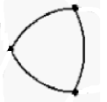 TRI-VESICAPISCES ....................................................... 5
76.  METATRON’S CUBE ....................................................... 5
77.  FLOWER OF LIFE ....................................................... 5
78. 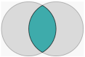 VESICA PISCES ....................................................... 5
79. 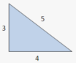 PYTHAGORUS TRIANGLE 3-4-5 ....................................................... 5
80. 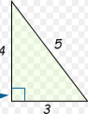 PYTHAGORUS TRIANGLE 4-3-5 ....................................................... 5
81. 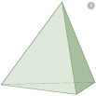 PYRAMID TRIANGLE ....................................................... 5

82. 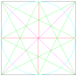 BEHIND THE VEIL ....................................................... 5
83. 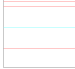 19.47 DEGREE ....................................................... 5
84. 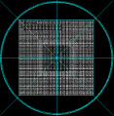 SQUARE OF NINE ....................................................... 5
85.  SRI YANTRA ....................................................... 5

Plotting Tool 
This tool will plot new graphs as well as update the existing graphs. Once you click on  icon following window will pop up. To plot new graph which is not available in our folder, you need to select the name of scrip from the drop down menu of c:/ box as shown below.
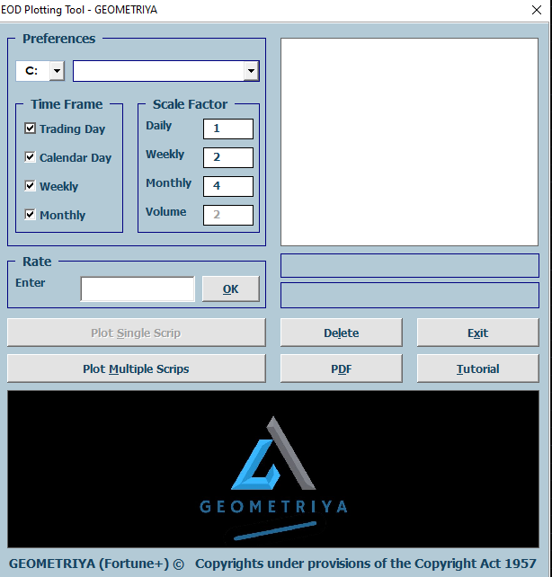
Scaling of graph is the soul of study, you can enter current price of scrip in the box mentioned as rate and press ok, you will get scale of the scrip. You need to mention scaling of graph in daily scaling box, all the other time frame scaling will get adjusted automatically. Finally, select the name of scrip appeared in list box and press plot single scrip button, wait for plotting to complete. Pop up windows will disappear, now you can see your chart in list menu on left side of software. If not, close the software and reopen it, else you can press refresh button on top of list appearing on left side of software. If you want to delete any unwanted chart, you can select the name in drop down menu and press delete button.
If you want to update all the charts existing in software, click on plot multiple scrip icon. You will get Following pop up window
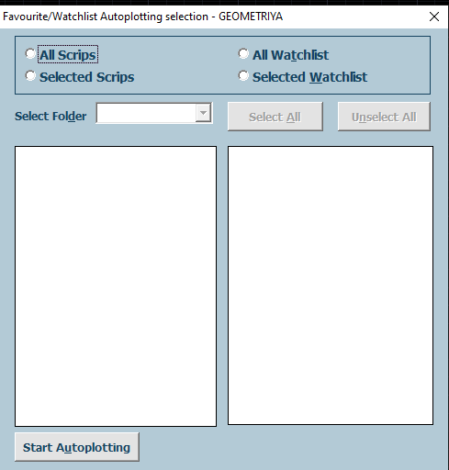
If you select All Scrips icon all scrip in software will get updated .When you click selected scrip icon you can select any particular folder or even any specific scrips and update them at once. When you select All watch list button only your selective scrip will update.

Counting 
With the help of this tool we can count the time distance between any two distant bars. We can use this tool on any time frame to count days/weeks/months between two candles.

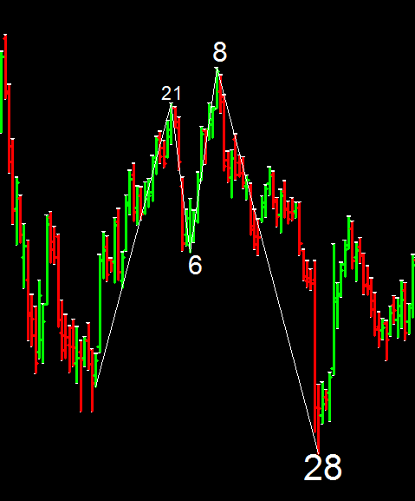
How to use Count tool:-
- Click on starting bar.
- Click on ending bar.
Counting will appear marked on top of the last bar.

TIME CALCULATOR 
This tool will calculate the timing of change or acceleration of trend. In TC , we count the time distance of a swing. By clicking on any lowest and highest point (not necessarily in the fresh ground), you will get the time distance written on top of the last bar. TC will also give you the one TC timeline and palindrome line wherein changes in trend can occur.
How to use TC:-
- Select TC tool from the tool bar.
- Select point A and point B.
- TC timeline and Palindrome line appears on the screen.

LOOKBACK 

It shows the location in the past related to specific price. We will take the price of major low or high and move backward for that many days and can check any type of volatility there. But this is only possible with mitotic scaled chart.
How to use Lookback tool:-
- Go to toolbar 1 and select  tool.
- Click on the major low or high.
- Lookback line will be drawn in the past.

PRICE DAY RANGE
It gives us price distance between any two points and also the time taken. If you click on any two points, PDR will calculate the price –time range.
How to use PDR:-
- Select PDR from the toolbar 1.
- Click on the major low or major high of the scrip.
- Select another point .
- Price range and time in days appears.
- Pytho timeline also appears on the scrip.
- Day range timeline appears in ratio of 0.382/0.618/1.616
ACTUAL ANGLE 
Actual angle is unique tools which measures exact angle of inclination of scrip and plots different subdivisions of it on chart. Due to the preciseness of angle calculation and scaling, these angles work precisely on the scrip.
How to use Actual Angle:-
- Click on the  tool from the toolbar 1.
- Then select point A and Point B on the scrip.
- Mention the line length in the box. By default it is 150.
- Actual angles will appear on the scrip.

GARTLEY 

In this tool we have taken all different Gartley patterns. One should be proficient enough to mark the points on chart. Once points are marked as per commentary shown while marking points we will get horizontal lines plotted for all the possible D points of gartley, from where changes in trend are possible.
How to use Gartley:-
- Click on the  tool from the toolbar 1.
- Then select point X,A,B and Point C on the scrip.
- All possible D points level will be plotted as horizontal lines.

IMPULSE TARGET 
In this tools we need to give two points of a swing and 3 different targeted areas will be shown as horizontal line.
How to use Impulse Target:-
- Click on the  tool from the toolbar 1.
- Then select point A and Point B on the scrip.
- All three different targets will be plotted as horizontal lines.

RATIO CALCULATOR
R/C is a tool where harmonic vibration of imp low price are matched with unique price/time ratio and when this ratio matches with mentioned low/high price, corresponding price is marked as imp vibration of said point. In F+ we can apply different ratios such as Musical ratios, Fibonacci ratios, Geometrical ratios. When we select any ratios , the color line of that particular ratio appears on the scrip.
How to use Ratio Calci tool:-
- Click on from the toolbar 1.
- Ratio calci window will pop up.
- Click on the ratios which we want to study.
- Press SELECT.
- Ratio calci lines appears on the scrip.

FORWARD COUNT 
This tool gives us probable dates of change in trend of a scrip. In this tool three different sets of high and low are counted and these three sets are projected from a mentioned low or high point.
How to use Forward Count tool:-
- Click on  from the toolbar 1.
- Click on set1 and mark number of points.
- Repeat the above step for set 2 & set 3.
- Press plot and select the point from which you want all these time sets to repeat. Vertical lines will be plotted, clusters are more useful.

CALENDER TO TRADING DAY CONVERSION 
CTC is the calender day to trading day count conversion. Calendar day chart takes into account Saturday, Sunday and holidays while plotting the graph. Hence the high and low price swings have different count of time in this graphs compared to the trading day chart. If this count is overlayed on trading day chart we get considerable hits on turning points, and since calendar day count is always larger, we get tentative points of future turning points on trading day chart in advance.
For applying this tool on the chart –
- Click on the option.
- CTC window will pop up.
- Click on respective points on calendar day chart.
- Press plot and now select point on trading day chart.

RETRACEMENT PERCENTAGE 
Retracement % is very simple tool to calculate the exact retracement between two swing points.
How to use retracement % tool:-
- Click on from the toolbar 1.
- Click on swing low, then click on swing high and finally clicks on retraced point.
- Exact Retracement % will appear at bottom of retraced point.

PERCENTAGE MOVE
This is unique tool which calculates % move from point 1 to point 2and projects same % move from the specified point.
How to use % move tool:-
- Click on from the toolbar 1.
- Click on swing low, then click on swing high and finally click on retraced point ( exactly opposite for down move)
- Projection line will be drawn which will be exact same % of move of point 1 and point 2, projected from point 3.

ABCD BEARISH

With the help of this tool, we project the level from which change is possible. You just have to find the upswing, click on the lower point(A), higher point(B) and the retracement point (C). It will automatically plot the price line (point D) from which change is expected.
How to use ABCD bearish:-
- Find an upswing which is in the fresh ground.
- Click on the lower point (A) of the swing.
- Click on the higher point (B) of the swing.
- Click on the retracement point (C).
- ABCD Bearish line appears on the scrip.

ABCD BULLISH

With the help of this tool, we project the level from which change is possible. You just have to find the downswing, click on the top point (A), lower point(B) and the retracement point (C). It will automatically plot the price line (point D) from which change is expected.
How to use ABCD bullish:-
- Find down swing which is in the fresh ground.
- Click on the higher point (A) of the swing.
- Click on the lower point (B) of the swing.
- Click on the retracement point (C).
- ABCD Bullish line appears on the scrip.

3 POINT PROJECTION DOWN
We use this tool for the projection of Fibonacci ratios. Select a topmost swing. Then click on the high , low and the retraced point. 3 P Projection gives us the price line in calculation with fibo ratios. We can expect change or acceleration of trend from this point.
How to use 3 Point Projection Down:-
- Select a topmost swing.
- Then click on the high , low and the retraced point.
- Fibo price line automatically appears on the screen.

3 POINT PROJECTION UP
We use this tool for the projection of Fibonacci ratios. It gives us the price line in calculation with fibo ratios. We can expect change or acceleration of trend from this point.
How to use 3 Point Projection Up:-
- Select a swing.
- Then click on the low, high and the retraced point.
- It will give us the price line in fibo ratios.

LAYER MANAGER 
It includes the F+ layers as well as planetary lines. We can switch on /off any layer or any planetary line to avoid the mess.
How to use Layer Manager:-
- Click on  from toolbar 1.
- Then check or uncheck which tools should be displayed on chart.
- Study of the unchecked tools will be available in background but not displayed. You can recall that study by again checking the box.

SQUARE OF HIGH / LOW 
With the help of this tool we can draw square between two mentioned points. Specifically square between low point and high point.
How to use Sqaure of High/Low:-
- Click on  from toolbar 1.
- Then click on important points of the swing.
- Square will be drawn between selected two points.

PENTAGON 
Pentagon is a polynomial which has the capability of going into the higher dimension. We can draw a pentagon by clicking any two points (high/low AND low/high). The vertices of pentagon acts as a timeline to look for change or acceleration of trend. We can extend pentagon 12 times for making Dodecahedron, a 3 Dimensional figure. Being a platonic solid, stability is assured.
How to apply Pentagon:-
- Click on the on the toolbar 1.
- Select any two points on the scrip.
- Pentagon will appear on the screen.

SQRANGLE 
Square angle is basically a square drawn by taking swing low and swing high as side of a square. If you click on any two Points, square angle will be drawn. Each vertices of the square has the energy. They work as the timeline which projects change/acceleration of trend. We can draw multiple angles intersecting sides of the square and project those in future to check for a long term support or resistance.
How to apply Square:-
- Click on the  tool on the toolbar 1.
- Select any two points on the scrip.
- Square will be drawn.

EQUILATERAL TRIANGLE 
It will plot the equilateral triangle from the two mentioned points. First, click on the equilateral triangle sign on the tool bar and then select point A and point B. Equilateral triangle will be drawn. The vertices of this triangle works as the timeline from which trend can change or accelerate. The horizontal magenta line which appears on the triangle is the cube root level. It works as a support line.
How to use Equilateral Triangle tool:-
- click on the equilateral triangle sign on the tool bar.
- select point A and point B .
- Equilateral triangle will be drawn.

SQUARE OF NUMBERS
This tool creates squares of any numbers in ascending as well as descending order which are used from numerological point of view. These numerological points helps us to determine the important points of support as well as resistance. We can create as many squares as required and paste besides any graph as a handy tool.
To apply this tool –
- Click on this tool.
- Sq-of-N window will pop up.
- Fill the required information.
- Click on the plot icon.
- Square of 9 table will appear on the graph.

ARC PLOTTER 
In this tool, Vesica Pisces is drawn keeping important swing as radius of both the circles. Distance between the two intersection points of Vesica Pisces is taken as radius to draw a larger circle from the base point of swing. Scrip normally obeys the larger circle in both price and time.
To apply this tool –
- Click on this tool.
- Select the swing starting point.
- Select the swing end point.
- Vesica Pisces and larger circle will appear on chart.

SECRET ANGLE 
This will plot the secret angle from low to high OR vice -versa. This method is based on Michael Jenkins Secret angle method. Once you click swing low and high points, all the important time lines, support lines, up angles, down angles, its subdivisions are plotted automatically to give us the guidance path of the future price and time levels of the scrip. It has been observed that most of the time the scrip changes its direction from the white color vertical line which is at the intersection of two cross lines. The magenta color line also works as the support.
To apply secrete angle tool—
- Click on the secrete angle icon 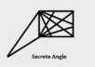on the tool bar.
- Then select up angle or down angle as per your study.
- Secret angle will be drawn. It has been observed that most of the time the scrip changes its direction from the white color vertical line which is at the intersection of two cross lines. The magenta color line also works as the support.
SQUARE ROOT OF PRICE IN TIME 
This will plot square root of price in time. The price which we have selected gets converted in to its square root and this square root changes in time. First click on the square root icon. Mention the scale of the scrip and lines to be drawn. Maximum limit is of 20. The vertical lines are the square root of the price which we have taken.
How to use Square Root of Price in time tool:-
- First click on the square root icon. 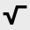
- Mention the scale of the scrip and lines to be drawn.
- Maximum limit is of 20.
- Vertical lines appear on the scrip.
SQUARE OF ALL
By using this tool we can plot all the different squares mentioned by W.D.Gann along with angles and subdivision on the chart . It draws squares of 144, 90, 52 as well as user defined square.
For applying Square of all tool--
- Click on the option.
- Squares window will pop up.
- Specify the required no. of squares.
- Gann squares will appear on the chart.

HEXAGON 
Apart from square of nine, W.D. Gann has extensively used Hexagonal time price chart. This tool gives us hexagonal spiral levels in price and time. .We can select degrees manually or can select the different aspects such as Trine, Square or Sextile thus selecting appropriate degrees needed for our study.
For applying Hexagon tool—
- Click on the  icon
- Square of 9 levels will pop up.
- By specifying the required information click on plot option.
- Hexagonal price and time levels will appear on the chart.

SQUARE OF 9 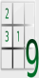
This tool gives us square of 9 levels up and down. It is difficult to plot vast numbers of square of 9 on a graph in time and price levels. In fortune plus one click will plot price and time levels of square of 9. Hence it is very easy to check in which vibration scrip is moving.
For applying square of 9 --
- First click on  this tool on the toolbar.
- Window of Square of 9 will pop up.
- Customize as per need and press plot.
- Select the required point on chart.
- Square of 9 levels will appear on chart.

SQUARRING OF RANGE
It draws the square and circle from the range of any two points generally major low and high of the scrip. It has been noticed that whenever scrip moves beyond square line or the circle, it changes it direction. The tangent to the circle works as a timeline.
For applying squaring of range:-
- First click on the icon.
- Then the software asks for mentioning the scale factor. Here by default we take scale of 1.
- Select high and low point of the scrip, squaring of range will be drawn.

PLANETORY LINES 
This will plot planetary lines on the calendar day chart. For applying this tool, we have to click on the planetary lines icon. Then it asks for entering the first date of the said scrip. Next click on the plot button. Twice it will open a MATCH FOUND window. After clicking on the OK button planetary lines will appear. These planetary lines are of Jupiter, Mars, Mercury, Moon, Neptune, Pluto, Uranus, Saturn, and Venus. Since our chart is Mitotic scaled which is related to 360 number it gives the accurate result.
How to apply Planetary lines:-
- First go to calendar day chart.
- Click on the planetary lines icon on the toolbar 1.
- Enter the first date of the said scrip.
- Next click on the plot button.
- Planetary lines get drawn.
MOON CYCLES 
It will plot moon cycles price and time lines. Many times it has been observed that scrip changes or accelerates from the moon cycle lines. Horizontal lines works as a good support/resistance and vertical lines as time lines.
How to apply Moon cycles lines:-
- Click on  icon and go to calendar day chart.
- Click on swing start and end points.
- Now go to trading day chart and select the swing start point.
- Vertical time lines and horizontal price lines will appear on chart.

SQUARE OF 9 PRICE LINES
It has been mentioned in some books that while trading on trading floor W.D. Gann was using hand print of square of nine. Square of nine has resemblance to pyramids of Egypt as well as Paramsayika chakra found in many Hindu temples. His Natural square calculator also was nothing but combination of time and price tools based on square of nine. Such is the importance of square of nine, hence rather than using numbers we plotted all levels on graph to make it easy for the testing purpose. Apart from this if we feel that all the levels are too much cluttered we have additional tools wherein we can select only the required time or price levels.Horizontal lines are the price lines and vertical are the time lines.
How to apply Square of 9 price lines:-
- Click on icon.
- Select which degree lines are required.
- Click on important point on chart.
SQUARE OF 9 TIME LINES
Similar to the price lines we can draw time lines of square of 9.
How to apply Square of 9 time lines:-
- Click on icon.
- Select which degree lines are required.
- Click on important point on chart.

LUCAS TIME SERIES 
In Lucas time series, we count lucas numbers in time from any imp low or high. It works as a time line from where change or acceleration is expected.
How to apply Lucas time series lines:-
- Click on  icon.
- Insert how many numbers in series are required.
- select the point. Time series will be plotted.
FIBONACCI TIME SERIES
In Fibonacci time series, we count Fibonacci numbers in time from any imp low or high. We can also start from the birth date of the scrip. It works as a timeline from where change or acceleration is expected.
How to apply Fibonacci time series lines:-
- Click on icon.
- Insert how many numbers in series are required.
- Select the point. Time series will be plotted.
FIBONACCI RETRACEMENTS 
This will plot Fibonacci retracement levels for up or down trend. It helps in finalizing the exact location of the scrip. Important retracement levels are 38.2%, 50% and 61.8%. We can also apply arc to these retracement. We applies FIB levels to 0 to highest high, extreme low to extreme high as well as to the fresh rally low to the high. We apply it on Monthly, Weekly and Daily chart.
For applying this, we have to click on FIB icon on the toolbar. Then select retracement level for up OR down trend. Next click on PLOT FIBINACCI LEVELS. Retracement levels will be drawn.
FIBONACCI PROJECTION CONFLUENCE 
It will plot the Fibonacci projection levels up or down trend. These levels work as price line. One can apply these lines to all major swing within the rally. Major cluster of lines work as important milestone.
How to apply Fibonacci projection confluence:-
- Click on icon.
- Select the line length.
- Select swing start and swing end points
- Projection lines will appear.

FIBONACCI SQUARE ROOT EXTENSION 
This tool plots the Fibonacci extensions of the square root of price. It has been observed that these levels acts as the support or resistance . You can also draw a circle to the extension level. Tangent to these circle also works as a timeline. These extensions are 0.618%, 1.618%, 2.618%, 4.236%, 6.857% and 11.08%.
How to apply Fibonacci square root extensions:-
- Click on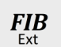 icon.
- Select line length.
- Select plot Fibonacci levels
- Projection lines will appear.

LOW EXTENSIONS 

This tool will plot the doubling or the fibo extn of given low. You can apply it on all time low of the scrip or any other imp low.
For this, you have to select the  option on the tool bar. The window will pop up. It will ask you for the doubling option and the fibo extn option. Doubling option will provide you the multiples of the given low. It can double the low upto 512 times. Fibo extn option will provide you the levels of fibo extn upto 76.012%. Choose the option you needed. Mention the actual scale of the scrip and then click on the low . Horizontal lines will appear on the screen.

TIME SERIES 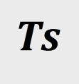
Time series is a numerical tool. As per Gann, scrip changes its direction in rhythmic fashion . By using this tool you can plot say 45 days distance lines from important low/high.
How to plot TS:-
- Click on TS tool.
- Window will pop up.
- Default Time in days and No of lines are already given.
- click on plot button.
- Then select any imp low or high on the scrip.
- Time distance line will be plotted.

TAN COS SIN TRIGNOMETRY

TIME CONVERSION BAR

TRIPPLE CROWN METHOD 
This is a Triple Crown method of Derrick Hobes. In this method 78.6% should be between 50% and 61.8% retracement.
For applying this tool:-
- Click on tool.
- Select point A, B, C and point D
Yellow colour line of 78.6% retracement will appear on the scrip. Possibility of change of the trend increases from this line.

SQUARRING THE RANGE TRADING SYSTEM 
Squaring the range helps us in finding exact timings of the change in trend as well as different support levels in the chart. We have five different methods of squaring the range. They are
- Plain angle
- Actual angle
- Node circles
- Octave angles
- Natural angles

ANDREW PICHFORK
This will plot Andrew Pitchfork lines. They behave like a trendlines.
To plot AP lines, click on icon on the tool bar.
You have to select the 3 points, first any low of the scrip then 2nd is the immediate top and the 3rd point is the retracement of the swing.
Then it will ask for the line length . you can give any number you wish but the default is 100.
After giving line length Andrew pitchfork lines get appear.
This AP lines acts as a trend line.

ELLIOT WAVE 
Wave is the theory developed by Ralph Nelson Elliot. This tool will plot Elliot wave retracement and projection.
As per Elliot, scrip always moves in a particular pattern. He found this pattern similar to the movement of waves in the ocean. According to him there are major 8 waves in the up move or down move of the scrip. Elliot Wave tool plots the retracements and projection points of the chart.
How to plot :-
- Click on the Elliot wave tool.
- Select UP or DOWN button as per your choice.
- Mention length of the line you want.
- Then click on any button of wave you want to plot.
- Last, select Plot button.

SQUARE OF 9 SEARCH ENGIN 

JTTL - JENKINS TRUE TRND LINES.
This tool plots the trend lines from the specified point. These lines are in combination with Gann’s Square of 9. Because of this feature these trend lines are of immense importance .These trend lines acts as a support or resistance to the scrip. JTTL lines are applied only on the calendar day chart.
How to apply JTTL
- Click on the Jttl tool icon.
- Window will appear.
- In the first column specify the no. of lines you want.
- The range of the line starts from 2 to 32.
- In the second column you have to mention from where the lines to be plotted.. Whether from top or bottom.
- In the third column you have to specify the days. Two options are given. 360 days or 365 days.
- Click on whichever option you needed.
ANGLES
Angles plays an important role in Fortune + software. Many times we have observed that the scrip has taken exact support or resistance at the angles. Because of these angles only we are able to identify the speed of the scrip,
and the time it will take to reach its target. We have 1*1, 2*1, 3*1,4*1,8*1, 1*2, 3*1, 4*1 , 8*1 up and down angles available in fortune +.
For applying angles
- Click on angles toolbar
- Click on any angle you want to study.
- That angle will be drawn.

ZERO BOUNCING 1
This tool will plot zero bouncing angle 45 deg down and 45 deg up. When you click on the low of the scrip, it fires a horizontal as well as 45 deg down angle from the mentioned low. At the intersection point of 0 and 45 degree it fires 45 deg up angle. Again, at the intersection point of horizontal line and 45 deg up it draws a vertical line which acts as a timeline.
For applying this tool
- Click on this icon
- Zero Bouncing window will appear.
- Specify the no of angles you want to draw.
- Then click on the plot button.
- Zero bouncing angles will be drawn.

ZERO BOUNCING 2
This zero bouncing2 angle will plot a vertical down angle and then up 45 deg. This 45 deg angle work as a timeline.
For using this tool
- Click on this icon.
- Select the high of the scrip.
- When you click on the high, down vertical line gets drawn upto zero deg and from that point it draws 45 deg up angle. With angle it also draws square. The tangent of the square also works as a time line.

ZERO BOUNCING 3
This zero bouncing3 angle will plot 45 deg down from the chosen low and vertical up. This vertical line works as a timeline.
For using this tool
- Click on this icon.
- Select the low of the scrip.
- When you click on the low , down 45 deg line gets drawn upto zero and from that point it draws vertical up line.

HIGH LOW ZERO BOUNCING

VIBRATION OCTAVE

For using this tool:-
- Click on the option on the tool bar.
- Vibrtion Octave window will pop up.
- Then select on UP angles /DOWN angles as per study.
- Specify the Octave Length. By default it is 16, but you can maximize it till 160.
- Then specify horizontal line length and angular line length. By default it is 300 & 1000 respectively.
- Click on Plot button.
- Horizontal and angular lines will be plotted.

GANN ZERO BOUNCING 
This is Gann Zero Bouncing Angle. In this method 45 deg up angle is fired from the low of important swing. It considers this important low as Zero. Whenever we select other lows of the scrip, vertical line gets drawn upto this important low point and from there it draws 45 up line.
How to use this tool:-
- Click on the  option.
- Select important swings low and high.
- If you want to select any other points , click on Yes or otherwise click on No option.

PRICE CONVERSION 
This is price conversion tool. We believe that Price can be converted into time and vice-versa. The same concept is used in this tool. There are three different methods of conveting . They are regular, fibbo and square root method. Here We select the highest bar and convert it into PC.
To use this tool:-
- Click on the  icon.
- PC window with three methods will pop up.
- Click on option you want to use.
- Place the number of lines.
- Lastly, click on the PLOT button.
- PC timelines will appear on the screen.

PLANETORY INFLUENCE SHEET 
In Fortune +, we believe that nature affects the universe so it affects the share market also. Our study of Planetary influence is a proof to it. It has been known that particular planet influences the specific sector. For eg:- Venus and Jupitor influences the Paper industry. Pharmaceutical industries are affected by Mars and Jupitor. In Fortune + readymade planetary influence sheet has been given so that it will be easier for the trader to find out which planet rules the specific industry.
For using this:-
- Click on  icon.
- Planetary excel sheet with symbols, sector, sub sector, rullling planet 1, planet 2, planet 3 and planet 4 will appear on the screen.
- Go to Find all form option and write the symbol of the company, the name of the rulling planet will automatically appears on the screen.
- Now it will be easier for the trader to plot the lines of that particular planets which affects it.

ABSS (up) 
ABSS is the Automated Buy and Sell Signal. When the scrip is in up move we have use ABSS up overlay. There are 6 archs and 7 angles in this overlay ,each having a specific geometric value. It has been proven many times that while moving , the scrip takes support or resistance of these archs and angles.
To use this overlay:-
- Initially find an upswing which is in the fresh ground.
- Then go to the tool palette which is at the right side of the F+ software.
- Click on 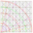 the option.
- Place it on the low point of the swing.
- Then stretch or adjust the blue arch to the highest point of the swing.

ABSS (down) 
ABSS (down) is used when scrip is in the down trend. It gives us future targets of down trend. ABSS helps us to project probable price at which scrip can make an important low. It also tells us about Time at which that important low will be made.
To use this tool :-
- First find out the down swing which is in the fresh ground.
- Then go to the tool palette.
- Next click on the 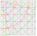tool.
- Place it on the highest point of the swing.
- Stretch or adjust it to the low of the particular swing.

ABSS (rotational-up) 
It has been observed that many times while coming down,the scrip goes up for particular days and then again comes down. While coming down, it goes below of that specified swing and starts the up ralley. In such cases ,we have to use ABSS UP-R i.e.rotational up. It gives us exact entries as well as exit just like ABSS.
For using this tool:-
- First recognise the UP swing where the scrip has broken the low of that particular swing.
- Then go to tool pallete .
- Select 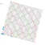 tool.
- Place it on the low of the swing.
- Here first you have adjust the blue color circle with the high of the swing and then the arrow has to be adjusted to the same point.
- Now the ABSS UP R has been properly applied to the scrip .
- From here , you can set your targets.

ABSS (rotational-down) 
It has been observed that many times while going up,the scrip goes down for particular days and then again goes up. While going up, it goes above of that specified swing and starts the down ralley. In such cases ,we have to use ABSS DN R i.e.rotational down. It gives us exact entries as well as exit just like ABSS.
For using this tool:-
- First recognise the Down swing where the scrip has broken the high of that particular swing.
- Then go to tool pallete .
- Select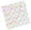 tool.
- Place it on the high of the swing.
- Here first you have adjust the blue color circle with the low of the swing and then the arrow has to be adjusted to the same point.
- Now the ABSS DOWN R has been properly applied to the scrip .
- From here , you can set your targets.

FIBO-EXTENSIONS 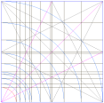

GEOMETRIC 

FLATS  (Fibonacci, Lucas arcs trading system)
FLATS is the Fibonacci Lucas Arcs Trading System. It is the combination of both, Fibonacci and Lucas. By default, there are 5 arcs but you have the option of extending them till level 55. These arcs makes us aware about the support and resistance of the scrip. the circles in Fibonacci number are marked
with red color and circle with Lucas number are marked by yellow color.All
the other circles are marked with green color. Red color here indicates
maximum resistance, yellow color indicating mediocre resistance and
green least resistance.
For using this tool:-
- Find out the up swing which is in the fresh ground.
- Then select 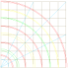 from the tool palette.
- Stretch or adjust it upto the high of the swing.
- Now you can set your entry and exit target.

360X360 GRID 

VORTEX-180° 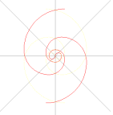
Vortex -180 gives us the price and time points. In vortex 180 we have 2 spirals. The arcs of the vortex works as the support as well as resistance in time and price level. The tangent to the arc also works as a timeline from where change in trend is expected. The horizontal line to the arc works as a price line.
For using this tool:-
- Click on the swing which is in the fresh ground.
- Then go to tool palette and select 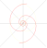.
- Place the center of the vortex to the swings retraced point.
- The next step is to align the spoke to the highest point of the swing.
- Then in the last step we have to adjust the arc to the swings highest point.

VORTEX-120° 
In vortex 120, we get 3 levels of main spirals. It is known as TRI- FIBONACCI vortex. It is adjusted just like vortex 180. The arcs of the vortex works as the support as well as resistance in time and price level. Tangent to the arch works as a timeline.
For using this tool:-
- Click on the swing which is in the fresh ground.
- Then go to tool palette and select 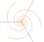.
- Place the center of the vortex to the swings retraced point.
- The next step is to align the spoke to the highest point of the swing.
- Then in the last step we have to adjust the arc to the swings highest point.

VORTEX-72° 
In the vortex of 72 , we have 5 spirals. It is adjusted just like the vortex of 180 and 120 . these are also known as Penta Fibo Vortex.

VAS (VORTEX ARC SYSTEM) 
VAS is the Vortex Arc System. Normally vortex is drawn in 5*5 grid but in VAS we can draw 21*21 grid vortex. Here we have the option of appling the multi level vortex on the scrip. You can see all the vortex at a time or you can make them invisible.
How to use this tool:-
- Select the important swing which is in the fresh ground.
- Then select VAS 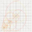 .
- Apply it to the low of the swing.
- Adjust or stretch it upto the highest point of the swing.
- You will find the Vortex of 5*5, 8*8, 13*13 and 21*21 grid.

VORTEX SQUARES 

SPOKES 

DEMAND ZONE 
Marking Demand zone on a chart is avery important task. It is considered as the potential turning zone in any scrip. There is the highest possibility of change in trend from the demand zone.Normally demand zone are marked horizontally i.e. only price content of a chart is extended in future.
For using this tool:-
- find out the demand zone from the scrip
- go to the tool palette and select Demand zone.
- Place it on the low and high of the candle.
- Demand zone will be marked. It can also be extended further.

SUPPLY ZONE 
Marking supply zone on a chart is a very important task. It is considered as the potential turning zone in any scrip. There is the highest possibility of change in trend from the supply zone. Normally supply zone are marked horizontally i.e. only price content of a chart is extended in future.
For using this tool:-
- find out the demand zone from the scrip
- go to the tool palette and select supply zone.
- Place it on the low and high of the candle.
- Supply zone will be marked. It can also be extended further.

CONCENTRIC CIRCLES 

FIBONACCI CIRCLES 

TRI-VESICAPISCES 

METATRON’S CUBE 
Metatrons cube is formed through basic geometric figure of flower of life. We can use flower of life figure as overlay on scaled chart. Petals of flower of life are in equilateral triangle shape and used to find support as well as trend change dates. Metatrons cube is formed by joining different points on flower of life and is very unique and important figure in geometry. All the basic geometrical structure can be drawn from metatrons cube, such as Cube, Tetrahedron, Star Tetrahedron, Octahedron ,Icosahedron. These all are basic platonic solids and have great geometrical importance.
How to use metatron’s cube:-
- Go to the tool palette.
- Select META-R.
- fix this overlay on chart.
- we can check which platonic solid is applicable to the individual graph thus identifying its characteristic, and we can apply the same platonic solid figures in future chart.

FLOWER OF LIFE 

VESICA PISCES 

PYTHAGORUS TRIANGLE 3-4-5 

PYTHAGORUS TRIANGLE 4-3-5 

PYRAMID TRIANGLE 

BEHIND THE VEIL 
Behind the veil is known as the STAR OF DAVID. it is widely known as Shield of David in Hebrew, is a Hexagram. The Star of David figure displays the number of intersection point at each level. The more the number of intersection horizontally, stronger will be the resistance or support in price. Similarly more intersection vertically suggests stronger time line. We can use this overlay in simple manner, i.e. just by expanding and contracting the size. Another way to use it by rotating as well as expanding and contracting.
How to use Star of David:-
- First find out the up swing which is in the fresh ground.
- Next go to F+ tool bar and select veil.
- Then place the centre of the veil at the highest point of the swing.
- Stretch the circle upto the low of the swings .

19.47 DEGREE 

SQUARE OF NINE 

SRI YANTRA 

Fibonacci vortex
Geometry has two great treasures,one is the theorem of Pythagoras the other the division of a line into extreme and mean ration.The first we may compare to a measure of gold,the second we name a Precious jewel.--Johannes Kepler
Needless to tell you that Isaac newton was so obsessed with Fibonacci vortex pattern that he had it carved into his bed frame.
Division of a line into extreme and mean ration is nothing but Fibonacci series and golden ratio of 1.618.
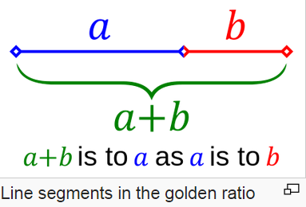
and here comes a famous fibonacci series 1,1,2,3,5,8,13,21,........
using this series if we draw square with sides of 1x1,1x1,2x2,3x3,5x5.....and place them adjacent to each other and then draw a arc joining diagonals of the square we can create golden spiral.Vertical and horizontal extreme point of vortex work as pressure point in market. Let us see how it develops...

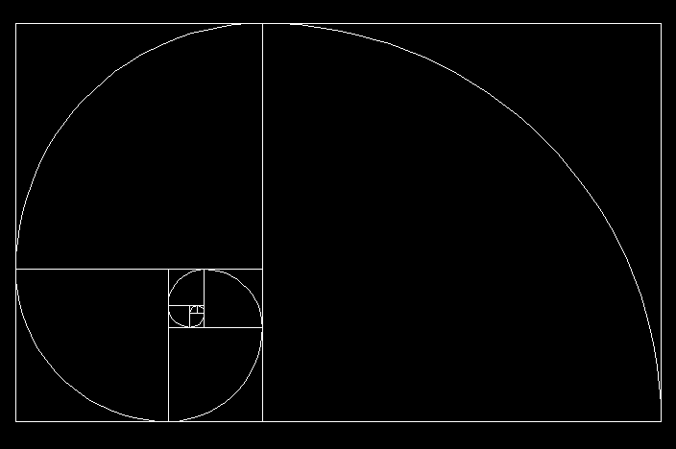

Golden spiral
Let us check different diagrams related to golden spiral which we can use as overlay in market.
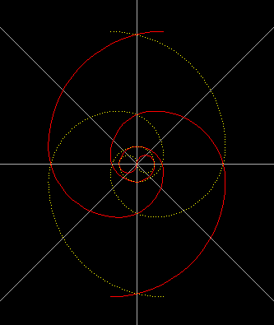
Fibonacci vortex 180° separated (180x2=360)
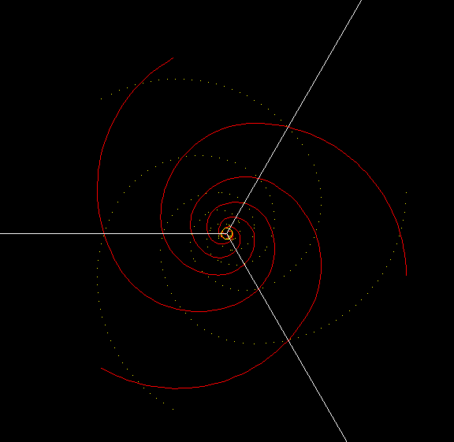
Fibonacci vortex 120° separated (120x3=360)
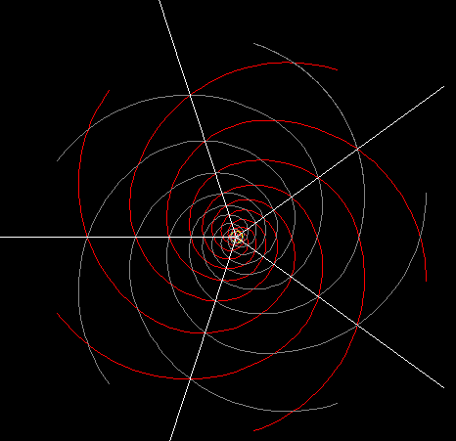

Fibonacci vortex 72° separated (72x5=360)

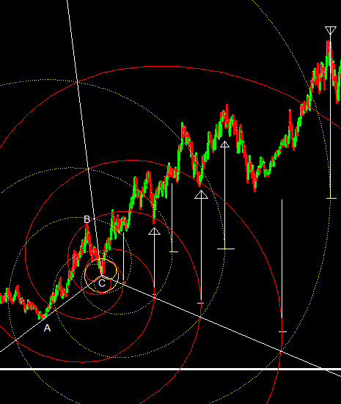

Fibonacci vortex 120° example
In the above example 120° fibonacci vortex has been alinged on initial swing points ABC such that point A and point C are on one of the spokes and spiral is attached to the point B. Extreme points of spiral gives us timing of change in trend and spiral itself acts as support and resistance.Out of 7 instances at 6 instances we can see considerable changes in trend of price.
Fibonacci vortex not only gives us expected time of change in trend it also acts as support and resistance in price and time levels. Check the following fibonacci vortex.
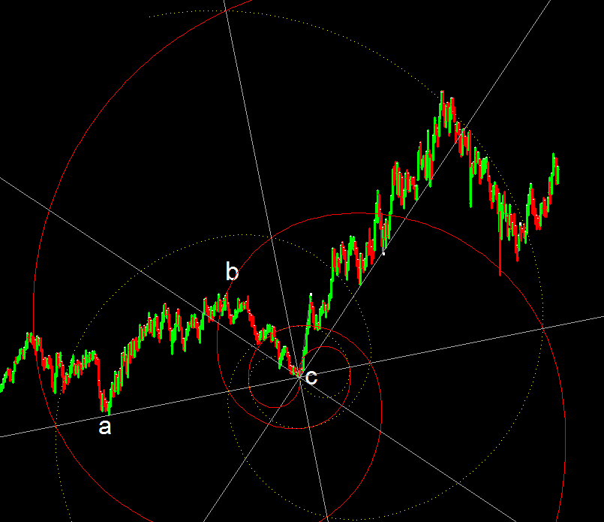

Fibonacci vortes support & resistance

In the above shown graph when fiboacci vortex is aligned to the swing points ABC such that spoke is aligned to Point A-B and fibonacci spiral is adjusted at point B, we get nice supports at 135° spoke and last spiral is acting as resistance similarly red spiral is acting as support. These points are possible to calculate only if the graph is properly scaled and overlays applied are precise in dimension.

Metatrons cube
Metatrons cube is formed through basic geometric figure of flower of life.We can use flower of life figure as overlay on scaled chart.Let us see Flower of life figure..

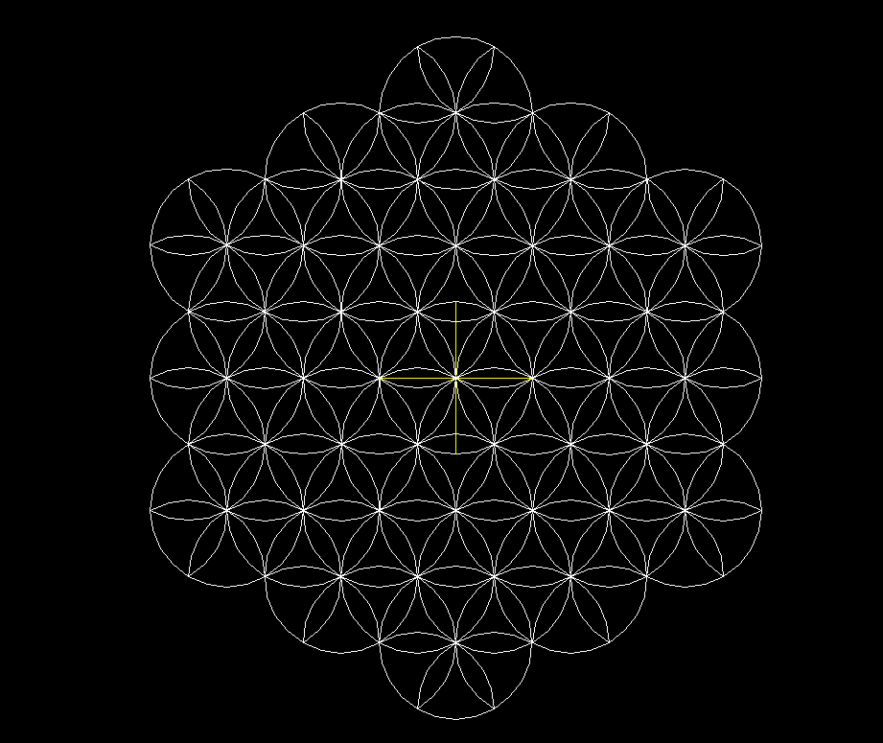

Flower of life
Petals of flower of life are in equilateral triangle shape and used to find support as well as trend change dates. Let us go further ahead, Metatrons cube is formed by joining different points on flower of life and is very unique and important figure in geometry. All the basic geometrical structure can be drawn from metatrons cube, such as Cube, Tetrahedron,Star Tetrahedron,Octahedron,Icosahedron.These all are basic platonic solidsand have great geometrical importance.

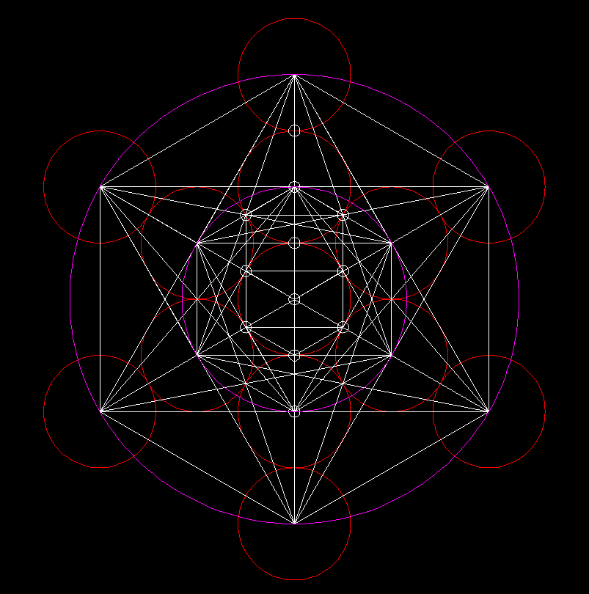

Metatrons cube
Once we fix this overlay on any chart we can check which platonic solid is applicable to the individual graph thus identifying its characteristic, and we can apply the same platonic solid figures in future chart. Its applicability is a skill of individual analyst and his imaginative power, more you work better you get
results out of this. Just check in the following chart how we can use cube as overlay which is formed after applying metatrons cube on fortune+ scaled chart.

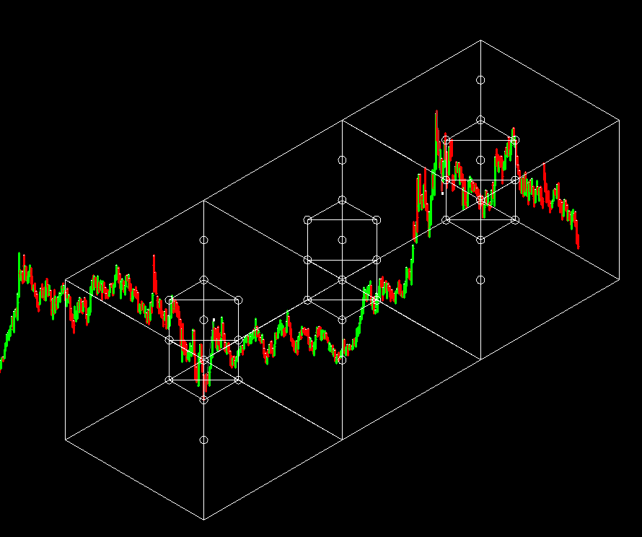

Cube in metatrons cube
Above metioned is one of the five alternative we can use to check its applicability and suitability to individual chart. Since the graph as well as overlay figure are perfect to the 14th decimal of point we get astonishing results in the market.
Above mentioned are few geometrical advantages of Fortune plus.
Let us move further ahead...
Square of Nine
As far as square of 9 is concerned it is difficult to plot vast numbers on grpah in price and time levels. In fortune plus one click will plot price and time levels of square of 9. Hence it is very easy to check in which vibration scrip is moving.

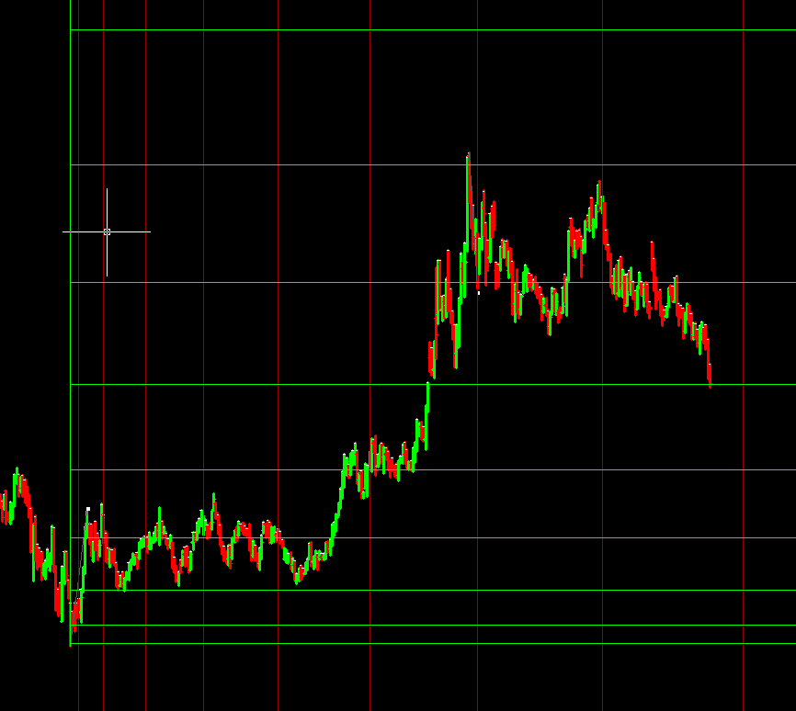

Square of Nine Price & Time levels

Actual Angle
Actual angle is unique tools which measures exact angle of inclination of scrip and plots different subdivisions of it on chart. You can see how precisely those angles work due to preciseness of angle calculation and scaling of graph in following example..

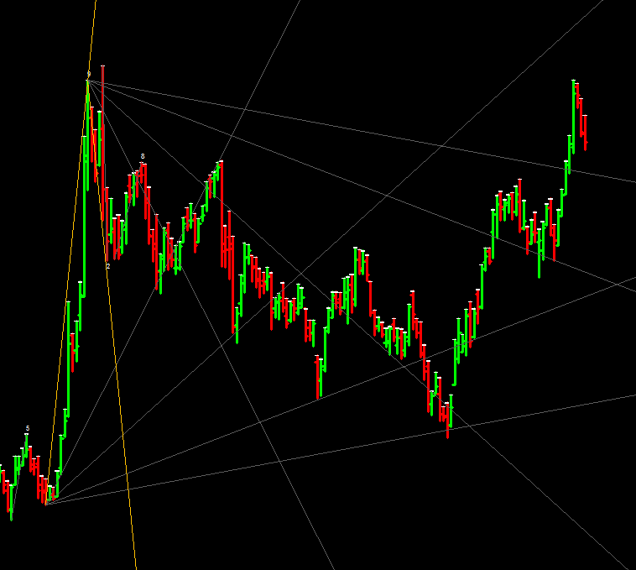

Actual Angle

Ratio Calculator
Ratio calculator is a unique tool wherein harmonic vibration of important low price are matched with unique price/time ratio and when ratio matches with mentioned low/high price, corresponding price is marked as important vibration of the said point. Surprisigly it is found that scrip vibrates to such ratios.
Let us have little clear idea about the concept through following example..
Suppose Rs 100/- is important low of the scrip then following will be one of the the possibilities......

PriceTime P/T ratio
100 | 1 | 100
101 | 2 | 50.5
102 | 3 | 34
103 | 4 | 25.75
104 | 5 | 20.8
105 | 6 | 17.5
106 | 7 | 15.14286
107 | 8 | 13.375
108 | 9 | 12
109 | 10 | 10.9
110 | 11 | 10

Corresponding price to the harmonic number
It is found that scrip actually takes resistance and support to the corresponding matched harmonic ratio. We may need to go thousands of iterations to match these unique ratios. In this tool we use different octave ratios,musical vibration ratios,geometrical ratios, harmonic ratios as well as inverse of all these ratios.
Now you can see, it becomes difficult for human brain to match thousands of iterations with hundreds of different ratios. This job is done by a click of mouse through this unique tool.Our job is to finalise which scrip is obeying which set of ratios by trial and error, once we know the set we know the unique charcteristic of that scrip,which the scrip follows in future. Let us see the screen shot ......
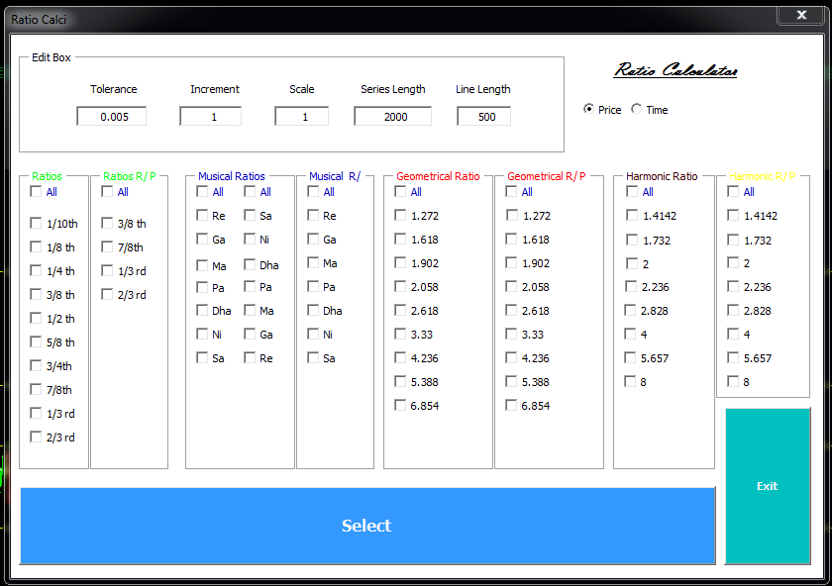

Ratio Calculator harmonic vibration tool
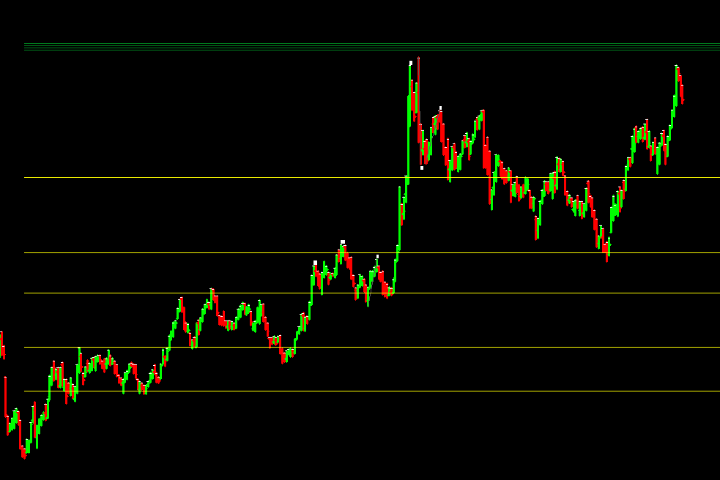

Ratio Calcy harmonic vibration of a scrip

Forward Count method by Dr C.K.Narayan

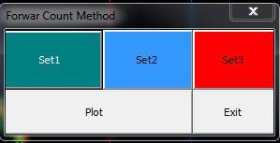

Forward Count method Tool
In the above mentioned tool three different sets of high and low are counted and these three sets are projected from a mentioned low or high point. This gives us probable dates of change in trend of a scrip.
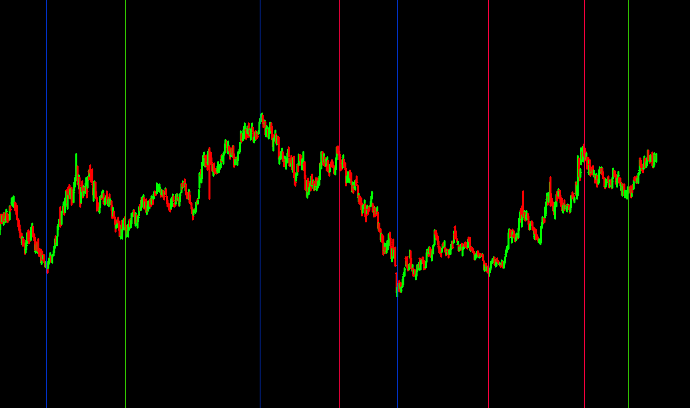

Forward Count method Tool apllied on a scrip

CTC- calender day to trading day count conversion
Calender day chart takes into account saturday,sunday and holidays while plotting the graph.Hence the high and low price swings have different count of time in this graphas compared to the trading day chart. If this count is overlayed on trading day chart we get considerable hits on turning points, and since calender day count is always larger we get tentative points of future turning points on trading day chart in advance.

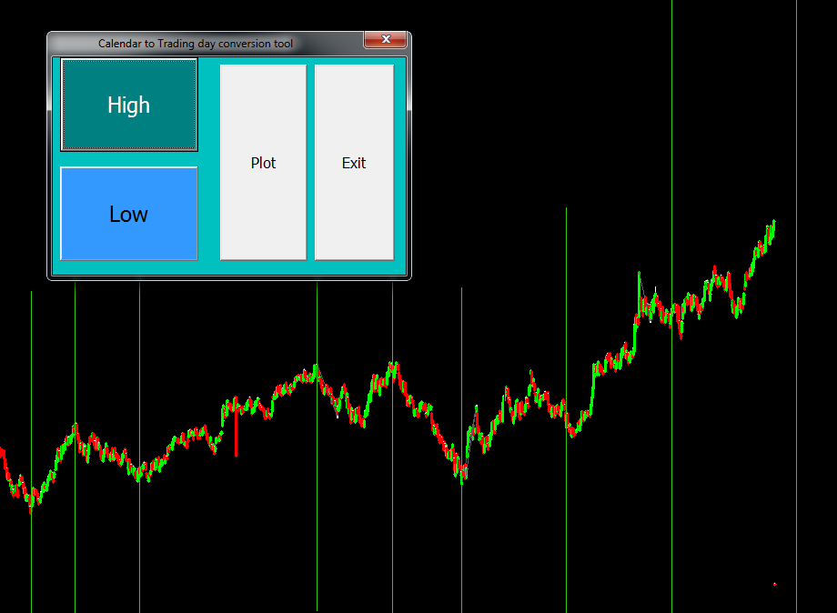

CTC-applied on a graph

Square of numbers
This is ready made tool which creates squares of any numbers in ascending as well as decending order which are used from numerological point to determine the important points of support as well as resistance. We can create as many squares required and paste besides any graph as handy tool.

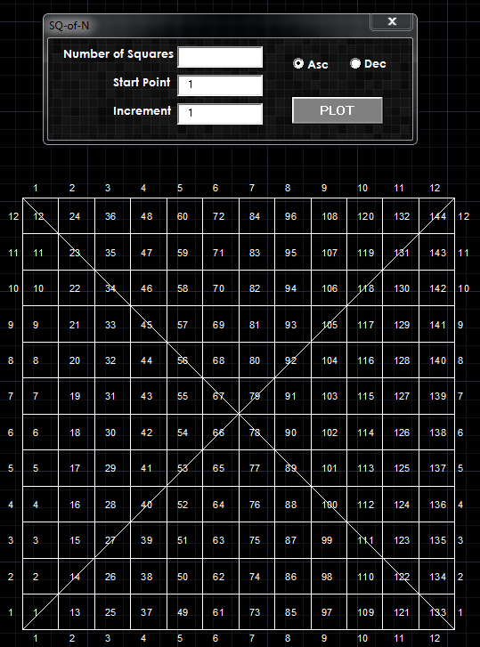

Square of N calculator

Secret Angle Method
This method is based on micheal Jenkin'n Secret angle method.Once you click swing low and high points, all the important time lines, support lines, up angles, down angles, its subdivisions are plotted automatically to give us the guidence path of the future price and time levels of the scrip.

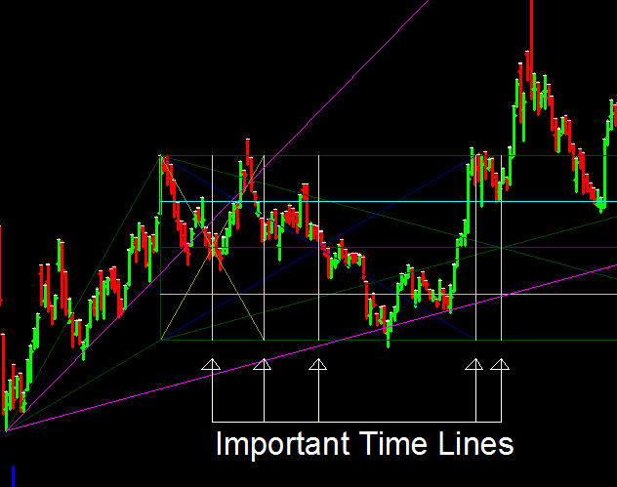

Secret Angle Method applied on a scrip

Gann Squares
All the different squares mentioned by W.D.Gann along with angles and subdivision can be plotted on chart with just a click of mouse
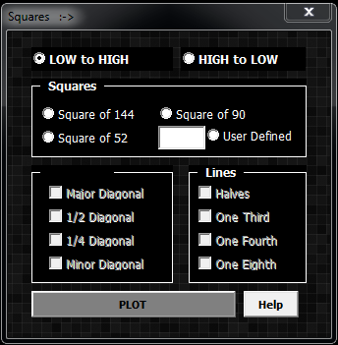

Gann Square Tool
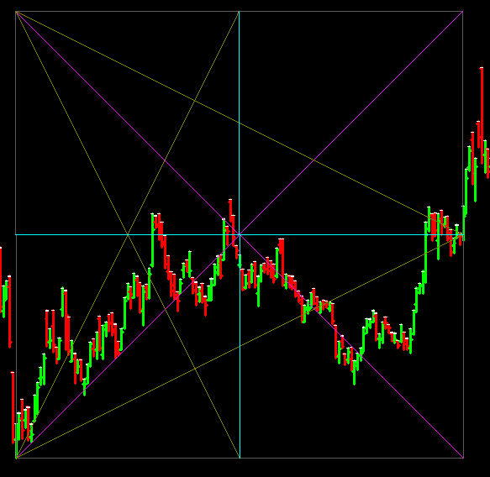

Gann Square Tool appplied on a scrip
Hexagonal Time & Price levels

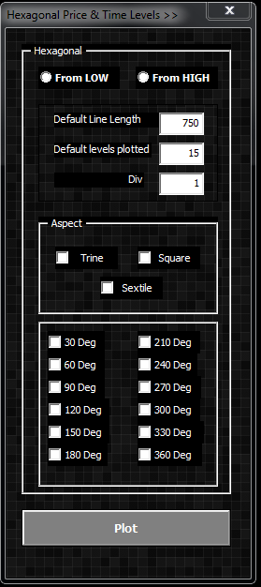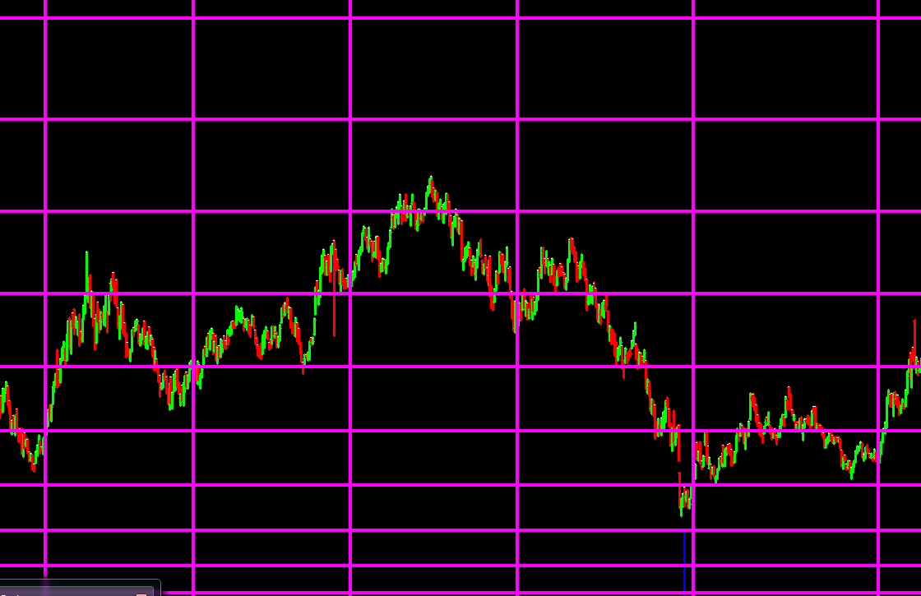

W.d.Gann has extensively used hexagonal time price chart apart from square of nine.These levels are very much difficult to calculate manually. After extensive work we found the answer to hexagonal price and time levels.We can select degrees manually or can select the different aspects such as Trine,Square or Sextile thus selecting appropriate degrees needed for our study.

Angular Square of Nine Time & Price levels

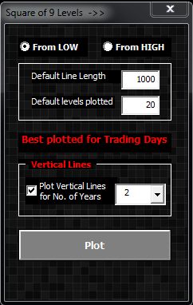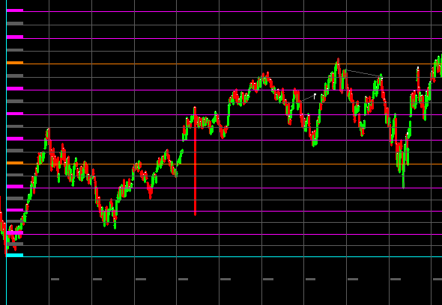
It has been mentioned in some books that while trading on trading floor W.D. Gann was using hand print of square of nine. Sqaure of nine has resemblance to pyramids of eygipt as well as Paramsayika chakra found in many hindu temples. His Natural square calculator also was nothing but combination of time and price tools based on sqaure of nine. Such is the importance of square of nine, hence rather then using numbers we plotted all levels on graph to make it easy for the testing purpose.
Apart from this if we feel that all the levels are too much cluttered we have additional tools wherein we can select only the required time or price levels.

Apart from this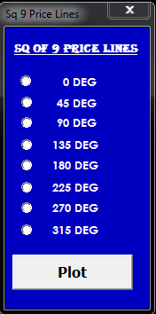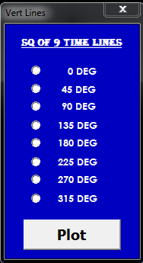
Planetary Lines
We can plot geocentric planetary lines of all the planets in our solar system as overlay just like moving averages on calender day chart. Here we have plane planetary lines as well as mirror planetary lines at a glance. Mirror planetary line are calculated using 360° less actual degree position of the planet.These lines can be plotted for next 25 years of actual position of the planets. All the positional degrees of the planets with respect to earth cannot go beyond 360° and our chart plotting is related to 360 count, hence these lines play a crucial role when applied to fortune plus scaled graph. Further study in astronomy will help us to make actual use of this tool.
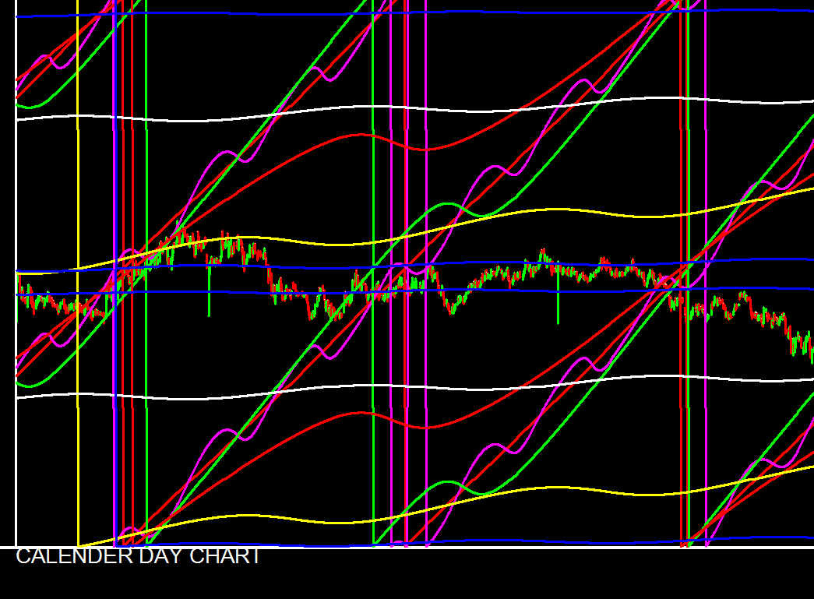
Planetory Lines applied on a Trading day chart

Trigonometry functions
Trigonometry is a branch of mathematics that studies relationships involving lengths and anglesof triangles.The 3rd-century astronomers first noted that the lengths of the sides of a right-angle triangle and the angles between those sides have fixed relationships: that is, if at least the length of one side and the value of one angle is known, then all other angles and lengths can be determined algorithmically. This methodology we can use to know the various possible trend change points. We can use different trigonometric ratios such as Tan, Cos, Sin for different trigonometric angles such as 30°, 45°, 60° and understand the future price and time resistance levels.

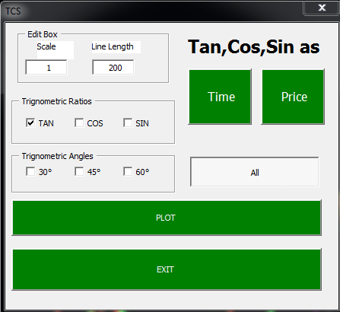
TCS Tool in Fortune Plus

Time conversion bar
TCS - time conversion bar is a unique technique used by Michael Jenkins in which time of the advance is taken into consideration and that is converted into price bar to measure equality points in the chart. We take here important swing of a chart and mark the lowest and highest points, time duration which is horizontal axis in chart is marked vertically and the unique angle is marked joining vertical line and lowest point of the swings. This gives us a unique method to identify the support level with the help of marked angle.

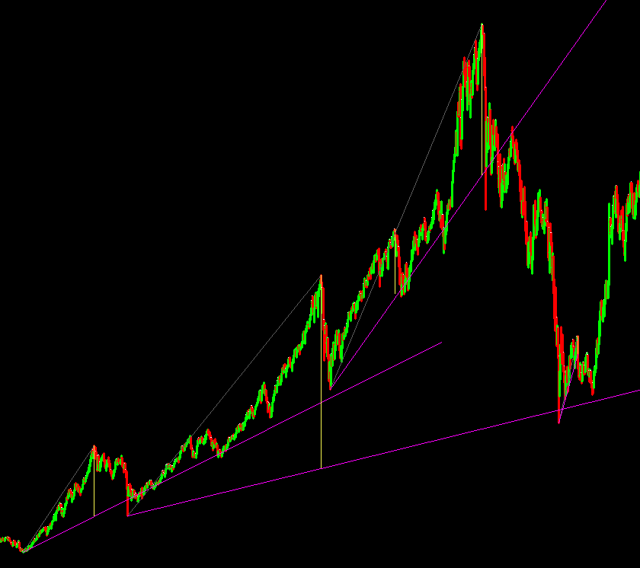

Time conversion bar support levels

Square the range trading system
In this module we have five different methods of squaring the ranges which helps in finding exact timings of the change in trend as well as different support levels in the chart.

1. Plain angles
In this method we initially select tree centre point and the swing low or high point. Then we select the important intermediate swing points, which get shifted to the tree axis and then the angle is plotted passing through those shifted points from the base of the move. Here angles play as support/res lines and the intersection of horizontal line from tree centre with these angles are important time lines for change in trend.

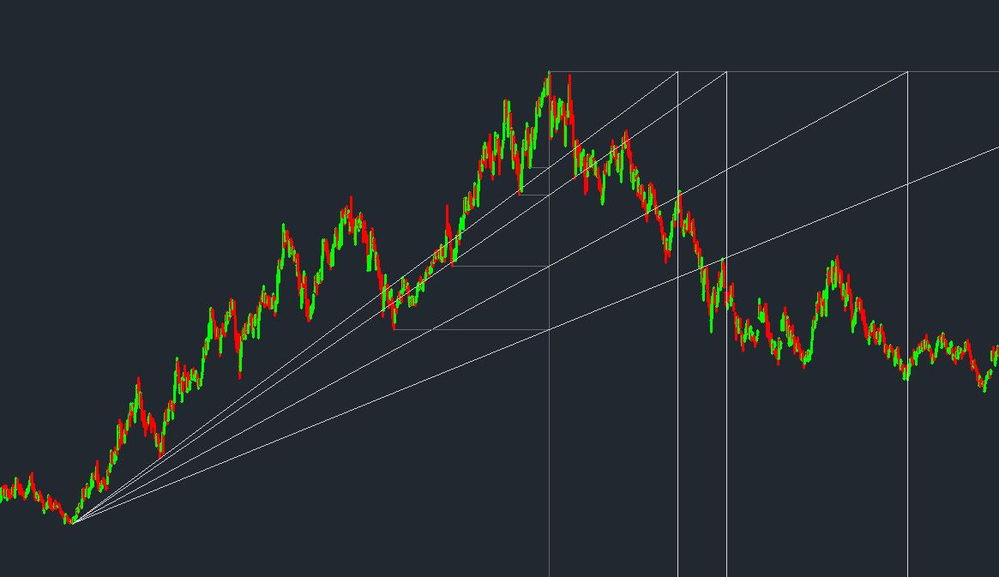
Plain angles of SRTS applied on a Chart

2. Actual angles
In this method we initially select tree centre point.Then we select the last nodal point/ important swing point which gets shifted to tree vertical axis point. Next we select the important swing point to the right side of tree centre point.This program will then draw angle from the shifted nodal point to the tree horizontal at the vertical of important swing point.This degree of angle is kept in memory and the same degree angles will be plotted from the other important swing points.
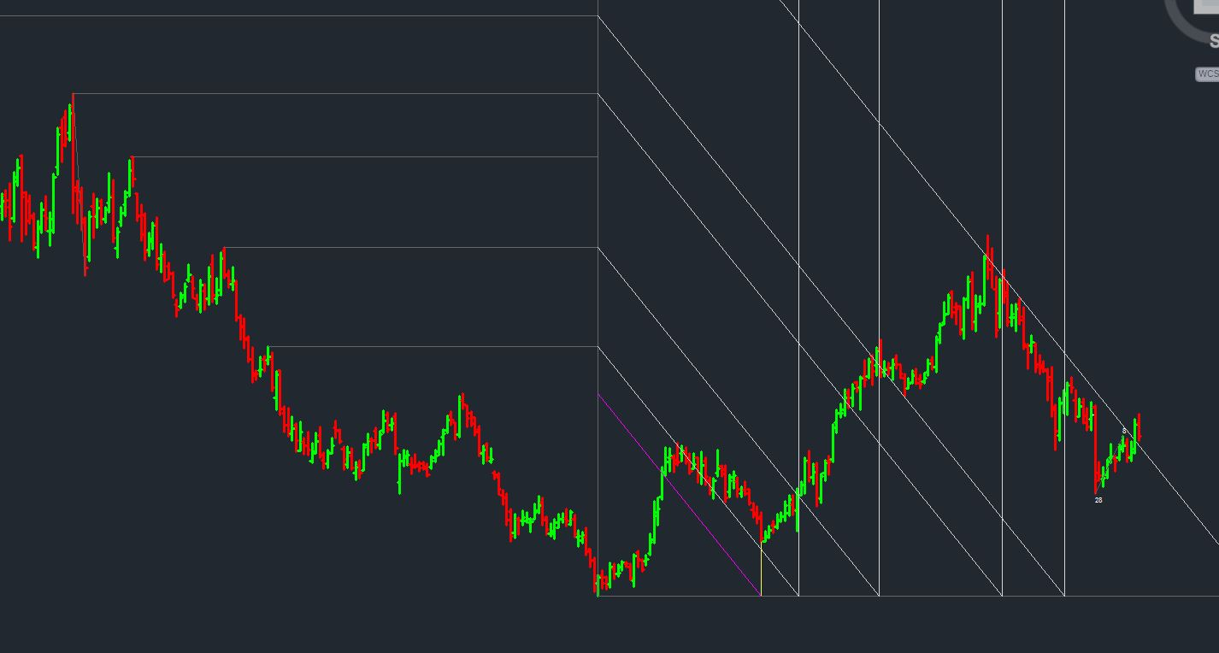
Actual angles of SRTS applied on a Chart
3. Node Circles
In this method we initially select tree centre point. Then we select the important intermediate swing points, which get shifted to the tree vertical axis and then circle are drawn taking tree centre and shifted nodal point as radius. Lastly vertical line as time lines are plotted from the intersection of tree horizontal axis and circle.
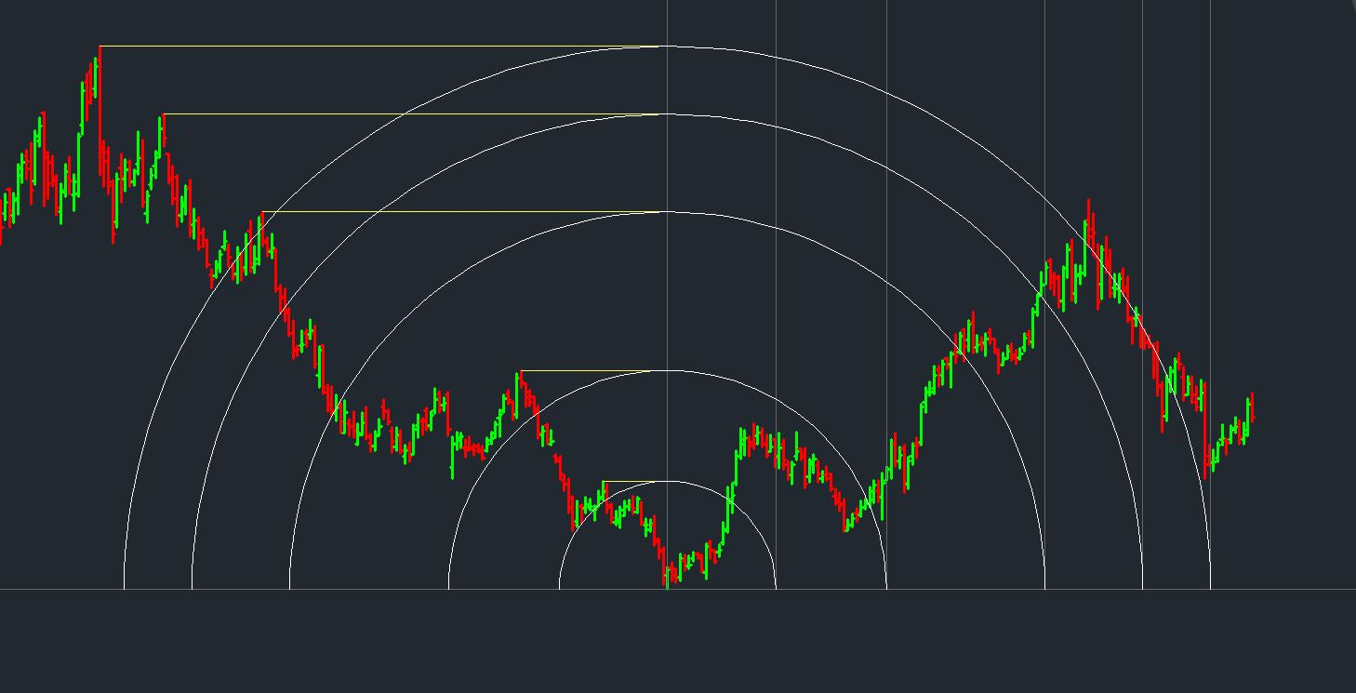
Node Circles of SRTS applied on a Chart
4. Octave Angles
In this method we initially select tree centre point & swing high/low point. The vertical distance between tree centre and swing point is then divided into 8 equal parts.Lastly angles are drawn from swing high/low point intersecting thru 8 points and extended to the tree horizontal line.Vertical line drawn from tree horizontal and intersection points are time line to look for change in trend.Also the angles are good support/ resistance lines.
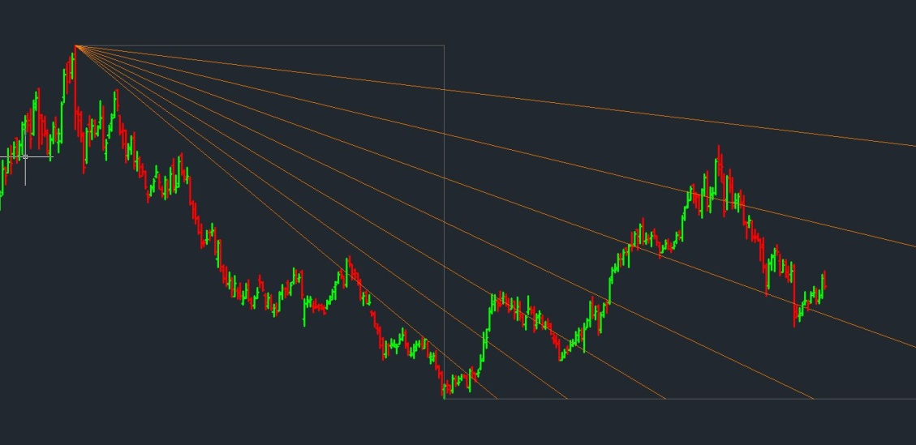
Octave Angles of SRTS applied on a Chart
5. Natural Angles
In this method we initially select tree centre point and the swing low/high point.Swing point is shifted to the vertical axis of tree centre point.Swing point to the right side of tree centre are then selected and line is drawn from swing low to the selected point and extended till tree horizontal line.

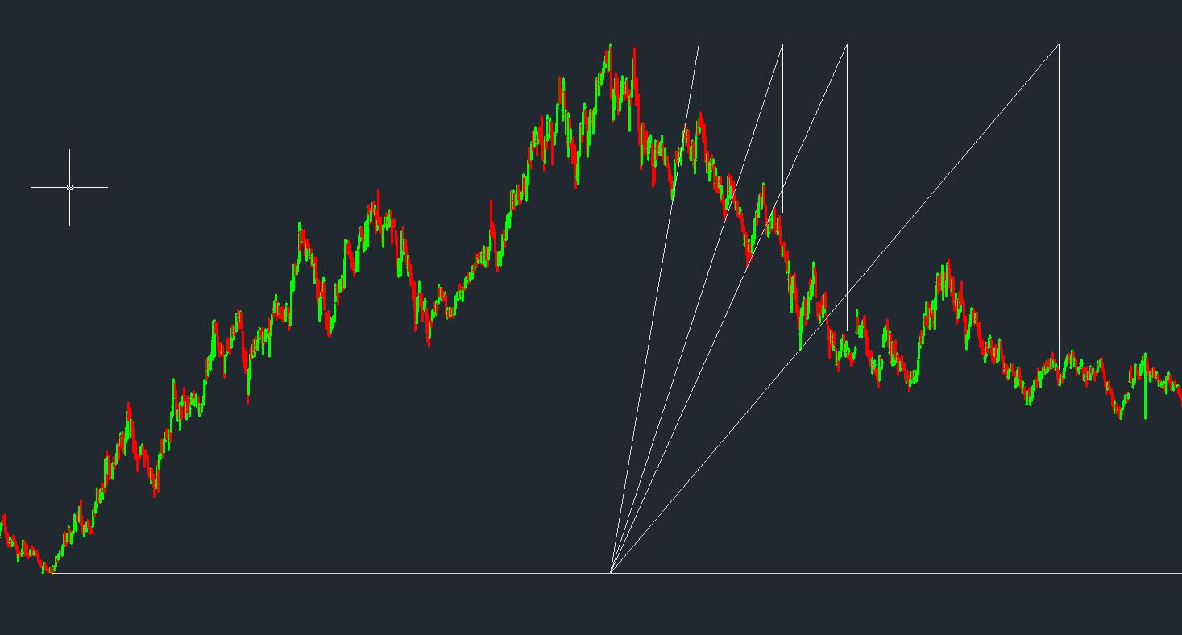
Natural Angles of SRTS applied on a Chart

Square of 9 search engine
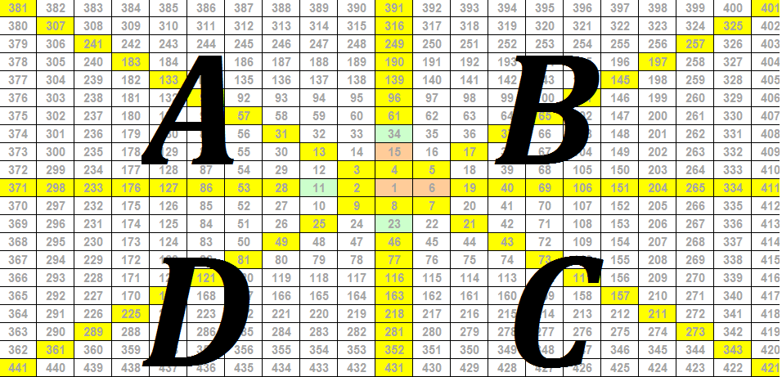
Square of 9 was prominently used by W. D. Gann for actual trading. It has been mentioned in lot of books that he developed this method using Paramsayika Chakra found in many Hindu temples, another theory mentions the relation of sq of 9 to the Pyramids of Egypt. Importance and applicability of sq of 9 can not be underestimated just due to the simplicity of structure.
In square of 9 we can mark 4 prominent squares we can name them as A,B,C,D. If the scrip is moving clockwise from A to B or B to C or C to D then we conclude that the scrip is getting stronger, on the contrary if the scrip is moving counter clockwise like D to C or C to B or B to A we can conclude that the scrip is getting weaker and weaker. Practically it is tedious job to find which scrip is getting stronger and getting weaker, hence we developed square of 9 search engine. Once we run this program it will give us the list of scrips which have ended in positive square or negative square and which scrips are neutral in view with respect to square of 9. Overall credit of idea and concept goes solely to the Legend in Gann study Dr. C. K. Narayan
I

ABSS OVERLAY TRADING METHADOLOGY
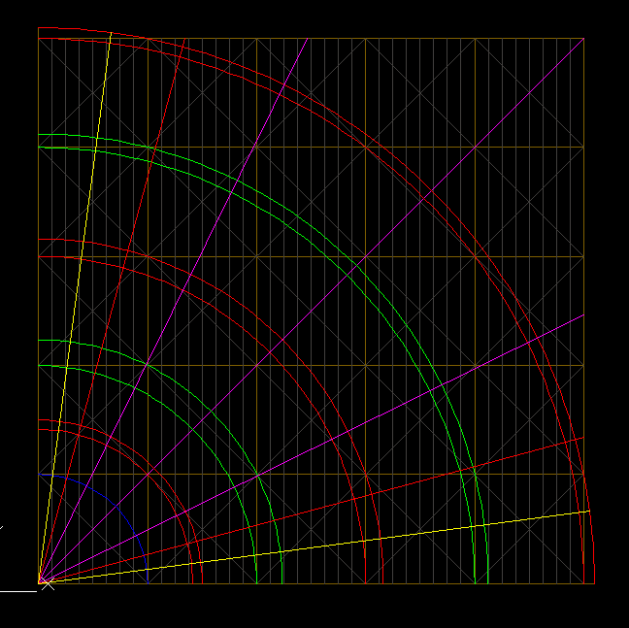
ABSS UP SETUP
1. Initially check for the Upswing. Now count swing low /high difference in time. Confirm that Initial impulse is in Fibonacci count. You may take also Lucas series for time counting. (since alternate numbers addition in Fibonacci series equals to Lucas series)
2. Now apply ABSS setup (either plane or rotation) to the swing low point, then stretch or adjust blue arc to the swing high point.
3. Vertical gray color lines are termed as time lines. Most important time lines are square boundaries in vertical. next important time line is centre of the square.
5. BUY ENTRY (perfect entry)- wait for the green bar touching lower angles also check the Fibonacci retracement between swing low/high at that level. Take long above the green candle high. One can take cautious entry by checking reversal bar or any other candlestick pattern.
6. TARGETS - 1st target- Blue arc.
2nd target- 1st arc (1st red double arc)
3rd target- 3rd arc (2nd red double arc)
4th target- 5th arc ( 3rd red double arc)
5th target- outer horizontal boundary of the square or setup
7. ADDITIONAL LONG ENTRIES -
1st entry- check close above blue arc as well as square boundary then take long above the high of the bar for target of 1st arc.
2nd entry- check close above 1st red double arc initial target is 1st green double arc, next target is 2nd red double arc.
3rd entry - check close above 1st green double arc, take long for target of 2nd red double arc.
4th entry- check close above 2nd red double arc initial target is 2nd green double arc , next target is 3rd red double arc.
8. SHORT ENTRY AGAINST THE TREND -
1st entry- after applying up setup check for the fake bar between 2nd and 3rd time line. one can initiate short entry below the Low of the fake bar for target of lower angles at important square time line i.e. 5th time line.
2nd entry- check red bar touching 1st red double arc take short below the low of the bar for targets, square boundry then blue arc or lower angles.
3rd entry- check red bar at 2nd red double arc take short below the low of the bar
4th entry-check red bar at 3rd red double arc take short below the low of the bar.

8. TIME LINE ADJUSTMENT-
Time line adjustments if necessary needs to be done after scrip reaches 3rd square or 4th square, with the help of blue triangles at the bottom of the ABSS setup.
9. STOP LOSS- HIGH OR LOW of consolidation

