OOPs class 2

Polymorphism > complile time polymorphism > operator overloading

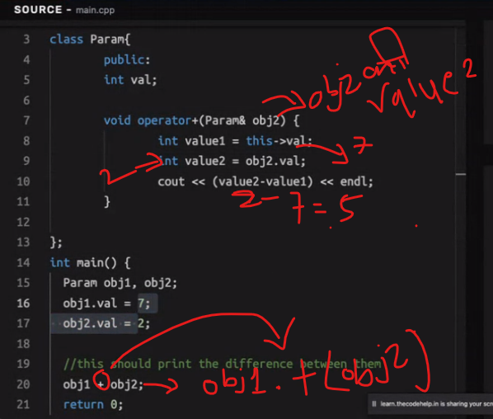

Polymorphism > runtime polymorphism > method overriding

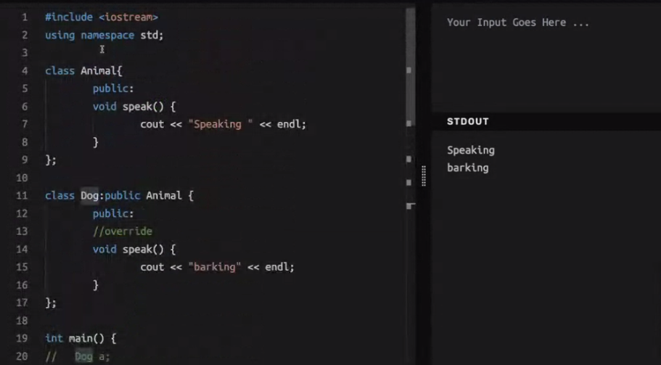

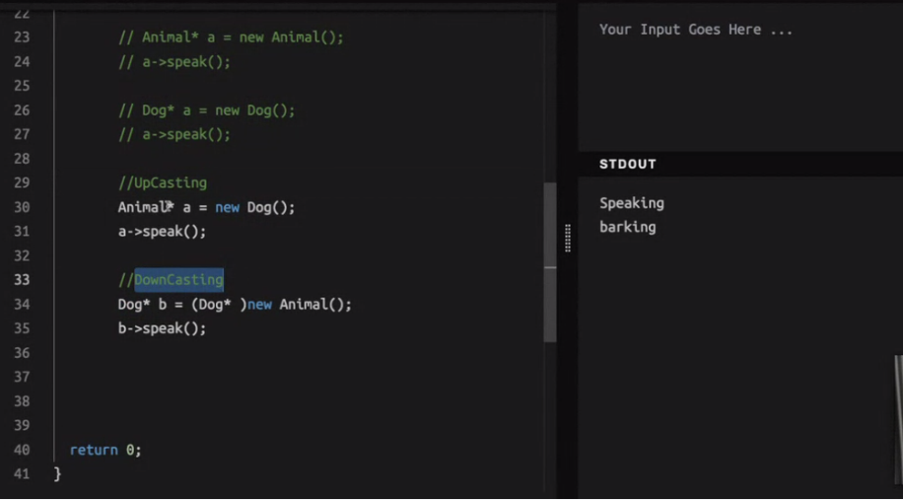

Iss case mai agar virtual parent class ke method pe nahi laga hoga toh , upcasting ho ya downcasting pointer class ka method call hoga.

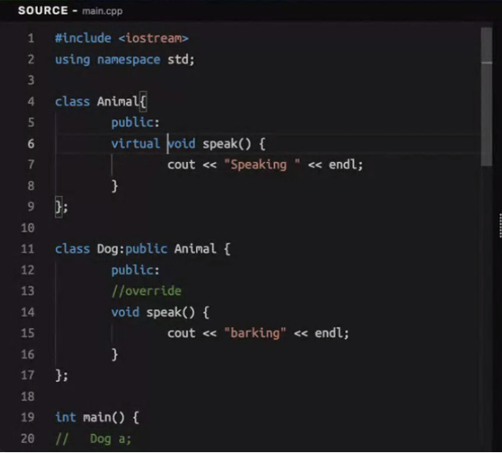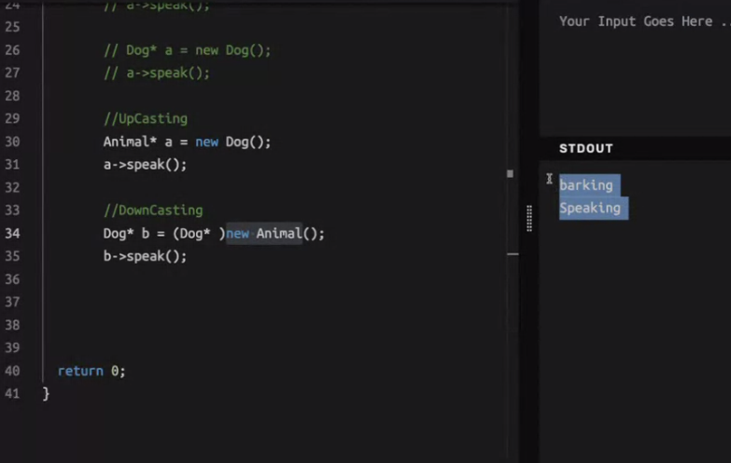

Agar parent class ke method pe virtual laga hoga toh ,jis type ka object bana hoga uska method call hoga