**Api gateway for lambda function**

Steps to create aws api gateway are:

1. Goto Api Gateway console 🡪 create API

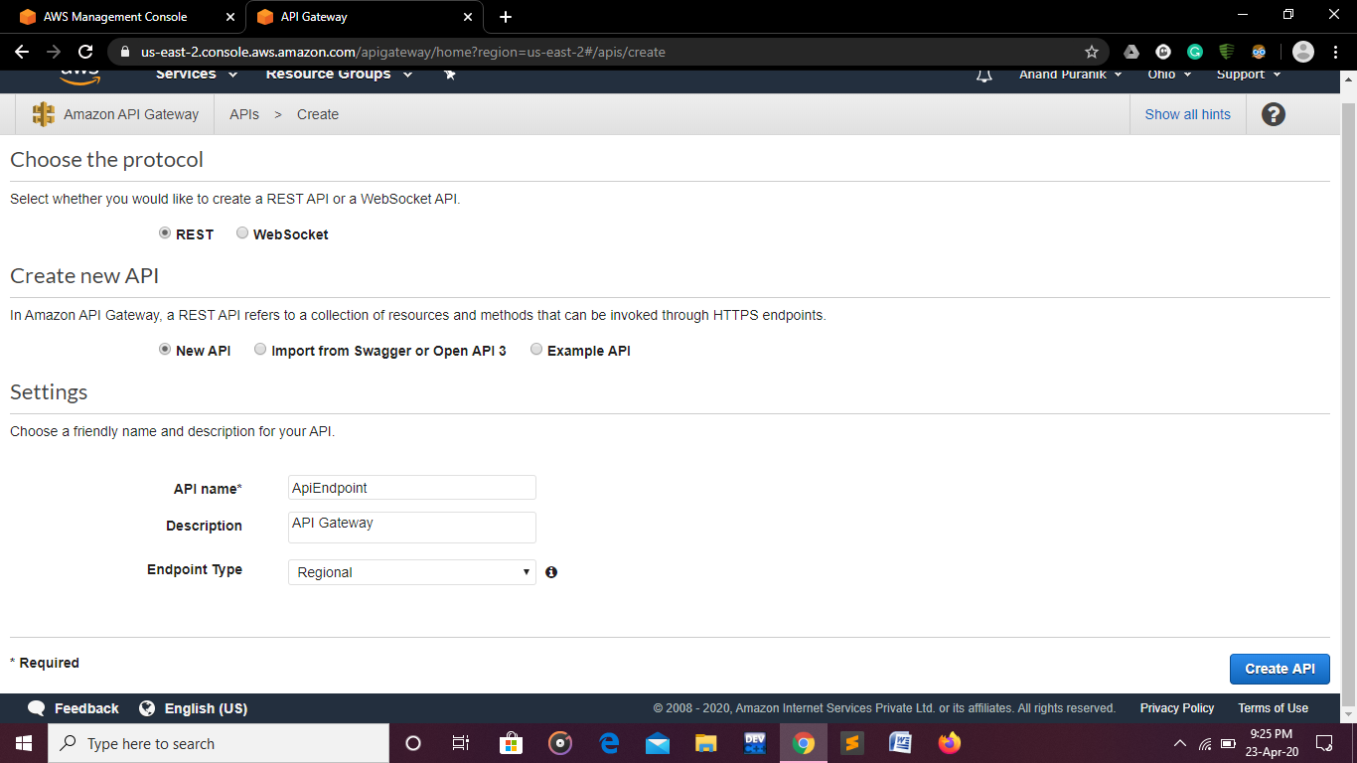

1. Give name to API create API
2. Create IAM role and choose lambda as use case create lambda function for the same

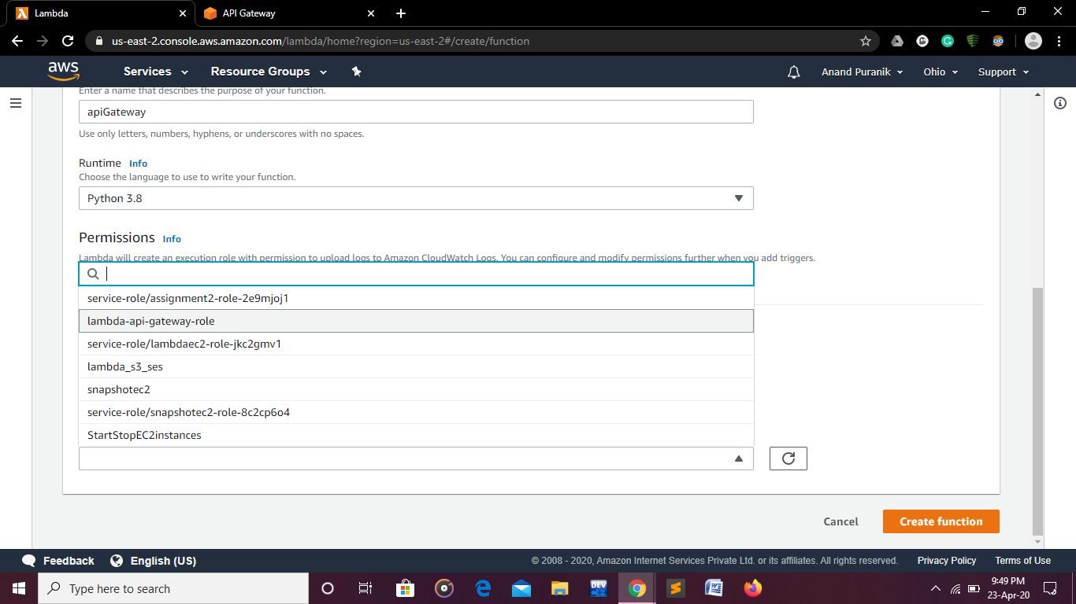

1. Create method, choose type of request i.e. get method

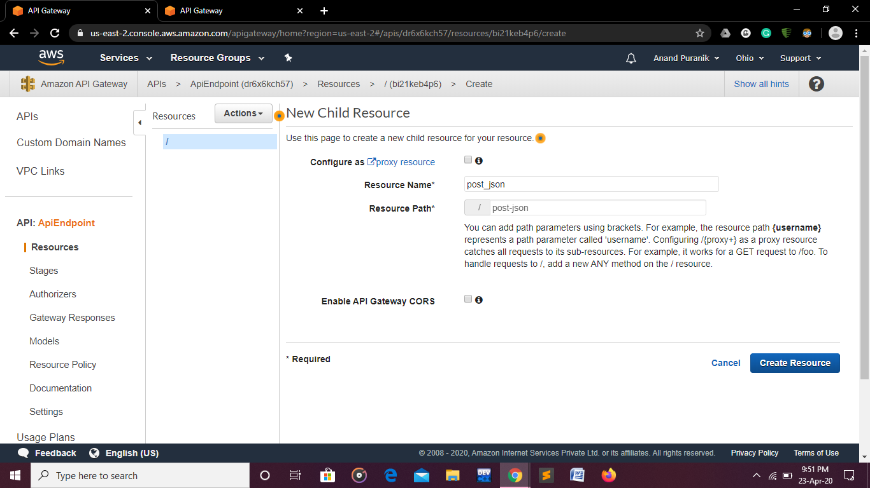

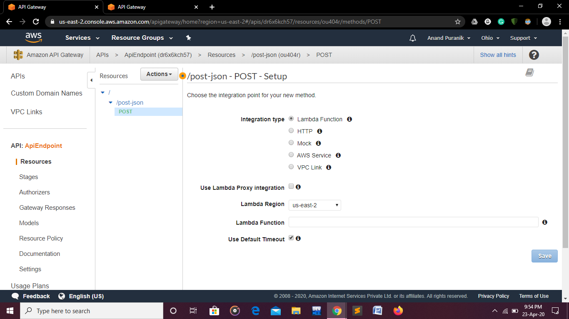

1. Here put & post method can be used

Invoke lambda function through invoke api gateway

1. It will show architecture and resources of api Gateway

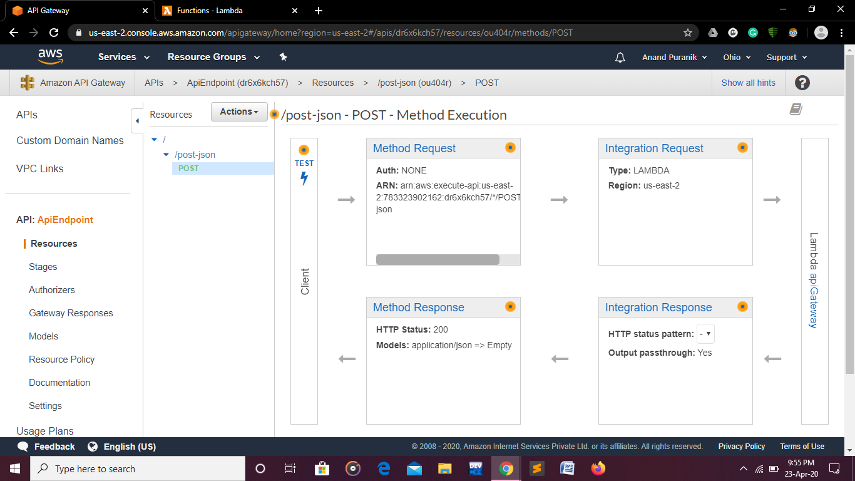

1. Check & test the cloudwatch logs.