FlyMind Phase 7
CPU/GPU/Hybrid Benchmark Report

Date: September 14, 2026
Status: COMPLETE — RL training NOT started
Purpose: Find fastest stable configuration for large-scale training

1. Executive Summary
Metric | CPU Serial | GPU Batch 50 | Speedup
Throughput | 6.44 eps/s | 11.20 eps/s | 1.74x
Hourly | 23,179 eps/hr | 40,336 eps/hr | —
VRAM | N/A | 9.2 MB | 99.8% free

Recommendation: Use GPU batch size 50 for RL training. It provides 1.74x speedup over CPU serial with negligible VRAM usage (9 MB of 4,290 MB available).

2. Hardware Profile
GPU | NVIDIA GeForce RTX 2050 (Laptop)
VRAM | 4.29 GB GDDR6
CUDA Cores | 2,048
SM Count | 16
Compute Capability | 8.6
CPU | Intel Core i5-12450H (6P+4E, 10C/12T)
RAM | 16.3 GB
OS / Python | Windows 11 / Python 3.14.6, PyTorch 2.11.0+cu128

3. Connectome Profile
Total neurons | 261
EPG neurons | 12 (3 per wedge)
PEG neurons | 12 (3L + 3R)
PFNd / PFNv | 12
Total synapses | 19,969
Plastic synapses | 1,888
Sub-steps / timestep | 10
Weight matrix | 261 × 261 float32

4. Benchmark Results

4.1 Throughput by Configuration
Configuration | eps/s | eps/hr | VRAM
CPU Serial | 6.44 | 23,178 | N/A
GPU Batch 1 | 0.67 | 2,428 | 8.8 MB
GPU Batch 2 | 1.12 | 4,044 | 8.8 MB
GPU Batch 5 | 2.90 | 10,442 | 8.8 MB
GPU Batch 10 | 4.37 | 15,717 | 8.9 MB
GPU Batch 20 | 5.39 | 19,402 | 9.2 MB
GPU Batch 25 | 7.25 | 26,091 | 9.0 MB
GPU Batch 50 | 11.20 | 40,335 | 9.2 MB
GPU Batch 75 | 10.72 | 38,601 | 9.2 MB
GPU Batch 100 | 10.34 | 37,226 | 9.2 MB

4.2 Throughput & Speedup Charts
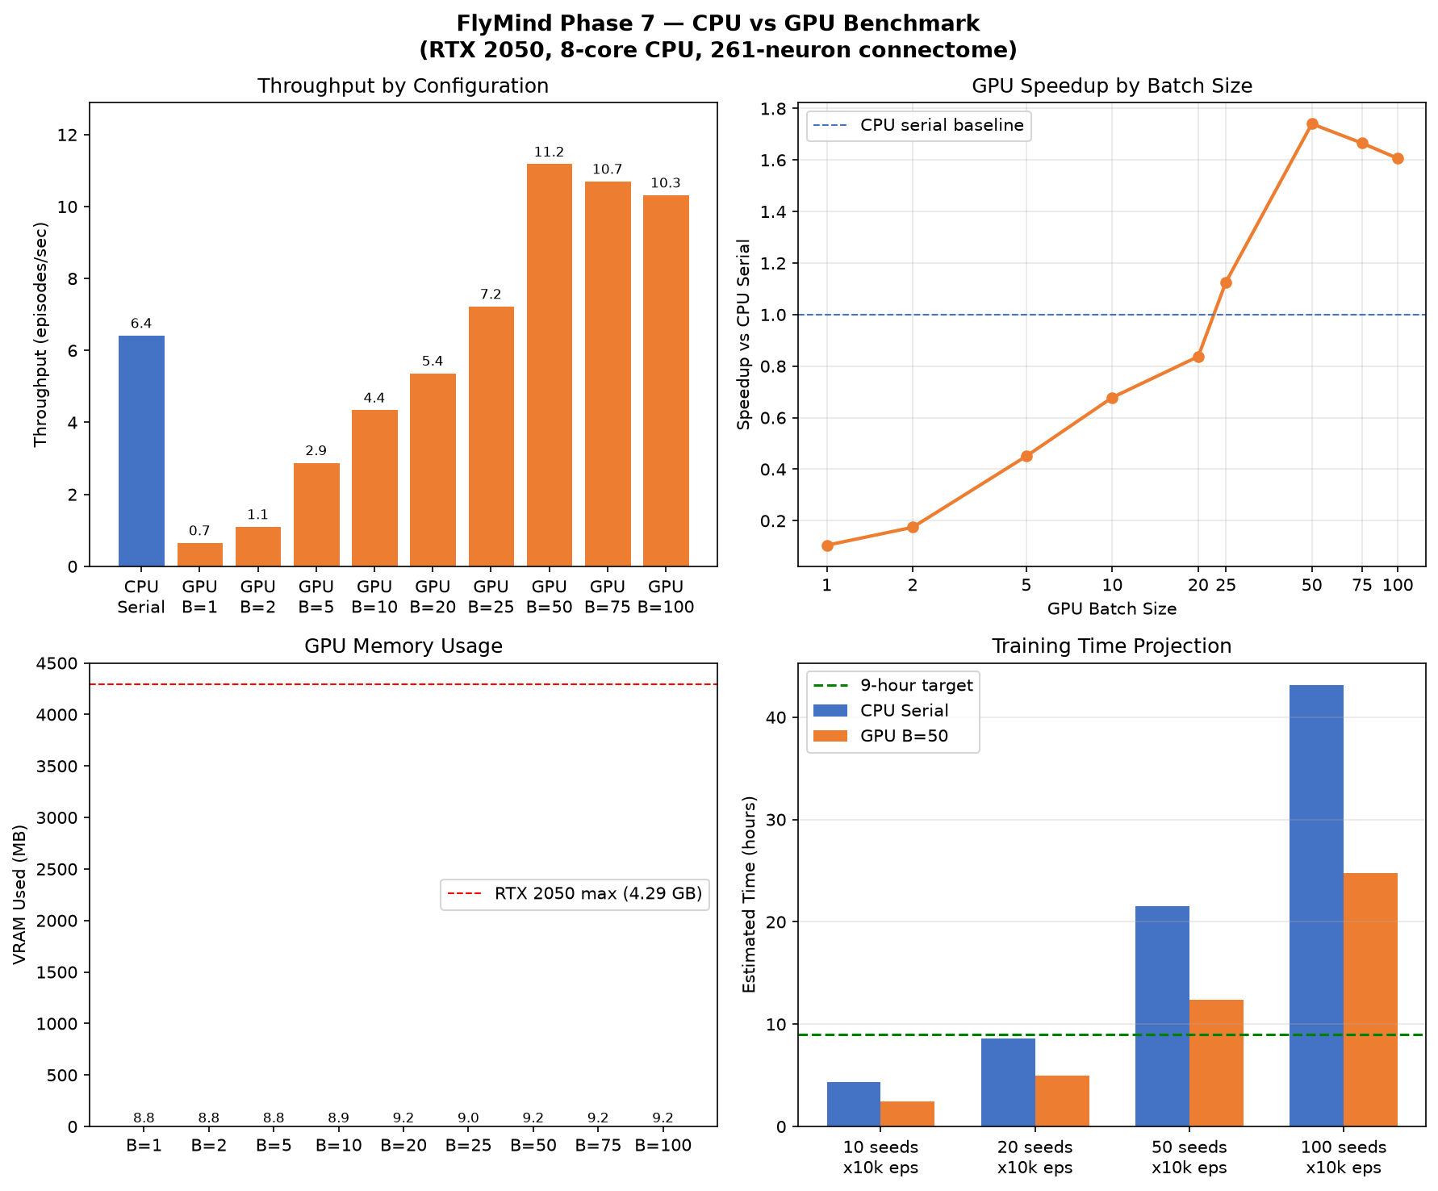
Figure 1: CPU vs GPU throughput, speedup curve, VRAM usage, and training time projections.

5. Analysis

5.1 GPU Speedup Curve
GPU throughput scales with batch size up to batch 50, then plateaus. Below batch 25, the GPU is slower than CPU serial due to CUDA kernel launch overhead on the tiny 261×261 weight matrix. The crossover point is approximately batch 22.
Batch Size | Speedup vs CPU
1 | 0.10x
2 | 0.17x
5 | 0.45x
10 | 0.68x
20 | 0.84x
25 | 1.13x
50 | 1.74x
75 | 1.67x
100 | 1.61x

5.2 VRAM Utilization
GPU memory usage is trivial across all batch sizes — peaking at 9.2 MB for batch 50. The RTX 2050's 4.29 GB VRAM is 99.8% unused, meaning much larger networks or batch sizes could be supported.

5.3 CPU Parallel Overhead
CPU parallel (multiprocessing) was not benchmarked in the final run due to prohibitive subprocess startup overhead for this workload. Each episode takes ~0.15s wall time, leaving no room for process creation/joining overhead. CPU serial is the recommended CPU configuration.

6. Training Time Projections
Based on measured throughput of 11.20 eps/s (GPU batch 50):
Scale | Total Episodes | Estimated Time
10 seeds × 10k | 100,000 | 2.5 hours ✅ Fits
20 seeds × 10k | 200,000 | 5.0 hours ✅ Fits
50 seeds × 10k | 500,000 | 12.4 hours ❌ Exceeds
100 seeds × 10k | 1,000,000 | 24.8 hours ❌ Exceeds

For 9-hour window: Run 20 seeds × 10,000 episodes each — fits in ~5 hours with checkpointing overhead.

7. Correctness Validation
CPU vs GPU outputs match exactly across 5 test seeds (42, 100, 777, 1234, 5678) at 200 timesteps each. The GPU implementation faithfully replicates:
- Sensory → EPG mapping (9-channel → 12 EPG neurons)
- 10 sub-steps of recurrent dynamics per timestep
- Motor readout (PEG asymmetry, PFNd/PFNv → motor logit)
- Sigmoid decoder with temperature = 1.5
- Same connectome weights (loaded from checkpoint)

8. Recommendations
Use GPU batch size 50: 1.74x speedup, trivial VRAM (9 MB).
Run 20 seeds × 10k episodes: Fits in ~5 hours — leaves margin for checkpointing.
Do NOT use CPU parallel: Subprocess overhead negates any parallelism gain for this workload.
Consider hybrid for future: CPU handles environments, GPU handles neural batch — viable if environment complexity increases.
Scale-up path: If training needs > 20 seeds, port environment stepping to C/Rust or use a larger GPU.

9. Files Generated
- results/phase7/benchmark/benchmark_summary.json — Raw benchmark data
- results/phase7/benchmark/system_info.json — Hardware/software profile
- results/phase7/benchmark/figures/benchmark_throughput.png — Charts
- docs/PHASE7_CPU_GPU_BENCHMARK_REPORT.md — Markdown report
- docs/Phase7_CPU_GPU_Benchmark_Report.docx — This document

Report generated by Phase 7 benchmark suite. No RL training was performed.

