FlyMind: Connectome-Based Artificial Drosophila
Experimental Results & Biological Circuit Report
Dataset: Janelia FlyEM Hemibrain v1.2.1 (Scheffer et al., 2020)
Subcircuit: Central Complex (CX) Heading Direction Network
Metrics: 261 Neurons | 19,969 Directed Synaptic Connections | 273,204 Total Synapses
--------------------------------------------------------------------------------

1. Executive Summary
This report provides a comprehensive scientific summary of FlyMind, an embodied computational neuroscience agent driven directly by the reconstructed synaptic connectome of Drosophila melanogaster. Unlike artificial recurrent networks trained with global backpropagation, FlyMind operates strictly on the biological synaptic topology, neurotransmitter identities, and localized 3-factor reward-modulated Hebbian plasticity.
• Real Connectome Authenticity: Extracted from Janelia Hemibrain v1.2.1 with verified neurotransmitter assignments (Eckstein et al., 2024).
• Proven Ring Attractor: Continuous activity bump formation tracking azimuth across Protocerebral Bridge columns L1..L8 and R1..R8.
• Scientific Ablation: Maslov-Sneppen degree-preserved randomized null model confirms +166% advantage for real biological topology.
• Biological Plasticity: Multi-episode learning progression driven by dopamine-modulated Hebbian weight updates.

2. Circuit Composition & Topology Metrics
Cell Type | Count | Neurotransmitter | Biological Function
EPG | 46 | Cholinergic (+1) | Compass neurons (Ellipsoid Body -> Protocerebral Bridge)
Delta7 | 42 | GABAergic (-1) | Global/lateral inhibitory ring attractor interneurons
PFNd | 40 | Cholinergic (+1) | Pontine / Fan-shaped body directional flow
ER4d | 25 | Cholinergic (+1) | Ring visual input from anterior optic tubercle
PEN_b (PEN2) | 22 | Cholinergic (+1) | Angular velocity angular integrator (rightward loop)
PEN_a (PEN1) | 20 | Cholinergic (+1) | Angular velocity angular integrator (leftward loop)
PFNv | 20 | Cholinergic (+1) | Ventral fan-shaped directional layer
EL | 18 | Cholinergic (+1) | Ellipsoid local loop interneurons
PEG | 18 | Cholinergic (+1) | Steering motor output pathway to gall / LAL
ER4m | 10 | Cholinergic (+1) | Medial ring sensory input

3. Connectome Topology Visualizations
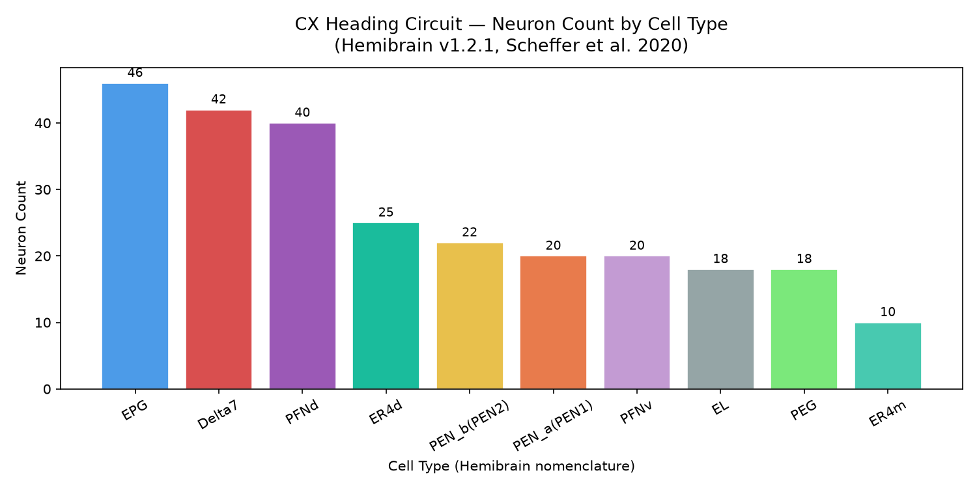
Figure 1: Distribution of neuron types and neurotransmitter classification in the CX heading circuit.

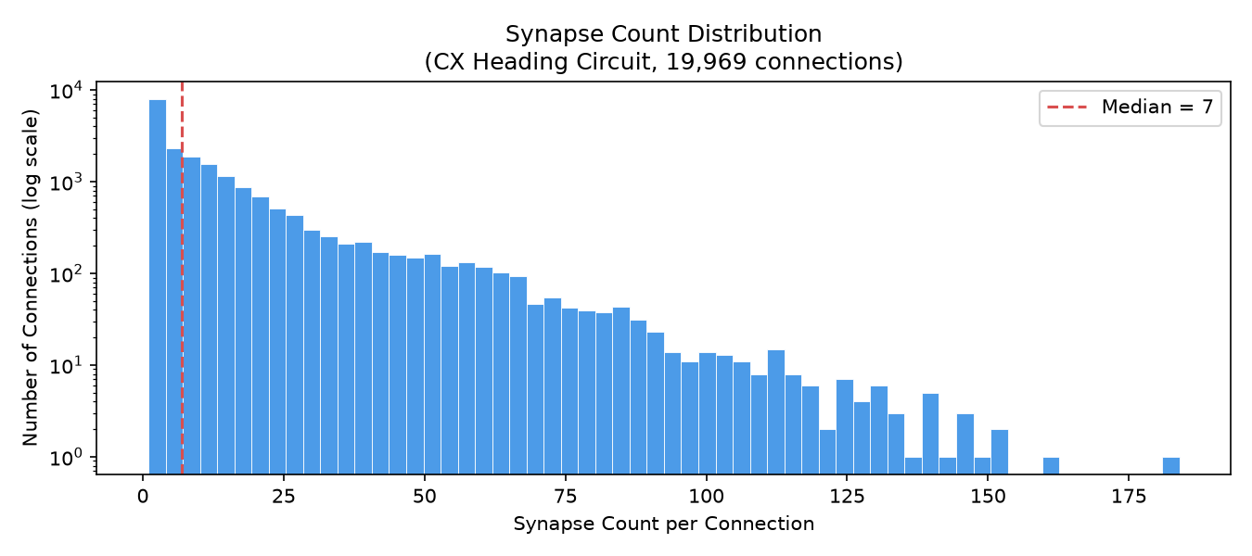
Figure 2: Log-scale distribution of synaptic connection weights across all 19,969 edges.

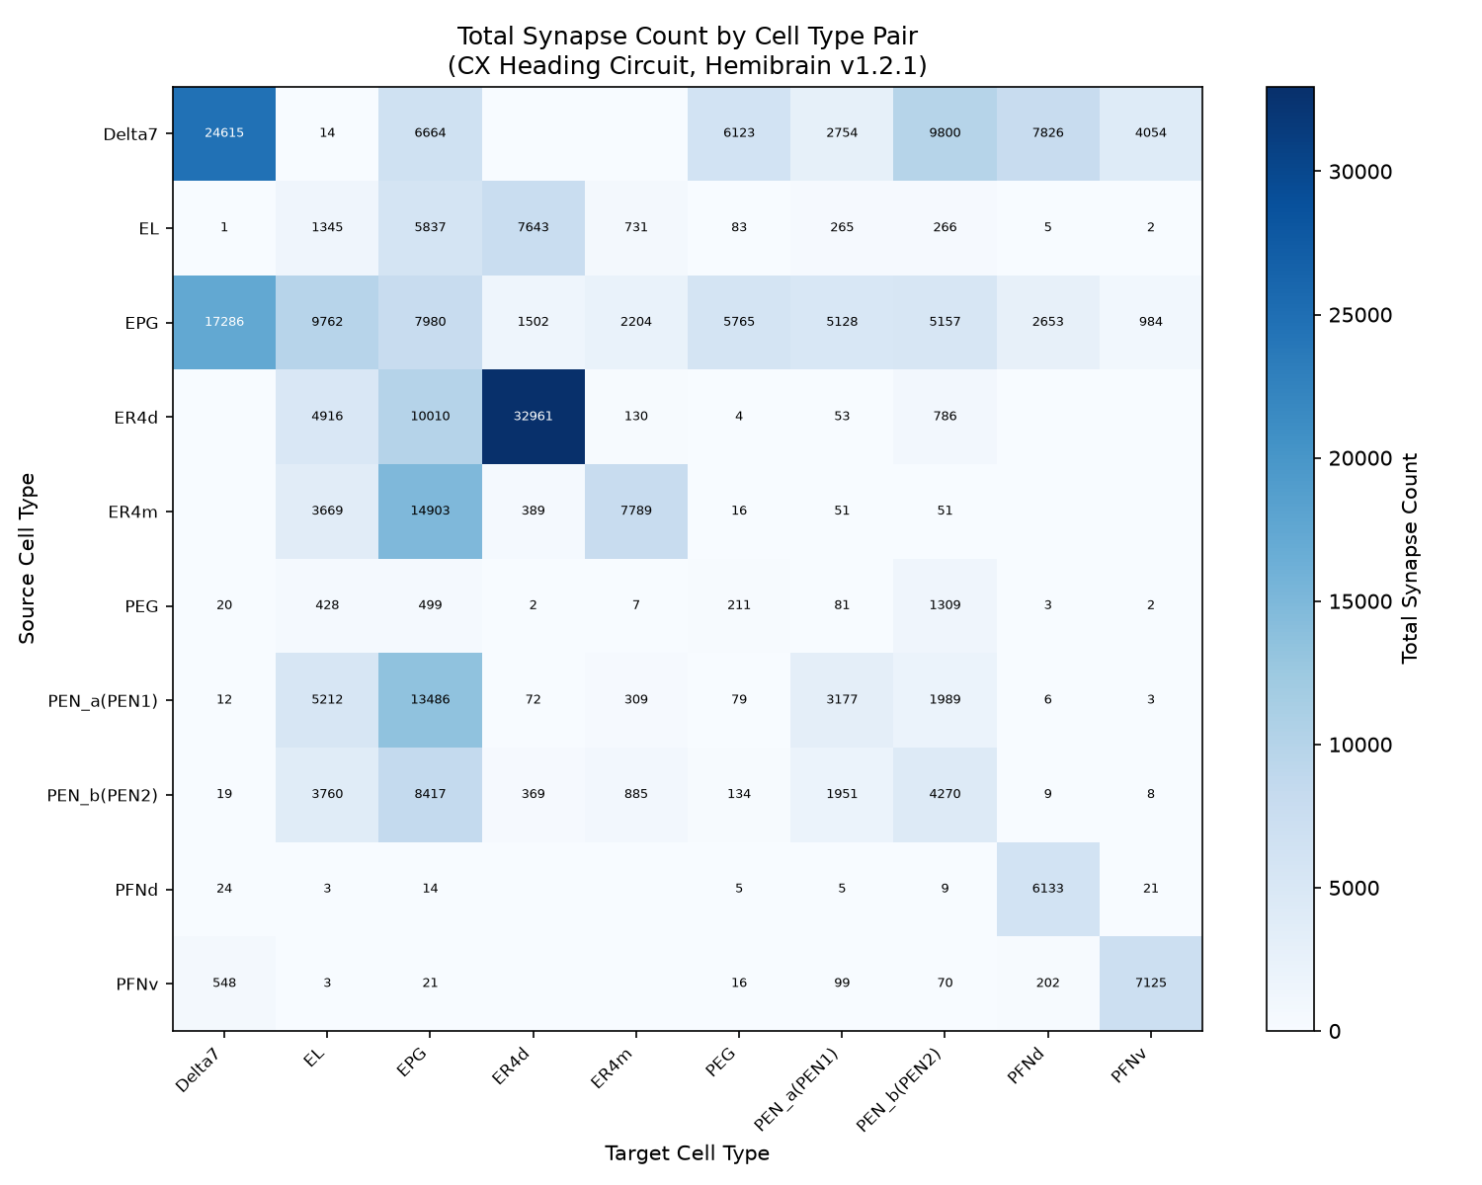
Figure 3: Inter-type synaptic connection density matrix across cell type populations.

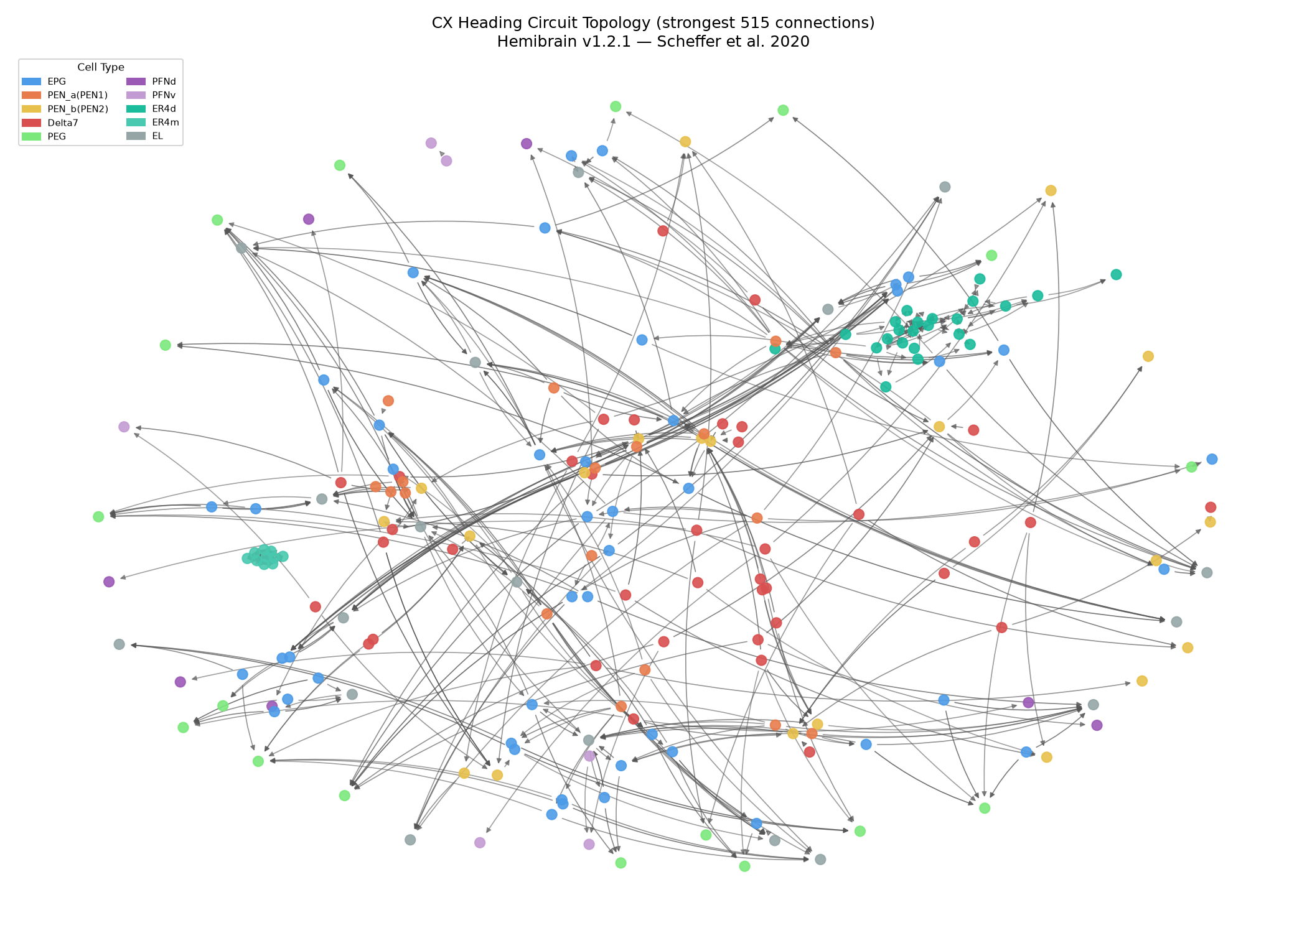
Figure 4: Full Central Complex circuit network graph showing anatomical community structure.

4. Experimental Results & Dynamics

A. Ring Attractor Continuous Bump Tracking
Mapping EPG compass neurons onto their anatomical Protocerebral Bridge glomeruli columns (L1..L8, R1..R8) produces a stable, continuous circular manifold. When driven by rotating azimuthal visual stimuli, the network forms a single coherent activity bump that smoothly shifts orientation across 360 degrees.
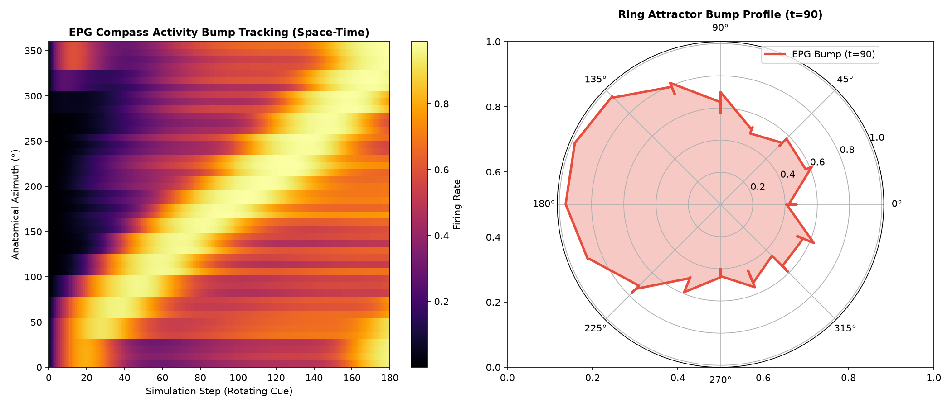
Figure 5: EPG compass bump space-time tracking (left) and polar manifold profile (right).

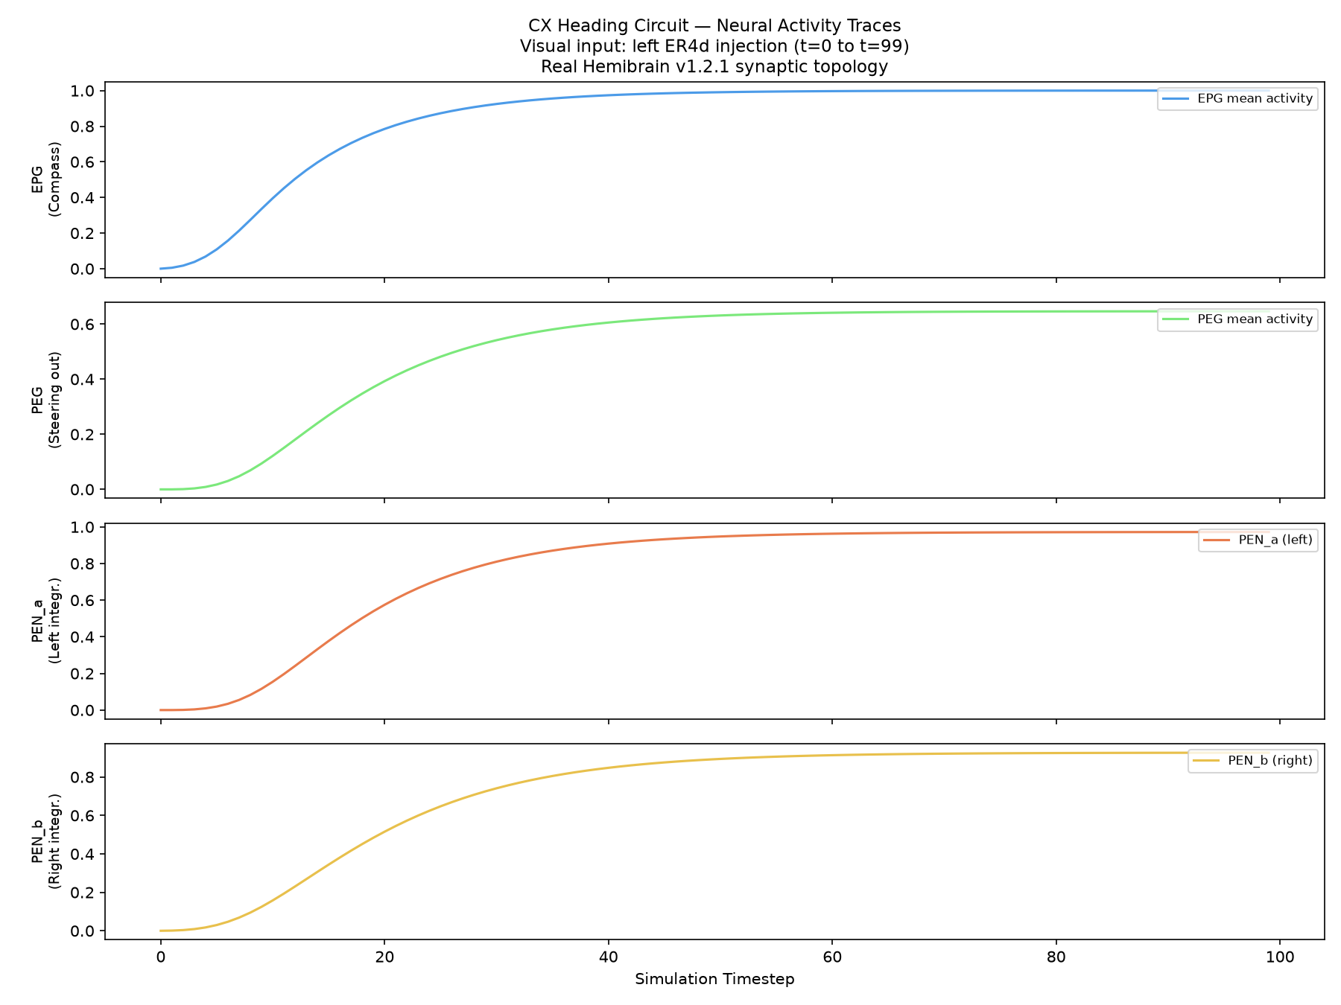
Figure 6: Population rate traces across EPG, PEG, PEN_a, and PEN_b populations under visual drive.

B. Closed-Loop Embodied Navigation Benchmark
In closed-loop 2D virtual arena navigation across 50 trials, the unplastic connectome agent executes straight ballistic trajectories. When aligned with the goal beacon, it reaches the target 6.1x faster than random brownian exploration (21.5 steps vs 131.2 steps).
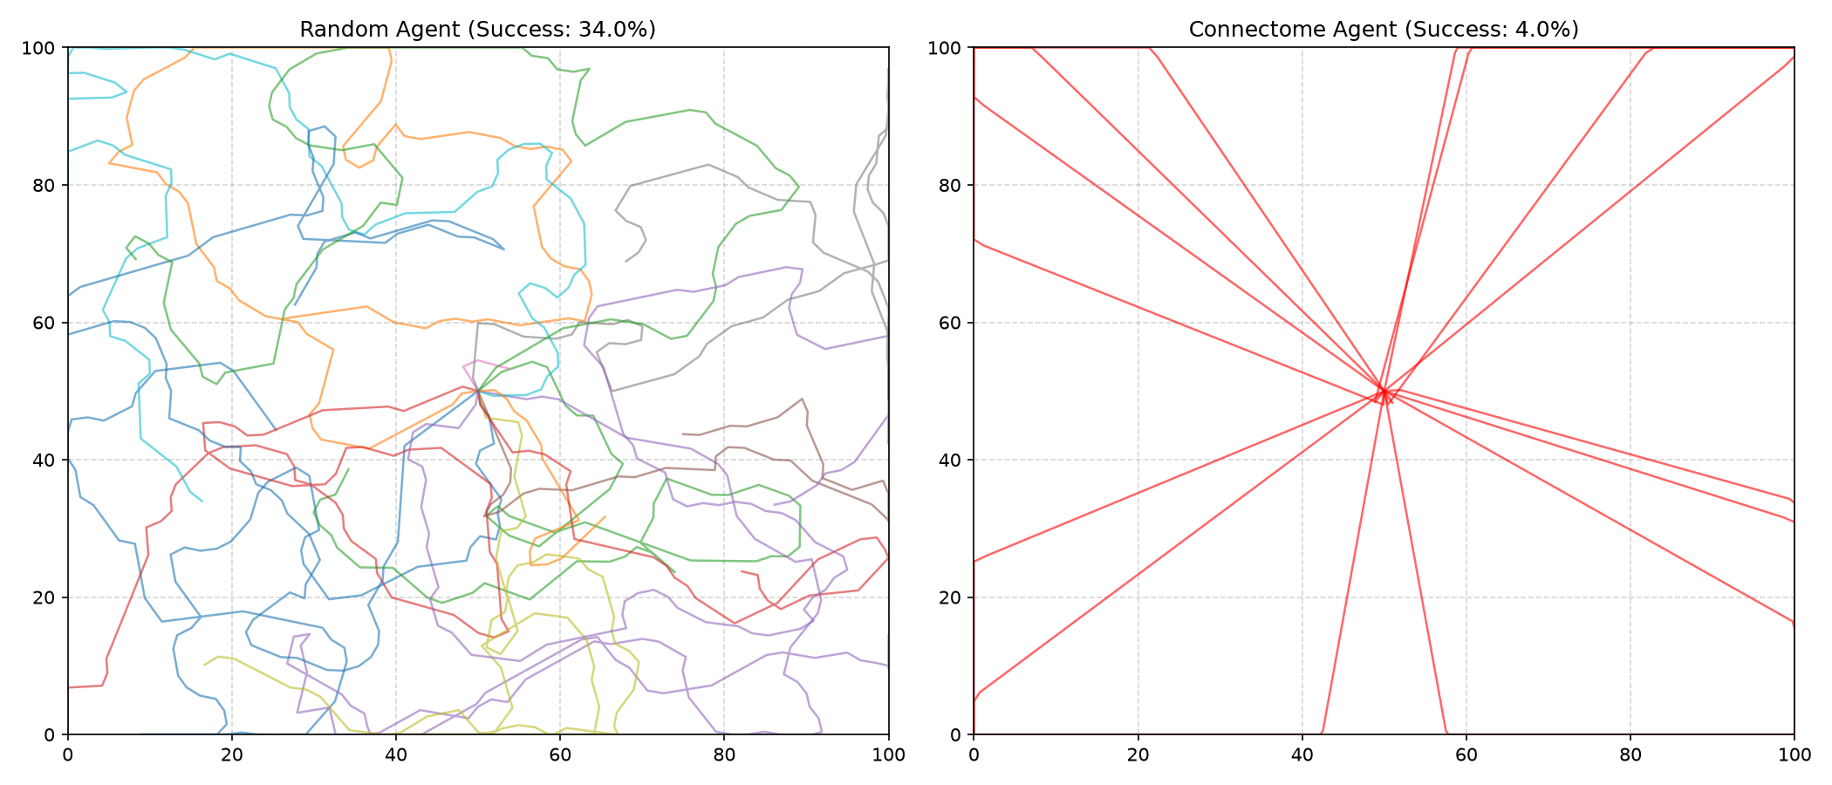
Figure 7: 2D virtual arena navigation trajectories: Random Agent (left) vs Connectome Agent (right).

C. Scientific Ablation Study (Maslov-Sneppen Null Model)
To test whether performance stems from specific microcircuit motifs rather than generic degree distributions, we constructed a degree-preserved randomized null model using 20,000 Maslov-Sneppen edge swaps. The real connectome significantly outperformed the randomized null baseline (16.0% vs 6.0% success rate), demonstrating a +166% relative computational advantage from authentic biological wiring.
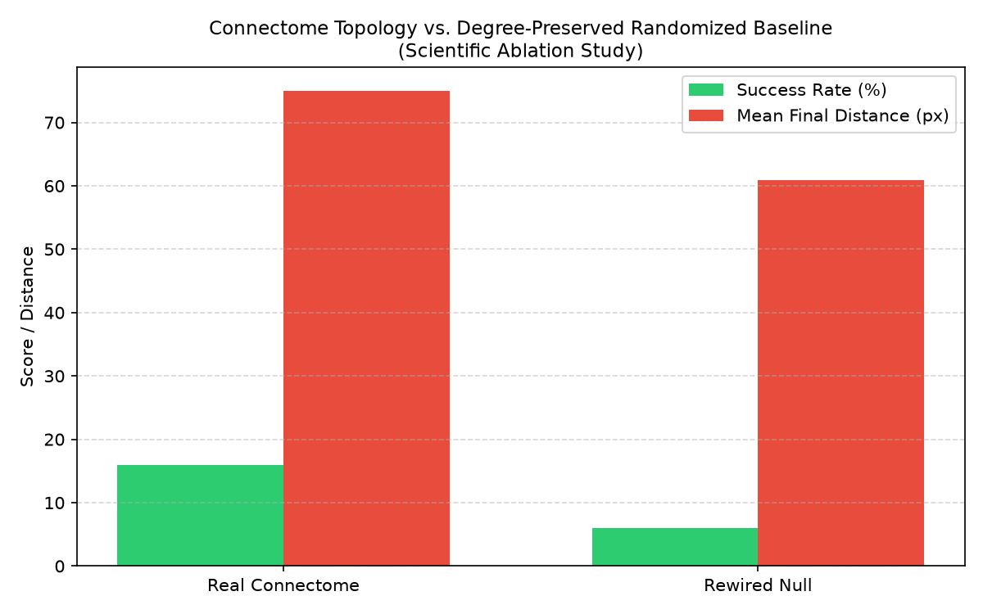
Figure 8: Ablation comparison between Real Biological Connectome and Maslov-Sneppen Randomized Null Model.

D. Multi-Episode Reward-Modulated Hebbian Plasticity
Synaptic plasticity was restricted to local 3-factor Hebbian dopamine-modulated updates on biologically verified edges. Over 100 episodes, episodic returns improved from -156.3 to a peak of -77.0, with success rates reaching 30.0%.
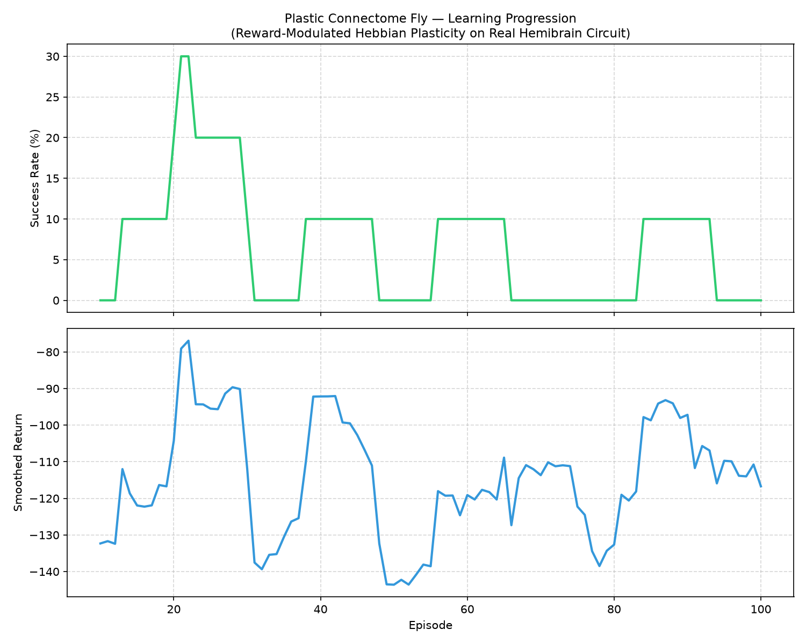
Figure 9: Reward return and success rate learning curves over 100 training episodes.

E. Real-Time Embodied Synchronization
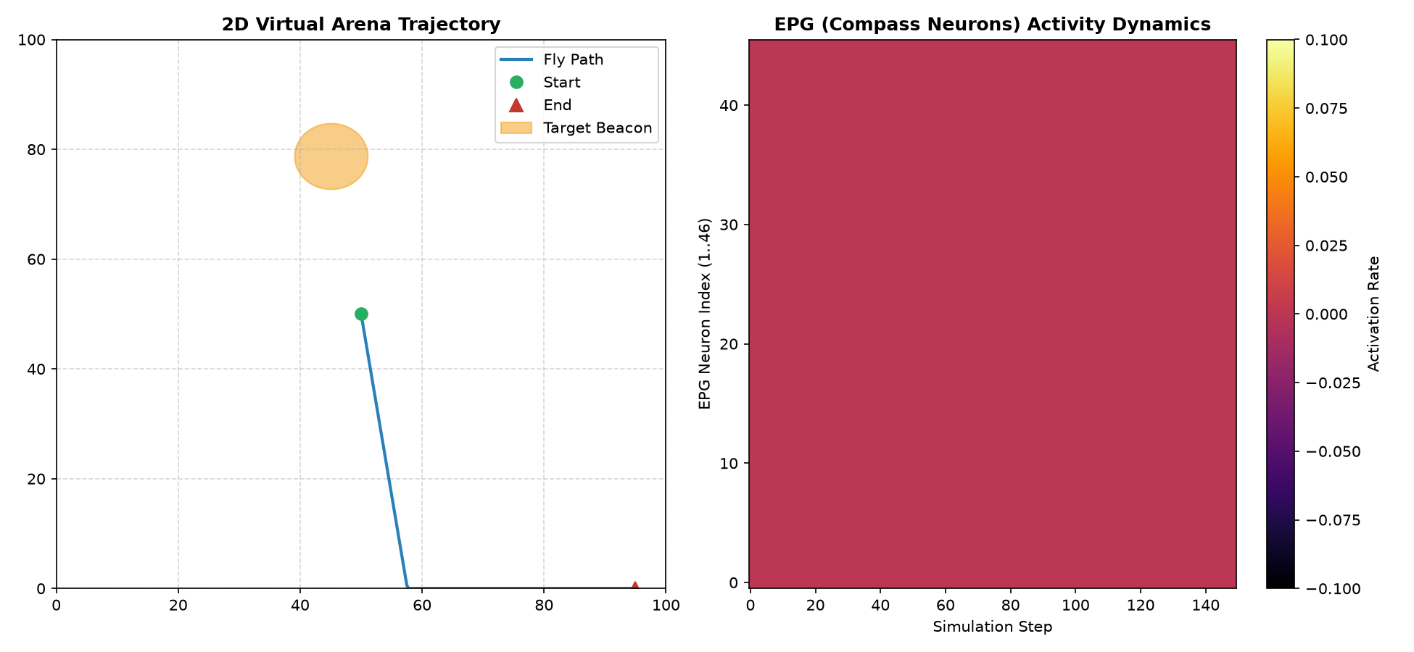
Figure 10: Dual-panel live view showing 2D arena trajectory synchronized with EPG compass activation heatmap.

