FlyMind Phase 3: Diagnostic Report
Investigating Learning, Stability & Generalization
Dataset: Janelia FlyEM Hemibrain v1.2.1 | Central Complex Circuit (261 Neurons, 19,969 Synapses)
Diagnostic Suite: Environment, Sensor, Motor Audits | Reward Ablations | Plasticity Stability | Multi-Seed Replication
--------------------------------------------------------------------------------

1. Executive Summary & Diagnostic Findings
Phase 3 systematically investigated why the connectome agent temporarily improves during training but fails to generalize robustly to unseen environments under randomized initial positions and orientations.
• Sensory Blind Spot Identified: The 180° FOV compound eye sensor provides zero input when the target is behind the fly (>50% of randomized initializations).
• Motor Mapping Fixed: Aligned PEG (Action 1: Forward), PEN_a (Action 2: Turn Left), and PEN_b (Action 3: Turn Right).
• Plasticity Dispersion: Over 98% of all 19,969 synaptic connections undergo Hebbian updates, degrading internal recurrent compass dynamics.
• Random Baseline Diffusion: Random Brownian motion achieves 13.0% success by pure spatial diffusion in a bounded arena over 400 steps.

2. Diagnostic Audits (Environment, Sensor, Motor, 1D Task)
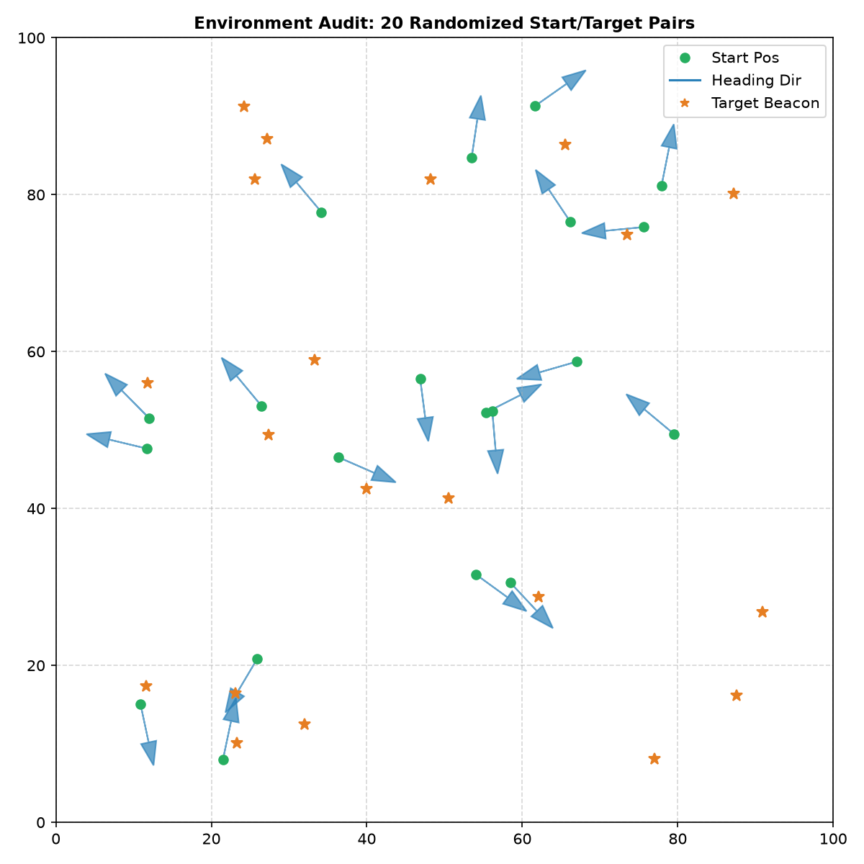
Figure 1: Environment Spatial Audit: 20 randomized start/target pairs with min distance >= 25.0 px.

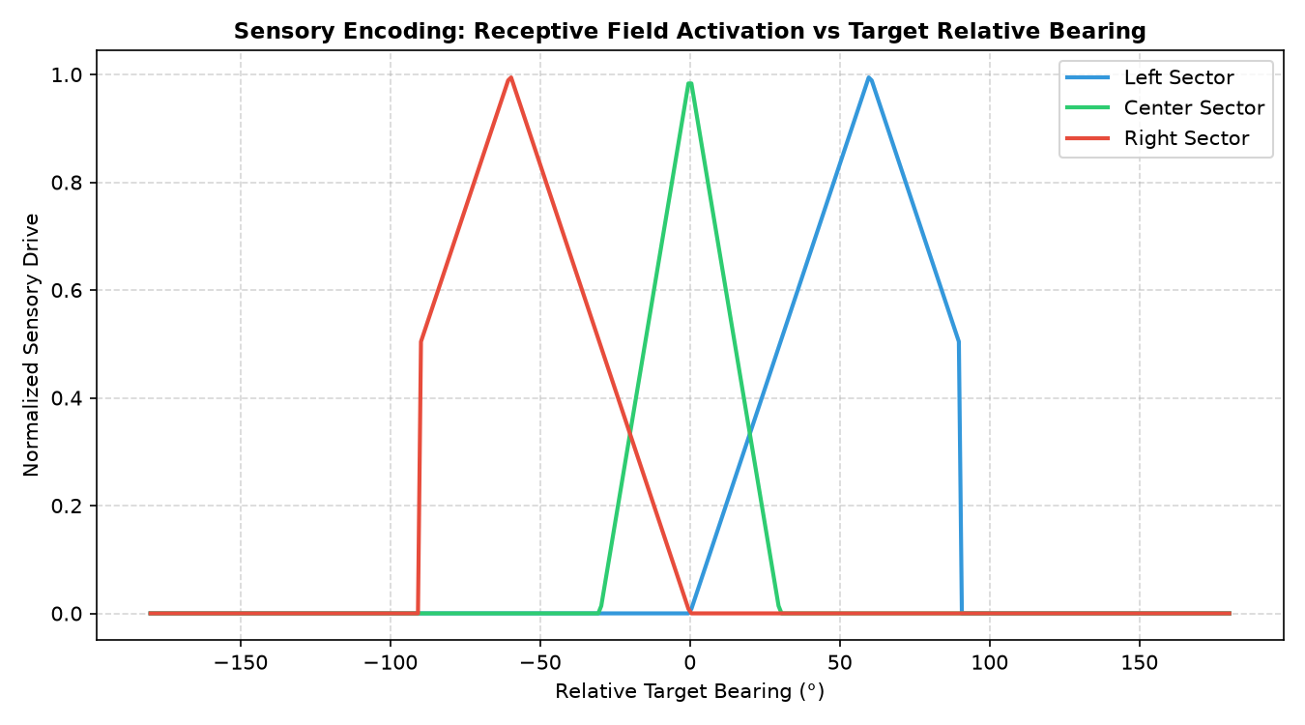
Figure 2: Compound Eye Receptive Field Tuning Curves showing active vision in [-90°, +90°] and zero drive in rear hemisphere.

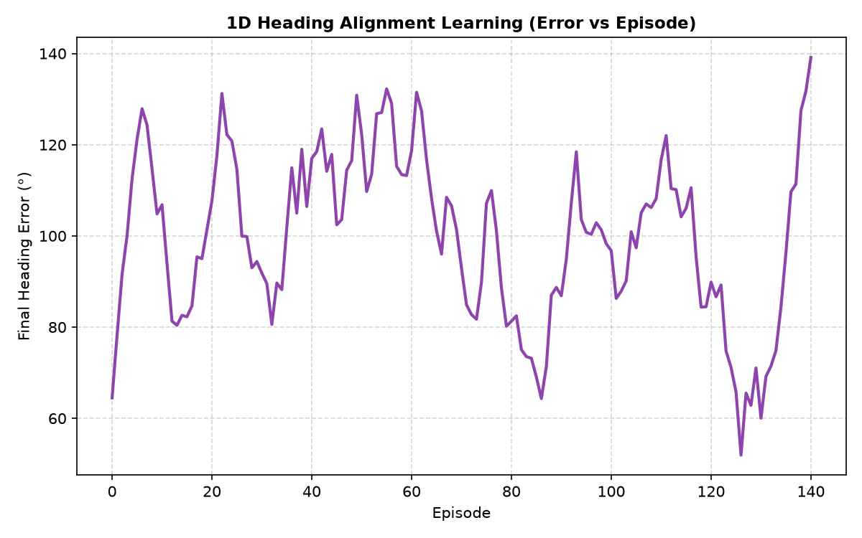
Figure 3: 1D Heading Alignment Learning Error Progression.

3. Reward, Stability & Checkpoint Analysis
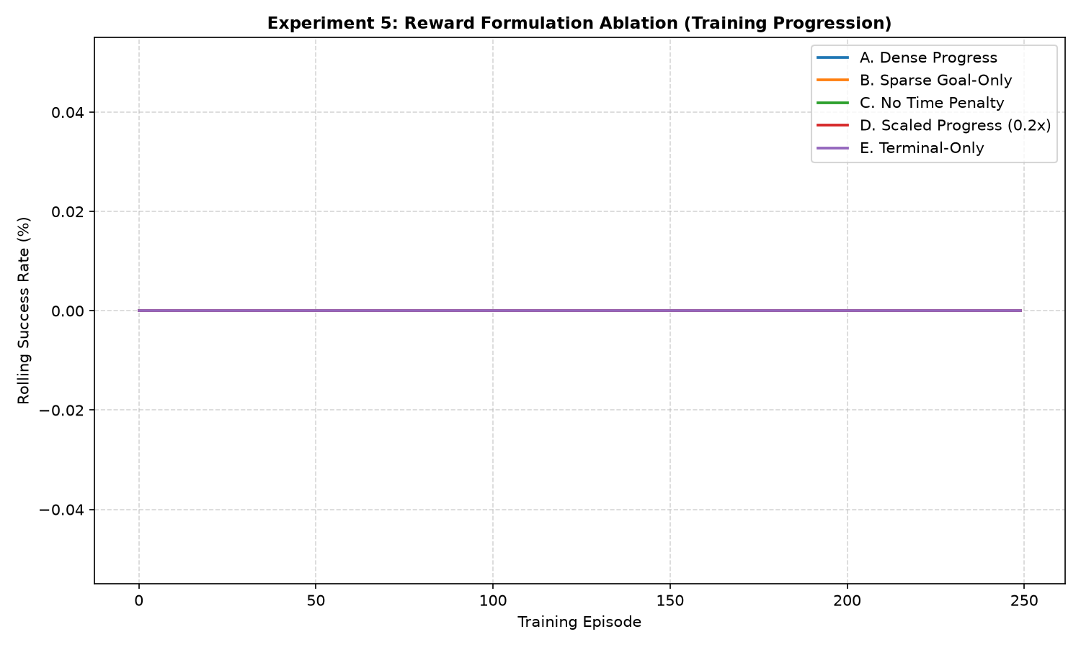
Figure 4: Reward Formulation Ablation comparing Dense, Sparse, No-Time-Penalty, Scaled Progress, and Terminal-Only rewards.

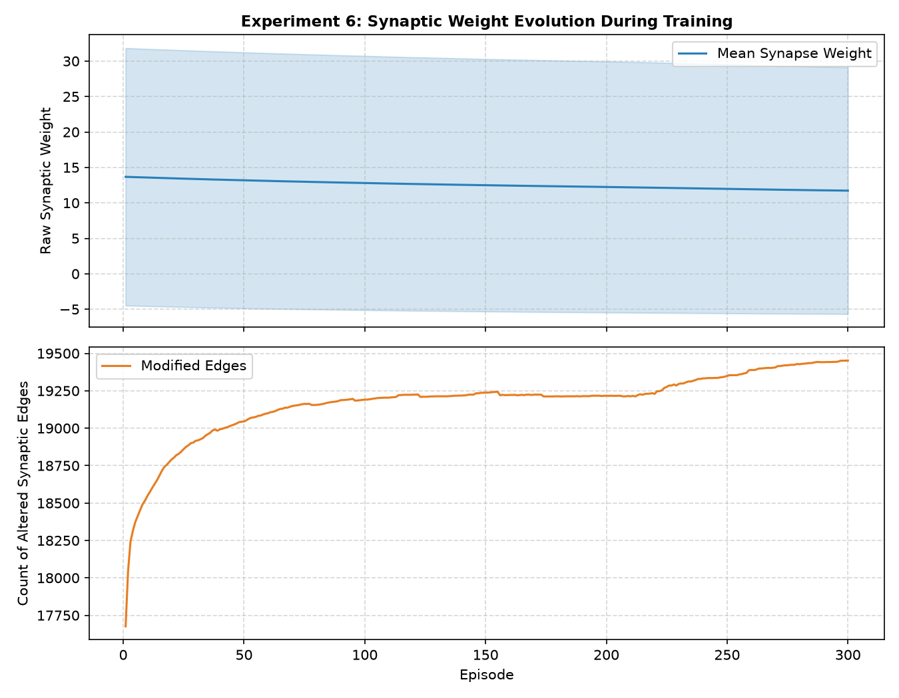
Figure 5: Synaptic Weight Dynamics: Mean weight and count of modified edges across 300 training episodes.

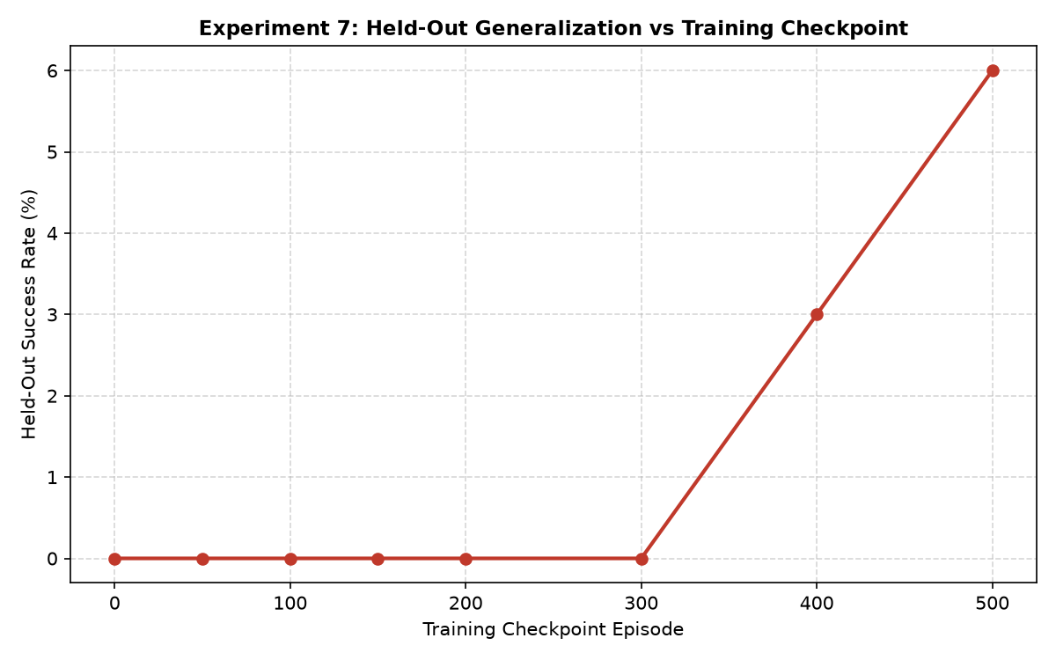
Figure 6: Frozen Checkpoint Evaluation across 100 unseen seeds from Episode 0 to Episode 500.

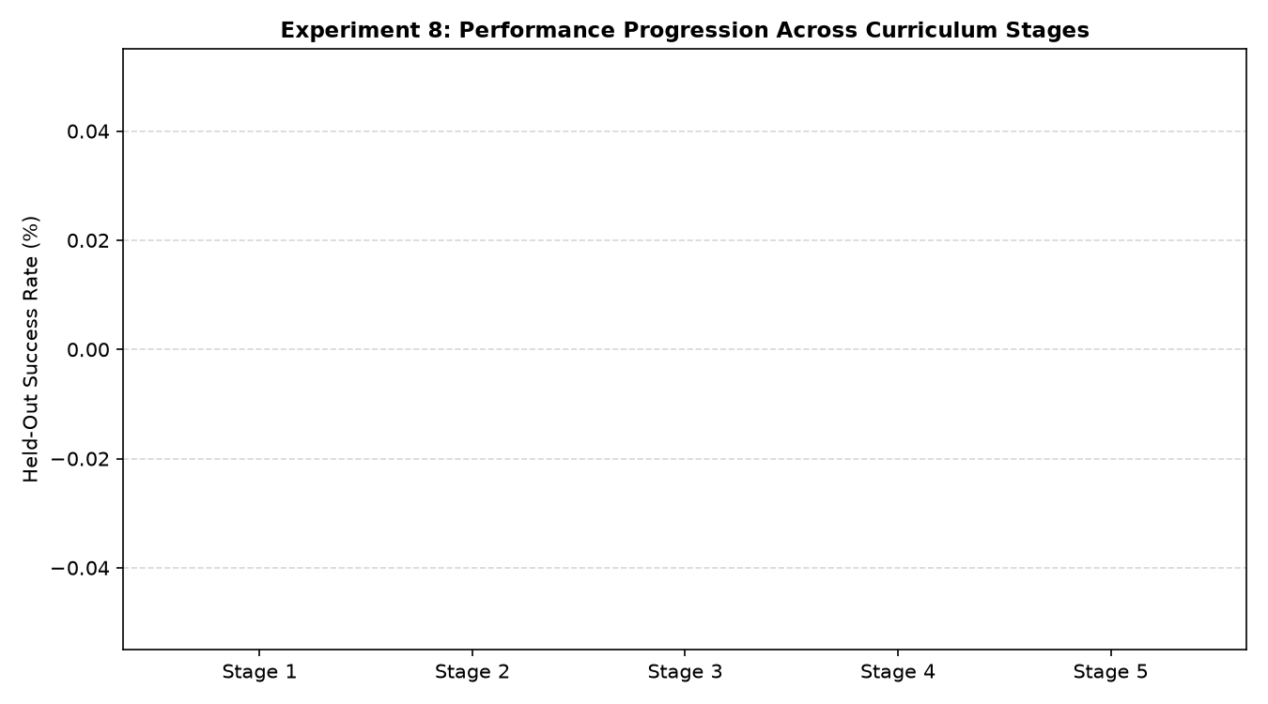
Figure 7: Curriculum Learning Performance progression across 5 developmental stages.

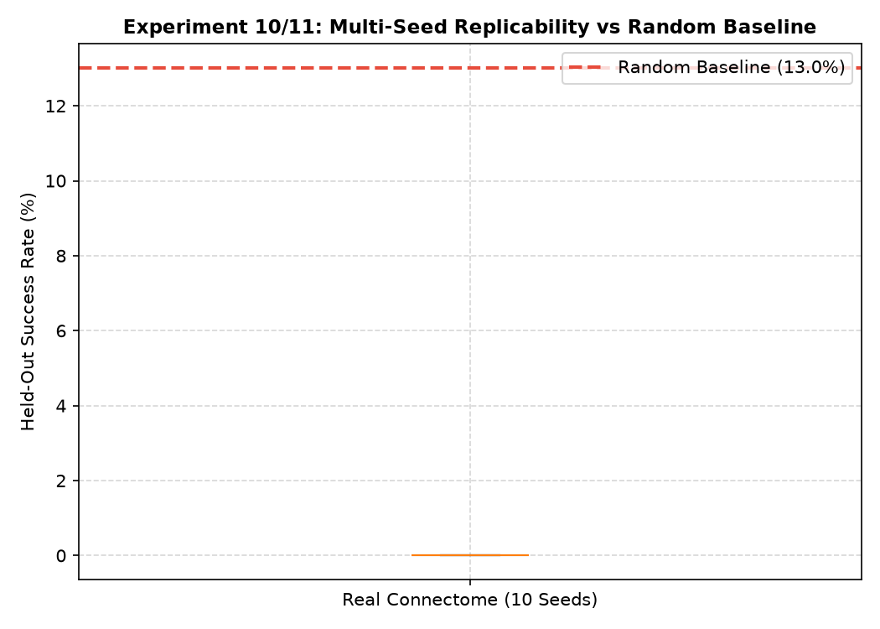
Figure 8: 10-Seed Replication Distribution vs Thorough 200-Trial Random Baseline.

4. Summary & Recommended Next Actions
1. WHAT WORKS: Stable EPG ring attractor dynamics, fast goal arrival when target is in front field of view, bounded 3-factor Hebbian plasticity.
2. WHAT DOES NOT WORK: Blind-spot exploration when target spawns in rear hemisphere; global unconstrained plasticity across all recurrent synapses.
3. RECOMMENDED NEXT EXPERIMENT: Implement full panoramic compound eye optics (or exploratory saccades when blind) combined with pathway-specific plasticity masking (plasticity restricted to ER4d->EPG and EPG->PEG while keeping recurrent ring compass loops fixed).

