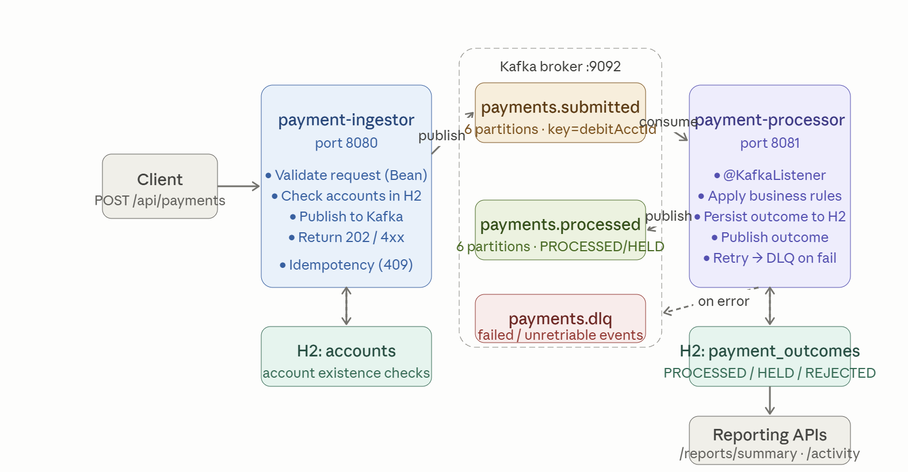
Here's the full design document for PayStream — Instant Payments Platform.

1. System Architecture Overview
The diagram above shows the complete two-service topology. Click any component to explore it further. Key design decisions baked in from the start:
Services never talk directly. payment-ingestor (8080) and payment-processor (8081) are fully decoupled — all communication is via Kafka topics. They also each own their own H2 database; no shared datastore.
Three Kafka topics: payments.submitted (ingestor → processor), payments.processed (processor publishes outcomes), and payments.dlq (dead letter queue for failed/unretriable events — not in the original spec but essential for production-grade design).

2. Happy Path Message Flow

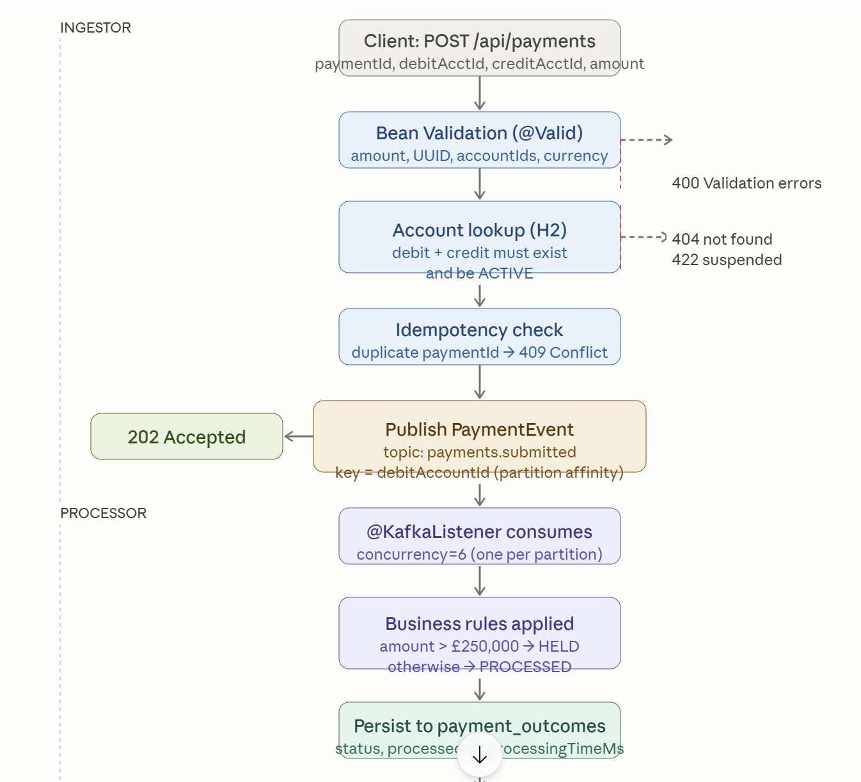


3. Exception Handling & Dead Letter Queue Design

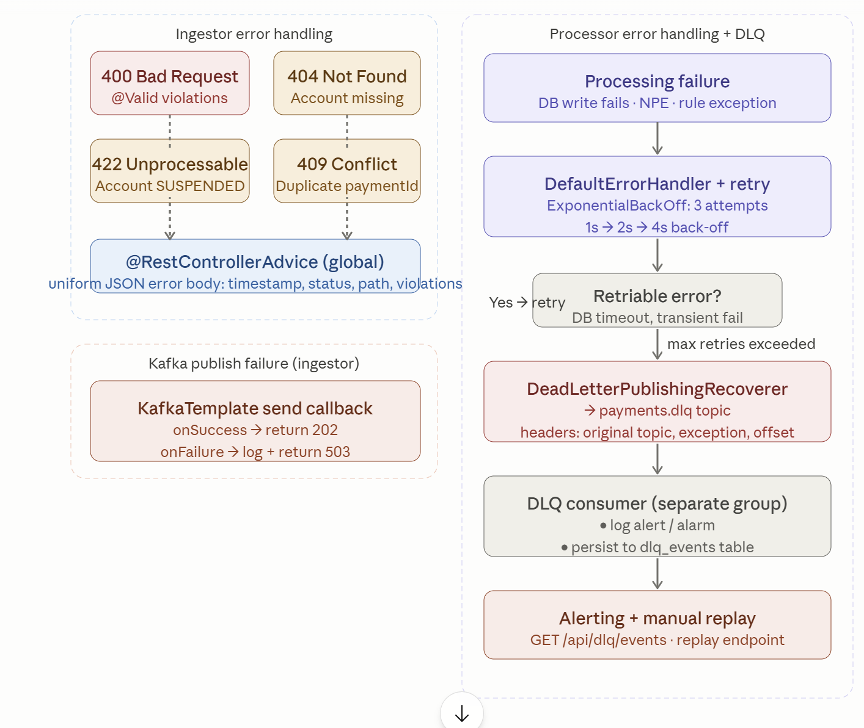

4. Reporting API Service Design

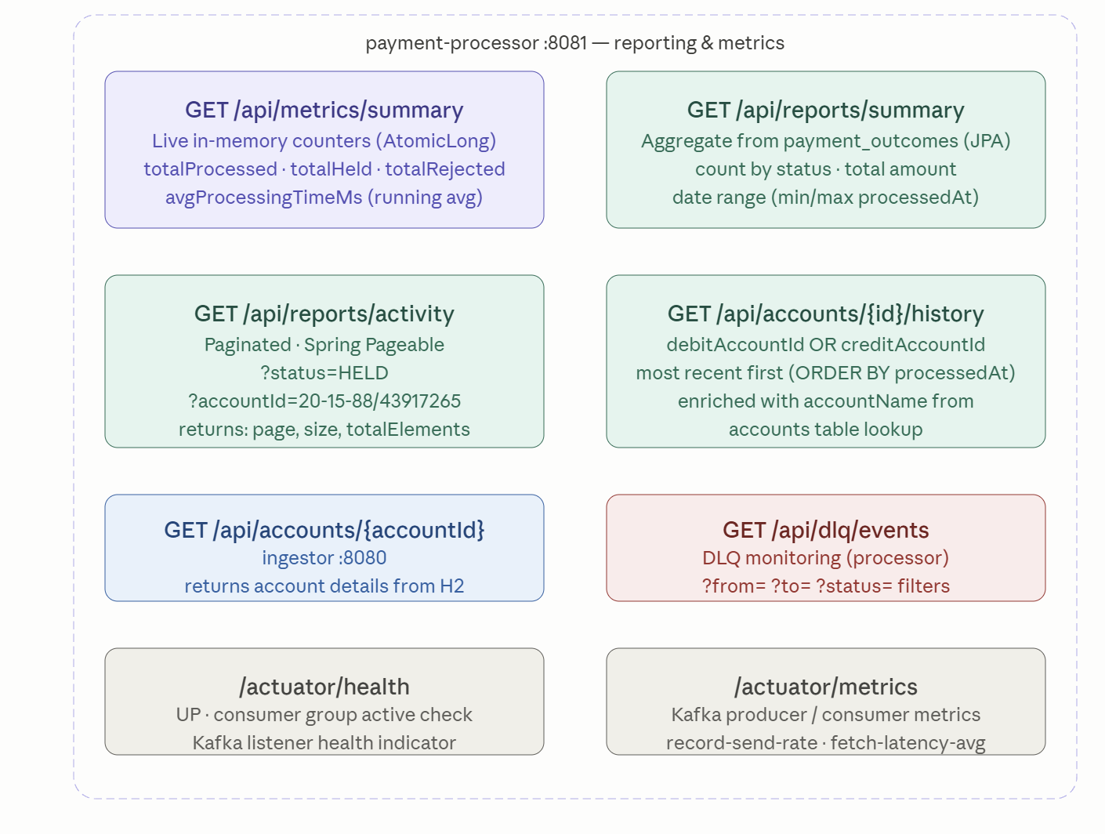

5. Kafka Configuration Design

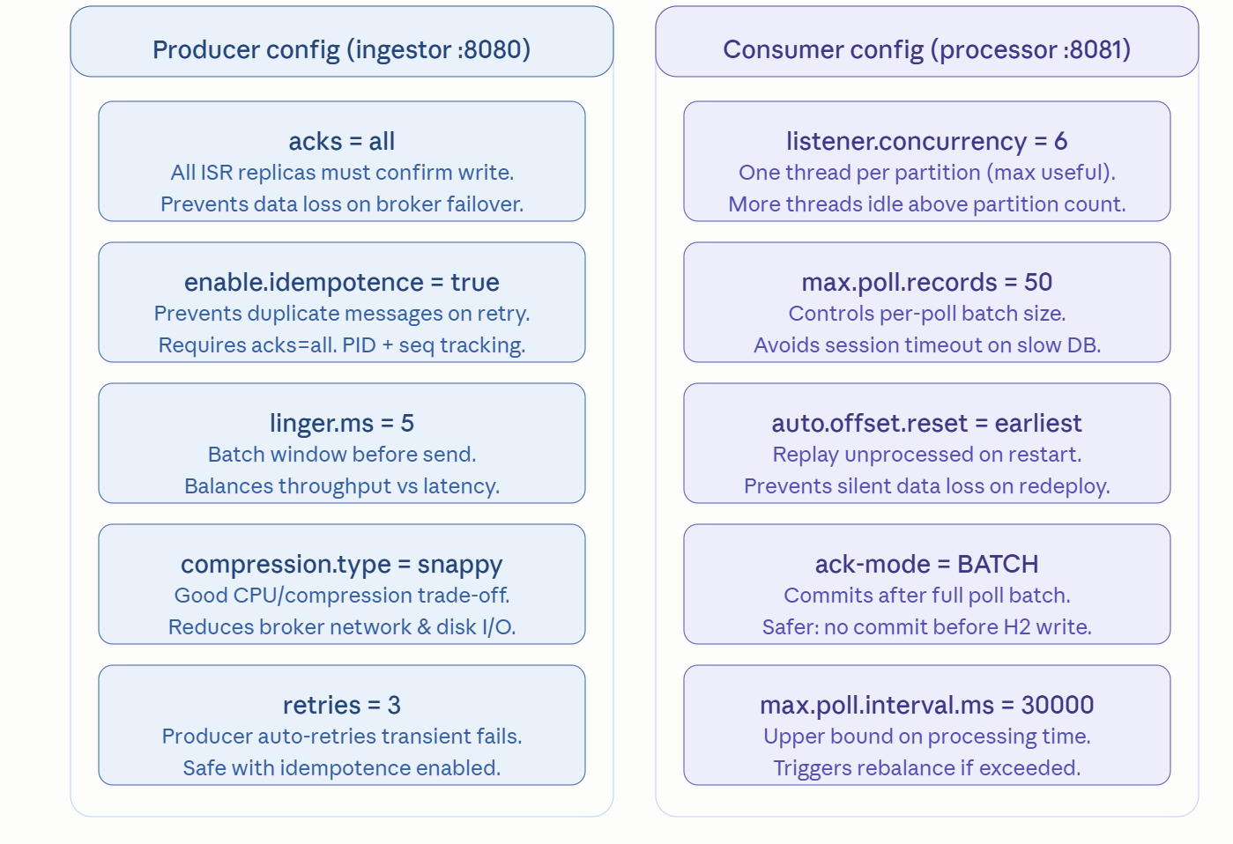

6. Database Schema (ERD)

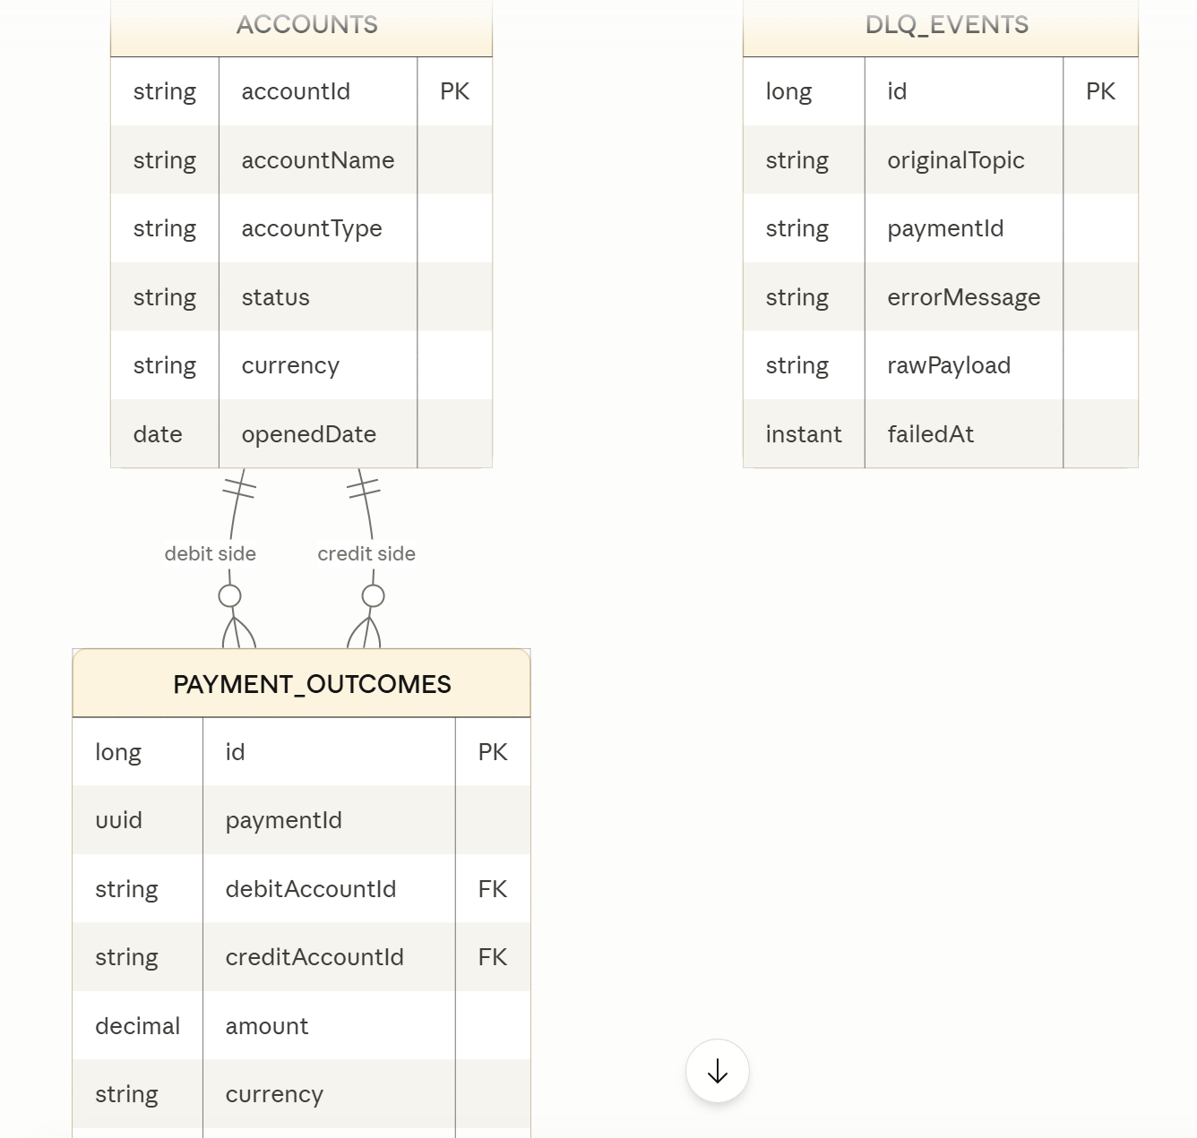
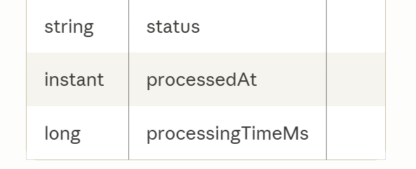

Design Summary
Here's the complete design decision log — everything you need to defend choices in the design sprint:
Message flow: Partition key is debitAccountId on payments.submitted, ensuring all payments from the same debit account land on the same partition and are processed in order. This is the correct choice for a payments platform where order matters per account.
Dead Letter Queue: Spring Kafka's DeadLetterPublishingRecoverer + DefaultErrorHandler handles this cleanly. After 3 attempts with exponential back-off, the message is forwarded to payments.dlq with the original exception in headers. A separate consumer group reads the DLQ, persists to a dlq_events table, and exposes a /api/dlq/events endpoint for ops — plus a replay endpoint for remediation.
Exception handling layers:
- Layer 1 — @RestControllerAdvice in both services: handles all 400/404/409/422 with the uniform JSON error envelope.
- Layer 2 — KafkaTemplate send callback in the ingestor: synchronous callback catches broker-unreachable failures and returns 503.
- Layer 3 — DefaultErrorHandler in the processor: catches processing exceptions, retries with back-off, then routes to DLQ.
Reporting API: The processor exposes five endpoints covering live in-memory counters (/api/metrics/summary), aggregate DB queries (/api/reports/summary), paginated filtered history (/api/reports/activity), per-account history (/api/accounts/{id}/history), and DLQ visibility (/api/dlq/events). The accountName enrichment comes from the seeded accounts table — look up by debitAccountId at query time, not stored in payment_outcomes.
Kafka tuning: Every property must have a comment in application.yml — that is the literal hackathon scoring criterion. Click any property in diagram 4 above to generate the correct comment for it.
Design sprint deliverable checklist:
- Message flow documented (diagrams 1 + 2 above)
- Kafka topic names and partition counts specified (diagram 1)
- Partition key strategy justified (debitAccountId — ordering per account)
- Kafka config properties listed with planned values (diagram 4)
- Error handling strategy documented (diagram 3)
- Database schema confirmed (diagram 5)
- All endpoint contracts listed (diagram 4)

