**Assignment/Project Day 4 | 22nd August 2020**:

* Launched 2 Linux instances: Linux1 and Linux2 in N. Virginia region

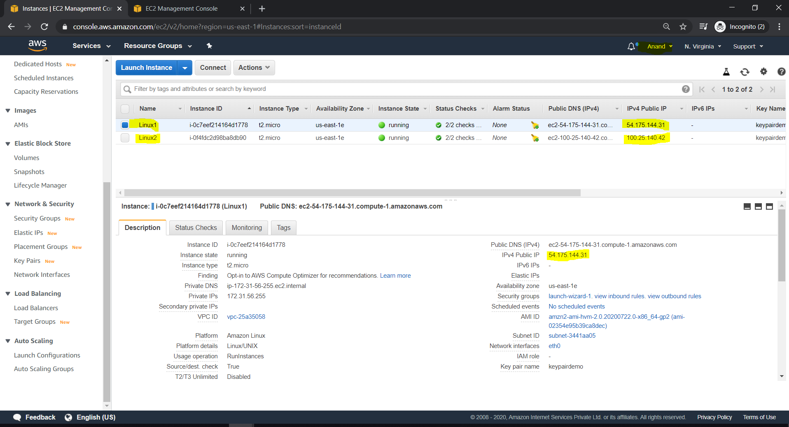

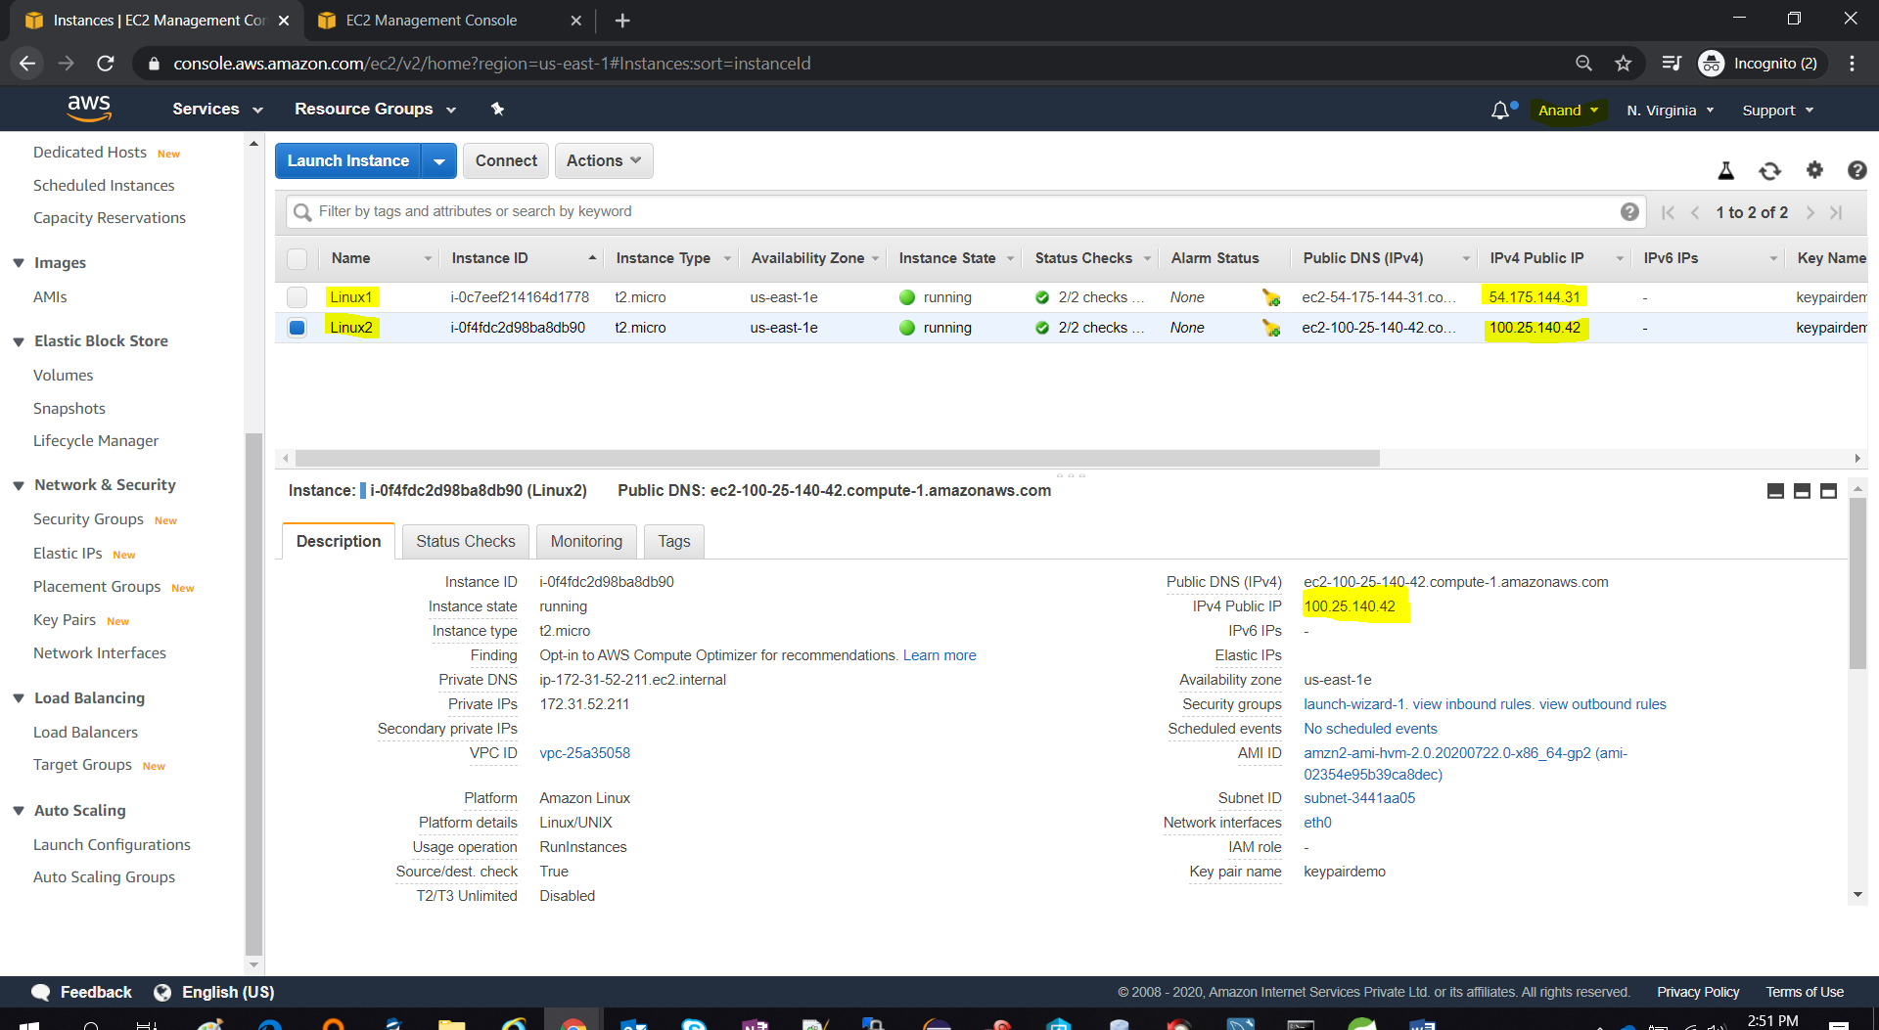

* Created a Load Balancer targeting both the Linux instances; selected all the availability zones.

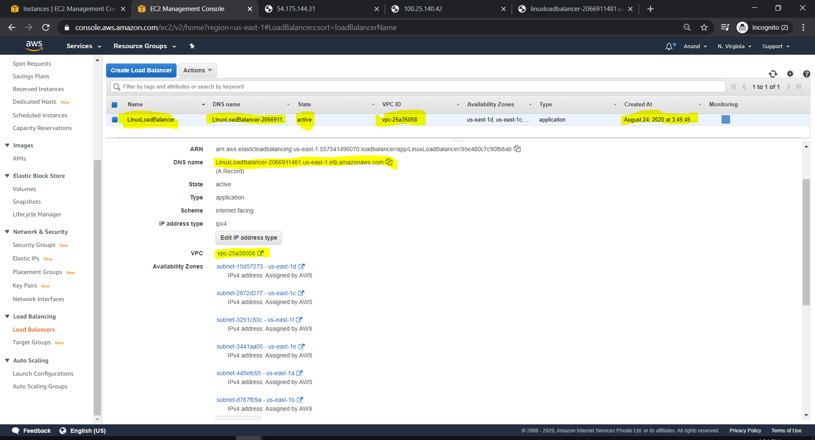

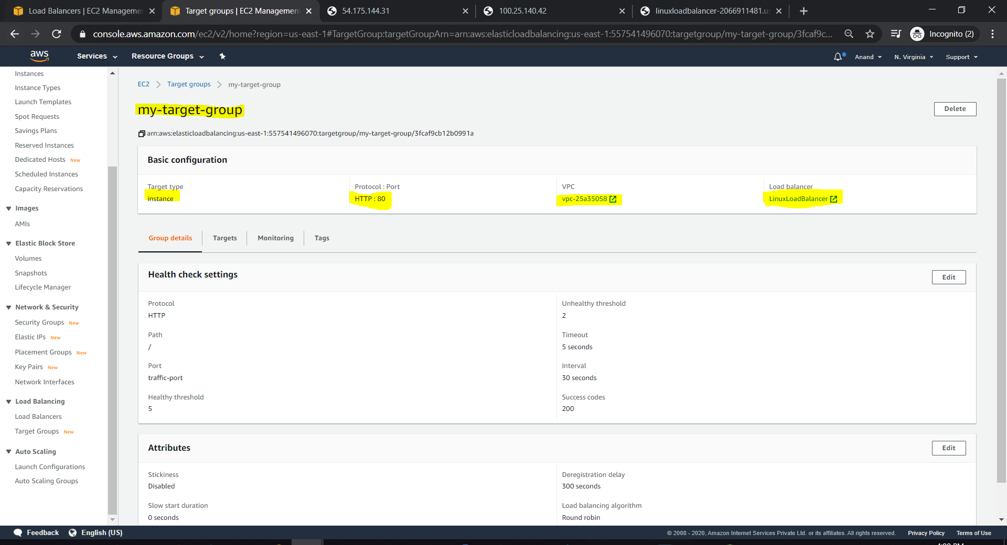

* Target group in healthy state now.

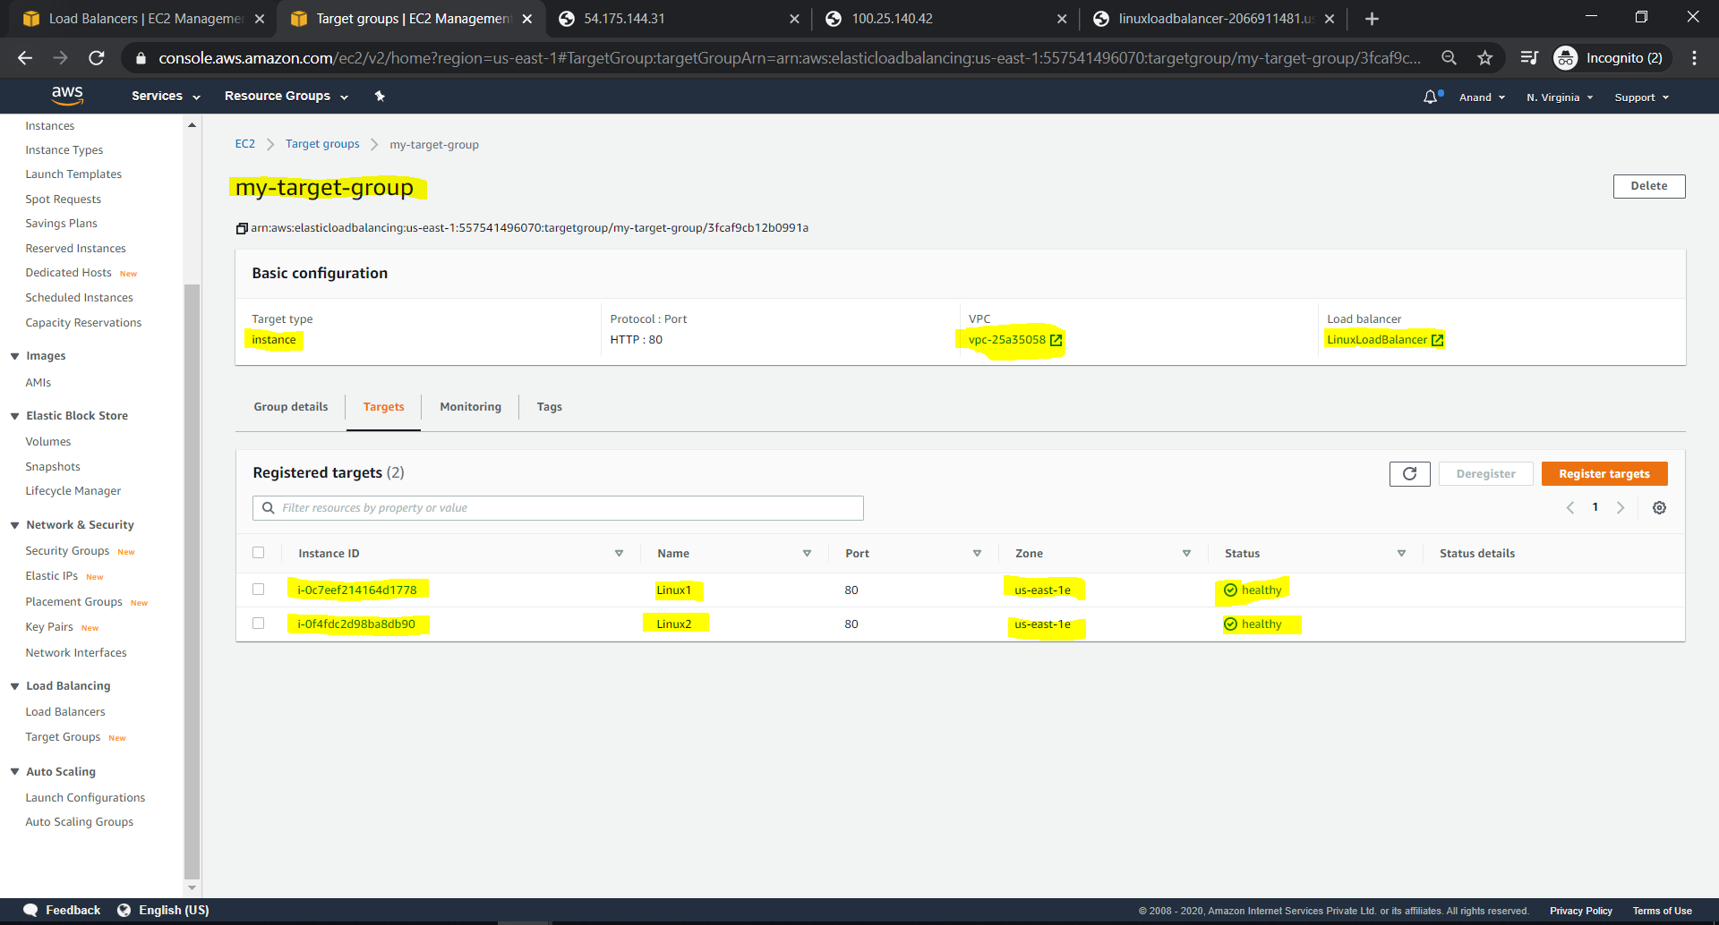

* Apache httpd Server running successfully on Linux 1 instance

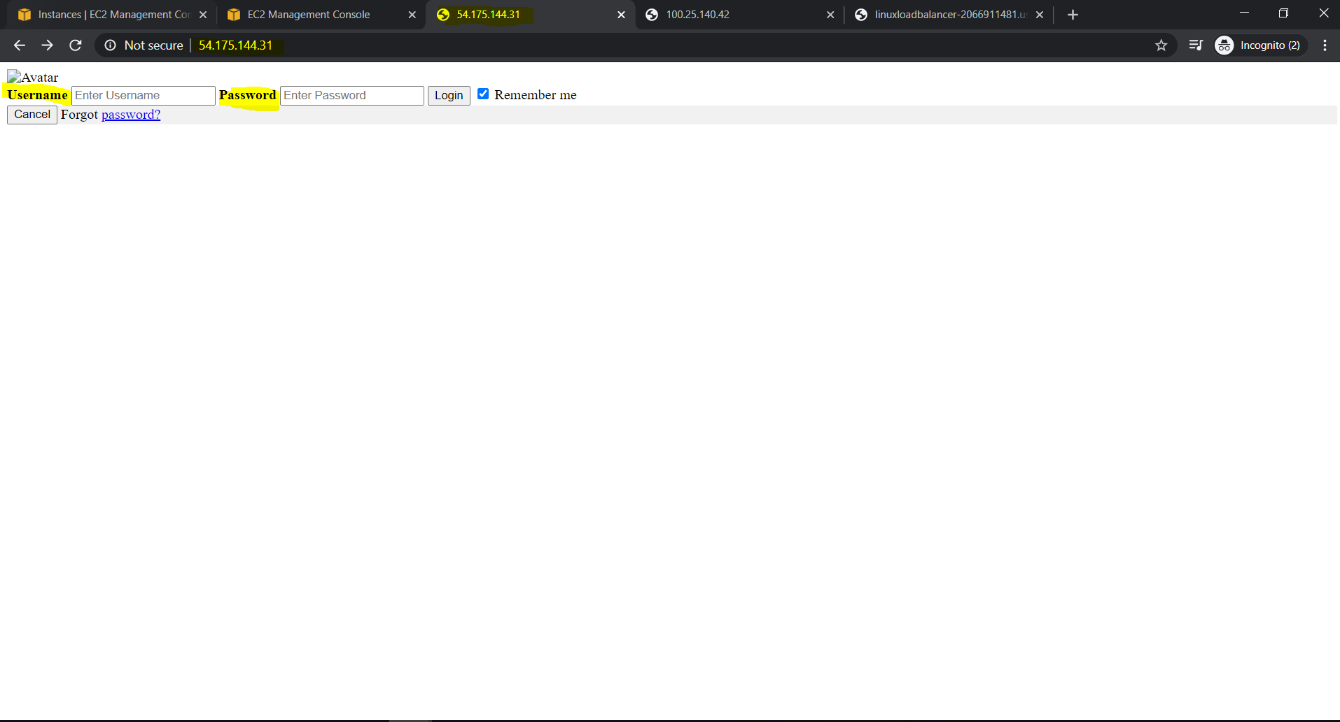

* Apache httpd Server running successfully on Linux 2 instance

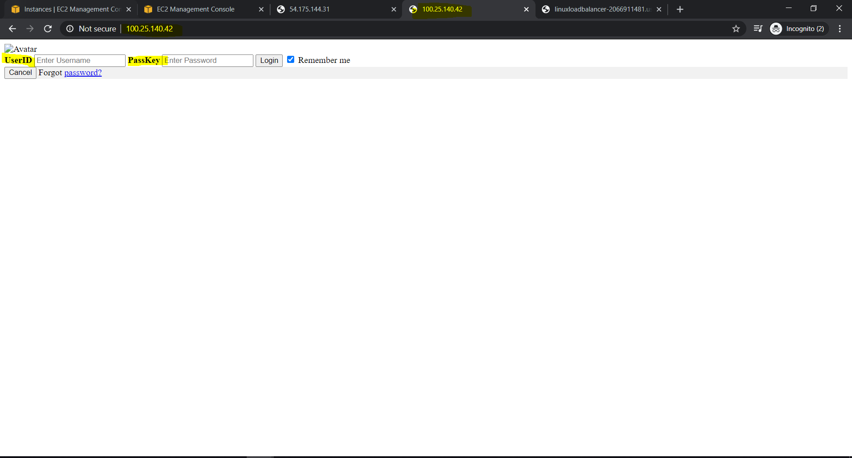

* Load Balancer routing the request to Linux 2 machine here.

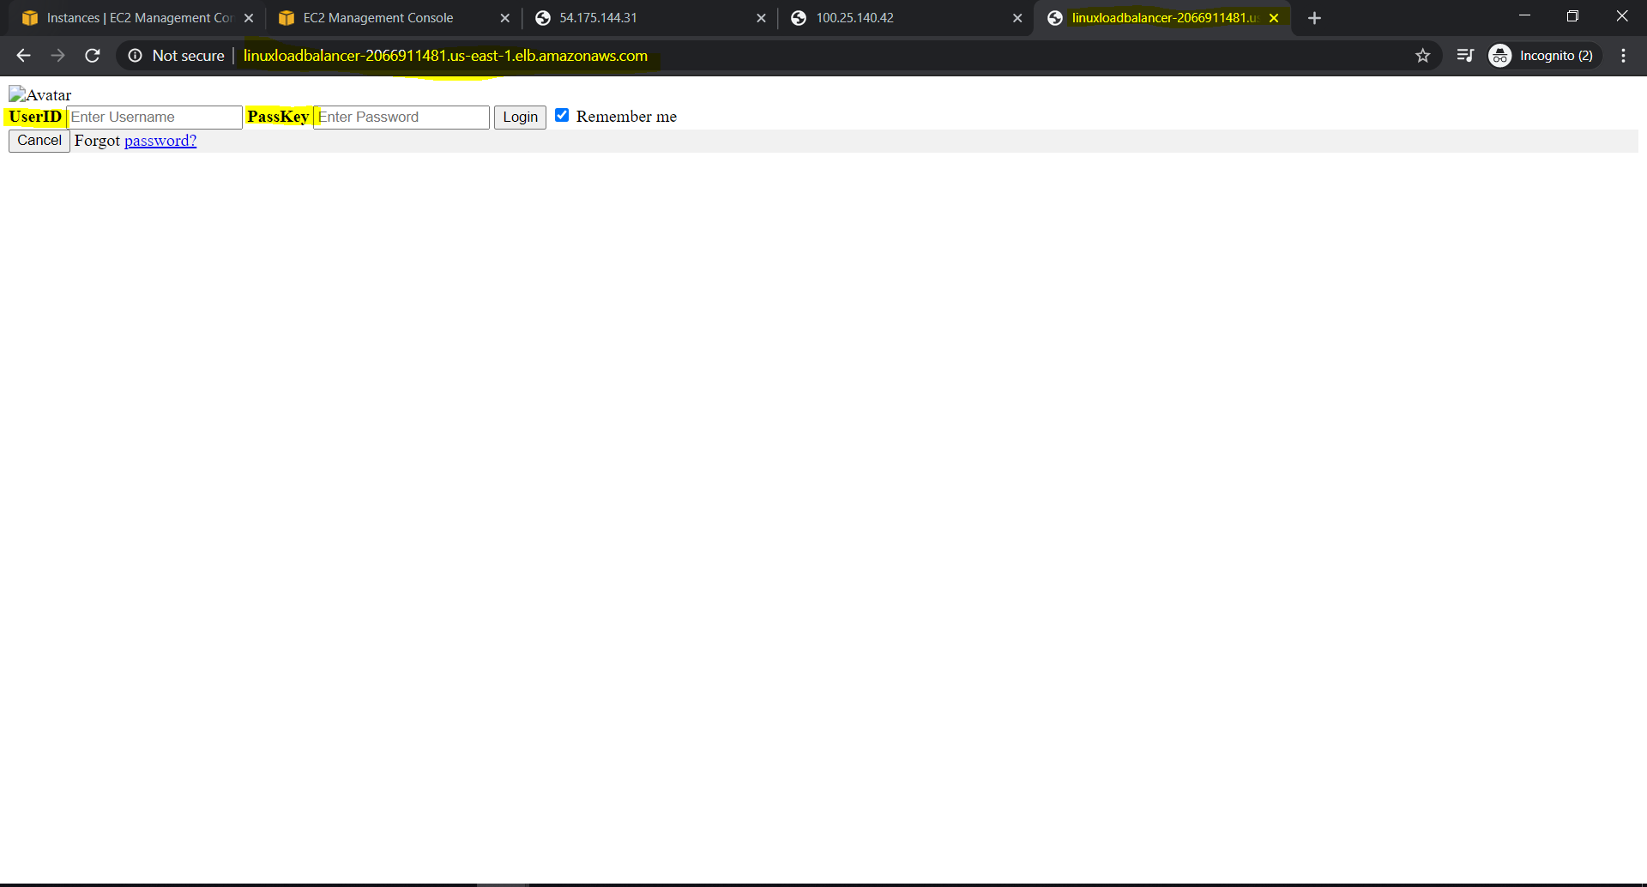

* Load Balancer routing the request to Linux 1 machine here.

