Experiment 2.1: Data Splitting
Aim
To divide the student dataset into training and testing sets, using 80% of the data for training and 20% for testing.
Algorithm
- Import Pandas and train_test_split from Scikit-learn.
- Load the dataset from data.csv.
- Select Hours_Studied, Attendance, and Assignments as input features.
- Select Result as the target output.
- Split the data into training and testing sets, using test_size=0.2 and random_state=42.
- Display the training and testing data.
- Display the number of samples in each set
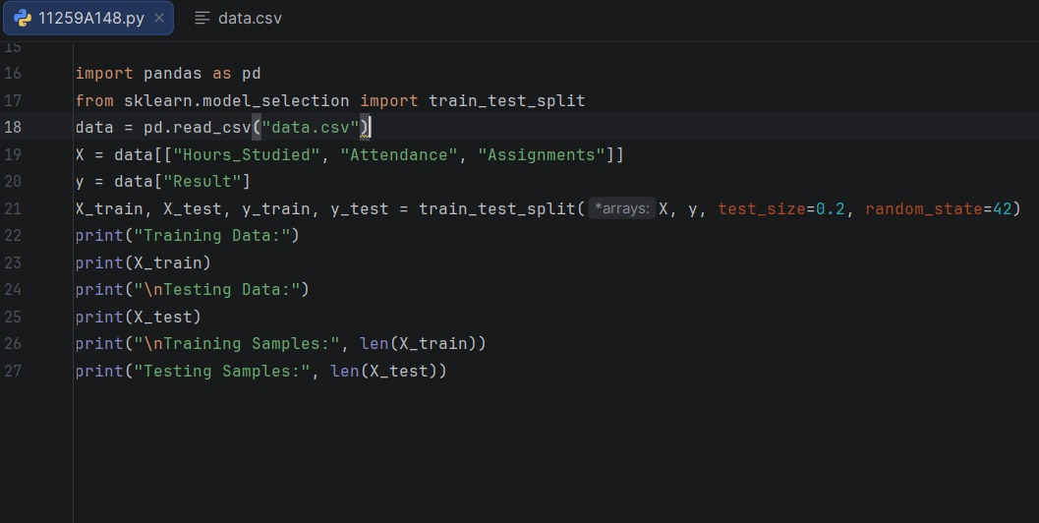
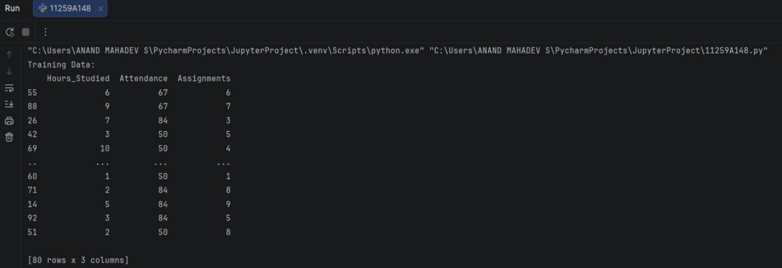
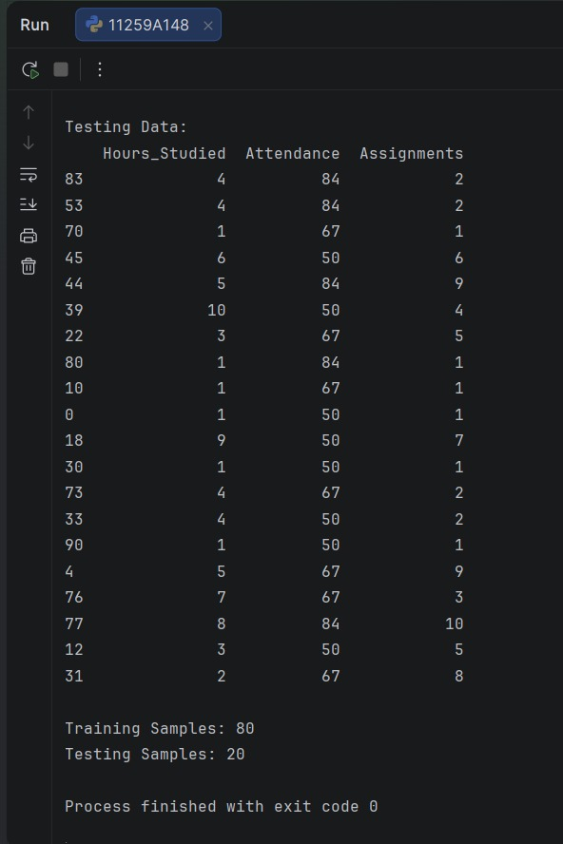
Result
The dataset was successfully divided into training and testing sets. The training set contains 80% of the samples, and the testing set contains 20%.

Experiment 2.2: Cross-Validation
Aim
To evaluate a K-Nearest Neighbors (KNN) classifier using 5-fold cross-validation and calculate its average accuracy.
Algorithm
- Import Pandas and the required Scikit-learn tools.
- Load the dataset from data.csv.
- Select Hours_Studied, Attendance, and Assignments as input features.
- Select Result as the target output.
- Split the data into training and testing sets, using 80% for training and 20% for testing.
- Display the number of samples in each set.
- Create a KNN classifier with n_neighbors=3.
- Evaluate the classifier using 5-fold cross-validation.
- Display the five cross-validation scores and their average.
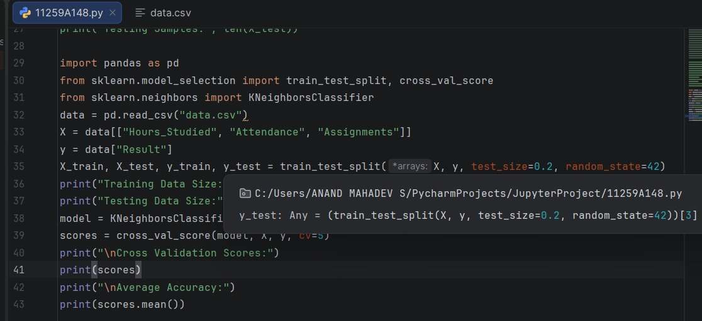
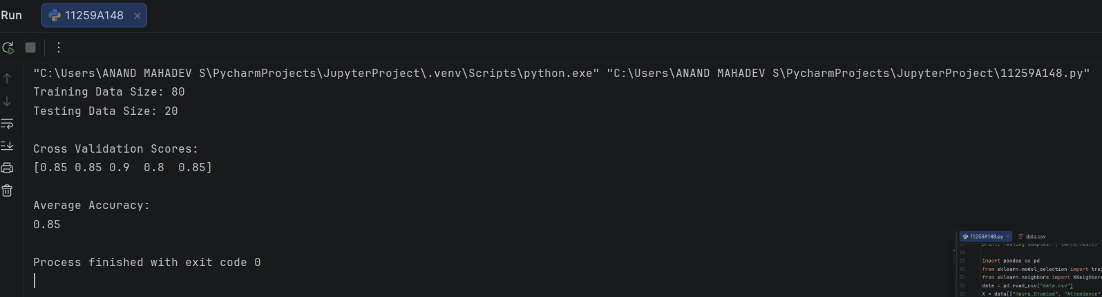
Result
The dataset was split into training and testing sets, and the KNN classifier was evaluated using 5-fold cross-validation. The cross-validation scores and average accuracy were displayed.

