Experiment 3: Linear Regression
Aim
To build a Linear Regression model that predicts students’ marks based on the number of hours they studied, and evaluate its performance.
Algorithm
- Import Pandas, Matplotlib, and the required Scikit-learn modules.
- Load the dataset from data.csv.
- Select Hours_Studied as the input feature and Marks as the target variable.
- Split the data into training and testing sets, using 80% for training and 20% for testing.
- Create a Linear Regression model.
- Train the model using the training data.
- Predict marks for the test data.
- Calculate and display the Mean Squared Error and R² score.
- Display the predicted marks.
- Plot the actual test marks and the regression line.
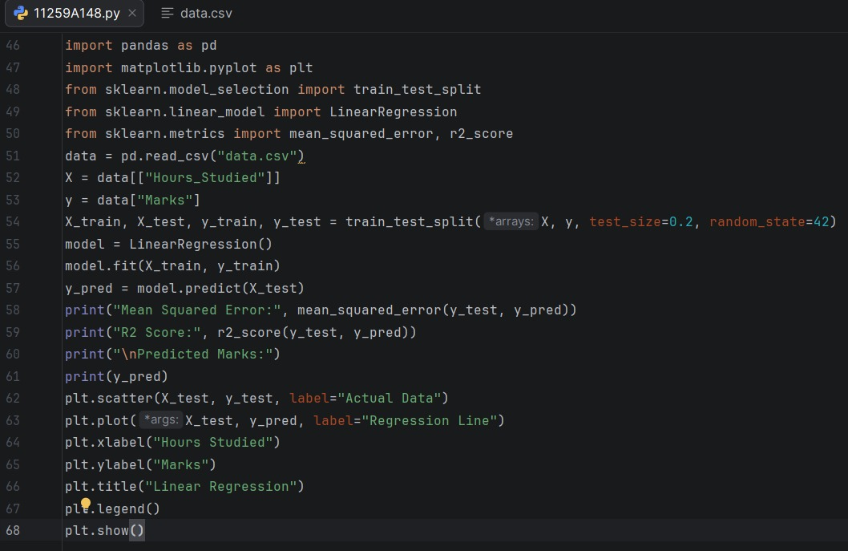
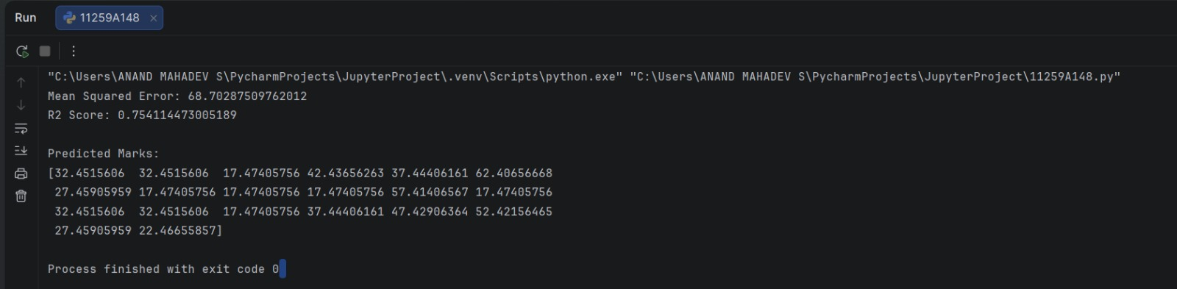
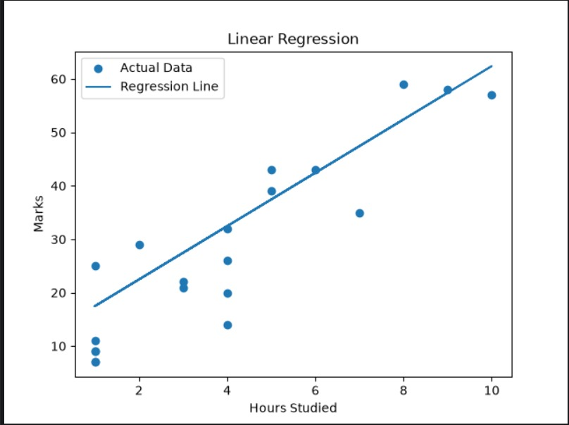
Result
The Linear Regression model was trained to predict marks from study hours. The predicted marks, Mean Squared Error, and R² score were displayed, and a graph comparing actual marks with the regression line was plotted.

