Experiment 4.1: KNN Classification and Evaluation Metrics
Aim
To build a K-Nearest Neighbors (KNN) classification model that predicts whether a student passes or fails based on study hours, attendance, and assignments, and to evaluate its performance.
Algorithm
- Import Pandas and the required Scikit-learn modules.
- Load the dataset from data.csv.
- Select Hours_Studied, Attendance, and Assignments as input features.
- Select Result as the target variable.
- Split the data into training and testing sets, using 80% for training and 20% for testing.
- Create a KNN classifier with n_neighbors=3.
- Train the model using the training data.
- Predict the results for the test data.
- Display the accuracy, confusion matrix, and classification report.
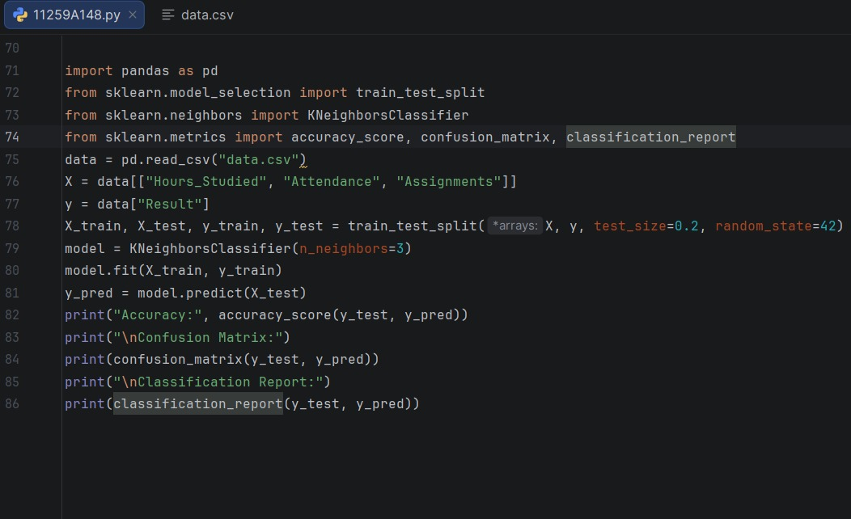
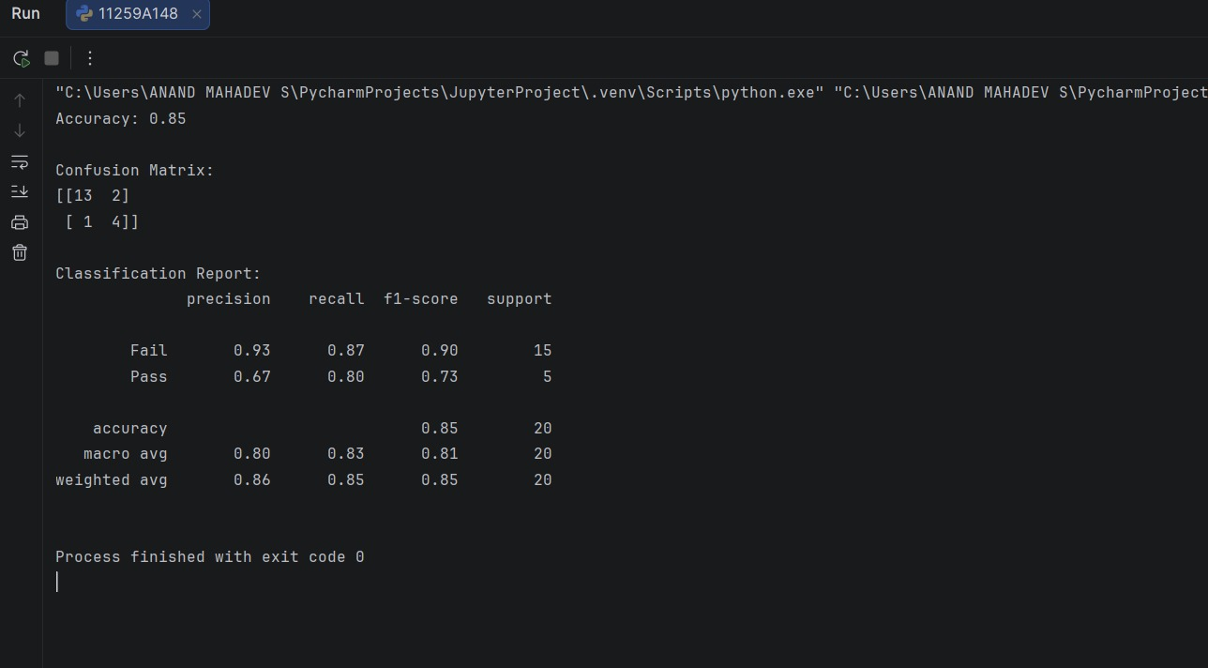
Result
The KNN classification model was trained and used to predict student results. Its accuracy, confusion matrix, and classification report were displayed.

Experiment 4.2: SVM Classification and Evaluation Metrics
Aim
To build a Support Vector Machine (SVM) classification model that predicts whether a student passes or fails based on study hours, attendance, and assignments, and to evaluate its performance.
Algorithm
- Import Pandas and the required Scikit-learn modules.
- Load the dataset from data.csv.
- Select Hours_Studied, Attendance, and Assignments as input features.
- Select Result as the target variable.
- Split the data into training and testing sets, using 80% for training and 20% for testing.
- Create an SVM classifier with a linear kernel.
- Train the model using the training data.
- Predict the results for the test data.
- Display the accuracy, confusion matrix, and classification report.
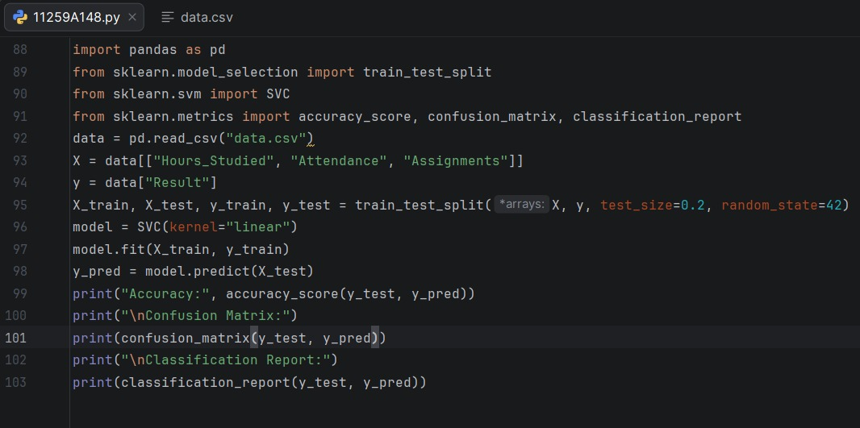
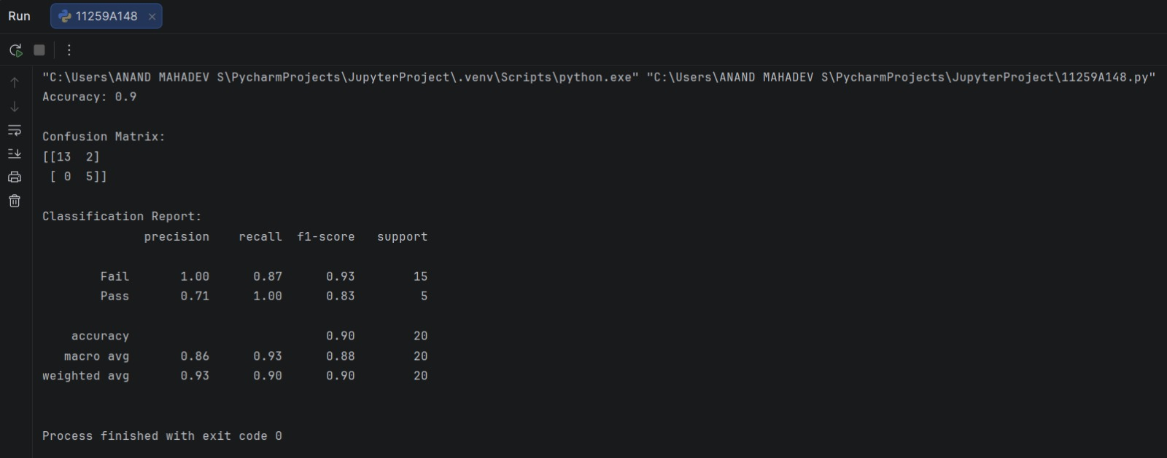
Result
The SVM classification model was trained and used to predict student results. Its accuracy, confusion matrix, and classification report were displayed.

