Experiment 5: K-Means Clustering
Aim
To group student data into three clusters based on hours studied and marks using the K-Means clustering algorithm, and visualize the clusters and their centroids.
Algorithm
- Import Pandas, Matplotlib, and the K-Means algorithm from Scikit-learn.
- Load the dataset from data.csv.
- Select Hours_Studied and Marks as the features for clustering.
- Create a K-Means model with three clusters and a fixed random state.
- Fit the model to the selected features.
- Obtain the cluster label for each data point.
- Add the cluster labels to the dataset and display it.
- Plot the data points, using color to show their clusters.
- Plot the cluster centroids and display the graph.
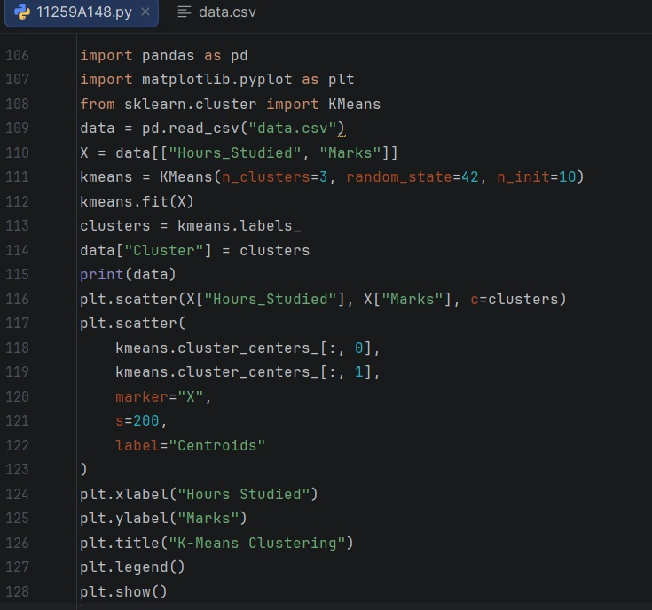
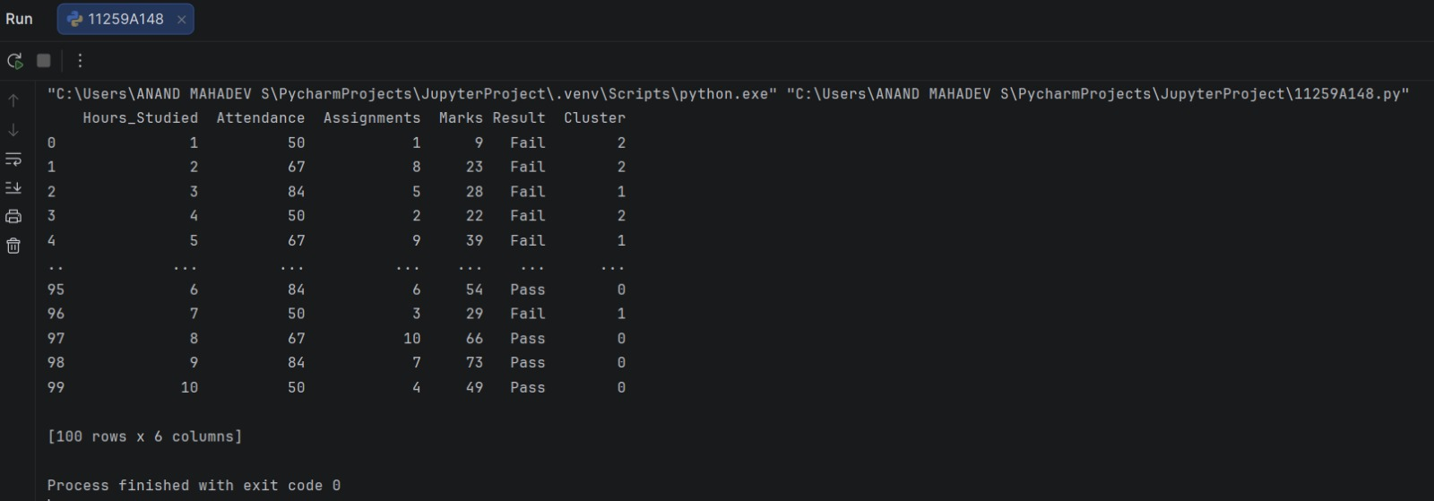
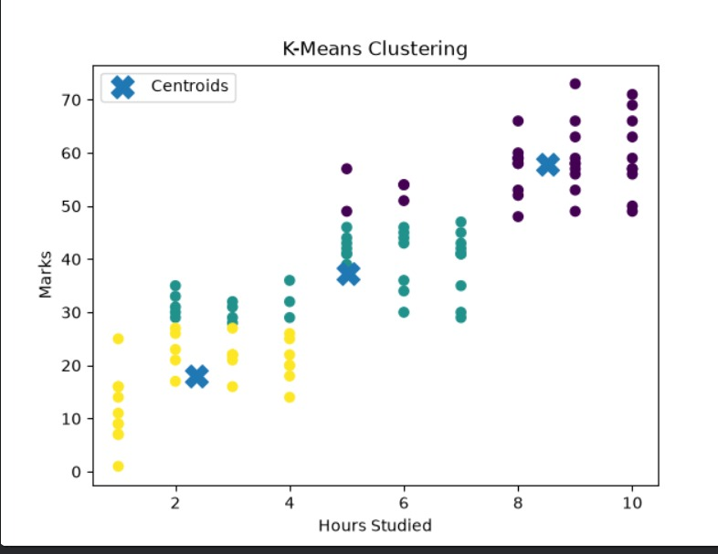
Result
The K-Means model grouped the student data into three clusters. The cluster labels and a graph showing the clusters and their centroids were displayed.

