Experiment 6: Hierarchical Clustering
Aim
To group student data into three clusters based on hours studied and marks using hierarchical clustering, and visualize the results with a dendrogram and scatter plot.
Algorithm
- Import Pandas, Matplotlib, SciPy’s hierarchical clustering functions, and Scikit-learn’s AgglomerativeClustering.
- Load the dataset from data.csv.
- Select Hours_Studied and Marks as the features for clustering.
- Create a linkage matrix using Ward’s method.
- Plot and display the dendrogram.
- Create an agglomerative clustering model with three clusters.
- Fit the model to the selected features and obtain cluster labels.
- Add the cluster labels to the dataset and display it.
- Plot the data points, coloring them by cluster, and display the graph.
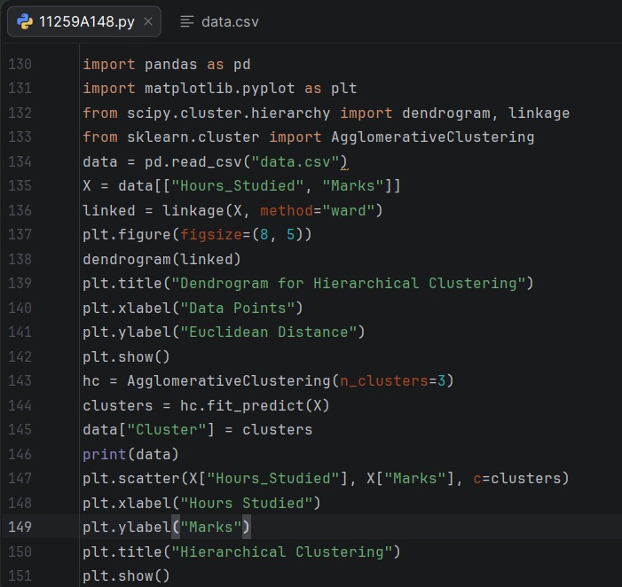
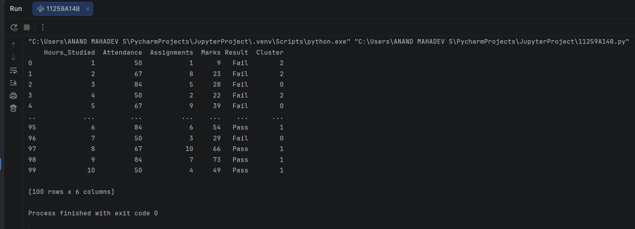
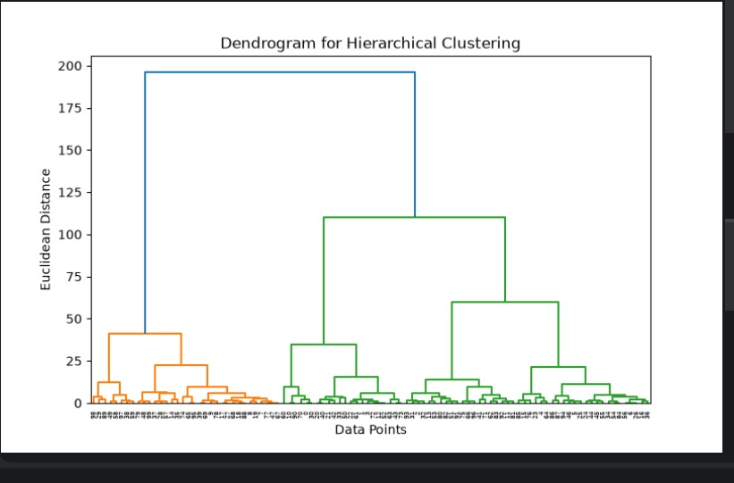

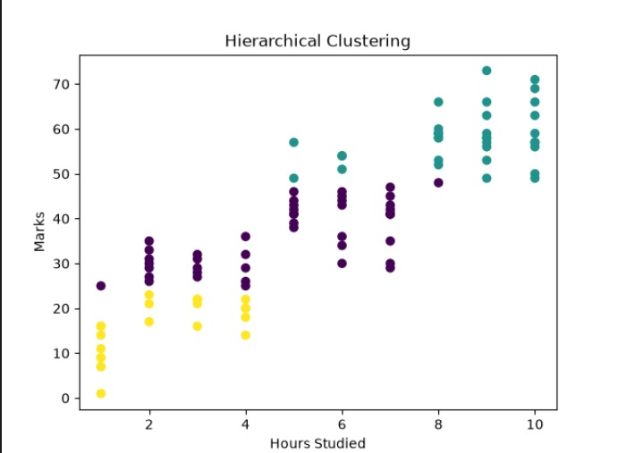

Result
The student data was grouped into three clusters using hierarchical clustering. The dendrogram, cluster labels, and scatter plot were displayed.

