Experiment 7: Random Forest Classification and Performance Analysis
Aim
To build a Random Forest classifier that predicts student results from study hours, attendance, and assignments, evaluate its performance, and visualize the importance of each feature.
Algorithm
- Import Pandas, Matplotlib, and the required Scikit-learn modules.
- Load the dataset from data.csv.
- Select Hours_Studied, Attendance, and Assignments as input features.
- Select Result as the target variable.
- Split the data into training and testing sets, using 80% for training and 20% for testing.
- Create a Random Forest classifier with 100 trees.
- Train the model using the training data.
- Predict the results for the test data.
- Display the accuracy, confusion matrix, and classification report.
- Plot the importance scores of the input features.
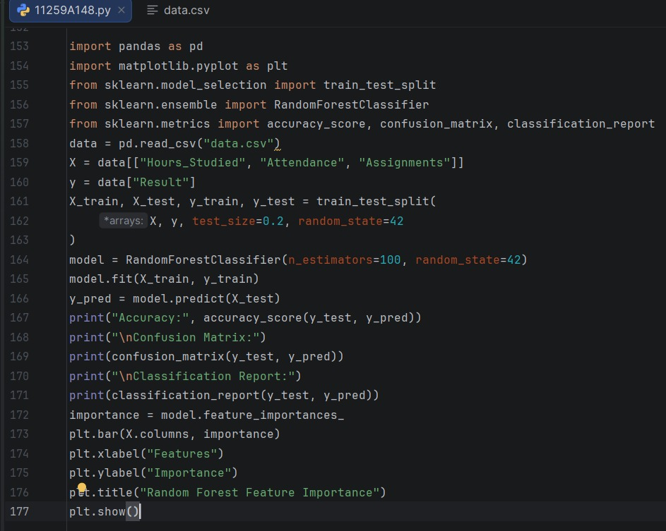

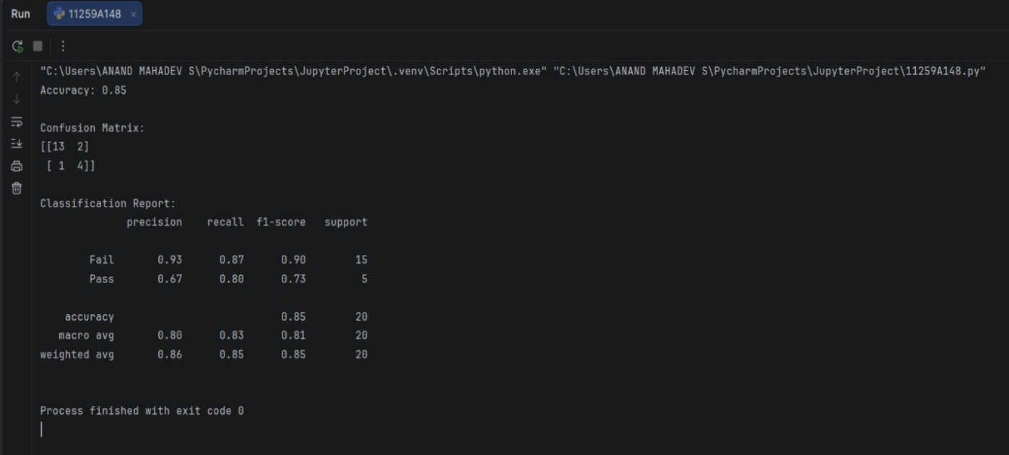
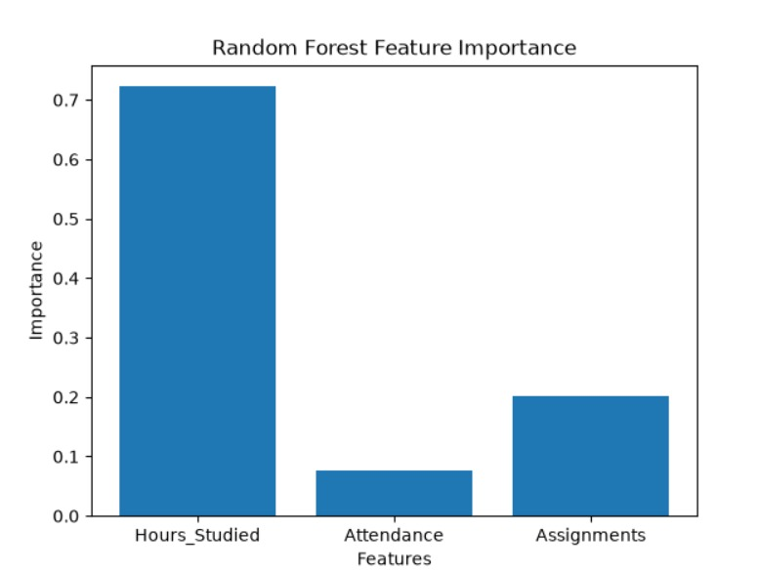
Result
The Random Forest classifier was trained to predict student results. Its evaluation metrics and a feature importance graph were displayed.

