Experiment 8: AdaBoost Classification and Performance Analysis
Aim
To build an AdaBoost classifier that predicts student results from study hours, attendance, and assignments, evaluate its performance, and visualize the importance of each feature.
Algorithm
- Import Pandas, Matplotlib, and the required Scikit-learn modules.
- Load the dataset from data.csv.
- Select Hours_Studied, Attendance, and Assignments as input features.
- Select Result as the target variable.
- Split the data into training and testing sets, using 80% for training and 20% for testing.
- Create an AdaBoost classifier with 50 estimators.
- Train the model using the training data.
- Predict the results for the test data.
- Display the accuracy, confusion matrix, and classification report.
- Plot the importance scores of the input features.
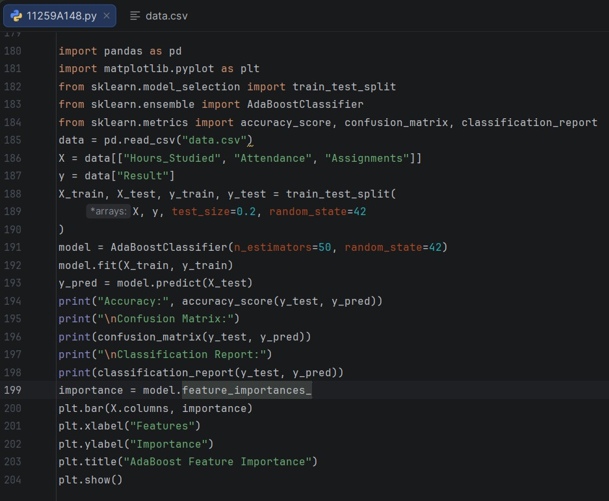
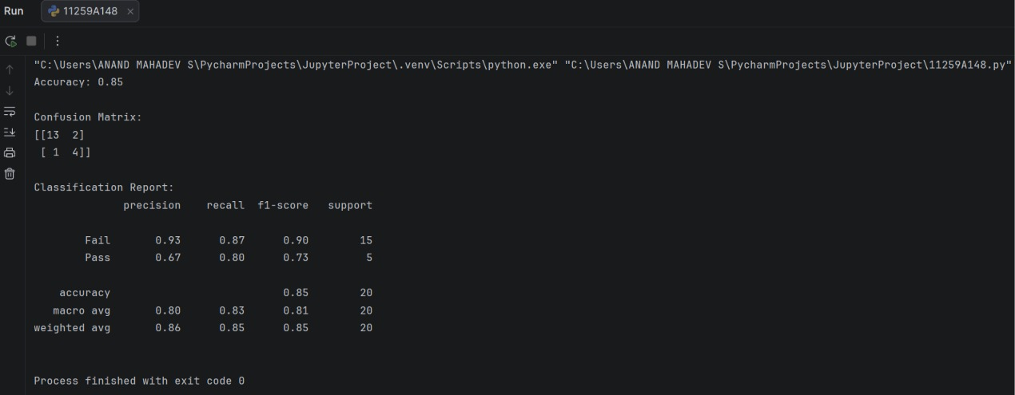

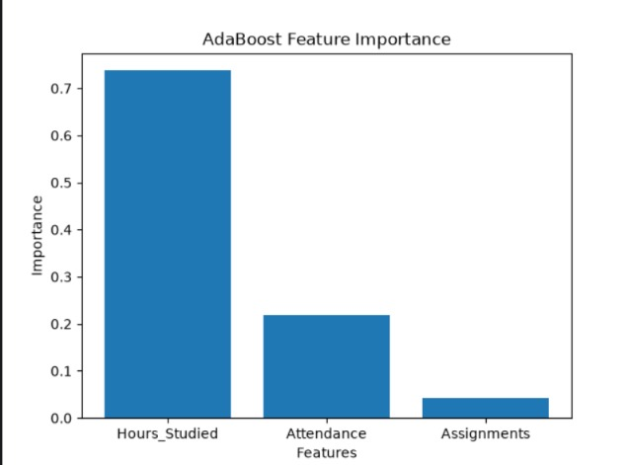
Result
The AdaBoost classifier was trained to predict student results. Its evaluation metrics and a feature importance graph were displayed.

