Experiment 9: Q-Learning and Neural Network Classification
Aim
To implement a Q-Learning model that learns actions for reaching a goal state and a neural network that predicts student results based on study hours, attendance, and assignments.
Algorithm
- Import the required libraries.
- Create the reward matrix and initialize the Q-table with zeros.
- Set the discount factor and number of training episodes.
- For each episode, select a random starting state.
- Choose valid actions, update the Q-table, and continue until the goal state is reached.
- Display the trained Q-table.
- Load the student dataset from data.csv.
- Select Hours_Studied, Attendance, and Assignments as input features and Result as the target.
- Convert the Fail and Pass labels to numeric values.
- Split the data into training and testing sets, then standardize the input features.
- Build and compile a neural network with two hidden layers and a sigmoid output layer.
- Train the network for 50 epochs.
- Predict the test results, convert probabilities to class labels, and display the accuracy.
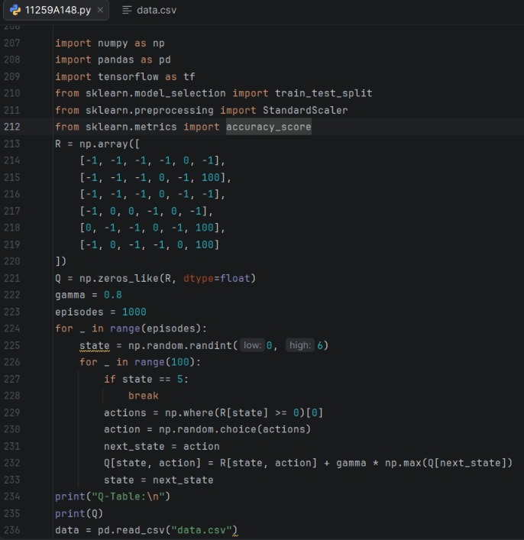
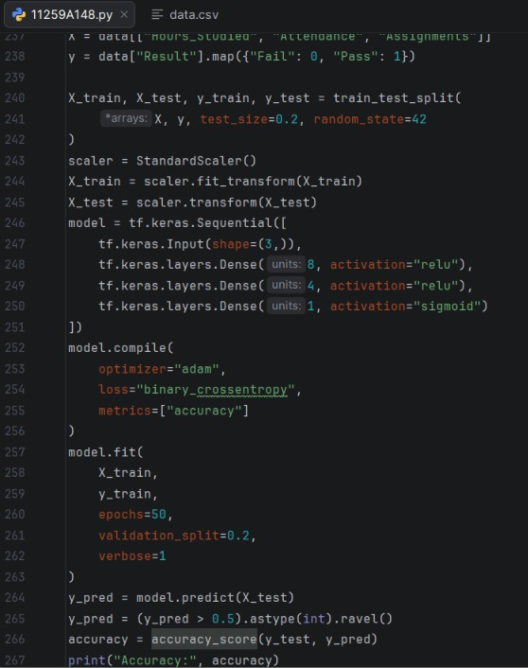

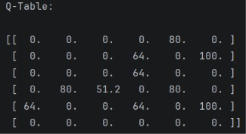
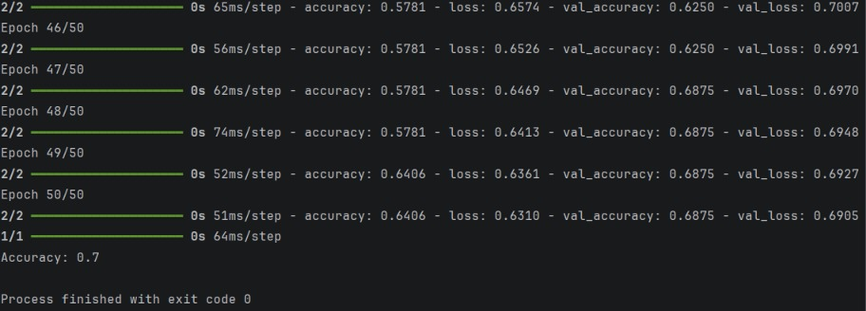
Result
The program trained the Q-Learning model and displayed its Q-table. It also trained the neural network to classify student results and displayed its accuracy.

