

Safety Plan Lane Assistance

**Document Version: 1.0, Released 2018-07-01**

**Template Version 1.0, Released on 2017-06-21**



# Document history

|  |  |  |  |
| --- | --- | --- | --- |
| Date | Version | Editor | Description |
| 06/30/18 | 1.0 | Anand Mandapati | Initial Version |
|  |  |  |  |
|  |  |  |  |
|  |  |  |  |
|  |  |  |  |

# Table of Contents

Document history

Table of Contents

Introduction

Purpose of the Safety Plan

Scope of the Project

Deliverables of the Project

Item Definition

Goals and Measures

Goals

Measures

Safety Culture

Safety Lifecycle Tailoring

Roles

Development Interface Agreement

Confirmation Measures

# Introduction

## Purpose of the Safety Plan

This Safety Plan provides a framework for the assurance of Functional Safety throughout the Lane Assistance System project through concept, development, production, and operation, according to ISO 26262 principles.

## Scope of the Project

For the lane assistance project, the following safety lifecycle phases are in scope:

Concept phase

Product Development at the System Level

Product Development at the Software Level

The following phases are out of scope:

Product Development at the Hardware Level

Production and Operation

## Deliverables of the Project

The deliverables of the project are:

Safety Plan

Hazard Analysis and Risk Assessment

Functional Safety Concept

Technical Safety Concept

Software Safety Requirements and Architecture

# Item Definition

The item defined here is a simplified version of a Lane Assistance System, which is a type of Advanced Driver Assistance System (ADAS). The Lane Assistance System helps the vehicle’s driver keep the vehicle centered in the ego lane by both warning about lane departures and augmenting driver control to remain within the lane. It consists of two main functions - Lane Departure Warning (LDW) and Lane Keeping Assistance (LKA).

The System consists of four Sub-Systems - the Camera Sensor, the Car Display, the Electronic Power Steering, and the Electronic Power Steering ECU. The architecture is described in the figure and text below.

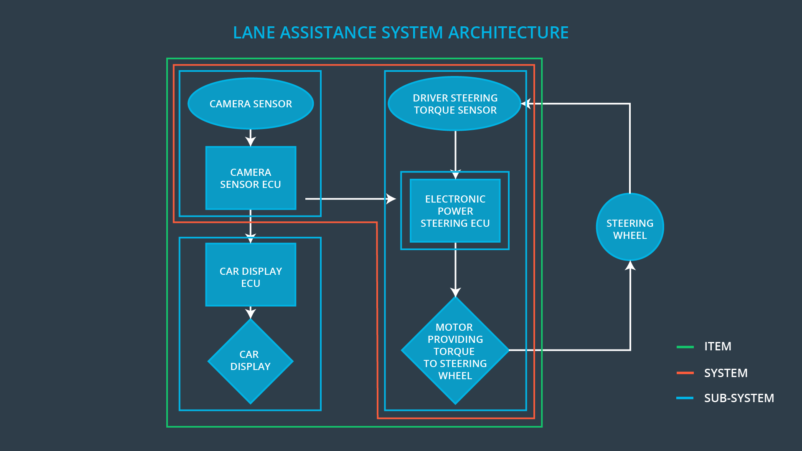

* **Lane Departure Warning (LDW):** This function of the System detects lane lines using the Camera Sub-System, applies an oscillating torque to the steering wheel for haptic feedback when the vehicle departs the ego lane using the Electronic Power Steering Sub-System, and presents a warning light on the Car Display Sub-System.
* **Lane Keeping Assistance (LKA):** If the driver doesn’t respond to the LDW, this function of the System adds steering torque to move the vehicle back to the center of the ego lane using the Electronic Power Steering Sub-System, and additionally provides a warning light on the Car Display Sub-System that it is doing this.

# Goals and Measures

## Goals

The goal of this Safety Plan is to analyze the functional safety case for the Lane Assistance System using the ISO 26262 principles. We identify scenarios of risk within or caused by the electrical and electronic components of the System, quantify the risk of those scenarios, and attempt to eliminate or reduce those risks to an acceptable level.

## Measures

|  |  |  |
| --- | --- | --- |
| Measures and Activities | Responsibility | Timeline |
| Follow safety processes | All Team Members | Constantly |
| Create and sustain a safety culture | All Team Members | Constantly |
| Coordinate and document the planned safety activities | Safety Manager | Constantly |
| Allocate resources with adequate functional safety competency | Project Manager | Within 2 weeks of start of project |
| Tailor the safety lifecycle | Safety Manager | Within 4 weeks of start of project |
| Plan the safety activities of the safety lifecycle | Safety Manager | Within 4 weeks of start of project |
| Perform regular functional safety audits | Safety Auditor | Once every 2 months |
| Perform functional safety pre-assessment prior to audit by external functional safety assessor | Safety Manager | 3 months prior to main assessment |
| Perform functional safety assessment | Safety Assessor | Conclusion of functional safety activities |

# Safety Culture

Our organization has the following characteristics of a good safety culture:

* **High priority**: safety has the highest priority among competing constraints like cost and productivity
* **Accountability**: processes ensure accountability such that design decisions are traceable back to the people and teams who made the decisions
* **Rewards**: the organization motivates and supports the achievement of functional safety
* **Penalties**: the organization penalizes shortcuts that jeopardize safety or quality
* **Independence**: teams who design and develop a product should be independent from the teams who audit the work
* **Well defined processes**: company design and management processes should be clearly defined
* **Resources:** projects have necessary resources including people with appropriate skills
* **Diversity:** intellectual diversity is sought after, valued and integrated into processes
* **Communication**: communication channels encourage disclosure of problems

# Safety Lifecycle Tailoring

For the Lane Assistance System project, the following safety lifecycle phases are in scope:

* 1. Concept phase
  2. Product Development at the System Level
  3. Product Development at the Software Level

The following phases are out of scope:

* + Product Development at the Hardware Level
  + Production and Operation

# Roles

|  |  |
| --- | --- |
| Role | Org |
| Functional Safety Manager- Item Level | OEM |
| Functional Safety Engineer- Item Level | OEM |
| Project Manager - Item Level | OEM |
| Functional Safety Manager- Component Level | Tier-1 |
| Functional Safety Engineer- Component Level | Tier-1 |
| Functional Safety Auditor | OEM or external |
| Functional Safety Assessor | OEM or external |

# Development Interface Agreement

The Development Interface Agreement (DIA) defines the roles and responsibilities between companies involved in developing a product. The DIA also specifies what evidence and work products each party will provide to prove that work was done according to the agreement. The ultimate goal is to ensure that all parties are developing safe vehicles in compliance with ISO 26262. All involved parties need to agree on the contents of the DIA before the project begins.

Here are the responsibilities of each party to the DIA.

|  |  |
| --- | --- |
| Organization | Responsibilities |
| OEM | * Manage the overall functional safety project * Plan, coordinate, develop the Lane Assistance System on item level * Provide information support to Tier 1 organization * Audit the functional safety of the System * Assess the functional safety of the System |
| Tier-1 | * Plan, coordinate, and document the development phase of the safety lifecycle * Maintain the Safety Plan * Monitor progress against the safety plan * Perform pre-audits before the safety auditor * Develop, integrate, and test the required hardware and software changes to the System |

# Confirmation Measures

Confirmation measures serve two purposes:

* that a functional safety project conforms to ISO 26262
* that the project really does make the vehicle safer

The people who carry out confirmation measures need to be independent from the people who actually developed the project.

**Confirmation Review**

Ensures that the project complies with ISO 26262. As the product is designed and developed, an independent person would review the work to make sure ISO 26262 is being followed.

**Functional safety audit**

Checking to make sure that the actual implementation of the project conforms to the safety plan is called a functional safety audit.

**Functional safety assessment**

Confirming that plans, designs and developed products actually achieve functional safety is called a functional safety assessment.