

Technical Safety Concept Lane Assistance

**Document Version: 1.0, Released on 2018-07-01**

**Template Version 1.0, Released on 2017-06-21**



# Document history

|  |  |  |  |
| --- | --- | --- | --- |
| Date | Version | Editor | Description |
| 07/01/2018 | 1.0 | Anand Mandapati | Initial Version |
|  |  |  |  |
|  |  |  |  |
|  |  |  |  |
|  |  |  |  |

# 

# Table of Contents

Document history

Table of Contents

Purpose of the Technical Safety Concept

Inputs to the Technical Safety Concept

Functional Safety Requirements

Refined System Architecture from Functional Safety Concept

Functional overview of architecture elements

Technical Safety Concept

Technical Safety Requirements

Refinement of the System Architecture

Allocation of Technical Safety Requirements to Architecture Elements

Warning and Degradation Concept

# Purpose of the Technical Safety Concept

The purpose of the Technical Safety Concept portion of the Safety Plan is to derive more detailed technical hardware and software requirements from the functional safety requirements to mitigate the identified risks in the electrical and electronic components that constitute the Lane Assistance System. The requirements are then allocated to the appropriate location in the system architecture.

# Inputs to the Technical Safety Concept

## Functional Safety Requirements

|  |  |  |  |  |
| --- | --- | --- | --- | --- |
| **ID** | **Functional Safety Requirement** | **ASIL** | **Fault Tolerant Time Interval** | **Safe State** |
| Functional  Safety  Requirement  01-01 | The Electronic Power Steering ECU shall ensure that the lane departure oscillation torque amplitude is below Max_Torque_Amplitude. | C | 50 ms | Reduce steering torque to zero |
| Functional  Safety  Requirement  01-02 | The Electronic Power Steering ECU shall ensure that the lane departure oscillation torque frequency is below Max_Torque_Frequency. | C | 50 ms | Reduce steering torque to zero |
| Functional  Safety  Requirement  02-01 | The Electronic Power Steering ECU shall ensure that the lane keeping assistance torque is applied for only Max_Duration. | B | 500 ms | Reduce steering torque to zero |

## Refined System Architecture from Functional Safety Concept

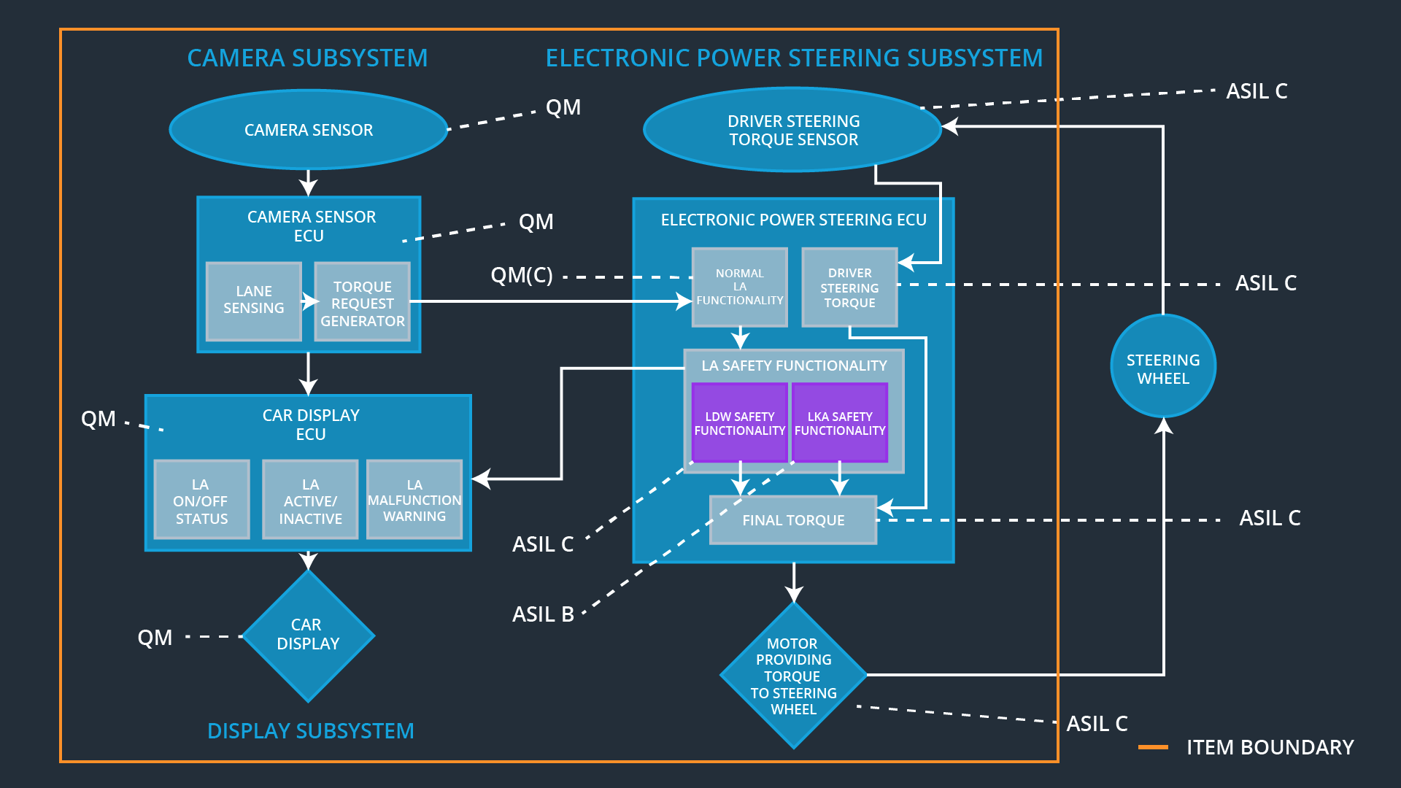

### Functional overview of architecture elements

|  |  |
| --- | --- |
| **Element** | **Description** |
| Camera Sensor | Provides the Camera Display ECU with images of the roadway in front of the vehicle. |
| Camera Sensor ECU - Lane Sensing | Detects lane lines, the vehicle position with respect to the lanes, and whether the vehicle is outside the ego lane. |
| Camera Sensor ECU - Torque request generator | Provides a correction torque if the vehicle is departing the ego lane. |
| Car Display | Displays various information to the driver. |
| Car Display ECU - Lane Assistance On/Off Status | Provides the Car Display with information of the On/Off state of the Lane Assistance System. |
| Car Display ECU - Lane Assistant Active/Inactive | Provides the Car Display with information of the Active/Inactive state of the Lane Assistance system. |
| Car Display ECU - Lane Assistance malfunction warning | Provides the Car Display with information of a possible malfunction of the Lane Assistance system. |
| Driver Steering Torque Sensor | Senses the steering torque provided by the driver. |
| Electronic Power Steering (EPS) ECU - Driver Steering Torque | Measure the steering torque sensed by the Driver Steering Torque Sensor. |
| EPS ECU - Normal Lane Assistance Functionality | Implements both Lane Assistance functions. Receives torque requests from Camera Sensor ECU and generates any augmented steering torque. |
| EPS ECU - Lane Departure Warning Safety Functionality | Ensures that torque amplitude and frequency are below Max_Torque_Amplitude and Max_Torque_Frequency. |
| EPS ECU - Lane Keeping Assistant Safety Functionality | Ensures that the LKA function is not activated for longer than Max_Duration time. |
| EPS ECU - Final Torque | Combines torque requests from LKA and LDW functions with the Driver Steering Torque to generate the final torque to be sent to the motor. |
| Motor | Applies the final torque to the steering wheel of the vehicle. |

# Technical Safety Concept

## Technical Safety Requirements

**Lane Departure Warning (LDW) Requirements:**

Functional Safety Requirement 01-01 with its associated system elements

(derived in the functional safety concept)

|  |  |  |  |  |
| --- | --- | --- | --- | --- |
| **ID** | **Functional Safety Requirement** | **Electronic Power Steering ECU** | **Camera ECU** | **Car Display ECU** |
| Functional  Safety  Requirement  01-01 | The lane keeping item shall ensure that the lane departure oscillating torque amplitude is below Max_Torque_Amplitude | X |  |  |

Technical Safety Requirements related to Functional Safety Requirement 01-01 are:

|  |  |  |  |  |  |
| --- | --- | --- | --- | --- | --- |
| **ID** | **Technical Safety Requirement** | **ASIL** | **Fault Tolerant Time Interval** | **Architecture Allocation** | **Safe State** |
| Technical  Safety  Requirement  01 | The LDW safety component shall ensure that the amplitude of the ‘LDW_Torque_Request’ sent to the ‘Final electronic power steering Torque’ component is below ‘Max_Torque_Amplitude’ | C | 50ms | EPS ECU -LDW Safety  Component | LDW torque output is set to zero. |
| Technical  Safety  Requirement  02 | As soon as the LDW function deactivates the LDW feature, the ‘LDW Safety’ software block shall send a signal to the car display ECU to turn on a warning light. | C | 50ms | EPS ECU -LDW Safety  Component | LDW torque output is set to zero. |
| Technical  Safety  Requirement  03 | As soon as a failure is detected by the LDW function, it shall deactivate the LDW feature and the ‘LDW_Torque_Request’ shall be set to zero. | C | 50ms | EPS ECU -LDW Safety  Component | LDW torque output is set to zero. |
| Technical  Safety  Requirement  04 | The validity and integrity of the data transmission for ‘LDW_Torque_Request’ signal shall be ensured. | C | 50ms | EPS ECU – Data Transmission Integrity Check | LDW torque output is set to zero. |
| Technical  Safety  Requirement  05 | Memory test shall be conducted at startup of the EPS ECU to check for any faults in memory. | A | Ignition cycle | EPS ECU –  Safety Startup Memory Test | LDW torque output is set to zero. |

Functional Safety Requirement 01-2 with its associated system elements

(derived in the functional safety concept)

|  |  |  |  |  |
| --- | --- | --- | --- | --- |
| **ID** | **Functional Safety Requirement** | **Electronic Power Steering ECU** | **Camera ECU** | **Car Display ECU** |
| Functional  Safety  Requirement  01-02 | The lane keeping item shall ensure that the lane departure oscillating torque frequency is below Max_Torque_Frequency | X |  |  |

Technical Safety Requirements related to Functional Safety Requirement 01-02 are:

|  |  |  |  |  |  |
| --- | --- | --- | --- | --- | --- |
| **ID** | **Technical Safety Requirement** | **ASIL** | **Fault Tolerant Time Interval** | **Architecture Allocation** | **Safe State** |
| Technical  Safety  Requirement  01 | The LDW safety component shall ensure that the amplitude of the 'LDW_Torque_Request' sent to the 'Final electronic power steering Torque' component is below 'Max_Torque_Frequency. | C | 50 ms | EPS ECU -LDW Safety  Component | Torque Freq. set to zero |
| Technical  Safety  Requirement  02 | As soon as the LDW function deactivates the LDW feature, the 'LDW Safety' software block shall send a signal to the car display ECU to turn on a warning light. | C | 50 ms | EPS ECU -LDW Safety  Component | N/A |
| Technical  Safety  Requirement  03 | As soon as a failure is detected by the LDW function, it shall deactivate the LDW feature and the 'LDW_Torque_Request' shall be set to zero. | C | 50 ms | EPS LDW Safety Software Component | Torque set to zero. |
| Technical  Safety  Requirement  04 | The validity and integrity of the data transmission for 'LDW_Torque_Request' signal shall be ensured. | C | 50 ms | EPS ECU -Data Transmission Integrity Check | N/A |
| Technical  Safety  Requirement  05 | Memory test shall be conducted at start up of the EPS ECU to check for any faults in memory. | A | Ignition Cycle | Safety Startup | N/A |

**Lane Keeping Assistance (LKA) Requirements:**

Functional Safety Requirement 02-1 with its associated system elements

(derived in the functional safety concept)

|  |  |  |  |  |
| --- | --- | --- | --- | --- |
| **ID** | **Functional Safety Requirement** | **Electronic Power Steering ECU** | **Camera ECU** | **Car Display ECU** |
| Functional  Safety  Requirement  02-01 | The lane keeping item shall ensure that the lane keeping assistance torque is applied for only Max_Duration | X |  |  |

Technical Safety Requirements related to Functional Safety Requirement 02-01 are:

|  |  |  |  |  |  |
| --- | --- | --- | --- | --- | --- |
| **ID** | **Technical Safety Requirement** | **ASIL** | **Fault Tolerant Time Interval** | **Allocation to Architecture** | **Safe State** |
| Technical  Safety  Requirement  01 | The LKA safety component shall ensure that the duration of the lane keeping assistance torque applied is less than Max_Duration. | B | 500ms | EPS ECU - LKA Safety  Component | Torque set to zero. |
| Technical  Safety  Requirement  02 | As soon as the LKA function deactivates the LKA feature, the ‘LKA Safety’ software block shall send a signal to the car display ECU to turn on a warning light. | B | 500ms | EPS ECU - LKA Safety  Component | N/A |
| Technical  Safety  Requirement  03 | As soon as a failure is detected by the LKA function, it shall deactivate the LKA feature and the ‘LKA_Torque_Request’ shall be set to zero. | B | 500ms | EPS ECU - LKA Safety  Component | Torque set to zero. |
| Technical  Safety  Requirement  04 | The validity and integrity of the data transmission for ‘LKA_Torque_Request’ signal shall be ensured. | B | 500ms | EPS ECU – Data Transmission Integrity Check | N/A |
| Technical  Safety  Requirement  05 | Memory test shall be conducted at startup of the EPS ECU to check for any faults in memory. | A | Ignition cycle | EPS ECU –  Safety Startup | N/A |

## Refinement of the System Architecture

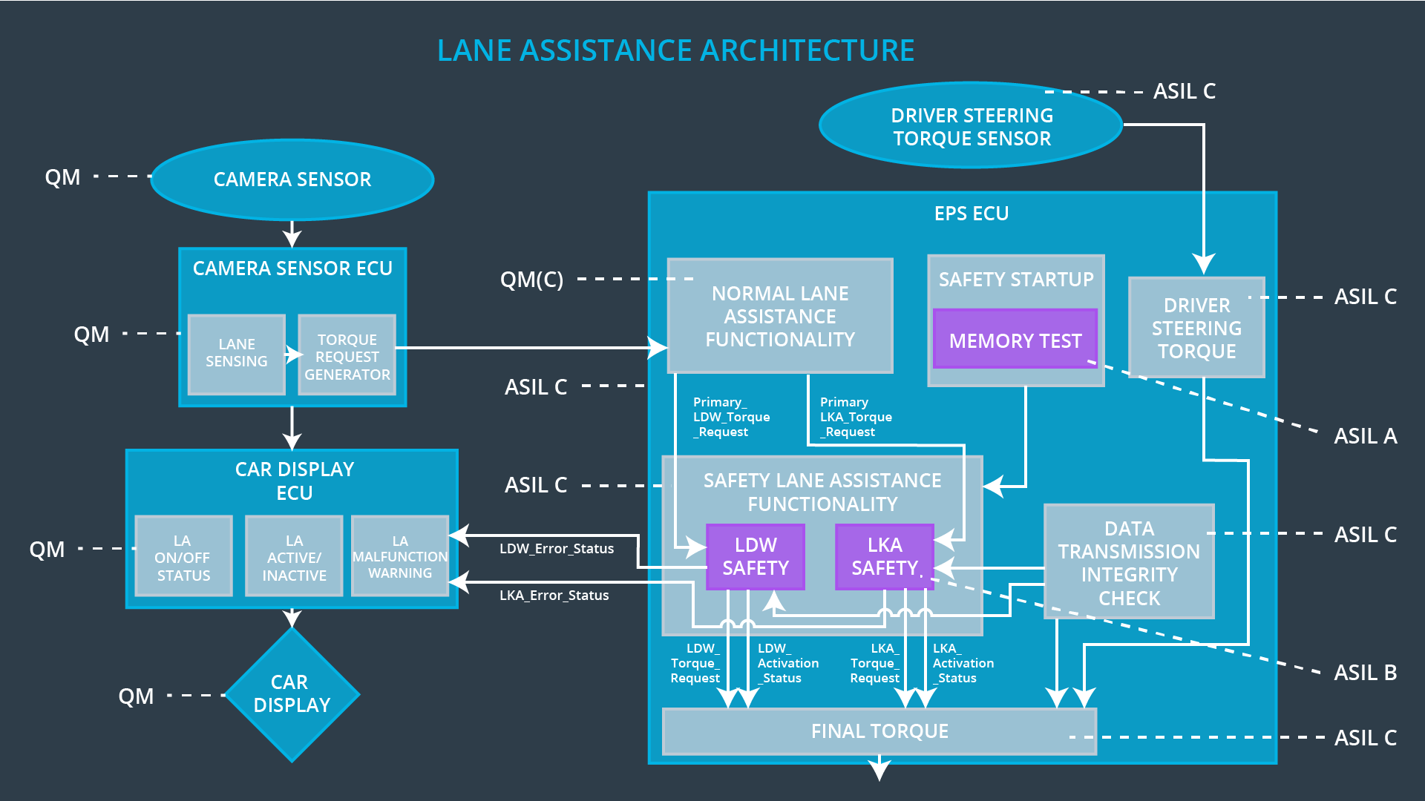

## Allocation of Technical Safety Requirements to Architecture Elements

All Technical Safety Requirements are allocated to the Electronic Power Steering ECU.

## Warning and Degradation Concept

|  |  |  |  |  |
| --- | --- | --- | --- | --- |
| **ID** | **Degradation Mode** | **Trigger for Degradation Mode** | **Safe State invoked?** | **Driver Warning** |
| WDC-01 | Turn off LDW functionality | Vibration amplitude too high or frequency too high. | Yes, LDW oscillating torque shall be set to zero | Lane assistance functionality set inactive and malfunction warning to the driver via car display. |
| WDC-02 | Turn off LKA functionality | Lane keeping assistance duration exceeds Max_Duration | Yes, LKA added extra torque shall be set to zero | Lane assistance functionality set inactive and malfunction warning to the driver via car display. |