***Lab Task 2***

***ANAND M K***

***242CS008***

* 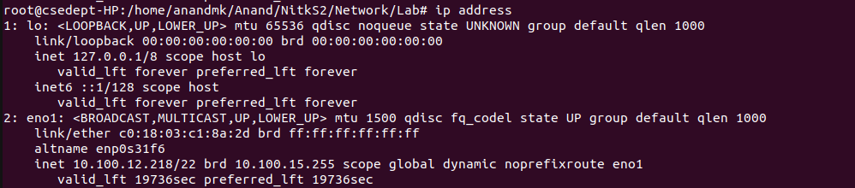ip a / ip address

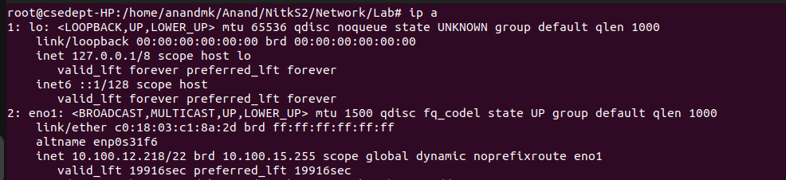

* 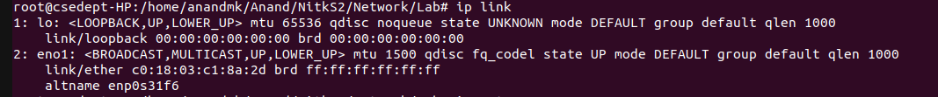Ip link
* 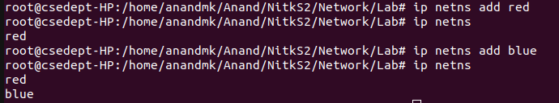Create network namespace
* 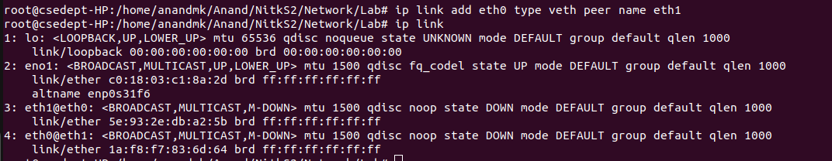Add Link (Add eth0 and eth1)
* 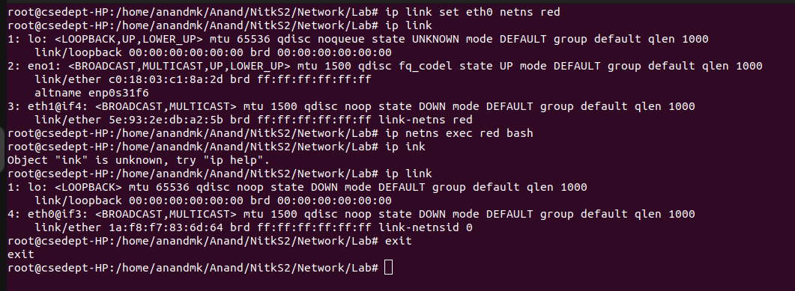Shift ethernet interface to namespace

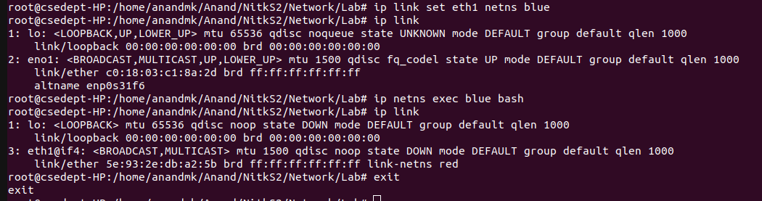

* 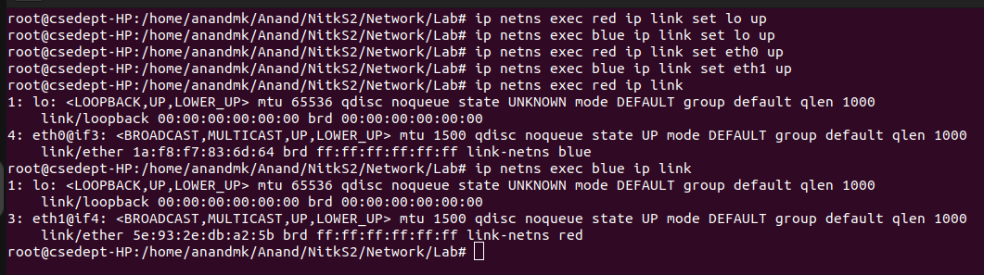Turn on all interface
* Assign ip
* 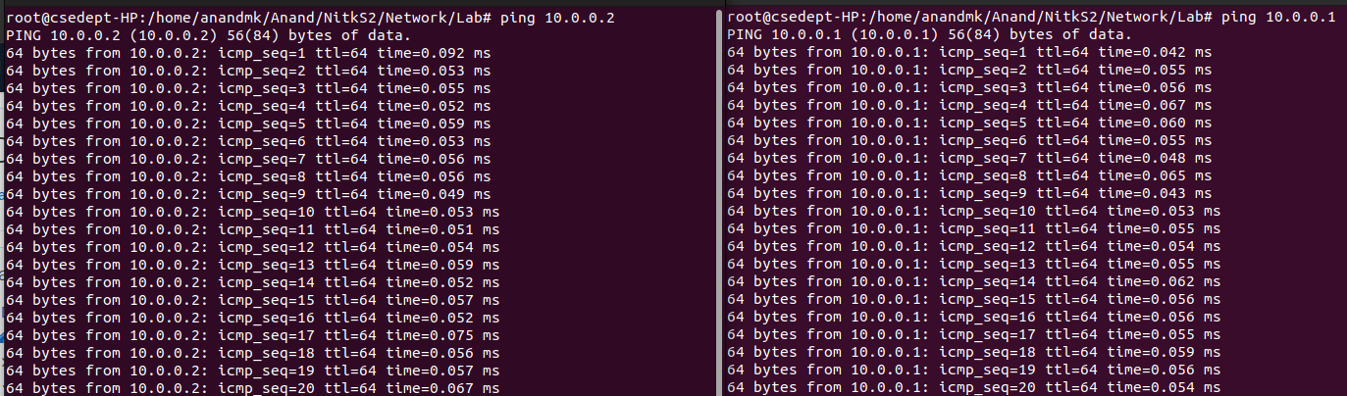Ping
* Evaluate Network Performance

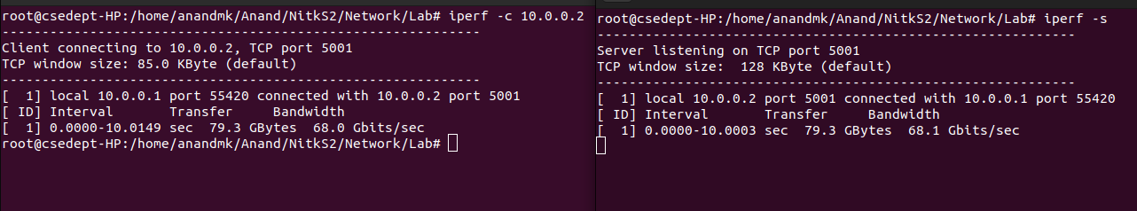

* 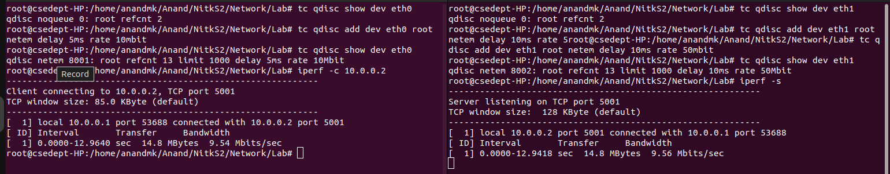Traffic Control subsystem