**CS751: Network Engineering**

**Lab task 4: Using Linux Bridge in netns**

**Subtask 1: Namespace talking to the outside world using the Linux bridge.**

* 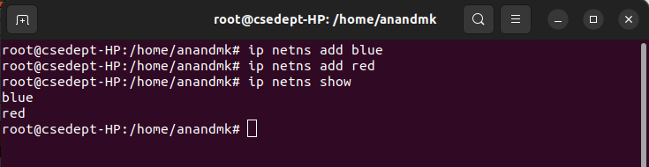Create two network namespaces
* Create a bridge interface named v-net-0

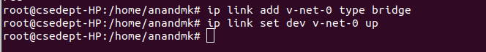

* Create two pairs of virtual Ethernet interfaces (veth pairs)
* Move one end of each veth pair to its respective namespace
* Attach the veth-blue-br to the bridge v-net-0. Attach the veth-red-br to the bridge v-net-0



* Assign IP addresses to the interfaces in their respective namespaces.
* Bring up the interfaces in their respective namespaces.
* Bring up the bridge
* Ping the other Google DNS (8.8.8.8) at this stage from the blue namespace.
* 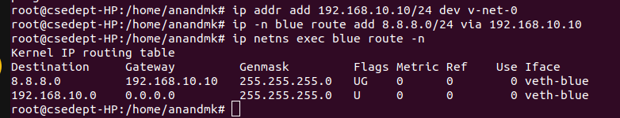Set the gateway on the Linux bridge:
* Ping 8.8.8.8 from blue namespace

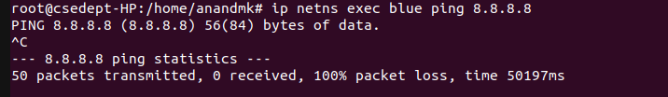

* Set up the NAT rule in the NAT table
* 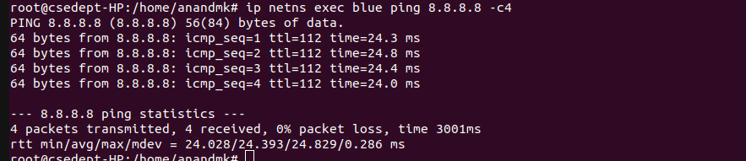ping the google dns server

**Subtask 2: Setting Up FTP Server in Network Namespace.**

* 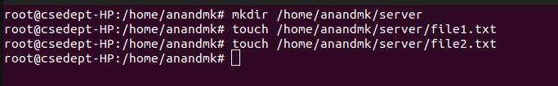Setup Directories
* 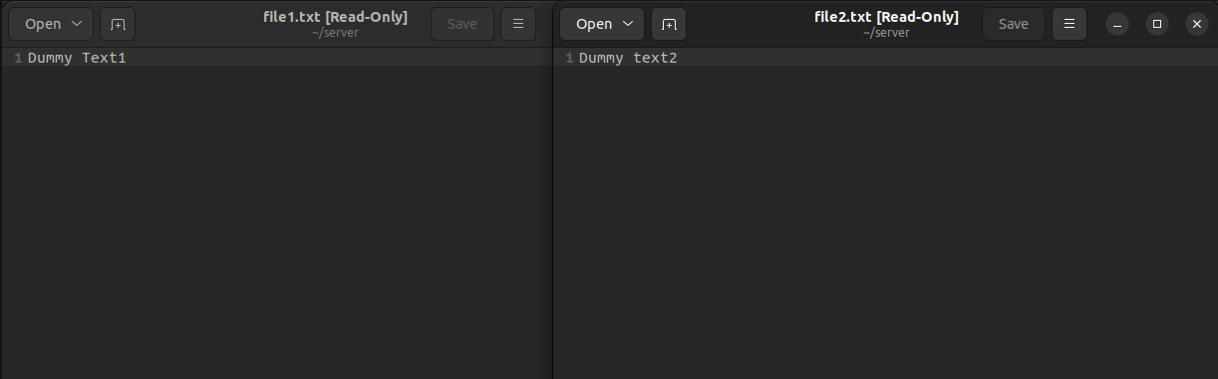Add Dummy Text to Files
* 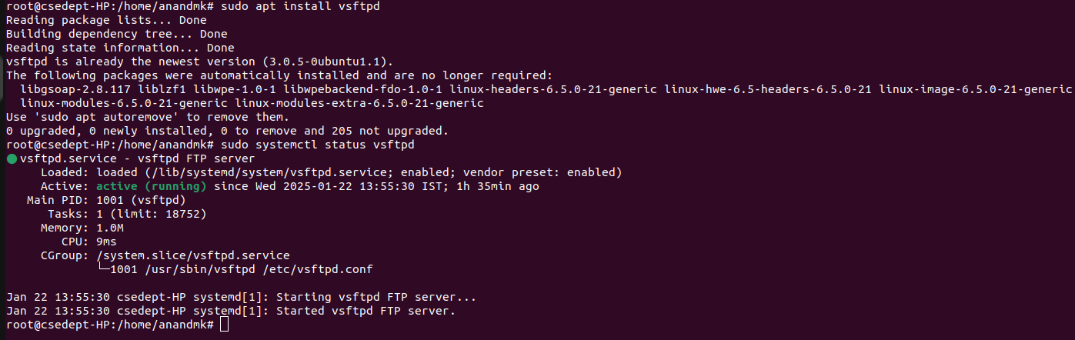Install FTP Server
* Take Backup of vsftpd.service config file
* Add Network Namespace Path to Service File

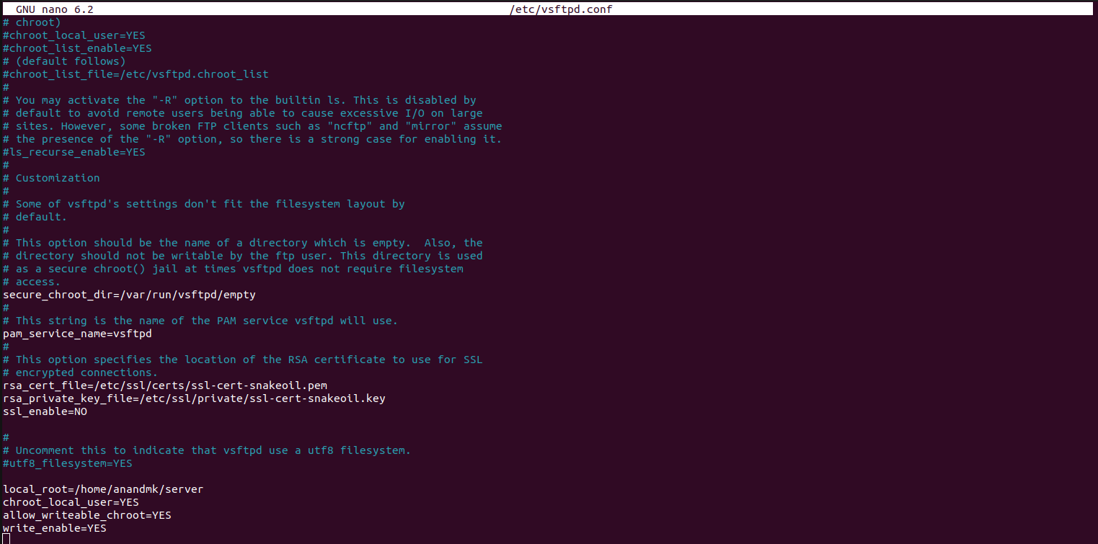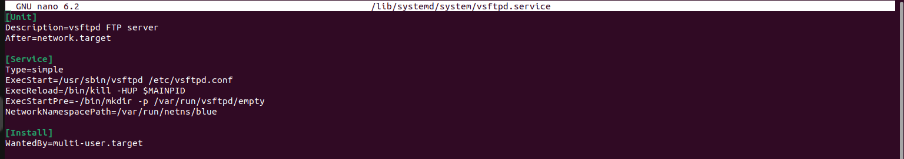

* 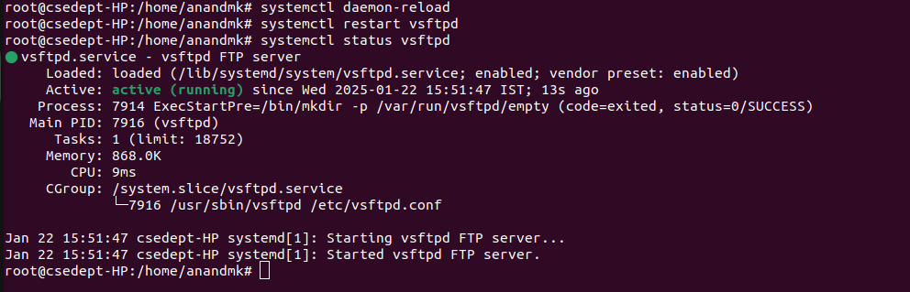Restart the Service
* Log in to the Server from the Red Namespace

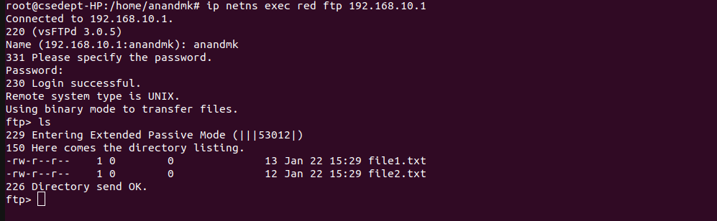

* 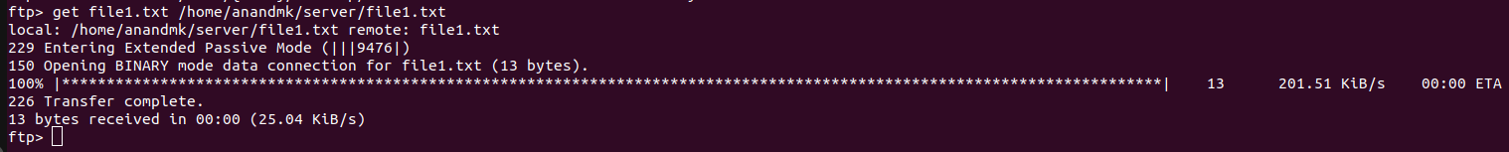Perform various FTP commands within the FTP session

