Lab task 3
ANAND M K
242CS008

- Creating namespace

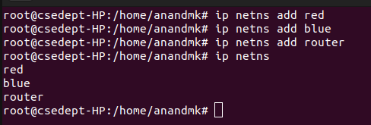

- Add two links
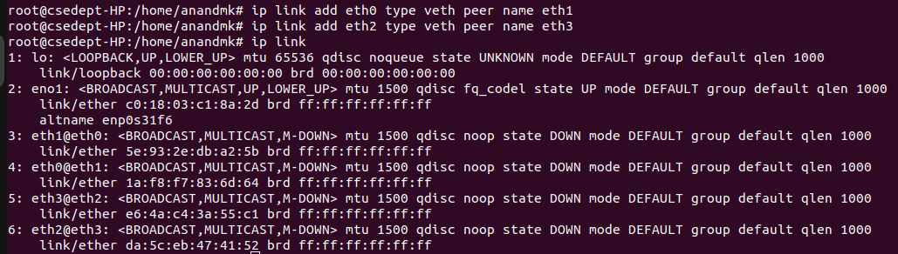
- Shift ethernet interface to namespace
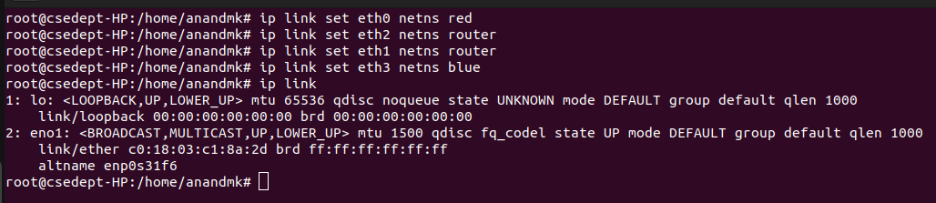

- Turn on all interface
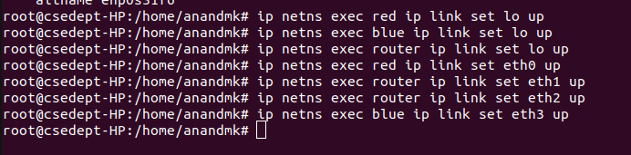
- Assigning ip Address
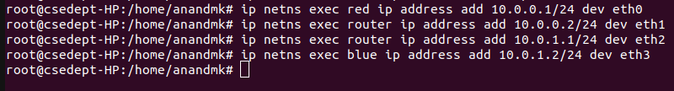
- Setting default route
- Setting ip forwarding
- Ping

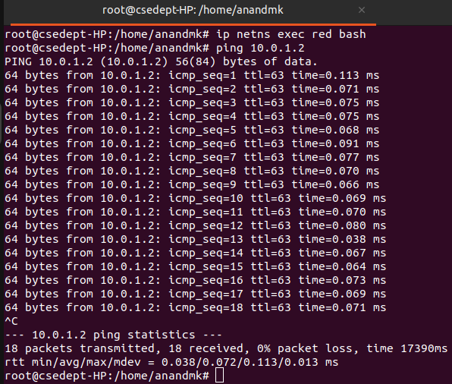

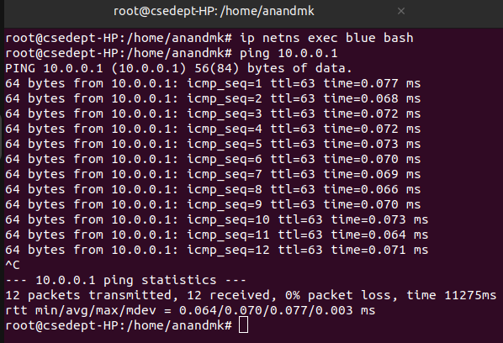

- Iperf
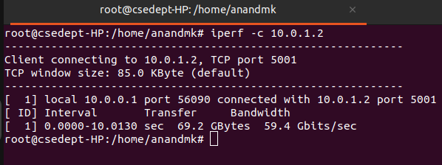

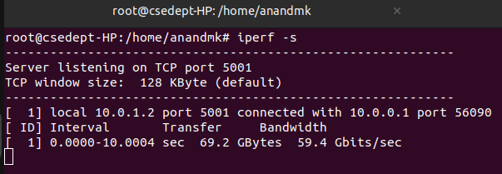

- Tcpdump -i eth1
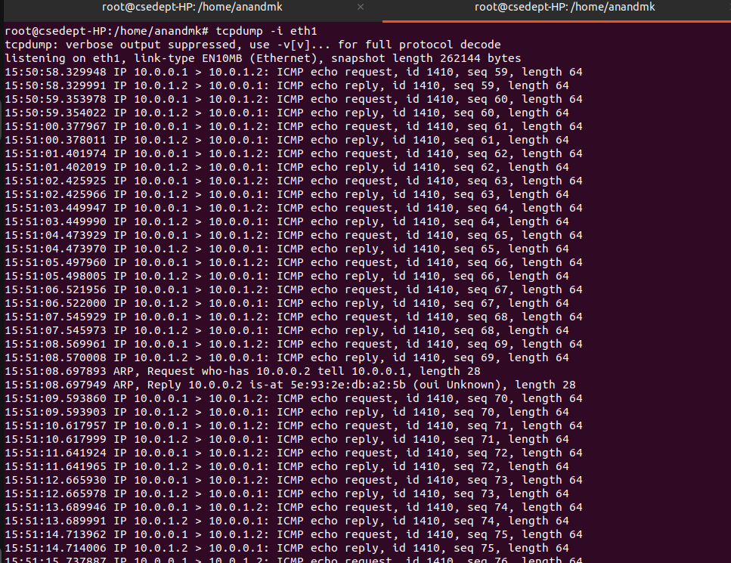
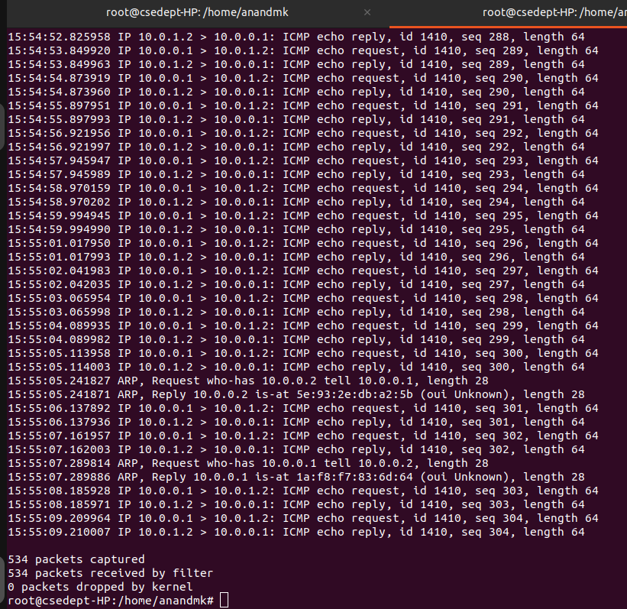

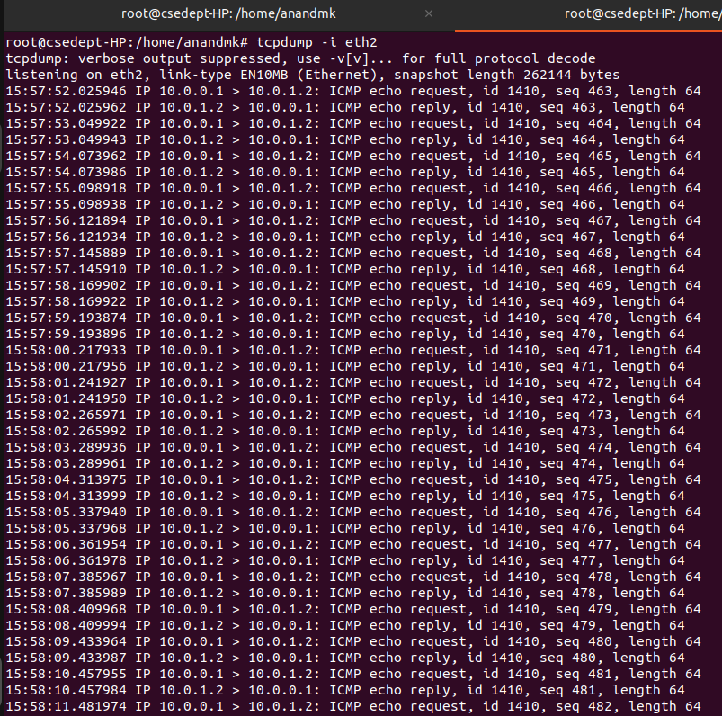
- Tcpdump -i eth2

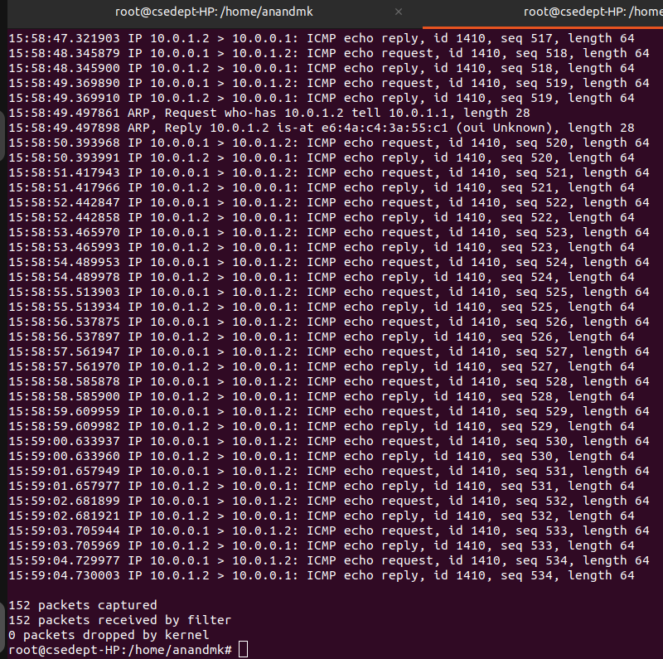

- NETPERF
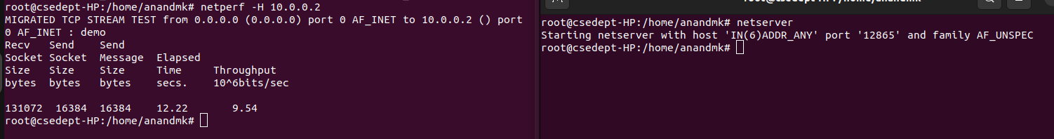
- Stream
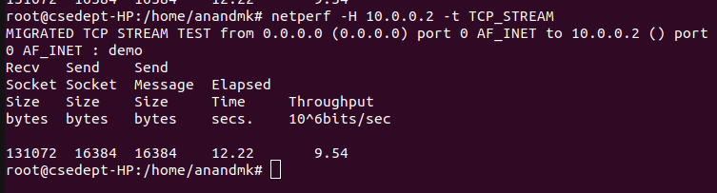
- Reverse stream
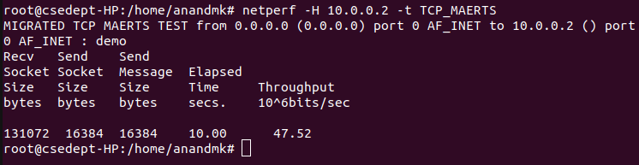
- TCP_RR
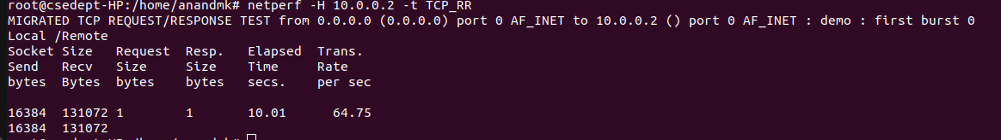
- TCP_CRR

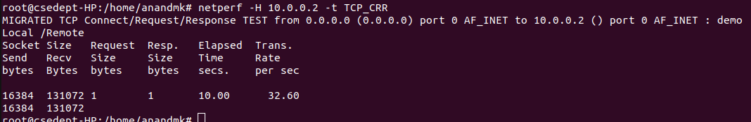

- Stop netserver process
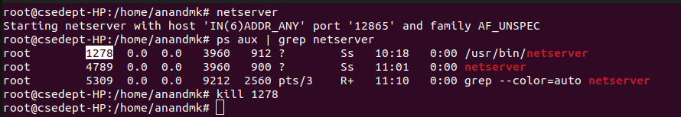

- Iperf3
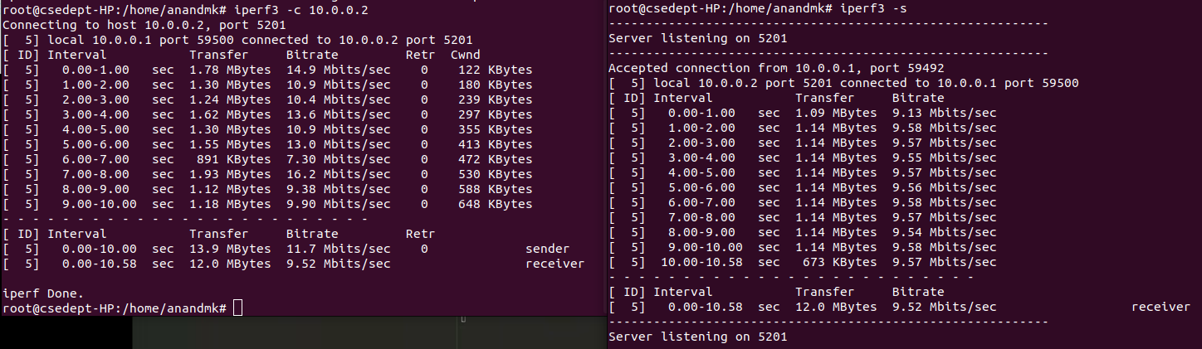
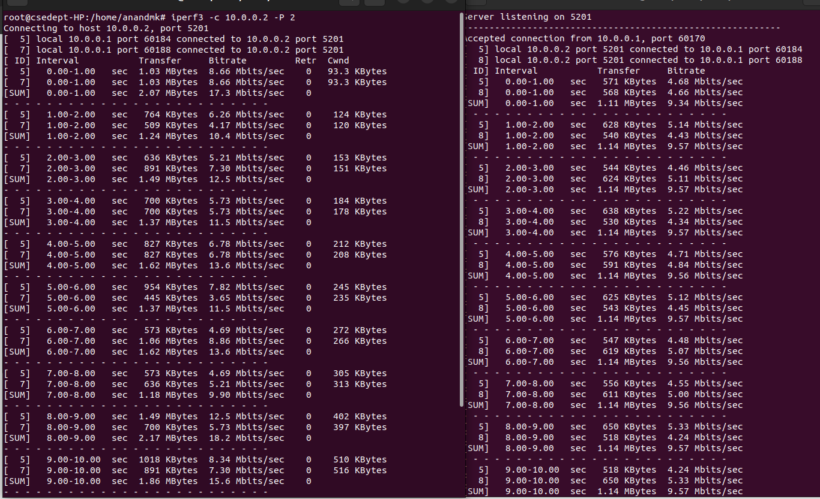

- Generating entries with Bitrate 1Mb/s(default)
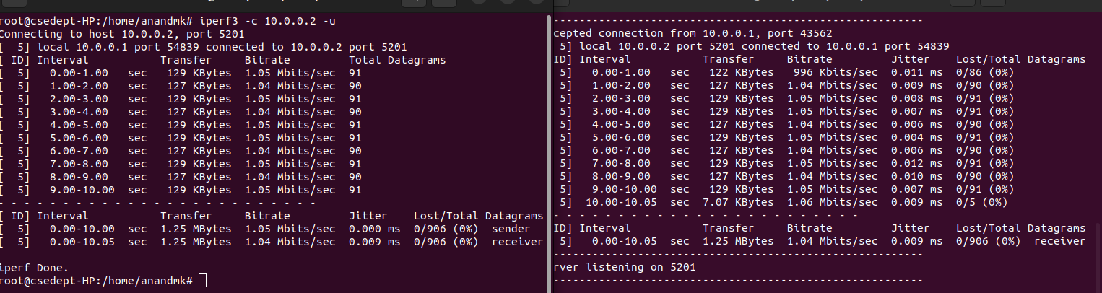
- Generating entries with Bitrate 5Mb/s

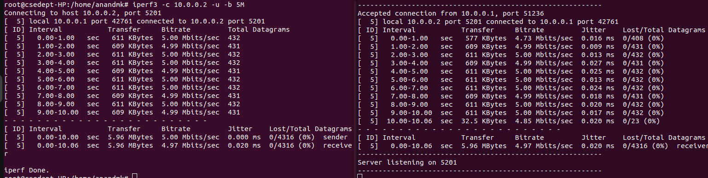

- Generating entries with Bitrate 20Mb/s)
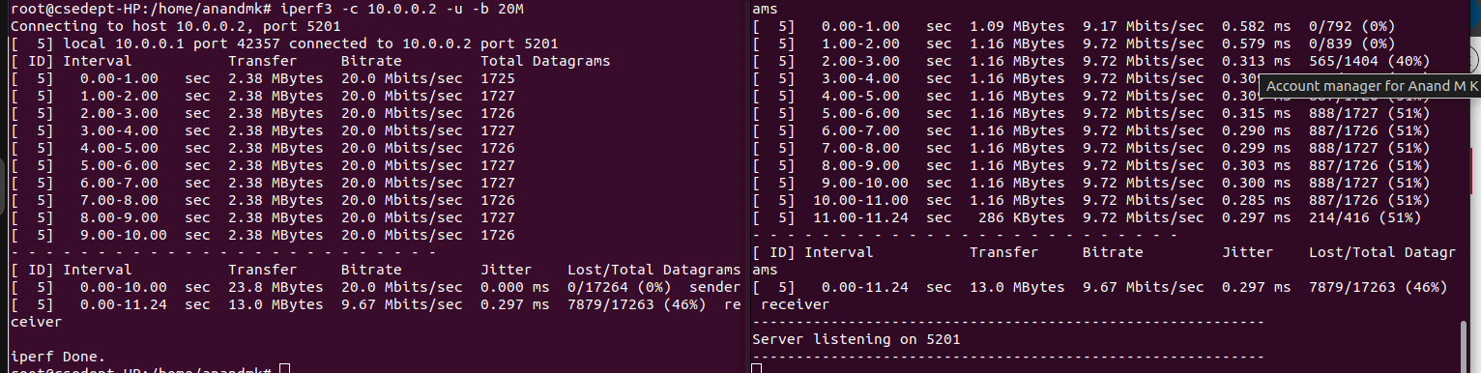
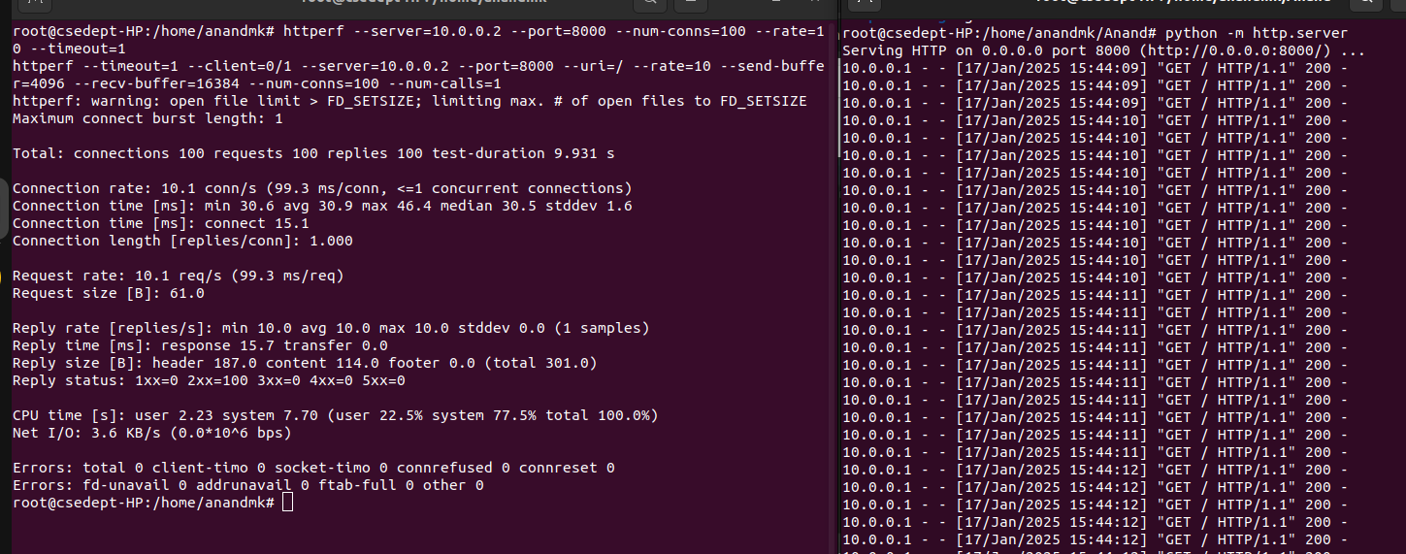

- Httperf

