BookMyMovie High Level Design (HLD)
Project Description
BookMyMovie is a Spring Boot backend platform for movie ticket discovery and booking. The current implementation keeps two primary business scenarios active: a read scenario for browsing theatres and show timings by selected city, movie, and date, and a write scenario for booking movie tickets by selecting a show and preferred seats.
The system is implemented using Java 17, Spring Boot, Spring Data JPA, and a relational database. It also keeps modern integration capabilities such as Redis for temporary seat lock caching, Kafka for booking-created events, Prometheus metrics, Micrometer tracing with Zipkin export, and structured application logging with correlation IDs.
The design focuses on a layered architecture, clear API contracts, strong validation, centralized exception handling, and concurrency-safe seat allocation to prevent double booking during high-contention seat selection.
Key Functional Capabilities
- Master Data and Scheduling Capabilities
- Create and list cities
- Create and list theatres with screens and seats
- Create and list movies
- Create shows for active movies
- Generate show-level seat inventory automatically when a show is created
- Customer Read Capabilities
- Browse theatres currently running a selected movie in a selected city on a chosen date
- View show details by show id
- View all shows by movie, city, and date
- View seat layout and seat availability for a selected show
- Customer Write Capabilities
- Lock preferred seats for a selected show
- Create booking from a valid lock reference
- Fetch booking details after successful booking
- Automatically release expired seat locks
Database Relationship Summary
- One City has many Theatres.
- One Theatre has many Screens.
- One Screen has many Seats.
- One Movie can have many Shows.
- One Show belongs to one Screen and one Movie.
- One Show has many ShowSeatInventory rows, one per seat for that show.
- One Booking belongs to one Customer and one Show.
- One Booking has many BookingSeat rows.

Browse Theatres And Show Timings

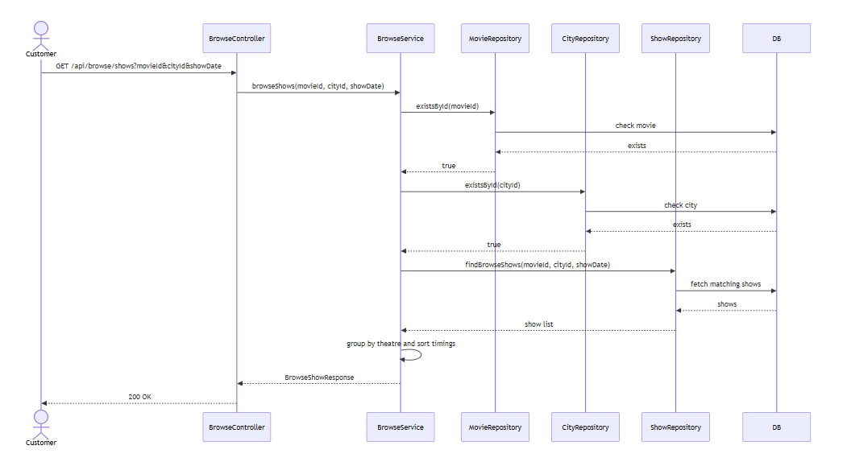

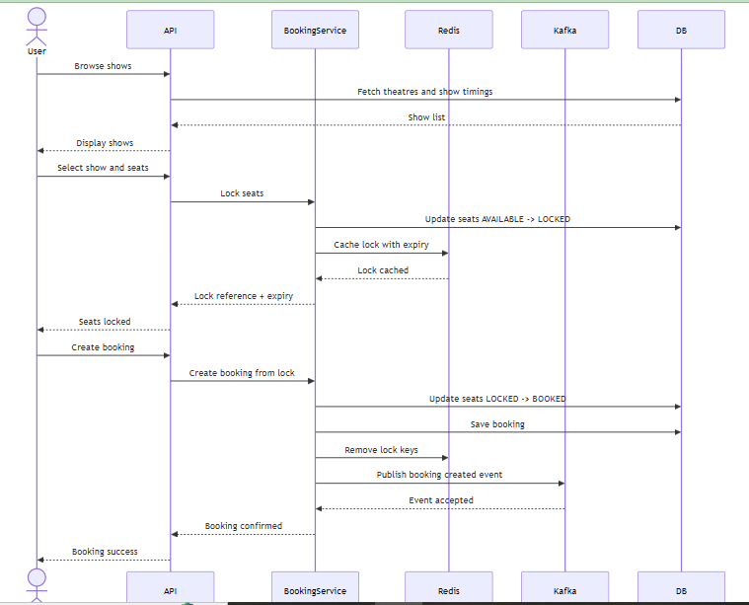

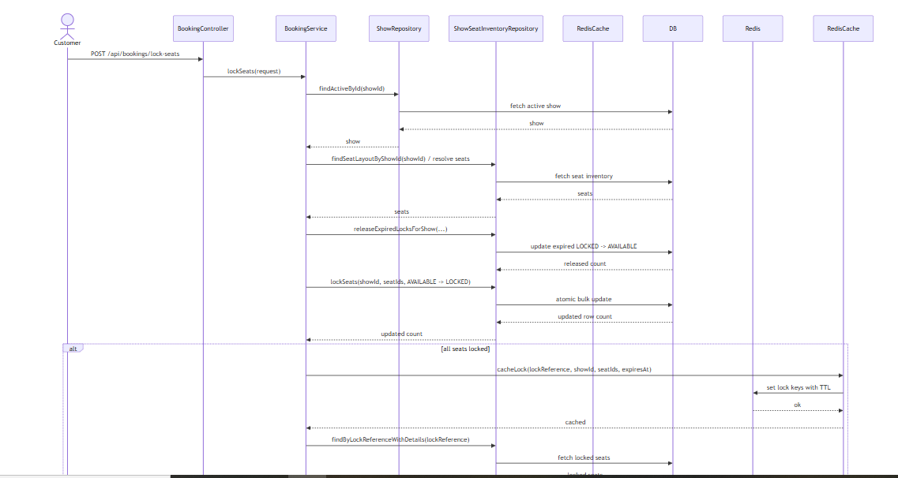

Core Transaction Strategy for Double-Booking Prevention
The most critical business rule is that two users must not book the same seat for the same show.
BookMyMovie prevents this using an atomic database update strategy on show seat inventory rows.
Requested seats are locked only if their current status is AVAILABLE.
The application checks that the updated row count exactly matches the requested seat count.
If even one seat was already taken by another request, the full lock request is rejected.
This approach avoids partial success and protects correctness under concurrent booking attempts.

Non-Functional Requirements (NFR) Coverage
Scalability
The application is built with stateless REST APIs and a layered service model, so multiple instances can be scaled horizontally behind a load balancer.
Redis offloads temporary lock visibility and Kafka supports asynchronous downstream processing without coupling it to the booking response path.
Availability
The core booking correctness remains in the relational database, so optional integrations do not become the single source of truth.
No-op fallback implementations allow the app to continue running even when Redis or Kafka are disabled for a local or reduced environment.

Performance
Browse responses use targeted repository queries, while seat locking relies on direct bulk status updates instead of row-by-row write logic.
Redis helps reduce repeated lookups for temporary lock visibility, and Micrometer metrics capture booking and seat-lock durations for performance analysis.

Data Consistency
Show-level seat inventory and transactional state changes provide strong booking consistency.
Atomic AVAILABLE -> LOCKED -> BOOKED transitions ensure that booked seats cannot be sold twice.
Reliability
Critical booking operations are transactional and validated before status transitions occur.
Kafka publication is best-effort for downstream workflows, so booking persistence is not blocked by event-consumer unavailability.
Fault Tolerance
If Redis is unavailable, the database remains the source of truth and booking still works.
If Kafka is unavailable, booking is still completed and only the asynchronous event publication is skipped or logged as failed.
Security
The current codebase applies request validation, DTO boundaries, and centralized exception handling.
Authentication and authorization are not active in this retained scope, but the REST design is ready for future API security additions.
Observability
The system includes structured console logging, correlation IDs using MDC, Micrometer metrics, Prometheus scrape support, and distributed tracing with Zipkin export configuration.
This helps measure booking latency, lock success and failure rates, and request traceability across the service.
Extensibility
The codebase uses clear service interfaces, DTO-based API models, mapper classes, and modular configuration classes.
This makes it easier to add future capabilities such as payment workflows, notifications, partner APIs, discounts, or separate microservices.
Maintainability
The implementation follows layered architecture with centralized exception handling, OpenAPI documentation, and focused service classes.
The structure is intentionally kept manageable so that new developers can understand the code without navigating unrelated business modules.
Current API Summary
GET /api/browse/shows
GET /api/shows/{showId}
GET /api/shows?movieId=&cityId=&date=
GET /api/shows/{showId}/seats
POST /api/bookings/lock-seats
POST /api/bookings
GET /api/bookings/{bookingId}
Actuator endpoints for health, metrics, and Prometheus scraping are also available.
Summary
BookMyMovie demonstrates a modern backend architecture for movie discovery and ticket booking with production-style layering and operational readiness.
The current solution supports browse flow, show-level seat inventory, concurrency-safe seat locking, booking creation, Redis caching, Kafka event publishing, and observability features while keeping the business scope intentionally focused.
The design is suitable for extension into payments, notifications, partner operations, and broader distributed-service workflows in later phases.
Project Path: F:\2026_1\BookMyMovie

