Project: - Covid19-Count_Tracker_for_India

Sir,

I know the code that I have designed is no way close to the real expectations but with the limited understanding about Python and the language which I could manage to learn since the inception of Mar28 batch, I could manage to come only this far and this is my honest attempt.

I felt as I also started competing, I must submit my project even though it’s no way close to the reality. That’s the reason I am submitting my code.

The more I learn about Python, I will definitely gone participate in remaining challenges with more enthusiasm.

Output:-

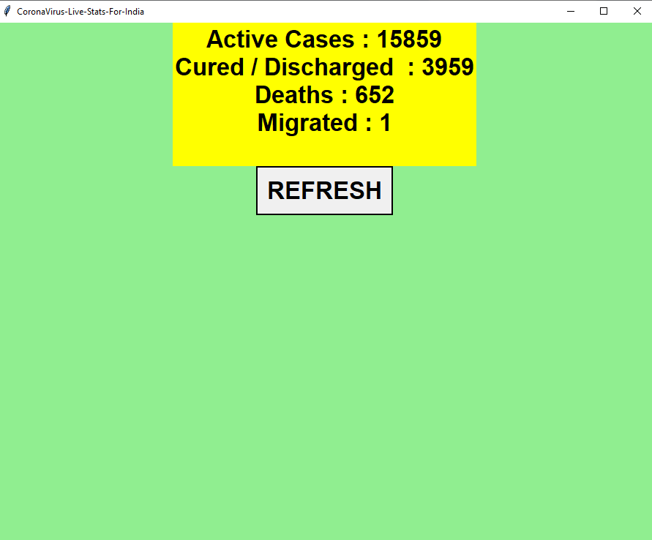

Desktop Notification:-

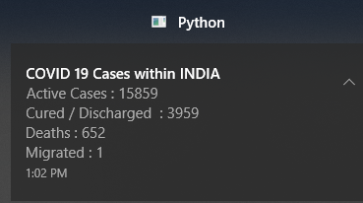

GitHub link:-

<https://github.com/anandmohite8/iNeuron-ML-Mar28/blob/master/Covid-19_Count_Tracker_for_India.ipynb>