Global AI in Education Analytics
Tableau Dashboard Project Report
Data Analysis, Dashboard Development, Findings and Recommendations

1. Introduction
Artificial Intelligence (AI) is increasingly being integrated into the education sector. AI-based tools can support students, teachers and educational institutions through personalized learning, content generation, automated assistance, assessment support and other educational applications. As the use of AI increases, it becomes important to understand how AI adoption differs across countries, regions, educational environments and demographic groups.
The Global AI in Education Analytics project analyzes AI adoption in education using data related to student AI usage, teacher AI usage, school-level AI adoption, daily AI usage time, internet penetration, education index, government AI policies, AI tools, curriculum integration, urban-rural differences and gender gaps.
The project uses Tableau to transform the dataset into interactive visualizations and dashboards. The analysis is intended to help understand patterns of AI adoption, identify differences between regions and countries, examine equity-related gaps, and explore relationships between AI adoption and factors such as internet penetration and education index.
The analysis is based on the countries and observations available in the dataset and therefore should not be interpreted as a complete representation of every country worldwide.

2. Problem Statement
The increasing use of AI in education creates a need for data-driven analysis of how AI technologies are being adopted by students, teachers and schools.
However, AI adoption may vary according to geographical location, infrastructure, educational conditions, government policies and demographic factors. Without systematic analysis, it can be difficult to identify regions with higher or lower adoption, understand differences between students and teachers, identify urban-rural disparities, and evaluate the role of AI tools and curriculum integration.
Therefore, the problem addressed by this project is:
To analyze AI adoption patterns in education across countries and regions and identify relationships between AI usage, educational infrastructure, policy, curriculum integration and equity-related factors using data analytics and Tableau visualization.

3. Objectives
The main objectives of the project are:

3.1 Analyze AI adoption
To analyze student AI usage, teacher AI usage and school-level AI adoption across the countries and regions represented in the dataset.

3.2 Compare countries and regions
To identify differences in AI adoption between countries and geographical regions.

3.3 Analyze AI tool usage
To identify the most frequently recorded AI tools and examine their distribution across regions.

3.4 Study temporal trends
To analyze how AI adoption changes over time from 2015 to the latest available observations.

3.5 Analyze infrastructure relationships
To examine the relationship between internet penetration and AI adoption.

3.6 Analyze education-related relationships
To investigate the relationship between education index and AI adoption.

3.7 Examine government policy
To analyze the distribution of government AI policy statuses and their relationship with AI adoption.

3.8 Examine curriculum integration
To compare AI adoption between observations where AI is and is not included in the curriculum.

3.9 Analyze equity
To examine urban-rural AI usage differences and gender-related AI usage gaps.

3.10 Support data-driven decision making
To provide an interactive Tableau-based analytical solution that can support educators, educational technology professionals, researchers and decision-makers.

4. Dataset Description
The project uses the dataset: Global AI in Education.csv
The dataset contains 1,360 records and 16 fields.
The observations cover the period from 2015 to 2026 and include information about countries, regions, AI adoption, infrastructure, policy and educational factors.

4.1 Dataset Fields
Field | Description
Year | Year of the observation
Month | Month of the observation
Country | Country represented by the observation
Region | Geographical region
Student AI Usage % | Percentage of students using AI
Teacher AI Usage % | Percentage of teachers using AI
School AI Adoption % | Percentage representing school-level AI adoption
Avg Daily AI Usage (Min) | Average daily AI usage time in minutes
Top AI Tool | AI tool identified as the top tool
Internet Penetration % | Internet penetration percentage
Education Index | Education-related index value
Government AI Policy | Government AI policy status
Urban AI Usage % | AI usage percentage in urban areas
Rural AI Usage % | AI usage percentage in rural areas
AI in Curriculum | Whether AI is included in the curriculum
Gender Gap AI Usage % | Gender-related AI usage gap

The dataset includes observations from 10 countries and 6 geographical regions.

5. Data Preprocessing
Data preprocessing was performed before creating the Tableau visualizations to improve consistency and analytical reliability.

5.1 Data Inspection
The dataset was initially inspected to understand:
- Number of records
- Number of columns
- Field names
- Data types
- Missing values
- Numerical ranges
- Categorical values
- Potential duplicate records
The dataset contains 1,360 records and 16 columns.

5.2 Missing Values
The Government AI Policy field contains missing values.
There are 441 records where government policy information is unavailable, representing approximately 32.4% of the dataset.
These values were not interpreted as "No Policy." Instead, missing policy information was treated as:
Not Available
This distinction is important because missing information does not necessarily mean that a government has no AI policy.

5.3 Data Type Validation
The fields were checked and assigned appropriate data types.
Numerical fields
- Year
- Month
- Student AI Usage %
- Teacher AI Usage %
- School AI Adoption %
- Average Daily AI Usage
- Internet Penetration %
- Education Index
- Urban AI Usage %
- Rural AI Usage %
- Gender Gap AI Usage %
Categorical fields
- Country
- Region
- Top AI Tool
- Government AI Policy
- AI in Curriculum

5.4 Percentage Validation
The percentage fields were checked to ensure that their values fall within reasonable ranges. The following fields were treated as percentage measures:
- Student AI Usage %
- Teacher AI Usage %
- School AI Adoption %
- Internet Penetration %
- Urban AI Usage %
- Rural AI Usage %
The Education Index was retained as a decimal index rather than being treated as a percentage.

5.5 Duplicate Checking
Potential duplicate records were considered using the combination of Year, Month and Country. Duplicate records were not blindly removed because records with the same year, month and country may still contain different valid measurements.

5.6 Text Consistency
Categorical fields such as country, region, AI tool and policy status were checked for consistency. This helps avoid analytical problems caused by variations such as:
- India
- India (with a trailing space)
- india
Consistent naming ensures that Tableau treats the same category as one value.

6. Data Preparation and Calculated Fields
After preprocessing, the cleaned dataset was connected to Tableau. Several calculated fields were created to support analysis.

6.1 Date
A date field was created using the year and month fields. The calculation used was:
MAKEDATE([Year], [Month], 1)
This allows the data to be analyzed as a continuous time series.

6.2 Government Policy Status
A calculated field was created to handle missing government policy information.
IF ISNULL([Government AI Policy]) THEN
"Not Available"
ELSE
[Government AI Policy]
END
This creates three useful categories:
- Active
- Draft
- Not Available

6.3 Overall AI Adoption %
A custom overall adoption measure was created by averaging student AI usage, teacher AI usage and school AI adoption.
(
[Student AI Usage %]
+
[Teacher AI Usage %]
+
[School AI Adoption %]
) / 3
This measure provides a simple way to compare overall adoption. It is important to note that this is a project-specific analytical measure and is not an official global AI adoption index.

6.4 Urban-Rural AI Gap
The urban-rural difference was calculated as:
[Urban AI Usage %] - [Rural AI Usage %]
A positive value indicates that urban AI usage is higher than rural AI usage.

6.5 Student-Teacher AI Gap
The difference between student and teacher AI usage was calculated as:
[Student AI Usage %] - [Teacher AI Usage %]
This allows the difference between student and teacher adoption to be examined.

6.6 Student-School Adoption Gap
The difference between student usage and school adoption was calculated as:
[Student AI Usage %] - [School AI Adoption %]
This helps identify differences between individual student usage and institutional adoption.

7. Exploratory Data Analysis
Exploratory Data Analysis (EDA) was conducted to identify major patterns and relationships in the dataset before and during dashboard development. The analysis focused on:
- Overall AI adoption
- Regional adoption
- Country-level adoption
- Student and teacher usage
- Urban-rural differences
- AI tool distribution
- Internet penetration
- Education index
- Government policy
- Curriculum integration
- Gender gaps
- Daily AI usage
- Time-based adoption trends
The EDA findings were subsequently represented using Tableau charts and dashboards.

8. Tableau Dashboard Development
Tableau was used as the primary visualization and dashboard development platform. The cleaned dataset was connected to Tableau and transformed into a set of analytical worksheets and dashboards.
A total of 20 worksheets were created and combined into 5 interactive analytical dashboards.

8.1 Worksheets Developed
The following worksheets were created:
- KPI Student
- KPI Teacher
- KPI School
- KPI Internet
- KPI Education
- Adoption Trend
- Regional Adoption
- Country Adoption
- Student vs Teacher
- Urban vs Rural
- Urban Rural Gap
- AI Tools
- AI Tools Region
- Policy Adoption
- Curriculum Adoption
- Internet Correlation
- Education Correlation
- Gender Gap
- Daily Usage
- Monthly Adoption Trend
These worksheets provide different perspectives on AI adoption and its associated factors.

8.2 Dashboard 1 — Global AI Education Overview
The first dashboard provides a high-level overview of AI adoption. It includes:
- Student AI Usage KPI
- Teacher AI Usage KPI
- School AI Adoption KPI
- Internet Penetration KPI
- Education Index KPI
- Adoption Trend
- Monthly Adoption Trend
Purpose
This dashboard provides an overall view of the state and development of AI adoption in education.

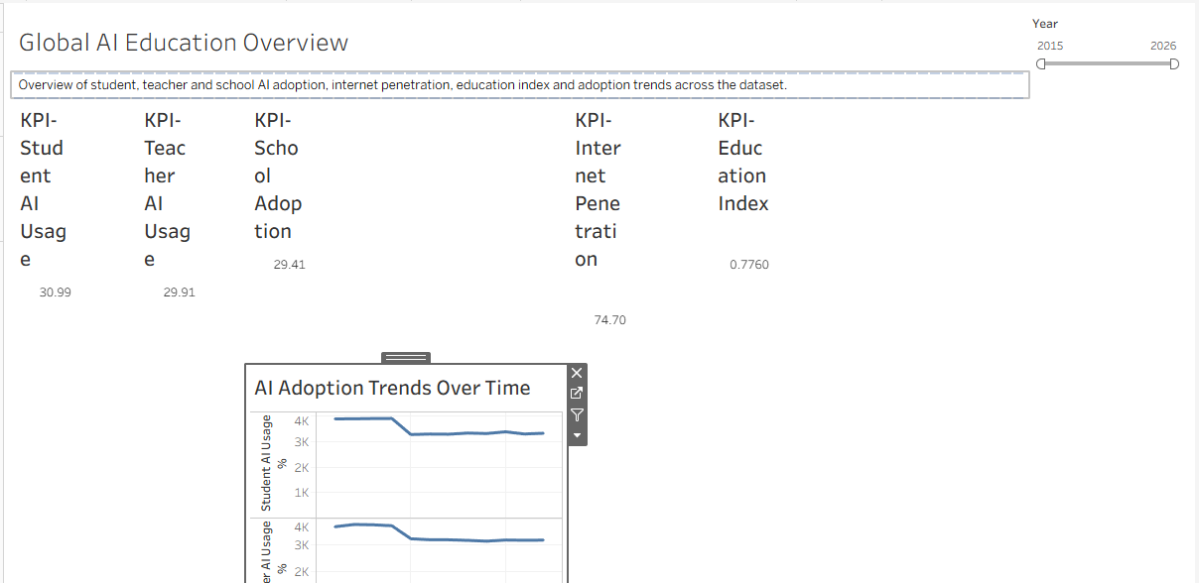

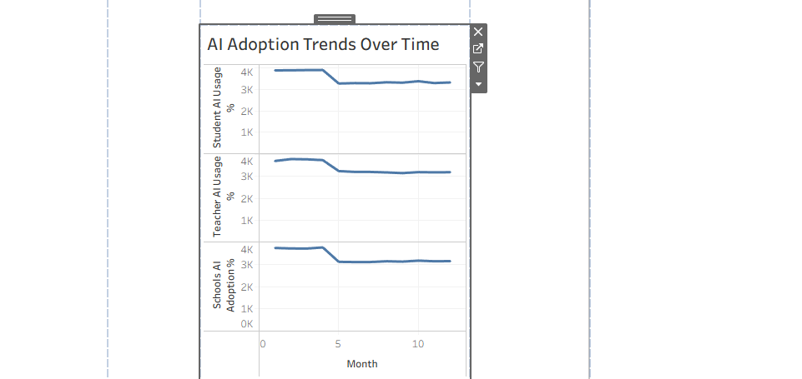

8.3 Dashboard 2 — Regional & Country Analysis
This dashboard focuses on geographical differences. It includes:
- Regional Adoption
- Country Adoption
- Student vs Teacher
- Urban vs Rural
- Urban-Rural Gap
Purpose
The dashboard helps users compare countries and regions and identify differences in student, teacher, urban and rural AI adoption.
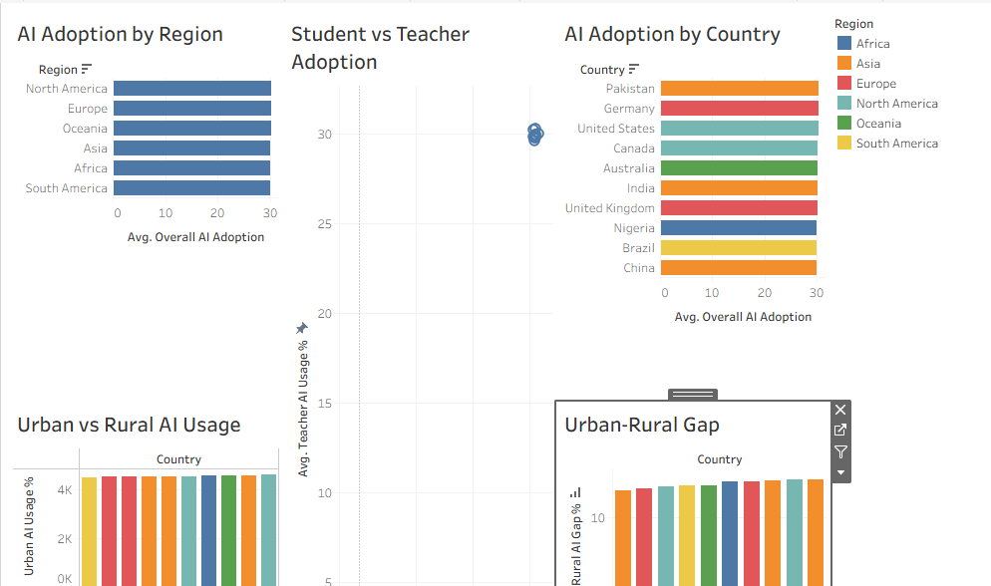

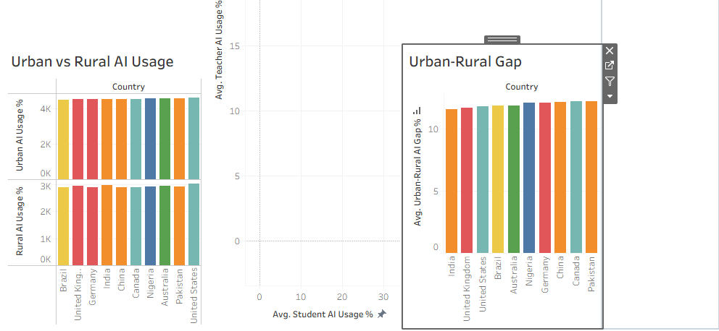

8.4 Dashboard 3 — AI Tools & Market Adoption
This dashboard focuses on AI tools and usage patterns. It includes:
- AI Tools
- AI Tools by Region
- Daily AI Usage
- Monthly/temporal adoption information where appropriate
Purpose
This dashboard helps understand which AI tools appear most frequently in the dataset and how tool usage varies across regions.
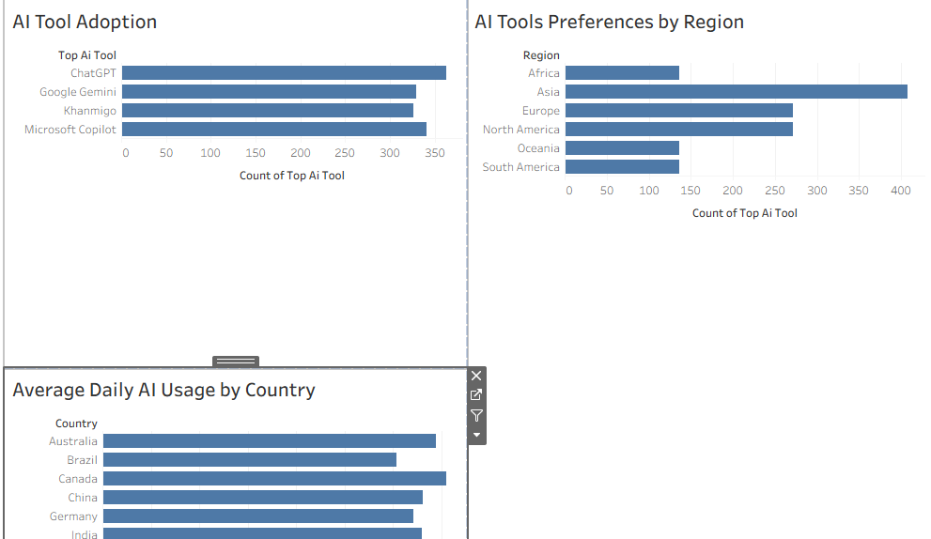

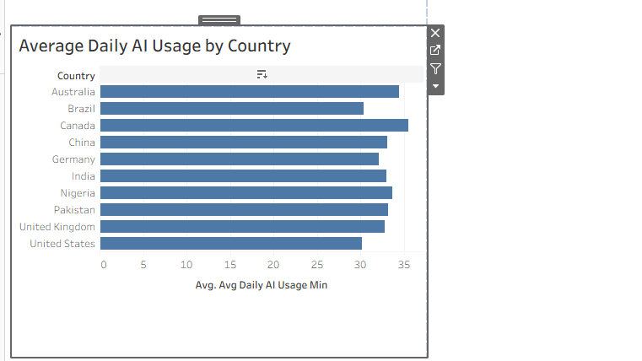

8.5 Dashboard 4 — Policy, Infrastructure & Education
This dashboard examines policy and educational factors associated with AI adoption. It includes:
- Government Policy Adoption
- Curriculum Adoption
- Internet Penetration Correlation
- Education Index Correlation
Purpose
The dashboard allows users to examine relationships between AI adoption and policy, curriculum, internet infrastructure and education-related indicators.
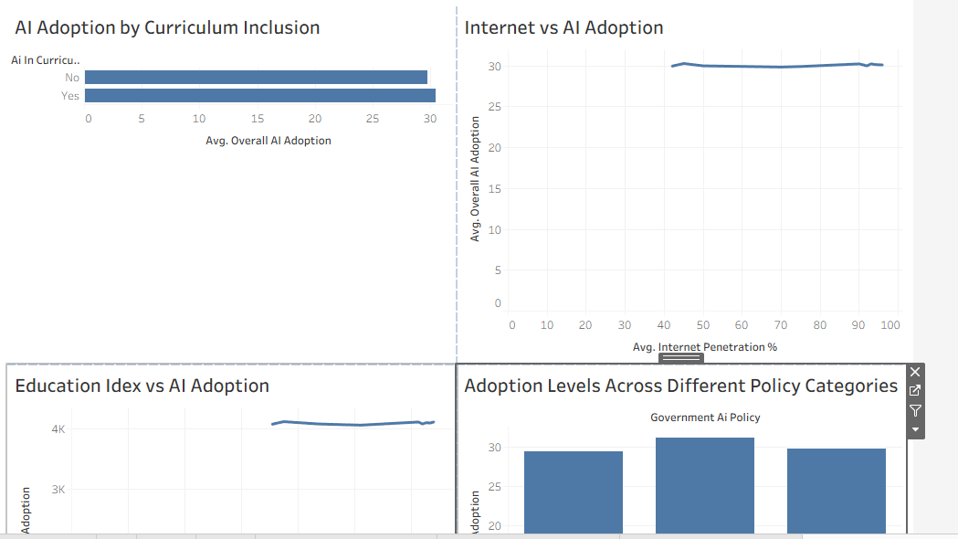

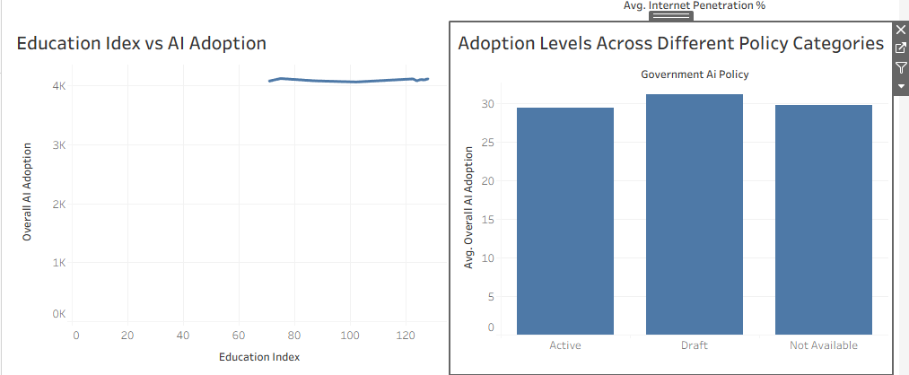

8.6 Dashboard 5 — Equity & Accessibility
This dashboard focuses on differences and accessibility. It includes:
- Gender Gap
- Urban-Rural Gap
- Student vs Teacher
- Daily AI Usage
Purpose
The dashboard highlights potential inequalities and differences in AI access and usage across demographic and geographic groups.
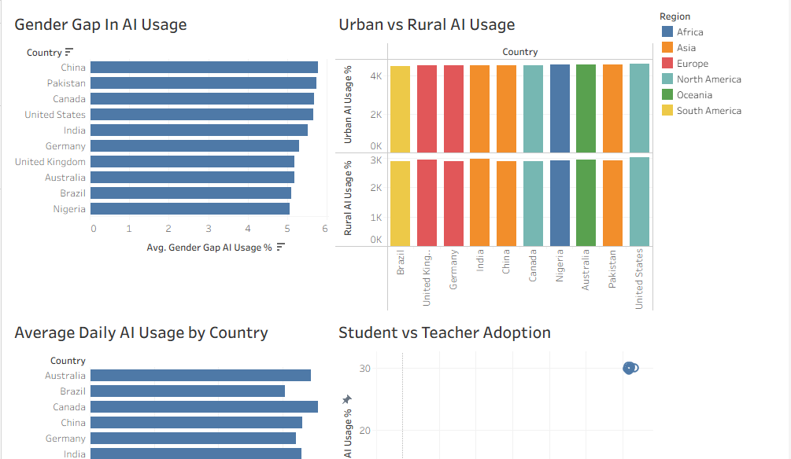

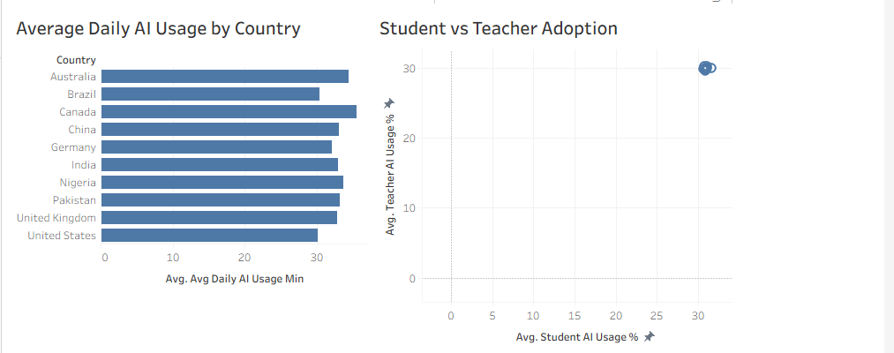

8.7 Tableau Visualization Techniques
Different visualization types were used according to the analytical objective.
Analysis | Visualization
KPI values | KPI cards
Adoption over time | Line chart
Regional comparison | Bar chart
Country comparison | Bar chart
Student vs Teacher | Scatter plot
Urban vs Rural | Comparative bar chart
AI tools | Bar chart
Policy status | Bar chart
Curriculum adoption | Bar chart
Internet relationship | Scatter plot
Education relationship | Scatter plot
Gender gap | Bar chart
Daily usage | Bar chart
Monthly adoption | Line chart

8.8 Dashboard Design
The dashboards were designed to provide a clear and organized view of the analysis. KPI cards were positioned at the top of the main overview dashboard to provide immediate access to important indicators. Charts were then arranged according to their analytical purpose, allowing users to move from high-level information to detailed comparisons.
The dashboards were designed to support three major analytical perspectives:
Educational leadership
Understanding overall adoption, regional differences, policy and curriculum integration.
EdTech/business perspective
Understanding AI tool usage, market patterns and temporal adoption.
Research perspective
Examining relationships between AI adoption, infrastructure, education and equity.

8.9 Dashboard Development Outcome
The final Tableau solution consists of:
1 cleaned dataset → 20 analytical worksheets → 5 dashboards → project findings and recommendations
The dashboards provide a visual interface for exploring AI adoption patterns and support data-driven interpretation of AI integration in education. The subsequent analysis section uses these dashboards to identify major trends, differences, relationships and equity-related findings.

9. Analysis, Observations & Findings

9.1 Overall AI Adoption
The overall average AI adoption score, calculated from student AI usage, teacher AI usage and school AI adoption, is approximately 30.1%. The individual averages are:
Metric | Average
Student AI Usage | 31.0%
Teacher AI Usage | 29.9%
School AI Adoption | 29.4%
Overall AI Adoption | 30.1%

Observation: Student AI usage is slightly higher than teacher AI usage, while school-level AI adoption is the lowest of the three. This indicates that individual AI usage is slightly ahead of institutional adoption.
Note: The Overall AI Adoption value is a project-created composite measure and is not an official AI adoption index.

9.2 Regional Analysis
The average overall AI adoption by region is:
Region | Overall Adoption
North America | 30.22%
Europe | 30.15%
Oceania | 30.14%
Asia | 30.07%
Africa | 29.99%
South America | 29.94%

Observation: North America has the highest average overall AI adoption, while South America has the lowest. However, the difference between the highest and lowest regions is only about 0.28 percentage points, meaning the regional averages are quite close in this dataset.
This is an important finding: the dataset does not show a very large regional difference in overall AI adoption.

9.3 Country Analysis
The countries ranked by average overall AI adoption are:
Rank | Country | Overall Adoption
1 | Pakistan | 30.31%
2 | Germany | 30.27%
3 | United States | 30.26%
4 | Canada | 30.18%
5 | Australia | 30.14%
6 | United Kingdom | 30.02%
7 | India | 30.02%
8 | Nigeria | 29.99%
9 | Brazil | 29.94%
10 | China | 29.88%

Observation: Pakistan has the highest average overall adoption in the dataset, while China has the lowest. However, the difference is only about 0.43 percentage points, so country-level differences are also relatively small.

9.4 Student vs Teacher Adoption
The dataset shows Student AI Usage = 31.0% and Teacher AI Usage = 29.9%. Therefore, student usage is approximately 1.08 percentage points higher than teacher usage.
Observation: Students show slightly greater AI usage than teachers. This may indicate that student-level adoption is developing somewhat faster than teacher adoption. However, the difference is relatively small, so the dataset does not indicate an extremely large student-teacher divide.

9.5 Urban vs Rural AI Adoption
Average Urban AI Usage = 33.56% and average Rural AI Usage = 21.60%. The average urban-rural gap is therefore approximately 11.96 percentage points.
Observation: Urban AI usage is substantially higher than rural AI usage. This is one of the clearest disparities in the dataset. The finding suggests that location and access conditions may be important considerations when planning equitable AI implementation in education.
Note: The data shows an association/disparity, but it does not prove why the gap exists.

9.6 AI Tool Adoption
The four AI tools in the dataset occur with the following frequencies:
AI Tool | Records
ChatGPT | 363
Microsoft Copilot | 341
Google Gemini | 330
Khanmigo | 326

Observation: ChatGPT appears most frequently as the top AI tool in the dataset, followed by Microsoft Copilot, Google Gemini, and Khanmigo. ChatGPT represents approximately 26.7% of the records, while the other tools are relatively close behind.
Note: These numbers represent the frequency of the Top AI Tool value in this dataset. They should not automatically be described as global market share.

9.7 Internet Penetration and AI Adoption
The average internet penetration is 74.7%. The correlation between internet penetration and the project's overall AI adoption measure is approximately 0.002, which is essentially zero.
Observation: In this dataset, internet penetration does not show a meaningful linear relationship with the calculated overall AI adoption measure. This is an interesting result because better internet access might normally be expected to be associated with greater AI adoption.
Note: This does not mean that internet access has no effect on AI adoption. The dataset simply does not demonstrate a meaningful correlation between internet penetration and the calculated overall AI adoption measure.

9.8 Education Index and AI Adoption
The average education index is 0.776. The correlation between education index and overall AI adoption is approximately 0.003, which is also essentially zero.
Observation: There is no meaningful linear correlation between education index and the calculated overall AI adoption measure in this dataset. This suggests that, within these observations, higher education index values are not clearly associated with higher AI adoption.
Note: This does not mean education has no effect on AI adoption. It only describes the relationship observed in this dataset.

9.9 Government AI Policy
Government policy values are:
Policy Status | Records
Active | 474
Draft | 445
Not Available | 441

Approximately 32.4% of records have no government policy value recorded. Average overall adoption by policy status:
Policy Status | Overall Adoption
Draft | 31.13%
Not Available | 29.79%
Active | 29.43%

Observation: Records classified as Draft have the highest average overall adoption in this dataset, followed by records with unavailable policy information and then Active policy records. However, this does not mean draft policies cause higher AI adoption. There are many other possible factors, and the dataset is observational.
Note: Not Available must not be interpreted as "No Policy."

9.10 AI in Curriculum
The dataset contains Yes: 687 records and No: 673 records, so the distribution is almost evenly divided. Average overall adoption:
AI in Curriculum | Overall Adoption
Yes | 30.44%
No | 29.75%

Observation: Records where AI is included in the curriculum have a slightly higher average overall AI adoption than records where AI is not included. The difference is approximately 0.69 percentage points. This suggests a positive association, but the difference is relatively small and should not be interpreted as proof that curriculum inclusion causes higher adoption.

9.11 Gender Gap
The average gender gap measure is approximately 5.41 percentage points. Country averages range approximately from 5.76 (China) to 5.05 (Nigeria):
Country | Gender Gap
China | 5.76
Pakistan | 5.73
Canada | 5.68
United States | 5.66
India | 5.51
Nigeria | 5.05

Observation: The dataset shows a measurable gender gap in AI usage across the countries represented. China has the highest average value of the gender-gap measure, while Nigeria has the lowest.
Note: The gender_gap_ai_usage_pct field does not by itself indicate which gender has higher usage unless the dataset documentation defines the direction of the calculation. Therefore, no conclusion is drawn on whether male or female usage is higher.

9.12 Daily AI Usage
Average daily AI usage is 32.82 minutes per day. Country averages:
Country | Daily Usage
Canada | 35.46 min
Australia | 34.43 min
Nigeria | 33.66 min
Pakistan | 33.18 min
China | 33.09 min
India | 32.99 min
United Kingdom | 32.82 min
Germany | 32.08 min
Brazil | 30.34 min
United States | 30.18 min

Observation: Canada has the highest average daily AI usage at approximately 35.5 minutes, while the United States has the lowest at approximately 30.2 minutes among the countries represented. The overall difference is about 5.3 minutes per day.

9.13 Yearly AI Adoption Trend
This is one of the strongest findings. Average overall adoption by year:
Year | Overall Adoption
2015 | 4.13%
2016 | 9.42%
2017 | 14.29%
2018 | 19.04%
2019 | 24.28%
2020 | 29.27%
2021 | 34.36%
2022 | 39.00%
2023 | 44.16%
2024 | 49.22%
2025 | 54.07%
2026* | 59.67%

Observation: Overall AI adoption shows a strong upward trend throughout the period. The average calculated adoption measure increases from approximately 4.13% in 2015 to 59.67% in the available 2026 observations, an increase of approximately 55.5 percentage points.
Important 2026 note
The dataset has 120 records for each year from 2015–2025, but only 40 records for 2026. Therefore, 2026 appears to be a partial year. AI adoption continues to show an upward trend toward the latest available 2026 observations; 2026 should not be described as the highest full-year adoption.

9.14 Key Findings — Overall
After analyzing the dataset, the major findings are:
- AI adoption increases strongly over time.
- Student AI usage is slightly higher than teacher usage.
- School-level adoption is slightly lower than student and teacher usage.
- Urban AI usage is substantially higher than rural AI usage.
- Regional differences in overall adoption are relatively small.
- Country-level differences are also relatively small.
- ChatGPT is the most frequently recorded top AI tool.
- Internet penetration has almost no observed correlation with overall AI adoption in this dataset.
- Education index also has almost no observed correlation with overall AI adoption.
- Records with AI in the curriculum show slightly higher overall adoption.
- A measurable gender gap exists across the represented countries.
- Daily AI usage averages about 32.8 minutes.
- Government policy status varies considerably, with a substantial amount of missing policy information.

9.15 Recommendations
Based on the findings, the project recommends the following:
1. Focus on rural accessibility
The urban-rural difference is one of the largest observed disparities. Educational institutions and policymakers should consider improving access to AI-related resources and infrastructure in rural areas.
2. Strengthen teacher adoption
Student AI usage is slightly ahead of teacher usage. Therefore, teacher training and professional-development programs could help educators effectively integrate AI into teaching.
3. Support responsible curriculum integration
Records with AI included in the curriculum show slightly higher adoption. Educational institutions could consider structured AI education, including responsible use, AI literacy, evaluation of AI outputs, and academic integrity.
4. Develop clear AI policies
The dataset contains both Active and Draft policies, as well as many records where policy information is unavailable. Organizations should maintain clear and updated AI-use policies.
5. Address equity gaps
The gender gap and urban-rural gap suggest that AI implementation should consider equity and accessibility, rather than focusing only on overall adoption.
6. Monitor AI tools
ChatGPT, Copilot, Gemini and Khanmigo all appear frequently. Educational organizations should evaluate tools based on educational value, privacy, security, cost, accessibility and responsible-use requirements rather than adoption alone.

9.16 Limitations
Limitation 1 — Represented countries
The dataset contains 10 countries, so the analysis should not be described as representing every country in the world. It is a global analysis based on the countries represented in the dataset.
Limitation 2 — Observational data
The relationships observed in the data do not establish causation. For example, the dataset cannot prove that internet access causes AI adoption.
Limitation 3 — Missing policy data
There are 441 records without government AI policy information, approximately 32.4% of the dataset. Therefore, policy-related conclusions should be interpreted carefully.
Limitation 4 — Partial 2026 data
2026 contains only 40 records, compared with 120 records for each previous year. Therefore, 2026 should not be treated as a complete annual observation.
Limitation 5 — Composite adoption measure
The Overall AI Adoption % is a custom average of Student AI Usage, Teacher AI Usage and School AI Adoption. It is an analytical measure created for this project, not an officially recognized global AI adoption index.
Limitation 6 — Tool frequency
The AI-tool analysis is based on the frequency of the Top AI Tool field. It should not automatically be interpreted as actual global market share.
Limitation 7 — Gender-gap direction
The gender-gap field indicates a numerical gap, but without a documented direction no conclusion can be drawn about which gender has higher AI usage.

9.17 Conclusion
The analysis of the Global AI in Education dataset shows a strong increase in AI adoption over the observed period, with student, teacher and school adoption all increasing substantially from 2015 toward the latest available observations. Student AI usage is slightly higher than teacher and school adoption, while a significant urban-rural difference highlights the importance of equitable access to AI technologies.
Regional and country-level differences in overall adoption are relatively small compared with the strong change observed over time. ChatGPT is the most frequently recorded AI tool, while daily AI usage averages approximately 32.8 minutes. The analysis also shows that internet penetration and education index have very weak correlations with the calculated overall AI adoption measure in this dataset.
Curriculum inclusion of AI is associated with slightly higher adoption, while government policy information is incomplete and therefore requires careful interpretation. Overall, the findings emphasize that successful AI integration in education requires not only increasing adoption but also addressing accessibility, teacher readiness, curriculum integration and equity.
The results should be interpreted within the limitations of the dataset, particularly its limited country coverage, missing policy information, observational nature and incomplete 2026 data.

