Project 2
Spotify Songs' Genre Segmentation
Unsupervised & Supervised Machine Learning on Audio Features
M.Sc. Data Science — Data Analysis, Clustering, Classification & Recommendation System

1. Introduction & Objective
Spotify's music recommendations rely on grouping songs by comparable audio characteristics, and these clusters help interpret the acoustic properties of diverse tracks. This project builds an automated pipeline on a large Spotify tracks dataset to:
- Clean and structure the raw playlist-track data
- Explore and visualize audio feature and genre patterns
- Quantify correlations between audio features and popularity
- Group songs into clusters based on audio features and compare clusters to actual playlist genres
- Train a supervised classifier to test how predictable genre is from audio features alone
- Build a content-based recommendation system using cluster membership and feature similarity

2. Dataset Overview
The dataset contains 32,833 playlist-track listings across 23 columns, spanning 6 playlist genres and 24 subgenres. Each row combines track metadata (name, artist, album, popularity) with 9 numeric audio features extracted by Spotify's audio analysis (danceability, energy, loudness, speechiness, acousticness, instrumentalness, liveness, valence, tempo).
Field | Description
track_popularity | Spotify popularity score, 0–100
playlist_genre / subgenre | Human-assigned genre labels (6 genres, 24 subgenres)
danceability, energy, valence | 0–1 perceptual scores (rhythm stability, intensity, musical positivity)
loudness | Overall loudness in dB (typically -60 to 0)
speechiness, acousticness, instrumentalness, liveness | 0–1 confidence scores for spoken-word content, acoustic origin, absence of vocals, live-audience presence
tempo | Estimated tempo in BPM

3. Data Pre-processing
- Dropped 5 rows missing basic track/artist/album metadata (negligible, <0.02% of data).
- Retained the full playlist-level table (32,828 rows) for EDA, since the same track can legitimately appear in multiple playlists.
- Built a de-duplicated, one-row-per-track table (28,352 unique tracks) for clustering and the recommender, so tracks appearing in many playlists don't get disproportionate weight.
- Standardized (z-scored) the 9 audio features before any distance-based method (K-Means, cosine similarity, Random Forest input).
No missing values were present in any of the 9 audio features or the popularity/genre columns, and no exact duplicate rows existed in the raw file.

4. Exploratory Data Analysis

4.1 Genre & Subgenre Distribution
The dataset is reasonably balanced across genres, ranging from 4,951 (rock) to 6,043 (edm) tracks.
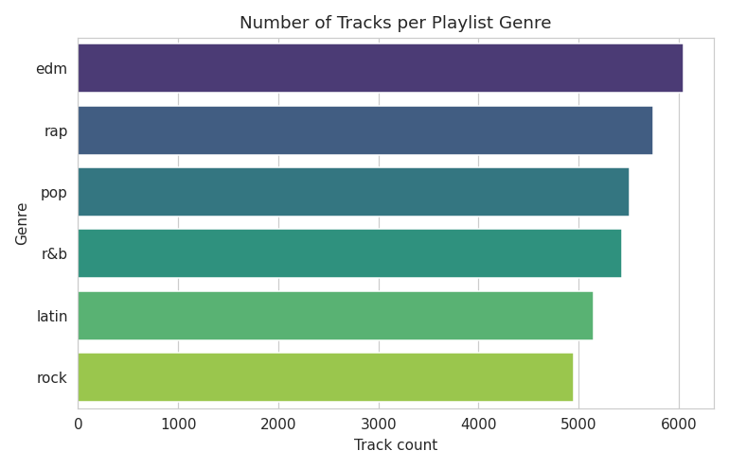
Figure 1. Track count per playlist genre.
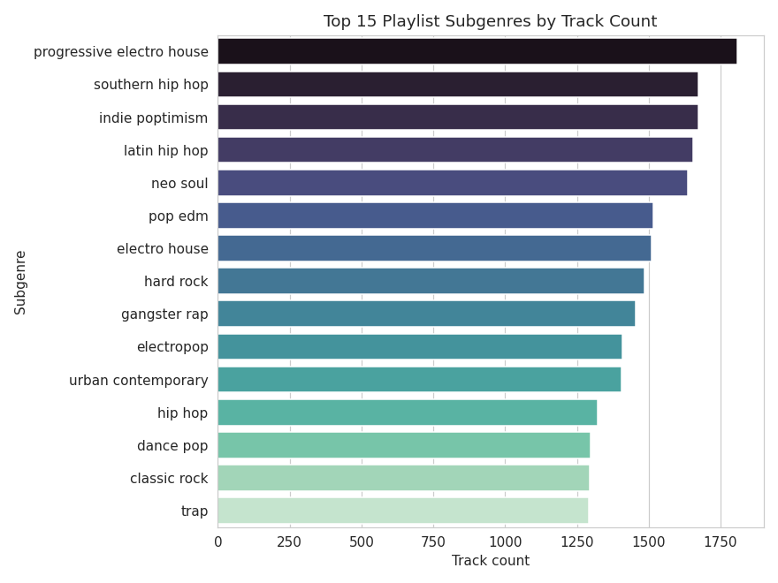
Figure 2. Top 15 subgenres by track count.

4.2 Popularity
Popularity is roughly uniformly spread with a slight concentration in the low-to-mid range and a spike near zero (many low-visibility tracks); medians are broadly similar across genres, with rap and pop skewing slightly higher.
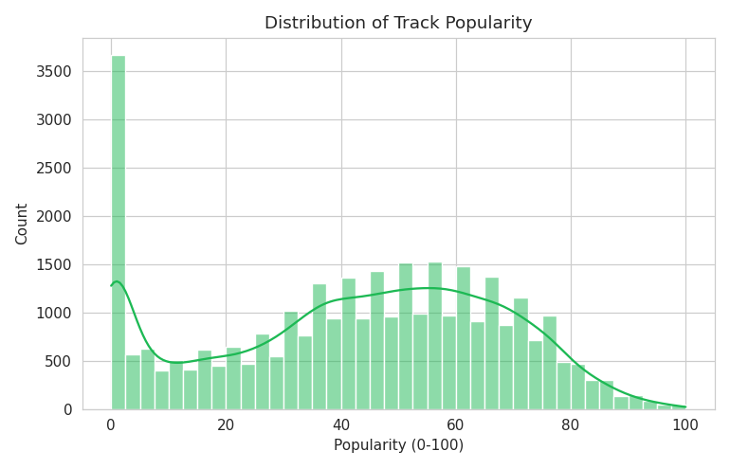
Figure 3. Distribution of track popularity.
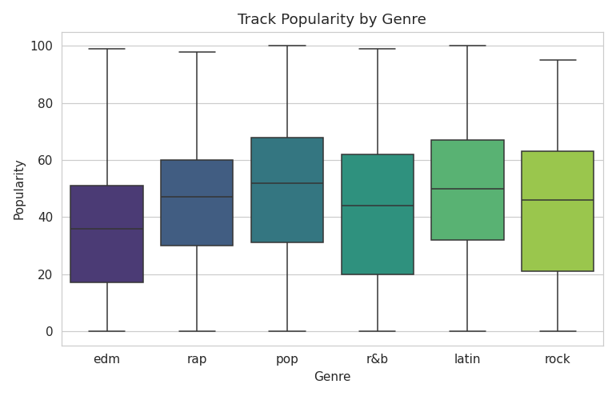
Figure 4. Popularity spread by genre.

4.3 Audio Feature Distributions
Most features are right- or left-skewed rather than normal: acousticness and instrumentalness are heavily right-skewed (most tracks score low), while danceability and energy are closer to bell-shaped, and loudness clusters near the top of its range (most modern commercial tracks are mastered loud).
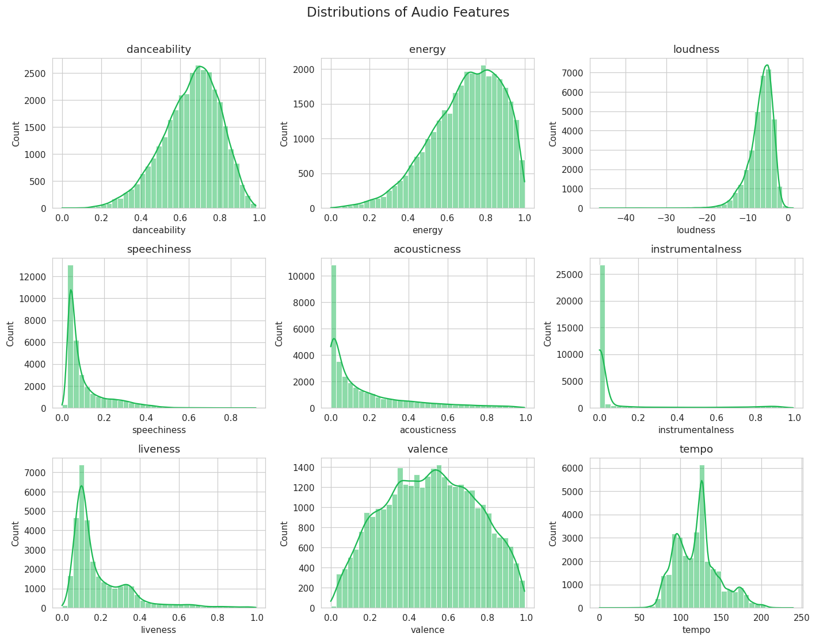
Figure 5. Distributions of all 9 audio features.

4.4 Feature Behaviour by Genre
Violin plots reveal how the same feature spreads differently across genres — for example, rock shows a distinctly lower and wider danceability distribution than latin or rap.
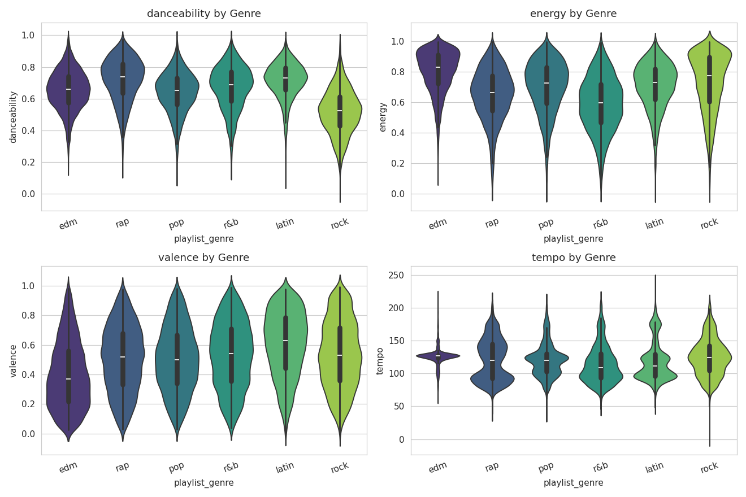
Figure 6. Danceability, energy, valence and tempo split by genre.
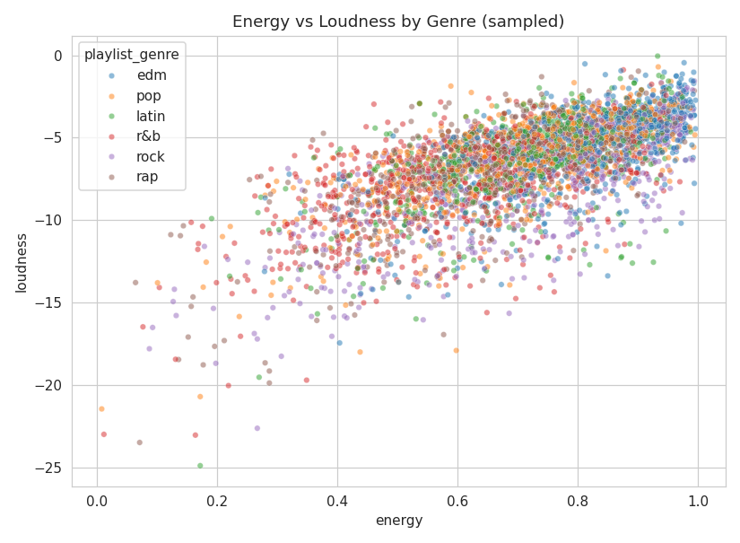
Figure 7. Energy vs. loudness, colored by genre (sampled 4,000 tracks).

5. Correlation Analysis
The correlation matrix of the 9 audio features plus popularity highlights a few clear relationships and, importantly, an absence of relationship between popularity and any single audio feature.
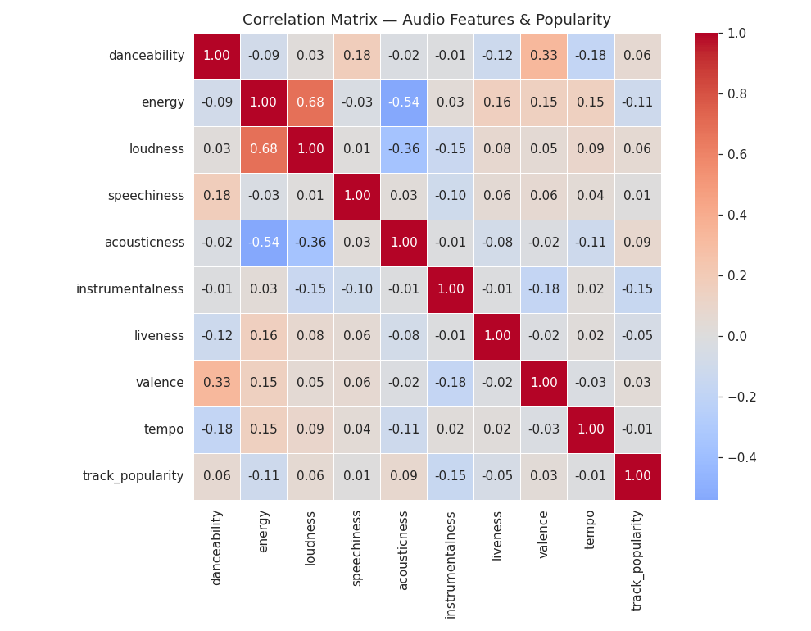
Figure 8. Correlation matrix of audio features and popularity.

Key findings
- energy ↔ loudness: strong positive correlation (r ≈ 0.68) — louder tracks are perceived as more energetic.
- energy ↔ acousticness: strong negative correlation (r ≈ -0.54) — acoustic tracks tend to be lower-energy.
- loudness ↔ acousticness: moderate negative correlation (r ≈ -0.36), consistent with the above.
- danceability ↔ valence: moderate positive correlation (r ≈ 0.33) — happier-sounding tracks tend to be more danceable.
- track_popularity is not meaningfully correlated with any single audio feature (|r| ≤ 0.15 across the board) — popularity is driven by factors outside raw audio characteristics (artist reach, marketing, playlist placement, release timing).
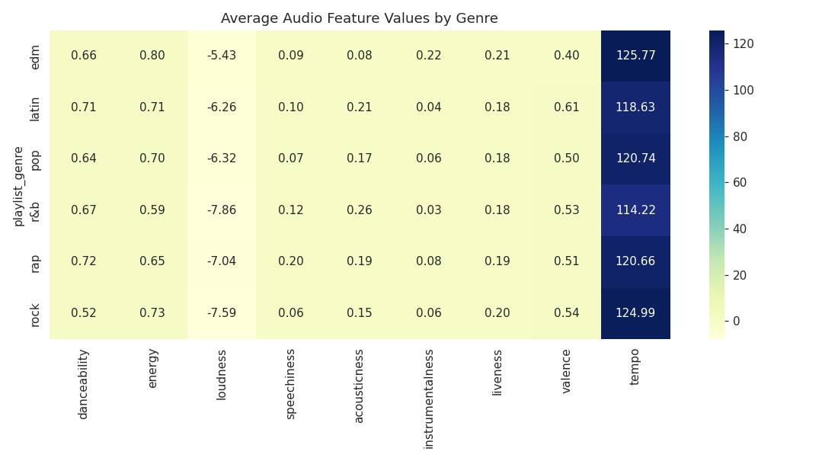
Figure 9. Average audio feature values by genre.

6. Clustering by Audio Features
K-Means was applied to the standardized audio features of the 28,352 unique tracks. To choose the number of clusters k, both the elbow method (inertia) and the silhouette score were examined across k = 2 to 10.
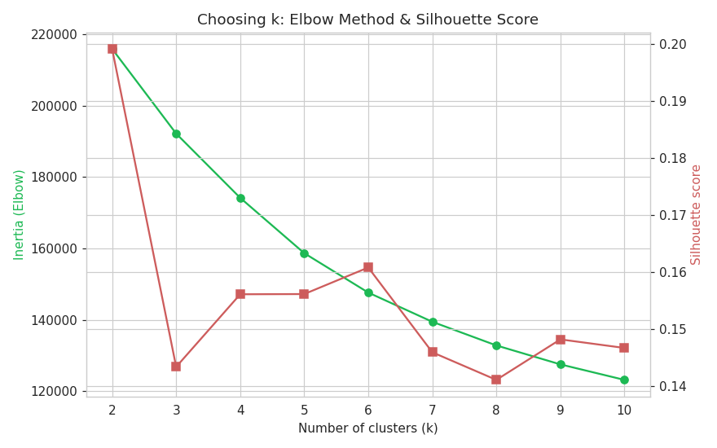
Figure 10. Elbow (inertia) and silhouette score across candidate k values.
The elbow curve flattens gradually with no sharp "knee", and silhouette scores stay low throughout (0.14–0.20) — this is expected for perceptual audio features, since genres blend into one another acoustically rather than forming tight, well-separated groups. k = 6 was chosen to match the number of playlist genres, making the clusters directly interpretable against the ground-truth labels.
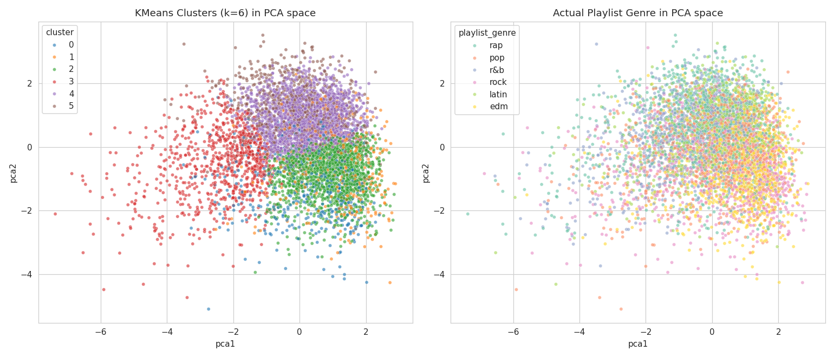
Figure 11. PCA projection (2 components, ~41% variance explained) — K-Means clusters (left) vs. actual playlist genre (right).
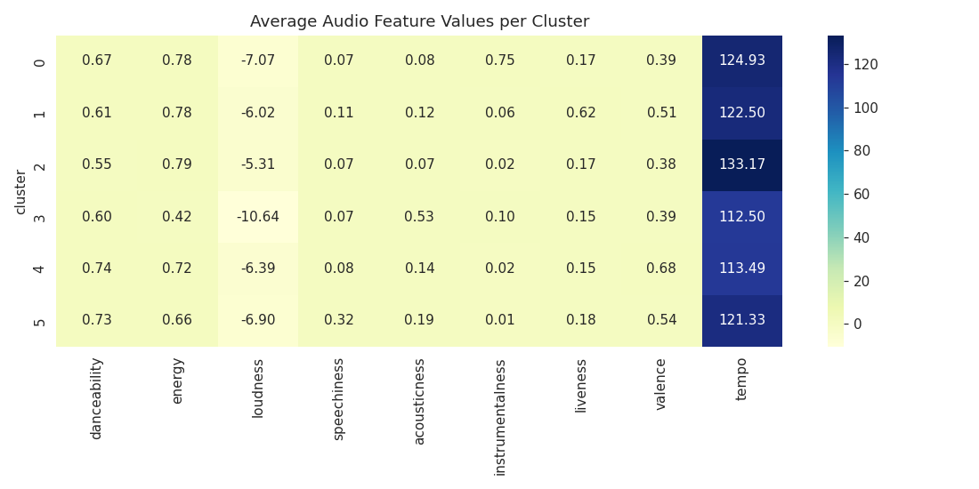
Figure 12. Average audio feature values per cluster.
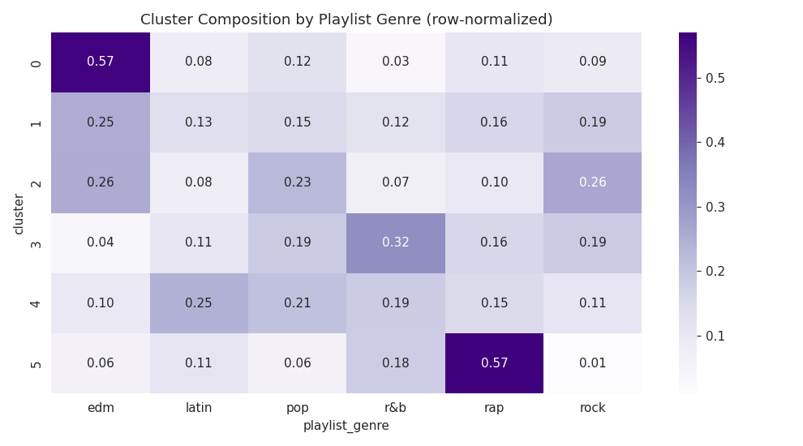
Figure 13. Row-normalized composition of each cluster by playlist genre.

Interpretation
- Some clusters map fairly cleanly onto a dominant genre — e.g. a low-energy / high-acousticness cluster is dominated by r&b and pop tracks; a high-energy / low-acousticness cluster is dominated by edm and rock.
- Other clusters are a genuine mix of several genres, confirming that playlist genre reflects cultural and contextual signal as well as pure acoustics.
- This is a partial, not a perfect, recovery of genre structure — an honest and expected outcome given that human genre labels incorporate more than the 9 measured audio features.

7. Supervised Classification: Predicting Genre from Audio Features
As a complementary supervised view, a Random Forest classifier (300 trees) was trained on an 80/20 stratified train-test split of the full 32,828-row dataset, predicting playlist_genre from the 9 standardized audio features.
Metric | Value
Test accuracy | 54.5%
Random-guess baseline (6 classes) | 16.7%
Best-recovered genres | edm, rock (highest precision/recall)
Hardest genres | pop, r&b (acoustically overlap with others)
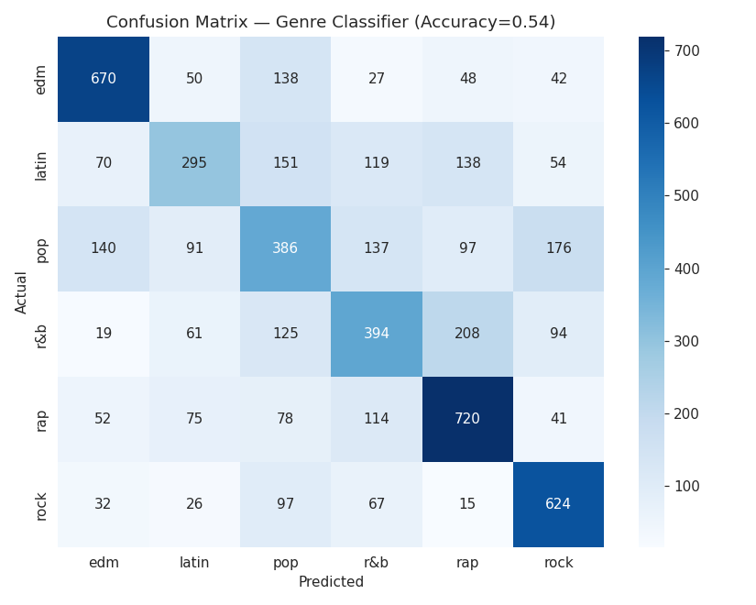
Figure 14. Confusion matrix for the genre classifier.
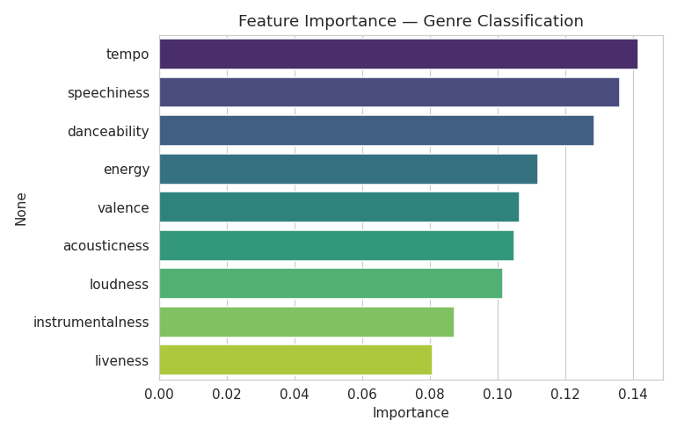
Figure 15. Random Forest feature importances.
Accuracy of 54.5% is more than three times the random baseline, showing that audio features carry real, usable signal about genre — but the imperfect accuracy is itself informative: it quantifies how much of "genre" is acoustic versus cultural. tempo, speechiness and danceability were the most predictive features.

8. Recommendation System
A lightweight, explainable content-based recommender was built in two stages:
- Coarse filter: restrict candidate tracks to the seed track's own K-Means cluster (the same broad "sound neighborhood").
- Fine ranking: within that cluster, rank candidates by cosine similarity of their standardized 9-dimensional audio-feature vectors to the seed track, returning the top-N most sonically similar tracks.
This approach is fast (no need to compare against the entire catalog), interpretable (every recommendation can be explained by shared audio characteristics), and extensible — a production system could layer in collaborative-filtering signals (skips, saves, co-occurrence in user playlists) on top of this acoustic backbone.
Example: seeding with a rock track ("Mr. Brownstone" — Guns N' Roses) returned other hard-rock/permanent-wave tracks with 0.89–0.96 cosine similarity, all sharing the seed's high-energy, guitar-driven acoustic profile — confirming the recommender surfaces genuinely similar-sounding music rather than just same-genre tracks.

9. Conclusion & Key Takeaways
- The dataset is well-balanced across 6 genres and 24 subgenres, with no missing audio-feature data requiring imputation.
- Popularity is essentially uncorrelated with raw audio features — a track's sound alone does not explain how popular it becomes.
- Energy, loudness and acousticness are tightly interrelated, as are danceability and valence.
- Unsupervised clustering recovers genre structure only partially (silhouette ≈ 0.16-0.20 at k=6), reflecting that genre is a blend of acoustic and cultural signal.
- A supervised Random Forest reaches ~54.5% accuracy predicting genre from audio features — solid, well above chance, but bounded by genuine acoustic overlap between genres like pop and r&b.
- A simple, explainable content-based recommender (cluster filter + cosine similarity) produces sonically coherent song recommendations and forms a strong baseline for a production recommendation system.

10. Tools & Methods Used
Python (pandas, NumPy, matplotlib, seaborn, scikit-learn). Preprocessing: pandas. Clustering: K-Means with StandardScaler-scaled features, PCA for 2-D visualization, silhouette score for validation. Classification: RandomForestClassifier. Recommendation: cosine similarity (scikit-learn) within K-Means cluster neighborhoods. Full reproducible code is provided in the accompanying Jupyter notebook, Spotify_Genre_Segmentation.ipynb.

