GitLab 8.0.4 Server Setup Documentation on Ubuntu 14.04

Table of Contents
- Introduction.................................................................................

- Requirements ............................................................................

- Installation types............................................................................

- GitLab CE Omnibus package installation.......................

- Manual step by step installation............................................

- Gitlab Login............................................................................

- Pulling repository using Eclipse...............

- Pushing to remote Repository using Eclipse........

9.References

10.Documentation Control

Introduction
GitLab is a web-based Git repository manager with wiki and issue tracking features. GitLab offers hosted accounts similar to GitHub, but also allows its software to be used on third-party servers,discuss issues, plan milestones,do code reviews and make line comments. It also allows to mention your colleagues anywhere and view activity streams of projects or people.GitLab has integrations for tons of tools such as Slack, Hipchat, LDAP, JIRA, Jenkins, many types of hooks and a complete API.
It is available as an Omnibus package which takes care of installing and setting all the dependencies along with Gitlab. GitLab is free and is distributed under the MIT License

Requirements
There are many issues with ubuntu 15.04 like gitlab omnibus installation package for Ubuntu 14.04 (Omnibus package for Ubuntu 15.04 is not available as of now)will not run on it or on reboot system sometimes will give "System running on low graphics mode" error or Login page will get stuck in loop and user will not be able to log into the system. Best solution for this is to use Ubuntu 14.04.

Installation includes:
- Packages / Dependencies
- Curl
- Openssh-server
- Ca-certificates
- Postfix
- Git
- Ruby
- Database (Omnibus package contains Postgresql)
- Redis
- Nginx
- Gitlab

Installation types
- GitLab CE Omnibus package (Recommended)
- Manual

GitLab CE Omnibus package installation

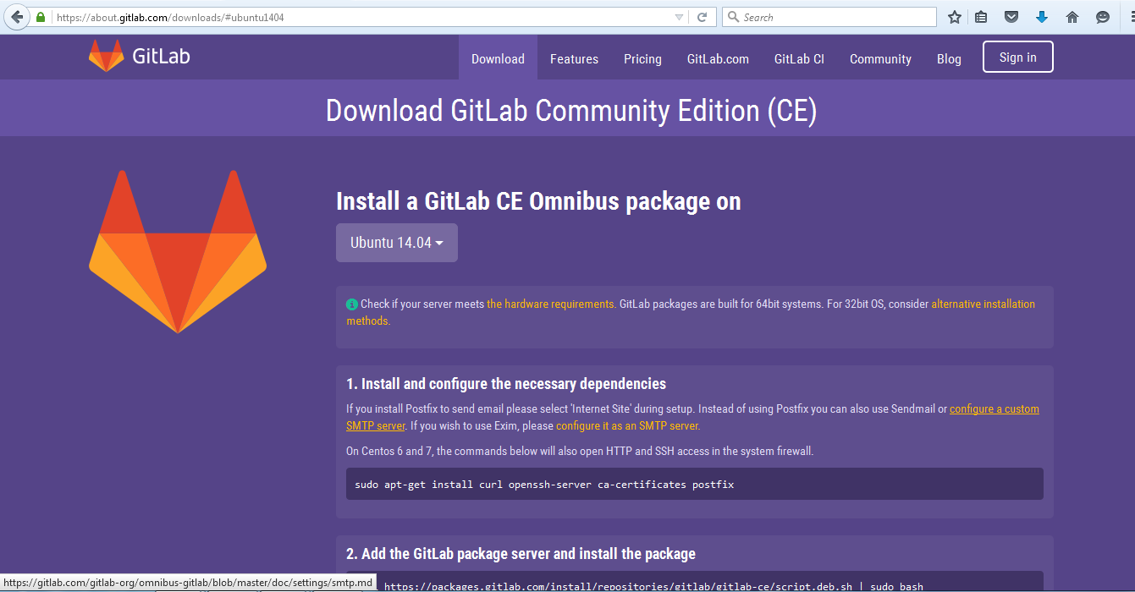

This package contains all the required components like Ruby,Postgresql,Redis,Nginx and Gitlab etc. When installing the package all manual steps for setting this components are executed automatically. So we don't have to set them one by one and installation is done and ready to use in just 2 mins
Check if your server meets the hardware requirements. GitLab packages are built for 64bit systems. For 32bit OS, consider alternative installation methods.
- Install and configure the necessary dependencies
If you install Postfix to send email please select 'Internet Site' during setup. Instead of using Postfix you can also use Sendmail or configure a custom SMTP server.

On Centos 6 and 7, the commands below will also open HTTP and SSH access in the system firewall.
sudo apt-get install curl openssh-server ca-certificates postfix

- Add the GitLab package server and install the package
curl https://packages.gitlab.com/install/repositories/gitlab/gitlab-ce/script.deb.sh | sudo bash sudo apt-get install gitlab-ce
If the script above does not work please download the .deb package manually from this page by clicking on Download link on the top right corner:
https://packages.gitlab.com/gitlab/gitlab-ce/packages/ubuntu/trusty/gitlab-ce_8.0.4-ce.1_amd64.deb
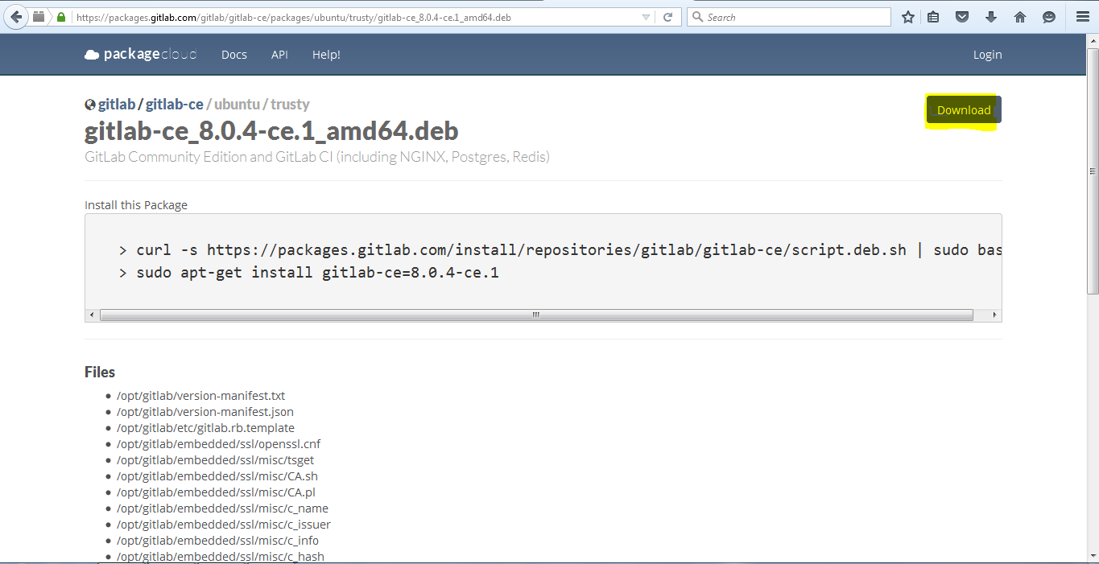
Install the package using:
dpkg -i gitlab-ce_8.0.4-ce.1_amd64.deb
- Configure and start GitLab
Set External-Url as URL you want to set as your Gitlab home.
sudo gitlab-ctl reconfigure

2. Manual Installation
To see all the manual steps for Gitlab installation please visit followng link:
http://doc.gitlab.com/ce/install/installation.html#system-users
You will be taken to a page containing steps for manual installation of Gitlab.
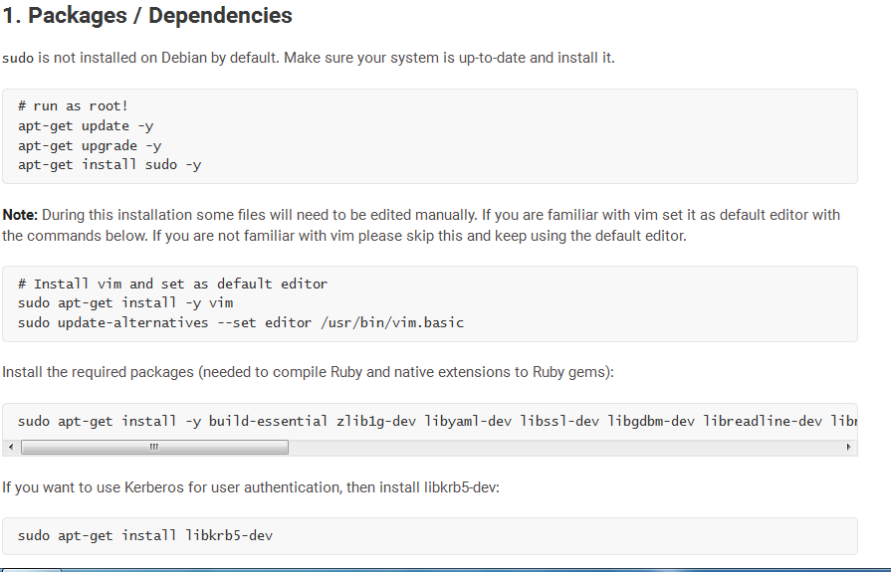

Gitlab Login
After installating Gitlab browse to the hostname that you have set as externalURL in gitlab.rb doc(e.g. http://mastersoft-desktop/) and login using:
Username: root
Password: 5iveL!fe

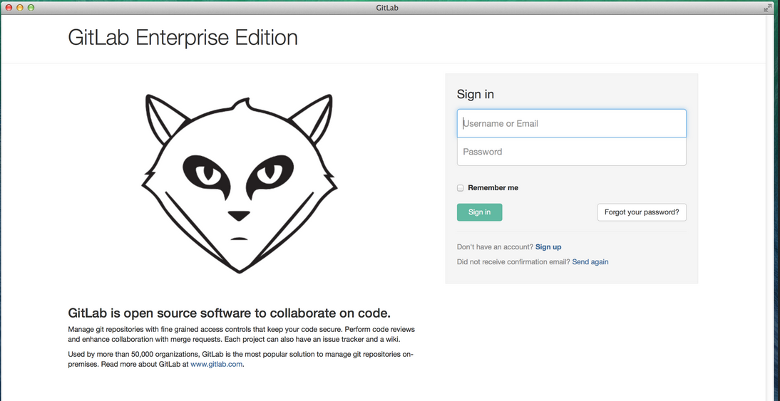

Post login Gitlab willask you to change the password.
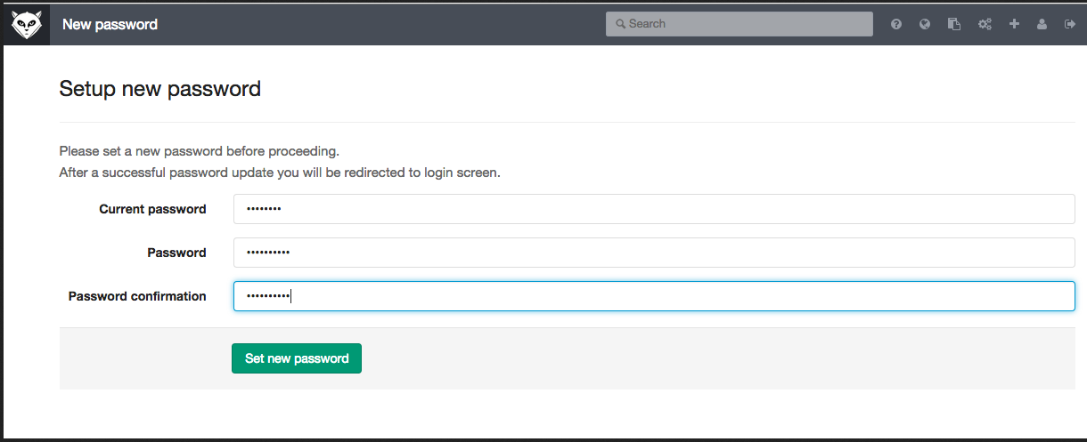

After changing password we are taken back to login screen. Login with username root and your changed password.

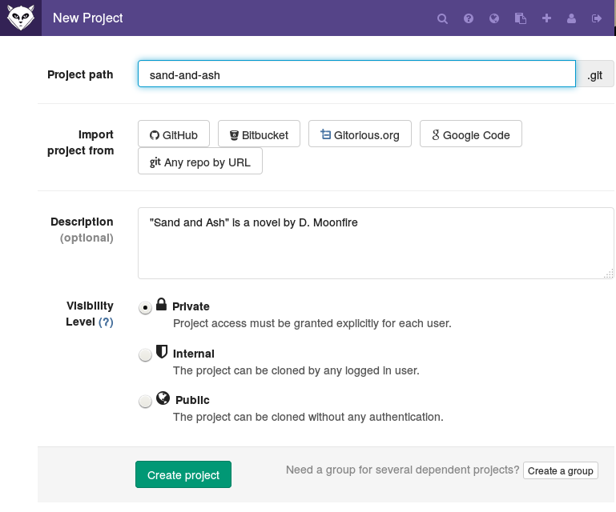
The server steup by us for example is accessed at URL:
http://192.168.0.111/root/Complaint_Module.git
We have used username root
and password iitms123

Pulling repository using Eclipse

Steps for pulling a project into eclipse for the first time.

- Start Eclipse. In project explorer right click and import.

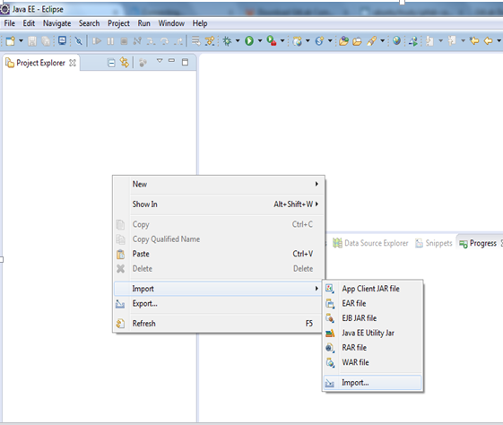

or click on File and import.

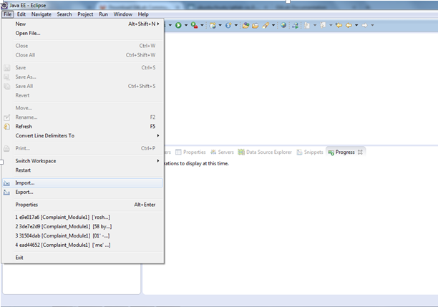

- Inside import popup select Git--> Projects from Git and click Next.

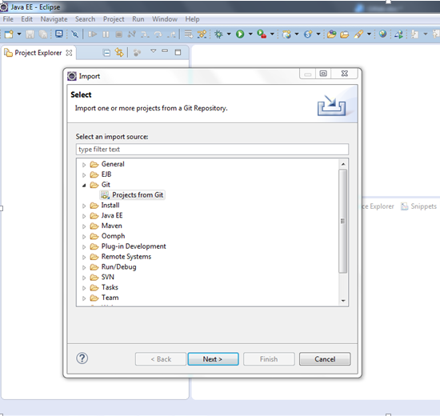

3.Select Clone URI from given options and click Next.

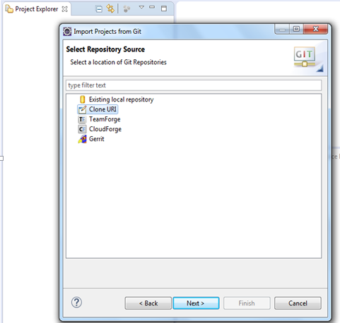

4.Enter the URI,host,remote repository path etc for accessing the repository on server and click Next.

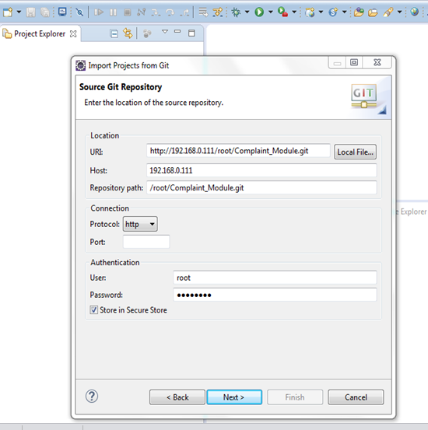

5. Select master branch which is the default main branch of any newly created repository and click Next.

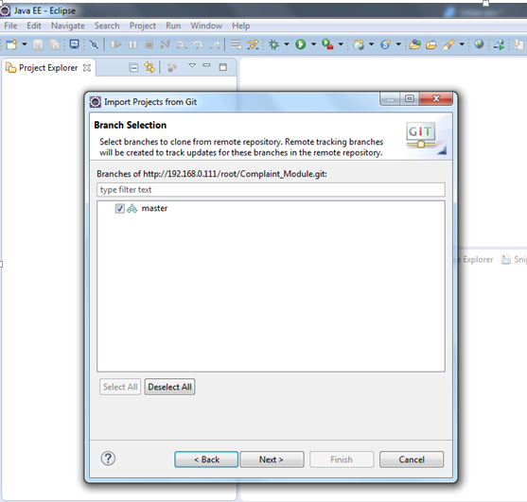

6. Provide a local directory path to store remote repository and click Next.

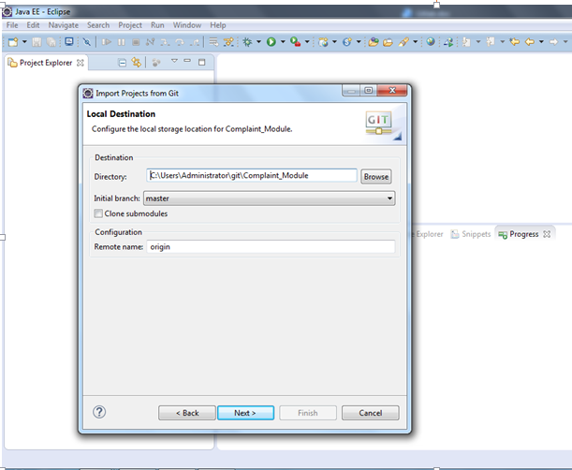

7.Eclipse will start cloning the remote repository to local directory. Click Next.

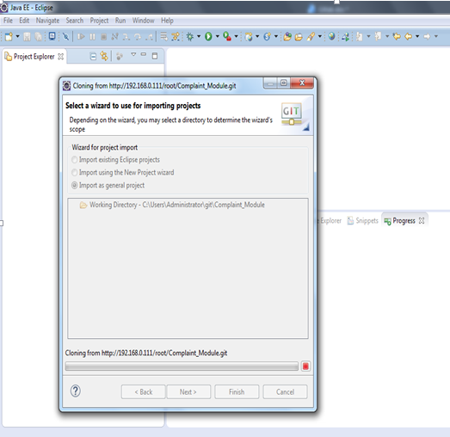

8. Then it will import the repository into your current workspace. Click Finish..

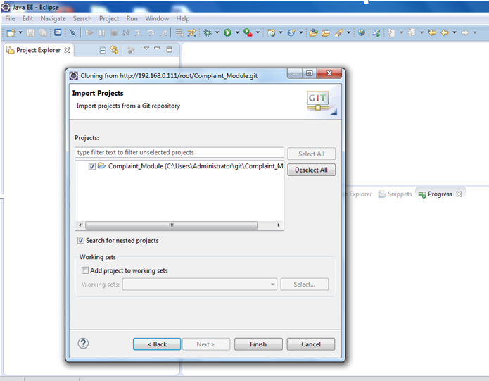

9.This is how your project imported as a repostory will look like in Eclipse workspace.

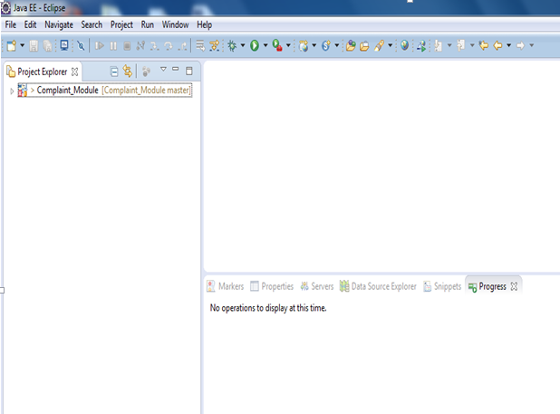

REFERENCES

Apache Tomcat:
http://tomcat.apache.org/

First Servlet Creation:
http://www.srccodes.com

DOCUMENT CONTROL

Change History

Version | Date | Author | Approver | Comment
0.1 | 09/10/2015 | Vaishnavi Gharote |  | First draft version

Open Issues

Opening Version | Date | Author | Action | Owner | Status | Closing version

