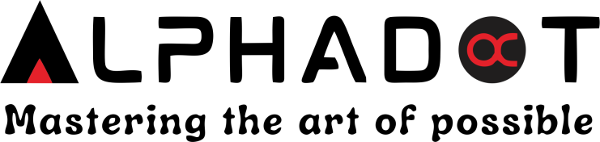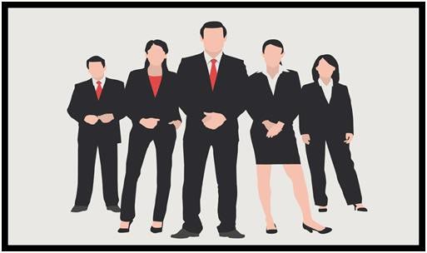

Dress code and Appearance



# Formal Attire:

A formal dress code policy typically requires employees to dress professionally in business attire. The policy generally outlines guidelines for clothing, footwear and accessories.

* **Clothing**: Men may be required to wear shirt, Trousers. Women may be required to wear formal

tops, shirts, trousers, Kurtas etc. Clothing should be conservative in colour and style.

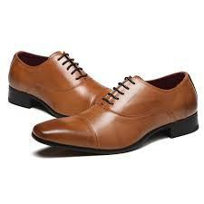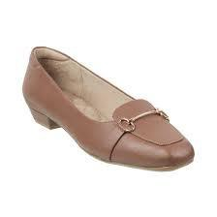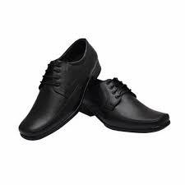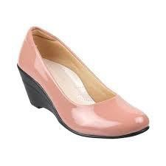

* **Footwear:** Dress shoes are typically required for men and women. Which includes leather shoes, loafers, boots, formal shoes, *sandals*, ballerinas, slip-on *shoes.*
* **Accessories:** Jewellery and other accessories should be understated and conservative. Excessive or distracting accessories should be avoided.

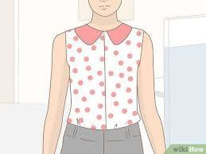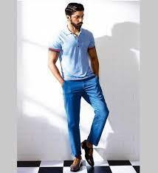

# Smart Casuals:

A smart casual dress policy typically refers to a dress code that is less formal than traditional business attire but still looks professional. Here are some key points what might be considered appropriate in a smart casual dress code:

* For men, T-shirt, Polo-shirt, jeans etc. are a good option.
* Women may wear dress pants, T-shirts, tops, jeans should be appropriate. Avoid wearing anything too casuals

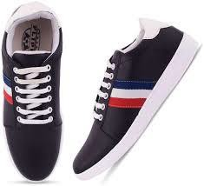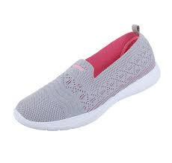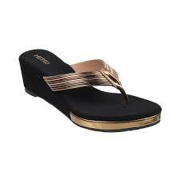

* Both men and women should choose shoes that are clean and in good condition. Dress

shoes, loafers, or fashionable sneakers are good options.

* Accessories such as belts, watches and jewellery can add a finishing touch to your outfit,

but avoid anything too flashy or distracting.

Ultimately, the specifics of a smart casual dress code can vary depending on the company or event.



# Uniform:

* This dress code policy requires employees to wear a specific uniform that identifies them as part of the organization or company.

# Exceptions:

* Companies should consider allowing for exceptions to the policy in certain circumstances. For example, an employee who has a medical condition may need to wear clothing that differs from the policy to accommodate their needs.

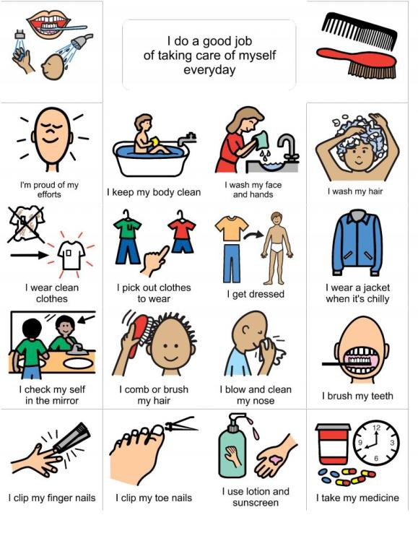

# Grooming and Hygiene:

* Employee should come neatly and cleanly dressed and should be well groomed.
* The dress should be appropriate to the work environment properly ironed with no wrinkles.
* The attire should project professionalism.
* Clean and good shape clothes should be used at work. The clothes with rips, holes or tears are not allowed.
* The attire employees are expected to wear should come under business, business casual, smart casual and casual as per the rules and day allotment done by organization.



* + **Why it is importance?**
  + Professionalism
  + Makes an good impression
  + Maintains the decorum and represents the company
  + Builds an confidence
  + Eliminates the subjectivity or miscommunication.



Thank you!