**Sum of squares**

import java.util.Scanner;

import java.lang.Math;

public class SumOfN {

public static void main(String[] args) {

Scanner s = new Scanner(System.in);

int N = s.nextInt();

// Define an array of integers of size N.

int[] numArray = new int[N];

int sum = 0;

for(int i=0; i<N; i++){

numArray[i] = s.nextInt();

sum=(int)(sum+Math.pow(numArray[i],2));// Get the input

}

//Print the sum

System.out.print(sum);

s.close();

}

}

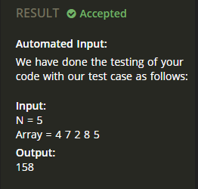

**Sum of N**

import java.util.Scanner;

public class SumOfN {

public static void main(String[] args) {

Scanner s = new Scanner(System.in);

int N = s.nextInt();

// Define an array of integers of size N.

int[] numArray = new int[N];

int sum = 0;

for(int i=0; i<N; i++){

numArray[i] = s.nextInt();

sum=sum+numArray[i];// Get the input

}

// Write the logic to add these numbers here:

// Print the sum

System.out.print(sum);

s.close();

}

}

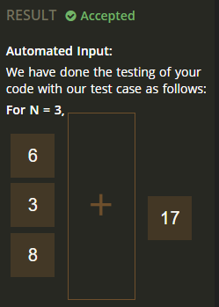

**Write a program to print your name as output**

import java.io.BufferedReader;

import java.io.InputStreamReader;

class TestClass {

public static void main(String args[] ) throws Exception {

BufferedReader br = new BufferedReader(new InputStreamReader(System.in));

// read the name from the input

String line = br.readLine();

// print the name

System.out.println("Hello "+ line);

}

}

