Assignment – 3

Group – 81

Anand Manojkumar Parikh – 20CS10007

Soni Aditya Bharatbhai – 20CS10060

1. Half Adder

Logic :

s = a ^ b

c = a & b

Truth Table :

|  |  |  |  |
| --- | --- | --- | --- |
| a | b | s | c |
| 0 | 0 | 0 | 0 |
| 0 | 1 | 1 | 0 |
| 1 | 0 | 1 | 0 |
| 1 | 1 | 0 | 1 |

Circuit Diagram : 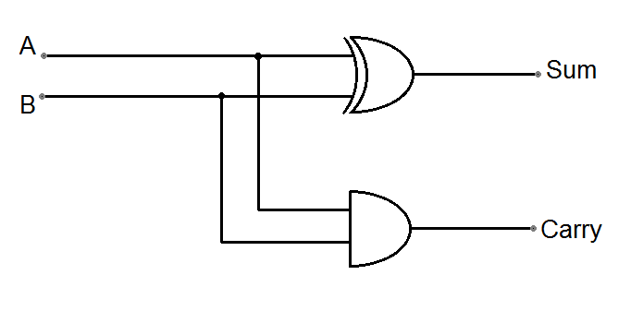

[ A = a , B = b , Sum = s , Carry = c ]

1. Full Adder :

Logic :

s = a ^ b ^ c0

c = ( a & b ) | (c0 & ( a ^ b ))

Truth Table:

|  |  |  |  |  |
| --- | --- | --- | --- | --- |
| a | b | c0 | s | c |
| 0 | 0 | 0 | 0 | 0 |
| 0 | 0 | 1 | 1 | 0 |
| 0 | 1 | 0 | 1 | 0 |
| 0 | 1 | 1 | 0 | 1 |
| 1 | 0 | 0 | 1 | 0 |
| 1 | 0 | 1 | 0 | 1 |
| 1 | 1 | 0 | 0 | 1 |
| 1 | 1 | 1 | 1 | 1 |

Circuit Diagram :

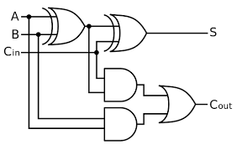

[ A = a , B = b , Cin = c0 , S = s , Cout = c]