INFO 151: Assignment 3 (5’)
To work on the assignment, you may need to refer to related textbook chapters and lecture materials for week 3, located on the class’ Blackboard site, as well as tutorials at: http://www.w3schools.com/JS/.

Please create a directory for this assignment and a web page for each problem.

Problem 1
Write a JavaScript program that prompts the user 3 times for an integer and outputs XHTML text that displays the sum of the integers in that group.

HINT. Use the prompt method in the window object to get each of the 3 numbers. See

http://www.w3schools.com/JS/js_popup.asp

for information on the prompt and alert methods in the window object. The prompt method returns a string value. Since you are asked to perform some addition, you will have to convert the number entered by the user from type string to type number. To do this, you will have to use JavaScript’s parseInt() function, which is described in:

http://www.w3schools.com/jsref/jsref_parseInt.asp

The outline of your program is:
- Declare variables to hold the string version of user input, the numeric version of user input, and the sum of the integers.
- 3 times you
  - prompt the user for a number
  - convert the result to a number
  - add the number to your sum variable
- write the sum into the XHTML document for display.

Problem 2
Write a script that
- Asks the user to enter his name (See Figure 1.)
- Determines the current hour of the day and
- Prints “Good Morning” if the hour is between 0 and 12 (Note, for convenience we’ll use the military 24-hour clock), or
- Prints “Good Afternoon” if the hour is > 12 and less than 18, or
- Prints “Good Night” if the hour > 18 and < 24. (See Figure 2)

You will need some additional JavaScript skills to do this. First, JavaScript provides an object Date that contains the method getHours(). Convenient, eh? getHours() returns a number between 0 and 24 (the military time), which is just what is needed. Date is a little different from other objects we have studied (document, window, etc.). In order to use the Date facilities we need to create a new Date object. This is done as shown in the line below:

var myDate=new Date();

The variable myDate is the name of a new Date object, which is initialized to the current date and time; and contains several useful methods for dealing with date calculations. See:

http://www.w3schools.com/jS/js_obj_date.asp

for more details.

The next bit of new JavaScript needed is the conditional statement, in particular the if statement used when you want to execute some code only if a specified condition is true. The syntax s

if (condition)
{
code to be executed if condition is true
}

More information is available at

http://www.w3schools.com/JS/js_if_else.asp

Basically, then, you create a new Date object, extract the hours, do some testing using if statements and print the appropriate greeting.

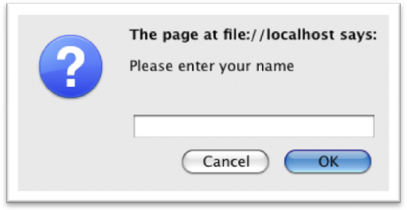
Figure 1. Problem 2 -= ask user for name
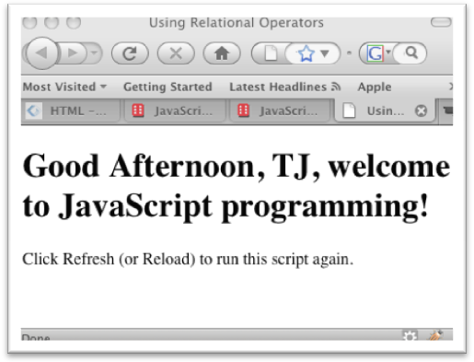
Figure 2. Afternoon Greeting

Problem 3.
Design an XHTML form:
- Include a text input box for the user to enter a name;
- Include a “Say Hello” button in the form;

When the user clicks on the “Say Hello” button, show a welcome message “Welcome, [Name]!” in an alert window. ([Name] is whatever the user puts in the text box.)

Hint: Register the onclick event to the button and use window.alert to display the message. Be sure to give the form and the text input box a name so that you can refer to it using something like document.yourform.yourname.value.

Problem 4
Write a script that reads two integers from the user and determines if the first is a multiple of the second. Produce an HTML page that displays the 2 numbers and a “Yes” if the first is a multiple of the second, a “No” if not.

Hint: Use the modulus operator, i.e., %.

After you are done with all problems, upload all four pages/solutions (with scripting codes) to your web site. On one entry page (e.g., your index.html page), provide links to the four pages above. Submit the link to the entry page (ONE link only) to assignment 3 on blackboard.

