Anand Patel

EN.645.621

Project 1

**Task 1** – NIRSLab was downloaded

Nirslab was downloaded for neural data analysis.

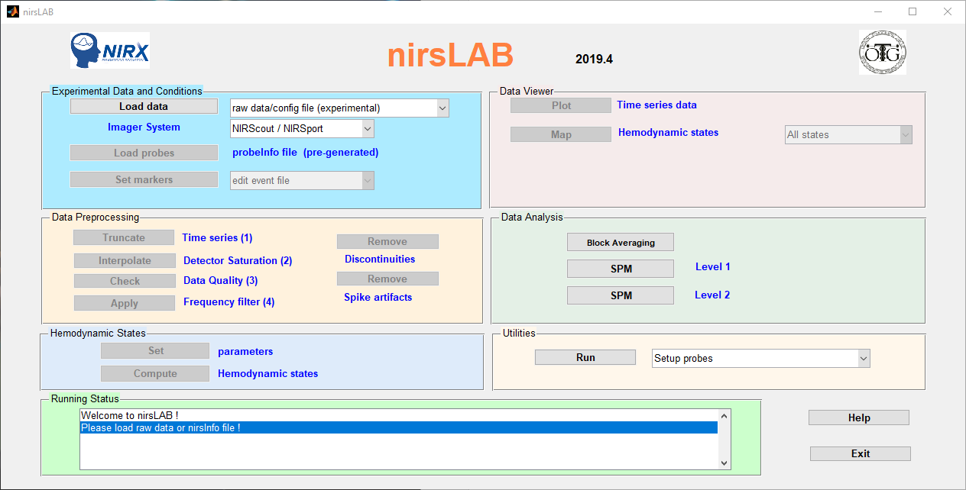

Figure - Initial nirsLAB screen

We are using Subject 1’s channel 13 data.

The sampling rate is 7.8 Hz. 55 data points in the block averages start.

There is a hemodynamic response delay of 55 seconds.

**Task 2** – Pre-processing subjects’ neural data

I used demo data for this task to demonstrate pre-processing subject’s neural data.

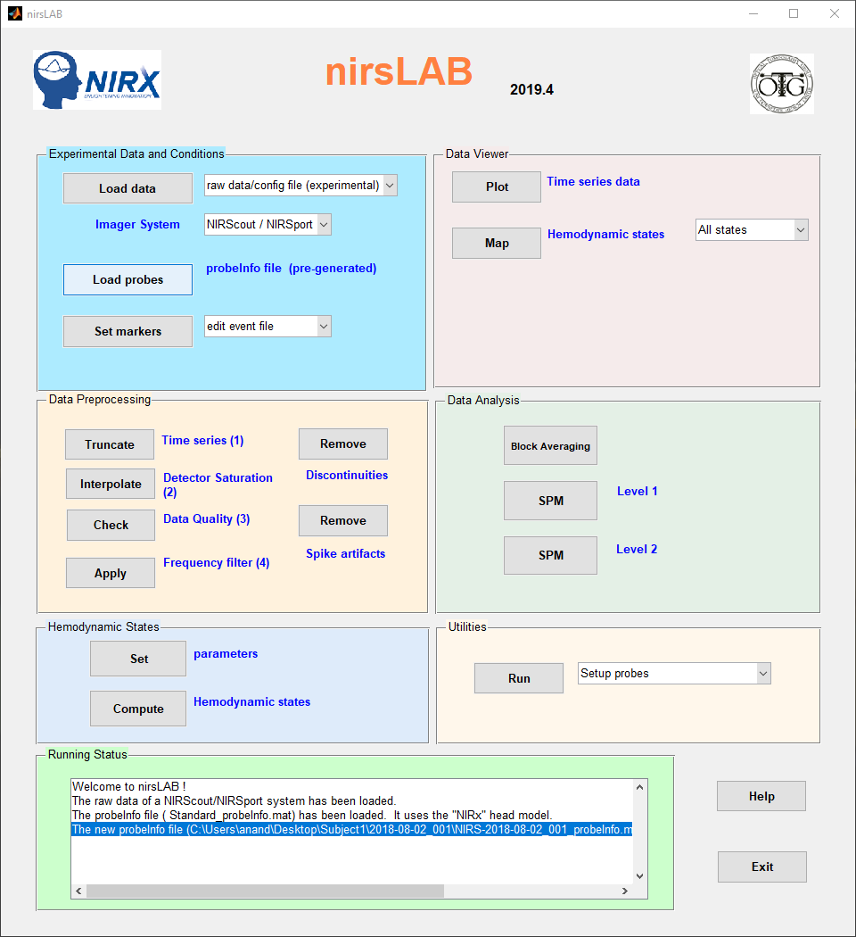

Figure - Loaded configuration file and probe file

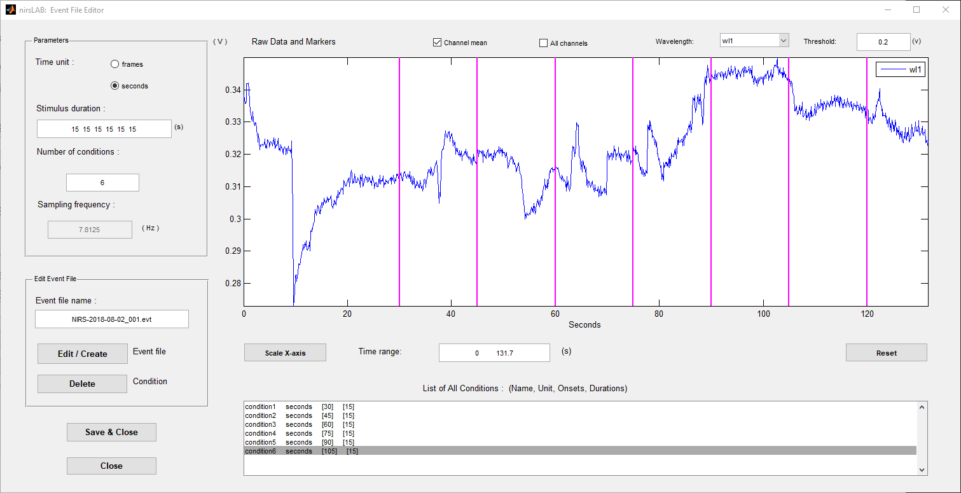

Figure 3 - adding multiple conditions

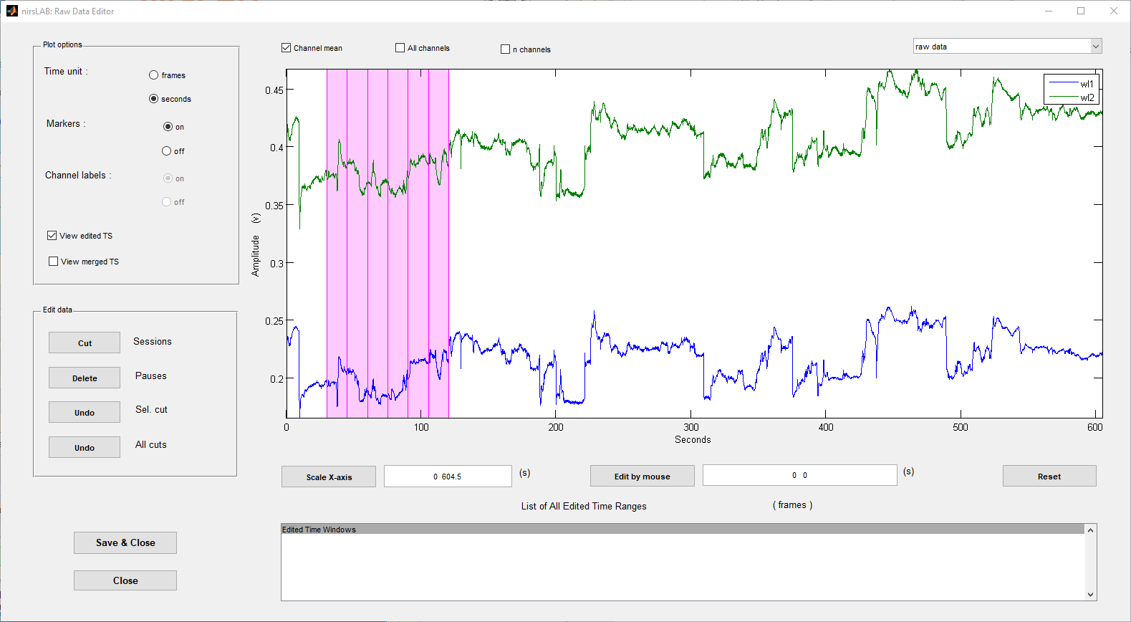

Figure 4: Truncation

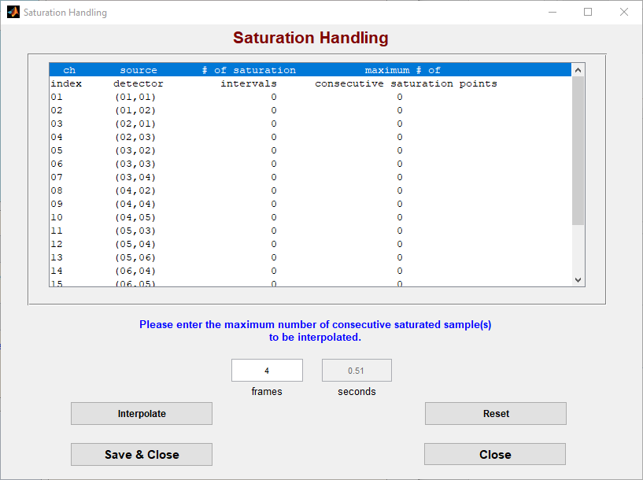

Figure 5: Saturation Handling

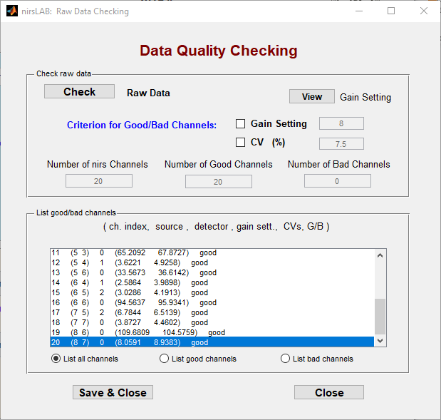

Figure 6: Data Quality Checking

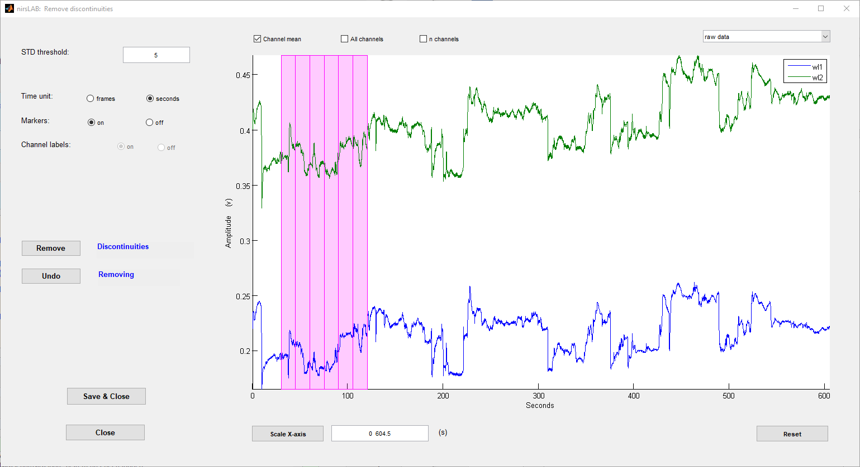

Figure 7: Did not remove any discontinuities

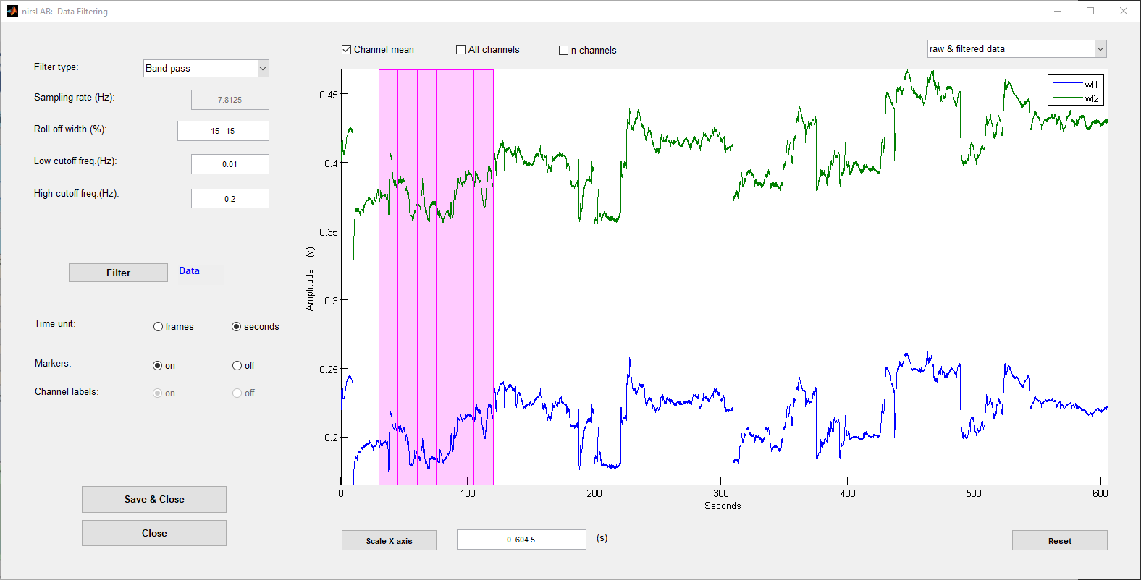

Figure 8: Did not apply any filters

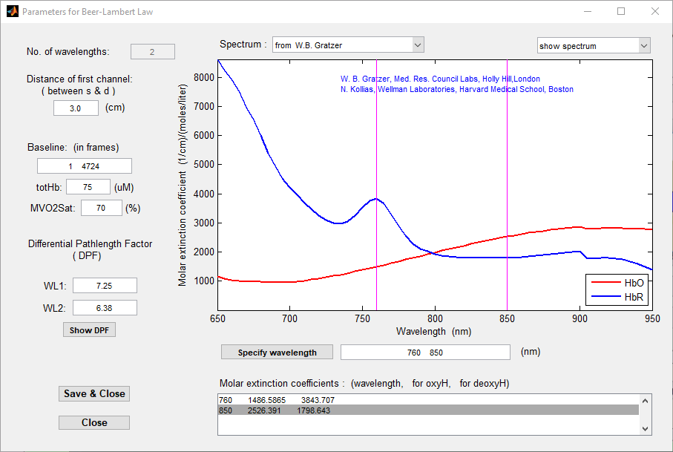

Figure 9: Beer-Lambert Law

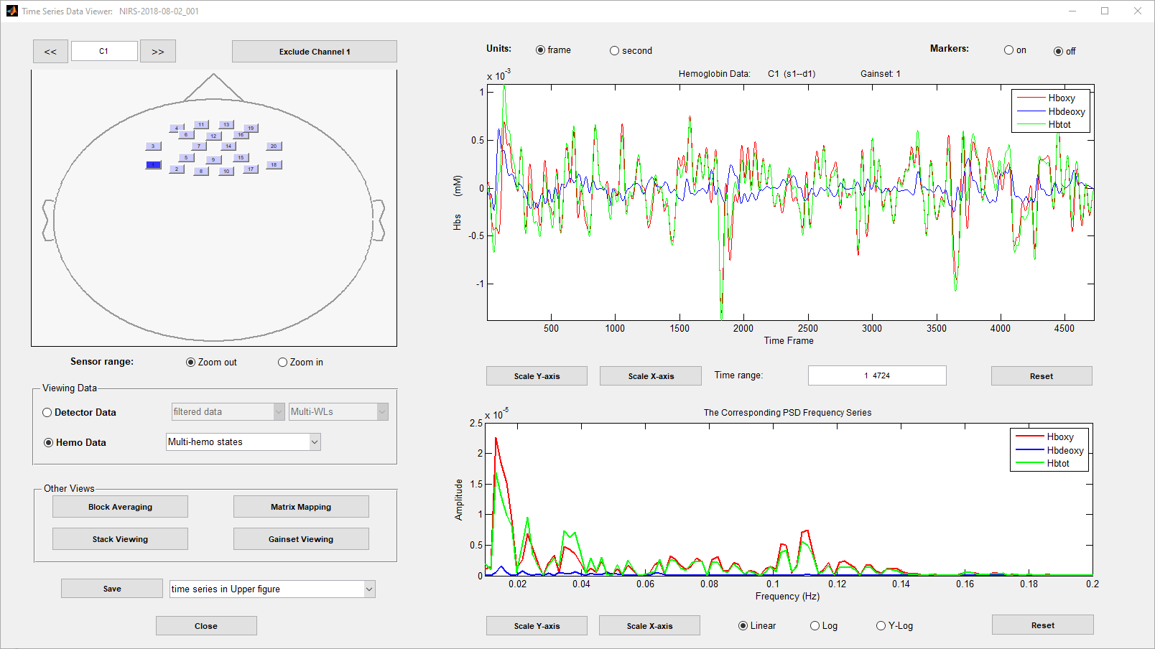

Figure 10: Channel 13

**Task 3** – Analysis of channel 13 for all subjects. Title should have been changed to right pole activity.

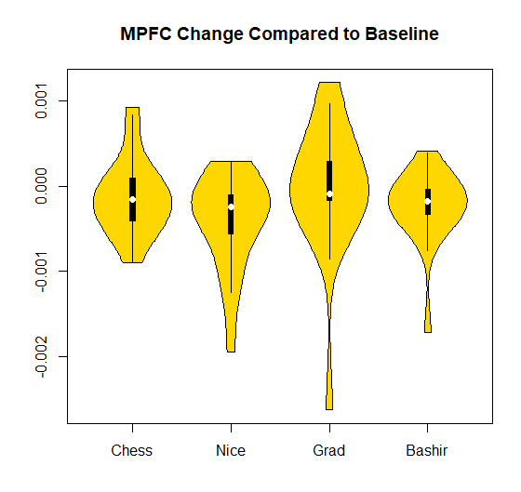

Figure 11 - rPFC Activity

One Sample t-test

data: HbO$A

t = -1.2696, df = 17, p-value = 0.2213

alternative hypothesis: true mean is not equal to 0

95 percent confidence interval:

-0.0003483271 0.0000866077

sample estimates:

mean of x

-0.0001308597

> t.test(HbO$B, mu=0)

One Sample t-test

data: HbO$B

t = -3.0922, df = 17, p-value = 0.006614

alternative hypothesis: true mean is not equal to 0

95 percent confidence interval:

-0.0006880577 -0.0001299411

sample estimates:

mean of x

-0.0004089994

> t.test(HbO$C, mu=0)

One Sample t-test

data: HbO$C

t = -0.14068, df = 17, p-value = 0.8898

alternative hypothesis: true mean is not equal to 0

95 percent confidence interval:

-0.0004210853 0.0003684412

sample estimates:

mean of x

-2.632207e-05

> t.test(HbO$D, mu=0)

One Sample t-test

data: HbO$D

t = -2.3263, df = 17, p-value = 0.03263

alternative hypothesis: true mean is not equal to 0

95 percent confidence interval:

-0.0004583642 -0.0000223683

sample estimates:

mean of x

-0.0002403663

**The p-value is not high enough to reject the hypothesis.**

**Task 4** – Analysis of variance for differences in action for channel 13

Df Sum Sq Mean Sq F value Pr(>F)

ind 3 1.444e-06 4.815e-07 1.45 0.236

Residuals 68 2.258e-05 3.321e-07

20 observations deleted due to missingness

**The summary states the the value is not enough to reject the hypothesis.**

**Task 5** – regression model to estimate the impact of channel 13 brain activation on a change in sectarianism

> t.test(score~sect,sec.test) #Is there a difference in sectarianism Shi'a Sunni

Welch Two Sample t-test

data: score by sect

t = -0.13532, df = 19.692, p-value = 0.8937

alternative hypothesis: true difference in means is not equal to 0

95 percent confidence interval:

-1.493720 1.311902

sample estimates:

mean in group Shi'a mean in group Sunni

3.534091 3.625000

> #Test effect of neural activity on change in behavior (sectarianism)

> mod1<-lm(ch.sec~HbO$A + sec.test$sect)

> summary(mod1)

Call:

lm(formula = ch.sec ~ HbO$A + sec.test$sect)

Residuals:

Min 1Q Median 3Q Max

-3.4970 -1.6395 0.3038 1.1885 4.9426

Coefficients:

Estimate Std. Error t value Pr(>|t|)

(Intercept) -0.4910 0.7059 -0.696 0.497

HbO$A 350.2559 1205.9044 0.290 0.775

sec.test$sectSunni 0.1142 1.0314 0.111 0.913

Residual standard error: 2.174 on 15 degrees of freedom

(5 observations deleted due to missingness)

Multiple R-squared: 0.006421, Adjusted R-squared: -0.1261

F-statistic: 0.04847 on 2 and 15 DF, p-value: 0.9528

> mod2<-lm(ch.sec~HbO$B + sec.test$sect)

> summary(mod2)

Call:

lm(formula = ch.sec ~ HbO$B + sec.test$sect)

Residuals:

Min 1Q Median 3Q Max

-3.6773 -1.6632 0.2961 1.2280 4.6661

Coefficients:

Estimate Std. Error t value Pr(>|t|)

(Intercept) -0.4228 0.7616 -0.555 0.587

HbO$B 329.4530 945.9900 0.348 0.732

sec.test$sectSunni 0.1608 1.0382 0.155 0.879

Residual standard error: 2.172 on 15 degrees of freedom

(5 observations deleted due to missingness)

Multiple R-squared: 0.008847, Adjusted R-squared: -0.1233

F-statistic: 0.06694 on 2 and 15 DF, p-value: 0.9355

> mod3<-lm(ch.sec~HbO$C + sec.test$sect)

> summary(mod3)

Call:

lm(formula = ch.sec ~ HbO$C + sec.test$sect)

Residuals:

Min 1Q Median 3Q Max

-3.5874 -1.7617 0.2848 1.1414 4.8631

Coefficients:

Estimate Std. Error t value Pr(>|t|)

(Intercept) -0.5372 0.6893 -0.779 0.448

HbO$C 66.0409 666.2896 0.099 0.922

sec.test$sectSunni 0.1189 1.0344 0.115 0.910

Residual standard error: 2.18 on 15 degrees of freedom

(5 observations deleted due to missingness)

Multiple R-squared: 0.001486, Adjusted R-squared: -0.1316

F-statistic: 0.01117 on 2 and 15 DF, p-value: 0.9889

> mod4<-lm(ch.sec~HbO$D + sec.test$sect)

> summary(mod4)

Call:

lm(formula = ch.sec ~ HbO$D + sec.test$sect)

Residuals:

Min 1Q Median 3Q Max

-3.5680 -1.7563 0.2243 1.1615 4.9217

Coefficients:

Estimate Std. Error t value Pr(>|t|)

(Intercept) -0.5631 0.7775 -0.724 0.480

HbO$D -86.8075 1218.7212 -0.071 0.944

sec.test$sectSunni 0.1263 1.0449 0.121 0.905

Residual standard error: 2.18 on 15 degrees of freedom

(5 observations deleted due to missingness)

Multiple R-squared: 0.00117, Adjusted R-squared: -0.132

F-statistic: 0.008788 on 2 and 15 DF, p-value: 0.9913

> #Test impact of age, education, and identification

> dem<-surv.data[,c(11,12,25,30,35,40)]

> dem1<-dem[1:23,]

> dem1[4,]<-dem[5,]

> dem1[5,]<-dem[4,]

> dem1[22,]<-dem[24,]

> dem.test<-data.frame(sec[1:23],sec1.sect,dem1)

> names(dem.test)<-c("score","sect","age","educ","ID1","ID2","ID3","ID4")

> mod5<-lm(HbO$C~dem.test$age + dem.test$educ + dem.test$ID3 + dem.test$sect +dem.test$score)

> summary(mod5)

Call:

lm(formula = HbO$C ~ dem.test$age + dem.test$educ + dem.test$ID3 +

dem.test$sect + dem.test$score)

Residuals:

Min 1Q Median 3Q Max

-0.0019520 -0.0003152 0.0000681 0.0004779 0.0010872

Coefficients:

Estimate Std. Error t value Pr(>|t|)

(Intercept) 1.716e-03 1.788e-03 0.959 0.360

dem.test$age -1.014e-04 7.498e-05 -1.353 0.206

dem.test$educHS -2.076e-04 5.843e-04 -0.355 0.730

dem.test$educMA 1.328e-03 9.858e-04 1.348 0.208

dem.test$ID3 -1.564e-04 1.962e-04 -0.797 0.444

dem.test$sectSunni -3.626e-04 4.624e-04 -0.784 0.451

dem.test$score 3.099e-04 1.929e-04 1.607 0.139

Residual standard error: 0.0008601 on 10 degrees of freedom

(6 observations deleted due to missingness)

Multiple R-squared: 0.3094, Adjusted R-squared: -0.105

F-statistic: 0.7466 on 6 and 10 DF, p-value: 0.6257

> mod6<-lm(HbO$C~ dem.test$ID3)

> summary(mod6)

Call:

lm(formula = HbO$C ~ dem.test$ID3)

Residuals:

Min 1Q Median 3Q Max

-0.0024877 -0.0001898 -0.0001100 0.0005650 0.0012741

Coefficients:

Estimate Std. Error t value Pr(>|t|)

(Intercept) 1.039e-04 3.274e-04 0.317 0.755

dem.test$ID3 -8.083e-05 1.648e-04 -0.490 0.631

Residual standard error: 0.0008122 on 16 degrees of freedom

(5 observations deleted due to missingness)

Multiple R-squared: 0.0148, Adjusted R-squared: -0.04677

F-statistic: 0.2404 on 1 and 16 DF, p-value: 0.6305