DESIGN AND SIMULATION OF A MICROSTRIP SLOT ANTENNA FOR 2.4 GHz WIRELESS COMMUNICATION APPLICATIONS USING CST

23VA1015- ANTENNA DESIGN USING EM SIMULATOR

A PROJECT REPORT

Submitted by
ANAND P 2023PECEC561
BAALAMURUGAN K M 2023PECEC577
ABENESH R 2023PECEC309
in partial fulfilment for the award of the degree
of

BACHELOR OF ENGINEERING
IN

ELECTRONICS AND COMMUNICATION ENGINEERING


PANIMALAR ENGINEERING COLLEGE
(An Autonomous Institution, Affiliated to Anna University, Chennai)

SEPTEMBER 2026

PANIMALAR ENGINEERING COLLEGE
(An Autonomous Institution, Affiliated to Anna University, Chennai)

BONAFIDE CERTIFICATE

Certified that this project report “DESIGN AND SIMULATION OF A MICROSTRIP SLOT ANTENNA FOR 2.4 GHz WIRELESS COMMUNICATION APPLICATIONS USING CST” is the bonafide work of ANAND P (2023PECEC561), BAALAMURUGAN K M (2023PECEC577), ABENESH R (2023PECEC309), who carried out the project work under my supervision.

Dr. S. RAJAKUMAR, M.E., Ph.D., Mrs. N. PRITHA, M.E., (Ph.D).,
HEAD OF THE DEPARTMENT SUPERVISOR
Department of Electronics and Department of Electronics and Communication Engineering, Communication Engineering, Panimalar Engineering College, Panimalar Engineering College, Chennai -600 123. Chennai -600 123.

ABSTRACT

This project presents the design and simulation of a microstrip-line-fed rectangular slot antenna for the 2.4 GHz ISM band (Wi-Fi and Bluetooth) applications. The antenna is built on a 1.6 mm FR4 substrate. A half-wavelength slot is etched in the ground plane and is excited by a 50 Ω microstrip line on the opposite face, which ends in an open-circuited stub of about a quarter of a guided wavelength. The initial dimensions of the slot, the feed line and the ground plane are calculated from standard design equations and the antenna is then simulated in CST Studio Suite. The simulated S₁₁ shows a resonance at 2.416 GHz with a minimum of −6.16 dB (VSWR about 2.9), and the 3D far-field plot gives a directivity of 4.98 dBi with a total efficiency of −2.05 dB. The matching has not yet reached the −10 dB level, so further tuning of the feed stub and slot dimensions is identified as the next step.

TABLE OF CONTENTS

CHAPTER TITLE PAGE

ABSTRACT iv
LIST OF FIGURES vii
I INTRODUCTION
  - Slot Antenna 2
    - Introduction 2
    - Need for Slot Antenna 3
    - Applications 3
  - Objective 3
- LITERATURE SURVEY
  - Review of Literature 6
- PROPOSED SYSTEM
  - Proposed Project 11
  - Antenna Description 11
  - Design Formulas 12
  - Design Calculations 13
- RESULTS AND DISCUSSIONS
  - S₁₁ Response 15
  - Surface Current Distribution 16
  - Far Field 3D Response 16
  - Far Field 1D Response 17
- CONCLUSION
  - Conclusion 19
REFERENCES 20

LIST OF FIGURES

Fig. 1.1 A slot and its complementary dipole 2
Fig. 3.1 Geometry of the proposed slot antenna 12
Fig. 4.1 Simulated S₁₁ response 15
Fig. 4.2 Surface current distribution 16
Fig. 4.3 Far-field 3D response 17
Fig. 4.4 Far-field 1D radiation pattern (Phi = 90°) 17

Chapter I INTRODUCTION

Slot Antenna

Introduction
A slot antenna consists of a narrow opening, or slot, cut in a large conducting surface such as a ground plane or the wall of a waveguide. When the slot is excited by an RF source it radiates electromagnetic energy into the space on both sides of the surface. A slot that is about half a wavelength long behaves much like a half-wave dipole, and the slot antenna is, in fact, the complement of the dipole antenna.
This relationship is explained by Babinet’s principle. The field radiated by a slot is the same as that of a dipole of the same size, except that the electric and magnetic fields are interchanged. The radiation pattern of a slot is therefore that of the dipole, but its polarisation is rotated by 90°; for a horizontal slot the electric field is vertical, as shown in Fig 1.1.
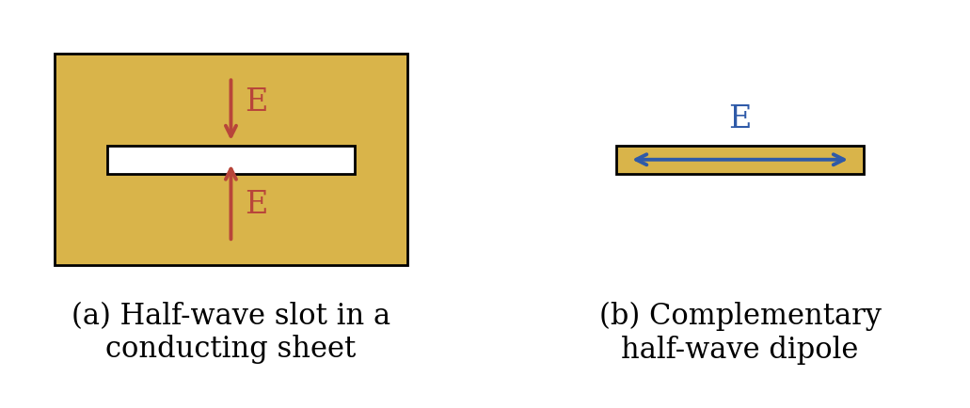
Fig 1.1 A slot and its complementary dipole (Babinet’s principle)
In printed form, the slot is etched in the ground plane of a dielectric substrate and is fed by a microstrip line, a coplanar waveguide or a probe. Such a printed slot antenna can be made with the ordinary PCB process and is compatible with planar RF circuits, so it is widely used in modern wireless devices.

Need for Slot Antenna
Modern wireless systems need antennas that are small, light, cheap and easy to integrate with the rest of the circuit. The slot antenna is attractive for these reasons:
- Low profile: the slot is cut in an existing metal surface, so the antenna can be mounted flush without any projecting parts.
- Simple and low-cost fabrication: the slot and the feed line are produced together by standard PCB etching.
- Easy integration: the planar structure can be fed by a microstrip line and combined with other planar RF circuits on the same board.
- Good bandwidth: a printed slot gives a wider impedance bandwidth than a conventional microstrip patch, and the bandwidth can be increased further by widening the slot.
- Dipole-like radiation: it gives a bidirectional, dipole-like pattern with linear polarisation, which suits many access-point and indoor links.

Applications
Slot antennas are used wherever a compact, flush-mounted or planar radiator is needed. Typical applications are:
- Wi-Fi and Bluetooth devices operating in the 2.4 GHz band, such as routers, laptops and IoT nodes.
- Flush-mounted antennas on aircraft, vehicles and other metallic bodies.
- RFID readers and tags, and wireless sensor networks.
- Waveguide slot arrays used in radar and communication systems.

Objective
The aim of this project is to design and analyse a slot antenna using CST Studio Suite. The specific objectives are:
- To understand the principle of operation of a slot antenna.
- To calculate the dimensions of a microstrip-line-fed rectangular slot antenna for the 2.4 GHz band using standard design equations.
- To model the antenna in CST Studio Suite and tune its dimensions for good impedance matching.
- To study the S₁₁ response, surface current distribution, far-field gain and radiation patterns of the antenna.

Chapter II LITERATURE SURVEY

REVIEW OF LITERATURE
- Title: Slot Aerials and Their Relation to Complementary Wire Aerials (Babinet’s Principle)
Author: H. G. Booker
Source & Year: Journal of the IEE, Part IIIA, 1946
This paper shows that a slot cut in a conducting sheet is the complement of a wire antenna of the same shape: the two radiate the same pattern with the electric and magnetic fields interchanged. It forms the theoretical basis for the design of slot antennas, including the half-wave slot used in this project.
- Title: A Microstripline Slot Antenna
Author: Y. Yoshimura
Source & Year: IEEE Transactions on Microwave Theory and Techniques, 1972
The paper describes a slot made in the ground plane of a microstrip line and excited directly by the line. It gives a planar antenna that can be made with printed-circuit technology, which is the basic structure of the printed slot antenna designed in this project.
- Title: Microstrip Antennas
Author: D. M. Pozar
Source & Year: Proceedings of the IEEE, 1992
This review paper explains the basic characteristics of printed antennas, their feeding techniques, the effect of substrate parameters on bandwidth and efficiency, and the analysis methods. It is a useful reference for the substrate selection and feed design of planar slot antennas.
- Title: Bandwidth Enhancement of a Microstrip-Line-Fed Printed Wide-Slot Antenna
Author: J.-Y. Sze and K.-L. Wong
Source & Year: IEEE Transactions on Antennas and Propagation, 2001
The authors show that a wide slot fed by a microstrip line, with a fork-like tuning stub on the feed, gives a much larger impedance bandwidth than a conventional narrow printed slot. They study how the slot size and the feed affect the matching, which is directly useful for tuning the present design.
- Title: Experimental Studies of Printed Wide-Slot Antenna for Wide-Band Applications
Author: Y. F. Liu, K. L. Lan, Q. Xue and C. H. Chan
Source & Year: IEEE Antennas and Wireless Propagation Letters, 2004
A microstrip-fed printed wide-slot antenna with an arc-shaped slot and a square-patch feed is studied experimentally. It reaches an impedance bandwidth of about 120 % (1.82–7.23 GHz), but the board is large (110 mm × 110 mm), which shows the trade-off between bandwidth and size.
- Title: Investigation of Wide-Band Microstrip Slot Antenna
Author: S. K. Sharma, L. Shafai and N. Jacob
Source & Year: IEEE Transactions on Antennas and Propagation, 2004
This work studies a quarter-wavelength slot cut at the edge of a finite ground plane and fed by a microstrip line. The bandwidth can be adjusted through the substrate permittivity and thickness, the slot width and position, and the feed and ground-plane dimensions. An impedance bandwidth of up to about 60 % was obtained at 3 GHz, and a dual complementary slot was also examined for polarisation diversity.

Chapter III PROPOSED

DESIGN

3.1 PROPOSED PROJECT
The proposed project is the design and simulation of a microstrip-line-fed rectangular slot antenna operating in the 2.4 GHz ISM band. A rectangular slot of about half a guided wavelength is etched in the ground plane of a double-sided FR4 substrate and is excited by a 50 Ω microstrip line printed on the opposite face of the substrate. The antenna is simple to fabricate, has a low profile and can be connected directly to planar RF circuits.
The initial dimensions are calculated from the design equations given in Section 3.3. They are then optimised in CST Studio Suite by varying the slot length, the slot width and the length of the feed stub until a good impedance match is obtained at the centre frequency.

ANTENNA DESCRIPTION
The antenna has three parts: the substrate, the ground plane with the radiating slot, and the microstrip feed line. The substrate is FR4 with a relative permittivity of 4.4 and a thickness of 1.6 mm. The top copper layer is the ground plane, and a rectangular slot of length L_{s} and width W_{s} is etched at its centre. On the bottom layer, a 50 Ω microstrip line of width W_{f} runs from the edge of the board, crosses the slot at right angles at its centre and continues beyond it as an open-circuited stub of length L_{f}.
The slot is excited by the current of the microstrip line crossing it. The stub is about a quarter of a guided wavelength long, so the open end of the stub appears as a short circuit at the slot position. This gives maximum current, and hence maximum coupling, at the slot. The geometry and the initial dimensions are shown in Fig 3.1.
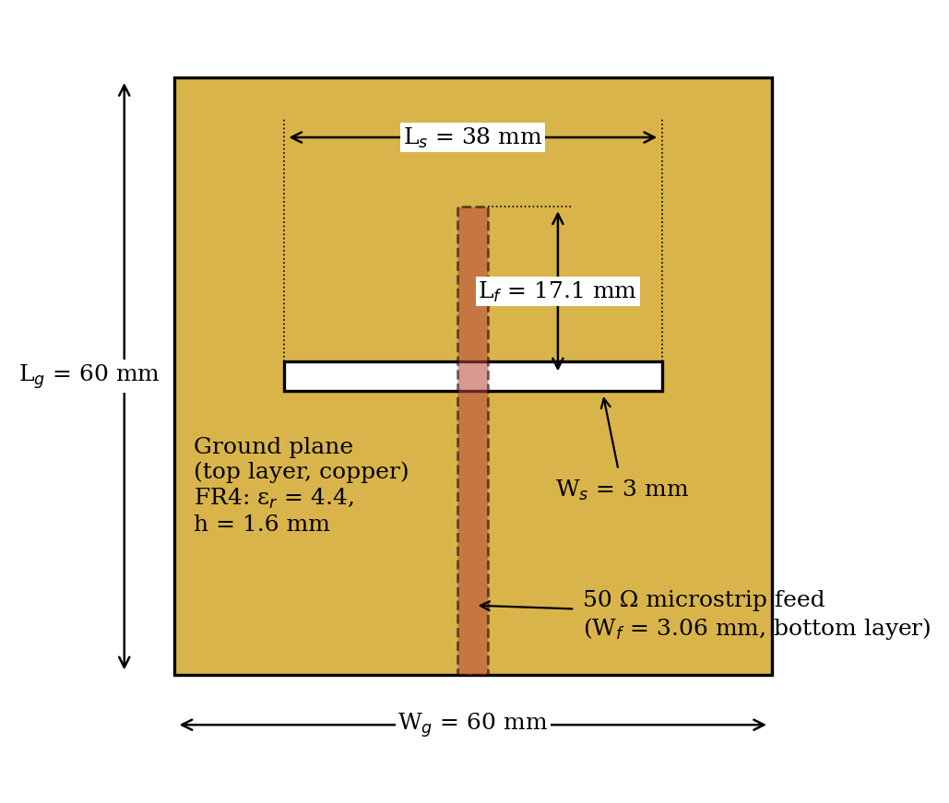
Fig 3.1 Geometry of the proposed slot antenna

DESIGN FORMULAS
The design equations used to obtain the initial dimensions are given below. Here c is the speed of light, f₀ is the resonant frequency, ε_{r} is the relative permittivity and h is the thickness of the substrate.
λ₀ = c / f₀ (3.1)
ε_{eff} = (ε_{r} + 1) / 2 (3.2)
λ_{g} = λ₀ / √ε_{eff} (3.3)
L_{s} ≈ λ_{g} / 2 (3.4)
W_{s} ≈ 0.025 λ₀ (3.5)
W/h = 8e^{A} / (e^{2A} − 2), A = (Z₀/60)√((ε_{r}+1)/2) + ((ε_{r}−1)/(ε_{r}+1)) (0.23 + 0.11/ε_{r}) for W/h ≤ 2 (3.6)
ε_{eff,ms} = (ε_{r} + 1)/2 + ((ε_{r} − 1)/2)(1 + 12h/W)^{−1/2} (3.7)
λ_{gm} = λ₀ / √ε_{eff,ms}, L_{f} = λ_{gm} / 4 (3.8)
Equation (3.2) gives the effective permittivity seen by the slot, which has the substrate on one side and air on the other. The slot width in (3.5) is only a starting value of a narrow slot and is tuned in CST. Equations (3.6) and (3.7) give the width and effective permittivity of the 50 Ω microstrip line (Z₀ = 50 Ω), and (3.8) gives the length of the quarter-wave open stub.

DESIGN CALCULATIONS
Given: f₀ = 2.4 GHz, ε_{r} = 4.4, h = 1.6 mm, Z₀ = 50 Ω.
λ₀ = (3 × 10⁸) / (2.4 × 10⁹) = 0.125 m = 125 mm
ε_{eff} = (4.4 + 1) / 2 = 2.7
λ_{g} = 125 / √2.7 = 76.07 mm
L_{s} = λ_{g} / 2 = 38.04 mm ≈ 38 mm
W_{s} = 0.025 × 125 = 3.1 mm ≈ 3 mm
A = (50/60)√2.7 + (3.4/5.4)(0.23 + 0.11/4.4) = 1.530,
W/h = 8e^{1.530}/(e^{3.060} − 2) = 1.912
W_{f} = 1.912 × 1.6 = 3.06 mm
ε_{eff,ms} = 2.7 + 1.7 / √(1 + 12 × 1.6/3.06) = 3.33
λ_{gm} = 125 / √3.33 = 68.5 mm,
L_{f} = 68.5 / 4 = 17.1 mm
The substrate and ground plane are taken as 60 mm × 60 mm (about 0.5λ₀), which is large enough for the slot and keeps the board compact. The calculated values are summarised in Table 3.1.
Table 3.1 Initial design parameters of the slot antenna (starting values)
Parameter | Symbol | Value
Resonant frequency | f₀ | 2.4 GHz
Substrate (FR4) relative permittivity | ε_{r} | 4.4
Substrate thickness | h | 1.6 mm
Free-space wavelength | λ₀ | 125 mm
Guided wavelength in the slot | λ_{g} | 76.07 mm
Slot length | L_{s} | 38 mm
Slot width | W_{s} | 3 mm
50 Ω microstrip line width | W_{f} | 3.06 mm
Guided wavelength in the line | λ_{gm} | 68.5 mm
Open stub length | L_{f} | 17.1 mm
Substrate / ground plane size | W_{g} × L_{g} | 60 mm × 60 mm

Chapter IV

RESULTS AND

DICUSSIONS

S₁₁ RESPONSE
The antenna was modelled in CST Studio Suite on a 60 mm × 70 mm FR-4 (lossy) substrate with ε_{r} = 4.3 and h = 1.6 mm, with a slot in the copper ground plane and a microstrip feed line on the opposite face. The final dimensions used in the model are listed in Table 4.1. They differ from the initial values calculated in Chapter III: the slot is longer and the feed stub is shorter, as found during the simulation. A parametric sweep of the substrate length and width (Sub_L and Sub_W) was run, and the run with the lowest S₁₁ near 2.4 GHz is shown in Fig 4.1. A value of S₁₁ below −10 dB (VSWR ≤ 2) is normally taken as the limit of the operating band.
Table 4.1 Final dimensions used in the CST model
Parameter | Name in CST | Value
Substrate length | Sub_L | 60 mm
Substrate width | Sub_W | 70 mm
Substrate thickness (FR-4) | Sub_H | 1.6 mm
Copper thickness | Cu_H | 0.035 mm
Slot length | L_slot | 57.5 mm
Slot width | W_slot | 3.0 mm
Microstrip feed width | W_line | 3.0 mm
Feed stub length | L_stub | 14 mm

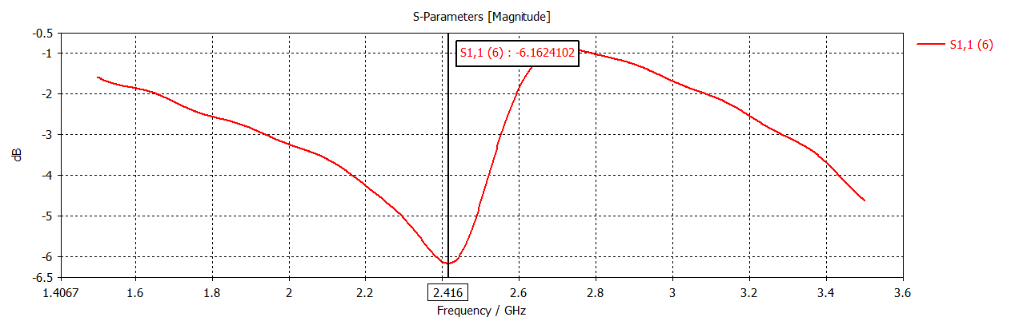
Fig 4.1 Simulated S₁₁ response
The S₁₁ curve has its minimum of −6.16 dB at 2.416 GHz, so the resonance falls inside the 2.4 GHz ISM band. At this point |S₁₁| is about 0.49, which corresponds to a VSWR of about 2.9, and roughly 76 % of the input power is accepted by the antenna. S₁₁ stays above −10 dB over the whole plotted range, so the present design does not yet have a −10 dB impedance bandwidth. The match is therefore improved but still incomplete. Further tuning of the feed stub length, the slot length and width, and the feed position is required to bring S₁₁ below −10 dB, and is left as future work.

SURFACE CURRENT DISTRIBUTION
Fig 4.2 shows the surface current distribution on the ground plane at the resonant frequency. In a half-wave slot, the current flows around the slot and crowds along its long edges. This is equivalent to a magnetic current along the slot, which is what radiates.
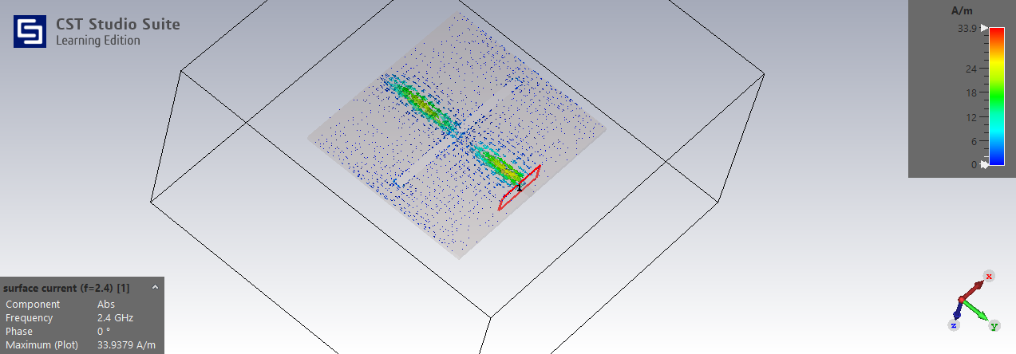
Fig 4.2 Surface current distribution at the resonant frequency
At 2.4 GHz the surface current reaches a maximum of 33.94 A/m. It is concentrated along the slot, in two strong bands on either side of the slot centre, and it is weak over the rest of the ground plane. This confirms that the slot is the radiating element.

FAR FIELD 3D RESPONSE
The three-dimensional far-field directivity pattern at 2.4 GHz is shown in Fig 4.3. The slot radiates on both sides of the ground plane, so a bidirectional, dipole-like pattern is expected.
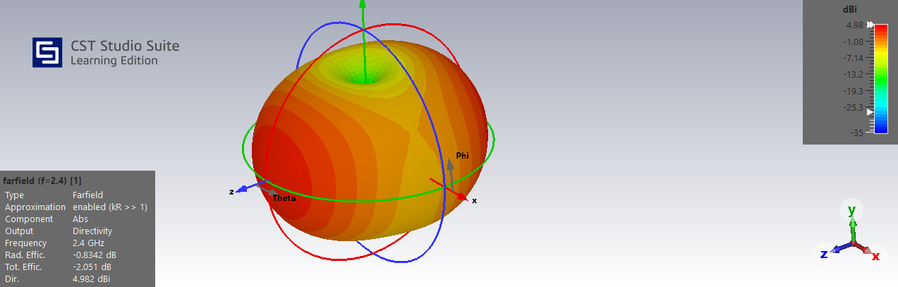
Fig 4.3 Far-field 3D response
The pattern is broad and doughnut-shaped with a shallow dip along the y-axis, which is the dipole-like radiation expected from a slot antenna. At 2.4 GHz CST gives a directivity of 4.98 dBi, a radiation efficiency of −0.83 dB (about 82 %) and a total efficiency of −2.05 dB (about 62 %). The total efficiency is lower because it also includes the mismatch loss at the port. The corresponding gain is about 4.15 dBi (directivity plus radiation efficiency), and the realised gain is about 2.93 dBi.

FAR FIELD 1D RESPONSE
Fig 4.4 shows the polar plot of the far-field directivity at 2.4 GHz in the φ = 90° plane, which is the plane containing the y and z axes.

Fig 4.4 Far-field 1D radiation pattern (φ = 90°)
The main lobe has a magnitude of 4.98 dBi and points along θ = 179°, that is, along the z-axis, normal to the board. The 3 dB angular width of the main lobe is 79.4°. CST reports a side-lobe level of −1.2 dB, which corresponds to the almost equal lobe on the opposite side of the slot, so the pattern is bidirectional. There are deep nulls at θ = 90°, along the y-axis, which agrees with the dip seen in the 3D pattern.

Chapter V

CONCLUSION

CONCLUSION
In this project, a microstrip-line-fed rectangular slot antenna for the 2.4 GHz ISM band was designed on a 1.6 mm FR4 substrate. The initial dimensions were obtained from the standard design equations and the antenna was then modelled and simulated in CST Studio Suite, where the final dimensions were a 57.5 mm × 3 mm slot, a 3 mm wide feed line with a 14 mm stub, and a 60 mm × 70 mm board. The simulated S₁₁ shows a resonance at 2.416 GHz with a minimum of −6.16 dB (VSWR about 2.9), and the antenna has a directivity of 4.98 dBi (3 dB beamwidth of 79.4°) and a total efficiency of −2.05 dB with a dipole-like, bidirectional radiation pattern. The resonant frequency agrees with the design target, but S₁₁ does not yet reach −10 dB, so the impedance matching still needs improvement.
As future work, the matching can be improved by tuning the feed stub length, the slot width and length, and the feed position using a parameter sweep in CST. The tuned antenna can then be fabricated and measured with a vector network analyser.

REFERENCES
    - C. A. Balanis, Antenna Theory: Analysis and Design, 4th ed. Hoboken, NJ, USA: Wiley, 2016.
    - H. G. Booker, “Slot aerials and their relation to complementary wire aerials (Babinet’s principle),” J. Inst. Elect. Eng., Part IIIA, vol. 93, 1946.
    - Y. Yoshimura, “A microstripline slot antenna,” IEEE Trans. Microw. Theory Techn., vol. 20, no. 11, pp. 760–762, Nov. 1972.
    - D. M. Pozar, “Microstrip antennas,” Proc. IEEE, vol. 80, no. 1, pp. 79–91, Jan. 1992.
    - J.-Y. Sze and K.-L. Wong, “Bandwidth enhancement of a microstrip-line-fed printed wide-slot antenna,” IEEE Trans. Antennas Propag., vol. 49, no. 7, pp. 1020–1024, Jul. 2001.
    - Y. F. Liu, K. L. Lan, Q. Xue and C. H. Chan, “Experimental studies of printed wide-slot antenna for wide-band applications,” IEEE Antennas Wireless Propag. Lett., vol. 3, pp. 273–275, 2004.
    - S. K. Sharma, L. Shafai and N. Jacob, “Investigation of wide-band microstrip slot antenna,” IEEE Trans. Antennas Propag., vol. 52, no. 3, pp. 865–872, Mar. 2004.
    - S.-W. Qu, C. Ruan and B.-Z. Wang, “Bandwidth enhancement of wide-slot antenna fed by CPW and microstrip line,” IEEE Antennas Wireless Propag. Lett., vol. 5, pp. 15–17, 2006.
    - M. A. Saed, “Broadband CPW-fed planar slot antennas with various tuning stubs,” Prog. Electromagn. Res., vol. 66, pp. 199–212, 2006.

