AAVA Feature Builder — Use Case Briefs
Frontend Engineer / Feature Builder persona — Learning Module vs. Practical Application Module
Codebase: angular-erp-crm-mfe-main (public GitHub repo)
Both use cases below train the same end-to-end AAVA Code Feature Builder workflow — login, index the codebase, provide the requirement, review impacted files, HITL-approve the generated change, then run and validate. Both use cases work in the same two files (the CRM remote's Customers list) so no second component needs to be learned, but each targets a different table column/value so Use Case 2 cannot be passed by copying Use Case 1’s exact diff.

Sample Project Access
- Repository: github.com/anandpotta/angular-erp-crm-mfe-main — public, no login required to view or clone.
- Both use cases in this document use the same codebase and the same two files — one link covers Use Case 1 (Learning Module) and Use Case 2 (Practical Application Module).
- This is an Angular 21 multi-project workspace (not Nx) using @angular-architects/native-federation for a shell host plus crm-app/inventory-app/accounting-app remotes. All dependencies install from the public npm registry — no private feed credentials needed, and no UI/notification libraries (no PrimeNG, Material, ag-grid, or toast library) are installed, so the feature must be built with plain Angular + the CSS already in the shared-ui components.
- Setup for learners: use the Node version pinned in .nvmrc (nvm use), run npm ci, then open four terminals — npm run start:crm, npm run start:inventory, npm run start:accounting, npm run start:shell — and browse to http://localhost:4200. From the shell, open the CRM remote and click the “Customers” tab (http://localhost:4200/crm/customers).
Project link: https://github.com/anandpotta/angular-erp-crm-mfe-main
Scope note: this phase covers the Frontend Engineer — Feature Builder persona only (the two use cases below). Additional personas are planned after October.

Use Case 1 — Learning Module (Guided / Demo)
Persona | Frontend Engineer — Feature Builder
Location | CRM remote — Customers page (projects/crm-app/src/app/crm-feature.component.ts, CustomersComponent)

Feature Requirement / User Story
As someone browsing the CRM Customers list, I want a quick way to copy a customer’s ID, so I can paste it into a support ticket or another system without retyping it.

Acceptance Criteria
- Prerequisite: learner has cloned the repository, and npm ci / the four npm run start:* commands run successfully, before starting Step 1 of the guide.
- On the CRM → Customers page, each row shows a small “Copy” control next to the Customer ID column value.
- Clicking it copies the customer ID to the clipboard and shows a brief inline “Copied” confirmation next to the control for ~1.5 seconds — there is no toast/snackbar library in this codebase, so the confirmation must be a local UI state change, not a new dependency.
- The Leads and Opportunities tables (which reuse the same shared ui-data-table component) keep rendering exactly as before for columns that do not opt into the new copy behavior.

Files Expected to Change
- projects/shared-ui/src/lib/data-table.component.ts — the generic table currently supports column type: 'badge' (see toneFor()/formatValue()); it needs a new type: 'copy' that renders the cell value plus a Copy button, wired to the Clipboard API with a short-lived “Copied” state.
- projects/crm-app/src/app/crm-feature.component.ts — CustomersComponent's columns array needs its { key: 'id', label: 'Customer ID' } entry changed to add type: 'copy'.

Complete Code Context — Current / Before State
projects/shared-ui/src/lib/data-table.component.ts (current — full file)
import { Component, input } from '@angular/core';
import { BadgeTone, formatCurrency, formatDate, statusTone, TableColumn } from 'shared-core';
import { BadgeComponent } from './badge.component';

@Component({
selector: 'ui-data-table',
imports: [BadgeComponent],
template: `
<div class="table-wrap">
<table>
<thead>
<tr>
@for (column of columns(); track column.label) {
<th>{{ column.label }}</th>
}
</tr>
</thead>
<tbody>
@for (row of rows(); track rowIndex; let rowIndex = $index) {
<tr>
@for (column of columns(); track column.label) {
<td>
@if (column.type === 'badge') {
<ui-badge [tone]="toneFor(value(row, column))">{{ value(row, column) }}</ui-badge>
} @else {
{{ formatValue(row, column) }}
}
</td>
}
</tr>
}
</tbody>
</table>
</div>
`,
styles: [
`
.table-wrap { overflow-x: auto; }
table { width: 100%; border-collapse: collapse; min-width: 42rem; }
th, td { padding: 0.85rem 1rem; border-bottom: 1px solid #e2e8f0; text-align: left; vertical-align: middle; white-space: nowrap; }
th { color: #64748b; font-size: 0.75rem; font-weight: 800; text-transform: uppercase; background: #f8fafc; }
td { color: #1e293b; font-size: 0.9rem; }
tr:last-child td { border-bottom: 0; }
`,
],
})
export class DataTableComponent {
readonly columns = input<TableColumn[]>([]);
readonly rows = input<unknown[]>([]);

protected value(row: unknown, column: TableColumn): unknown {
return (row as Record<string, unknown>)[column.key];
}

protected formatValue(row: unknown, column: TableColumn): string {
const cellValue = this.value(row, column);
if (typeof cellValue === 'number' && column.type === 'currency') { return formatCurrency(cellValue); }
if (typeof cellValue === 'string' && column.type === 'date') { return formatDate(cellValue); }
if (typeof cellValue === 'number') { return cellValue.toLocaleString('en-US'); }
return String(cellValue);
}

protected toneFor(value: unknown): BadgeTone {
return statusTone(String(value));
}
// copy-to-clipboard for type: 'copy' columns does not exist yet — to be added
}
projects/crm-app/src/app/crm-feature.component.ts — CustomersComponent (current — relevant excerpt; full file has sibling Leads/Opportunities/Pipeline components using the same DataTableComponent)
@Component({
selector: 'app-crm-customers',
imports: [CardComponent, DataTableComponent],
template: `
<ui-card title="Customers" subtitle="Customer health is represented with shared badge tones">
<ui-data-table class="card-body" [columns]="columns" [rows]="rows" />
</ui-card>
`,
})
export class CustomersComponent {
protected readonly rows = customers;
protected readonly columns = [
{ key: 'id', label: 'Customer ID' }, // <-- Use Case 1 adds type: 'copy' here
{ key: 'name', label: 'Name' }, // <-- Use Case 2 adds type: 'copy' here
{ key: 'segment', label: 'Segment' },
{ key: 'region', label: 'Region' },
{ key: 'health', label: 'Health', type: 'badge' },
{ key: 'recurringRevenue', label: 'MRR', type: 'currency' },
];
}

Suggested AAVA Prompt (Step 4 of the guide)
“In the CRM Customers table, add a small Copy button next to each customer’s Customer ID. Clicking it should copy the ID to the clipboard and show a short inline confirmation. There is no toast library in this project, so use a local component state to show and hide the confirmation — don’t add a new dependency. Keep the Leads and Opportunities tables, which share the same table component, working exactly as they do today.”

End Goal
Learner watches/follows AAVA index the codebase, locate data-table.component.ts and crm-feature.component.ts, propose the diff that adds a reusable type: 'copy' column behavior, approves via HITL, and confirms the copy-to-clipboard + inline confirmation works when running the app — without breaking the Leads/Opportunities tables that reuse the same shared component.

Visual Example — Target End State

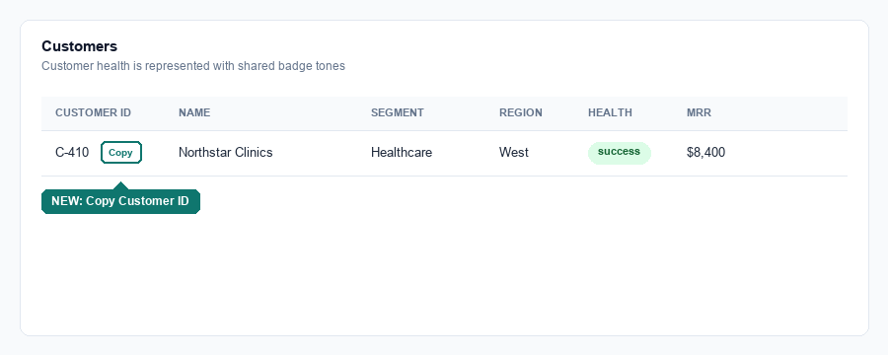
Mockup: CRM Customers table with the new “Copy” control next to the Customer ID value.

Use Case 2 — Practical Application Module (Independent Practice)
Persona | Frontend Engineer — Feature Builder
Location | CRM remote — Customers page (projects/crm-app/src/app/crm-feature.component.ts) — same file as Use Case 1

Feature Requirement / User Story
As someone browsing the CRM Customers list, I want a quick way to copy a customer’s name, so I can paste it elsewhere (an email, a search box, another system) without retyping it.

Acceptance Criteria
- Prerequisite: learner has the same repository (from Use Case 1) already installed and running — no separate clone needed.
- On the CRM → Customers page, each row now also shows a Copy control next to the Name column value.
- Clicking it copies the customer name to the clipboard and shows the same brief inline “Copied” confirmation, reusing the type: 'copy' column behavior added in Use Case 1 (no changes to data-table.component.ts should be needed).
- Existing Copy behavior on the Customer ID column (from Use Case 1) and the Leads/Opportunities tables remain unaffected.

Files Expected to Change
- projects/crm-app/src/app/crm-feature.component.ts — CustomersComponent's columns array needs its { key: 'name', label: 'Name' } entry changed to add type: 'copy', following the same shape as the Customer ID column from Use Case 1.

Complete Code Context — Current / Before State
Same two files as Use Case 1 — see the full current-state listing above. By the time Use Case 2 starts, data-table.component.ts already contains the Use Case 1 changes (the type: 'copy' rendering + clipboard logic), and crm-feature.component.ts already has type: 'copy' on the id column; the learner is extending the columns array independently, not starting from a clean copy.

Suggested AAVA Prompt
“In the CRM Customers table, add the same Copy button to the Name column that the Customer ID column already has. Clicking it should copy the customer’s name to the clipboard and show the same confirmation.”

End Goal
Learner independently repeats the full Feature Builder workflow (login → index → provide requirement → review impacted files → HITL approve → run/validate) with no guided steps, proving they can transfer the skill to a new column in the same file rather than recalling Use Case 1’s exact diff.

Visual Example — Target End State

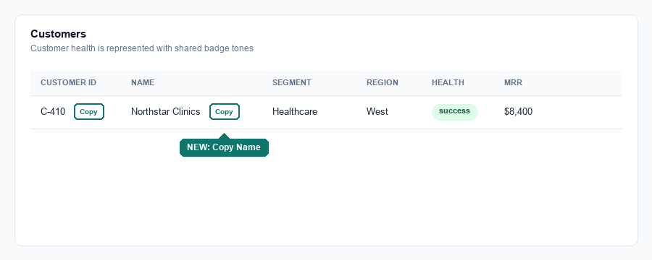
Mockup: CRM Customers table with the new “Copy” control next to the Name value (Copy on Customer ID from Use Case 1 already in place).

Why This Pair Works
Both use cases train the exact same underlying skill — locate a shared, data-driven table component, add a small event-driven feature behind a new column type, wire up the Clipboard API plus a lightweight local confirmation (there’s no toast library to lean on), HITL-approve, and validate — but target a different column with a different value. Use Case 1 does the harder work of introducing the reusable type: 'copy' behavior into the shared shared-ui table component; Use Case 2 proves the learner understood that abstraction well enough to apply it to a new column with a one-line change, rather than needing to be walked through it again. A learner who only memorized Use Case 1’s diff cannot paste it unchanged into the Name column and pass — they have to recognize and reuse the pattern they just built.

