AAVA Feature Builder — Use Case Briefs
Frontend Engineer / Feature Builder persona — Learning Module vs. Practical Application Module
Codebase: angular-boilerplate (public GitHub repo)
Both use cases below train the same end-to-end AAVA Code Feature Builder workflow — login, index the codebase, provide the requirement, review impacted files, HITL-approve the generated change, then run and validate. Both use cases work in the same file (the Users List page) so no second component needs to be learned, but each adds a different field/action so Use Case 2 cannot be passed by copying Use Case 1’s exact diff.

Sample Project Access
- Repository: github.com/ArslanAmeer/angular-boilerplate — public, no login required to view or clone.
- Both use cases in this document use the same codebase and the same file — one link covers Use Case 1 (Learning Module) and Use Case 2 (Practical Application Module).
- All dependencies (Angular, @ngxpert/hot-toast, @ngx-translate, etc.) install from the public npm registry — no private feed credentials needed.
- Setup for learners: git clone the repository, run npm install, then npm start (or ng serve) and open the printed local URL.
Project link: https://github.com/ArslanAmeer/angular-boilerplate
Scope note: this phase covers the Frontend Engineer — Feature Builder persona only (the two use cases below). Additional personas are planned after October.

Use Case 1 — Learning Module (Guided / Demo)
Persona | Frontend Engineer — Feature Builder
Location | Users List page (src/app/pages/users/list)

Feature Requirement / User Story
As someone browsing the Users List, I want a quick way to copy a user’s email address, so I don’t have to manually select/retype it when reaching out to them.

Acceptance Criteria
- Prerequisite: learner has cloned the repository, and npm install / npm start runs successfully, before starting Step 1 of the guide.
- On the Users List page, each row shows a small copy icon next to the Email column value.
- Clicking it copies the email to the clipboard and shows a toast confirming the copy (using the existing HotToastService already used for the row-click toast).
- No change to existing row-click behavior.

Files Expected to Change
- src/app/pages/users/list/list.component.html — the Email <td> needs an icon added beside {{ user.email }}.
- src/app/pages/users/list/list.component.ts — needs a new copyEmail(email: string) method using the Clipboard API and the already-injected HotToastService.

Complete Code Context — Current / Before State
src/app/pages/users/list/list.component.ts (current — full file)
import { Component, inject, OnInit, ChangeDetectionStrategy } from '@angular/core';
import { UseRandomUser } from '@core/usecases';
import { RandomUserEntity } from '@core/entities';
import { HotToastService } from '@ngxpert/hot-toast';
import { TranslateService } from '@ngx-translate/core';

@Component({
selector: 'app-list',
templateUrl: './list.component.html',
styleUrl: './list.component.scss',
changeDetection: ChangeDetectionStrategy.Eager,
standalone: false,
})
export class ListComponent implements OnInit {
users: RandomUserEntity[] = [];
isLoading = true;

private readonly _useRandomUser = new UseRandomUser();
private readonly _toast = inject(HotToastService); // <-- already available for the new copy toast
private readonly _translateService = inject(TranslateService);

ngOnInit() {
this._useRandomUser.getAllUsers().subscribe({
next: (users) => {
this.users = users;
this.isLoading = false;
},
error: (error) => {
console.error(error);
},
});
}

userClicked() {
this._toast.show(this._translateService.instant('User clicked'));
}
// copyEmail() / copyPhone() do not exist yet — to be added
}
src/app/pages/users/list/list.component.html (current — full file)
<section class="main-container">
<h2 translate>Users List</h2>

<div class="user-table-container">
<table class="user-table">
<thead>
<tr>
<th translate>Avatar</th>
<th translate>Full Name</th>
<th translate>Email</th>
<th translate>Phone</th>
<th translate>Location</th>
</tr>
</thead>
<tbody>
@if (!isLoading) {
@for (user of users; track user.id) {
<tr (click)="userClicked()">
<td>
<img [src]="user.picture.thumbnail" alt="{{ user.name.first }}'s avatar" />
</td>
<td>{{ user.name.title }} {{ user.name.first }} {{ user.name.last }}</td>
<td>{{ user.email }}</td>
<td>{{ user.phone }}</td>
<td>{{ user.location.city }}, {{ user.location.country }}</td>
</tr>
}
} @else {
<tr>
<td colspan="5" style="text-align: center" translate>Loading...</td>
</tr>
}
</tbody>
</table>
</div>
</section>

Suggested AAVA Prompt (Step 4 of the guide)
"In the Users List page, add a copy icon next to each user’s email in the table. Clicking it should copy the email to the clipboard and show a toast confirming the copy. Be careful not to trigger the existing row-click handler."

End Goal
Learner watches/follows AAVA index the codebase, locate list.component.html/.ts, propose the diff, approves via HITL, and confirms the copy-to-clipboard + toast works when running the app — without breaking the existing row-click toast.

Visual Example — Target End State
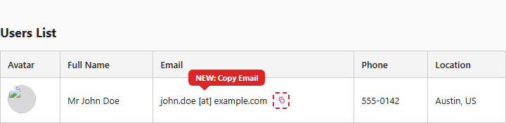
Mockup: Users List table with the new "Copy Email" icon next to the email address.

Use Case 2 — Practical Application Module (Independent Practice)
Persona | Frontend Engineer — Feature Builder
Location | Users List page (src/app/pages/users/list) — same file as Use Case 1

Feature Requirement / User Story
As someone browsing the Users List, I want a quick way to copy a user’s phone number, so I can paste it elsewhere without retyping it.

Acceptance Criteria
- Prerequisite: learner has the same repository (from Use Case 1) already installed and running — no separate clone needed.
- On the Users List page, each row shows a new copy icon next to the Phone column value.
- Clicking it copies the phone number to the clipboard and shows a toast confirming the copy, following the same HotToastService pattern used for Copy Email (and the existing row-click toast).
- Existing Copy Email action (from Use Case 1) and row-click behavior remain unaffected.

Files Expected to Change
- src/app/pages/users/list/list.component.html — the Phone <td> needs an icon added beside {{ user.phone }} (same pattern as the Email column, different field).
- src/app/pages/users/list/list.component.ts — needs a new copyPhone(phone: string) method, following the same shape as copyEmail() from Use Case 1.

Complete Code Context — Current / Before State
Same two files as Use Case 1 — see the full current-state listings above. By the time Use Case 2 starts, list.component.ts/.html will already contain the Use Case 1 changes (copyEmail + its icon); the learner is extending that same file independently, not starting from a clean copy.

Suggested AAVA Prompt
"In the Users List page, add a copy icon next to each user’s phone number, the same way the email column already has one. Clicking it should copy the phone number to the clipboard and show a confirmation toast."

End Goal
Learner independently repeats the full Feature Builder workflow (login → index → provide requirement → review impacted files → HITL approve → run/validate) with no guided steps, proving they can transfer the skill to a new field in the same file rather than recalling Use Case 1’s exact code.

Visual Example — Target End State
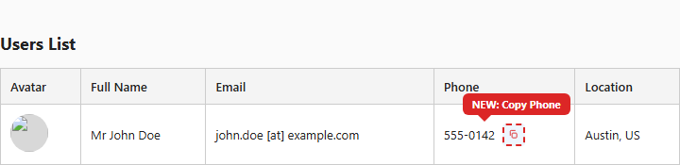
Mockup: Users List table with the new "Copy Phone" icon next to the phone number (Copy Email from Use Case 1 already in place).

Why This Pair Works
Both use cases train the exact same underlying skill — locate a table cell, add a small event-driven feature, wire up clipboard + toast, HITL-approve, and validate — but target a different field with a different label and message. Because Use Case 2 is attempted after Use Case 1’s change already exists in the file, a learner who only memorized the Email diff cannot paste it unchanged into the Phone column and pass; they have to re-derive the pattern for a new field.

