# INTRODUCTION

According to WHO, there is no single 'official' definition of mental health. Mental health refers to a person's psychological, emotional, and social well-being; it influences what they feel and how they think and behave. The state of cognitive and behavioural well-being is referred to as mental health. The term 'mental health' is also used to refer to the absence of mental disease.

Mental health means keeping our minds healthy. Mankind generally is more focused on keeping their physical body healthy. People tend to ignore the state of their minds. Human superiority over other animals lies in his superior mind. Man has been able to control life due to his highly developed brain. So, it becomes very important for a man to keep both his body and mind fit and healthy. Both physical and mental health are equally important for better performance and results.

An emotionally fit and stable person always feels vibrant and truly alive and can easily manage emotionally difficult situations. To be emotionally strong, one has to be physically fit too. Although mental health is a personal issue, what affects one person may or may not affect another; yet, several key elements lead to mental health issues.

Many emotional factors have a significant effect on our fitness level like depression, aggression, negative thinking, frustration, and fear, etc. A physically fit person is always in a good mood and can easily cope up with situations of distress and depression resulting in regular training contributing to a good physical fitness standard.

Mental fitness implies a state of psychological well-being. It denotes having a positive sense of how we feel, think, and act, which improves one’s ability to enjoy life. It contributes to one’s inner ability to be self-determined. It is a proactive, positive term and forsakes negative thoughts that may come to mind. The term mental fitness is increasingly being used by psychologists, mental health practitioners, schools, organisations, and the general population to denote logical thinking, clear comprehension, and reasoning ability.

.

## 1.1 PROBLEM DEFINITION

In the current pandemic situation, everyone just looks at the bad memories they had, and it is becoming hard to focus on a good picture and remember the good times. This not only affects the mental health of an individual but also impacts the youth as it gets involves into multiple daily activities.

**1.2 EXISTING SYSTEM**

In today’s world, many of us rely on social media platforms such as Facebook, Twitter, Snapchat, YouTube, and Instagram to find and connect with each other. While each has its benefits, it’s important to remember that social media can never be a replacement for real-world human connection. It requires in-person contact with others to trigger the hormones that alleviate stress and make you feel happier, healthier, and more positive. Ironically for a technology that’s designed to bring people closer together, spending too much time engaging with social media can make you feel lonelier and more isolated—and exacerbate mental health problems such as anxiety and depression.

**1.3,1.4 OBJECTIVE and PROPOSED SYSTEM**

The sole purpose or objective of this solution is to provide the exact thing which is required and not to impose the positivity among people. It is designed to bring out the good memories’ refreshment during bad times. And it also involves just the Like and delete feature, which people can use when they would like to share with people.

## 1.5 PURPOSE, SCOPE AND APPLICABILITY

**1.5.1 PURPOSE**

The main idea behind this project is to connect people and positivity without addiction together to efficiently process and reduce mental stress specially in these tough times. Posts can be easily put to the platform with no percentage errors. Digitalizing all the card-based memories allows the people to get in touch with their memories easily and access it quickly when they feel low.

It is a good platform to capture the memories by categorizing them on the month basis. Multiple people like to look back at the year in the end of it and want to start the new year with good memories.

* Capturing memories in one single frame.
* Elegant card like structure for every memory.
* Like, Delete, Edit feature for every memory.
* Support of Gif instead of a photograph

**1.5.2 Scope**

Fear, worry, and stress are normal responses to perceived or real threats, and at times when we are faced with uncertainty or the unknown. So it is normal and understandable that people are experiencing fear in the context of the COVID-19 pandemic.

Added to the fear of contracting the virus in a pandemic such as COVID-19 are the significant changes to our daily lives as our movements are restricted in support of efforts to contain and slow down the spread of the virus. Faced with new realities of working from home, temporary unemployment, home-schooling of children, and lack of physical contact with other family members, friends, and colleagues, it is important that we look after our mental, as well as our physical, health.

WHO, together with partners, is providing guidance and advice during the COVID-19 pandemic for health workers, managers of health facilities, people who are looking after children, older adults, people in isolation and members of the public more generally, to help us look after our mental health?

**1.5.3 Applicability**

This project provides a platform to share memories, where people can like, share, edit and add picture/gif to the card and not only this, but we can also add a new memory but just adding a few parameters like name, headline, tag, and comment.

Not only this, but this project also brings out positive vibes among people to enhance the creativity and unity. It helps everyone to refresh the good memories they had during tough times. COVID 19 mental report says that 34.6% people are now focusing more on the bad picture as the pandemic has impacted their mental health. This project would be a live example which would bring out good vibes.

This project is very reliable and flexible enough to scale out and replace multiple social medias and it also does not bring out the addiction. Here, people can post their memories without worrying about likes, dislikes, comments, and chat media.

# SYSTEM ANALYSIS AND REQUIREMENTS

**2.1 PROBLEM DEFINITION** For the existing system, it’s noticeable when you're quickly irritated by minor events or statements, become offended, and argue with your family, friends, or co-workers. It occurs because of a build-up of internal irritation. A sense of alienation from your loved ones might have a negative influence on your mental health. It makes you feel lonely and might even put you in a state of despair. You can prevent mental illness by taking care of yourself like calming your mind by listening to soft music, being more social, setting realistic goals for yourself, and taking care of your body. Surrounding oneself with memories brings out positivity and help in taking care of ourselves during tough times.

#### Hardware Requirements

All the hardware requirements that are necessary in developing and deploying the proposed system is listed below.

**Table 2.3 Hardware Requirements**

|  |  |  |
| --- | --- | --- |
| **Sl No** | **Requirement Name** | **Description** |
| **1** | Processor | Minimum Intel Core 2 |
| **2** | Hard Disk Space | 30 GB or more |
| **3** | RAM | Minimum 2 GB |
| **4** | Display Unit | EGA/VGA Color Monitor |
| **5** | Keyboard | Standard keyboard |

#### Software Requirements

Software’s tools and servers that are required to implement and run the applications are listed in the below table.

**Table 2.4 Software Requirements**

|  |  |  |
| --- | --- | --- |
| **Sl No** | **Requirement Name** | **Description** |
| 1 | Operating System | Windows 7 – 64 bit or higher |
| 2 | Software Tools | 3dsMAX, Fusion 360 |
| 3 | Programming Language | JavaScript |
| 4 | Database | Mongo Db |

**DevOps practices followed in the team**

* **Version Control for All Production Artifacts**

Both Dev and Ops should use version control for everything. And they should share the same single source of truth.

* **Continuous Integration and Deployment**

Check in code every day and check into the trunk every day, as opposed to hanging onto private code branches and integrating only at the end of the release.

* **Automated Acceptance Testing**

Stop the line not only when the build breaks but also when something breaks. This is true for all software testing, whether it's an automated user test, an integration test, or a system test. This step keeps things in an always-deployable state.

* **Peer Review of Production Changes**

Use peer reviews for better quality; leverage your team’s familiarity, shared goals, and mutual accountability, as opposed to external change approval (such as a change advisory board).

* **High-Trust Culture**

This is both a practice and an outcome result from a single source of truth, peer reviews, and shared goals.

* **Proactive Monitoring of the Production Environment**

Monitor and communicate across the teams so everyone can see, understand, and affect end results and customer utilization.

* **Win-Win Relationship (and Outcomes) Between Dev and Ops**

This approach counters the learned behaviour that deployments hurt. By deploying code into production every day, you can change lives in Operations. Deployments don’t have to be done at midnight on Friday with Ops working all weekend to get things running. When Ops employees are working the same hours as Dev, there is a sense of teamwork and joint accomplishment.

**WHY IS TEAM FOLLOWING DEVOPS?**

Developers always want to deliver the changes in the product as soon as possible whereas the operation team want reliability and stability in the product. This situation was explained clearly in “wall of confusion” by Lee Thomson. This wall of confusion not only gives the mentalities of two teams but also the tools they practice.

Development team uses some tools and Operations team uses different tools to perform the same task. DevOps bridge the gap between the development and operations for better and faster results

**WHAT DRIVES TOWARDS THE NEED OF DEVOPS?**

1. Strong collaboration between development and operation teams.

2. Synchronized deployment across multiple platforms.

3. Pressure to release applications to meet customer requirements or to enter into the new market.

4. Improving end user capability levels.

5. Vast usage of smart devices

6. Necessity to develop and deploy into cloud-based applications.

7. Increasingly complex IT infrastructure.

8. Need to reduce the cost for IT industry

## What value does DevOps add to the business value of the product?

DevOps applies agile and lean principles in the complete software deployment process to enhance the speed of delivery of product or service from the initial release to the production release and to the feedback given by the client based on the release. DevOps return our investment in these three areas.

1. **Enhanced Customer Experience** Delivering an enhanced product for the customer leads to build loyalty and increase in market share. To deliver an enhanced product we need to continuously obtain and respond to the customer’s feedback faster and perform required changes suggested by the customer.
2. **Increased capacity to Innovate** Lean thinking approaches are used in modern organizations to increase their innovation capacity. Their goals are to utilize the resources efficiently for other activities by reducing waste and rework. An example of lean thinking in organization is A-B testing in which large organizations asks a small group of users to test and rate two or more sets of software having different capabilities then the better capability set is picked up for the users and unsuccessful version is rolled back. This A-B testing is reliable only if efficient and automated mechanisms are adopted such as DevOps.

A-B testing is the comparison of two web pages to know which will perform fast and efficient. It is also called as split testing. We compare two web pages by showing the two variants (let's call them A and B) to similar visitors at the same time. The one which has more conversion rate is accepted.

3. **Faster time to value**: This involves in development of new culture and practices and automating the project leads to fast and reliable delivery process throughout the production phase. This DevOps can be worked as a business capability with the tools for release planning, predictability and success. The DevOps main goal is to deliver the value faster and in efficient way and the value definition changes with organization or with the project.

## IV. DEVOPS PHASES AND DELIVERY PIPELINE

A. **Continuous Planning Business** plans are already using agile methodologies to deliver quickly and change according to market conditions. It is better to have the checkpoints so that we can easily do the necessary changes given as feedback by customer. Dev / Test teams adapting to quick changes is not an easy task in business environments. DevOps allows us to prioritize the product backlogs and taking business perspective into consideration. This is the continuous process of planning, executing, getting feedback from the customer, the cycle continues [11].

B. **Continuous Integration Continuous Integration** means dynamically integrating the changes made to the project to the team and not restricted to our local machine and validates the behaviour of the code. Sharing with component teams but integrating beyond component boundaries at product integration level. Further the process optimization refers to automation as soon as the developer delivers the change build systems must detect the change and trigger a build taking sanity test and building repository. This must be a cyclic process across the development [9, 10].

C. **Continuous Deployment Continuous Deployment** is the heart of the DevOps and acts as the Centre point to the complete software delivery optimization. Most of the surveys said that in many organizations the reason for the delay in software delivery is the operations. Hardware setting in the development build may vary from days to weeks. These deployment processes are inconsistent and manual. DevOps principles recommend the automation of deployment and hardware provision and cloud play a vital role in this field. DevOps proposes a concept called Infrastructure as a code (IAAC) which says that complete infrastructure provision should be maintained in source code repository [6].

D. **Continuous Testing** Automation is the best option for continuous testing to test every test case. If any process need to do repeatedly for some constant time it is better to automate that process. They are humongous applications available in the market for do that type of testing process to meet the goal. There will be a chance of maximum to automate the manual testing process we need to evaluate on the same. Software delivery process must be able to execute the test suite automatically with the user intervention leading towards the goal reach easily. This kind of process not only makes testing process automate but also allows test cases to be carried out fast in production like system (deployment) [6].

E**. Continuous Monitoring** As discussed in all the above approaches we adopted, there is a chance to observe various parameters and react to them accordingly. The capability to test early and production like systems we can react to them in timely manner.

**DELIVERY PIPELINE**

DevOps approach delivery pipeline is shown in above figure (figure 7). It can be compared with manufacturing unit delivery pipeline. Each build / release should undergo this cycle of dev - fvt - regression - stage - production - test phases by clearing all the quality parameters. With this automated pipeline there will be consistent releases [7, 8].

**V. ARCHITECTURE OF PRODUCT SYSTEM**

The proposed system architecture contains the three phases known as DEV, STG and PRD. These three phases are explained here with some of the tools required to work in these phases [14].

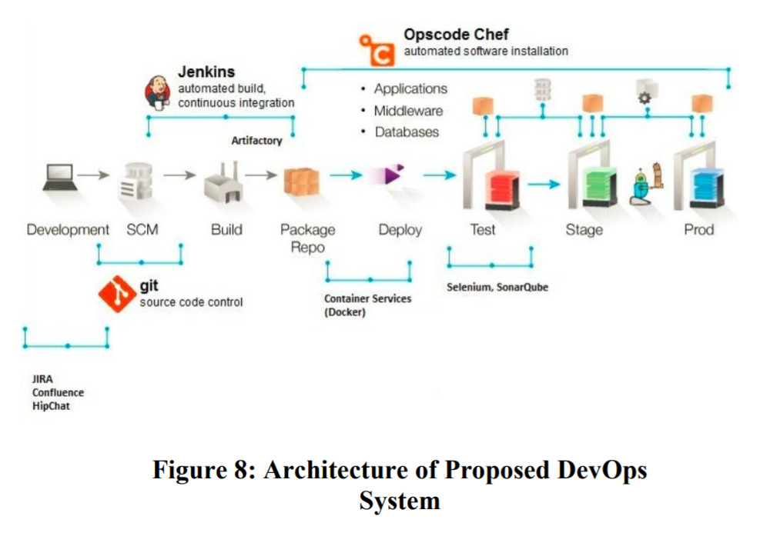



1. **DEV:**

Dev is the kind of server in which the complete development of the project is done and uses various tools in this phase. After completion of the development process the project is sent for testing and this is tested in the test server. In some cases, Dev is also used for testing purposes like debugging [13].

1. **TEST**

Test is also a kind of server in which the testing takes place for the developed project. This testing will have some test cases written for testing of project. Testing can be manual or automated.

1. **STG**

STG also known as staging in which all the test cases passed and the project configuration and acceptance testing by the customer is done. If the customer agrees then it goes to deployment otherwise it will be changed according to the instructions given by the client.

1. **PRD**

PRD server is used for the production purpose. After accepting by the customer, the complete project after passing through all the tests will be deployed and released into the market.

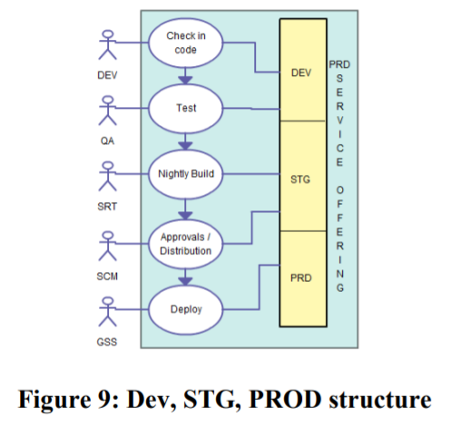

**Product Insights:**

