My Best Model

Hyper Parameters :
epochs:1024
Neurons : 181
Layers :3
hidden_dropout_ratio: 0.1%
l1: 1e-7
activation:"TanhWithDropout"

Results:
Train & Test on Training Data
Evaluation on Full Training data :
h2o.r2(churnperfBest) : 0.7239016
mean(data.frame(h2o.accuracy(churnperfBest))$accuracy) : 0.9004239
max(data.frame(h2o.accuracy(churnperfBest))$accuracy) : 0.9346856

Train on 80% Subset Training Data :
Evaluation on Full Training data :
h2o.r2(churnperfBest) : 0.1588853
mean(data.frame(h2o.accuracy(churnperfBest))$accuracy) : 0.698247
max(data.frame(h2o.accuracy(churnperfBest))$accuracy): 0.7860041
mean(h2o.sensitivity(churnperfBest)$tpr): 0.6508268
mean(h2o.specificity(churnperfBest)$tnr): 0.7148589
Evaluation on data :
h2o.r2(churnperfBest) : 0.1769442
mean(data.frame(h2o.accuracy(churnperfBest))$accuracy) : 0.7139594
max(data.frame(h2o.accuracy(churnperfBest))$accuracy) : 0.7796954
mean(h2o.sensitivity(churnperfBest)$tpr) : 0.592751
mean(h2o.specificity(churnperfBest)$tnr) : 0.7572004

Graphs of all the runs :

First Run without epochs I.e default epochs = 10
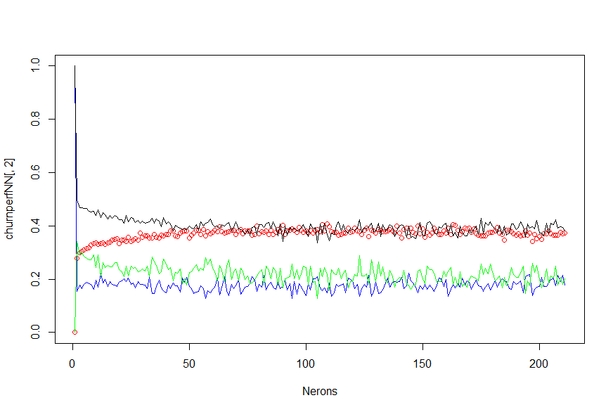

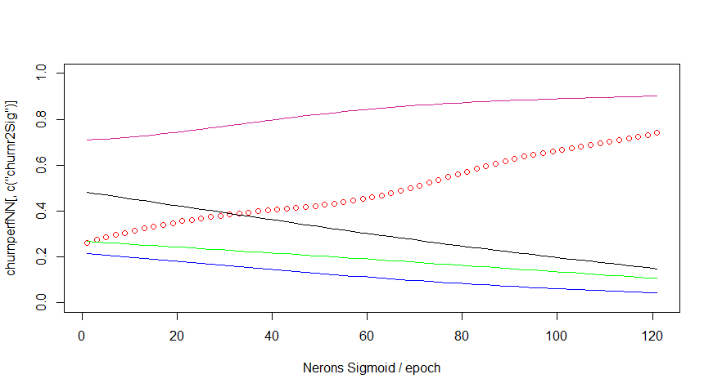
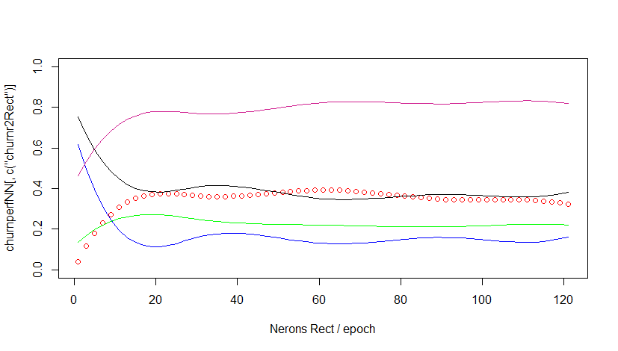

Epochs = 421

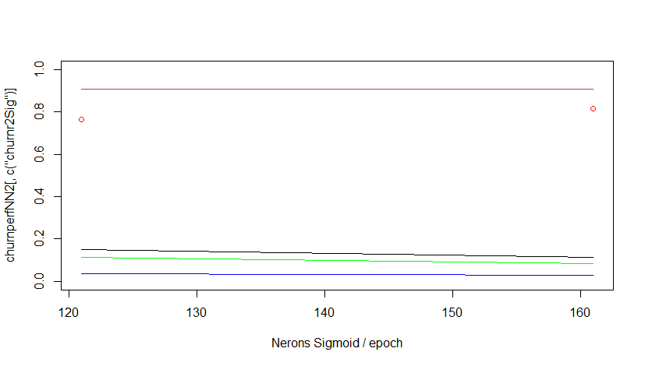
Epochs = 521-721

