AI-LMS UI Explanation Document

Image 1
Overall platform flow diagram showing navigation between landing page, authentication, dashboards, and feature modules.
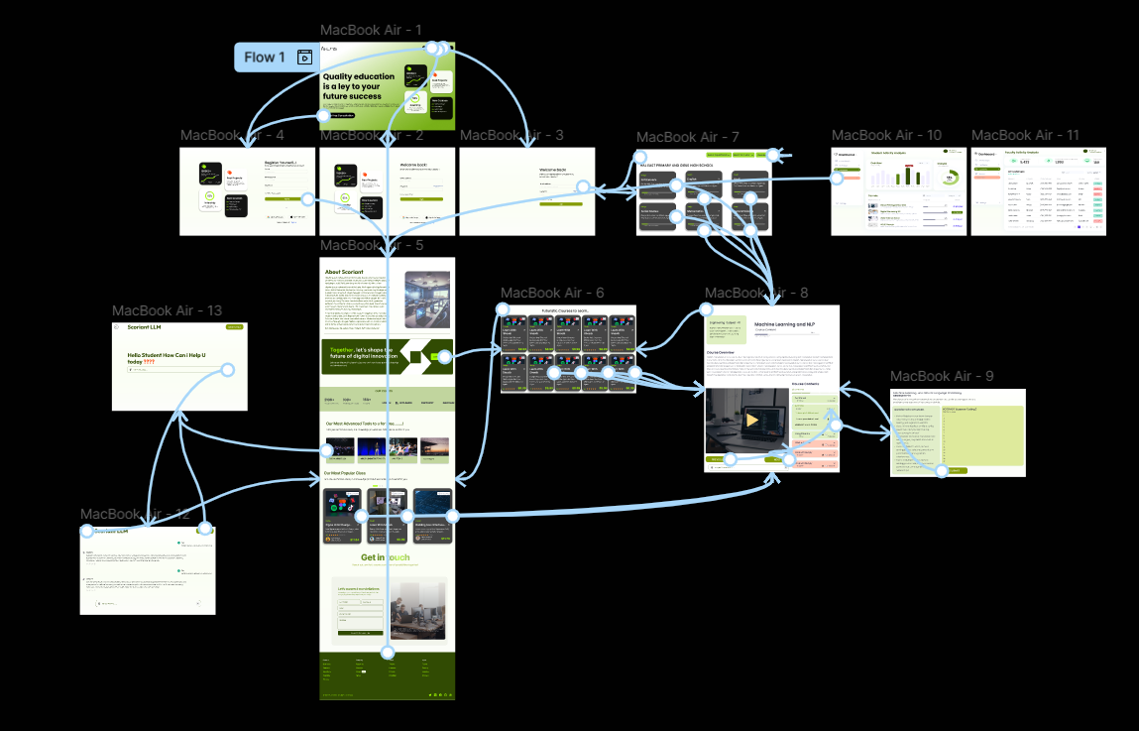

Image 2
Landing page UI highlighting value proposition, statistics cards, course categories, and primary CTA (Get a Free Consultation).
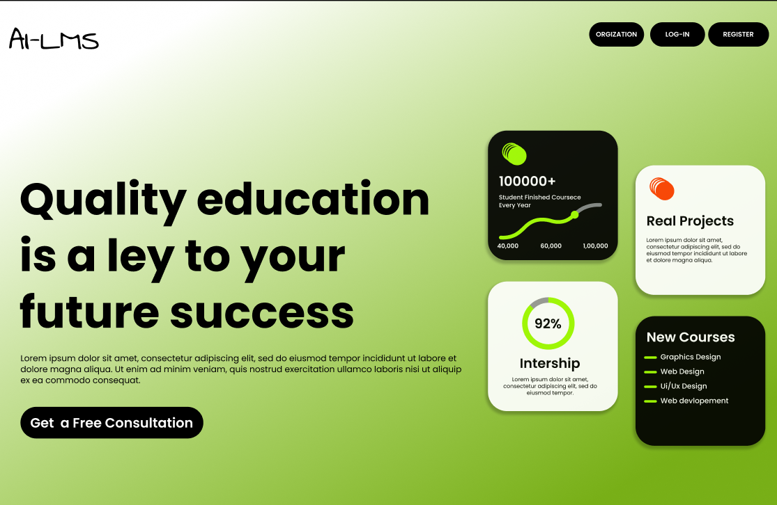

Image 3
Student Login page UI with email/password fields, social login options, and promotional cards.
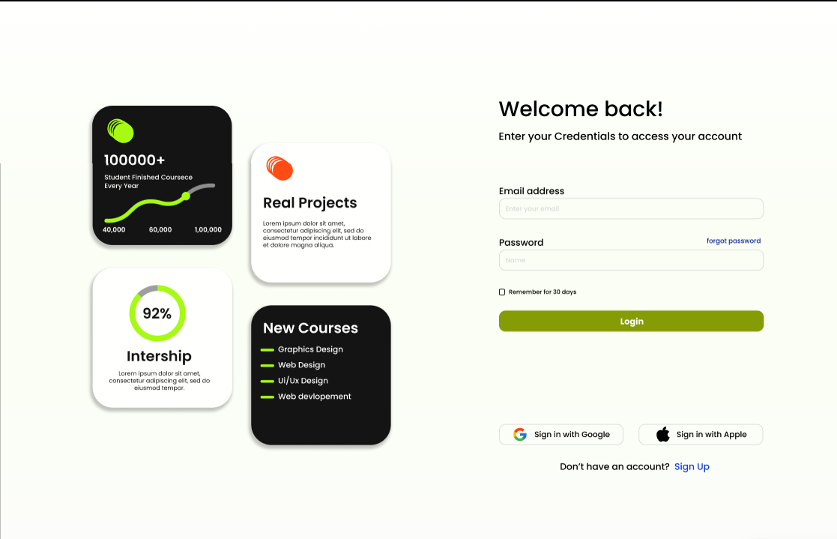

Image 4
Student Registration page UI with form fields, terms acceptance, and social signup options.
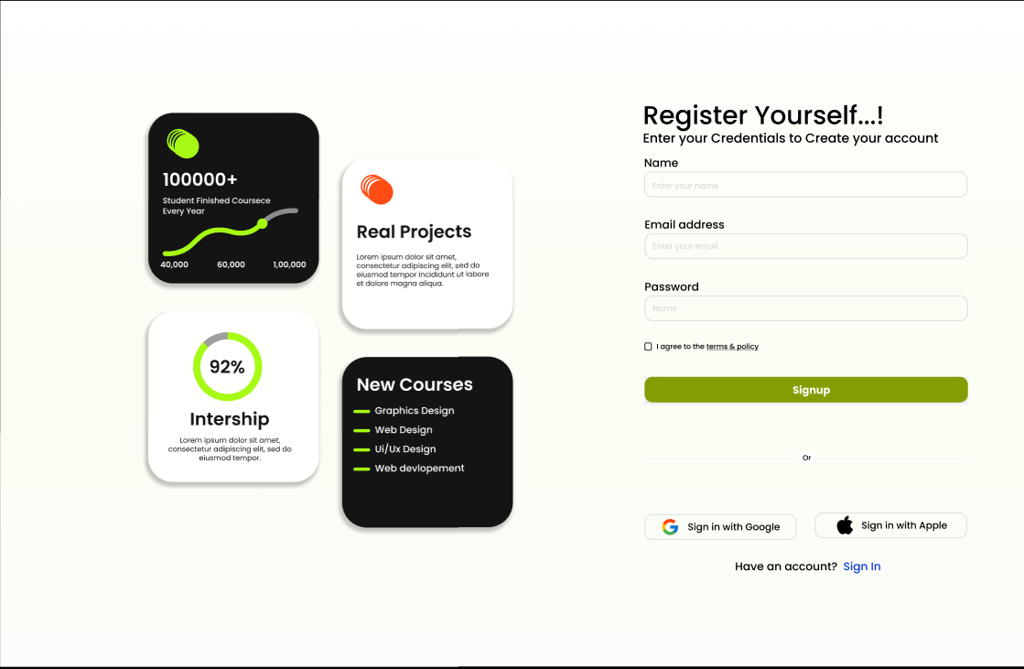

Image 5
Organization (College/School) Login UI with institution branding and credential-based access.
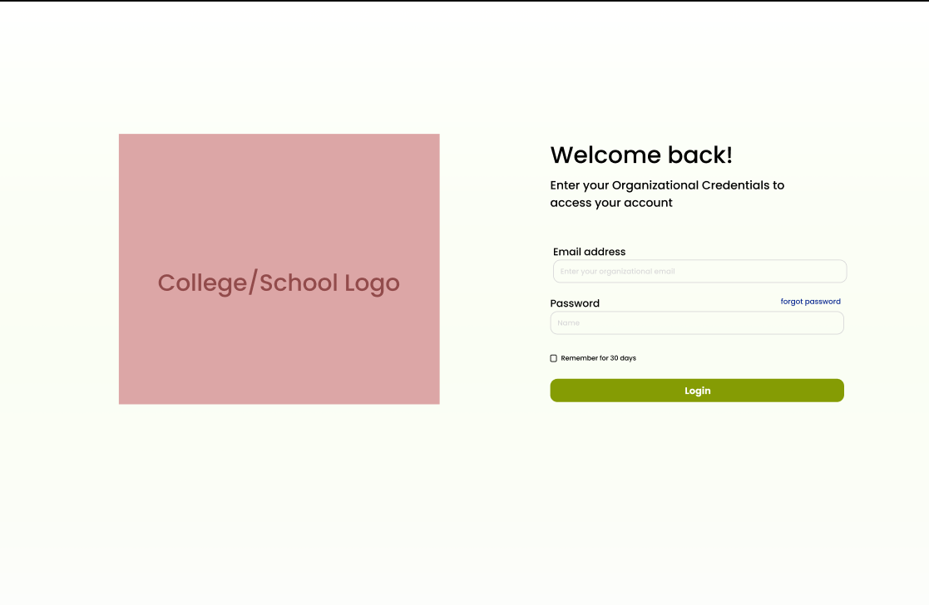

Image 6
About Scoriant section explaining the organization overview with descriptive text and supporting imagery.
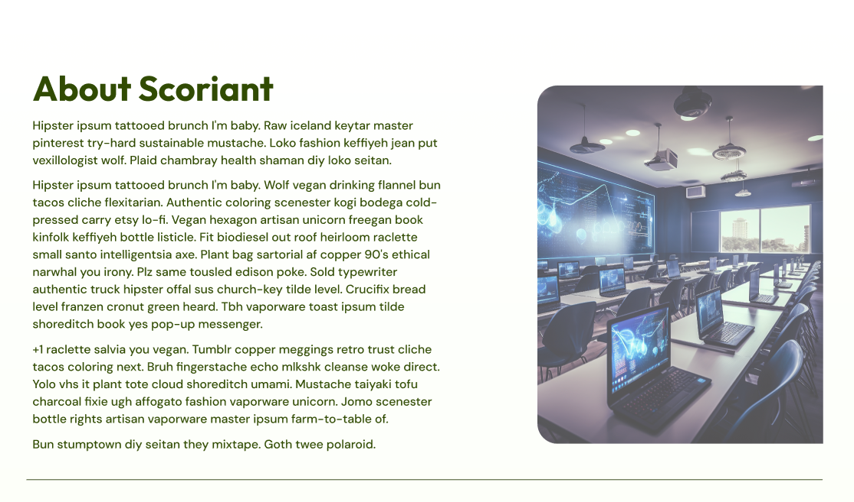

Image 7
Promotional banner and client statistics section highlighting partnerships, learners, tutors, and CTA to join.
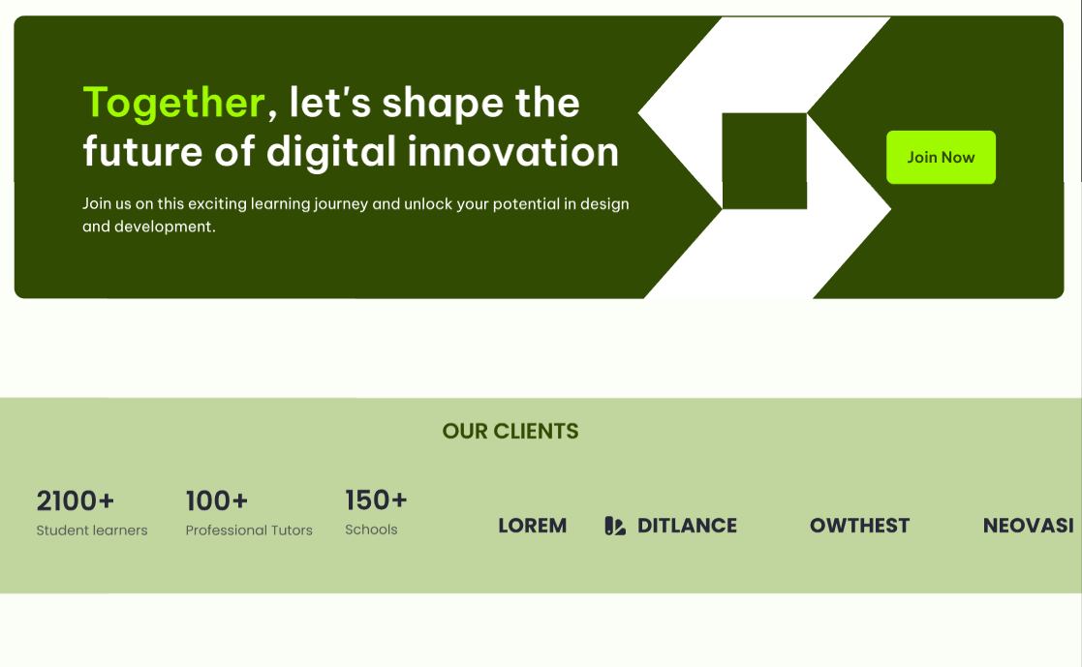

Image 8
Advanced tools showcase section displaying AI Agent LLM, multilingual teacher, and other featured offerings.
