ASSIGNMENT 2

NAME:-Anand Sharma (MT19059)
Analysis Report

QUESTION 1:-
Query:-['unfalsifiable', 'theism', 'hypothesis']
k=30
OUTPUT:-<class 'list'>
[3960, 3701, 3025, 3068, 5029, 11578, 3828, 5015, 6340, 6897, 3691, 3143, 3609, 2352, 5101, 18344, 5515, 3724, 3281, 3660, 3745, 5182, 6551, 6672, 3569, 3429, 11718, 6634, 3252, 3797]

Query:-"path cmu harvard is howland"
k=30
OUTPUT:-<class 'list'>
<class 'list'>
[49, 164, 176, 366, 458, 463, 476, 517, 665, 672, 675, 708, 945, 994, 1078, 1126, 1159, 1247, 1364, 1474, 1476, 1590, 1634, 1709, 1734, 1761, 1813, 1870, 1926, 1944]
[ ]:
​

The high list is created based on mean of term frequency r value is chosen based on mean of term frequency

QUESTION 2:-
[1]
(59P1 +59P2+59P3 + …. 59P59)*26!*17!*1!*0!
[2]
(a)
DCG:-18.131248583612233
IDCG:_51.5909308074698
nDCG:-0.35144255588788537

(b)
DCG:-10418.862647482101
IDCG:-10955.46078343931
NDCG:-0.9510200304154846

for qid=4
12.337484420604602
19.407247618668023
0.6357153091990775

[3]
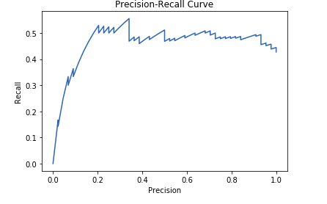

Question 3:-

(1) Receiver Operator Characteristic (ROC) curves are commonly used to present results for binary decision problems in machine learning. However, when dealing with highly skewed datasets, Precision-Recall (PR) curves give a more informative picture of an algorithm’s performance
ROC curve plot True Positive Rate Vs. False Positive Rate; Whereas, PR curve plot Precision Vs. Recall. a deep connection exists between ROC space and PR space, such that a curve dominates in ROC space if and only if it dominates in PR space

(2) To Prove that a curve dominates in ROC space if and only if it dominates in PR space. We have to proof both A implies B and B implies A . We will proof both If a curve dominates in ROC space then it dominates in PR space and If a curve dominates in PR space then it dominates in ROC space
Claim 1 (⇐):Proof by contradiction. Suppose we have curve I and curve II (as shown in Figure 3) such that curve I dominates in ROC space, yet, once we translate these curves in PR space, curve I no longer dominates. Since curve I does not dominate in PR space, there exists some point A on curve II such that the point B on curve I with identical Recall has lower Precision. In other words, PRECISION(A) > PRECISION(B) yet RECALL(A) = RECALL(B). Since RECALL(A) = RECALL(B) and Recall is identical to TPR, we have that TPR(A) = TPR(B). Since curve I dominates curve II in ROC space FPR(A) ≥ FPR(B). Remember that total positives and total negatives are fixed and since TPR(A) = TPR(B): TPR(A) = TPA Total Positives TPR(B) = TPB Total Positives we now have TPA = TPB and thus denote both as TP. Remember that FPR(A) ≥ FPR(B) and FPR(A) = FPA Total Negatives FPR(B) = FPB Total Negatives This implies that FPA ≥ FPB because PRECISION(A) = TP FPA + TP PRECISION(B) = TP FPB + TP we now have that PRECISION(A) ≤ PRECISION(B). But this contradicts our original assumption that PRECISION(A) > PRECISION(B).
Claim 2 (⇐): If a curve dominates in PR space then it dominates in ROC space. Proof by contradiction. Suppose we have curve I and curve II (as shown in Figure 4) such that curve I dominates curve II in PR space, but once translated in ROC space curve I no longer dominates. Since curve I does not dominate in ROC space, there exists some point A on curve II such that point B on curve I with identical TPR yet FPR(A) < TPR(B). Since RECALL and TPR are the same, we get that RECALL(A) = RECALL(B). Because curve I dominates in PR space we know that PRECISION(A) ≤ PRECISION(B)that RECALL(A) = RECALL(B) and RECALL(A) = TPA Total Positives RECALL(B) = TPB Total Positives We know that TPA = TPB, so we will now denote them simply as TP. Because PRECISION(A) ≤ PRECISION(B) and PRECISION(A) = TP TP + FPA PRECISION(B) = TP TP + FPB we find that FPA ≥ FPB. Now we have FPR(A) = FPA Total Negatives FPR(B) = FPB Total Negatives This implies that FPR(A) ≥ FPR(B) and this contradicts our original assumption that FPR(A) < FPR(B).
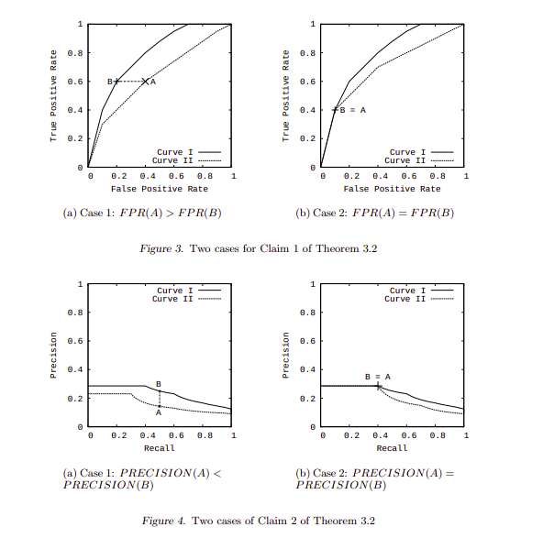
(3) when we interpolate between points in PR space by simply drawing a straight line connecting the two points. As the level of Recall varies, the Precision does not necessarily change linearly due to the fact that FP replaces FN in the denominator of the Precision metric. In these cases, linear interpolation is a mistake that yields an overly-optimistic estimate of performance Remember that any point A in a Precision-Recall space is generated from the underlying true positive (TPA) and false positive (FPA) counts. Suppose we have two points, A and B which are far apart in Precision-Recall space. To find some intermediate values, we must interpolate between their counts TPA and TPB, and FPA and FPB. We find out how many negative examples it takes to equal one positive, or the local skew, defined by F PB−F PA T PB−T PA . Now we can create new points TPA +x for all integer values of x such that 1 ≤ x ≤ TPB −TPA, i.e. TPA+1, TPA+2, ..., TPB −1, and calculate corresponding FP by linearly increasing the false positives for each new point by the local skew. Our resulting intermediate Precision-Recall points will be TPA + x Total Pos , TPA + x TPA + x + FPA + F PB−F PA T PB−T PA x ! First, we find the convex hull in ROC space (Corollary 3.1). Next, for each point selected by the algorithm to be included in the hull, we use the confusion matrix that defines that point to construct the corresponding point in PR space (Theorem 3.1). Finally, we perform the correct interpolation between the newly created PR points.

