ArchitectureDesign

# Customer Life Time ValuePrediction

|  |  |
| --- | --- |
| **Written By** | Anand Shrivastav |
| **DocumentVersion** | 0.3 |
| **LastRevisedDate** |  |

**DOCUMENTCONTROL**

## ChangeRecord:

|  |  |  |  |
| --- | --- | --- | --- |
| **VERSION** | **DATE** | **AUTHOR** | **COMMENTS** |
| 0.1 | 06-may -  2024 | Anand | Introductionandarchitecture defined |
| 0.2 | 08 -may-  2024 |  | Architecture&Architecturedescriptionappendedand  updated. |
|  |  |  |  |
|  |  |  |  |

**ApprovalStatus:**

|  |  |  |  |  |  |
| --- | --- | --- | --- | --- | --- |
| **VERSION** | **REVIEW**  **DATE** | **REVIEWEDBY** |  | **APPROVEDBY** | **COMMENTS** |
|  |  |  |  |  |  |

# Contents

1. Introduction 04
   1. WhatisArchitectureDesign Document? 04
   2. Scope 04
2. Architecture 05
   1. TableauArchitecture 05
   2. TableauServerArchitecture 05
   3. Gateway/LoadBalancer 06
   4. Application Server 06
   5. VIZQL Server 07
   6. DataEngine 07
   7. Backgrounder 07
   8. DataServer 07
   9. TableauCommunicationFlow 07
3. Deployment 08
   1. DeploymentOptionsinTableau 09
   2. SingleNodeArchitecture 10
   3. ThreeNodeArchitecture 11
   4. FiveNodeArchitecture 12

# Introduction

## WhatisArchitecture designdocument?

Any software needs the architectural design to represents the design of software. IEEE definesarchitecturaldesignas“theprocessofdefiningacollectionofhardwareandsoftwarecomponents and their interfaces to establish the framework for the development of a computersystem.” The software that is built for computer-based systems can exhibit one of these manyarchitectures.

Eachstylewilldescribeasystemcategorythatconsistsof:

* Asetofcomponents(eg:adatabase,computationalmodules)thatwillperformafunctionrequiredbythesystem.
* Thesetofconnectorswillhelpincoordination,communication,andcooperationbetweenthe components.
* Conditionsthathowcomponentscanbeintegratedtoformthesystem.
* Semanticmodelsthathelpthedesignertounderstandtheoverallpropertiesofthesystem.

## Scope

ArchitectureDesignDocument(ADD)isanarchitecturedesignprocessthatfollowsastep-by-steprefinement process. The process can be used for designing data structures, required softwarearchitecture, source code and ultimately, performance algorithms. Overall, the design principlesmaybedefinedduringrequirementanalysisandthenrefinedduringarchitectural designwork.

# Architecture

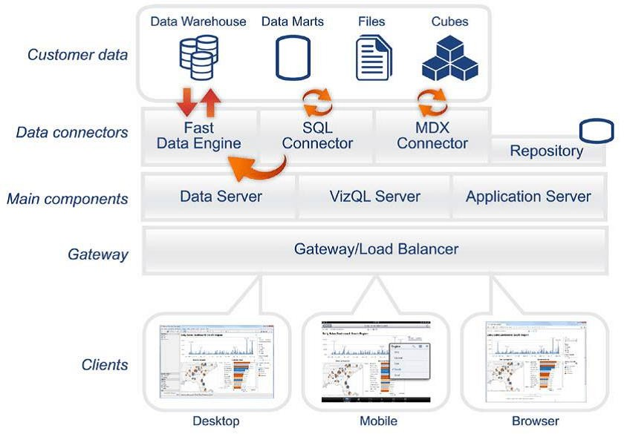

**TableauServerArchitecture**

Tableau has a highly scalable, n-tier client-server architecture that serves mobile clients, webclients and desktop-installed software. Tableau Server architecture supports fast and flexibledeployments.

### ARCHITECTUREDESIGN

**6**

ThefollowingdiagramshowsTableauServer’sarchitecture:

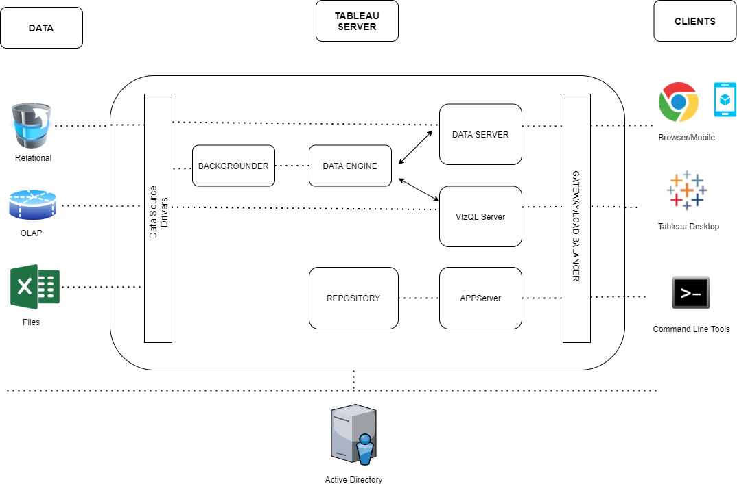

TableauServerisinternallymanagedbythemultipleserverprocesses.

**1.Gateway/LoadBalancer**

It acts as an Entry gate to the Tableau Server and also balances the load to the Server if multipleProcessesareconfigured.

**2)ApplicationServer:-**

Application Server processes (wgserver.exe) handle browsing and permissions for the TableauServer web and mobile interfaces. When a user opens a view in a client device, that user starts asession on Tableau Server. This means that an Application Server thread starts and checks thepermissions forthat userandthat view.

1. **Repository:-**

Tableau Server Repository is a PostgreSQL database that stores server data. This data includesinformation about Tableau Server users, groups and group assignments, permissions, projects,datasources, andextractmetadata andrefreshinformation.

1. **VIZQLServer:-**

Once a view is opened, the client sends a request to the VizQL process (vizqlserver.exe). The VizQLprocess then sends queries directly to the data source, returning a result set that is rendered asimagesandpresentedtotheuser.EachVizQLServerhasitsowncachethatcanbesharedacrossmultiple users

1. **DataEngine:-**

ItStores dataextractsandanswers queries.

1. **Backgrounder:-**

The backgrounder Executes server tasks which includes refreshes scheduled extracts, tasksinitiatedfromtabcmdandmanagesother backgroundtasks.

1. **DataServer:-**

DataServerManagesconnectionstoTableauServerdatasources

ItalsomaintainsmetadatafromTableauDesktop,suchascalculations,definitions,andgroups.

**8)TableauCommunicationFlow**

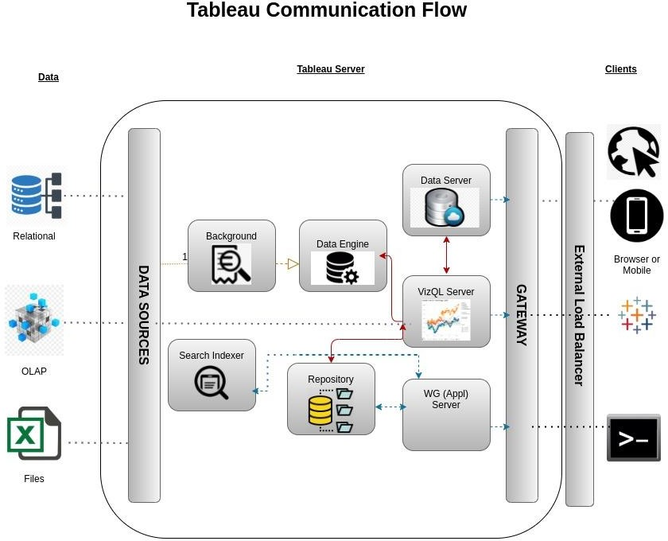

# DeploymentDescription

## DeploymentoptionsinTableau

Tableau’sanalyticsplatformoffersthreedifferentdeploymentoptionsdependingonyour

environmentandneeds.Thebelowgraphicshowseachoptionataglance:

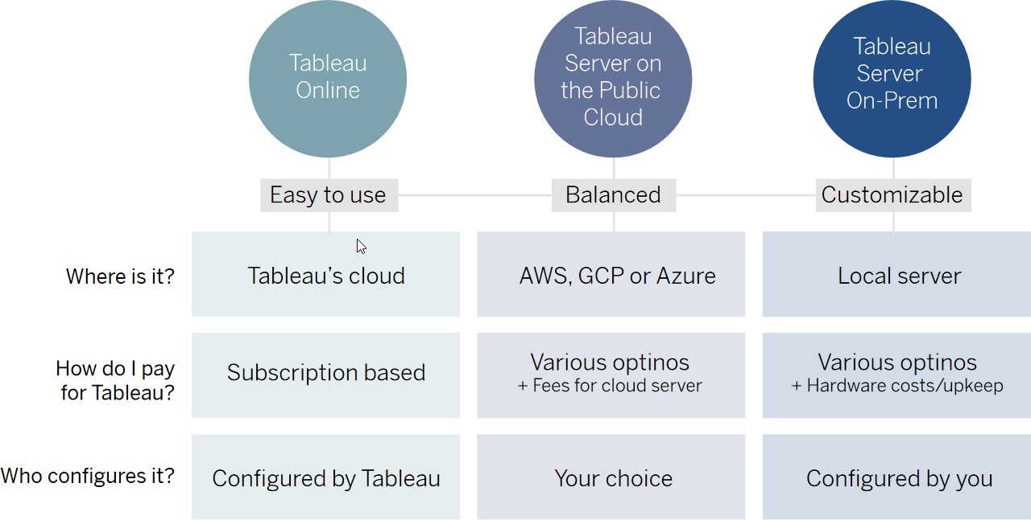

1. **Tableau Online** Get up and running quickly with no hardware required. Tableau Online is fullyhostedbyTableauso allupgradesandmaintenanceareautomaticallymanagedforyou.
2. **Tableau Server** deployed on public cloud: Leverage the flexibility and scalability of cloudinfrastructure without giving up control. Deploy to Amazon Web Services, Google CloudPlatform, or Microsoft Azure infrastructure to quickly get started with Tableau Server (on yourchoiceofWindowsorLinux).Bringyourownlicenseorpurchaseonyourpreferredmarketplace.
3. **Tableau Server deployed on-premises**: Manage and scale your own hardware and software(whether Windows or Linux)asneeded.Customizeyour deploymentas yousee fit.

## SingleNodeArchitecture

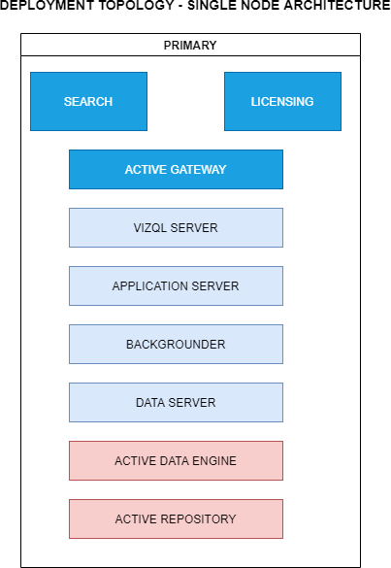

Thisarchitectureisasinglenodearchitecture.Thisisthemostsimpledeploymenttopology.

## 3NodeArchitecture

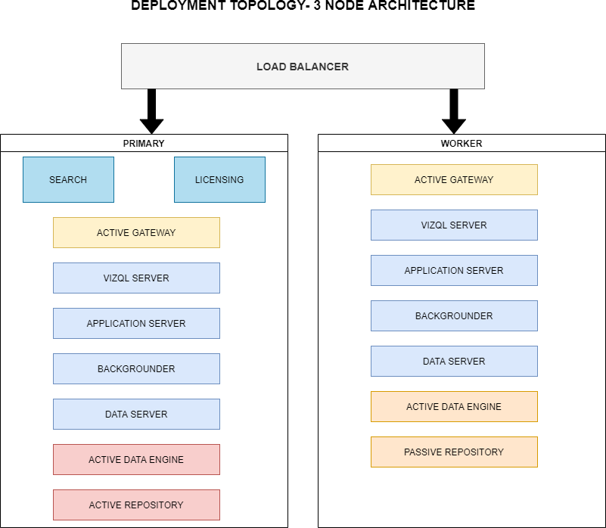

Thisarchitectureisa3NodeArchitecturewhichismorecapabletohandleconcurrentrequests.

Ifweneedfailoverorhighavailability,orwantasecondinstanceoftherepository,wemustinstallTableau Server on a cluster of at least three computers. In a cluster that includes at least threenodes,youcanconfiguretwoinstancesoftherepository,whichgivesourclusterfailovercapability.

## 5NodeArchitecture

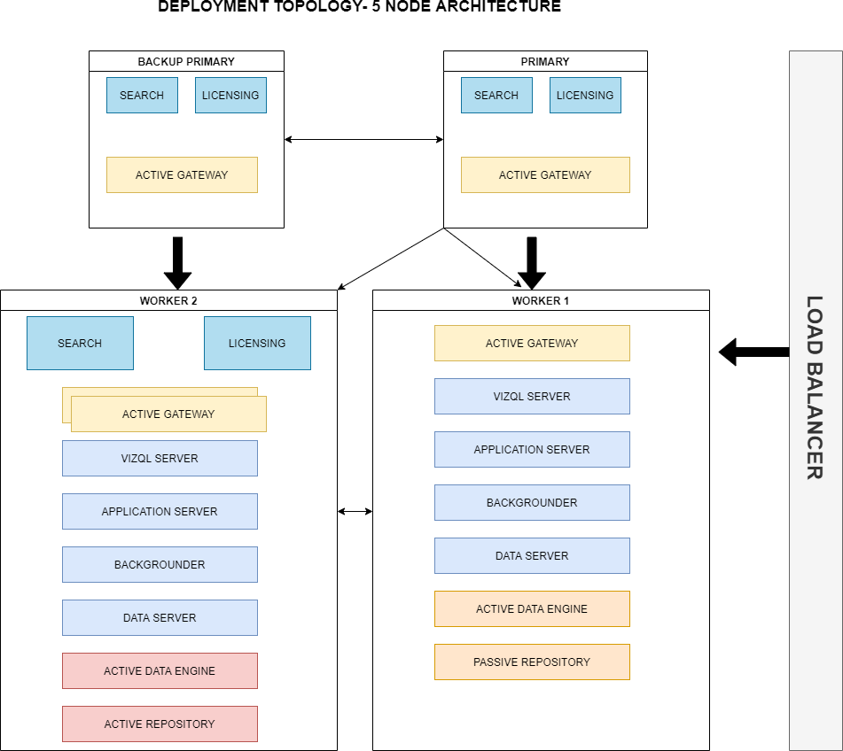

When we install Tableau Server on a Five-node cluster, we can install server processes on one orboth nodes. A five-node cluster can improve the performance of Tableau Server, because thework isspread acrossmultiplemachines.

Notethefollowingaboutfive-nodeclusters:

* + - Afive-nodeclusterdoesnotprovidefailoverorsupportforhighavailability.
    - You can't install more than one instance of the repository on a two-node cluster, and therepositorymust beontheinitial node.