RETAIL SALES ANALYTICS REPORT

Prepared By:
Anand Singh Gaherwar
MBA (Marketing & Business Intelligence and Data Analytics)
Chandigarh University

Date: 30 May 2026

Table of Contents

1. Project Objective

2. Total Sales Analysis

3. Profitability Analysis

4. Regional Performance Analysis

5. Product Category Analysis

6. Customer Insights

7. Product Performance Analysis

8. Sales Trend Analysis

9. Conclusion

Dataset Source=Sample Retail Sales Dataset

Records Analyzed= 9995 Rows

Tools Used:

• MS Excel

• MySQL

• MS Word

1.Project Objective

The objective of this project is to analyze retail sales data using SQL and Excel to identify sales trends, customer behavior, regional performance, product profitability, and customer purchasing patterns. The analysis aims to generate meaningful business insights to support data-driven decision-making and improve overall business performance.

2. Total Sales Analysis

The retail sales analysis revealed a total sales revenue of ₹32,912.92 during the analyzed period. This indicates a steady flow of customer purchases across different product categories and regions. The overall sales performance reflects the business's ability to generate revenue through a diverse product portfolio and customer base. Understanding total sales is essential for evaluating business growth, measuring market demand, and supporting future strategic decision-making. The sales data also serves as a foundation for further analysis of profitability, customer behavior, and regional performance.

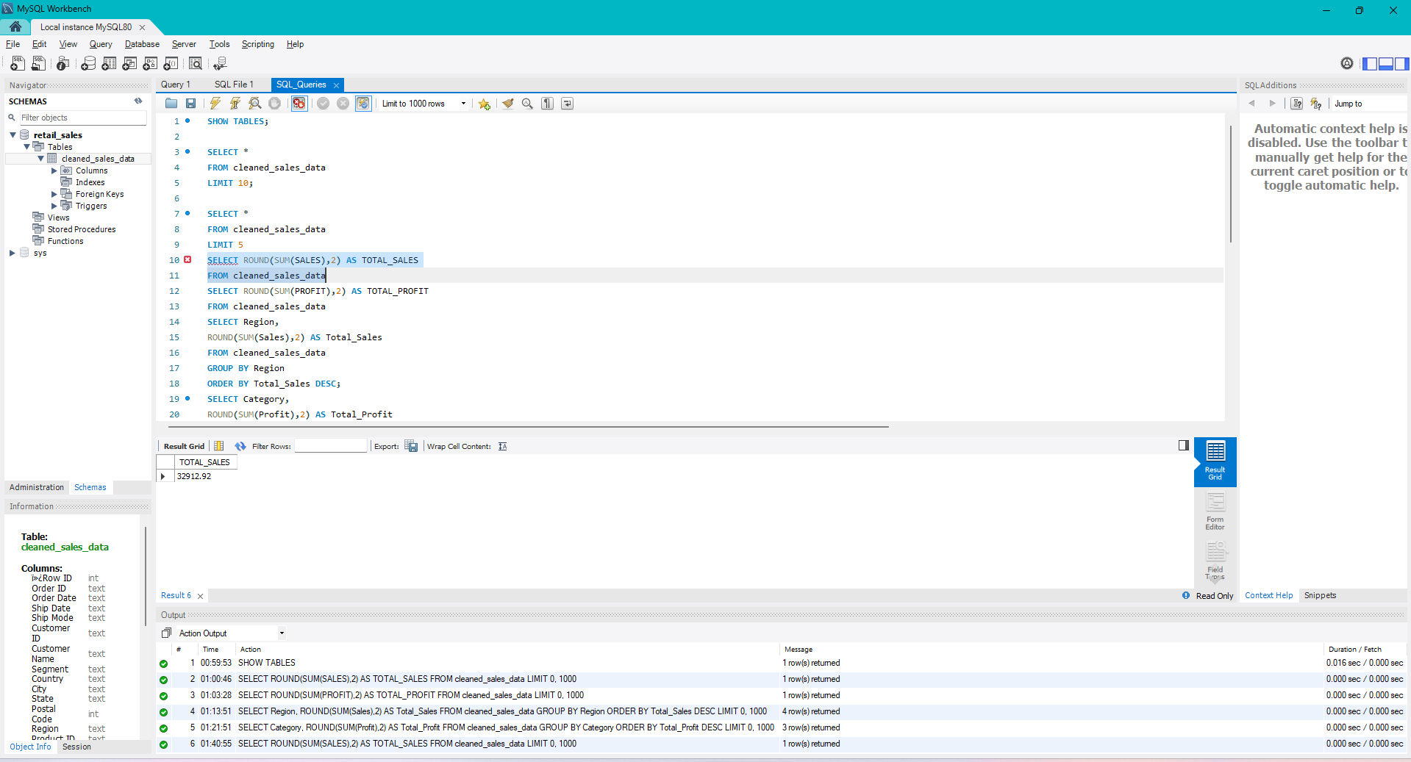

3. Profitability Analysis

The profitability analysis revealed a total profit of ₹1,587.82 during the analyzed period. This indicates that the business was able to generate earnings after covering its operational and product-related costs. Although the profit value is lower compared to total sales revenue, it reflects the organization's ability to maintain positive financial performance. The analysis highlights the importance of monitoring profit margins, controlling costs, and focusing on high-performing products and categories to improve overall profitability. Understanding profit trends enables better strategic planning and supports informed business decision-making aimed at sustainable growth.
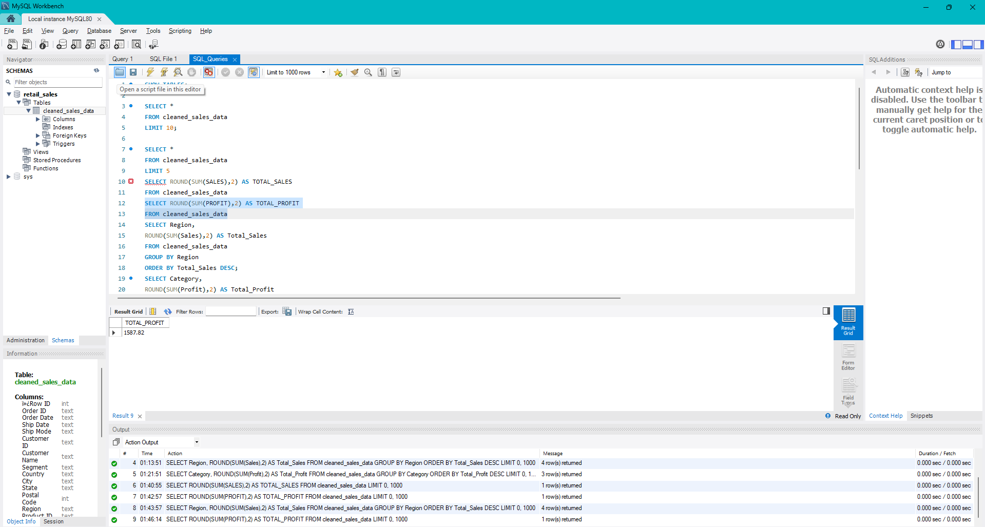

4. Regional Performance Analysis

The regional sales analysis identified West region with sales of 11259.34 as the highest-performing region in terms of revenue generation. This indicates stronger customer demand and market penetration compared to other regions. On the other hand, South region with sales of 4153.69 contributed the least revenue, highlighting potential opportunities for targeted marketing initiatives and sales improvement strategies. Understanding regional performance helps businesses allocate resources effectively, improve customer outreach, and focus on high-growth markets.
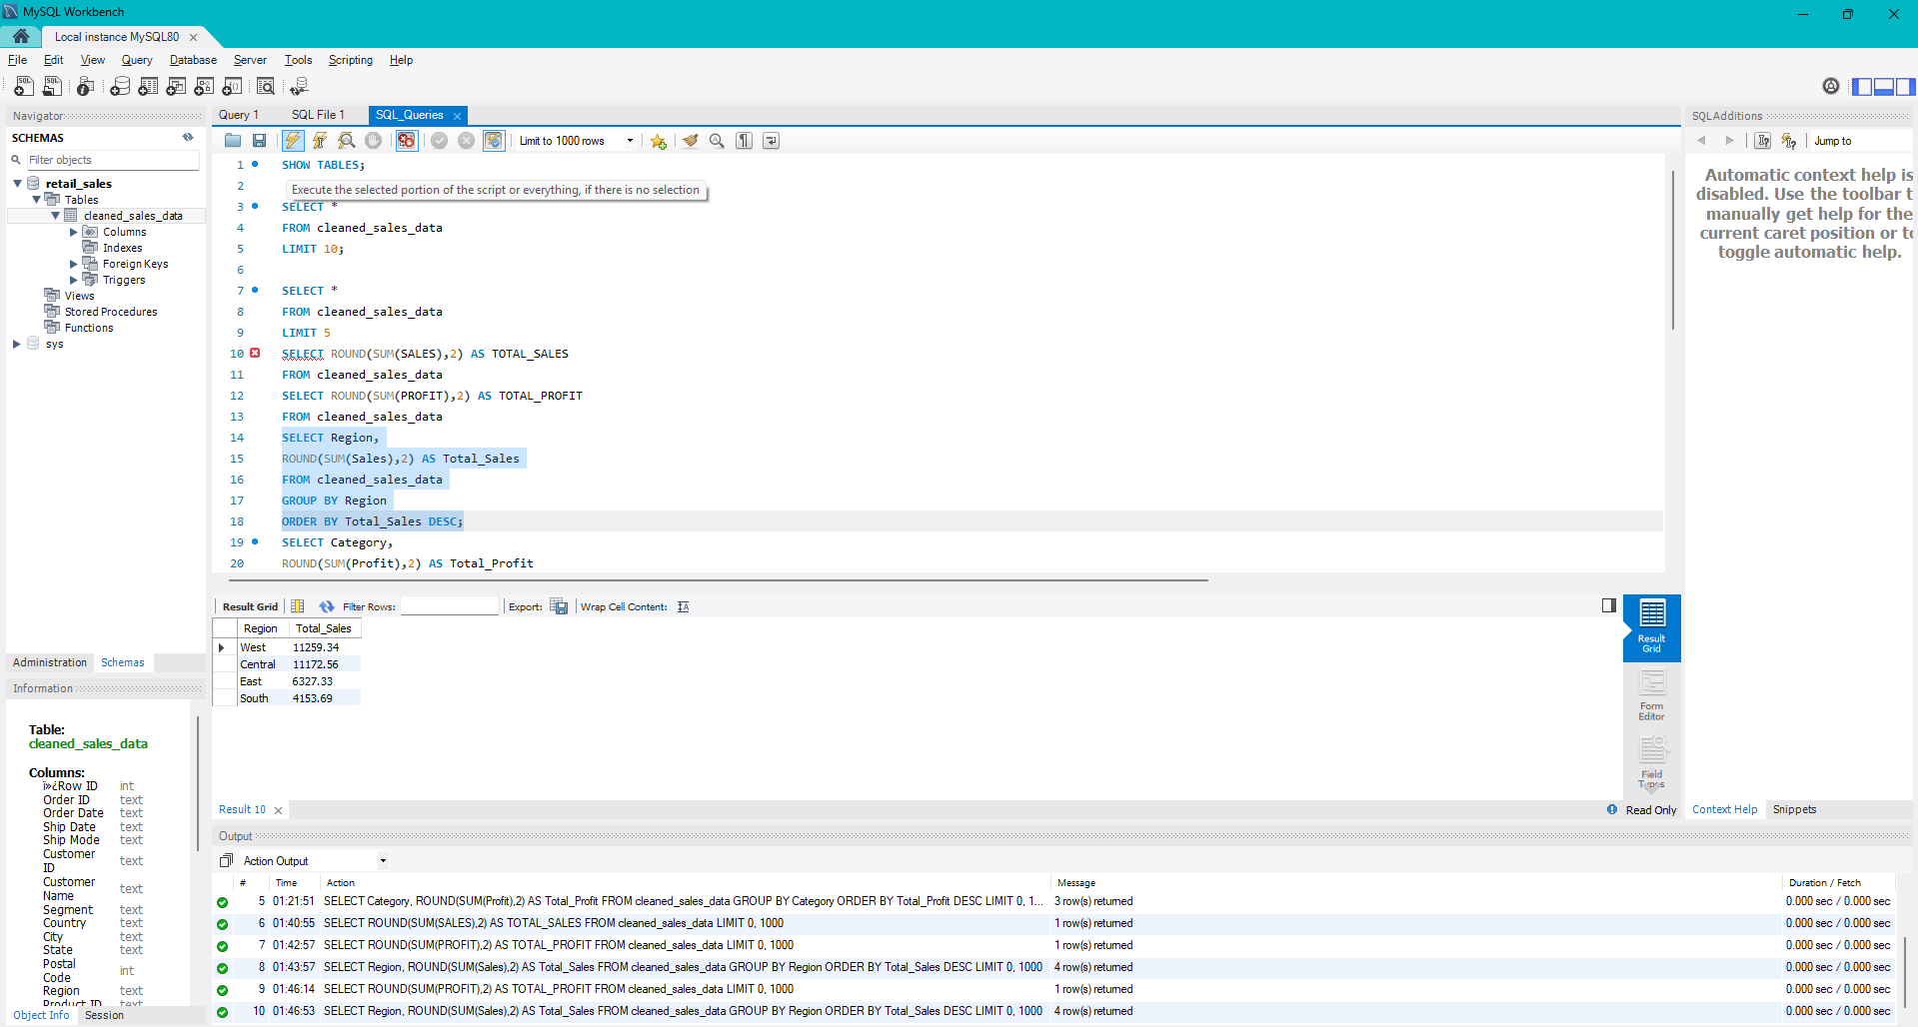

5. Product Category Analysis

The category-wise profitability analysis revealed that Office supply generated the highest profit of 1556.03 among all product categories. This suggests that products within this category enjoy strong customer demand and favourable profit margins. In contrast, lower-performing categories may require strategic attention through pricing adjustments, promotional campaigns, or inventory optimization. Category analysis helps businesses identify profitable segments and prioritize investment in high-performing product lines.
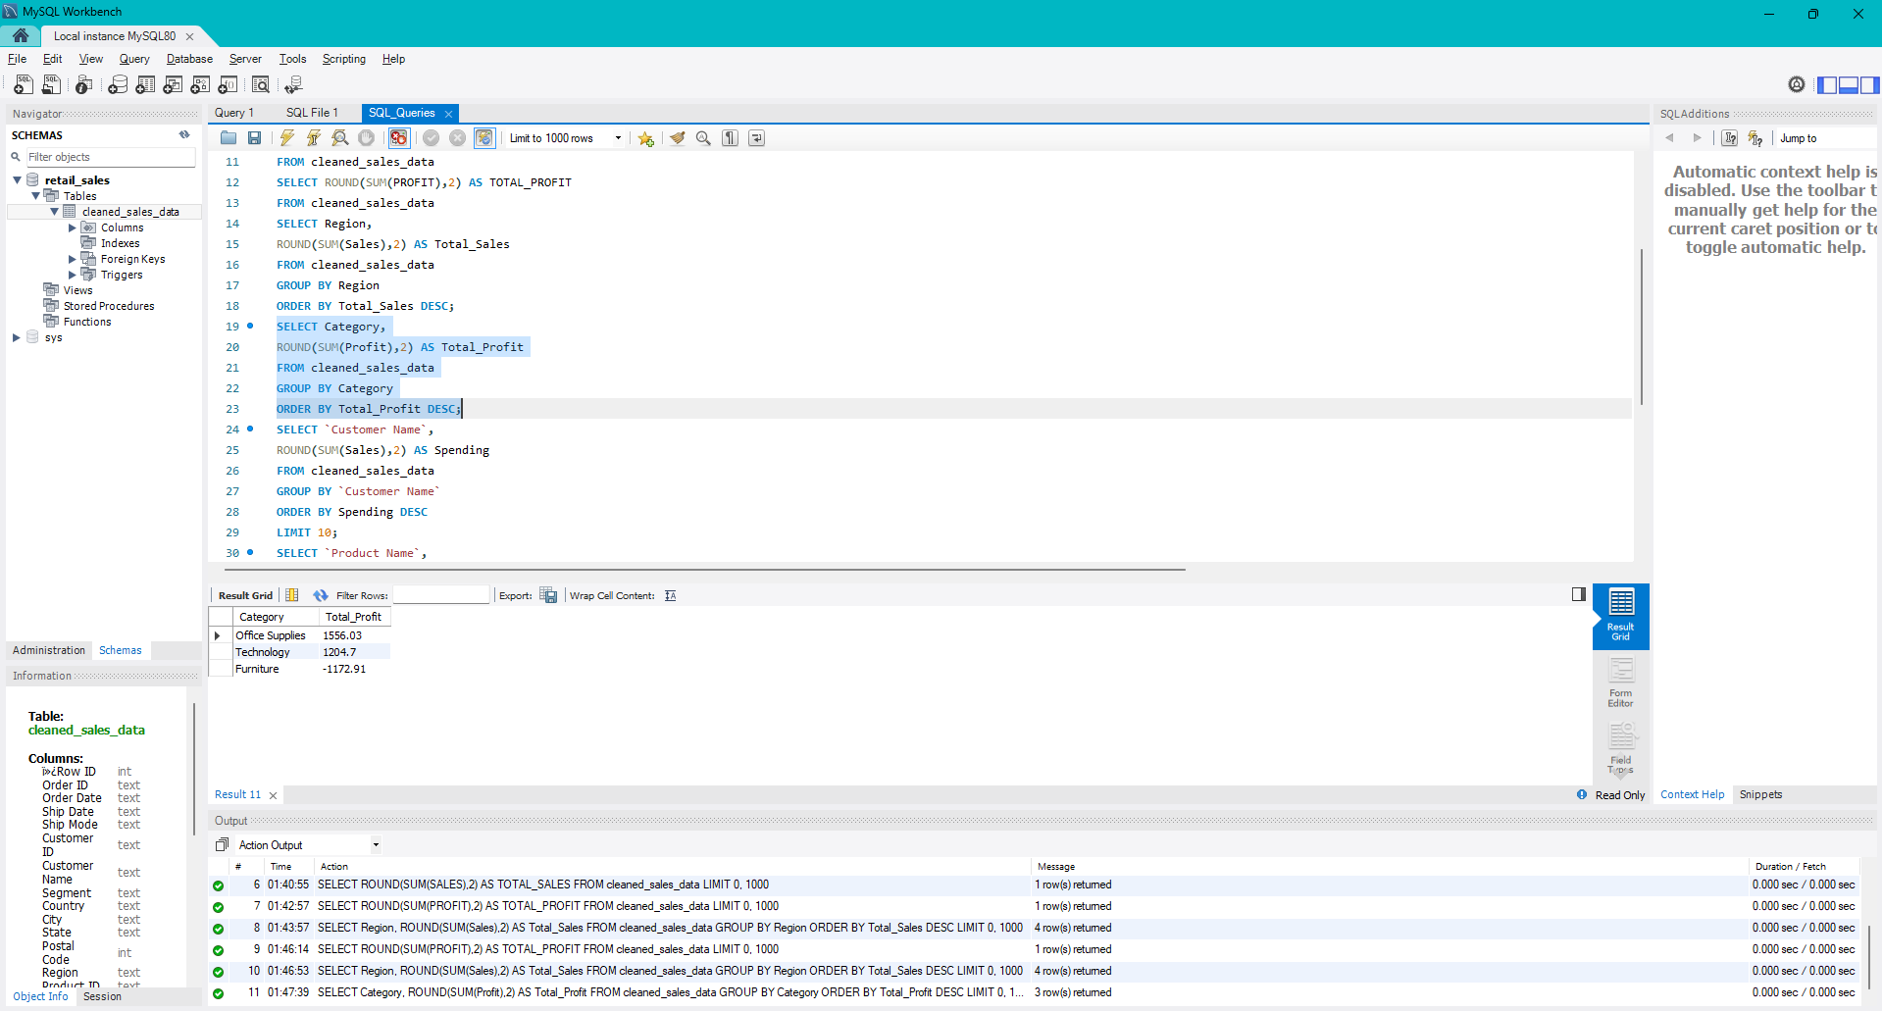

6. Customer Insights

Customer analysis highlighted the significant contribution of the top customers to overall sales revenue. The findings indicate that a relatively small group of customers generated a substantial portion of business revenue. This emphasizes the importance of customer retention, loyalty programs, and personalized engagement strategies. Maintaining strong relationships with high-value customers can lead to increased repeat purchases and long-term business growth.

7. Product Performance Analysis

The product performance analysis identified the best-selling products that contributed significantly to total sales revenue. The study also revealed certain products that generated lower profits or losses despite recording sales. These findings provide valuable insights for inventory management, pricing decisions, and product portfolio optimization. Focusing on high-performing products while addressing underperforming items can improve overall business profitability and operational efficiency.

8. Sales Trend Analysis

The sales trend analysis provided insights into revenue patterns over the analyzed period. The results indicate fluctuations in sales performance driven by customer demand, seasonal factors, and market conditions. Monitoring sales trends enables businesses to forecast future demand, optimize inventory planning, and develop effective sales strategies. Trend analysis plays a crucial role in identifying growth opportunities and supporting long-term business planning.

Key Findings

• Total Sales Revenue: ₹32,912.92
• Total Profit: ₹1,587.82
• Highest Sales Region: West
• Lowest Sales Region: South
• Most Profitable Category: Office Supplies
• Positive Overall Business Profitability

9. Conclusion

The Retail Sales Analytics project successfully analyzed sales, profit, customer behavior, product performance, and regional contributions using SQL and Excel. The analysis generated valuable business insights that can support strategic decision-making and improve overall business performance. Key findings included the identification of top-performing regions, profitable product categories, high-value customers, and important sales trends. This project demonstrates the practical application of data analytics in solving business problems and highlights the importance of data-driven decision-making in modern organizations.

