Value Collection Tool for Blue[i] Property

Background
There is a need for an industry leading value collection tool for a property risk management application, Blue[i] property. The tool should let admins create data-collection campaigns tied to property portfolios, assign users/internal or external contributors, and generate forms capturing COPE/Exposure values and other property attributes. Contributors can complete the forms either in-app (for authenticated users) or via signed links (for external users), with save-as-draft and submit flows. A reviewer then approves/rejects submissions. The workflow is governed by SLAs with automated reminders and escalation.
Competitive signals from market leaders (Aon, Origami, etc.) indicate must-haves such as: exposure values collection at scale, campaign progress tracking, configurable reminders and templates, mobile/offline capture, in-app analytics/dashboards, and role-based access.
This spec aims to define detailed requirements for such a system

Requirements

Assumptions & Constraints (confirmed)
- Embeds into existing Angular app (micro-frontend or iFrame + postMessage; shared theming, routing handoff).
- Internal users authenticated via SAML (IdP-initiated and SP-initiated SSO supported).
- Full audit trails required; data lineage handled by an existing subsystem — this tool will emit events + metadata to it.

MoSCoW Requirements

Must Have
- Campaign Management
  - Create/edit/archive campaigns with name, owner, portfolio scope (properties, regions), due dates, SLA (e.g., T+14 days), and timezone.
  - Assignment engine: assign tasks to internal users or external contacts; bulk import (CSV/API) and rule-based assignment.
  - Progress tracking (Not Started/In Progress/Submitted/Under Review/Approved/Rejected/Expired) with counts & percentages.
- Form Builder (Property/COPE/Exposure)
  - Versioned, schema-driven forms: property identity, location, construction/occupancy/protection/exposure (COPE), values (TIV, BI, contents), risk improvement status, attachments (photos, docs), comments.
  - Widgets: text/number/currency, dates, selects, multi-selects, file upload, address with geocoding, conditional sections, repeating groups (per-building), calculated fields (e.g., TIV sum), server-side validations.
- Collection Experiences
  - In-app authenticated flow for internal users.
  - Signed URL external flow with expiring, single-entity or multi-entity access; passcode & IP allowlist.
  - Save as Draft & Submit for both flows; client-side autosave.
- Review Workflow
  - Per-submission Approve/Reject with reviewer comments; state transitions logged; reopen on reject.
  - Multi-level optional approvals (e.g., analyst → manager) configured at campaign level.
- SLA & Reminders
  - SLA timers per assignment; automated email reminders and in-app notifications: initial invite, N-day reminders, escalation to manager on breach, final notice before expiry.
  - Reminder templates with merge fields; per-campaign schedule.
- RBAC & Permissions
  - Roles: Admin, Campaign Owner, Reviewer, Contributor (internal), External Contributor (link), Auditor (read-only).
  - Scope by portfolio/region/business unit.
- Auditability & Lineage Hooks
  - Immutable audit log for create/update/submit/review, including who/when/where (IP/User-Agent), old→new diffs, and attachment hashes.
  - Event stream (e.g., SubmissionCreated, FieldChanged, SubmissionSubmitted, SubmissionApproved) to publish lineage metadata to the existing system.
- Reporting & Dashboards
  - Campaign dashboards (completion %, SLA breaches, overdue counts); export CSV/Excel; API for BI.
- Security & Compliance
  - SAML SSO, signed URLs with exp/nonce, TLS 1.2+, AES-256 at rest, OWASP ASVS L2, rate limiting, CSRF protection, file AV scanning, PII redaction controls.
- Internationalization & Accessibility
  - i18n-ready labels & templates; WCAG 2.1 AA conformance for web.

Should Have
- Dynamic Targeting: auto-select form variant based on property attributes (e.g., occupancy type, TIV bands).
- Data Quality Controls: cross-field rules, outlier detection (z-score/IQR), required evidence for material changes.
- Integrations: property master data read API; push approved values to downstream modeling systems; webhooks for lifecycle events.
- Mobile-friendly external flow with camera/photo EXIF capture.
- Delegation & Out-of-Office for assignees.
- Bulk Actions: bulk reminders, bulk reassign, bulk approve (when policy allows).

Could Have
- Offline capture for field teams (PWA cache with conflict resolution).
- Geospatial: map-based property picker; hazard overlays.
- Standards alignment: import/export to Open Exposure Data (OED) format.
- AI assists: auto-suggest values from prior years; anomaly hints; OCR for documents.

Won’t Have (MVP)
- Native mobile apps (web-first), unless justified by adoption.

Non-Functional Requirements (NFRs)
- Performance: <300ms p95 read of forms, <1.5s p95 submit under 95th percentile load; concurrency 1k active contributors/campaign.
- Scalability: horizontally scalable stateless services; object storage for files; CDN for assets.
- Availability: 99.9% monthly SLO for collection endpoints during campaign windows.
- Observability: structured logs, traces, SLIs/SLOs for reminder latency & submit success.
- Extensibility: form schema as JSON; versioned; migrations supported.
- Maintainability: 80% unit test coverage for core validators; contract tests for webhooks.

Method

High-Level Architecture
- Frontend: Micro-frontend that plugs into your Angular host via Module Federation or Angular Elements (Web Component). Provides two shells:
  - Internal App Shell (authenticated via SAML SSO through your existing session): full-featured campaign admin, reviewer console, dashboards.
  - External Link Shell (standalone, minimal chrome): signed URL access, draft/save/submit, attachments, basic validation.
- Backend Services (suggested stack, but tech-agnostic):
  - Collection API (NestJS/Node or Java/Spring): campaign/task/form/submission endpoints, JSON Schema validation, RBAC.
  - Workflow & Reminders: SLA timers, escalations, notification templates, queue workers (e.g., BullMQ/SQS workers).
  - Audit & Lineage Bridge: immutable audit log + event publisher to your lineage system.
  - File Service: presigned upload/download (S3-compatible), AV scanning, hashing.
- Data Stores: Postgres (OLTP), Redis (cache & queues), S3-compatible object store (attachments, large diffs), optional Kafka/SNS for events.
- Integration Points: SAML via your existing IdP; property master read API; downstream exposure/renewal systems via webhooks or batch export.

Component Diagram

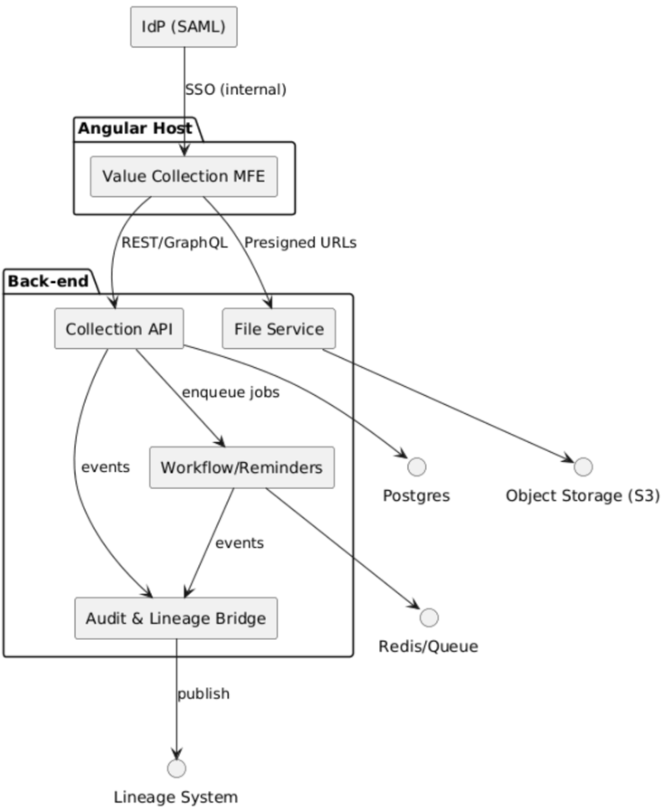

API Surface (selected)
- POST /campaigns create; GET /campaigns/:id read; PATCH /campaigns/:id update; POST /campaigns/:id/activate.
- POST /campaigns/:id/assignments:bulk (CSV or JSON rules) → creates assignment rows.
- GET /assignments?campaignId=...&status=... (paginated, role-scoped).
- GET /assignments/:id/link (admin) → issue signed link.
- GET /forms/:schemaVersionId → JSON Schema + UI schema.
- PUT /submissions/:assignmentId (draft save, idempotent) ; POST /submissions/:assignmentId/submit.
- POST /reviews/:submissionId/decision (approve/reject/comment/reopen).
- GET /dashboards/campaigns/:id → progress, SLA, breach counts.
- Webhooks: submission.submitted, submission.approved, assignment.overdue.

Validation & Calculations
- JSON Schema for client/server validation.
- Server-side rules: cross-field constraints (e.g., building_area >= sum(unit_area)), currency normalization, totals (TIV, contents, BI), and OED-aligned field mapping.

Signed URL Design
- Token: base64url(assignment_id | exp | jti | hmac_sha256(secret, assignment_id||exp||jti)).
- Validate IP allowlist (optional), expiry, replay via jti store in Redis; increment used_count.

SLA & Reminder Algorithm
- On assignment create: compute sla_due_at = start_at + sla_days.
- Persist reminder_schedule per campaign.
- Scheduler runs minutely; finds assignments where now() matches schedule boundaries relative to due date; enqueues notification jobs.
- On breach (now() > sla_due_at and status not in terminal), escalate per policy and update escalation_level.

Review Workflow (sequence)

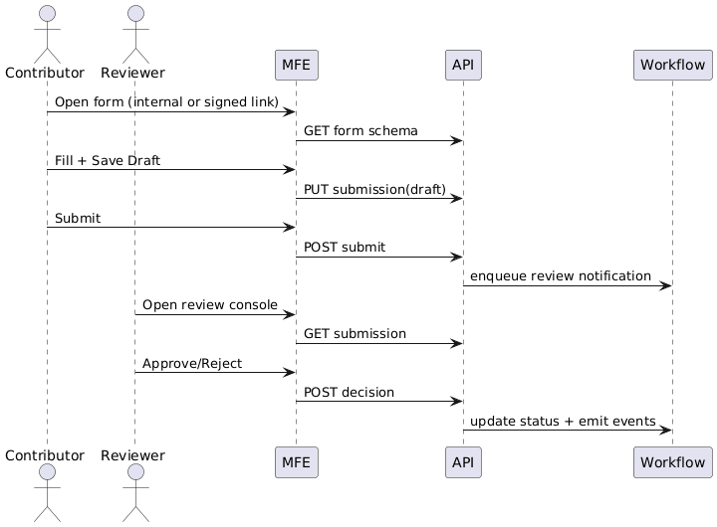

RBAC Model
- Admin: all campaigns within scope; manage templates/schedules.
- Owner: manage own campaigns; assignments; issue links.
- Reviewer: read submissions; issue decisions.
- Contributor (internal): edit/submit assigned properties.
- External: edit/submit via signed link only.
- Auditor: read-only, access to audit trail exports.

Observability & Audit
- Correlate every API request with trace_id; include in audit_log rows.
- Store field-level diffs (JSON Patch) in audit_log.diff; large payloads in S3.
- Emit lineage events after: create/update/submit/approve with full context (campaign, property, schema version, actor, timestamps, hashes).

Frontend Integration Details
- Angular host lazy-loads the MFE via Module Federation (@angular-architects/module-federation).
- Provide custom events (postMessage) for navigation and SSO session checks.
- Form renderer powered by JSON Schema (e.g., Angular JSON Schema Form or custom renderer) with autosave (debounced) and attachment uploader using presigned URLs.

Success Criteria & KPIs
- Completion: ≥95% assignments completed by due date; overdue rate <5%.
- Cycle Time: median time to submit ≤ 7 days; p95 reminder latency < 5 minutes.
- Quality: rejection rate <10%; <1% validation failures on final submit.
- Auditability: 100% actions logged with actor, IP, UA; audit export within SLA.
- Performance: p95 read <300ms, submit <1.5s during campaign peaks.

Monitoring & Feedback Loop
- Dashboards: campaign progress, SLA breaches, reminder effectiveness.
- Quarterly review of schema fields vs. downstream model needs; track mapping drift (esp. OED alignment if enabled).
- Support runbook metrics: email deliverability, AV scan failures, link-abuse detection.

Post-Launch Validation
- Shadow-run a campaign versus previous spreadsheet process; compare completion time and error rate.
- Conduct reviewer calibration sessions to standardize approve/reject thresholds.

