

MELZG554 HSCD LAB ASSIGNMENT 1

HSCD of SIMPLE ISA



Submitted by,

Anand S – 2021HT80003

# Contents

Contents 2

Table of Figures 3

Question 1: Intro to Partial Reconfiguration Flow Lab 4

Q1.a: Screenshot of the adder VHDL module with updated code 5

Q1.b: Screenshot of device view after floorplanning and partition pins are introduced 5

PR_verify result 8

Q1.c: Screenshot from file manager 8

Q1.d: Screenshot of verification of addition/subtraction operations at the serial terminal window 10

Q1.e: Screenshot of Zedboard using the camera app in the RLab PC after programming Config_addleft_pblock_reconfig_leds_partial.bit 10

# Table of Figures

Figure 1 Assignment question with considerations 4

Figure 2 File name: ./Sources/rModule_addsub/adder/adder.vhd 5

Figure 3 Introduction of Partition Pins (shown in white blocks). data_out[5] is highlighted. This is the placed design view of ‘reconfig_addsub’ module 6

Figure 4 For reconfig_leds(Bottom-left box), SNAPPING_MODE was ON. This resulted in whole colum going through the pblock being covered, no static logic is placed here. 6

Figure 5 Same picture as above, but with the region highlighted in yellow. Upper highlighted sector has Partition pins placed. Bottom sector has the actual pblock defined. 7

Figure 6 PR_Verify summary 8

Figure 7 Screenshot of the files present as Bitstreams 9

Figure 8 md5 checksum of each bitstream file in file manager 9

Figure 9 Screenshot of addition and subtraction 10

Figure 10 ZedBoard screenshot 11

Figure 11 Close-up screenshot of zedboard functioning 11

# Question

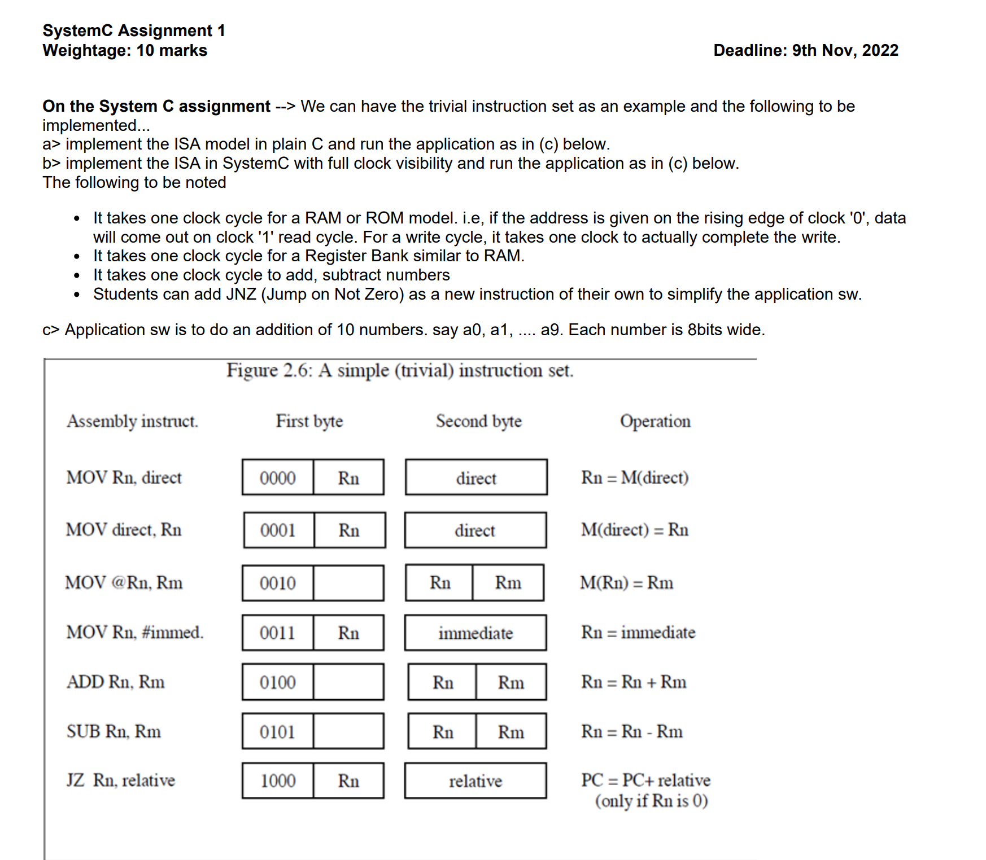

# PART C: Application code to add ten numbers



Figure Application code to add 10 numbers

The SW adds 10 numbers 0, 1, 2, 3, … 9 to get a sum of 45 (0x2d)

# PART A: Implement the ISA model in plain C and run the application code in PART C







Figure C code for the simple ISA

Figure Execution log of the C model output

Thus the C code was executed for the application SW by coding the assembly into the instruction memory array. The execution of the code showed the final value of R3 = 8’d45 = 8’h2d, which is the expected output. Thus the execution was verified.

# PART B: Implement the ISA as timing accurate HW model

## Architecture of the simple_isa CPU

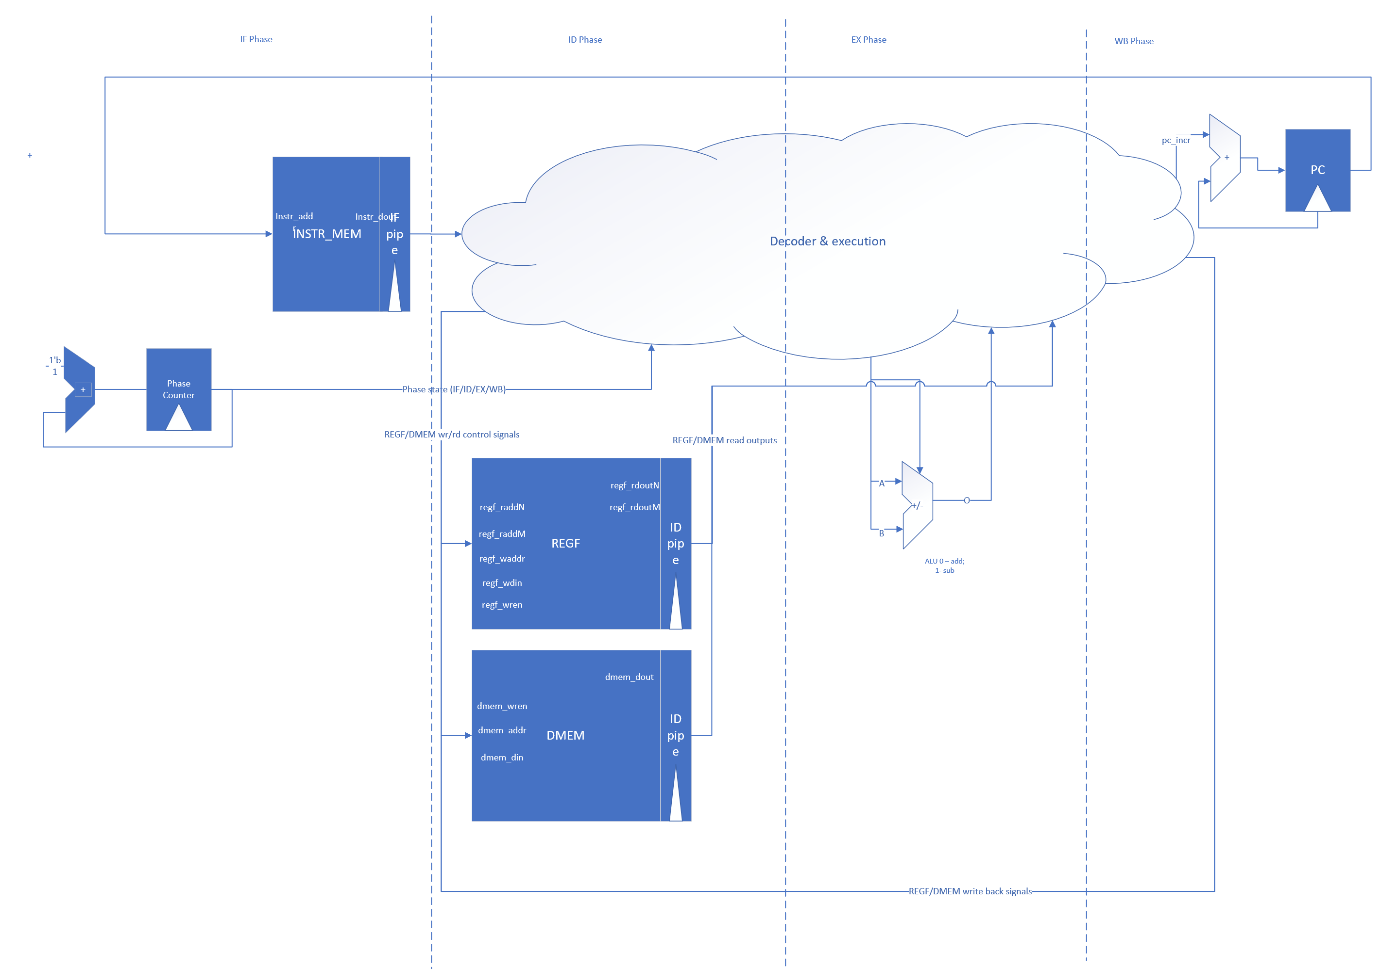

Figure High level arch of the simple_isa CPU

## Implementing systemVerilog design for accurate timing

THE END.

ANAND S

2021HT80003