**G. H. RAISONI COLLEGE OF ENGG., NAGPUR**

**(An Autonomous Institute under UGC Act 1956)**

**Department of Computer Science & Engg.**

**Date: 08/09/2020**

**Practical Subject: Compiler Design**

**Session: 2020-21**

**Student Details:**

|  |  |
| --- | --- |
| **Roll Number** | 70 |
| **Name** | MOSIN SHEIKH |
| **Semester** | 5 |
| **Section** | A |
| **Branch** | C.S.E |

**Practical Details: Practical Number- 02**

**AIM:-** Write a LEX program to Count no. of lines, blanks, words, and characters supplied at a command prompt.

**Theory:-**

Specification of lex:

The lex code consists of three parts:-

* Definition section
* Rule section
* User subroutines

Here, in the below code:

* Definition section includes:- declaration of count_of_variavles.
* Rule section includes:- pattern and action that will be applied on the text.
* User subroutines section:- it includes main function that prints the counts of lines, words, characters and spaces.

**LOGIC:-**

Read the text which will be provided by the user:

* Check if it is a letter(A-Z or a-z or simple dot(.)), if yes then increment the count of characters by 1, or if not then leave the count as it is.
* Check if it has spaces, if yes then increase the count of spaces and also increment the count of words by 1, or if not then leave the count of spaces as it is.
* Check if it has any new lines, if yes then increment the count by 1, otherwise not.

Here, we have used yylex(); and yyleng.

yylex() = return a value indicating the type of token that has been obtained.

yyleng = it is used to get the length of the string

**Program to count number of spaces, lines, words, and characters**

**CODE:-**

%{

// This is a program to Count the number of lines, words, and spaces

#include<stdio.h>

// Declaring the variables

int lines=0, spaces=0, words=1, c_char=0;

%}

%%

[\n] lines++;

[' '] spaces++, words++;

[^' '\n\t] c_char=c_char+yyleng;

%%

int main()

{

yylex();

printf("\n No. of total lines: %d", lines);

printf("\n No of total words: %d", words);

printf("\n No of total spaces: %d", spaces);

printf("\n No of total characters: %d\n", c_char);

return 0;

}

**OUTPUT:-**

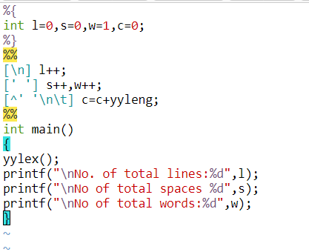

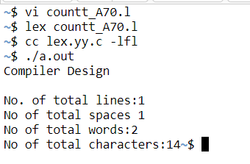

**CONCLUSION:-** Hence, the lex code to count the number of spaces, lines, words, and characters is executed successfully.